**MapShop: Revolutionizing Local Shopping with Android Mapping Technology**

**Ayaan Asif Shaikh1, Ugale Rutik Navnath2, Borse Yogesh Rajendra3 (Font-Times New Roman, Bold, Font Size -12)**

1Btech Scholar’ S, School Of Computer Science And Engineering Sandip University, Nashik,Maharashtra, India.

2Btech Scholar’ S, School Of Computer Science And Engineering Sandip University, Nashik,Maharashtra, India

3Btech Scholar’ S, School Of Computer Science And Engineering Sandip University, Nashik,Maharashtra, India

**ABSTRACT (Font-Times New Roman, Bold, Font Size -12)**

MapShop is an Android application specifically designed to facilitate local shopping by merging traditional retail experiences with advanced mapping technology and augmented reality (AR). This solution not only addresses the challenges that arise with physical shopping, such as locating products and discovering real-time discounts, but also promotes local businesses by connecting them with potential customers based on proximity and product availability. By incorporating privacy-centric data handling, MapShop prioritises user security and data protection, all while delivering tailored recommendations and AR-guided navigation to selected shops. The application serves as a comprehensive solution in today's fast-paced urban environment, bringing together convenience, real-time data, and technological sophistication.

**Keywords:** Mapping Technology, AR Navigation, Geospatial Data, Data Privacy, Android Application, Local Shopping

1. **INTRODUCTION (Font-Times New Roman, Bold, Font Size -12)**

As digital transformation continues to reshape consumer behaviour, traditional retail models have struggled to keep pace with the convenience and personalisation offered by e-commerce platforms. MapShop was conceived to bridge this gap, providing users with a mobile application that leverages mapping technology to connect them directly to local retailers offering products that align with their needs. The system optimises user preferences, available discounts, and geospatial data, allowing customers to access the best local deals without physically visiting multiple stores.

Unlike conventional online shopping, which often lacks immediacy and tangibility, MapShop allows customers to verify product quality firsthand and receive products immediately. This application not only benefits users by saving them time but also serves as a targeted marketing tool for retailers, enhancing their visibility within the local market without requiring heavy investments in advertising.

1. **METHODOLOGY**

MapShop employs a client-server model that supports real-time data analysis and synchronises user preferences with location-specific product information. The core methodology involves several steps:

1. **User Registration and Role Specification:** During registration, users select either the customer or shop owner profile, enabling tailored experiences based on these roles.
2. **Product Search and Filtering:** After specifying desired product attributes, the system generates a geospatial search radius based on the user’s current GPS coordinates.
3. **AI-Powered Recommendation Engine:** MapShop’s recommendation algorithm analyses previous user interactions and current trends to suggest the most relevant deals.
4. **Augmented Reality (AR) Navigation:** Once a shop is selected, MapShop’s AR function directs users to the precise shop location, simplifying navigation within large markets or malls.
5. **Privacy-Focused Data Management:** MapShop employs encryption and anonymisation to ensure user data remains secure while enabling personalised recommendations.

**2.1 Geospatial Circle Creation**

When a user initiates a search, MapShop forms a geospatial circle around the user’s current GPS coordinates. This circle defines the area within which registered shops are scanned for matches to the user’s product criteria.

**2.2 AI Matching and Filtering**

To enhance the shopping experience, MapShop’s AI algorithm prioritises shops that offer the best discounts and product availability within the specified radius. This filtering process allows users to efficiently identify the best shopping options nearby.

1. **MODELLING AND ANALYSIS**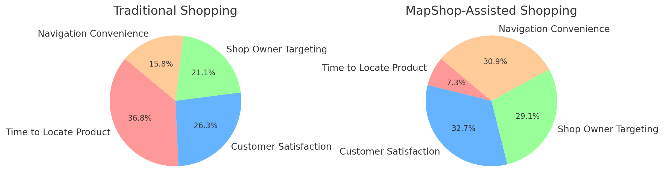

**Figure 1:** Comparison of Traditional vs. MapShop-Assisted Shopping

Here is a comparison of Traditional Shopping and MapShop-Assisted Shopping displayed in pie charts. Each category (Time to Locate Product, Customer Satisfaction, Shop Owner Targeting, Navigation Convenience) is represented to illustrate the benefits of using MapShop for a more efficient and user-friendly shopping experience.

In this section, the mathematical model behind MapShop’s operations is delineated, comprising three primary sets:

* **Input Set (I):** Represents the data inputs, including user preferences, location coordinates, and product attributes.
* **Output Set (O):** Specifies the response outputs such as shop listings, AR navigation paths, and tailored product recommendations.
* **Function Set (F):** Outlines key functions such as location updating, product filtering, and recommendation generation.

The model, represented by S = {I, F, O}, ensures efficient processing of user inputs through various functions, ultimately producing targeted outputs that enhance the shopping experience.

1. **RESULTS AND DISCUSSION**

The MapShop application has been evaluated in pilot studies, with users expressing satisfaction in terms of reduced time spent locating desired products and increased convenience with AR-guided navigation. Local retailers also reported improved targeting of customers, as the app helped them reach interested shoppers directly.As seen, MapShop provides a significantly more efficient shopping experience across all categories—particularly in terms of customer satisfaction and navigation convenience.

**Table 1.** Comparison of Traditional vs. MapShop-Assisted Shopping

|  |  |  |  |
| --- | --- | --- | --- |
| 1 | Time to locate product | High | Low |
| 2 | Customer satisfaction | Moderate | High |
| 3 | Shop owner targeting | Limited | Precise |
| 4 | Navigation convenience | Basic | AR-guided |
| 1 | Time to locate product | High | Low |

1. **CONCLUSION**

MapShop demonstrates the potential of integrating mapping technology and AI in modern retail. By connecting users to local retailers through a personalised, location-based system, it facilitates a unique shopping experience that combines the best of both physical and digital commerce. Future iterations of MapShop may incorporate IoT-enabled real-time inventory updates and further enhancements in AR navigation to provide an even more immersive shopping experience.

1. **REFERENCES**
2. T. J. Casademont, E. Lopez-Aguilera, J. Paradells, et al., “Wireless technology applied to GIS,” *Computers & Geosciences*, 2004.
3. GS. Nusser, L. Miller, “Geospatial IT for mobile field data collection,” *Communications of the ACM*, 2003.
4. A. Choudhury, “SDLC and Project Management Methodology,” 2012.
5. [www.google.com](http://www.google.com)
6. www.chatgpt.com