ATMOS

|  |  |  |
| --- | --- | --- |
| A. Anirudh  *B. Tech*  *School of Engineering*  Computer Science – AI&ML  Malla Reddy University, India. | A. Kiran Kumar  *B. Tech*  *School of Engineering*  Computer Science – AI&ML  Malla Reddy University, India. | A. Rama Krishna  *B. Tech*  *School of Engineering*  Computer Science – AI&ML  Malla Reddy University, India. |
| A. Pranitha  *B. Tech*  *School of Engineering*  Computer Science – AI&ML  Malla Reddy University, India. | A. Maheshwara Reddy  *B. Tech*  *School of Engineering*  Computer Science – AI&ML  Malla Reddy University, India.  Guide: Chinni krishna sir  *Asst Professor*  *School of Engineering*  Computer Science – AI&ML  Malla Reddy University, India. |  |

***Abstract:***

The development of a comprehensive weather application, Atmos, is designed to provide real-time, seasonal, and emergency weather services to the public. This mobile application will offer accurate, up-to-date weather forecasts, crucial seasonal insights for agriculture, health risk alerts for diseases associated with seasonal weather changes, and an emergency SOS feature for immediate rescue notifications, even in offline situations. By harnessing meteorological data and advanced analytics, Atmos aims to enhance public safety, support agricultural decision-making, and improve community health awareness. The application is tailored to benefit both the general public and specialized users, like farmers, by providing actionable insights based on weather predictions and local environmental factors. Furthermore, Atmos offers health risk alerts linked to weather conditions, such as alerts for respiratory issues or disease outbreaks that correlate with specific weather patterns. This proactive health feature enables users to take preventive measures, thereby contributing to public health and awareness in affected areas. One of the most innovative features of Atmos is its built-in emergency button, designed to function even without an internet connection. This feature allows users to send a distress message to rescue teams in case of sudden, weather-related disasters, such as floods or hurricanes, ensuring that help can be dispatched promptly.

***Keywords:*** Python, Nlp

I. INTRODUCTION

In recent years, unpredictable weather events and natural disasters have increased in both frequency and intensity, making reliable and accessible weather information essential for communities worldwide. Atmos is conceived as a user-friendly, interactive weather application focused on delivering real-time forecasts, seasonal predictions, and emergency assistance, even in situations with limited connectivity. This application is envisioned not only to provide weather forecasts but also to serve specific needs for communities, especially farmers, who rely heavily on weather patterns to determine planting cycles. Additionally, Atmos will alert users to potential health risks associated with changing weather conditions, such as heightened risks of respiratory illnesses during specific seasons. A unique feature of the application is its emergency button, which sends a distress signal to rescue teams to enable immediate response during natural disasters. Atmos leverages data-driven insights and emergency response features to deliver a service that enhances everyday decision-making and ensures safety during critical situations.

II. REQUIRED TOOLS

***a) Software Requirements***

1. Operating System: Compatible with Android and iOS platforms to maximize accessibility.

2. Frontend Development: Utilization of frameworks such as Flutter or React Native for cross-platform development, ensuring a smooth and responsive user experience.

3. Backend Server: A robust backend using Node.js, Python (Flask/Django), or similar technology to handle real-time data requests and ensure seamless data flow.

4. Database: PostgreSQL or MongoDB to store user data, emergency contacts, and historical weather data, along with managing disease and crop recommendation modules.

5. APIs and Integrations:

Weather APIs like OpenWeatherMap, ClimaCell, or National Weather Service APIs for live and seasonal weather data.

Health and agricultural APIs to fetch disease prevalence and crop season information for different regions.

SMS/Communication APIs (e.g., Twilio, Nexmo) for the emergency button, which can operate offline by using stored protocols and fallback SMS technology

***b) Hardware Requirements***

* 1. Smartphone Compatibility: The application should work on mid-range smartphones with Android or iOS operating systems, allowing for a broad user base.
* 2. Network Requirements: While Atmos provides essential functionalities offline, optimal performance relies on network connectivity to ensure real-time updates.
* 3. Emergency Protocol Hardware: Devices with SMS capabilities are required to support the emergency button feature. Additional support for GPS would enhance location accuracy in distress situations.
* 4. Battery Optimization: Since weather apps can consume significant battery due to GPS and data refresh, optimization techniques will be used to minimize battery drain and ensure that the emergency feature remains accessible even with low battery levels.

III. MODULES

**a) Weather Forecasting Module:** This module provides real-time weather updates, daily and weekly forecasts, and seasonal predictions using data from global weather APIs. It delivers hyper-local information, enabling users to plan daily activities and prepare for upcoming weather changes.

**b) Emergency Alert Module:** The emergency button feature in this module enables users to send distress signals during sudden disasters, even offline. Using SMS protocols or low-bandwidth communication, it dispatches location-based alerts to nearby rescue teams, ensuring immediate assistance.

IV. ARCHITECTURE

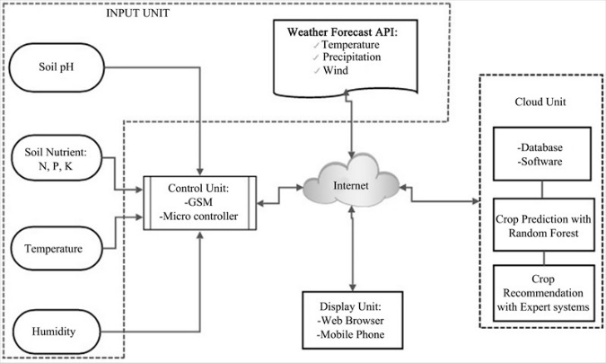

Here are the main components of the architecture of a

Atmos :

1. Frontend Layer: Built using cross-platform frameworks like Flutter or React Native, the frontend handles the user interface and user interactions. This layer displays real-time weather data, seasonal recommendations, health alerts, and emergency functionalities in an accessible and user-friendly format.

2. Backend Layer: The backend server, hosted on platforms like AWS or Google Cloud, processes weather data requests, manages user profiles, and handles emergency messages. Using Node.js or Python-based frameworks, this layer coordinates between the app’s data sources and the client, ensuring smooth data flow and secure communication.

3. Data Aggregation and Processing: This layer collects data from various external APIs (weather, agricultural, and health databases). Machine learning algorithms are applied here to analyze historical weather patterns, forecast crop recommendations, and assess health risks. This processed data is then sent to the backend for delivery to users

4. Emergency Communication System: Designed for low connectivity, this system uses SMS or LoRa protocols to ensure emergency messages reach rescue teams even without internet access. This offline capability ensures user safety by storing and dispatching distress alerts when a minimal signal is available.

V. DESIGN

***UML/ USECASE DIAGRAM:***

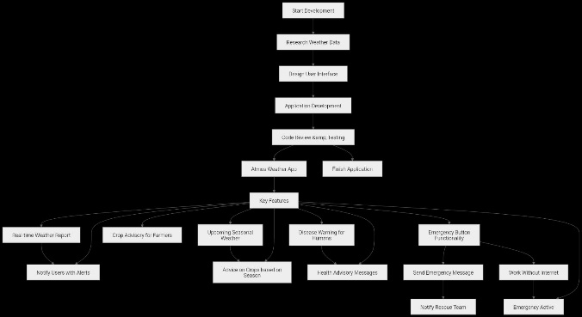

1. Start Development - The beginning of the app development process.

2. Research Weather Data - Collecting data for accurate weather information.

3. Design User Interface - Creating a user-friendly design for the app.

4. Real-time Weather Report - Provides live updates on weather conditions.

5. Crop Advisory for Farmers - Offers advice on farming practices based on weather.

6. Upcoming Seasonal Weather - Gives information on expected seasonal changes.

7. Disease Warning for Humans - Warns users about health risks related to weather.

8. Emergency Button Functionality - Sends emergency messages and notifies rescue teams.

9.Work Without Internet - Ensures that certain app features remain functional even when offline.

* 1. RESULTS

Executing the above code after importing the necessary modules and packages we get the following output:

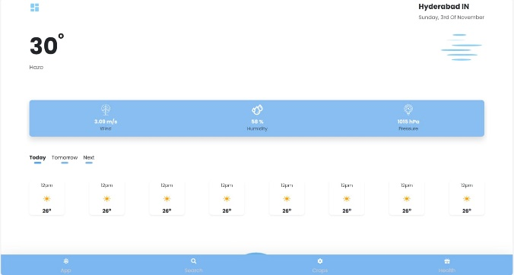

This is a screen shot of the output of the Atmos..

* 1. CONCLUSION

The Atmos weather application represents an essential advancement in how communities interact with and respond to changing weather patterns. By combining real-time and seasonal weather updates, crop suggestions, health risk warnings, and an offline emergency button, Atmos empowers users with timely information for both daily planning and critical situations. Its benefits for farmers, in particular, are valuable, as the application’s predictive capabilities align crop selection with environmental conditions, thus potentially improving agricultural yields. The emergency response feature addresses a vital need for reliable communication during disasters, ensuring user safety even without internet access. Ultimately, Atmos is designed not only to enhance day-to-day convenience but also to build resilience against climate-related risks, making it a valuable tool for individuals and communities alike.

ACKNOWLEDGMENT

My major project would not have been successful without the help of several people. I would like to thank those who were part of my project in numerous ways and who provided outstanding support from the beginning. I am extremely thankful to our honorable Vice Chancellor, V. S. K. Reddy Sir, for providing the necessary infrastructure and resources for the accomplishment of my project. I am highly indebted to Prof. Kailasa Rao, Dean of the School of Engineering, for his support during the tenure of the project. I am very much obliged to our beloved Prof. Thayyaba Khatoon, Head of the Department of Artificial Intelligence & Machine Learning, for providing the opportunity to undertake this project and for her encouragement in its completion. I hereby wish to express my deep sense of gratitude to Prof. Balaiah for the esteemed guidance, moral support, and invaluable advice provided for the success of the project.

REFERENCES

The development of Atmos draws upon various sources of meteorological, agricultural, and health data to ensure accuracy and reliability. Weather information is gathered through trusted APIs such as OpenWeatherMap and ClimaCell, which provide up-to-date forecasts and seasonal trends. For agricultural insights, databases and resources from government and academic institutions offer guidelines on crop suitability and planting schedules. Health advisories are informed by public health data sources, which track disease prevalence linked to specific weather patterns. Additionally, SMS and low-bandwidth communication protocols for emergency services are based on best practices in emergency response technology, ensuring robust offline functionality. These references ensure that Atmos delivers scientifically backed, high-quality information to users.