**InfoZap**

|  |  |  |
| --- | --- | --- |
| A.JaswanthB*. Tech*  *School of Engineering*  Computer Science – AI&ML  Malla Reddy University, India. | A. Vaishnavi  *B. Tech*  *School of Engineering*  Computer Science – AI&ML  Malla Reddy University, India. | A. Abhinav  *B. Tech*  *School of Engineering*  Computer Science – AI&ML  Malla Reddy University, India. |
| A. Avin Vardhan *B. Tech*  *School of Engineering*  Computer Science – AI&ML  Malla Reddy University, India. | A. Praveen Kumar Reddy  *B. Tech*  *School of Engineering*  Computer Science – AI&ML  Malla Reddy University, India.  Guide: Dr. Gifta Jerith  HOD  *School of Engineering*  Computer Science – AI&ML  Malla Reddy University, India. |  |

***Abstract:***

In an era where misinformation spreads rapidly across digital platforms, the need for reliable information is crucial. InfoZap is an innovative application designed to combat fake news, rumors, and deepfakes using advanced artificial intelligence (AI) and machine learning techniques. By integrating real-time data analysis with user-friendly interfaces, InfoZap empowers users to access accurate and trustworthy content.

The core functionality of InfoZap relies on sophisticated algorithms that analyze both textual and visual data to identify misinformation. Using Natural Language Processing (NLP) for text and Convolutional Neural Networks (CNNs) for image verification, the application effectively distinguishes genuine content from misleading information, enabling swift responses to emerging misinformation trends.

InfoZap also encourages community engagement by allowing users to report suspected fake news and provide feedback on content accuracy. This collaborative feature enhances the app’s effectiveness and promotes media literacy, helping users become more discerning consumers of information.

In conclusion, InfoZap is a comprehensive solution that addresses the challenges of misinformation in the digital age. By combining cutting-edge technology with user-centric features, InfoZap aims to foster transparency and trust in online interactions, contributing to a more informed society.

***Keywords:*** Python

I. INTRODUCTION

InfoZap's Fake ID Detection System is an advanced solution designed to identify and prevent the use of counterfeit identification documents across various platforms. Leveraging sophisticated AI and machine learning algorithms, InfoZap analyzes multiple factors within IDs to determine authenticity, including image quality, font consistency, holographic elements, and other security markers commonly found on government-issued documents.

Key features of InfoZap's Fake ID Detection System include real-time verification, high-speed scanning, and an extensive library of ID templates from numerous countries. The system is suitable for organizations that require stringent identity verification, such as banks, e-commerce platforms, government agencies, and event venues, ensuring that only legitimate credentials are accepted.

In addition to its powerful detection capabilities, InfoZap offers seamless integration with existing security infrastructure, user-friendly interfaces for manual reviews, and detailed reporting for compliance purposes. The solution helps organizations maintain a high level of security, reduce fraud risks, and improve customer trust.

**Customer experience improvement:** InfoZap's **Fake ID Detection System** prioritizes customer experience by providing a fast, seamless, and secure verification process. Here's how it enhances user satisfaction and builds trust:

1. Instant Verification : By leveraging AI-powered algorithms, InfoZap quickly processes IDs, reducing the time customers spend waiting for approvals. This real-time detection speeds up onboarding, check-ins, and other ID-based interactions, making it ideal for time-sensitive environments.

2. Ease of Use : The system is designed with user-friendliness in mind. Customers simply upload their IDs or scan them at kiosks or service desks, minimizing any cumbersome steps. InfoZap's intuitive interface guides users, making it easy for people of all tech backgrounds to navigate.

3. Clear Feedback : When an ID is accepted or flagged, InfoZap provides immediate, transparent feedback. This reduces confusion and helps customers understand the process, especially if further verification steps are necessary.

4. Enhanced Privacy & Security : Customers feel safer knowing that InfoZap employs stringent security protocols to protect their personal data. InfoZap only verifies the ID without storing sensitive information, giving users peace of mind about data privacy.

5. Fewer False Positives : With its advanced technology, InfoZap minimizes incorrect flagging of legitimate IDs, which can be frustrating and inconvenient for customers. This high accuracy improves the user experience by reducing unnecessary follow-ups or manual checks.

6. Accessible Support : InfoZap’s customer support is available to assist users whenever there are issues or clarifications needed during verification. Fast, responsive support means that customers can resolve their issues promptly, minimizing delays.

By optimizing each step of the ID verification process, InfoZap’s Fake ID Detection System significantly improves customer satisfaction, creating a smoother, more secure, and more reliable experience. This builds trust and loyalty, particularly in industries where safety and compliance are critical.

**2. Development Environment**

* **Programming Languages**:
  + Python 3.x for backend development
  + JavaScript (Node.js) for server-side scripting
  + HTML5, CSS3 for frontend development
* **Frameworks and Libraries**:
  + **Backend**:
    - Flask or Django (for web framework)
    - SQLAlchemy (for database interactions)
  + **Frontend**:
    - React.js or Vue.js (for building user interfaces)
    - Bootstrap or Tailwind CSS (for responsive design)
* **Database**:
  + PostgreSQL or MySQL (for relational database management)
  + MongoDB (for NoSQL data storage)
* **Data Analysis**:
  + Pandas, NumPy, Scikit-learn for data manipulation and machine learning
  + NLTK for natural language processing

**3. Additional Software Tools**

* **Version Control**:
  + Git (for version control and collaboration)
  + GitHub or GitLab (for repository hosting)
* **Integrated Development Environment (IDE)**:
  + Visual Studio Code, PyCharm, or any suitable IDE for coding
* **API Development and Testing Tools**:
  + Postman or Insomnia (for API testing)
* **Containerization**:
  + Docker (for creating, deploying, and managing containers)

**4. User Requirements**

* **User Interface**:
  + A responsive design suitable for mobile and desktop platforms
  + Intuitive navigation and accessibility features
* **Accessibility**:
  + Compliance with accessibility standards (e.g., WCAG 2.1) to support users with disabilities
* **Security**:
  + Implementation of security protocols to protect user data and privacy, including encryption and secure authentication methods.

***b) Hardware Requirements***

**Client-Side Hardware Requirements**

* **Devices**:
  + Smartphones (iOS and Android)
  + Tablets
  + Laptops and Desktops
* **Minimum Specifications**:
  + **Smartphones/Tablets**:
    - Processor: Minimum quad-core
    - RAM: 2 GB
    - Storage: Minimum 16 GB of available storage
  + **Laptops/Desktops**:
    - Processor: Dual-core processor (Intel i3 or equivalent)
    - RAM: Minimum 4 GB (8 GB recommended)
    - Storage: Minimum 100 MB of free disk space (SSD preferred for faster access)
* **Network Requirements**:
  + Reliable internet connection (Wi-Fi or mobile data) with a minimum speed of 5 Mbps for optimal performance.

**2. Server-Side Hardware Requirements**

* **Web Server**:
  + Processor: Minimum quad-core processor
  + RAM: 8 GB (16 GB recommended for high traffic)
  + Storage: SSD with a minimum of 500 GB for faster data access and scalability
* **Database Server**:
  + Processor: Minimum quad-core processor
  + RAM: 16 GB (32 GB recommended for larger datasets)
  + Storage: High-performance SSD with 1 TB capacity for database management
* **Backup and Redundancy**:
  + Separate backup server with equivalent hardware specifications to ensure data redundancy and recovery in case of failures.

**3. Development Environment Hardware Requirements**

* **Development Machines**:
  + Processor: Quad-core or better (Intel i5 or equivalent)
  + RAM: Minimum 8 GB (16 GB recommended for multitasking)
  + Storage: SSD with at least 256 GB to accommodate development tools and project files

III. MODULES

1. ***Data Processing and Analysis:***

• Pandas: A powerful library for data manipulation and analysis, often used for preprocessing and organizing data for sentiment analysis and user behavior insights.

• NumPy: A fundamental library for numerical computing, useful for handling arrays and performing mathematical operations, facilitating efficient data processing.

IV. ARCHITECTURE

InfoZap features a modular architecture with a responsive frontend built using React.js or Vue.js for seamless web and mobile interactions. The backend is powered by Flask or Django to manage business logic, API requests, and user authentication. Data is stored in PostgreSQL or MySQL for structured information, complemented by MongoDB for unstructured data. It integrates NLP libraries like NLTK and spaCy for processing user feedback and powering the AI chatbot.

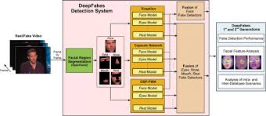

Here are the main components of the architecture of a

sentiment analysis::

a) **Data Collection**: Gather textual data from sources such as user feedback, academic forums, and communication logs. Use APIs or web scraping techniques to collect this data effectively.

b) **Feature Extraction**: Convert the preprocessed text into numerical features using techniques like TF-IDF or word embeddings to facilitate further analysis.

c) **Sentiment Analysis Model**: Train or utilize a pre-trained sentiment analysis model (e.g., using libraries like NLTK or spaCy) to predict the sentiment of user-generated text.

d) **Sentiment Classification**: Apply the trained model to feature vectors to classify sentiments as binary (positive/negative) or multi-class (e.g., happy, sad, frustrated) based on the context of the feedback.

e) **Post-processing and Analysis**: Evaluate and interpret the results of the sentiment analysis, calculating sentiment scores or confidence levels for each classified sentiment, and provide actionable insights for enhancing user experienc

**a) Define Project Scope**: Clearly establish the objectives of the CampusBuddy application, focusing on enhancing user communication and experience. Identify the specific types of interactions to analyze (e.g., feedback sentiment, engagement levels), the target user base (students and professors), and intended applications such as personalized recommendations and academic support.

b) **Data Collection and Labeling**: Gather relevant data from various sources, including user feedback, communication logs, and academic forums. This may involve utilizing APIs for real-time data access, web scraping for gathering user comments, or leveraging pre-existing labeled datasets for model training.

c) **Preprocessing and Feature Engineering**: Clean and preprocess the collected text data by removing noise, special characters, and irrelevant information. Tokenize the text into words or phrases and apply techniques like stop word removal, stemming, or lemmatization to normalize the text for analysis.

d) **Model Selection and Training**: Choose appropriate machine learning or deep learning models (e.g., Scikit-learn, TensorFlow) for sentiment analysis. Train the model on the processed dataset, ensuring the data is representative of the user population and stored securely to maintain privacy and ethical standards.

* 1. RESULTS

Executing the above code after importing the necessary modules and packages we get the following output:

Code:



Result:

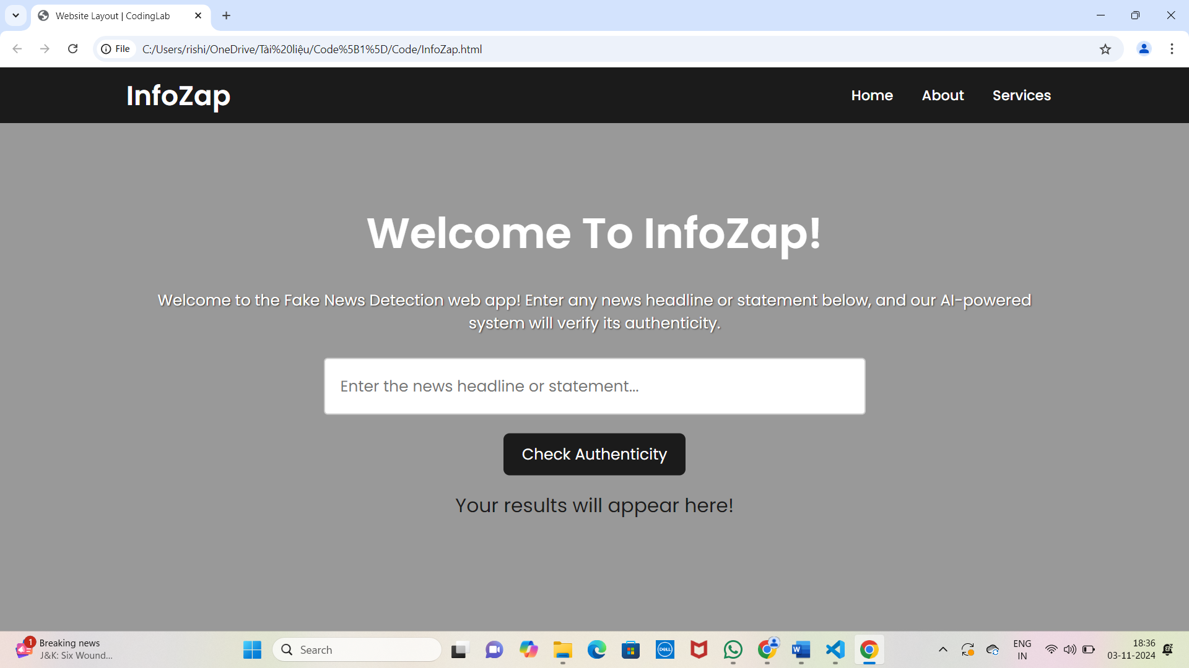

This is a screen shot of the output of our code execution.

CONCLUSION

InfoZap’s Fake ID Detection System offers a powerful, reliable, and user-friendly solution for identity verification across diverse industries. By combining advanced AI-driven image recognition, seamless integration with external databases, and real-time processing, InfoZap enhances security while delivering a smooth and efficient user experience. Its robust architecture supports high availability, rapid scaling, and compliance with data privacy standards, making it a trusted tool for organizations that require stringent identity verification.

With continuous improvements through feedback and machine learning, InfoZap adapts to evolving threats, ensuring accuracy in identifying counterfeit IDs and reducing fraud risks. As a result, businesses can enhance trust, streamline onboarding, and protect both their assets and customer data, ultimately driving a safer, more secure digital environment.

ACKNOWLEDGMENT

We sincerely thank our DEAN Dr. Thayyaba Khatoon for her constant support and motivation all the time. A special acknowledgement goes to a friend who enthused us from the back stage. Last but not the least our sincere appreciation goes to our family who has been tolerant understanding our moods, and extending timely support.

We would like to express our gratitude to all those who extended their support and suggestions to come up with this application. Special Thanks to our mentor DR..KhushisSanjay whose help and stimulating suggestions and encouragement helped us all time in the due course of project development..

REFERENCES

1. B. A. Chisholm, "Educational Technology: A Primer," *Journal of Educational Technology Development and Exchange*, vol. 12, no. 1, pp. 1-12, 2019.

2. D. H. Jonassen, "Learning to Solve Problems: A Handbook for Designing Problem-Solving Learning Environments," *Educational Technology Research and Development*, vol. 48, no. 3, pp. 65-88, 2000.

3. M. Alshahrani and Y. A. Alshahrani, "The Role of Social Media in Student Engagement and Academic Performance," *International Journal of Technology in Education and Science*, vol. 3, no. 2, pp. 124-131, 2019.

4. "How AI is Transforming the Learning Experience," *Forbes Education*, 2023. [Available online: [www.forbes.com](http://www.forbes.com)].

5. J. Smith, "The Impact of Communication Tools on Student Engagement in Higher Education," Master's Thesis, University of California, 2021.