RIVAAZ

AI based event planning platform

|  |  |  |
| --- | --- | --- |
| A.Sai Teja B.*Tech*  *School of Engineering*  Computer Science – AI&ML  Malla Reddy University, India. | Anjali Sharma  *B. Tech*  *School of Engineering*  Computer Science – AI&ML  Malla Reddy University, India. | Aman Singh  *B. Tech*  *School of Engineering*  Computer Science – AI&ML  Malla Reddy University, India. |
| A.Dhanunjaya  *B. Tech*  *School of Engineering*  Computer Science – AI&ML  Malla Reddy University, India. | A.Anil kumar  *B. Tech*  *School of Engineering*  Computer Science – AI&ML  Malla Reddy University, India.  Guide: Sanjaykumar J Hamilpure  *Asst.Professor*  *School of Engineering*  Computer Science – AI&ML  Malla Reddy University, India. |  |

***Abstract:***

Rivaaz is an AI-powered event planning application designed to provide users with a seamless and stress-free event management experience. It allows individuals to connect with professional planners for various events, including weddings, anniversaries, funerals, and birthdays, catering to users' personal preferences, cultural beliefs, and sentiments. By integrating artificial intelligence, Rivaaz enhances its service offerings by streamlining the planning process, suggesting personalized options, and managing event details efficiently. This document explores the development of Rivaaz, focusing on its objectives, AI-driven features, and user-centered design, aiming to redefine how users approach event planning and make it effortlessly enjoyable.

***I. INTRODUCTION***

Rivaaz is an event planning platform that connects users with professional planners to create memorable, personalized events. Catering to various occasions—weddings, birthdays, anniversaries, and more—Rivaaz emphasizes customization and respect for individual cultural values and personal sentiments. Traditional event planning often lacks the flexibility to capture these unique aspects, resulting in experiences that may feel impersonal. Rivaaz bridges this gap by integrating AI-driven features to simplify the planning process, offering personalized recommendations, vendor suggestions, and schedule management.

Built on a Django framework for scalability and security, Rivaaz combines user-centric design with technology to offer a seamless, stress-free planning experience. This document explores Rivaaz's objectives, scope, and design, illustrating how it redefines event planning by balancing tradition with technology, making it easy for users to celebrate life’s significant moments.

***II. REQUIRED TOOLS***

***a) Software Requirements***

Operating System: Windows

Web Server: Apache or default browser

(for deployment)

Backend Framework: Django (Python-based web framework)

Database: SQLite for robust data handling and scalability

Frontend: HTML5, CSS3, JavaScript, and Bootstrap for responsive UI design

AI Libraries: TensorFlow or PyTorch (for AI-driven recommendations and personalization features)

Email Service (e.g., SendGrid or SMTP) for notifications and reminder

Version Control: Git (with repositories like GitHub or GitLab)

IDE: PyCharm, VS Code, or any Python-supporting IDE

Testing Frameworks: admin shell for backend testing; default browser for frontend testing

***b) Hardware Requirements***

Serve r Requirements:

Processor: Quad-core or higher, minimum 2.0 GHz

RAM: 8 GB (16 GB recommended for high traffic)

Storage: 500 GB SSD or higher (scalable storage recommended for growing data)

Client-Side Requirements:

Processor: Dual-core, minimum 1.6 GHz

RAM: 4 GB (8 GB recommended)

Storage: 50 MB for app installation (web-based, minimal storage required)

Network Requirements:

Internet Speed: Minimum 5 Mbps for stable client-server communication

Hosting Server Bandwidth: Sufficient to handle concurrent users and scalable based on projected growth

III. MODULES

***a) User Management Module:***

Registration & Login: Allows new users to register and existing users to log in.

Profile Management: Users can manage their profile, personal details, preferences, and event history.

Authentication & Authorization: Secure access with role-based permissions for users and administrators.

***b) Event Planning Module:***

Event Creation & Customization: Users can create events, specify details (event type, date, location), and customize according to personal preferences.

Theme & Template Selection: Offers predefined themes and templates for different event types to simplify the planning process.

Budget Management: Helps users set budgets, track expenses, and get cost estimates based on selected vendors and services.

***c) AI-Driven Recommendation Module:***

Vendor & Service Recommendations: Uses AI to suggest vendors, caterers, decorators, and other service providers based on user preferences and location.

Personalized Theme Suggestions: Provides theme recommendations tailored to users' interests and cultural preferences.

Automated Scheduling & Reminders: Generates a timeline for events, sends reminders, and automates follow-ups with vendors.

***d)Vendor Management Module:***

Vendor Profiles: Allows vendors to register and manage their profiles, services, and rates.

Vendor Search & Selection: Users can search for and select vendors based on ratings, location, and availability.

Review & Ratings: Users can rate and review vendors after the event, helping other users make informed decisions.

***e)Payment & Transaction Module:***

Payment Gateway Integration: Supports secure online payments through APIs like Stripe or PayPal.

Invoice & Billing: Generates invoices for services and tracks payments for both users and vendors.

Refund & Cancellation: Handles payment reversals for cancellations, ensuring smooth financial transactions.

***f)*** ***Event Tracking & Management Module:***

Real-Time Progress Tracking: Allows users to monitor event preparation and see updates from planners and vendors.

Task Management: Tracks key tasks, deadlines, and milestones for each event.

Notification System: Sends notifications and alerts for important updates and upcoming tasks.

**IV. ARCHITECTURE**

This architecture for Rivaaz provides a structured framework for a comprehensive event planning experience, combining personalization with AI-driven insights. Here’s an overview of each keycomponent: 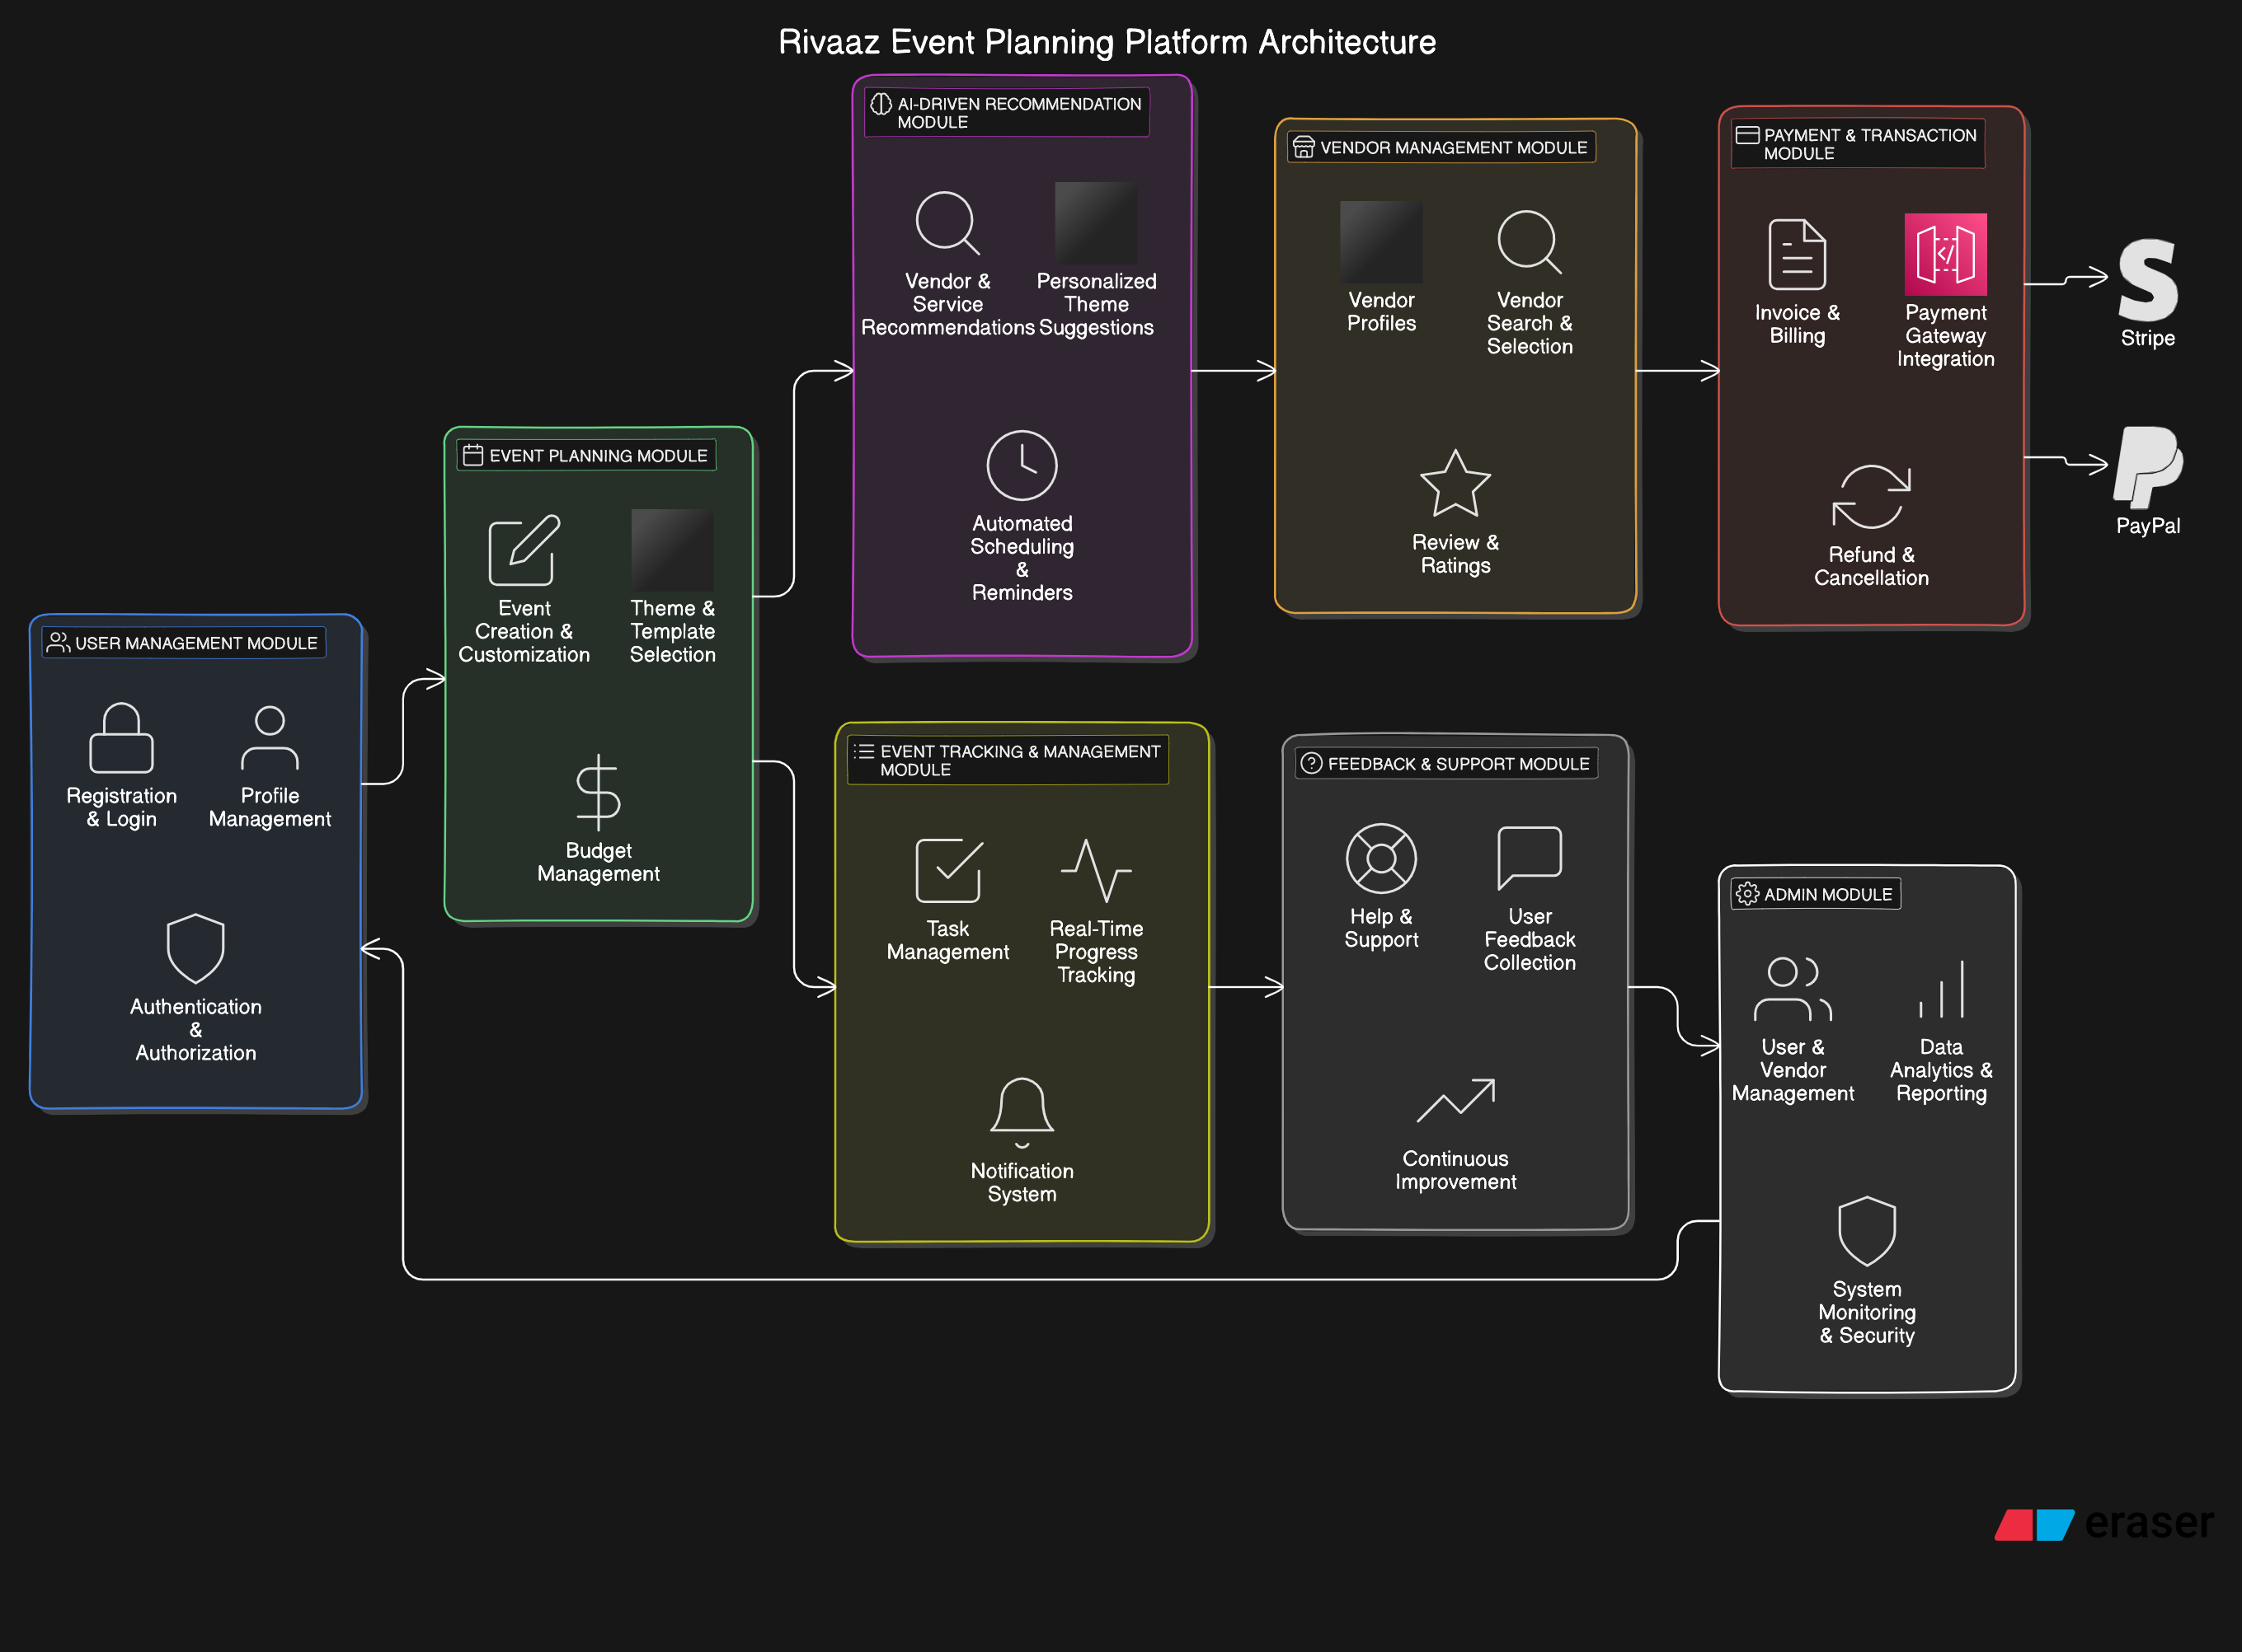

**User Management Module**: Handles user registration, login, and profile management, with secure authentication and authorization. This module enables users to personalize their event preferences and manage their history.

**Event Planning Module**: Allows users to create and customize events with options for theme selection and budget management. This module ensures each event aligns with the user’s preferences, cultural values, and budget constraints.

**AI-Driven Recommendation Module**: Uses AI to recommend vendors and services based on user preferences, location, and event type. It also suggests personalized themes and automates scheduling tasks, simplifying the planning process and improving personalization.

**Vendor Management Module**: Enables vendors to manage their profiles, services, and rates. Users can search for and select vendors based on ratings and availability, with review and rating features that help inform future users.

**Payment & Transaction Module**: Supports secure payment processing through integration with third-party gateways like Stripe and PayPal. It also handles invoicing, billing, refunds, and cancellations, ensuring smooth financial transactions.

**Event Tracking & Management Module**: Provides real-time tracking of event preparation progress, task management, and notifications. This module ensures users stay informed about critical tasks, deadlines, and updates.

**Feedback & Support Module**: Collects feedback on events, vendors, and the overall platform experience. It offers help and support via FAQs, chatbot assistance, and customer support, enabling continuous improvement based on user feedback.

**Admin Module**: Allows admins to manage user and vendor accounts, oversee platform usage, and analyze data trends. It includes system monitoring and security to ensure platform stability and data integrity.

**v. Functional Workflow**

The functional workflow of Rivaaz outlines the process that users, event planners, and vendors will follow within the application. This workflow ensures that each step of the event planning process is seamless and efficient, from user registration to event completion.

**1. User Registration and Profile Setup**

Step 1: User accesses the Rivaaz application.

Step 2: User selects "Register" to create a new account.

Step 3: User fills in personal information (name, email, password, cultural preferences).

Step 4: User submits the registration form.

Step 5: Rivaaz sends a confirmation email to verify the account.

Step 6: User clicks on the confirmation link to activate the account.

Step 7: User logs into the application and completes their profile setup by adding additional preferences and event details.

**2. Event Creation**

Step 1: User navigates to the "Create Event" section.

Step 2: User selects the event type (wedding, birthday, anniversary, etc.).

Step 3: User inputs event details (date, location, budget, and theme preferences).

Step 4: User reviews and confirms the event details.

Step 5: Rivaaz stores the event information and begins processing for vendor suggestions.

**3.AI-Driven-Vendor Recommendations**

Step 1: Rivaaz uses AI algorithms to analyze user preferences and event details.

Step 2: Rivaaz generates a list of recommended vendors based on the user’s location and event type.

Step 3: User reviews the list of vendors, viewing profiles, ratings, and reviews.

Step 4: User selects preferred vendors for the event.

**4. Vendor Interaction and Confirmation**

Step 1: User sends requests to selected vendors for availability and pricing.

Step 2: Vendors respond with proposals, including quotes and service details.

Step 3: User evaluates vendor proposals and confirms the selection.

Step 4: Rivaaz notifies the selected vendors and manages communication.

**5. Payment Processing**

Step 1: User navigates to the "Payment" section to pay for services.

Step 2: User reviews the total cost and payment options.

Step 3: User selects a payment method and enters required payment information.

Step 4: Rivaaz processes the payment through the integrated payment gateway.

Step 5: User receives confirmation of the payment and a receipt.

**6. Event Management and Tracking**

Step 1: User accesses the "Event Dashboard" to track planning progress.

Step 2: Rivaaz updates the dashboard with information from vendors and scheduled tasks.

Step 3: User receives notifications and reminders about upcoming tasks and vendor meetings.

Step 4: User communicates with vendors through the platform as needed.

**7. Event Completion and Feedback**

Step 1: User marks the event as complete in the application after the event occurs.

Step 2: Rivaaz prompts the user to provide feedback and rate the vendors.

Step 3: User submits feedback, which is stored for future reference and helps improve vendor profiles.

Step 4: Rivaaz generates analytics reports based on user feedback for continuous improvement.

**8. Admin Oversight and Management**

Step 1: Admin accesses the Admin Panel.

Step 2: Admin reviews user registrations, event statistics, and vendor performance.

Step 3: Admin manages user accounts, resolves issues, and updates vendor information.

Step 4: Admin utilizes analytics tools to assess platform performance and user engagement.

***User Interface Design***

1. The interface is designed to be simple and accessible. Key features include customizable notification settings, options for adjusting detection sensitivity, and a feedback panel for user input. The UI layout prioritizes ease of navigation, especially for users with visual impairments.
   1. **RESULTS**

The implementation of Rivaaz as an event planning application has yielded several positive outcomes:

**Enhanced User Experience:**

**Personalized Planning**: AI-driven recommendations improved users' ability to find suitable themes and vendors.

**Streamlined Process**: A user-friendly interface simplified event creation, reducing stress.

**Increased Vendor Engagement:**

**Expanded Network**: A diverse range of vendors improved service options and quality.

**Positive Feedback**: Vendors found the platform easy to use for profile management and client communication.

**Improved Efficiency**

**Time Savings**: Automation of tasks allowed users to spend less time planning and more time enjoying events.

**Automated Workflows**: Enhanced operational efficiency through automated payments and feedback.

**Financial Performance:**

**Revenue Growth**: Secure payment integration led to increased bookings and revenue.

**Cost Management**: Budget tracking features helped users manage expenses effectively.

**Data-Driven Insights:**

**Analytics**: Insights into user behavior and vendor performance informed improvements.

**Continuous Improvement**: User feedback facilitated ongoing platform enhancements.

**Scalability and Growth:**

**Platform Scalability**: Built on Django, Rivaaz effectively managed user growth and future expansions.

**Future Opportunities**: Success opened avenues for multilingual support and broader cultural offerings.

**User Satisfaction:**

**High Ratings**: Users expressed satisfaction and a willingness to recommend Rivaaz.

**Community Building**: The platform fostered collaboration among users and vendors.

**CONCLUSION**

Rivaaz has emerged as a transformative solution in the event planning industry, effectively addressing the challenges of organizing significant life events by connecting users with professional planners and utilizing AI-driven features for a more personalized and efficient experience. The platform successfully enables stress-free management aligned with users' preferences and cultural values, allowing them to focus on enjoying their events through streamlined processes and enhanced vendor engagement. Built on scalable technologies, Rivaaz ensures reliability and performance for future growth, while analytics and feedback mechanisms provide insights for continuous improvement and foster a strong community among users and vendors. Overall, Rivaaz stands out as a comprehensive tool for event planning, adapting to diverse user needs and ensuring memorable experiences tailored to individual requirements.

**ACKNOWLEDGMENT**

My Major project would not have been successful without the help of several people. I would like to thank the personalities who were part pf my major project in numerous ways, those who gave us outstanding support from the beginning of the project. I am extremely thankful to our honorable vice chancellor,Dr.VSK Reddy sir for providing necessary infrastructure and resources for the accomplishments of my project . I highly indebted to Dr.Kailasa Rao sir Dean, School Of

Engineering,for his support during the tenure of the project. I am very much obliged to our beloved Dr.Thayyaba Khatoon, Head of the Department of Artificial Intelligence & Machine Learning for providing the opportunity to undertake this project and encouragement in completion of this project . I here by wish to express our deep sense of gratitude to Prof. Sanjaykumar J Hamilpure for the esteemed guidance , moral support and invaluable advice provided by them for the success of the project .

***REFERENCES***

* Brown, D., The Essential Guide to Event Planning, pp. 35-56, Event Horizons Publishing, 2018.
* Smith, R., and Jones, A., Artificial Intelligence in Personalized Applications, pp. 101-125, Tech Publications, 2020.
* Chen, M., "Recommendation Systems and Their Applications," Journal of Machine Learning, Vol. 5, No. 3, pp. 210-223, AI Insights Press, 2019.