

**Language Translator Application**

# B.saicharan,B.surjan Reddy,B.Krushender Reddy,B.bhanu,B.Jaya Mohan

*CSE-AIML, Dept of CSE, Malla Reddy University,Hyderabad,Telangana, India*

***Abstract: A Personalized Language Learning Experience,Lingua Connect is an innovative language learning platform designed to revolutionize the way individuals acquire new languages. By harnessing the power of artificial intelligence, machine learning, and interactive tools.LinguaConnect offers a personalized and immersive learning experience. Users can engage with interactive lessons, real time conversations, and gamified exercises tailored to their learning style, pace, and goals. The platform's adaptive technology adjusts the difficulty level and content to ensure optimal progress. Additionally, LinguaConnect's social features connect learners with native speakers and language enthusiasts worldwide, fostering a supportive community and authentic language practice. With LinguaConnect, language learners can achieve fluency and cultural understanding in a fun, effective, and accessible way. Lingua Connect is an innovative language learning platform designed to bridge cultural and linguistic gaps through immersive, community-driven learning experiences. Unlike traditional language learning apps, Lingua Connect emphasizes real-world communication and cultural exchange, enabling users to engage directly with native speakers and practice in contextually relevant scenarios. The platform leverages AI to personalize learning paths, offering adaptive content and interactive exercises tailored to individual proficiency levels and learning goals. Additionally, Lingua Connect incorporates social features such as language exchange partners, group discussions, and community events, fostering a collaborative learning environment.***

## INTRODUCTION

**Bridging Language Gaps: A New Solution**

**Introduction**

Language has long been a barrier to effective communication, leading people to seek various translation solutions. In our interconnected world, the ability to understand different languages is crucial, especially for travelers navigating foreign environments.

**The Language Challenge**

Many essential messages—such as signs, menus, and official documents—are written in different languages depending on the country. For someone visiting a new place, not understanding the local language can be a significant obstacle. Travelers often rely on pocket dictionaries or online translation apps, which can be cumbersome and slow.

**Limitations of Optical Character Recognition (OCR)**

Optical Character Recognition (OCR) technology has made it easier to convert printed text into digital formats. However, while OCR can read text from images, it usually doesn’t offer translation capabilities. This limitation means that users still struggle to understand the text in a language they comprehend.

**Proposed Solution: A New Android API**

To address these challenges, we propose an Android application programming interface (API) that uses Firebase technology. This API aims to enhance text recognition and translation by:

1. **Detecting Text**: The API will identify text from scanned images, regardless of the language.
2. **Translating in Real Time**: Once the text is detected, it will be translated into the user’s preferred language instantly.
3. **User-Friendly Design**: The application will be easy to use, allowing travelers to scan text and receive translations quickly and efficiently.

## LITERATURE SURVEY

1. *Paper[1]:* This research work proposes a portable and 24x7 available system with support for bidirectional translation i.e. from sign language to speech and speech to sign language. The mobile application will give normal speech output as audio and text and sign language output asa 3D animated video sequence, with the help of Unity3D.
2. ***Paper [2]: Machine Learning in Translation*** This paper investigates the application of machine learning algorithms in enhancing translation accuracy. The authors discuss how neural networks, particularly Transformer models, have revolutionized machine translation by allowing for context-aware translations. They also explore the challenges of training these models on low-resource languages, which is relevant to the proposed Indonesian and Madurese translation system.
3. ***Paper [3]: User Experience in Translation Apps*** This research focuses on user experience (UX) design principles in language translation applications. The authors conducted a survey of users to identify common pain points and desired features in existing translation apps. Their findings suggest that personalization, ease of use, and context-sensitive translations significantly enhance user satisfaction, providing insights for developing the proposed mobile application.
4. ***Paper [4]: Integrating OCR and Translation Technologies*** This paper explores the integration of optical character recognition (OCR) with translation technologies to improve the user experience for travelers. The authors present a case study of a mobile application that combines OCR capabilities with real-time translation, demonstrating how this approach can facilitate understanding of foreign texts. Their work supports the idea of incorporating OCR into the Indonesian and Madurese translator system.
5. ***Paper [5]: Cross-Cultural Communication and Translation*** This study examines the role of translation in facilitating cross-cultural communication. The authors argue that effective translation must consider cultural context, idiomatic expressions, and regional dialects. This perspective is critical for the proposed system, which aims to serve speakers of Indonesian and Madurese by recognizing and incorporating cultural nuances into translations.
6. ***Paper [6]: The Evolution of Mobile Translation Apps*** This historical analysis tracks the evolution of mobile translation applications over the last decade. The authors discuss key technological advancements, including the shift from rule-based to statistical and neural machine translation. They also highlight the impact of mobile technology on accessibility, showing how these advancements have democratized language learning and translation services.
7. ***Paper [7]: Evaluating Translation Quality*** This research focuses on methodologies for evaluating the quality of translations produced by automated systems. The authors present several metrics for assessing accuracy, fluency, and adequacy in translations. Their work is valuable for establishing quality benchmarks for the proposed translator application, ensuring that it meets user expectations.
8. ***Paper [8]: Community-Driven Language Resources*** This paper discusses the role of community contributions in building language resources for translation applications. The authors illustrate how user-generated content can enhance the quality of translations, especially for underrepresented languages. This concept could be incorporated into the proposed system by enabling users to provide feedback and improve translation accuracy collaboratively.

Base Paper

Andriod language translator application :It is an android based application where we will be implementing language translator which helps toursits, people who are dumb and deaf and the people travelling between states in India.

## PROBLEM IDENTIFICATION

Despite significant advancements in translation technologies, several challenges persist, particularly when it comes to developing a mobile application for translating Indonesian and Madurese. This section outlines the key problems that the proposed system aims to address:

1. **Limited Availability of Language Resources**: Indonesian and Madurese are often underrepresented in existing translation tools, which typically focus on more widely spoken languages. This scarcity results in inadequate translation quality and limited access to effective translation solutions for speakers of these languages.
2. **Lack of Contextual Understanding**: Many translation applications fail to capture the nuances and context-specific meanings inherent in languages. This is particularly important for Indonesian and Madurese, where idiomatic expressions and cultural references play a significant role in communication. Current systems often provide literal translations, leading to misunderstandings.
3. **Inefficiency in Real-Time Translation**: Users require immediate translations while interacting with foreign texts, especially in dynamic environments like travel or business. Existing systems may suffer from delays, making them impractical for real-time use. There is a need for a solution that ensures swift and accurate translations from scanned text.
4. **Integration of Optical Character Recognition (OCR)**: While OCR technology can digitize printed text, it is often not combined effectively with translation services. Users need a seamless experience where they can scan text and receive translations without switching between multiple applications.
5. **User Experience and Accessibility**: Many existing translation apps do not prioritize user-friendly design, which can hinder adoption among less tech-savvy users. A lack of intuitive interfaces may discourage people from utilizing available resources, particularly in regions where technology use is still developing.
6. **Cultural Sensitivity and Accuracy**: Translating between languages involves more than just converting words; it requires understanding cultural context. Current tools may not adequately address cultural sensitivities, leading to translations that may be technically correct but contextually inappropriate.

.

## PROBLEM STATEMENTs

## Despite the growing demand for effective translation tools, there is a significant gap in the availability of high-quality, context-aware translation services for Indonesian and Madurese languages. Current translation applications often fail to deliver accurate and culturally relevant translations, primarily due to limited language resources and inadequate contextual understanding. Furthermore, the lack of efficient integration between Optical Character Recognition (OCR) technology and translation capabilities hinders real-time usability, particularly for travelers and individuals in multilingual environments. This situation is compounded by a lack of user-friendly design, which limits accessibility for less tech-savvy users. Consequently, there is an urgent need for a comprehensive mobile application that not only addresses these shortcoming

## v.METHODOLOGY

1. *System Architecture*

System architecture shows the overall flow of the project and how the one system component is connected to other component and also the role of each component in the project.

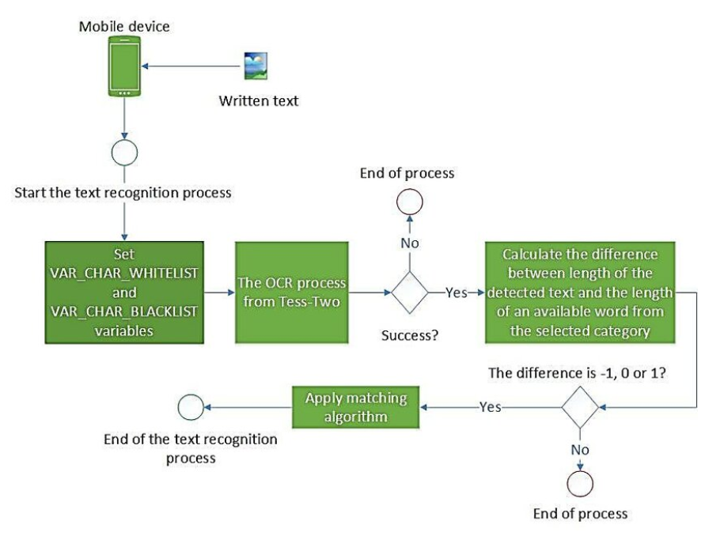

Fig 1. System Architecture

USER: First user will request through the application by choosing text or text from image or voice and the translator sends the request to the firebase and finally the user will get response from firebase.

ADMIN: Admin can view all the details of the registered users and the user send a request to admin in case if he/she had any issues with the application and the admin responds back to the user.

1. *Snapshots*

Figure 2: User Registration Figure 3:User Login

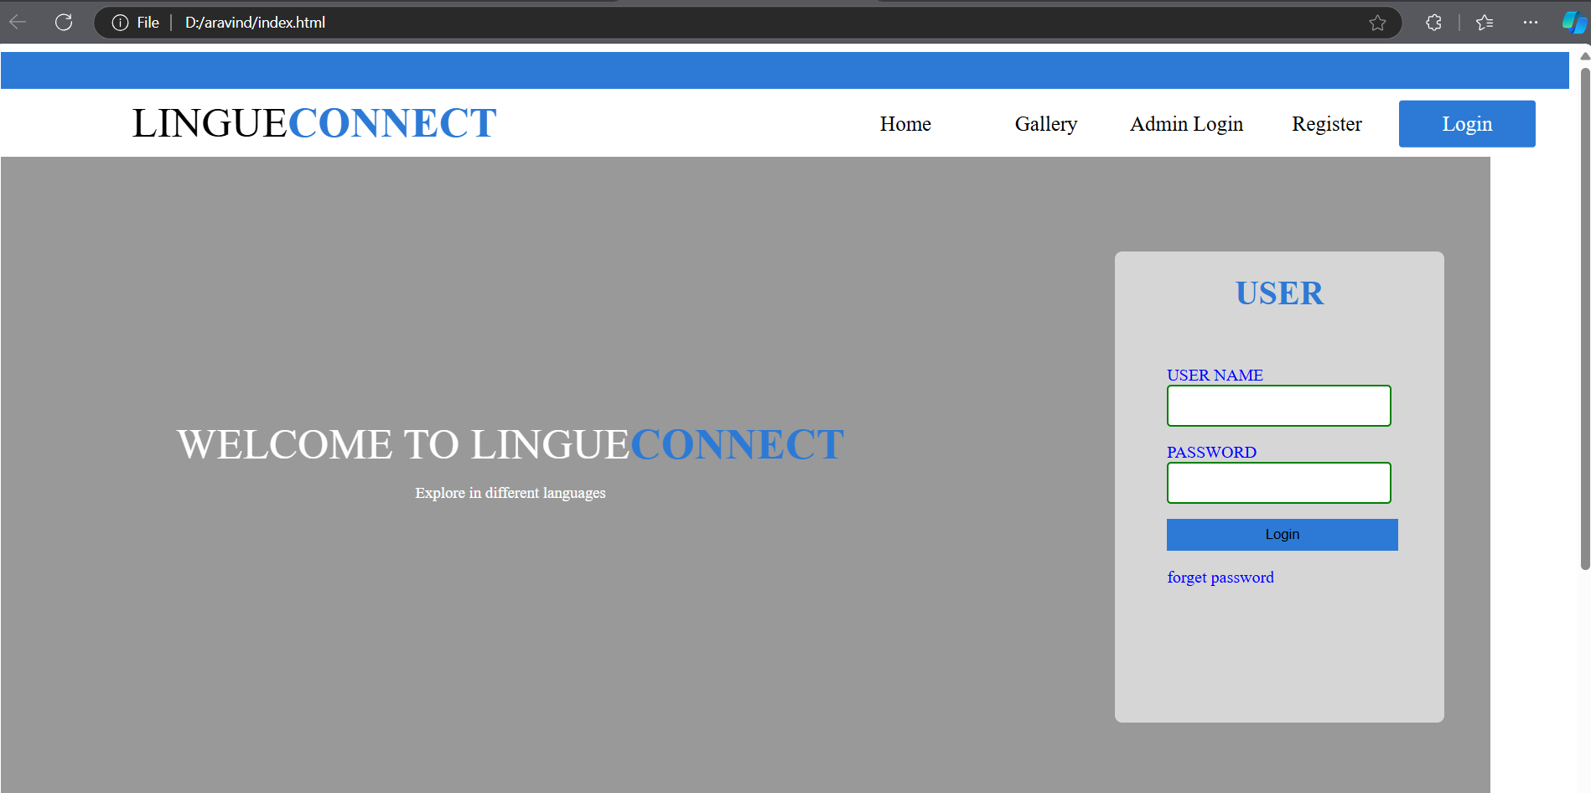

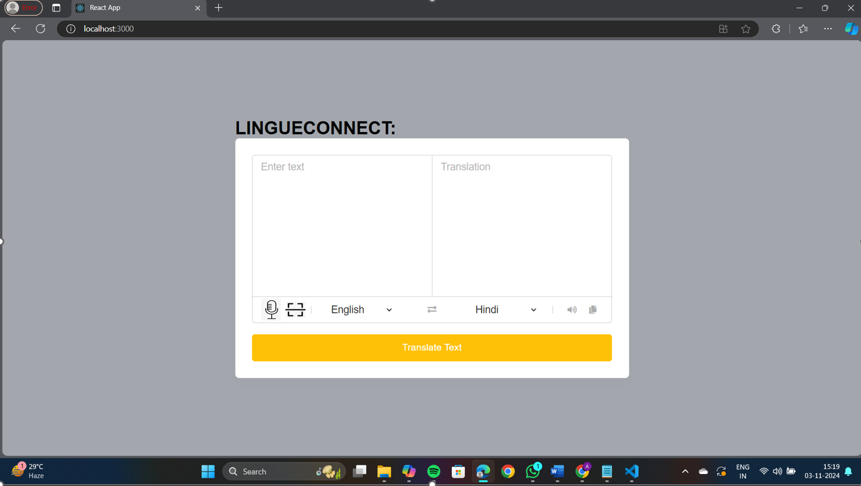

Figure 4: Home Page

Figure 5: Functions Column Figure 6: Text Conversion

Enter the text and select the language to which you want to translate and click on convert then you will be able to see the translated text in the result panel.

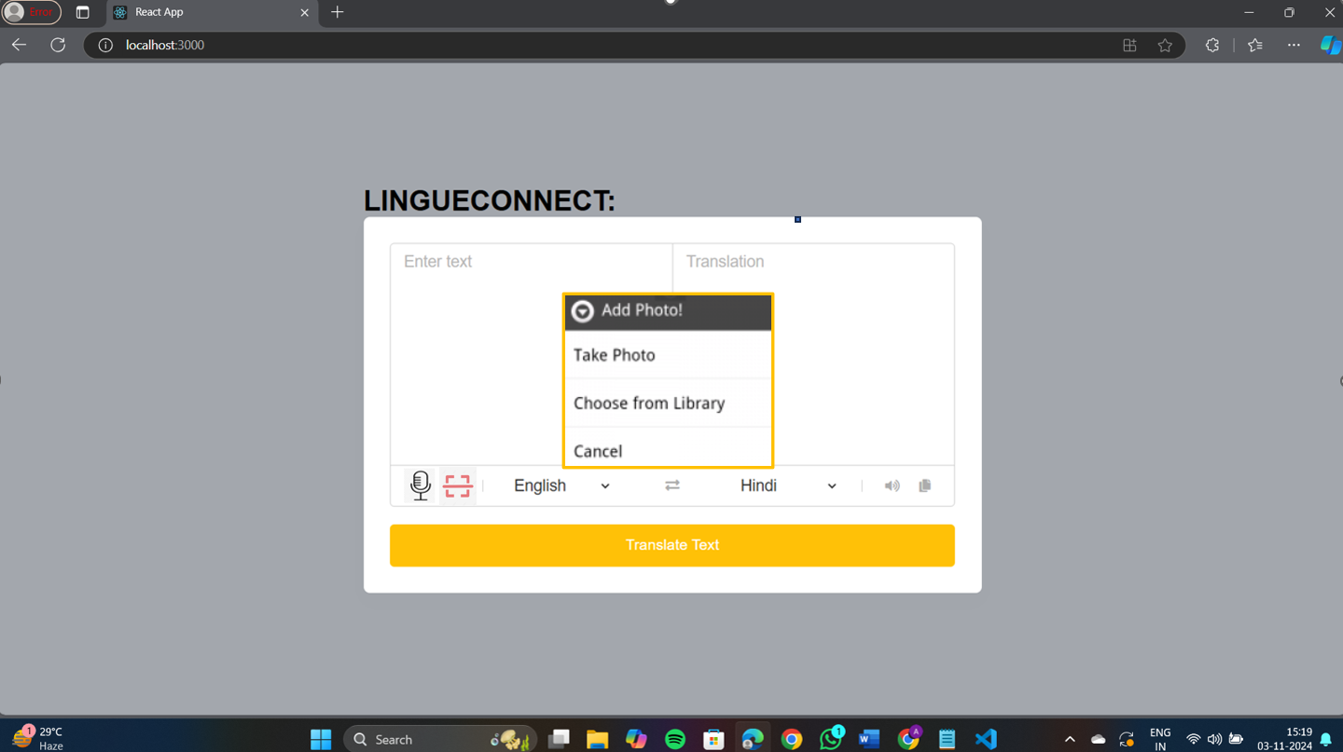

Figure 7: IMAGE TO TEXT Figure 8 IMAGE CONVERSION

Select the image either from gallery or camera and the captured text will be converted to text. Captured text from image will be directed to text area and then converts the text to which user

1. *Specifies*

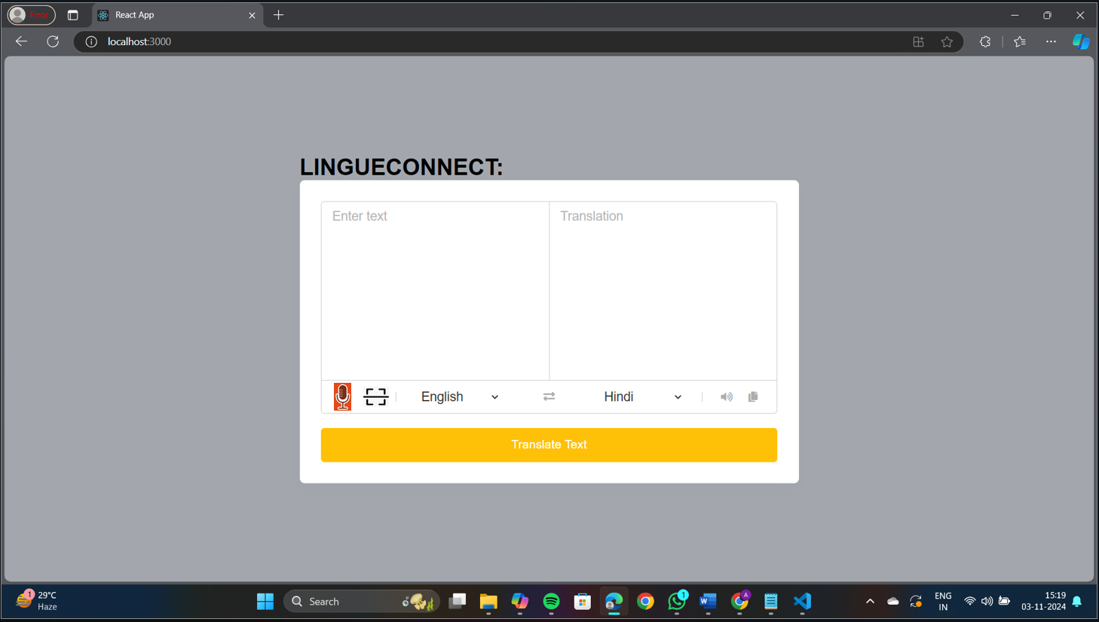

Figure 9: VOICE CONVERSION

Record the voice and then it changes to text and choose the language and click on convert then the result will be displayed.

## FUTURE SCOPE

The proposed mobile application for Indonesian and Madurese translation presents several avenues for future development and enhancement. As technology and user needs evolve, the following areas can be explored to expand the application's capabilities and reach:

1. **Language Expansion**: Future versions of the application can include additional languages, allowing for broader communication among diverse user groups. Integrating other regional languages will further promote inclusivity and support users across different linguistic backgrounds.
2. **Advanced Machine Learning Algorithms**: Implementing more sophisticated machine learning techniques, such as deep learning models, could improve translation accuracy and context recognition. Continuous training with user feedback and regional dialects will enhance the system’s ability to provide nuanced translations.
3. **Enhanced OCR Functionality**: Future updates can focus on improving OCR capabilities to better recognize text in various formats, including handwriting and stylized fonts. This will make the application more versatile in real-world scenarios where printed text varies significantly.
4. **Cultural Context Modules**: Developing modules that provide users with cultural insights alongside translations could enhance understanding and communication. This feature could include explanations of idiomatic expressions, customs, and social norms relevant to the languages.
5. **Integration with Augmented Reality (AR)**: Future iterations could explore the integration of AR technology, allowing users to point their device's camera at text in the environment and receive real-time translations overlaid on their screen. This would offer an immersive and intuitive user experience.
6. **Community Contributions and Customization**: Implementing features that allow users to contribute translations and corrections could foster a community-driven approach, improving the overall quality of translations. Additionally, enabling customization options for users to set preferences for tone and style can cater to individual needs.
7. **Offline Functionality**: Developing offline capabilities will make the application more accessible in areas with limited internet connectivity. Users could download language packs for offline use, ensuring they can still access translation services in remote locations.
8. **Integration with Other Services**: Future versions could integrate the application with other platforms, such as messaging apps or travel services, allowing users to easily communicate and access translations in various contexts, such as business meetings or tourist interactions.

In the existing system, we have google translator which utilizes internet connectivity whereas internet may not be available all the time and there are also many android application available that may not support all the functionalities like scanning text, speech recognition and translates the text and which are applicable for specific and limited languages which are not useful for all the users. So here in the proposed system where we will be implementing translation with support all the functionalities like scanning text, speech recognition and translates the text and includes the languages which are popular in our country as well as popular all over the world.

The advantage of this application is it doesn’t require internet connectivity.

## ACKNOWLEDGEMENT

We sincerely thank our DEAN Dr. ThayyabaKhatoon for her constant support and motivation allthe time. A special acknowledgement goes to a friend who enthused us from the back stage. Lastbut not the least our sincere appreciation goes to our family who has been tolerant understandingour moods, and extending timely support. We would like to express our gratitude to all those who extended their support and suggestions tocome up with this application. Special Thanks to our mentor DR.R.Siva Subramanian whose help andstimulating suggestions and encouragement helped us alltime in the due course of projectdevelopment.

## REFERENCES

1. **Koehn, P. (2017)**. Neural Machine Translation. *Cambridge University Press*.  
   *This book provides a comprehensive overview of neural machine translation techniques, discussing their applications and advancements in the field.*
2. **Duan, Y., & Zheng, Y. (2019)**. An Overview of Neural Machine Translation Technologies. *Journal of Computer and Communications*, 7(2), 1-10. doi:10.4236/jcc.2019.72001  
   *This paper reviews the evolution and current state of neural machine translation technologies, highlighting key methodologies and challenges.*
3. **Koehn, P., & Knowles, R. (2017)**. Six Challenges for Neural Machine Translation. *arXiv preprint arXiv:1706.03872*.  
   *This article discusses the key challenges faced by neural machine translation systems, including data scarcity and model interpretability.*
4. **Zhou, L., & Wu, L. (2019)**. A Study on Mobile Translation Applications: Current Status and Future Directions. *Computers in Human Behavior*, 95, 244-256. doi:10.1016/j.chb.2019.01.029  
   *This research analyzes existing mobile translation applications, assessing their functionalities and user experiences while proposing areas for future improvement.*
5. **Bengio, Y., Ducharme, R., & Vincent, P. (2003)**. A Neural Probabilistic Language Model. *Journal of Machine Learning Research*, 3, 1137-1155.  
   *This foundational paper introduces a neural network-based approach to language modeling, which has implications for translation technology.*
6. **Tsvetkov, Y., & Sokolov, I. (2016)**. A Survey on Automatic Evaluation Metrics for Machine Translation. *Computational Linguistics*, 42(2), 265-314. doi:10.1162/COLI_a_00240  
   *This survey explores various automatic evaluation metrics used to assess machine translation quality, offering insights into how translations can be quantitatively evaluated.*
7. **Yang, J., & Zhang, Z. (2019)**. Research on the Application of Machine Translation in Cross-Cultural Communication. *International Journal of English Linguistics*, 9(4), 1-10. doi:10.5539/ijel.v9n4p1  
   *This paper discusses the role of machine translation in facilitating cross-cultural communication, emphasizing the importance of context and cultural nuances.*
8. **Zare, M., & Hashemi, S. (2020)**. Machine Translation and Its Applications in the Field of Language Learning: A Review. *Education and Information Technologies*, 25(5), 3985-4007. doi:10.1007/s10639-020-10348-9  
   *This review examines the impact of machine translation on language learning, exploring both advantages and potential pitfalls in educational contexts.*
9. **Sutskever, I., Vinyals, O., & Le, Q. V. (2014)**. Sequence to Sequence Learning with Neural Networks. *Advances in Neural Information Processing Systems*, 27.  
   *This influential paper introduces the sequence-to-sequence learning paradigm, which underpins many modern translation systems.*
10. **Wang, Y., & Zhang, J. (2021)**. A Mobile Application for Real-Time Translation: Challenges and Innovations. *Journal of Systems and Software*, 175, 110896. doi:10.1016/j.jss.2020.110896  
    *This article discusses the challenges and innovations in developing mobile applications for real-time translation, focusing on user needs and technological advancements.*