**STUDY ON THE ANALYSIS OF CSR STRATEGIES AND IMPLEMENTATION**

**Ms. Dhristi Chhajed**

**M.Com. in Business Management, H.R. College of Commerce and Economics, Churchgate – Mumbai**

**_______________________________________________________________________**

**ABSTRACT**

Business activities have both positive and negative impacts on both society and the environment. The goal should be to reduce negative impacts and increase positive ones. Society has higher expectations for businesses to be socially, environmentally, and legally responsible, and many companies have responded with Corporate Social Responsibility (CSR) activities. However, businesses need to know where to focus their efforts and how to become better while avoiding criticism. In a previous project, a framework was developed that incorporates CSR concepts and helps businesses make more strategic decisions that benefit both the company and society. This research analyzes the CSR activities of the TATA Group using this framework. In a new project, different companies in the USA and India are studied to understand their CSR strategies, implementation procedures, and effectiveness. The project includes a survey conducted in India.

**INTRODUCTION**

Corporate social responsibility (CSR) is an important concept that refers to an organization's responsibility for the impact of its decisions and activities on society and the environment. It encompasses transparent and ethical behavior that is aligned with sustainable development and

the welfare of society. CSR takes into account the expectations of stakeholders and is in compliance with applicable laws and consistent with international norms of behavior. It must be integrated throughout the organization, from the top-down, and is an ongoing, evolving process.

The concept of CSR has gained significant attention and importance in modern business practices, and it is also referred to as corporate responsibility, corporate accountability, corporate ethics,

corporate citizenship, responsible entrepreneurship, and triple bottom line. More recently, the terms "responsible competitiveness" and "corporate sustainability" have been used to reflect the integration of CSR into business strategies and practices.

CSR is not a universally accepted concept and its definition continues to evolve. Generally, CSR is understood as the way firms integrate social, environmental, and economic concerns in a transparent and accountable manner, thereby establishing better practices within the firm, creating wealth, and improving society. As sustainable development becomes increasingly

important, the way in which businesses address these issues is also becoming a crucial element of CSR.

**LITERATURE REVIEW**

## CSR AT BOEING:

Source: The research gate, 17th March, 2013

The Boeing Company is an aerospace company headquartered in Chicago, Illinois and is the largest combined manufacturer of commercial jetliners and military aircrafts. Revenue for 2012 was a record $81.7 billion, with earnings from operations of $6.3 billion and earnings per share of $5.11 (Boeing Press Release, 2013).

According to a press release issued in January 2013, Boeing’s objectives for 2013 include to resolve the battery problems on its 787 fleet “and return the airplanes safely to service with our customers. At the same time, we remain focused on our ongoing priorities of profitable ramp up in commercial airplane production, successful execution of our development programs, and continued growth in core, adjacent and international defense and space markets”.

Boeing Donates 250,000 Medical Masks to Battle Coronavirus in China

Jan 29, 2020

Donation will be directed to local health officials in Wuhan City, Hubei Province, and Zhoushan, Zhejiang Province of China.

ANALYSIS:

Boeing emphasizes Corporate Social Responsibility (CSR) through its integrated approach across education, environment, military support, disaster responses, and more, evident in its CSR report since 2006. Their CSR philosophy revolves around innovation, ethical business practices, and partnerships to enhance education, health, environment, and civic awareness. This strategy integrates CSR into their entire enterprise, impacting products, services, and partnerships. They're simultaneously addressing environmental concerns, developing eco-friendly jetliners, and collaborating with entities like American Airlines for environmentally focused flights. The article also highlights Boeing's financial success in 2012 and objectives for 2013, including overcoming challenges and expanding into defense and space markets. Additionally, Boeing's global CSR is exemplified by donating medical masks during the 2020 coronavirus outbreak, underscoring their commitment to community support and social responsibility.

**RATIONALE OF RESEARCH**

This project aims at analyzing the strategies and the implementation of Corporate Social Responsibility policies undertaken by different companies from around the world with the help of examples. It also mentions the different laws and guidelines to be followed by the companies.

This project will help understand these CSR policies in depth and to find out if these policies have been helpful to society through case studies.

**RESEARCH METHODOLOGY**

## RESEARCH METHODS

* Primary as well as Secondary research was employed in this project.
* Primary research is the first-hand research that the researcher collects, by interacting with the sample population and the conclusions and analysis he/she draws from the data that has been obtained.
* Primary research in this project involved interacting with 130 individuals via a survey and 2 individuals via interviews to understand and comprehend if they are aware of CSR and if they have come across any programs.
* Secondary research is the background research done by the researcher on already existing information regarding the topic.
* This helps the researcher in determining whether previous research papers have been writtenon that particular topic and if and how new ground on that particular topic can be covered.
* It also helps the researcher in building a base for the questions to be asked to the samplepopulation and to construct an informative questionnaire and ask all the right questions.
* Secondary research in this project involved reading articles and reports about programs and initiatives taken by corporates.

**QUANTITATIVE DATA: SURVEYS**

This method captures information through the input of responses to a research instrument containing questions (such as a Questionnaire)

Information can be input either by the respondents themselves (E.g.: An Online Survey) or, the researcher can input the data (E.g.: a phone survey, a one-on-one survey, a mall intercept, etc).

The main methods for distributing surveys are via a website, postal mail, phone, or in person.

However, newer technologies are creating additional delivery options including through wireless devices, such as smart phones and technologies wherein the information gets recorded in real time and can be viewed and intercepted very easily through pie charts and bar graphs.

Survey for this study was undertaken via an online questionnaire. Questions included views of the people from various backgrounds.

**QUALITATIVE DATA COLLECTION**

Qualitative data collection requires researchers to interpret the information gathered, most often without the benefit of statistical support. If the researcher is well trained in interpreting respondents’ comments and activities, this form of research can offer very good information.

However, it may not hold the same level of relevancy as quantitative research due to the lack of scientific controls with this data collection method.

# RESEARCH DESIGN

The research design comprised a method of primary data collection using a survey given to 130 respondents. The design also included secondary data expressed through a review of past literature in the concerned area, indicating that a certain segment of the study was exploratory in nature.

The design used descriptive tools such as pie chart and bar graphs to highlight the data analysis. Survey started: October 2023

Survey ended: December 2023

# RESEARCH INSTRUMENT

The research tool used was that of a survey comprising 11 questions as well as personal interviews that covered different areas of the research problem. The questions were multiple choice in nature and closed ended and only one question was open ended. It was compulsory for all 130 respondents to answer 11 questions. The survey was anonymous but certain demographic details such as age and occupation were asked for. The questionnaire made is enclosed in the annexure.

**OBJECTIVES OF THE STUDY**

The main objectives of the study are:

1. To comprehend the significance and range of Corporate Social Responsibility.
2. To examine various approaches adopted by businesses.
3. To scrutinize the execution of such approaches and their effects on society.
4. To evaluate how these policies influence the public perception and standing of the company.
5. To explore different facets of CSR.

**ANALYSIS AND INTERPRETATION**

CSR is commonly understood as the way companies integrate social, environmental, and economic concerns into their values, culture, decision-making, strategy, and operations in a transparent and accountable manner. This creates better practices within the company, generates wealth, and contributes to improving society. CSR's elements are often interdependent and interconnected, and applicable to businesses worldwide. It is important to note that there are two drivers for CSR: public policy and business.

A CSR strategy is a detailed plan that outlines a company's approach to designing, implementing, and evaluating their corporate social responsibility initiatives. It includes various aspects such as the areas of focus, program design, promotion and communication strategies, and procedures for assessing the outcomes.

Having a CSR strategy is essential because successful CSR initiatives are complex, require demonstrable impact, and are public-facing. They also offer several business benefits that can be missed out on without proper planning. A well-designed CSR strategy can help companies organize their initiatives, improve their impacts, and protect their brand reputation.

Organizing a CSR initiative involves managing multiple goals, people, data, and responsibilities, which can be achieved through a CSR strategy. Comprehensive strategies are more likely to be successful, according to Deloitte's third annual global survey of over 2,000 C-suite executives at companies with societal impact goals. A CSR strategy can also help companies improve their impact by setting measurable goals, tracking progress, and identifying areas for improvement.

CSR initiatives are public-facing, and poor implementation can damage a company's reputation. A CSR strategy can minimize this risk by outlining goals, timelines, and procedures for follow- through, which demonstrates a company's commitment to CSR. Failing to follow through on CSR initiatives can lead to a company's reputation for big talk and no action, which can ultimately affect the bottom line.

The benefits of a CSR strategy are clear, but it is essential for companies to implement it effectively. To do this, companies should first identify their key stakeholders and the social and environmental issues that are most relevant to them. This will help to ensure that the CSR strategy is tailored to the specific needs and concerns of the company's stakeholders.

**CSR STRATEGY IMPLEMENTATION (TATA)**

Tata Steel

Tata Steel is committed to corporate social responsibility (CSR) and has implemented several measures to ensure sustainable development. The company has adopted various indices and models such as the Corporate Citizenship Index, Tata Business Excellence Model, and the Tata Index for Sustainable Development.

Furthermore, Tata Steel spends a significant portion of its profit after tax on CSR initiatives, amounting to 5-7 percent.

One of the initiatives that Tata Steel has undertaken is the formation of self-help groups (SHGs) to alleviate poverty. Currently, over 500 SHGs operate under various poverty alleviation programs, with more than 200 engaged in income-generating micro-enterprises. Additionally, women's empowerment programs through SHGs have been extended to 700 villages.

Tata Steel also supports various social welfare organizations such as the Tata Steel Rural Development Society, Tribal Cultural Society, Tata Steel Foundation for Family Initiatives, National Association for the Blind, and Shishu Niketan School of Hope. The company has initiated healthcare projects such as the Tata Steel Centenary Project, which focuses on child education, immunization, childcare, plantation activities, and creating awareness about AIDS and other healthcare projects.

Tata Steel also provides assistance to the government by hosting 12 Lifeline Expresses in association with the Ministry of Railways, Impact India Foundation, and the Government of Jharkhand, which has served over 50,000 people.

Moving on to Tata Motors, the company has implemented various measures to reduce pollution, including introducing vehicles with Euro norms. Additionally, Tata Motors' joint venture with Cummins Engine Company, USA, in 1992 was a major effort to introduce emission control technology in India. To make environment-friendly engines, the company has taken the help of world-renowned engine consultants like Ricardo and AVL. The company has also manufactured CNG versions of buses and passenger cars such as the Indica.

Tata Motors has also taken steps to restore ecological balance by planting trees in the works and the township. More than 2.4 million trees have been planted in the Jamshedpur region, and over half a million trees have been planted in the Poona region.

Finally, Tata Motors has introduced scholarship programs for higher education, including Vidyadhanam, which supports 211 students. Out of these students, 132 are from marginalized sections of society, and they receive books, copies, and other study materials.

Overall, Tata Steel and Tata Motors have implemented several CSR initiatives to ensure sustainable development, focusing on poverty alleviation, women's empowerment, social welfare, healthcare, economic empowerment, pollution control, ecological balance, employment generation, and human capital development.

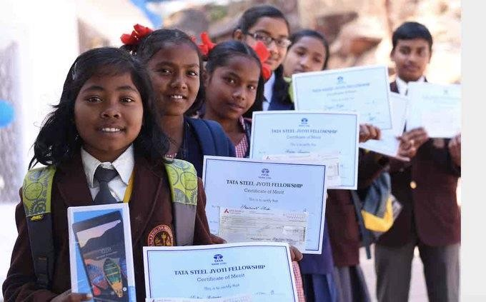

Source: https://thecsrjournal.in/wp-content/uploads/2022/07/Tata-Steel-CSR.jpeg

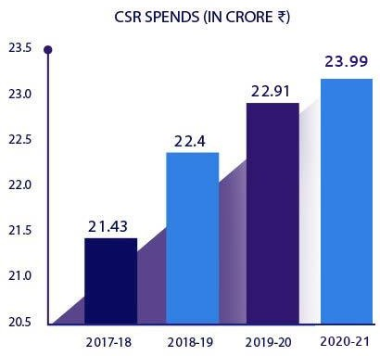Source: https:/[/www.tatamotors.com/wp](http://www.tatamotors.com/wp-)- content/themes/tatamotors_2019/images/g1.jpg

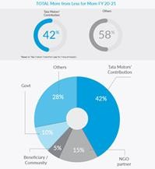

Source: https:/[/www.tatamotors.com/wp](http://www.tatamotors.com/wp-content/themes/tatamotors_2019/images/g2.jpg)-[content/themes/tatamotors_2019/images/g2.jpg](http://www.tatamotors.com/wp-content/themes/tatamotors_2019/images/g2.jpg)

Businesses worldwide are recognizing their responsibility to society and are getting involved in various social and environmental initiatives. To effectively implement corporate social responsibility (CSR), companies need to develop strategic policies and adopt appropriate instruments that align with their history, content, and relationships with different stakeholders, ultimately leading to sustained environmental, social, and economic growth.

While the banking, financial services, and insurance (BFSI) sector in India has shown interest in integrating sustainability into their business models, their CSR reporting practices have room for improvement. Only a few companies report their activities based on triple bottom line principles, and there are no uniform standards for rating CSR practices, unlike financial ratings.

Many companies use CSR practices as a marketing tool or engage in token efforts, such as donating to charitable trusts, NGOs, and sponsoring events. Few have a clearly defined CSR philosophy, and CSR implementation is often disconnected from their business processes, and companies do not disclose how much they spend on CSR activities. Voluntary actions need to be taken by financial bodies to ensure the socio-environmental feasibility of projects to be financed.

Although many Indian companies have adopted the universal language of CSR, there is confusion about its implementation. Companies define CSR in their limited ways and contexts, and the end result is mainly philanthropy or an extension of philanthropy. There is a need to increase the understanding and active participation of businesses in equitable social development as an integral part of good business practices.

The BFSI sector plays a vital role in the financial improvement of any country, and this research

provides insight into their practices. Companies in this sector must recognize their relationship with society and strive to benefit society in every possible way. While many companies focus on building customer loyalty, reputation, employee motivation, brand value, and employee retention through CSR activities, it would be wise to focus on areas of society in need to ensure universal advancement of the country. Actual implementation of activities needs to improve, beyond media coverage.

## QUESTION 1:

What is your gender?

|  |  |
| --- | --- |
| GENDER | NO OF RESPONDENTS |
| MALE | 83 |
| FEMALE | 47 |
| OTHER | 0 |

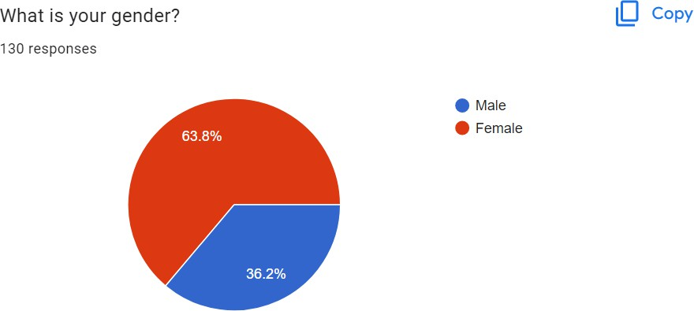

Analysis:

Out of 130 participants, 63.8% are female and 36.2% are male, the survey has relatively morefemale respondents than male.

## QUESTION 2:

What is your age?

|  |  |
| --- | --- |
| AGE | NO OF RESPONDENTS |
| 15-25 | 129 |
| 26-35 | 1 |
| 36-45 | 0 |
| 46-55 | 0 |

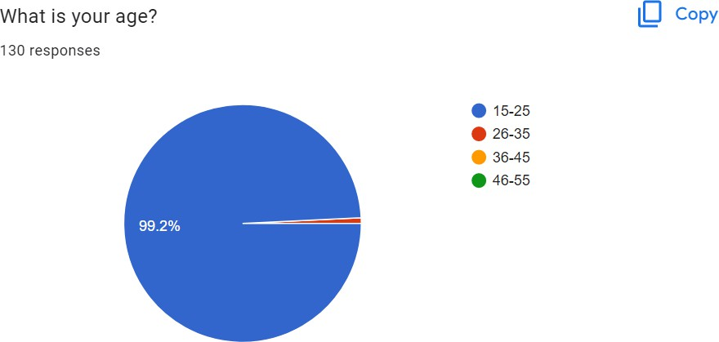

## ANALYSIS:

Majority of the respondents belong to the age group 15-25 and around 0.8% belong to the 26-35 age group.

This shows that the younger generation is more aware of CSR and its strategies and implementation.

|  |  |
| --- | --- |
| OCCUPATION | NO OF RESPONDENTS |
| STUDENTS | 118 |
| PROFESSIONAL | 11 |
| SELF EMPLOYED | 1 |
| HOMEMAKER | 0 |
| RETIRED | 0 |

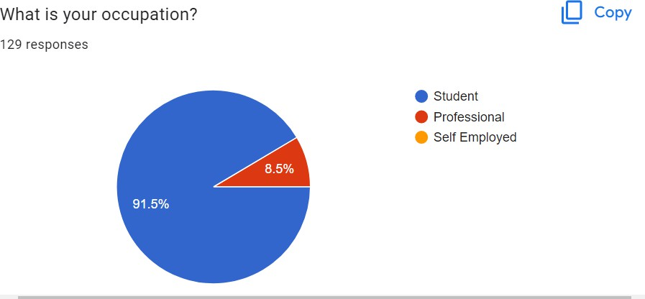

## ANALYSIS:

Majority of the respondents are students and 8.5% are professionals working in corporates.

This shows that the survey is highly influenced by the younger generation comprising of studentsand their views towards social responsibility.

|  |  |
| --- | --- |
| CSR MEANING | NO OF RESPONDENTS |
| YES | 130 |
| NO | 0 |
| MAYBE | 0 |

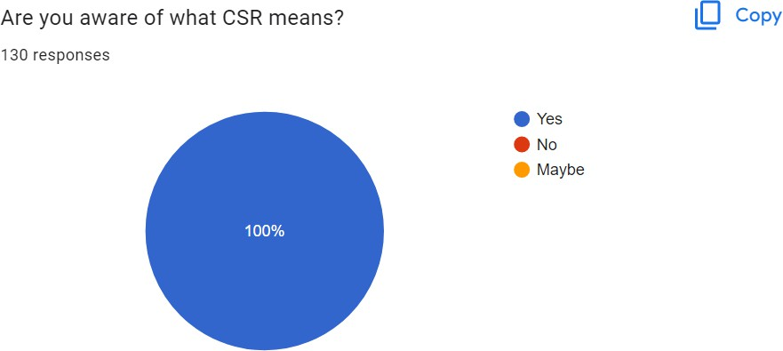

## ANALYSIS:

All of the respondents are aware of what CSR means and hence can be objective towards all the other questions.

|  |  |
| --- | --- |
| LIABILITY | NO OF RESPONDENTS |
| STRONGLY AGREE | 23 |
| AGREE | 73 |
| NEUTRAL | 34 |
| DISAGREE | 0 |
| STRONGLY DISAGREE | 0 |

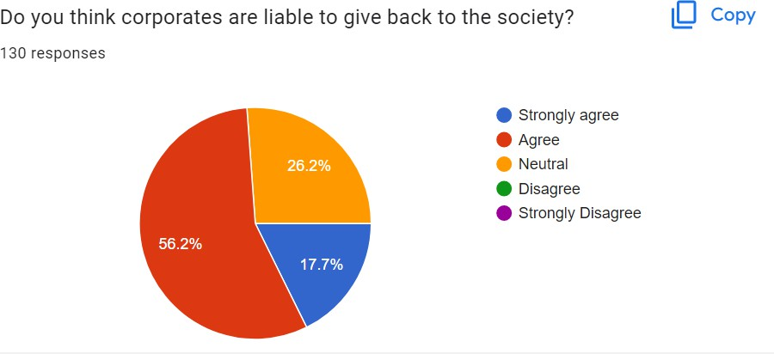

## ANALYSIS:

56.2% of the respondents strongly agree and think that corporates are liable to give back to society while 26.2% are neutral and think that they may or may not be liable towards giving backto society. 17.7% agree that they are responsible for the society that they operate in.

|  |  |
| --- | --- |
| IMPROVEMENT | NO OF RESPONDENTS |
| STRONGLY AGREE | 0 |
| AGREE | 74 |
| NEUTRAL | 55 |
| DISAGREE | 1 |
| STRONLGLY DISAGREE | 0 |

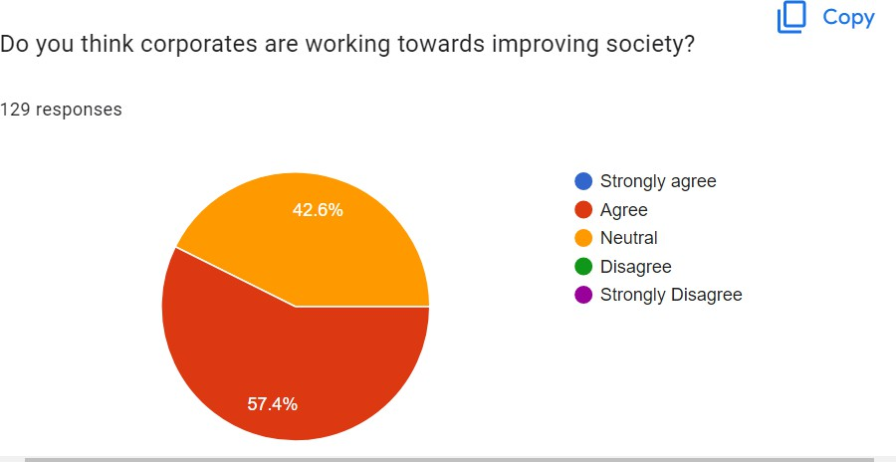

## ANALYSIS:

57.4% of the respondents agree that corporates today are working towards improving society butthey do not strongly agree which implies that there is still scope for improvement. 42.6%neutral and seem to be unhappy with the activities undertaken by corporates today. With this varied response one can conclude that people have very different views with the current scenarioof CSR.

## QUESTION 7:

Which is the area of social responsibility more significant to you?

|  |  |
| --- | --- |
| AREA OF CSR | NO OF RESPONDENTS |
| ENVIRONMENTAL SUSTAINABILITY | 0 |
| SOCIAL WELFARE | 63 |
| LABOUR AND HUMAN RIGHTS | 10 |
| ETHICAL BUSINESS PRACTICES | 54 |
| CONSUMER PROTECTION | 0 |
| DIVERSITY AND INCLUSION | 1 |
| PHILANTHROPHY | 2 |
| OTHER | 0 |

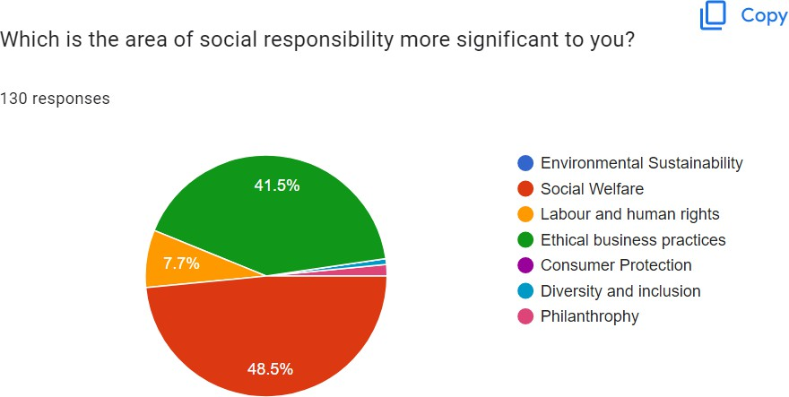

ANALYSIS:

Significant areas include social welfare, labour and human rights and ethical business practices

## QUESTION 8.

Have you ever witnessed a CSR act by a company before?

|  |  |
| --- | --- |
| CSR ACT | NO OF RESPONDENTS |
| YES | 107 |
| NO | 23 |
| MAYBE | 0 |

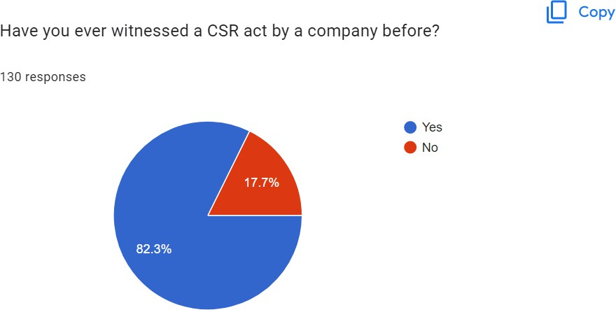

## ANALYSIS:

45.5% of the respondents have witnessed a CSR act before which implies that many corporatesare undertaking programs to help society. 17.7% of the respondents have not witnessed a CSR act.

If yes, then please mention the company and the act that you witnessed?

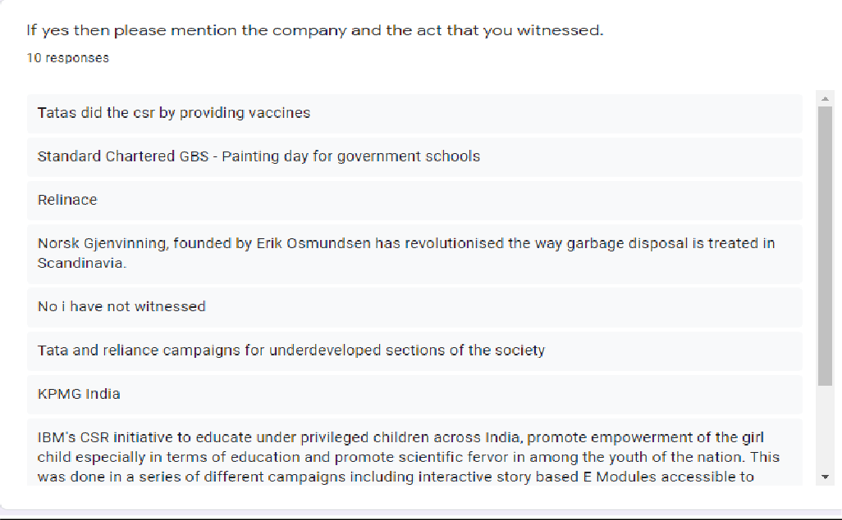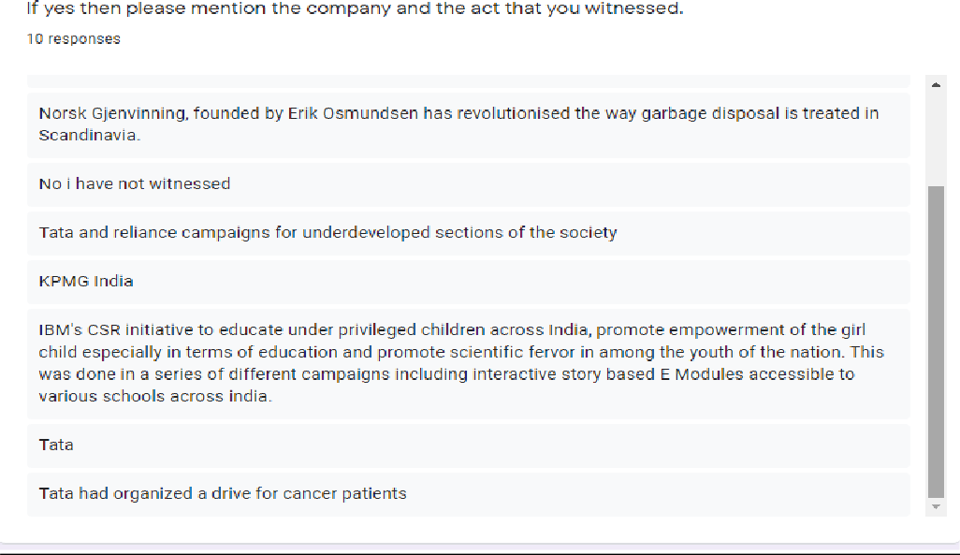

## ANALYSIS:

This was an open ended question which was not compulsory to answer, a lot of responses included tata and reliance. It also spoke about garbage disposal being revolutionized by NorskGlenvinning, IBM”s CSR to improve education for underprivileged children was also mentioned.

QUESTION 10

What do you think could be the main benefit of the adoption of measures for socialresponsibility?

|  |  |
| --- | --- |
| MAIN BENEFIT | NO OF RESPONDENTS |
| Enhanced reputation and brand image | 71 |
| Improved relationships with stakeholders | 33 |
| Reduced risk and improved compliance | 15 |
| Innovation and competitive advantage | 10 |
| Positive impact on society and the environment | 1 |

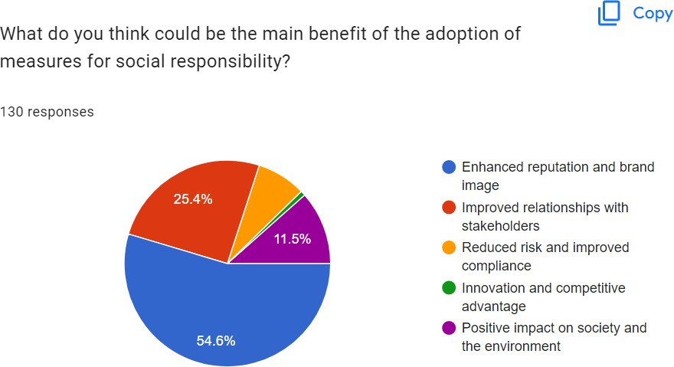

## ANALYSIS:

Majority of the respondents, 54.6% chose enhanced reputation and brand image as the main benefit for the adoption of measures of social responsibility. Improved relation with stakeholders was also another reason with 25.4% and then positive impact on society and the environment. Connecting with the community ranks the highest as that is what is most important in the long run.

In light of the current pandemic situation, do you think corporates have done their part in helping their employees and the community?

|  |  |
| --- | --- |
| EMPLOYEES AND COMMUNITY | NO OF RESPONDENTS |
| YES | 38 |
| NO | 28 |
| MAYBE | 49 |

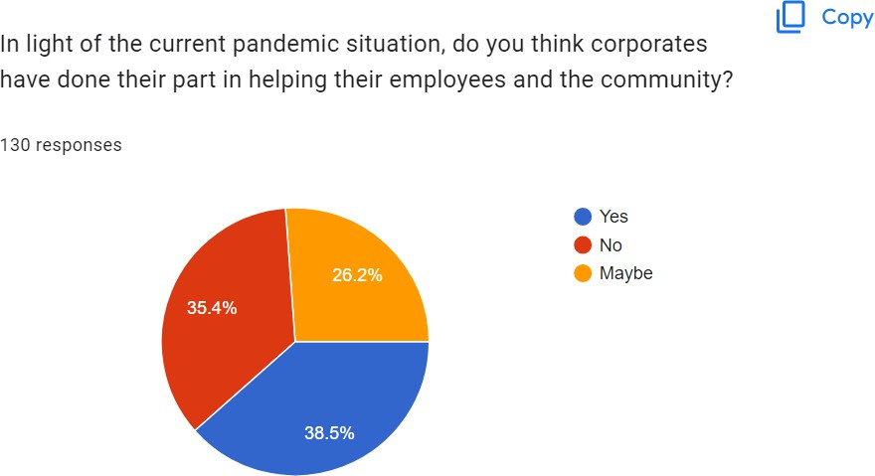

## ANALYSIS:

26.2% of the respondents chose the maybe option implying that they may or may not think that corporates in light of the current pandemic situation have done their part towards aiding the community and their employees by providing vaccinations, monetary aid to employees and theirfamilies etc.

As a consumer, are you more favorable to companies that undertake CSR as compare to thosewho don't?

|  |  |
| --- | --- |
| FAVORABLE | NO OF RESPONDENTS |
| STRONGLY AGREE | 53 |
| AGREE | 31 |
| NEUTRAL | 31 |
| DISAGREE | 0 |
| STRONGLY DISAGREE | 0 |

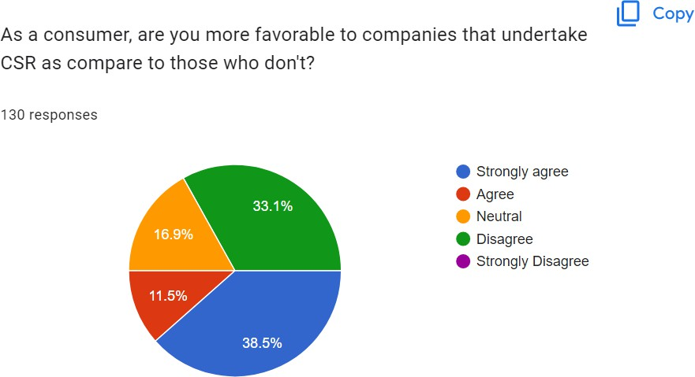

## ANALYSIS:

All the respondents have a positive or neutral response, majority of them would be influenced ifthe company did undertake CSR activities and would be more likely to be a customer to said company.

# INTERVIEWS

1. Interviewee: Vipul Sinha (BlinkIt Manager Pune)
   1. Do you think it’s necessary for corporates to undertake responsibility towards

society and why?

In the business world, the commonly used term is "stakeholder", which refers not only to employees and customers but also to the broader society. Therefore, it is justifiable for companies to engage in activities that benefit all stakeholders in order to sustain their growth.

* 1. What companies do you think have done their share of giving back to society? Can you state a few examples?

Two companies that I can think of right away are TATA and WIPRO, and the impact they have had on people's lives is difficult to quantify.

* 1. What areas do you think are important and in need of reforms and programs? (Eg. sustainability)

Corporate social responsibility (CSR) initiatives should prioritize essential areas such as skill development and promotion of sustainable livelihoods, education, financial inclusion, healthcare, as well as providing assistance during natural disasters and other emergencies.

* 1. Can you elaborate on what Zomato did to help those in need?

Zomato did a lot to help people in need during the pandemic. They are an online food delivery and restaurant discovery platform. To support COVID-19 relief efforts, they added a new feature to their app that allowed users to donate money to trusted NGOs. They also teamed up with state governments to distribute food to those who needed it. Zomato converted their offices into shelters for stranded migrant workers and provided them with food and other necessary items. Finally, they offered financial aid to their restaurant partners who were struggling due to the pandemic.

# ANALYSIS

Mr Sinha thinks that all businesses are responsible to their stakeholders and that includes employees, customers and to society as well. He believes that Tata and Wipro have touched a lot of lives with their CSR initiatives. Main areas in need according to him are skill development and sustainable livelihood, education, financial inclusion, health care, providing support for natural calamities and disasters, etc. He also spoke

about how Zomato does their share through skill training, providing financial literacy and also disaster management control during the pandemic.

1. Interviewee: Kunal Chhajed

AIESEC (World’s largest youth run not for profit organization.)

1. Do you think it’s necessary for corporates to undertake responsibility towards society and why?

It’s important for businesses to engage in environmentally friendly practices. Corporations contribute to greenhouse gas emissions, pollution, waste, and natural resource depletion. By committing to environmental responsibility, the business can take ownership over its impact on the environment and it’s also a good way of staying relevant and having a good business image if we look at it from a business/marketing perspective.

1. What companies do you think have done their share of giving back to society? Can you state a few examples?

I would say TATA there are many but they’re my favorite because they help deprived communities all over the country with basic needs and also help students with scholarships not just in India but they also have scholarships for students going to USA.

1. What areas do you think are important and in need of reforms and programs? (Eg sustainability)

I was working with this brand called as Updapt which works in the sustainability sector, during that time I realized there’s so many things in which companies can improve their overall Sustainability and the ESG score, I believe it should be compulsory for companies with high profit to keep aside some amount for activities related to sustainability that way we can make sure everyone is doing their bit. Government should also track the way a company is functioning it should be a complete tracking process even small details like the way their employees use resources (traveling), etc.

1. Can you elaborate on what AIESEC did to help those in need?

AIESEC works toward achieving peace and fulfilment of humankind’s potential and also towards the 17 sustainable development goals set by the UN these goals were, Education for all, gender equality, etc. We sent volunteers to developing countries and they taught English or other things to underprivileged children.

## ANALYSIS:

Mr. Chhajed believes that it is essential that corporates conduct their business in an environment friendly manner so as to take ownership for the waste and pollution they generate and also for the natural resources that they use. Undertaking CSR activities can help make them accountable and give back to society. He really appreciates what TATA has done for the community and believes that sustainability is a very important cause and that companies should keep aside a part of their profits for these sustainable development.

# SUGGESTIONS

Here are some suggestions on how to improve CSR strategies and their implementation:

1. Define clear goals and objectives: CSR initiatives should have clear and measurable goals that align with the company's overall mission and values. This will help to ensure that the initiatives are effective and contribute to the company's broader sustainability strategy.
2. Engage stakeholders: Companies should engage with stakeholders to understand their perspectives and ensure that their CSR initiatives address the key social and environmental issues that are important to them. This will help to build trust and credibility with stakeholders, and ensure that the initiatives are relevant and impactful.
3. Integrate CSR into business strategy: CSR should be integrated into the company's overall business strategy, rather than being viewed as a separate and optional activity. This will help to ensure that CSR initiatives are aligned with the company's core business activities and are integrated into decision-making processes.
4. Measure and report on impact: Companies should establish clear metrics for measuring the impact of their CSR initiatives and regularly report on their progress. This will help to demonstrate the value and effectiveness of the initiatives and ensure that they are contributing to the company's sustainability goals.
5. Collaborate with partners: Companies should collaborate with other organizations, including NGOs, governments, and other businesses, to leverage their expertise and resources and to maximize the impact of their CSR initiatives.
6. Continuously improve: CSR strategies and initiatives should be reviewed and updated regularly to ensure that they remain relevant and effective. Companies should be open to feedback and willing to make changes as needed to ensure that their initiatives are meeting the needs of stakeholders and contributing to their sustainability goals.

## CONCLUSION

Nowadays, it is increasingly important for companies to prioritize social responsibility, which refers to a business's obligation to pursue positive long-term goals for both its people and the world at large. Many successful companies use social responsibility to give back to society and show gratitude to their customers, often through projects, movements, or empowerment of individuals. While some companies may not see it as mandatory, there are several reasons why it is important for businesses to focus on social responsibility.

Firstly, having a strong CSR strategy can help attract and retain employees, as it demonstrates compassion and care for people, including employees. It can also create a more positive and productive work environment and encourage employee volunteering and positive efforts.

Secondly, prioritizing social responsibility can improve customers' perception of your brand and create a platform to market and earn their attention. By showing a commitment to improving society, businesses can build a good reputation, earn trust and loyalty from clients, and distinguish themselves from competitors.

Thirdly, social responsibility can show accountability to investors, making businesses more attractive to them by demonstrating responsible financial management and ethical corporate behavior. Moreover, having a CSR strategy can save money by increasing customer loyalty and employee retention.

Finally, social responsibility can enable businesses to better engage with customers by allowing direct interaction with members of society, who may also be customers or potential customers, and receiving direct feedback.

In summary, companies should prioritize social responsibility to give back to society, attract customers, and retain employees. In today's business world, customer satisfaction and employee retention are crucial to a successful business, and social responsibility can be an effective way to achieve them.

# BIBLIOGRAPHY

Books:

Anderson, J.W., Jr. (1989). Corporate Social Responsibility: Guidelines for Top Management. New York: Quorum Books.

Bowen, H. R. (1953). Social responsibilities of the businessman. New York: Harper & Brothers.

Crane, A., & Matten, D. (2003). Business Ethics: a European Perspective. Managing Corporate Citizenship and Sustainability in the Age of Globalisation. Oxford: Oxford University Press.

Baker, M (2008). Corporate Social Responsibility-What does it mean?

Friedman, M. (1970), The social responsibility of business is to increase its profit, New York Times Magazine, September 13.

Research Papers:

K, S. (2015). A Study on Corporate Social Responsibility Initiatives of Wipro Ltd.

Kumari, S. (2016). Corporate Social Responsibility Practices and Their Impact on the Community : A Case Study of Ambuja Cement Ltd.

Mishra, P. M. (n.d.). Corporate Social Responsibility (CSR) – Case Study of Tata Group. Mumbai.

Srivastava, A.K., Negi G., Mishra V., Pandey S., (2012), Corporate Social Responsibility: A Case Study Of TATA Group. University of Lucknow: India.

Newspaper Articles:

Boeing and Corporate Social Responsibility. https:/[/www.rese](http://www.researchgate.net/publication/265907988_Boeing_and_Corporate_Social_Respon)a[rchgate.net/publication/265907988_Boeing_and_Corporate_Social_Respon](http://www.researchgate.net/publication/265907988_Boeing_and_Corporate_Social_Respon)sibility

CSR: Aditya Birla Group. https://economictimes.indiatimes.com/csr_adityabirlagroup.cms

Corporate Social Responsibility: A Review of its Advancement in India. <http://iosrjournals.org/iosr-jbm/papers/vol3-issue5/D0351727.pdf>

Web Links:

Aditya Birla Group - Commitment to Global Compact. <http://www.adityabirla.com/Media/Commitment-to-Global-Compact>

Aditya Birla Group - Milestones. <http://www.adityabirla.com/About-Us/milestones>

Tata Trusts. <http://www.tata.in/article/inside/Trustee-to-the-community>

Tata Steel - Corporate Social Responsibility Policy. <http://www.tatasteel.com/corporate/pdf/CSR-Policy.pdf>

Aditya Birla Group - Corporate Social Responsibility Overview. <http://www.adityabirla.com/csr/overview>

Aditya Birla Group - CSR Brochure. <http://adityabirla.com/content/resource/csr_brochure.pdf>

International Organization of Scientific Research (IOSR) Journals. <http://www.iosrjournals.org/>

Evolution of corporate social responsibility in India. https://en.wikipedia.org/wiki/Evolution_of_corporate_social_responsibility_in_India

Corporate Social Responsibility (CSR) in India: A Review. <http://ijbssnet.com/journals/Vol_5_No_3_March_2014/1.pdf>

Corporate Social Responsibility. https://insights.ccl.org/wp- content/uploads/2015/04/CorporateSocialResponsibility.pdf

Corporate Social Responsibility: The Indian Scenario. <http://www.cluteinstitute.com/ojs/index.php/IBER/article/viewFile/7970/8024>

Boeing - Community Engagement. <http://www.boeing.com/principles/community-> engagement.page

The Growing Importance of Social Responsibility in Business. https:/[/www.forbes.com/sit](http://www.forbes.com/sites/forbesbusinesscouncil/2020/11/18/the-growing-importance-of-)e[s/forbesbusinesscouncil/2020/11/18/the-growing-importance-of-](http://www.forbes.com/sites/forbesbusinesscouncil/2020/11/18/the-growing-importance-of-) social-responsibility-in-business/?sh=22ada1092283