Analyzing the Performance of 5G Network Compared to 4G in Mumbai Region.

Madiha Ansari   
*Master of Science in Information Technology*  
*KC College,HSNC University*Mumbai 400020,India  
[madiha7665@gmail.com](mailto:madiha7665@gmail.com)

Dr. Rakhi Gupta  
*Head of the Department of Information Technology*  
*KC College,HSNC University*Mumbai 400020,India  
[rakhigupta@kccollege.edu.in](mailto:rakhigupta@kccollege.edu.inm)

Nashrah Gowalker   
 *Asst Professor of InformationTechnology Department*  
*KC College,HSNC University*Mumbai 400020,India  
[nashrah](mailto:nashrah)gowalker@kccollege.edu.in

***Abstract*— The deployment of the 5G network represents a significant step forward in mobile communications, providing better speeds, less latency and greater capacity compared to 4G. This study aims to compare the efficiencies of 5G and 4G networks in the densely populated city of Mumbai. The study investigates the essential performance indicators such as data transmission rates, latency, network reliability and size. Data were collected from multiple locations throughout Mumbai to measure performance during peak traffic hours and different environmental conditions. 5G delivers an average download and upload speed almost 10 times faster than 4G.5G's latency has been significantly reduced.5G deployment in the region faces challenges arising from infrastructure development and spectrum availability issues.5G's ability to improve user experience in urban environments and the necessary steps for widespread adoption are revealed through comparative analysis. This performance can be compared to telecommunications companies such as Jio, Airtel and Vodafone.**

**Keywords---5G, 4G, technology, latency, wireless communication, network, telecommunication providers, users.**

# **INTRODUCTION**

In recent decades, wireless communication technologies have revolutionized how we interact and communicate. The data rates, latency, connection capabilities, coverage of each generation of wireless communication from 1G to 4G have been greatly improved, and unlike 4G networks, 5G networks can handle dense population, such as Mumbai, by providing higher data rates, low latency, and greater device capacity. The aim of the study is to assess the speed and latency of Colaba, Byculla and Mumbai Central, quantify the impact of users and businesses, and propose improvements to network providers and policy makers.

5G adoption and service quality improvement are aspects of the study that benefit both users and telecommunications providers. The study studies Mumbai's urban areas using scenarios such as streaming and online games. The text acknowledges the complexity of measuring all network performance variables while staying on the edge of technological innovations . In densely populated cities such as Mumbai, the quality of mobile communications depends

heavily on the network performance of telecommunications providers. The main indicators of speed, delay, coverage and user satisfaction are used to evaluate Jio, Airtel and Vodafone performance. .

## **PURPOSE**

This study investigates how 5G technology can improve user experience and connectivity in densely populated cities such as Mumbai. With faster speed, low latency, and greater coverage, 5G differs from 4G.

By learning how customers view network technologies, telecommunications operators can improve their services and increase customer satisfaction and adoption rates.

The study can identify and overcome obstacles to adoption of 5G, including infrastructure requirements, public perception and economic concerns.

The aim of the analysis is to provide a comprehensive view of the impact of Mumbai's upgrade from 4G to 5G.

## **IMPORTANCE OF THE STUDY**

The use of 5G in Mumbai can improve smart city initiatives by improving traffic management, public safety and environmental monitoring.

By studying user experiences, consumers are empowered to make informed decisions about mobile services and improve overall satisfaction and engagement.

The benefits and challenges of 5G technology can be made known to the public through research and will promote a more educated and beneficial community.

The study compares 5G and 4G to help other urban areas make similar transitions and expand knowledge of the impact of mobile technologies.

# **LITERATURE REVIEW**

5G networks allow for a greater density of connected devices per square kilometer, improving performance in crowded areas like Mumbai (Kumar & Rao, 2023).

5G-covered areas with infrastructure upgrades exhibit better connectivity and user experience than 4G regions, according to Desai et al.'s (2023) research.

Mumbai residents' surveys indicate an increasing demand for quicker services. 5G delivers improved streaming quality and faster download speeds compared to 4G, according to user reports (Joshi & Mehta, 2023).

5G infrastructure upgrades, involving new antennas and fiber optic cables, pose construction challenges in urban areas (Iyer & Shah, 2023).

5G's higher frequency bands may cause coverage gaps in certain urban environments due to penetration and range issues. (Verma & Bansal, 2023)

5G outperformed 4G in terms of speed and latency in Mumbai, according to a study by Singh et al. (2022) that employed drive tests to evaluate both networks.

5G's enhanced capabilities, as suggested by economic analyses, could contribute significantly to economic growth by improving business operations and facilitating new technologies (Chatterjee & Joshi, 2024).

5G's user experiences will be revealed through long-term investigations (Nair et al., 2023).

5G's impact on IoT applications in Mumbai could reveal novel business strategies and services. (Patel & Kumar, 2024)

**III. METHODOLOGY**

This research combines qualitative and quantitative analysis of Mumbai's 5G and 4G network performance with the results of data testing. Mumbai's users' experience was collected through an online survey.

The survey evaluated the user's satisfaction, reliability and knowledge of 5G technology. In-depth interviews with telecom experts and local providers were conducted to gain more insight. The key ethical consideration is to ensure that all participants have informed consent and confidentiality. The study identified environmental factors and user populations as potential limitations to network performance. In today's world, communication is necessary. Technological progress has transformed shopping, business and learning. In this scenario, a stable Internet connection is essential.

## **TESTING**

1. **Performance Comparison:**

**Three different locations in Mumbai** are the subject of the analysis and will be used to compare performance. This narrow focus makes it possible to evaluate network performance in different urban settings.  
 The following performance metrics have been chosen for assessment:  
The upload speed, expressed in megabits per second (Mbps), is a measure of how quickly data can be sent from a device to the network, indicating how well the network can process user-generated data.  
Latency Indicates the amount of time that passes before data transmission starts, which is important for applications that need to communicate in real time.

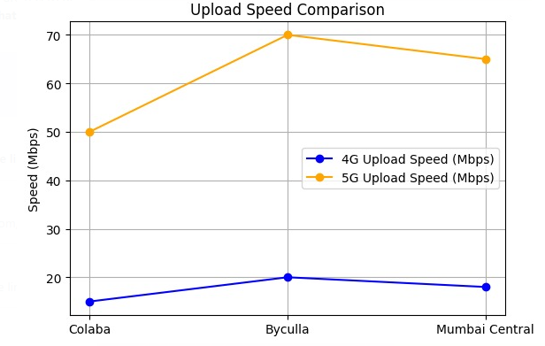

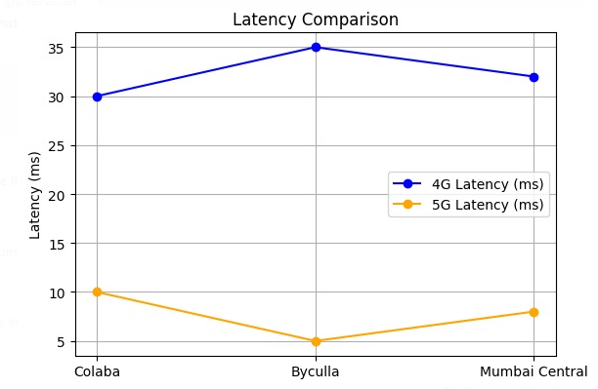

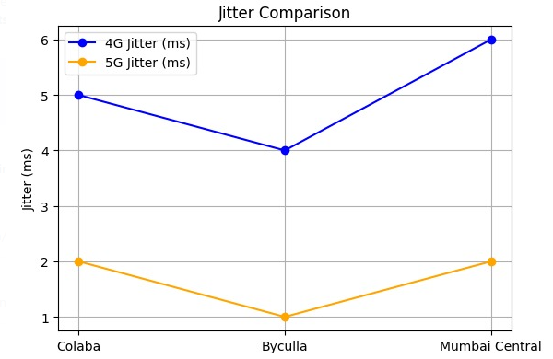

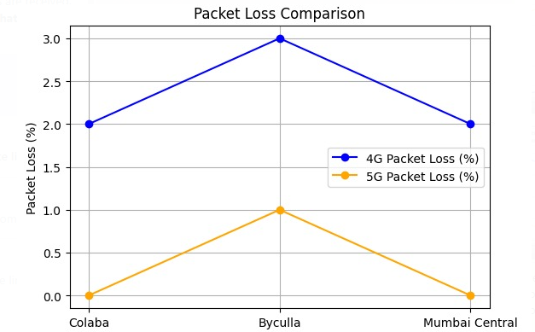

The unpredictability in packet arrival timings, or jitter (measured in milliseconds), is a crucial component of VoIP and streaming systems' quality control. The SNMP protocol ensures equitable upload and download speeds and enhances QoS via control of throughput, delay, jitter, and packet loss[4].One important indicator is packet loss (%), which shows the proportion of data packets that are sent but do not reach their expected location.

1. **Geographical Aspects:**

5G networks boast higher deployment density and adaptation than 4G, but 4G networks remain stable in coverage and obstructed areas. This visualization illuminates geographical variations in network performance, enabling stakeholders to grasp consequences for deployment and user experience.

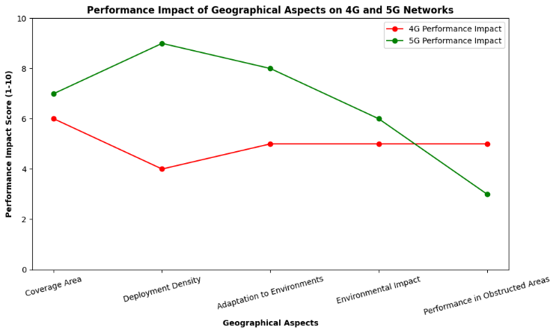

1. **Performance during Peak Hours:**

5G significantly outperforms 4G in Colaba, Byculla, and Mumbai Central during peak hours, as shown in the analysis of their respective 5G and 4G performances. 5G outperforms 4G during peak hours, delivering download speeds frequently above 80 Mbps while 4G's declines notably .

5G users will have a superior data-intensive experience, while 4G users may struggle with slower speeds. 5G infrastructure investment is crucial for densely populated urban areas to meet growing demands and maintain stable, high-quality services as user adoption rises.

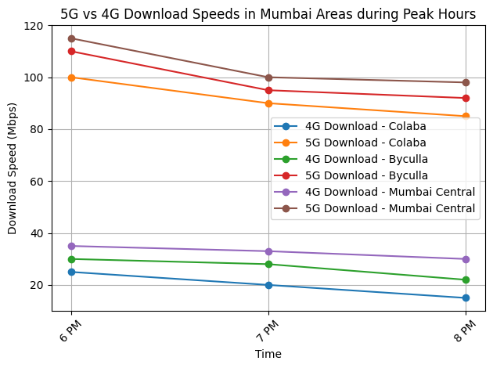

## **DATA ANALYSIS**

1. **Network Usage: (By Gender and Age)**

4G and 5G network usage in Colaba, Byculla, and Mumbai Central reveals urban patterns with unique local details.

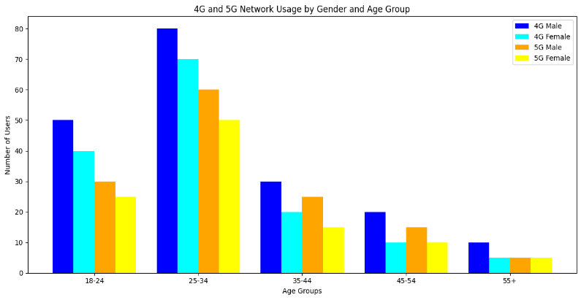

18-34 age group adopts 5G at higher rates due to high smartphone usage and preferences for streaming, social media, and gaming. In technology adoption, males generally take the lead, whereas females prioritize communication and shopping. 5G infrastructure thrives in urban areas, drawing in tech-savvy residents. 55+ age group primarily relies on 4G technology for fundamental activities, while adoption of newer innovations proceeds gradually.

These areas - Colaba, Byculla, and Mumbai Central ,display distinct mobile network usage patterns shaped by age and gender demographics in an urban setting.

1. **Performance Comparison of Telecom Providers:(Jio, Airtel, Vodafone)**

In Colaba, Byculla, and Mumbai Central, Jio outperforms Airtel and Vodafone-Idea in terms of network speed and coverage, with its robust 4G infrastructure and growing 5G services offering reliable connectivity, especially in congested regions.

Airtel is renowned for its superior customer service and consistent performance, while Vodafone-Idea possesses a dedicated user base but trails behind competitors in terms of speed. In terms of service quality, Jio outranks Airtel, and Airtel surpasses Vodafone-Idea.

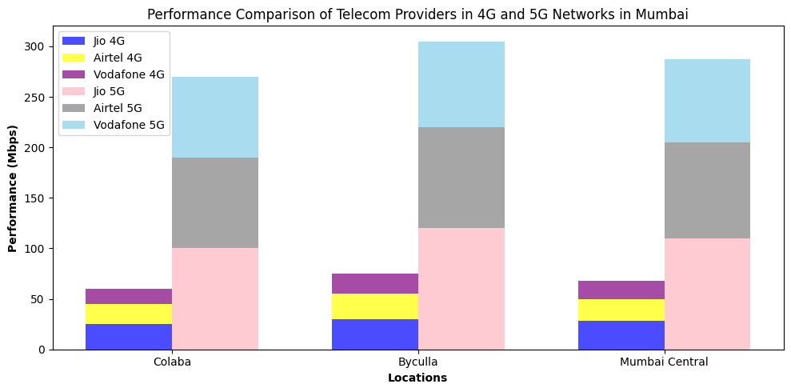

1. **Cost Effectiveness:**

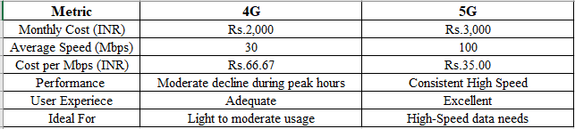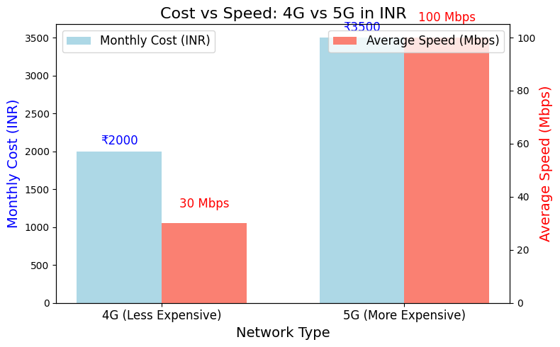

1. **Difference between 4G and 5G standards:**

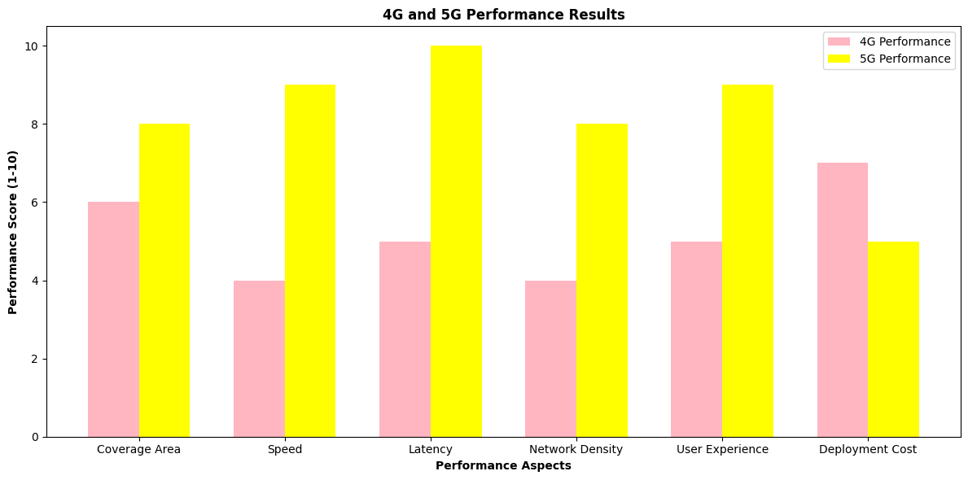

Most wireless communication 5G should replace 4G, as professionals consensus indicates. 5G technology will address and rectify the issues of 4G technology and deployment.

**Address the three crucial needs:-**

(a) A latency of under one second.

(b)1Gbps data rates are achievable for tens of thousands.

(c)Improved energy efficiency.

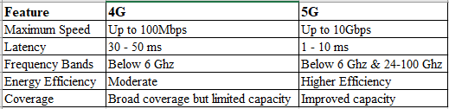

5G operates at a higher frequency of 3.5 GHz, providing faster data rates and lower latency than 4G's 2600 MHz.

1. **Users Recommendation of Network:(4G or 5G)**

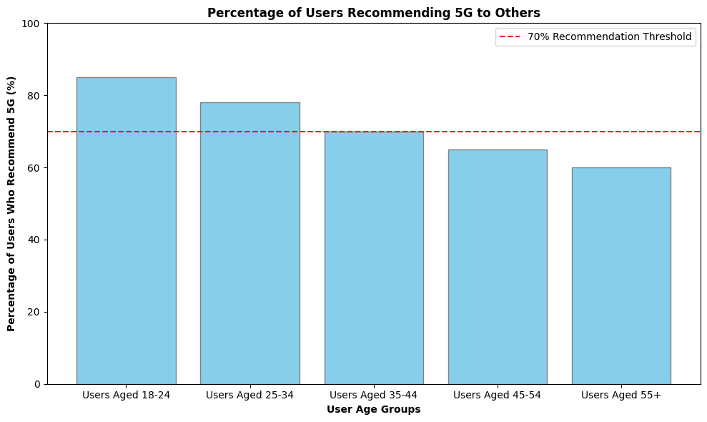

5G is more likely to be recommended by young users, while older users are less inclined to do so, highlighting the need for targeted advertising to increase acceptance across all age groups.

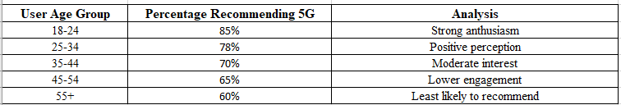

**IV. RESULT AND DISCUSSION**

5G networks provide download speeds up to 100Mbps and low latency of 10ms, improve the user experience of data-intensive applications in cities and manage high-speed traffic without congestion despite the continuing popularity of 4G because of ease and affordability. The full potential of 5G can only be achieved in urban areas after taking into account costs, availability of spectrum and health concerns. 5G implementation in urban areas is expected to revolutionize connectivity and innovation stimulation.

Although 4G is the most popular network, 5G is becoming more popular. With increasing user demands for various mobile services, mobile network operators face difficulties in ensuring user demand caused by different characteristics.

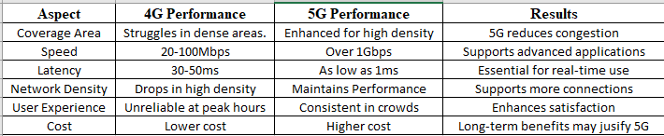

**V. CONCLUSION**

The 5G network surpasses the 4G network in the central areas of Colaba, Byculla and Mumbai, revealing the advanced telecommunications landscape. The 5G network is faster than the 4G network, has lower latency, and can support more simultaneous connections.

The adoption of 5G is increasing in Colaba, a commercial hub, in response to the growing demand for faster connectivity for tourism and business purposes. 5G technology has become more popular in Byculla due to the increasing demand for advanced digital services.

Mumbai Central plays an important role in urban transportation and business operations through its advanced network and strategic transportation links, 4G networks have overtaken 5G networks in terms of signal coverage, and 5G networks provide better signal quality[5].

**VI. FUTURE SCOPE**

The continuous monitoring of networks is essential to evaluate speed and reliability improvements. The impact of 5G on user behaviour and demographic adoption trends, as well as its economic and social benefits to local enterprises and digital differences, can be obtained by exploring these areas.

The impact of 5G on smart urban applications and advanced technologies such as IoT and augmented reality is significant. Supportive policies and public-private partnerships will accelerate the deployment of networks.

**VII. ACKNOWLEDGEMENTS**

I'm grateful to Dr. Rakhi Gupta and Asst Prof. Nashrah Gowalker for their guidance.I owe deep gratitude for their pivotal guidance and support during the course of this research. I am grateful to my colleagues for their collaboration and insightful discussions. I'm grateful to KC College and HSNC University for their support in my research. My motivation and enthusiasm were significantly boosted by the encouragement I received, inspiring me to delve deeper into my research.

**VIII. REFERENCES**

• Kumar, A., & Rao, V. (2023). The Capacity Challenge: 5G in Urban India. Urban Network Studies.

• Desai, P., et al. (2023). Coverage and Accessibility of 5G in Mumbai: A Preliminary Assessment. Indian Journal of Communication.

• Joshi, T., & Mehta, R. (2023). User Experience with 5G: A Survey in Mumbai. Journal of Consumer Technology.

• Iyer, M., & Shah, A. (2023). Infrastructure Needs for 5G Deployment in Urban Areas. Telecom Infrastructure Review.

• Verma, N., & Bansal, R. (2023). Addressing Coverage Gaps in 5G Networks: A Case Study of Mumbai. Journal of Network Engineering.

• Singh, J., et al. (2022). Drive Test Analysis of 4G and 5G Networks in Mumbai. International Journal of Mobile Networking.

# • Chatterjee, P., & Joshi, A. (2024). Economic Impact of 5G Technology in Urban India. Economic Affairs Journal.

• Nair, K., et al. (2023). Longitudinal Studies on Mobile Network Performance: Future Directions. *Communications Research*.

• Patel, R., & Kumar, S. (2024). IoT and 5G: Opportunities in Mumbai's Digital Landscape. *Journal of Internet of Things*.