**EFFECT OF CELEBRITY ENDORSEMENTS ON CONSUMER BUYING BEHAVIOUR**

**Vritika Sharma**

Masters student at H.R College of Commerce and Economics, Mumbai, Maharashtra, India

**ABSTRACT**

This paper examines whether celebrity endorsements have an effect on consumer buying behaviour. Endorsement is a form of brand advertising in which a celebrity represents the brand and vouches for the product. This is done by associating the celebrity’s personality, popularity and societal status to the brand. Celebrities are used to endorse the product or service to create brand awareness and to increase sales. This paper also examines whether celebrity endorsements lead to higher recall value of an advertisement, and if the endorsements help increase brand awareness. A survey was taken with 60 respondents, and the findings indicate that there is a significant influence of celebrities on consumer buying behaviour.

**Keywords:** Celebrity Endorsements, Consumer behaviour, Purchase Decision, Brand, Advertising

**1. INTRODUCTION**

As defined by McCracken (1989), a celebrity endorser is ‘Any individual who enjoys public recognition and uses this recognition on behalf of a consumer good by appearing with it in an advertisement’.

Celebrity endorsements can be used as a promotional tool to increase brand awareness and enhance the visibility of the brand. By doing so, the brand can be introduced to new markets, demographics and audiences. Celebrities endorse by associating their name and image with the product or service to promote it. Marketers and companies believe that the appearance of a celebrity with their product and their testimonials, will influence buyers to purchase the product.

For example, an actor advertising a product can lead to the actor’s fans buying the product as they consider the actor their role model.

It is important to understand if celebrity endorsements impact consumer buying behaviour, so that marketers can change their strategy of advertising and understand their consumers better.

**2. METHODOLOGY**

**2.1 Stating the Research Problem**

Studies on the relationship between celebrities in an advertisement and consumer buying behaviour have generated a lot of mixed opinions.

One widely held view is that celebrities in an advertisement have a direct and positive impact on the buying behaviour of people. Others believed that although celebrities are generally appealing, they still fail to evoke strong enough confidence to motivate consumers to purchase the promoted product. Furthermore, consumers may also avoid purchasing products that are endorsed by celebrities as they may associate it with higher cost. There is uncertainty on the exact nature of the impact of using celebrities in an advertisement and its influence on consumer purchasing behaviour.

**2.2 Objectives of the research**

1. To understand if celebrity endorsements have an effect on consumer buying behaviour.
2. To understand if celebrity endorsements increase advertisement recall value.
3. To understand the effectiveness of celebrity endorsements in increasing brand awareness.

**2.3 Review of Literature**

Anmol Randhawa and Javeed Ahmed Khan (2014) studied whether celebrity endorsements enhances product information and creates awareness among consumers. It helps them recall the brands of the endorsed products. They found that celebrity endorsed advertisements persuade consumers to purchase products rather than non-celebrity endorsed advertisements. However, it was also noted that the purchase attitude is influenced by the quality of products, rather than endorsement factors.

Humaira Mansoor Malik and Muhammad Mehtab Qureshi (2016) have studied the impact of celebrity endorsements on consumer buying behaviour. They noted that if a celebrity is attractive and trustworthy, it enhances the purchase intentions of a consumer, but to a low degree. The study also showed the negative and weak relationship between celebrities who endorse multiple products and consumer buying intention. When a celebrity endorses multiple products it has a negative impact on the consumer and they may hesitate to buy the product.

According to Shruti Sharma and Naveen Sharma (2023) celebrity endorsements effectively work and there are qualities that a celebrity endorsement has that leads to purchases. The first one is credibility, as consumers buy products from those they consider reliable and experienced. The second is, ‘Meaning that the celebrity has transferred to the product’ i.e. ‘meaning conveyed’ which also has a positive influence on the consumers purchase intentions.

**2.4 Research Methodology**

The research design comprised a method of primary data collection using a survey of 13 questions that was limited to 60 respondents. This study also includes secondary data collected via the internet.

**3. SECONDARY DATA**

Brands have created appealing advertising campaigns with celebrities such as movie stars, artists, musicians, sports personalities, and social media influencers.

Brands should consider the following while choosing the celebrity:

1. Alignment: In terms of image and values.
2. Audience: The extent of its target audience it can reach through the celebrity.

Advantages of Celebrity Endorsements:

* Build Credibility: Consumer feels a sense of attachment with their favourite celebrity. If the celebrity uses a particular brand, it shows their fans that the product is worth using and this further generates attention toward the brand.
* Competitive Differentiation: If a brand uses a celebrity to represent their product, they will be able to differentiate themselves from their competitors and stand out from other advertising campaigns. Celebrity endorsement can improve advertisement recall as it helps consumers remember the advertisement, and associate the brand with their favourite celebrity.

Disadvantages of Celebrity Endorsements:

* Volatility of Celebrity’s Image: When a celebrity endorses a brand, the brand is agreeing to sign on to everything that comes along with said celebrity. This includes bringing in some of their fan base as customers, but it can also lead to issues if the celebrity is involved in a scandal or if their commercial appeal lessens.
* Overshadow Brand: A brand can get overshadowed if the celebrity is too popular. If the campaign is too focused on the celebrity, it can lessen brand recognition. Another issue is when a celebrity endorses multiple brands simultaneously. Consumers can get confused, and on seeing the celebrity, associate them with a rival brand.

**3.1 Celebrity endorsements that impacted consumer buying behaviour positively:**

The origin of celebrity endorsements can be dated back to the 1760’s, when the term ‘brand’ had not even been coined yet. A British entrepreneur by the name of Josiah Wedgewood, created a tea set for Queen Charlotte. In a short time span everyone had heard about the tea set and started referring to it as ‘Queensware’, appreciating its elegance and sophisticated design. This set his business apart from the competition, and helped him earn profit while also creating a powerful brand image.

Important factors in the consumer decision-making process include awareness and familiarity with the brand. Through a celebrity’s promotion of the product, sales can see a rise.

Consumers show greater recall of products that have been endorsed by celebrities regardless of whether they are actual fans of the celebrity or not. The human brain recognises celebrities in a similar way to how it recognises people actually known by them in real life. If consumers happen to be followers of the celebrity, they might place a higher value on the products that the celebrity is endorsing, treating it as advice from a valued friend or family member.

Customers may believe that by purchasing a product advertised by a celebrity they see as a role model, they can replicate the celebrity’s attractive traits or can draw similar people into their own lives.

**3.2 Case Study: Lux**

Lux soap was brought into Indian markets in 1929. The goal was to further propel it’s global brand building strategy. One of their campaigns featured 26 of the main female movie stars of those times, which created a large impact among movie lovers who were their target audience. Along with this, directors also spoke on the importance of ‘smooth and youthful skin’ furthering the use of the product. Marketers believe that Lux began the trend of celebrity endorsements in Indian markets.

By associating itself with movie stars, Hindustan Unilever sold the concept of stardom and popularity along with the soap. The clever branding made people believe that Lux soap is the secret behind the beautiful appearances in the Bollywood film industry, and if customers start using it, they can also obtain similar beauty standards.

Lux became well known for its title of being the ‘Beauty soap of film stars’. The advertising was very strategic and soon it became synonymous with the glamorous lifestyles of film actors. Through this strategy of capitalising on the popularity of movie stars and using them as role models, Lux built relevance and brand awareness.

The Lux soap advertising saga has featured more than 50 female film stars as their past brand ambassadors such as:

* Madhubala and Leela Chitnis in the 50s
* Simi Garewal, Waheeda Rehman and Saira Banu in the 60s and 70s
* Hema Malini and Poonam Dhillon in the 80s
* Juhi Chawla, Madhuri Dixit, Sridevi and Karisma Kapoor in the 90s
* Rani Mukherji, Aishwarya Rai, Kareena Kapoor, Priyanka Chopra, Deepika Padukone, and Alia Bhatt till present

**3.3 Celebrity endorsement can also impact consumer buying behaviour negatively:**

1) TVS Jupiter launched a campaign with Amitabh Bachchan endorsing their scooter. Unfortunately, the brand that was advertising vehicles for the working middle class, did not align with the image of the celebrity endorser. The overall campaign failed to resonate with its target audience. The viewers could not establish the connection between an everyday product being sold for the masses and the rich actor endorsing it.

2)  Nike has been consistently using celebrities to endorse their brand. A highly renowned and successful collaboration between a brand and a celebrity is that of Nike and the basketballer Michael Jordan. The collaboration was so successful that after the campaign, Nike and Jordan collaborated and launched a new sport shoes product line known as the ‘Air Jordan’.

Nike had a very similar collaboration in the sports industry when it partnered with golfer Tiger Woods, to enter the golf category with apparel and equipment. Nike did not have much experience in selling merchandise to golfers but chose to partner and associate with the best golfer globally at the time, and have him endorse the brand. When Nike and Tiger Woods entered an endorsement deal in 2000, Nike’s market share saw an increase. However, when Tiger Woods went through a highly publicised scandal, Nike decided to keep working with him and this lead to the company suffering a loss in sales and losing a large amount of customers.

**4. PRIMARY DATA**

Primary Data was collected through a 13 question survey with 60 respondents.

Q1) Which year were you born:

|  |  |  |
| --- | --- | --- |
| **Serial Number** | **Year** | **Frequency** |
| 1 | Before 1960 | 4 |
| 2 | 1961-1970 | 6 |
| 3 | 1971-1980 | 7 |
| 4 | 1981-1990 | 7 |
| 5 | 1991-2000 | 12 |
| 6 | 2001-2010 | 20 |
| 7 | After 2010 | 4 |

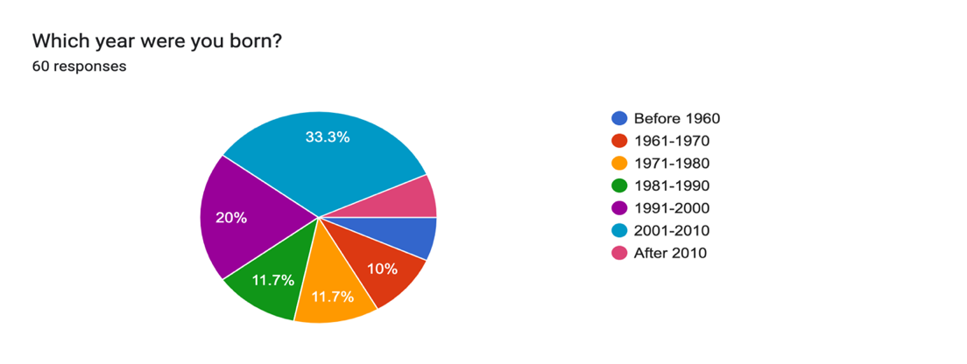

**Figure 1:** Pie chart depicting responses to question 1

**Analysis:** Majority of the respondents were born in the year group of 2001-2010, i.e. 33.3%, followed by 1991-2000 at 20%, with 1971-1980 and 1981-1990 at 11.7%, followed by 1961-1970 at 10%. Before 1960 and after 2010 was at 6.7%.

Q2) What is your gender?

|  |  |  |
| --- | --- | --- |
| **Serial Number** | **Gender** | **Frequency** |
| 1 | Male | 19 |
| 2 | Female | 41 |

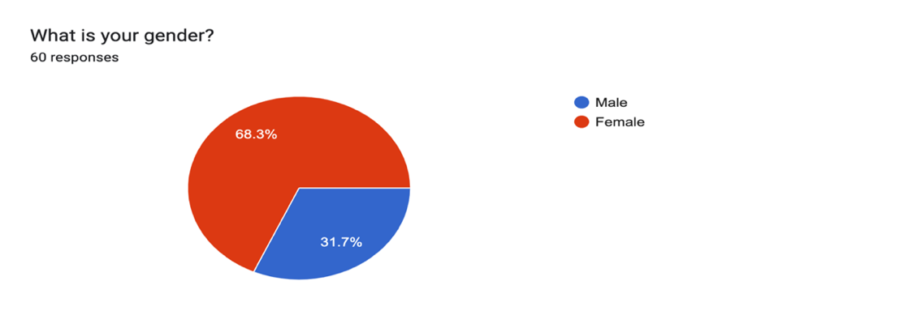

**Figure 2**: Pie chart depicting responses to question 2

**Analysis:** Majority of the respondents were females at 68.3%, while male respondents were at 31.7%.

Q3) Where do you come across advertisements?

|  |  |  |
| --- | --- | --- |
| **Serial Number** | **Media** | **Frequency** |
| 1 | Television, Radio | 5 |
| 2 | Newspaper | - |
| 3 | Social Media ( Facebook, YouTube, Instagram) | 22 |
| 4 | All | 33 |

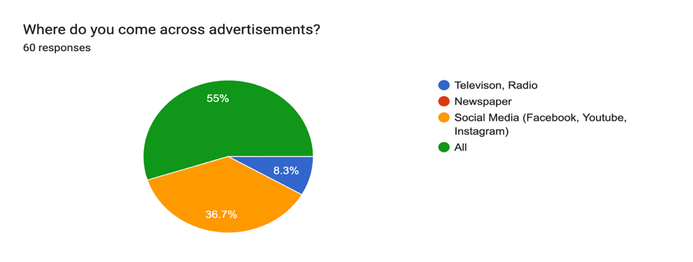

**Figure 3**: Pie chart depicting responses to question 3

**Analysis:** Majority of respondents came across advertisements on all platforms i.e. television, radio, social media and newspapers at 55%. Social media came in at 36.7%, and Television, Radio at 8.3%.

Q4) What are your thoughts on celebrity endorsements?

|  |  |  |
| --- | --- | --- |
| **Serial Number** | **Thoughts** | **Frequency** |
| 1 | Positive | 32 |
| 2 | Neutral | 24 |
| 3 | Negative | 4 |

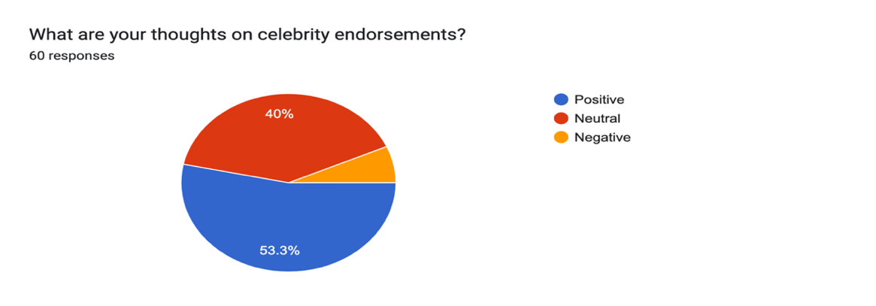

**Figure 4**: Pie chart depicting responses to question 4

**Analysis:** Most respondents had a positive view on celebrity endorsements at 53.3% while 40% were neutral and 6.7% thought negatively.

Q5) What are your thoughts on non-celebrity endorsers?

|  |  |  |
| --- | --- | --- |
| **Serial Number** | **Thoughts** | **Frequency** |
| 1 | Positive | 7 |
| 2 | Neutral | 51 |
| 3 | Negative | 2 |

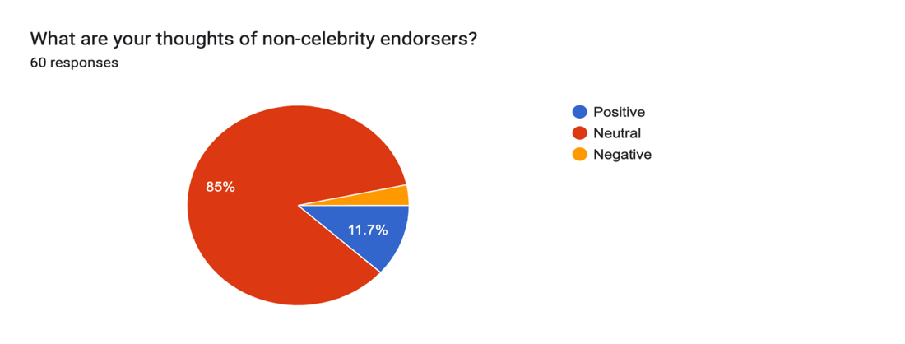

**Figure 5**: Pie chart depicting responses to question 5

**Analysis:** 85% of respondents were neutral towards non-celebrity endorsers, 11.7% positive and 3.3% negative.

Q6) How likely are you to buy a product because a celebrity endorses it?

|  |  |  |
| --- | --- | --- |
| **Serial Number** | **Likelihood** | **Frequency** |
| 1 | Very Likely | 13 |
| 2 | Likely | 29 |
| 3 | Unlikely | 18 |

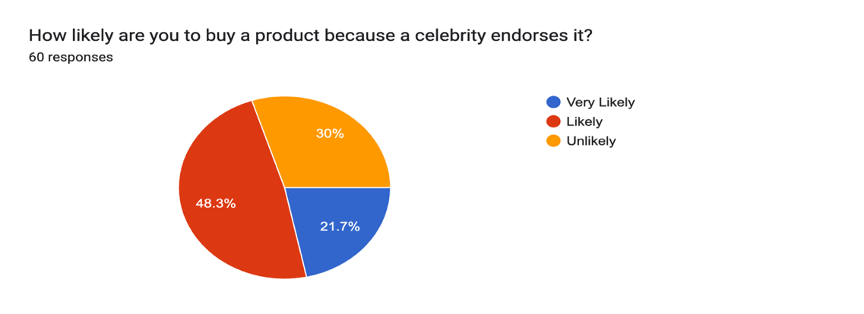

**Figure 6**: Pie chart depicting responses to question 6

**Analysis:** 21.7% respondents were very likely to buy a product because a celebrity endorsed it, 48.3% likely and 30% unlikely.

Q7) Do you trust a brand more if you see that a celebrity endorses it?

|  |  |  |
| --- | --- | --- |
| **Serial Number** | **Trust** | **Frequency** |
| 1 | Yes | 29 |
| 2 | No | 31 |

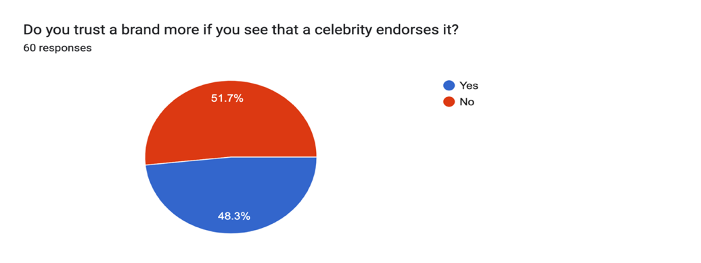

**Figure 7**: Pie chart depicting responses to question 7

**Analysis:** 51.7% respondents stated that they would not trust a brand more if a celebrity endorsed it and 48.3% said they would.

Q8) When you see an advertisement with a celebrity, where does majority of your attention go?

|  |  |  |
| --- | --- | --- |
| **Serial Number** | **Attention** | **Frequency** |
| 1 | To the product being advertised | 13 |
| 2 | To the celebrity | 6 |
| 3 | Both | 41 |

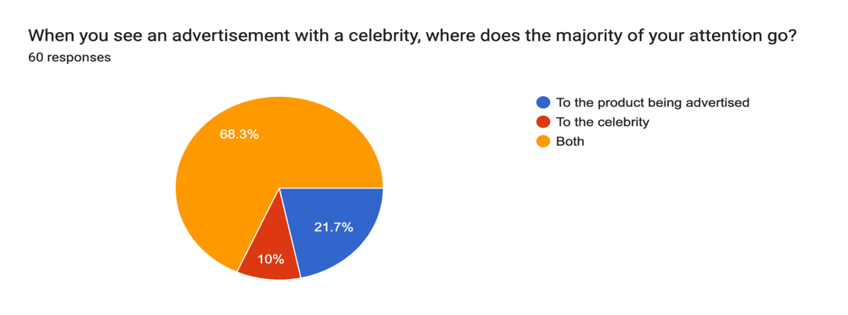

**Figure 8**: Pie chart depicting responses to question 8

**Analysis:** 68.3% of the respondents said that their attention goes to both the celebrity and the product being advertised, 21.7% said that it goes to the product, and 10% said that it goes to the celebrity.

Q9) Do you remember any advertisement a celebrity has appeared in?

|  |  |  |
| --- | --- | --- |
| **Serial Number** | **Advertisement recall** | **Frequency** |
| 1 | Yes | 53 |
| 2 | No | 7 |

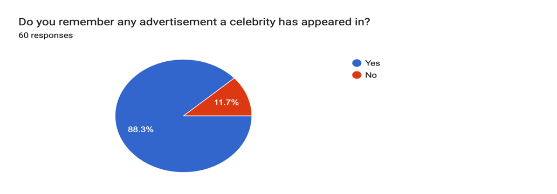

**Figure 9**: Pie chart depicting responses to question 9

**Analysis:** 88.3% stated that they remembered advertisements a celebrity has appeared in while 11.7% said that they did not.

Q10) Why do you think celebrities take brand endorsements?

|  |  |  |
| --- | --- | --- |
| **Serial Number** | **Reason** | **Frequency** |
| 1 | More for the money, less for the product | 34 |
| 2 | More for the product, less for the money | 2 |
| 3 | Both for the money and the product | 24 |

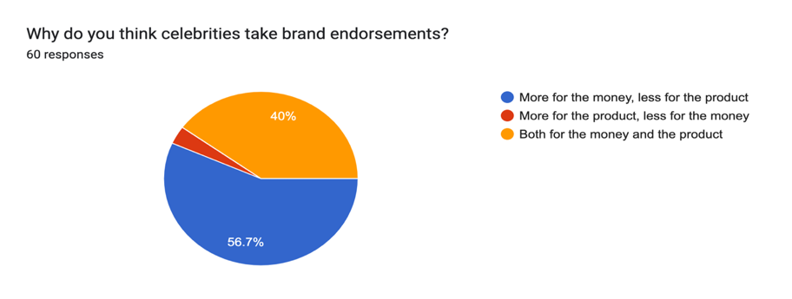

**Figure 10**: Pie chart depicting responses to question 10

**Analysis:** 56.7% of the respondents believed that celebrities take endorsements more for the money, less for the product, 40% believed both for the product and the money, and 3.3% believed for the product.

Q11) Have you ever been influenced to buy a product because of a celebrity endorsement?

|  |  |  |
| --- | --- | --- |
| **Serial Number** | **Influence** | **Frequency** |
| 1 | Yes | 31 |
| 2 | No | 29 |

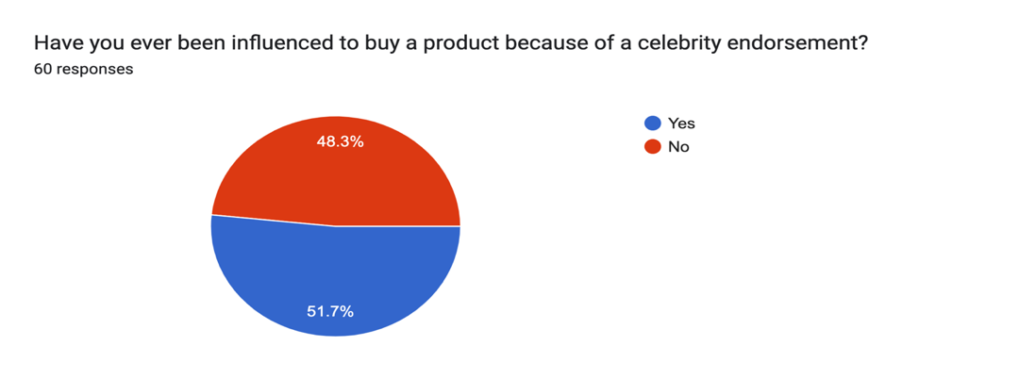

**Figure 11**: Pie chart depicting responses to question 11

**Analysis:** Majority of the respondents i.e. 51.7% had been influenced to buy a product because of a celebrity endorsement, whereas 48.3% had not.

Q12) Would you continue to use a product after a celebrity stops endorsing it?

|  |  |  |
| --- | --- | --- |
| **Serial Number** | **Continuation of usage** | **Frequency** |
| 1 | Yes | 51 |
| 2 | No | 9 |

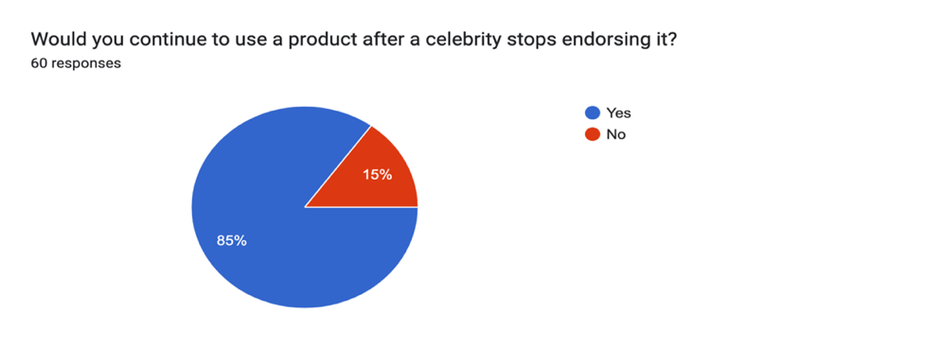

**Figure 12**: Pie chart depicting responses to question 12

**Analysis:** 85% of the respondents stated that they would continue to use a product after the celebrity is done endorsing it, while 15% stated that they would not.

Q13) Has a brand been brought to your notice by word of mouth around a celebrity endorsement?

|  |  |  |
| --- | --- | --- |
| **Serial Number** | **Word of Mouth** | **Frequency** |
| 1 | Yes | 37 |
| 2 | No | 23 |

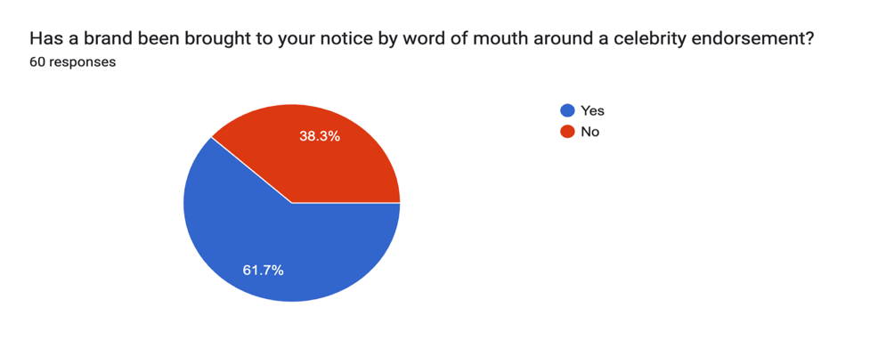

**Figure 13**: Pie chart depicting responses to question 13

**Analysis:** 61.7% of the respondents stated that they have noticed a brand due to word of mouth buzz following a celebrity endorsement, while 38.3% of the respondents stated that they had not.

**5. FINDINGS**

From this survey, we can see that celebrity endorsements have an influence on the consumers’ buying behaviour. It also has an impact on increasing advertisement recall value and increasing brand awareness.

* Most of the respondents had a positive view on celebrity endorsers, with a small percentage perceiving them as negative. Non-celebrity endorsers as per this survey were viewed neutrally.
* 70% of the respondents were very likely/ likely to buy a product endorsed by a celebrity, compared to the 30% who would not.
* More than 50% of the respondents did not trust a brand more if a celebrity endorsed it. This may be because trust in a brand is mostly generated due to the product being of good quality. Trust must be earned.
* Most of the respondents, when viewing an advertisement, focused on both the product and the celebrity, whereas few concentrated only on the product or only on the celebrity. Therefore, the goal of marketers should be for viewers’ attention to be more on the product.
* Majority of the respondents claimed that they remembered an advertisement that a celebrity has been in, which shows that celebrities help in increasing recall value in the minds of the consumer.
* Most of the respondents felt that celebrities took endorsements more for the money and less for their belief in the product, as compared to those who believed that celebrities took endorsements more for their belief in the product and less for the money. This shows that consumers are aware and cannot be fooled. If the consumer feels the celebrity is only doing it for the money it can lead to a negative perception.
* Majority of the respondents, i.e. more than 50% had been influenced into buying a product a celebrity had endorsed, which shows the impact of celebrity endorsements on consumers purchase intent.
* 85% of the respondents would continue to use a product even after the celebrity stopped endorsing it. This shows that if a product has good quality it will generate brand loyalty.
* From this survey we can also understand that more than 60% of the respondents had heard of a brand due to there being word of mouth buzz around a celebrity endorsement. This shows that brand awareness can be enhanced through celebrity endorsements.

**6. SUGGESTIONS**

Consumers these days are more aware and price conscious. They may be introduced to a brand via a celebrity, but will continue to use the product only if it is of good quality and gives value for money. As seen from the survey, celebrity endorsements have an impact on consumer buying behaviour, but consumers do not trust a brand more just because a celebrity endorses it.

Celebrity endorsements also help to increase advertisement recall value, but at times, while watching the advertisements, the viewers’ attention goes more on the celebrity rather than the product, which will be of no advantage to the marketer. Most consumers understand that celebrities do endorsements more for the money rather than the product, so brands should focus on matching the product being advertised to the right celebrity, otherwise it will come across as more disingenuous.

**7. CONCLUSION**

Celebrity endorsements, are an essential part of many marketers strategies in order to boost sales of their product. By taking advantage of the celebrity’s credibility, and popular appeal, companies can promote their products to the celebrity’s fans. Consumers will buy a product if they like the celebrity as it feels as if someone close to them has given a recommendation.

Thus, this study has concluded that celebrity endorsements have a positive effect on consumer buying behaviour. Moreover, there is an impact of celebrities on advertisement recall value and there is an effect of celebrity endorsements in increasing brand awareness.

**8. REFERENCES**

1. Grant McCracken, Who is the Celebrity Endorser? Cultural Foundations of Endorsement Process, Journal of Consumer Research, Volume 16 (3), Page 310-321, 1989.

2. Anmol Randhawa, Javeed Ahmed Khan, Impact of celebrity endorsement on consumer buying behaviour, International Journal of Business Management, Volume 1(2), 2014.

3. Humaira Mansoor Malik, Muhammad Mehtab Qureshi, The impact of celebrity endorsement on consumer buying behaviour, Journal of Marketing and consumer research, Volume 26, Page 112-127, 2016.

4. Sruthi Sharma, Naveen Sharma, A study of consumer buying behaviour as related to the effects of endorsements by celebrities, SGVU International Journal of Convergence of Technology and Management, Volume 9 (1), Page 09-19, 2023.

5. The Pros and Cons of Celebrity Endorsements, 2018, retrieved from <https://baerpm.com/2018/01/02/pros-cons-celebrity-endorsements/>

6. Ada Okoli, Impact of Celebrity Endorsement on Consumer Buying Behaviour, retrieved from <https://blog.zoovu.com/impact-of-celebrity-endorsement-on-consumer-buying-behavior/>

7. Sneha Yadav, Brand saga: Lux, the brand that pioneered celebrity endorsements, 2020, retrieved from <https://www.socialsamosa.com/2020/10/brand-saga-lux-soap-advertising-journey/>

8. What design should be thinking, 2020, retrieved from <https://www.lokusdesign.com/category/blog/>

9. Branding and Celebrity Endorsements, 2018, retrieved from <https://martinroll.com/resources/articles/branding/branding-and-celebrity-endorsements/>