H.R. College of Commerce and Economic

Business Management

S.Y.Mcom, semester 3

Subject - International Economics

Topic - Role of India in SAARC

Name – Shravani .R. Surve

**About SAARC**

* The seven South Asian countries, including Pakistan, India, Bangladesh, Nepal, Sri Lanka, Bhutan, the Maldives, and Afghanistan, settled in the late 1970s and agreed to create a trade bloc to provide a forum for the citizens of South Asia to function in the spirit of friendship, confidence and understanding at the same time.
* On May 2, 1980, Zia Ur Rahaman initially lifted this initiative to create a trade bloc.
* The first summit was held in Dhaka on December 8, 1985.
* In 2007, Afghanistan joined as the eighth member of SAARC.
* In 2007, India was the Chair of SAARC, the year the most productive year that SAARC had ever known.

It is a geopolitical and economic body of eight countries located in South Asia, created in 1985. The Headquarters of SAARC is located in Kathmandu, Nepal.

The eight member countries of SAARC are as follows:

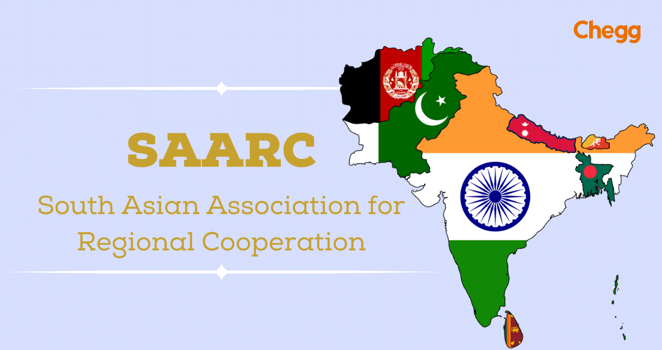

1. India
2. Bangladesh
3. Bhutan
4. Sri Lanka
5. Afghanistan
6. Nepal
7. Maldives
8. Pakistan

**SAARC SUMMITS**

The members States of SAARC are arranging meetings at Summit level, usually on annual basis for the execution SAARC agenda. The first summit was held in Dhaka, Bangladesh on 6-8, December 1985. Since then there were Nineteen Summits held at various capitals/ cities of member states. The 19th SAARC Summit was hosted by Pakistan in 2016. India including Afghanistan, Bhutan, Bangladesh, Sri Lanka and Maldives did not attend in this summit due to 2016 Uri terrorist attack. Pakistan postponed the SAARC summit announced that new dates would be released soon, but it did not happen.

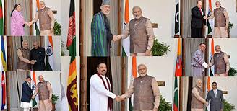

**OBJECTIVES OF SAARC**

¬ To promote the welfare of the people of South Asia and to improve their quality of life.

¬ To accelerate economic growth, social progress and cultural development in the region and to provide all individuals the opportunity to live in dignity and to realize their full potentials.

¬ To promote and strengthen collective self-reliance among the countries of South Asia.

¬ To contribute to mutual trust, understanding and appreciation of one another‘s problems.

¬ To promote active collaboration and mutual assistance in the economic, social, cultural, technical and scientific fields.

¬ To strengthen cooperation with other developing countries.

¬ To strengthen cooperation among themselves in international forums on matters of economic interests; and

¬ To cooperate with international and regional organizations with similar aims and purposes.

**INDIA’S CONTRIBUTION IN THE SAARC**

Right from the origin and evolutionary growth of SAARC, India has been playing a prominent role in it. Here to assess the India’s initiatives in the SAARC are:

• India took sincere effort for the formation of SAARC. It played a big role in the first summit, which was held during the origin of this organization as well as the preparation of its Charter.

• India was hosted to SAARC summits three times. The second summit was held in 1986: Eighth summit was held in 1995: and Fourteenth summit was held in 2007. During the 2nd Summit the Heads of State or Government welcomed the signing of the MOU on the establishment of the SAARC Secretariat by the Council of Ministers and their decision to locate the Secretariat in Kathmandu, Nepal and appoint Abul Ahsan of Bangladesh as the first Secretary-General of SAARC.

• India, given its size, population, economy and central location is indeed the pivot of SAARC. It has common land/sea borders with six of the seven other members which place it in an unquestionable leadership role.

• India because of its geography, economy, international stature and commitment to the region is central to SAARC. The SAARC region has acute asymmetrical power balance as India encompasses more than 75 percent of the region’s GDP and more than 70 percent of population, territorial dependency in India is high and it possesses enormous military power compared to other countries in the region. India has a special responsibility flowing from the geography of the region and the size of its economy. Taking the region along in India’s march towards progress and prosperity is both an economic and demographic imperative. India has so far contributed over US$ 530. - Million to SAARC institutions for socio-economic development.

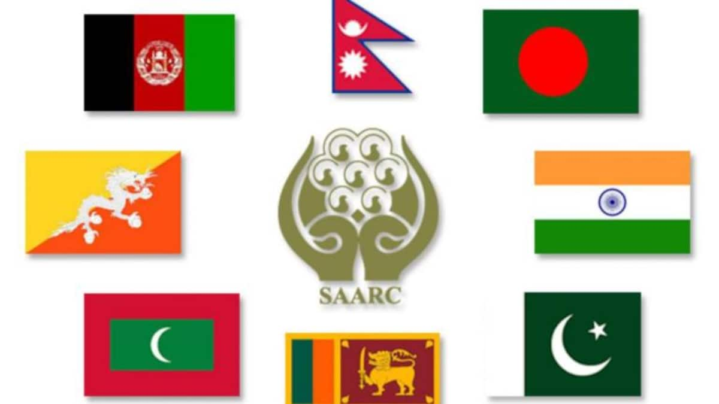

India’s trade with South Asia accounts for around 5.5% of its global trade. India have been advocating expedited negotiations/implementation of agreements, promoting investments, trade, exchanges in the region. India’s emphasis is on three central themes of SAARC- trade, connectivity and people-to- people contact. They were summarised hereunder:

• Under SAFTA, India has unilaterally offered duty free access on all items to the SAARC LDCs and has met the Phase II commitments for non-LDCs. It has zero tariff for goods coming from LDCs. We are eliminating 455 out of 480 tariff lines in our Sensitive Lists for LDCs.

• India is ready with its schedule of commitment of SAARC Agreement on Trade in Services (SATIS) which was come into force in December 2012. The Agreement provides for expanding intra-regional investments, trade liberalization in the services sector, etc. The 5 Least Developed Countries in the region, viz. Afghanistan, Bangladesh, Bhutan, Maldives and Nepal, are accorded special and differential treatment, commensurate with their developmental need

• The fledgling SAARC Development Fund (SDF) finances sub-regional projects envisaged under its social, economic and infrastructure windows. India is the only country to have paid its assessed contribution (for the entire 5 year period) of US$ 89.9 million and a voluntary contribution of US$ 100 million4.

• A currency swap arrangement for the region, with a base fund of US$ 2 billion from India provides short term foreign exchange liquidity requirements of Member States.

• With the initiation of India the member countries of SAARC have established a Free Trade Area (FTA) which will increase their internal trade and lessen the trade gap of some states considerably.

India has played a significant role in the South Asian Association for Regional Cooperation (SAARC) in a number of ways, including:

* Sharing technology

India has shared the benefits of its technological advances with other South Asian countries by extending its National Knowledge Network (NKN) to Bangladesh, Bhutan, and Sri Lanka.

* Financial support

India has provided financial support to cultural organizations that work for regional integration in SAARC.

* Regional projects

India has undertaken several regional projects in areas such as solar rural electrification, rainwater harvesting, and seed testing.

* Climate change

India has established an Endowment for Climate Change to fund environment-related projects.

* Medical visas

India has liberalized its medical visa regime for SAARC nationals.

* Tele-medicine

India has successfully run a tale-medicine project in Afghanistan.

* Assistance to other countries

India has provided food, medicine, and shelter to people affected by conflicts and disasters in other SAARC countries. India has also helped reconstruct infrastructure in these countries.

* Counter-terrorism

India has helped establish the SAARC Fear-based Oppressor Offenses Checking Work area, which monitors terrorist activities in the region.

* Contributions to SAARC institutions

India has contributed over US\$530 million to SAARC institutions for socio-economic development.

**SAARC and Its Impact on Indian Economy**

From the notes mentioned below learners will be able to get answers to, how does saarc affect Indian economy and also impact of SAARC on Indian economy project.

The South Asian Association for Regional Cooperation (SAARC) comprises India and 7 other South Asian nations. Though SAARC has made progress in certain areas, its impact on the Indian economy has been limited due to various reasons.

Potential benefits for India are sent below.

* A thriving regional market: Deeper economic integration within SAARC can create a large regional market for Indian goods and services. This could boost Indian exports and the manufacturing sector.
* Attract investment: An integrated South Asian economy could attract more foreign investment into the region, including into India.
* Improved connectivity: SAARC initiatives to enhance regional connectivity through transport and energy infrastructure could benefit India's economy.
* Common policies: Harmonizing economic policies in areas like trade, investment and agriculture could benefit India.
* Job creation: Thriving regional trade can boost labour-intensive manufacturing in India, helping generate more jobs.
* Attracting FDI: A liberalised investment regime within SAARC can help attract more foreign direct investment into high-potential sectors in India.
* Technology transfer: Improved cooperation in areas like agriculture, renewable energy and IT can facilitate technology transfer to India from other members.
* Improved food security: Initiatives to boost agricultural trade, research and technology sharing within SAARC can improve food security in India.
* Infrastructure boost: SAARC projects in transport, energy and digital connectivity sectors could support India's infrastructure needs.
* Poverty alleviation: Regional cooperation initiatives in areas like microfinance, rural development, healthcare and sanitation can benefit the poor in India.
* Tourism promotion: Promoting South Asia as a single destination under SAARC can boost tourism in India.
* Containing extremism: Effective security cooperation within SAARC can help India contain extremism and terrorism originating from the region.

CONCLUSION

India has given helpful help to other SAARC nations during critical crossroads. For instance, India has given food, medication, and sanctuary to individuals impacted by cataclysmic events and clashes. It has additionally assisted with reconstructing framework in these nations. India has additionally attempted to advance counter-illegal intimidation cooperation inside SAARC. It has imparted knowledge to other SAARC nations, and it has attempted to forestall psychological militant gatherings from working in the area. For instance, India has assisted with laying out the SAARC Fear based oppressor Offenses Checking Work area, which is answerable for following psychological militant exercises in the locale

Bibliography

<https://www.ijmra.us>

<https://testbook.com>

<https://mea.gov.in>

THANK YOU