**BRAIN DECO**

|  |  |  |
| --- | --- | --- |
| B.spoorthi  B.Tech  *School of Engineering*  Computer Science – AI&ML  Malla Reddy University, India. | Ch.karthik  *B. Tech*  *School of Engineering*  Computer Science – AI&ML  Malla Reddy University, India. | *Ch.HarshaVardhan*  *B. Tech*  *School of Engineering*  Computer Science – AI&ML  Malla Reddy University, India. |
| Ch.Satya *B. Tech*  *School of Engineering*  Computer Science – AI&ML  Malla Reddy University, India. | Ch. Manoj *B. Tech*  *School of Engineering*  Computer Science – AI&ML  Malla Reddy University, India.  Guide: Dr .G.Hariharan  Assistant Professor  *School of Engineering*  Computer Science – AI&ML  Malla Reddy University, India. |  |

***Abstract:***

It is a comprehensive educational app designed to enhance learning experiences for students of all ages. Brain Deco integrates advanced technologies such as artificial intelligence, adaptive learning algorithms, and interactive multimedia content to provide a personalized and engaging educational journey. The app features a vast library resources covering various subjects, including interactive quizzes, video lectures, and virtual labs. Brain Deco adaptive learning system tailors content to individual learning styles and paces, ensuring that each student receives customized support. Additionally, the app incorporates gamification elements to motivate and engage learners, fostering a more interactive and enjoyable learning environment. Teachers and parents can track progress through detailed analytics, enabling them to identify areas for improvement and celebrate achievements. Brain Deco aims to bridge the gap between traditional education methods and modern technological advancements, promoting a more accessible, flexible, and effective learning experience for all users.

Furthermore, the application utilizes natural language processing to enable features such as virtual tutoring, content summarization, and sentiment analysis for real-time feedback. Automated grading and content generation simplify the assessment process, while predictive analytics models forecast students' success and engagement levels. The inclusion of gamification elements, such as adaptive difficulty levels and rewards, further motivates and engages users.

In conclusion, this educational application presents a comprehensive and interactive learning platform that blends AI-driven personalization, adaptive content, and real-time feedback to foster an enriching educational experience. The application has the potential to transform traditional education systems by making learning more accessible,

efficient, and engaging for diverse learners worldwide.

***Keywords:*** Python, NLP

I. INTRODUCTION

In the fast-paced digital era, students are continually seeking innovative ways to enhance their academic experience, foster connections with peers, and stay abreast of the latest updates from their educational institutions. Enter Edx, an all-encompassing application meticulously designed to cater to the diverse needs of students, providing them with a seamless platform for reading e-books, fostering communication with college mates, and staying informed about crucial updates.

Brain Deco is a digital tool designed to facilitate learning and teaching through interactive and engaging methods. These apps provide users with access to various educational resources, such as lessons, quizzes, videos, and games, across different subjects and skill levels. They cater to diverse learning needs, offering personalized learning experiences, real-time feedback, and the ability to track progress.

Brain Deco can serve a wide range of purposes, including formal education (for schools, universities), self-paced learning, skill development, and exam preparation. Many also include features like gamification, social learning, and multimedia content to enhance user engagement and improve retention. With the increasing integration of technology into education, these apps have become essential for making learning more accessible, flexible, and efficient, benefiting students, teachers, and lifelong learners alike.

A more advanced feature to consider is simulations and virtual labs, especially for subjects that benefit from practical experience, such as science, engineering, or even healthcare. These tools allow students to experiment in a risk-free environment, making complex topics more accessible and easier to understand. Personalization is another critical factor. By using adaptive learning algorithms, an application can assess a user’s strengths and weaknesses, offering content and activities tailored to their individual needs. This creates a more efficient learning path, ensuring that users get the most relevant material at the right time, which can significantly enhance learning outcomes.

**Customer experience improvement:** To enhance the customer experience of CampusBuddy, we will focus on a user-friendly interface, personalized content, and a responsive AI chatbot for 24/7 support. Seamless communication between students and faculty will be prioritized, along with accessible onboarding tutorials and a feedback system for continuous improvement. Engaging community features and regular updates will ensure a smooth and efficient app experience, driving user satisfaction and engagement.

II. REQUIRED TOOLS

***a) Software Requirements***

**System Requirements**

* **FRONT END:** HTML and CSS will be used to develop the user interface of the application
* **BACK END:** Python is used as backend for storing and retrieving data.
* **Scripting Language:** Javascript is used as scripting language.
* **OPERATING SYSTEM:** windows 10
* **IDE:** visual studio code

**2. Development Environment**

* **Programming Languages**:
  + Python 3.x for backend development
  + JavaScript (Node.js) for server-side scripting
  + HTML5, CSS3 for frontend development
* **Frameworks and Libraries**:
  + **Backend**:
    - Flask or Django (for web framework)
    - SQLAlchemy (for database interactions)
  + **Frontend**:
    - React.js or Vue.js (for building user interfaces)
    - Bootstrap or Tailwind CSS (for responsive design)
* **Database**:
  + PostgreSQL or MySQL (for relational database management)
  + MongoDB (for NoSQL data storage)
* **Data Analysis**:
  + Pandas, NumPy, Scikit-learn for data manipulation and machine learning
  + NLTK for natural language processing

**3. Additional Software Tools**

* **Version Control**:
  + Git (for version control and collaboration)
  + GitHub or GitLab (for repository hosting)
* **Integrated Development Environment (IDE)**:
  + Visual Studio Code, PyCharm, or any suitable IDE for coding
* **API Development and Testing Tools**:
  + Postman or Insomnia (for API testing)
* **Containerization**:
  + Docker (for creating, deploying, and managing containers)

**4. User Requirements**

* **User Interface**:
  + A responsive design suitable for mobile and desktop platforms
  + Intuitive navigation and accessibility features
* **Accessibility**:
  + Compliance with accessibility standards (e.g., WCAG 2.1) to support users with disabilities
* **Security**:
  + Implementation of security protocols to protect user data and privacy, including encryption and secure authentication methods.

***b) Hardware Requirements***

**Client-Side Hardware Requirements**

* **Devices**:
  + Smartphones (iOS and Android)

IV. ARCHITECTURE

This architecture seems to represent a system design for a learning management platform

1. Brain Deco

Login Page: Users can log in by providing their Username and Password. If the credentials are correct (evaluated as True), they are redirected to the Home Page.

Create Account: New users can create an account by entering a Gmail ID and Password. Once done, they gain access to the system.

2. Data

The Data section interacts with the system database to store and retrieve information. It includes:

Reference Material: Materials needed for the courses are likely stored in the database.

Profile: Users’ personal information and preferences.

Notification: Communication between the system and the user (e.g., updates, alerts).

Database: Stores all data, including PDFs and Photos related to the content.

3. User

This section represents the interaction between the user and the system. The user can:

Download PDF: Users can download the course materials.

Saving Notes: Users have the ability to save personal notes within the system.

Uploading Notes: Users can upload their own notes or documents to the system.

It also contains:

**1. Modular Design**

**Separation of Concerns:** The system should be divided into distinct modules or services, such as user management, content management, and learning analytics, each handling specific functionalities. This helps in scaling and maintaining the app over time.

**Microservices Architecture:** Opting for a microservices approach enables the independent scaling and development of different parts of the application, such as authentication, content delivery, and progress tracking.

**2. User Authentication and Management**

**Multi-factor Authentication (MFA):** For enhanced security, implementing MFA can protect user data, especially sensitive information like payment or personal details.

**OAuth or SSO (Single Sign-On):** Allow users to sign in using their Google, Facebook, or Microsoft accounts for seamless onboarding.

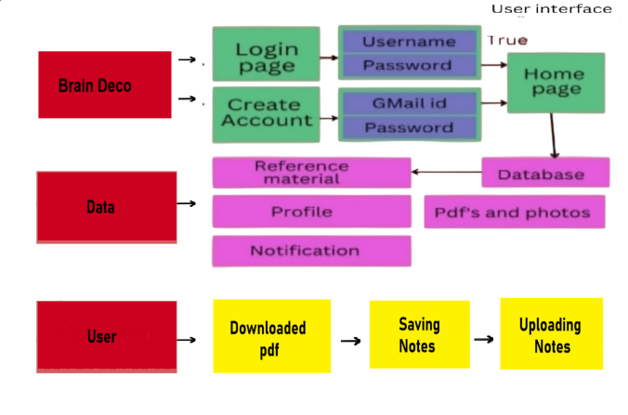

* 1. RESULTS

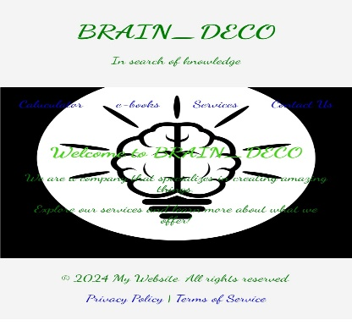Executing the above code after importing the necessary modules and packages we get the following output:

Code:

Result:

This is a screen shot of the output of our code execution.

CONCLUSION

The conclusion for an Brain deco app summarizes its impact, value to users, and areas for future development based on observed data, user feedback, and outcomes. Here’s a framework for crafting an effective conclusion:

**1. Summary of Key Findings**

Highlight the most significant results from deploying and using the app, focusing on the primary goals such as improving learning outcomes, user engagement, and personalized learning.

* **Learning Outcomes**: Summarize improvements in user knowledge and skill acquisition. For example, if users demonstrated significant knowledge gains in post-tests or showed strong concept mastery through quizzes, this reinforces the app’s educational effectiveness.
* **Engagement and Retention**: Mention if users consistently returned to the app, completed content, or followed adaptive learning paths. High engagement rates suggest that the app’s structure and content are relevant and engaging.
* **Personalization Success**: If personalized recommendations, adaptive paths, or chat features were well-received, note how these models contributed to a customized learning experience, helping users stay engaged and progress at their own pace.

**2. Educational Impact**

Explain the app’s educational impact on users, emphasizing how it supports learning, knowledge retention, and long-term educational habits.

* **Knowledge Retention**: If users retained knowledge over time, discuss how spaced repetition or follow-up assessments supported long-term retention.
* **Behavioral Shifts**: If data indicates that the app helped users develop positive study habits (like regular usage or revisiting challenging topics), this underscores its value beyond individual sessions.
* **Mastery and Skill Development**: Highlight if users achieved mastery in specific areas, which indicates that the app effectively delivers educational content that aligns with users’ learning goals.

**3. User Feedback and Satisfaction**

Discuss how users perceived the app, using feedback and survey results to support your analysis.

* **Positive Feedback**: Note areas of high user satisfaction, such as content relevance, ease of use, or quality of personalized recommendations. Positive feedback underscores the app’s usability and relevance.
* **Areas for Improvement**: Summarize any constructive feedback received, like desires for more challenging content, faster response times, or a more intuitive interface. Addressing this feedback in future updates can improve user satisfaction and retention.

ACKNOWLEDGMENT

We sincerely thank our DEAN Dr. Thayyaba Khatoon for her constant support and motivation all the time. A special acknowledgement goes to a friend who enthused us from the back stage. Last but not the least our sincere appreciation goes to our family who has been tolerant understanding our moods, and extending timely support. We would like to express our gratitude to all those who extended their support and suggestions to come up with this application. Special Thanks to our mentor prof P.Bhavani whose help and stimulating suggestions and encouragement helped us all time in the due course of project development.

REFERENCES

1.Brusilovsky, P., & Millán, E. (2007). "User models for adaptive hypermedia and adaptive educational systems." *The Adaptive Web*, 3-53. This paper discusses personalized learning and how user modeling can support adaptive educational systems.

2.Deterding, S., Dixon, D., Khaled, R., & Nacke, L. (2011). "From game design elements to gamefulness: defining 'gamification'." *Proceedings of the 15th International Academic MindTrek Conference: Envisioning Future Media Environments*. This research explores how gamification can enhance engagement in learning apps.

3.Anderson, L. W., & Krathwohl, D. R. (Eds.). (2001). *A Taxonomy for Learning, Teaching, and Assessing: A Revision of Bloom's Taxonomy of Educational Objectives*. This resource provides an understanding of cognitive learning objectives, which can guide content development and assessment.

4.Jonassen, D. H. (1999). *Designing Constructivist Learning Environments*. This work outlines constructivist approaches to learning, emphasizing active engagement and experiential learning in educational apps.

5.Norman, D. A. (2013). *The Design of Everyday Things: Revised and Expanded Edition*. This book provides insights into usability principles that can help in designing user-friendly interfaces for educational apps.

6.Shneiderman, B., & Plaisant, C. (2010). *Designing the User Interface: Strategies for Effective Human-Computer Interaction*. This text explores design principles that enhance the user experience, which is key for mobile learning applications.