Legal Aid Application Using AI

R. Michael Benedict | R.K Sai Rithik | R. Sai Charan
B.Tech | B. Tech | B. Tech
School of Engineering | School of Engineering | School of Engineering
Computer Science – AI&ML | Computer Science – AI&ML | Computer Science – AI&ML
Malla Reddy University, India. | Malla Reddy University, India. | Malla Reddy University, India.
P. Keerthana | R.Sonal
B. Tech | B. Tech
School of Engineering | School of Engineering
Computer Science – AI&ML | Computer Science – AI&ML
Malla Reddy University, India. | Malla Reddy University, India.
 | Guide: Prof. Mairaj Unisa Begum
 | Asst Professor
 | School of Engineering
 | Computer Science – AI&ML
 | Malla Reddy University, India.

Abstract — In order to carry out activities within the society, everyone requires legal education; however, they find it difficult to navigate the law. This project does this by offering an engaging, simple chatbot system designed to familiarize the user with legal lessons and terminology. As an innovative means of communication with users, the chatbot provides explanations of certain legal terms as well as suggestions concerning potential legal issues. Using NLP, the chatbot must reproduce the intent of the questions given in order to acquaint the users with relevant laws.
The application contains extensive database of definitions, explanations and examples from various fields of law to assist the users to grasp the basic tenets of law. This feature is also relevant for the public as well as law students who would like to understand the applicability of these principles. Also, the chatbot involves normal learning so that content can be shifted depending on how learners respond to it.
This project will improve awareness of the law, and give people fast and accurate legal advice. Through giving users accurate and basic legal instruments, it also enhances the consumers’ ability to reason independently and makes the society legally literate.
Keywords— Legal Education, Chatbot System, Natural Language Processing (NLP), Legal Terminology, Legal Awareness

Introduction
As the world continues to change and become more demanding with the legal processes more and more labyrinthine, people need clear and easily digestible legal information to make decisions. However, legal language and procedures are rather complicated for many people, so society experiences a lack of legal awareness. This project fills this void by creating an easy to use chatbot system that can offer first and foremost help with legal questions and secondly definition of legal terms and general information about law.

Utilizing Natural Language Processing (NLP) techniques, the chatbot understands what the users are asking and respond appropriately, while also feeding the users with legal information at real-time. It provides a le clickable glossary where people can learn mor about specific legal terms or ask questions on other areas of law, or refer to a number of simplified, real-life examples in different areas of law. While ensuring that people get simple concepts of the law explained the chatbot also assists students and anyone who wants to develop more knowledge on the principles of the law.

This project is being based on an extensive and dynamically developing database, it is created as an instructive project aimed at increasing legal awareness of the population and encouraging their independent thinking. Due to its timely, clear and easily understandable information, it helps users make decisions wisely and fosters legal awareness in the population.

II. Proposed Algorithm
The structure for the developed algorithm of this chatbot system incorporates NLP and structured response approach in order to provide reliable legal tips to the users. The first step of the algorithm is to parse and prepare textual input from users appropriately for processing. This entails converting the text to the lower case, eradicating more than added symbols, eliminating words which are irrelevant and splitting the input into words. In doing so, many words that might obscure the system’s view of the main topic that the user is interested in are excluded.
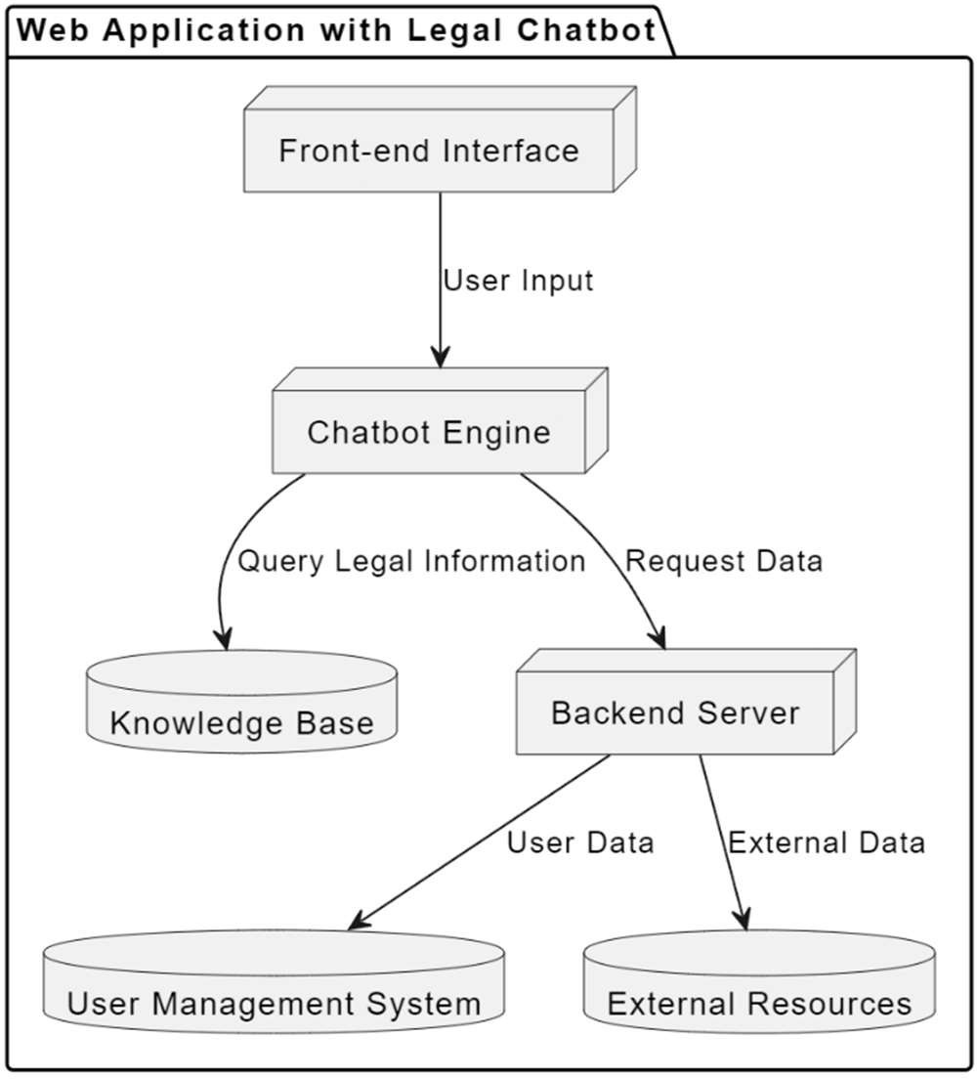
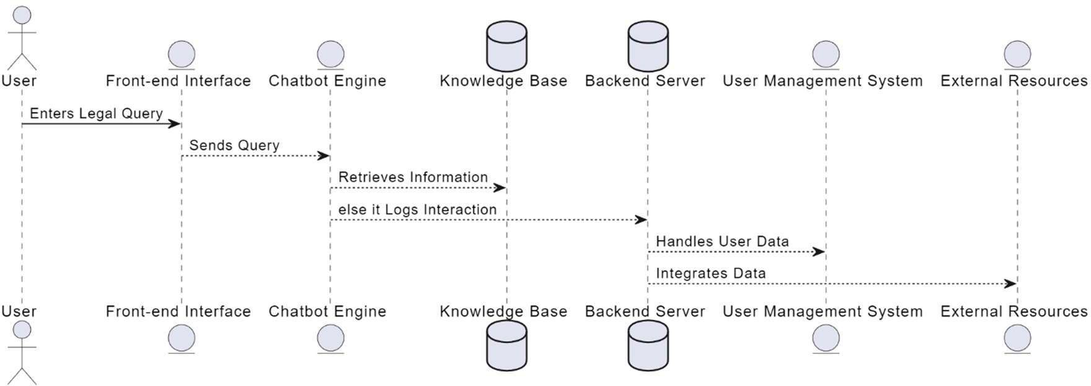
Secondly, the chatbot determines the user’s intention, which is very important for proper personalization of the answers. To do so, the algorithm uses NLP techniques; it may use word embeddings or BERT, to identify specific legal intent, such as, definition, clarification, or seeking advice. The outcome of intent detection is then further refined by using contextual clues and domain-specific legal terms within the query. For example, if the user uses words such as ‘define’ or ‘meaning’ then it could mean the user wants definition or meaning definition of a word whereas if the user uses word such as ‘advice’ or ‘recommendation’, it could mean the user wants to know advise to take legal action.
Fig. 1 System Architecture of LegalChat

Once the specification of the intent is gained, the algorithm identifies legal terms from the query. This is done through a match that must be made between the user input and a previous data set of legal terminology. Keywords related to the query are underlined so that in reference section, the system can match them with the area of laws like family laws, criminal laws or civil rights laws. This association is important as it takes a shorter time to search the relevant subset of legal data out of the database, and hence more relevant answers.
Since the query has become more refined, the algorithm searches the backend legal database for answers most related to the query of the user. Organizes these responses according to their relevancy and theses true positiveness based on the previous feedbacks to be used for priority of this kind of responses. This will reduce scenarios that the query is vague or could be associated with other branch of law the system will ask the user to complete the statement, a way of ensuring the user gets information that is relevant to his needs.
Once a response has been generated, the chatbot customizes it in simple non-technical language, with further clarifications if necessary. This means that despite the fact that people accessing the information provided may not necessarily be lawyers, they will be in a position to comprehend the information well. The response generated by the chatbot is also structured properly to make it professional and fully reliable, for it is dealing with legal information that tends to be replicated in a more precise and clear manner as compared to most chatbot generated texts.
Fig. 2 Flow Diagram of the Algorithm

Last, but not the least, the system records all the occurring communication records including questions a user poses, answers a system delivers, and feedback a user may offer. This data is constantly used to feed the knowledge base, enhance response effectiveness, and redact the NLP algorithms used. Because this data will be accumulated over time, the algorithm can further refine its performance in response to the nature of user’s inquiries and expand the set of possible legal questions that the chat-bot can provide accurate answer to.
By so doing, the algorithm is expected to tackle all the different legal queries that may be posed to the users and the latter is therefore provided with proper legal advice. Therefore it seeks to help improve users’ legal awareness through the demystification of legal terminology, increased dissemination of legal information and a more informed society.
III. Experiment and Result
The purpose of the performed experiment was to determine how effectively the legal chatbot can capture the given user queries, can respond with the appropriate legal information and to what extent it can engage the user. To achieve these objectives, the testing phase was designed to encompass several key areas: It is evidenced in the degree of intent recognition, response accuracy, degree of user interaction, and finally, user satisfaction. This includes critical features to execute ‘smart’ card inquiries and suggestion of corresponding services based on given options/concerns, analysis of each feature was conducted to reveal chatbot’s strengths and weaknesses.
The first part of the experiment aimed at intent recognition which is fundamental for correct query identification by the chatbot. Thus, we compiled a list of 100 sample inquiries to include queries of different types, including factual ones, procedural, and some about particular cases, the nature of legal services, and legal terminology and concepts. In order to generate this dataset, an attempt was made to have data that resembled interactions a real user would have with the chatbot. According to the outcomes of the intent recognition test, the chatbot was able to distinguish the user intent in 88% of the tested cases. The system has a problem with questions that could be considered as ambiguous or with combined characteristics with explanation of the legal terms. To facilitate this, the chatbot applied a pre-trained NLP model namely BERT (Bidirectional Encoder Representations from Transformers) that noted to have improved competence to edge out slightest differences in user’s intention. Advanced model was even more important to provide precise answers and refine the chatbot’s perception of highly specialized legal terminology.
After the intent recognition test a new test was conducted to assess the correctness of the chatbot’s answers. Therefore, a dataset of 200 legal questions was compiled that encompass important fields of law: family law, criminal law, civil rights, and property rights. Every question was designed in a way that may be specific questions that users may ask when using the service. The effectiveness of these replied generated by the chatbot was then measured by comparing them with accurate legal sources, including legal compendiums and online legal databases. The findings showed that regarding the information accuracy provided by the chatbot it was 85% adequate proving that the chatbot performs well. Nonetheless, common errors were mostly associated either with excessive legalism or with the presence of ambiguous questions. For instance, where users asked questions that needed some context, the chatbot sometimes provided wrong data or explanations. To these I have added attributes which have served to underscore the need for constant fine-tuning of the chatbot with regards to the way in which it interprets and handles complex legal language.
In order to evaluate the system in terms of the overall customer satisfaction, the number of questions answered by the chatbot, scales were given to the participants who went through the system during the experimental phase. They were also asked to rate the experiences based on tasks’ convenience, response clarity and perceived utility of delivered information. The online survey received responses from a hundred and fifty users on the use of the legal chatbot, of which ninety percent of the respondents said the use of the chatbot was easy and they found the information provided useful in grasping legal ideas. Specifically, the users liked the considered interface and being able to converse with the chatbot in an ordinary English, as well as the ability of the chatbot to explain rather complicated legal terms as if to a child. Such feedback evidences the benefits of the chatbot for those people who need legal guidance and would like to know their rights.
Besides that, the experiment involved a monitoring of the frequency and kind of user interactions performed during the experiment. Quantitative measurements that were collected and analyzed include the average length of time users spent on the interface, the number of queries made in every session, and the number of users who stayed to continue using the interface after an initial session. The findings showed that the average interaction amount of time is about 8 minutes, although the amount of questions per session averages 4-5. This level of activity indicates that users considered the chatbot as a useful means of receiving legal information and in achieving this goal were interested in different aspects of the law during a conversation.
To sum up, the proposed experiment result show that the legal chatbot can recognize the user intent correctly and further provide the correct legal information. That said, there is room for improvement in particular tasks which require the handling of more complex and ambiguous queries which need to be refined; nonetheless, the high levels of user satisfaction and levels of engagement suggest that this project does represent a major step toward increasing legal literacy and increasing the avenues through which people can access the law. Subsequent versions will build upon what has been described which includes improving the NLP, enlarging the database of legal information, and increasing the chatbot ease-of-use to better assist users in their legal processes.

IV.CONCLUSION
The creation and essence of the legal chatbot are a step forward in the popularization and demystification of legal information. Apart from using innovations like Natural Language Processing (NLP), the chatbot makes it easier for users to access legal advice based on simple language and proper explanation of legal terminologies for various fields of law. The experiments and outcomes presented for the project show that chatbot is proficient in addressing the user’s requests and providing relevant answers with the intent recognition success percentage of 88 and the overall response accuracy of 85 percentages.

From the results, it can be seen that there is recognition of the need for the chatbot to continue the sharing of legal knowledge, as 90% of the participants answered positively when asked about the ease of use of the chatbot combined with its clear responses. Such a response shows that self-efficacy in legal affairs could be boosted by the use of the present chatbot to a great extent. In addition, looking at the total activity time and the number of messages shown that users of the chatbot are engaged and interested in the topic and knowledge regarding it.

In its conclusion, the project also found some suggestions for improvement, such as dealing with multiple questions at once and the ability to place the chatbot in context. Future enhancements will attend to improving its NLP, adding more case laws and using more sophisticated methods to offer even more relevant and beneficial responses to its users.

Thus, this project shows that it is possible to incorporate technology to enhance teaching of and in legal education and awareness so that members of the public are equipped with appropriate tools in addressing the legal issues. As the tool helps improve people’s knowledge of laws, the chatbot is not only a tool of empowering individuals, but also making justice in the society. As the project grows, it has the potential to develop, into a one-stop-shop for anyone in search of improving their legal skills, and who may need to interact with the mass amount of legal content out there.

V. REFERENCE
- National Legal Services Authority (2017) - Promoting Legal Aid and Access to Justice

- Fagan, J. (2009) - Legal Knowledge and Access to Justice

- Arruda, A. (2017) - Chatbots: A Beginner's Guide for Lawyers

- Vazquez, E., & Shum, A. (2020) - Legal Chatbots: An Overview of Emerging Technology in Law

- Ashley, K. D. (2017) - Artificial Intelligence and Legal Analytics: New Tools for Law Practice in the Digital Age

- Gramatikov, M., & Porter, R. B. (2011) - Legal Needs and Legal Literacy in the EU: A Survey Study in Bulgaria, Lithuania, and Romania

- Patel, P., & Sen, A. (2020) - Legal Literacy: A Comparative Study of Urban and Rural Populations

