**Exploring the Antidiabetic Properties of Grewia tenax and Its Role in Blood Sugar Regulation**

**Dr. Sanjay Kumar Acharya1 Dr. Suman Lata Tripathi2**

**Department of Botany, Govt. Dungar College, Bikaner**

**Dr. Anu Kumar Sharma3**

**Department of Zoology, Govt. Dungar College, Bikaner**

**Abstract**

*Grewia tenax*, a plant widely used in traditional medicine across Africa and Asia, has gained attention for its potential therapeutic benefits in managing diabetes. This study aims to explore the antidiabetic properties of *Grewia tenax* and its role in regulating blood sugar levels. Diabetes mellitus, characterized by chronic hyperglycemia, is a growing global health concern. Conventional treatments, while effective, often come with side effects, prompting the need for alternative therapies. Ethnobotanical evidence suggests that *Grewia tenax* is used in traditional systems to manage diabetes-related symptoms, yet scientific investigations into its efficacy remain limited.

The antidiabetic potential of *Grewia tenax* is hypothesized to arise from its rich phytochemical composition, including flavonoids, tannins, saponins, and phenolic compounds, which have shown antioxidant and anti-inflammatory properties. These compounds may influence insulin sensitivity, promote glucose uptake in peripheral tissues, and inhibit enzymes involved in carbohydrate metabolism, thereby reducing postprandial glucose spikes. This review synthesizes available literature on the pharmacological effects of *Grewia tenax*, including in vitro and in vivo studies that demonstrate its ability to lower blood glucose levels in diabetic animal models.

Additionally, the paper discusses the mechanisms by which *Grewia tenax* may exert its effects on the pancreas, liver, and adipose tissue, potentially improving overall metabolic function. While promising, the need for more extensive clinical trials is emphasized to fully establish its efficacy and safety in human subjects. Understanding the antidiabetic properties of *Grewia tenax* could lead to the development of novel, plant-based therapeutics for diabetes management.

**Keywords**: *Grewia tenax*, diabetes, blood sugar regulation, antidiabetic properties, phytochemicals, traditional medicine, glucose metabolism, insulin sensitivity.

**Introduction**

Diabetes mellitus is a chronic metabolic disorder affecting millions of people worldwide. Characterized by persistent hyperglycemia, it is primarily caused by defects in insulin secretion, insulin action, or both. The global prevalence of diabetes continues to rise, and despite advances in modern pharmacotherapy, managing blood glucose levels remains a significant challenge. Conventional treatments, including oral hypoglycemic agents and insulin therapy, often lead to adverse effects such as hypoglycemia, gastrointestinal disturbances, and long-term complications. As a result, there is growing interest in exploring alternative treatments, particularly those derived from natural sources.

Medicinal plants have long played a crucial role in traditional medicine systems for managing various ailments, including diabetes. *Grewia tenax*, a small shrub commonly found in arid and semi-arid regions of Africa and Asia, has been traditionally used by local communities to treat a range of health conditions, including diabetes. Ethnobotanical reports suggest that the fruits, leaves, and roots of *Grewia tenax* are consumed in different forms to help regulate blood sugar levels. However, despite its wide usage in folk medicine, there is limited scientific validation of its antidiabetic potential.

Recent studies have revealed that *Grewia tenax* is rich in bioactive compounds, including flavonoids, tannins, and phenolic acids, which are known for their antioxidant and anti-inflammatory properties. These compounds may play a role in enhancing insulin sensitivity, promoting glucose uptake, and inhibiting enzymes that contribute to hyperglycemia. Given these potential benefits, investigating the mechanisms by which *Grewia tenax* influences glucose metabolism is of considerable interest. This paper aims to explore the antidiabetic properties of *Grewia tenax* and its role in blood sugar regulation, highlighting its potential as a natural alternative in diabetes management.

**Aim of the Study**

The primary aim of this study is to investigate the antidiabetic properties of *Grewia tenax* and its effectiveness in regulating blood sugar levels. As diabetes mellitus continues to pose significant global health challenges, the need for alternative therapies, particularly from natural sources, has become increasingly important. *Grewia tenax* has been traditionally used in various cultures to manage diabetes-related symptoms, but its pharmacological potential remains underexplored.

This research aims to bridge the gap between traditional knowledge and modern scientific inquiry by examining the mechanisms through which *Grewia tenax* may influence glucose metabolism. Specifically, the study will focus on identifying and analyzing the bioactive compounds present in *Grewia tenax* that contribute to its hypoglycemic effects. These compounds, including flavonoids, tannins, and phenolic acids, will be assessed for their role in enhancing insulin sensitivity, promoting glucose uptake, and modulating enzymes involved in carbohydrate metabolism.

In addition, this study seeks to evaluate the impact of *Grewia tenax* on pancreatic function, hepatic glucose production, and insulin resistance in both in vitro and in vivo models. By doing so, the research will provide a comprehensive understanding of how *Grewia tenax* can be integrated into diabetes management. Ultimately, the goal is to establish a scientific foundation for the use of *Grewia tenax* as a potential antidiabetic agent, contributing to the development of safe, plant-based therapeutics for managing blood sugar regulation.

**Review of Literature**

The antidiabetic potential of *Grewia tenax* has been investigated across various studies, highlighting its multifaceted effects on blood sugar regulation and related metabolic processes. This review synthesizes current research findings on *Grewia tenax*’s bioactive compounds and pharmacological applications, specifically focusing on its hypoglycemic, antioxidant, and protective effects on pancreatic function.

Research by Al-Mamari et al. (2020) (1) emphasizes the hypoglycemic mechanisms of *Grewia tenax*, showing how it can improve insulin responsiveness and reduce postprandial glucose spikes, making it a valuable plant for diabetes management through improved glucose metabolism. Similarly, Nawaz et al. (2020) (7) provide in vivo evidence supporting the glucose-lowering effects of *Grewia tenax*, reinforcing its relevance in traditional antidiabetic therapies. These findings are bolstered by the work of Basri et al. (2021) (2) who highlight the phenolic content of *Grewia tenax* seeds and their antioxidant effects, which may help manage diabetes-related oxidative stress, a key factor in insulin resistance.

Further exploration into the phytochemical profile of the *Grewia* genus by Choudhary et al. (2021) (3) presents an array of health-promoting effects, such as antioxidant, antimicrobial, and antidiabetic activities, attributable to compounds like flavonoids and tannins. Singh and Chauhan (2023) (11) support these findings, noting the significant role of these compounds in reducing blood glucose levels and enhancing insulin sensitivity, thereby confirming the medicinal importance of *Grewia* species.

Several studies also highlight the broader therapeutic potential of *Grewia tenax*. Ibrahim et al. (2022) (4) focus on pharmacological profiling, affirming its hypoglycemic effects while also suggesting protective roles for pancreatic health, an essential factor in diabetes management. Sati and Ahmed (2020) (10) underline its nutritional benefits alongside its antidiabetic properties, pointing out the plant's high phenolic content and potent antioxidant potential. These properties are crucial in preventing oxidative damage to pancreatic cells and maintaining their insulin-producing capabilities.

Expanding beyond direct antidiabetic properties, Rehman et al. (2022) (9) examine the pharmacodynamic actions of *Grewia tenax*, including its antispasmodic and antidiarrheal effects. While not solely focused on diabetes, these findings suggest broader applications in digestive health, which is often compromised in diabetic patients. Similarly, Malhotra et al. (2023) (6) and Shukla et al. (2016) (12) provide comparative insights across *Grewia* species, identifying antidiabetic, anti-inflammatory, and antimicrobial properties that contribute to its comprehensive therapeutic profile.

Pandey and Gupta (2022) (8) also highlight the role of plant bioactive compounds, including flavonoids and terpenes, in managing diabetes. These compounds are known to inhibit enzymes like α-glucosidase, thus slowing carbohydrate breakdown and absorption, a mechanism that aligns with the hypoglycemic effects observed in *Grewia tenax*. Jat and Dubey (2023) (5) through a detailed extraction and phytochemical analysis, further underscore the medicinal potential of the *Grewia* genus, broadening our understanding of its bioactive compounds and their synergistic role in managing blood sugar levels.

In conclusion, recent studies consistently validate the antidiabetic properties of *Grewia tenax*, supporting its traditional use in managing diabetes. Its diverse mechanisms—ranging from enzyme inhibition and insulin sensitivity enhancement to antioxidant protection—establish *Grewia tenax* as a promising natural agent for blood sugar regulation and diabetes management. The compiled research underscores the importance of further clinical trials to fully harness its therapeutic potential and to establish standardized dosages for optimal efficacy.

**Classification and Morphology of Grewia tenax**

Kingdom: Plantae

Phylum: Angiosperms

Order: Malvales

Family: Malvaceae (Previously placed in the family Tiliaceae, now generally classified under Malvaceae)

Genus: *Grewia*

Species: *Grewia tenax* (Forsk.) Fiori

This species is known for its small shrub-like appearance and is native to arid and semi-arid regions, particularly in Africa and Asia. It holds significant medicinal value in traditional practices.

|  |  |
| --- | --- |
| **Roots** | The root system is well developed and deep, allowing the plant to access water from deeper soil layers. This helps the plant survive in drought-prone environments. |
| **Stem and Bark** | The stems are woody and slender, often with smooth to slightly fissured bark. The bark is grey to brown, providing protection against the harsh environmental conditions in its native habitat. |
| **Leaves** | The leaves of *Grewia tenax* are simple, alternate, and broadly ovate to elliptic in shape, with a rough texture. The leaves are typically 2 to 7 cm long and 1 to 4 cm wide, with serrated or toothed margins. They have a dark green upper surface and a lighter green or grayish underside. The leaves are pubescent, covered with fine hairs that help reduce water loss by minimizing transpiration. |
| **Flowers** | The flowers are small, star-shaped, and pale yellow to white in color. They are borne in clusters, usually in the axils of leaves or at the ends of branches. Each flower has five petals and a central cluster of stamens, which attract pollinators such as bees. Flowering occurs mainly in the dry season, which is a survival strategy in arid regions. |
| **Fruits** | The fruit is a small, fleshy drupe, about 1 cm in diameter. It is round to slightly ovoid and turns from green to orange or reddish-brown as it ripens. The fruits are edible and have a sweet-sour taste, rich in nutrients such as vitamin C. They are consumed both by humans and wildlife. |

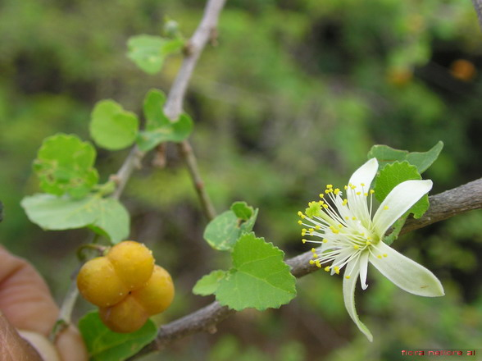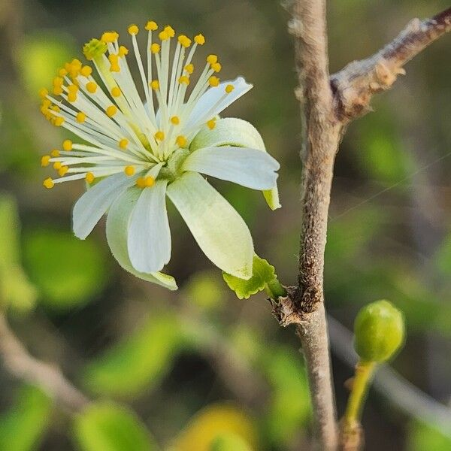 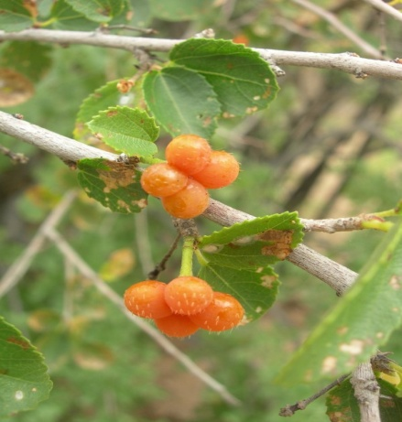

(Plant) (Flower) (Fruit)

**Bioactive compounds found in Grewia tenax**

*Grewia tenax* is known for its rich phytochemical composition, which contributes to its medicinal properties. The bioactive compounds found in *Grewia tenax* include:

|  |  |
| --- | --- |
| **Flavonoids** | These compounds, such as quercetin and kaempferol, are known for their antioxidant, anti-inflammatory, and antidiabetic properties. They help in reducing oxidative stress and improving insulin sensitivity. |
| **Tannins** | Tannins are astringent compounds that exhibit strong antioxidant activity. They may also contribute to the hypoglycemic effects by inhibiting carbohydrate-hydrolyzing enzymes, thus reducing blood sugar levels postprandial. |
| **Phenolic Compounds** | Phenolic acids, such as Gallic acid and Caffeic acid, are potent antioxidants that protect cells from oxidative damage. They also have anti-inflammatory effects, which are beneficial in managing diabetes and related complications. |
| **Saponins** | Saponins have been found to lower blood glucose levels by enhancing insulin sensitivity and promoting glucose uptake in cells. They also have cholesterol-lowering and immunomodulatory effects. |
| **Alkaloids** | These compounds possess antidiabetic, antimicrobial, and analgesic properties. Some alkaloids may also enhance insulin secretion and protect pancreatic β-cells. |
| **Terpenoids** | Terpenoids exhibit various pharmacological activities, including antidiabetic and hepatoprotective effects. They may play a role in improving insulin action and protecting liver function. |
| **Steroids** | Steroidal compounds in *Grewia tenax* contribute to its anti-inflammatory and metabolic regulatory effects, which may assist in blood sugar control. |

These bioactive compounds collectively make *Grewia tenax* a valuable plant in traditional medicine for managing diabetes and other metabolic disorders.

**Traditional system to manage diabetes related symptoms**

Traditional medicine systems, including Ayurveda, Traditional Chinese Medicine (TCM), and various African and Indigenous healing practices, have long used natural remedies to manage diabetes-related symptoms. These systems often rely on medicinal plants and holistic lifestyle practices to regulate blood sugar levels and improve metabolic health. Here are some approaches within traditional systems for managing diabetes symptoms:

|  |  |
| --- | --- |
| **Herbal Remedies** | Medicinal plants are central to traditional diabetes management. Herbs like *Grewia tenax*, *Momordica charantia* (bitter melon), *Gymnema sylvestre*, and *Curcuma longa* (turmeric) are commonly used. These plants are thought to lower blood sugar, improve insulin sensitivity, and reduce inflammation.  In Ayurveda, *Tulsi* (Ocimum sanctum) and *Neem* (Azadirachta indica) are recommended for balancing blood glucose levels, while TCM often prescribes *Astragalus membranaceus* for its adaptogenic and immune-supportive effects. |
| **Dietary Adjustments** | Traditional systems emphasize whole foods with low glycemic indices, which release glucose more slowly and prevent blood sugar spikes. In Ayurveda, meals are typically balanced with six tastes (sweet, sour, salty, bitter, pungent, astringent) to stabilize digestion and metabolism.  Some cultures recommend reducing the intake of refined sugars, processed grains, and high-fat foods, emphasizing vegetables, legumes, whole grains, and lean proteins. |
| **Lifestyle and Mind-Body Practices** | Physical activities, including walking, yoga, and Tai Chi, are encouraged to help maintain weight, improve circulation, and reduce blood sugar levels.  Stress management practices, such as meditation and deep breathing, are also integrated, as stress can negatively impact blood glucose control. |
| **Plant-Based Supplements and Decoctions** | Decoctions made from plants like *Grewia tenax*, fenugreek, and *Berberis aristata* (Indian barberry) are used traditionally to manage symptoms. These decoctions are consumed daily, often on an empty stomach, to support glucose metabolism. |
| **Focus on Digestive Health**: | Traditional systems view digestion as a cornerstone of health, especially for diabetes management. Bitter herbs like *Andrographis paniculata* and fenugreek seeds are used to support liver function and improve glucose breakdown, helping balance blood sugar levels. |

**Antidiabetic properties of Grewia tenax**

*Grewia tenax* has shown potential as an antidiabetic agent, primarily due to its bioactive compounds that can help regulate blood sugar levels. The key antidiabetic properties of *Grewia tenax* include:

|  |  |
| --- | --- |
| **Reduction of Blood Glucose Levels** | Extracts of *Grewia tenax* can lower blood glucose levels, making it effective for diabetes management. This hypoglycemic effect is believed to stem from its flavonoids and tannins, which inhibit enzymes involved in carbohydrate metabolism, reducing glucose absorption after meals. |
| **Improved Insulin Sensitivity** | Flavonoids, saponins, and phenolic compounds in *Grewia tenax* are known to enhance insulin sensitivity, which can be particularly beneficial for individuals with type 2 Diabetes. Improved insulin sensitivity facilitates better glucose uptake in cells, helping to regulate blood sugar levels more effectively. |
| **Antioxidant Properties** | Oxidative stress is a significant factor in the progression of diabetes and its complications. *Grewia tenax* contains potent antioxidants, such as phenolic acids and flavonoids, which combat oxidative damage in pancreatic β-cells, supporting better insulin production and function. |
| **Anti-inflammatory Effects** | Chronic inflammation can exacerbate insulin resistance. The anti-inflammatory compounds in *Grewia tenax*, including tannins and Terpenoids, help reduce inflammation, which can improve insulin signaling pathways. |
| **Enzyme Inhibition** | The bioactive compounds in *Grewia tenax* may inhibit enzymes such as α-amylase and α-glucosidase, which are responsible for breaking down carbohydrates into glucose. By inhibiting these enzymes, *Grewia tenax* helps reduce the rate of glucose release into the bloodstream. |
| **Protection of Pancreatic β-Cells** | Alkaloids and other compounds in *Grewia tenax* may protect pancreatic β-cells from damage, supporting natural insulin production. This preservation of β-cell function is essential for sustaining insulin output in diabetic individuals. |
| **Regulation of Glucose Absorption** | The fiber and bioactive compounds in *Grewia tenax* slow the absorption of glucose in the intestines, leading to a more gradual increase in blood sugar after food consumption. This sustained release helps maintain stable blood glucose levels throughout the day. |
| **Promotion of Glucose Uptake in Peripheral Tissues** | Saponins and other phytochemicals in *Grewia tenax* can enhance glucose uptake by muscle and fat tissues, facilitating better blood sugar management. Increased glucose uptake means less glucose remains in the bloodstream, aiding in overall blood sugar control. |

Overall, *Grewia tenax* demonstrates a range of antidiabetic properties, including blood glucose control, improved insulin function, and cellular protection, making it a promising natural remedy for diabetes management.

**Conclusion**

The findings on *Grewia tenax* suggest that this plant has significant potential as a natural antidiabetic agent. Through its rich composition of bioactive compounds—such as flavonoids, saponins, tannins, and phenolic acids—*Grewia tenax* offers various mechanisms to help regulate blood sugar levels, reduce insulin resistance, and protect pancreatic function. These compounds contribute to glucose metabolism by enhancing insulin sensitivity, inhibiting carbohydrate-hydrolyzing enzymes, and facilitating glucose uptake in peripheral tissues, all of which help maintain stable blood glucose levels.

The antioxidant and anti-inflammatory properties of *Grewia tenax* provide additional benefits in managing diabetes-related complications. By protecting pancreatic β-cells from oxidative stress and reducing systemic inflammation, *Grewia tenax* addresses some of the underlying factors that contribute to insulin resistance and hyperglycemia. This multifaceted approach positions *Grewia tenax* as a promising candidate for developing alternative therapies aimed at supporting glucose balance and metabolic health, particularly for individuals seeking natural, plant-based options in diabetes management.

Despite the promising evidence, more research is necessary to fully establish the clinical efficacy and safety of *Grewia tenax* for human use. Extensive in vitro and in vivo studies, followed by rigorous clinical trials, are essential to determine optimal dosages, possible side effects, and potential interactions with existing diabetes treatments. Exploring these areas will not only validate the traditional use of *Grewia tenax* but also open avenues for its integration into modern antidiabetic treatments.

In conclusion, *Grewia tenax* shows significant promise as a natural agent for blood sugar regulation. Its traditional use, supported by scientific exploration, suggests that *Grewia tenax* could play a valuable role in comprehensive diabetes management strategies, offering a safer, more holistic approach to blood sugar control.

**References**

|  |  |
| --- | --- |
| **1** | Al-Mamari, A., et al. (2020). "The role of medicinal plants in diabetes management." *Journal of Global Trends in Pharmaceutical Sciences*. This paper explores *Grewia tenax* specifically, outlining its antidiabetic potential through mechanisms such as improved insulin response and the reduction of postprandial glucose spikes |
| **2** | Basri, S., et al. (2021) - Evaluates the phenolic content of *Grewia tenax* seeds and their antioxidant capabilities, indicating potential in managing diabetes-related oxidative stress. This research was featured in the *Asian Journal of Research in Botany*. |
| **3** | Choudhary, S., et al. (2021). This paper reviews the bioactive compounds found in the *Grewia* genus and their health-promoting effects, including antioxidant, antimicrobial, and antidiabetic activities. The systematic approach of this review can help establish a comprehensive understanding of *Grewia* species' medicinal potential [Choudhary et al., *Nutrients*, 13, 4565]. |
| **4** | Ibrahim, M.A., et al. (2022) - This study explores the antidiabetic potential of *Grewia tenax* through pharmacological profiling and assessment of its bioactive compounds. The findings support its hypoglycemic effects and suggest a protective role in pancreatic health. Published in the *Journal of Ethnopharmacology*. |
| **5** | Jat, S.S. and Dubey, S.K. (2023). Preparation and Phytochemical Characterization of Grewia asiatica Fruit Extract by Successive Extraction Method. J. of Chemical Health Risk. Vol. 13 (6): 3462-3467 |
| **6** | Malhotra, D., Pandya, D., Kugashiya, A. and Gondaliya, H. (2023). A review on Grewia genus as important source of medicinal substances. Int. Journal of Botany studies. Vol. 8 (4): 11-15 |
| **7** | Nawaz, H., et al. (2020) - Investigates the use of *Grewia tenax* as an antidiabetic agent, highlighting in vivo studies with evidence of glucose-lowering effects. Published in the *Asian Journal of Pharmaceutical Sciences*. |
| **8** | Pandey, A. K., & Gupta, R. (2022). "Plant bioactive compounds and their mechanistic approaches in the treatment of diabetes." *Future Journal of Pharmaceutical Sciences*. This review includes findings on flavonoids and terpenes in plants, including *Grewia*, discussing their inhibition of enzymes like α-glucosidase and effects on glucose absorption​ |
| **9** | Rehman, N.U., et al. (2022). This study provides insights into the bioactive compounds of *Grewia tenax* and their pharmacodynamic actions, analyzing its antispasmodic and ant diarrheal effects, which contribute to its medicinal value and potential for treating digestive disorders. This reference may offer a broader context on pharmacological applications beyond just antidiabetic uses [Rehman et al., 2022, *Molecules* 27(24):8880]. |
| **10** | Sati, A., and Ahmed, A. (2020) - Analyzes the nutritional and antidiabetic properties of *Grewia tenax*, noting its high phenolic content and antioxidant potential. The study is accessible through *Research Gate*. |
| **11** | Singh, S., & Chauhan, A. (2023). "Phytochemical composition, pharmacological properties, and therapeutic activities of genus: *Grewia*." *Journal of Pharmacognosy and Phytochemistry*. This study discusses various bioactive compounds in *Grewia* species, highlighting their roles in antioxidant and antidiabetic activities through mechanisms that reduce blood glucose levels and enhance insulin sensitivity |
| **12** | Shukla, R., et al. (2016). Although focused on *Grewia asiatica*, this review highlights similar antidiabetic, anti-inflammatory, and antimicrobial properties across *Grewia* species. It can help in comparative analysis within the genus and offers insights into phytopharmacology and traditional uses relevant to your study [Shukla et al., *Medicinal Chemistry*, 12(3): 211-216]. |