**Name - Hatim Shabbir Merchant**

**H. R. College of Commerce & Economics**

**HSNC UNIVERSITY, Mumbai.**

**Topic -**

**ESTABLISHMENT OF STARTUPS IN INDIA**

***Abstract:***

*The goals of a startup are to be your own boss and give others employment that requires a lot of perseverance and sacrifice. Many people dream of starting and running their own business at some point in their lives. For many people, creating a product or service that customers enjoy or use is a very satisfying sense of accomplishment. The idea behind the company, market size, sales and profit goals are some of the important factors that need to be clearly defined before starting the journey. Starting a business takes more than an idea. It takes certain types of people and the right planning. It takes money and hard work. This research paper discusses how a person wants to start a business and some issues and challenges faced by an Indian startup. This research will further describe the things that are fundamental to starting your own business.*

***Keywords:*** *startup, business, challenges, capital, entrepreneur*

**Introduction:**

A start-up business can be defined as a new business that is in the early stages of operations, beginning to grow, and is usually funded by an individual or a small group of individuals. It takes certain types of people and good planning. It takes funding and hard work. Before a person even attempts to start a business, a person must decide if they have the personality and skills to be a successful entrepreneur. Start-ups are businesses focused on a single product or service that the founders want to market. According to The Complete Guide to Starting Your Own Business, if you like the stability of 9 to 5, wake up! Owning your own business means you work fixed hours because working almost around the clock to get things done is a true statement.

Starting a startup is a process and requires certain necessary things. Doing Business captures all the procedures officially required or commonly performed in practice for an entrepreneur to officially establish and operate an industry, or the minimum capital required. These procedures include obtaining all required licenses and permits and completing any required notices, verifications, or registrations for the company and the employees with the responsible authorities.

A business enterprise is an economic entity engaged in the production and/or distribution of goods and services for the purpose of making a profit and acquiring wealth. The field of activity of a company is very broad. It encompasses a large number of activities that can be grouped into two broad categories, namely industry and commerce. The production of goods falls under “Industry” and distribution under “Trade”. Every entrepreneur has the goal of starting a business and making it a successful venture. The term "entrepreneur" means seizing and pursuing opportunities and meeting people's needs and desires through innovation. He/she innovates and combines resources in the form of people, materials and money and brings them together to make the business profitable. Thus, innovation and risk are the two basic elements of good entrepreneurship. The entire process of starting a business begins with the creation of a business plan. A good business plan is the key to a successful business. Once a plan is in place, the entrepreneur faces various challenges in implementing the plan.

**Literature Review:**

India now contributes four percent to global GDP. Central government policies consider the collective aspirations and enterprise of risk-taking Indians to help them set up their businesses. In all business ideas play an important role; new companies can expand the spectrum. Some are unformed if we look at them in a commercial sense, where the business promoter focuses on an idea that he believes can fill an unmet need in consumers. In many other cases, promoters have pushed ahead to reach scale and turned the idea into a marketable product that has little to show for revenue.

The following is the literature review from various authors and various research scholars around the world –

Weiss: conducted a study in the US and concluded that small companies are generally less efficient compared to large management companies and concluded that on average about half of the total deliveries in the industries covered came from sub-optimal facilities originates.

Pratten: He found that sub-optimal scale operations accounted for 47.9% of all UK industry supplies.

Stiglitz and Weiss found that unlike other markets, the market for credit is exceptional, i.e., the price of the commodity and interest rates are not necessarily the same across the market.

Brown, Hamilton and Medoff: positive relationship found between employee compensation and firm size. This means lower compensation levels for small business employees.

Weiss: noted that the survival of any small business in any industry relies on the specialization of items with shorter production runs or certain niche segments, and therefore their relative market share.

**Objectives of the Study:**

* To understand the Concept of starting a new business.
* To study that doing a business in mixed economy like India is a good option or not.
* To study how to make that business a success & profitable.
* To study various challenges / obstacles that is been faced by the entrepreneur to start a new business.
* Market segmentation and Demand.
* Capital required for startups.
* The different challenges faced by the new business entrepreneur according to different sectors.
* To study the right technique and qualities to establish a successful startup in the market.

**Research Methodology:**

**1) Type of Research –** This is a Descriptive type of a research which mainly follows a quantitative method approach. This research includes a survey which was carried out through google forms.

**2) Sample Design –** The survey is carried out to definite people who have started a business recently or want to start a business soon.

**3) Sample Universe –** The survey is conducted only to students and startups in the city of Mumbai, India.

**4) Sample Size –** A total of 50 people took part in the survey conducted out of which 40 are students who want to start a business in future and 10 are people who already own a business.

**5) Method of Data Collection –** This research paper includes both **primary and secondary** sources of data. Primary source includes the survey carried out through a google form. The secondary source includes books, published research on google scholar, senior research papers and internet articles.

**Results & Discussions:**

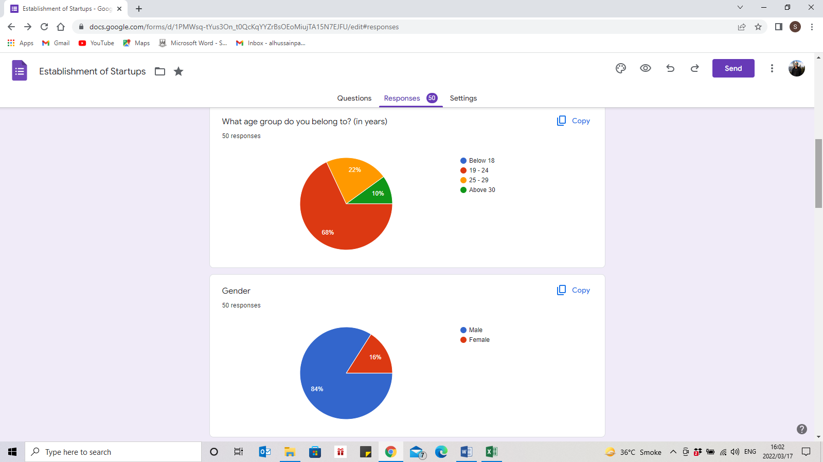

Pie Chart 1

It is observed that out of the 50 respondents 16% were females and the rest 84% were male.

Pie Chart 2

The respondents belonged to a diverse age category. The maximum belonged to age 19-24 accounting to 68%. Approximately 22 % people belonged to age 25-29 & only 10% of the respondents belonged to age group above 30.

Pie Chart 3

Most of the respondents think that business is a better source of income and livelihood than service sector. To be precise only 7 out of 50 prefer service sector but might want to change to business in the future.

Most of the aspiring entrepreneurs are still pursuing education and are undergraduates.

The grey bar shows the post graduated people who have already established their startups or are in the process of starting.

le who have already establishedve already establishes their startups or are in the process of starting.

In the above bar diagram, it is observed that out of the 50 respondents, there are equal number of people who believe that manufacturing and retail business are the most efficient and profitable startups. 13 respondents prefer wholesale business above the other 3 types and only 5 out of the 50 respondents want to establish an export/import business.

It is observed and deduced by that the responses and the study that for a startup to be establishes in the market and be successful a minimum of **2 to 4 years** is required.

While starting a business the first thing that comes to mind is the capital required. But as per the results it is easily deduced that capital is not the most important part to start a business. It is seen that 18 people are with a neutral mind which shows that it’s neither the most important nor it can be neglected completely. 16 and 2 respondents strongly disagree and disagree respectively to the above statement. Likewise, 8 and 7 people strongly agree and agree respectively that capital is indeed the most important part of establishing a startup.

With the help of the above bar diagram, it shows that maximum precisely 22 people believe that a strong management is important for a business to be a successful one. A strong marketing technique is the next closest requirement which also has 14 responses.

A business does indeed require demand or customers who buy their product, out of the 50 people, it is observed that 9 people think that a strong market demand would guarantee the best outcome for a startup.

And lastly 6 respondents feel that a strong capital is required to make a startup strong and guarantee a success. It is also seen that these people are somewhat the same respondents who believed that capital is the most important part of a startup as shown in the above diagram.

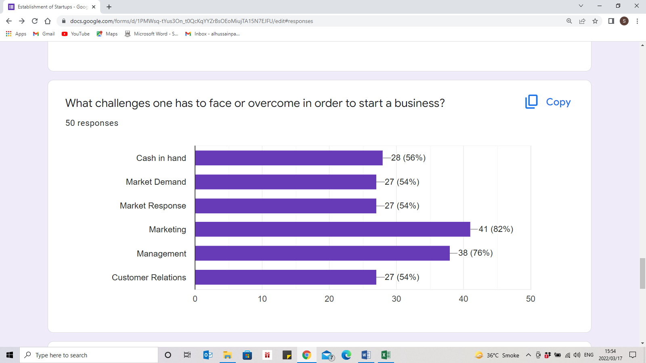

Challenges are the most important and the most difficult part of a startup or a business. According to the collected data, 54% of the people are facing challenges or need to overcome in future - market demand, market response & customer relations to establish their business and run their business efficiently once it is established.

A total of 56% respondents believes that the cash in hand is also an important factor to run a business as it allows the regular cash flow and operations easily. It is important to manage the cash available in the business efficiently and appropriately.

Management and Marketing are the major challenges one must overcome and face.

Almost all respondents believe that marketing game should be quite strong and that would help them overcome the competitors.

82% and 76% people find marketing and management the most challenging part of their entrepreneurship journey.

**Conclusion:**

Starting a new business can be very difficult in the current market environment. In India as well as abroad many people aspire to start their own business every day. The competition in the market is intense and one needs to be fully dedicated and committed to their business for it to thrive. According to my findings, it is seen that manufacturing and retail are the best type of businesses one can establish efficiently in the current market. Although manufacturing segment would require large capital amounts as respect to the retail segment, but it also promises better outcomes and more profits. It is observed that most of the people today believe that business is better than service and in all different demographics as well. Be it a male or a female, a 19-year-old or a 30+ year old person, everyone finds business a better source of income and livelihood with freedom. Further it is also observed that capital might seem the most important part of starting a new business, but according to businessman and the already entrepreneurs who responded it is indeed not. Capital does play an important role, but in today’s market better marketing and management techniques can help do wonders in the newly established startups to boom in the economy. Market demand & response and customer relations need to be maintained at its peak to overcome the hurdles faced and compete with the highly competitive market leaders. Finally for a startup to be established in the market and be successful a minimum of 2 to 4 years is required.

Don't underestimate the challenges of doing business in India - bureaucracy, corruption, Chalta Hai attitude, non-paying corporate clients, slow and unpredictable government decisions. However, do not give in to corruption or bribery, they will only rob you of your time, energy and reputation. Act responsibly because the future of this country rests on your shoulders. Employ, encourage and empower women - look at how countries like China are also making progress because there are many women in the workforce.

**References:**

[www.wikihow.com/Start-Your-Own-Business](http://www.wikihow.com/Start-Your-Own-Business)

[www.ibef.org.aspx](http://www.ibef.org.aspx)

[www.cci.in/pdfs/surveys-reports/Textile-Industry-in-India.pdf](http://www.cci.in/pdfs/surveys-reports/Textile-Industry-in-India.pdf)

[www.newdevtprojects.com/ilo/iloPdf](http://www.newdevtprojects.com/ilo/iloPdf)

[www.business-standard.com/article/companies/113082200618_1.html](http://www.business-standard.com/article/companies/113082200618_1.html)

<http://www.thehindu.com/business/Industry/article4967192.ece>

[www.india-exports.com](http://www.india-exports.com)

From reference of other projects of seniors and student researchers.

<https://www.researchgate.net/publication/280007861_Startup_Companies_Life_Cycle_and_Challenges>

<https://www.researchgate.net/publication/323855305_INDIAN_STARTUPS-_ISSUES_CHALLENGES_AND_OPPORTUNITIES>

<https://www.investopedia.com/terms/s/startup.asp>