**SOCIAL MEDIA AND MENTAL HEALTH: A CRITICAL EXAMINATION OF THEIR RELATIONSHIP**

**Aanchal Ahuja**

Post Graduation Student, H. R. College, HSNC University, Mumbai, Maharashtra, India

**ABSTRACT**

This research explores how social media influences mental health, aiming to clarify the intricate relationships between online activity and psychological well-being. Through a combination of quantitative surveys and qualitative analyses, the study examines usage patterns of social media and their connections to mental health outcomes, such as anxiety, depression, and self-esteem issues. It pays special attention to factors like cyberbullying, stress from social comparison, and the potential positive effects of supportive online interactions. By investigating these dynamics, the research offers insights into the multifaceted impacts of social media on mental health, providing valuable information for mental health professionals, policymakers, and individuals navigating the online landscape. The findings contribute to ongoing discussions about responsible social media practices and suggest strategies for fostering a positive online environment that supports mental well-being.

**Keywords:** Analysis, research, Social Media, Mental Health, Anxiety, Depression, Cyberbullying, Social Comparison

**INTRODUCTION**

As of 2023, approximately 4.9 billion people globally use social media, with projections suggesting this number could rise to around 5.85 billion by 2027. The usage of social media among adolescents and teenagers has seen a remarkable increase, soaring from 12% in 2005 to 90% in 2022. A survey conducted in April 2020 highlighted a significant rise in social media use among Belgian individuals during lockdowns, as many turned to these platforms to cope with feelings of loss, social isolation, and anxiety. While social media can foster identity development and help maintain connections across distances, it can also negatively impact self-esteem and self-image. This adverse effect may arise from negative feedback, inadequate social validation, and unhealthy competitive dynamics. Therefore, it is crucial to address the increasing mental health concerns linked to heightened social media reliance and digitalization, prompting a thorough review of existing literature on this critical relationship.

1. **METHODOLOGY**

In crafting a study to explore the influence of social media on mental health, a meticulous methodology is imperative for deriving meaningful and dependable results. My considerations for the methodology and design encompass several crucial aspects:

**2.1 Research Approach:**

The research is based on a judicious choice between quantitative, qualitative, or mixed methods approaches aligned with my research objectives.

**2.2 Sampling:**

Defining my target population is pivotal, factoring in variables like age, gender, cultural background, and social media usage patterns. Employing random or stratified sampling methods ensures the representativeness of my chosen sample.

**2.3 Data Collection:**

My approach involves a blend of self-reporting through surveys and questionnaires and objective measures like social media analytics and behavioral observations. Collecting data at multiple time points enhances my ability to capture dynamic changes.

**2.4 Analysis Plan:**

I'll select appropriate statistical or qualitative analysis methods, tailoring my approach to the research design. This may involve regression analysis, correlation, thematic analysis, or grounded theory, depending on the nature of my study.

**2.5 Validity and Reliability:**

Implementing strategies to enhance validity and reliability is paramount. Piloting surveys, using established measures, and conducting interrater reliability checks for qualitative coding are integral to the process.

**2.6 Generalizability:**

Acknowledging the study's limitations and constraints is essential. I'll carefully weigh the generalizability of my findings to broader populations, recognizing the unique context of my study.

By meticulously addressing these considerations, I aim to conduct a comprehensive and rigorous exploration of the impact of social media on mental health, contributing valuable insights to the existing body of literature.

1. **MODELING AND ANALYSIS**
2. **Primary Data** I designed and implemented Google Forms to conduct my research on the Impact of social media on Mental Health. I successfully collected valuable data from 20 respondents, providing a foundation for my study's analysis and insights.

Forms response chart. Question title: Have you ever felt anxious or stressed while using social media?
. Number of responses: 20 responses.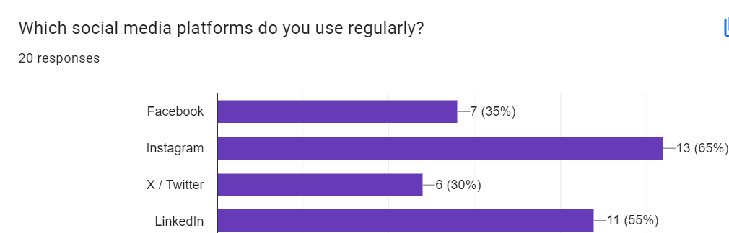Forms response chart. Question title: Do you find yourself comparing your life to others on social media?
. Number of responses: 20 responses.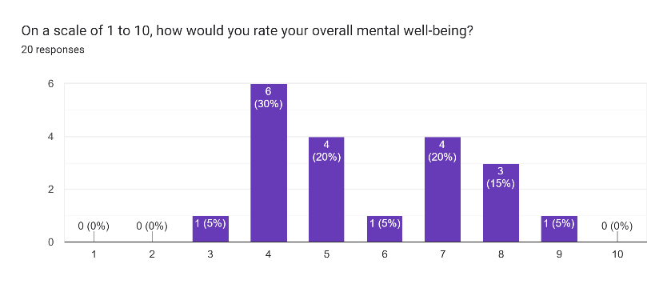Forms response chart. Question title: Has social media ever affected your self-esteem or body image?
. Number of responses: 20 responses.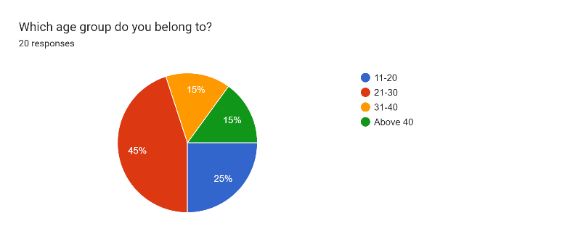Forms response chart. Question title: How many hours per day do you spend on social media?
. Number of responses: 20 responses.

Forms response chart. Question title: Has social media ever affected your self-esteem or body image?
. Number of responses: 20 responses.

Results of the Google forms filled by 20 participants.

1. **RESULTS AND DISCUSSION**

**Primary Data**

*Question 1: What age group do you belong to?*

The majority of respondents are in the 21-30 age group (45%), followed by the 11-20 age group (25%).

The 31-40 age group and those above 40 are each represented by 15% of the respondents.

*Implications*:

The prevalence of younger age groups in the sample suggests a focus on demographics with potentially higher social media engagement, reflecting the trends in the impact of social media on mental health among the younger population.

*Question 2: How many hours per day do you spend on social media?*

The most common time spent on social media is 3-5 hours per day (40%), followed closely by 1-2 hours (35%).

A smaller but notable portion spends 5-6 hours daily (25%).

*Implications*:

The significant percentage spending 3-5 hours indicates a substantial time commitment, raising questions about the potential impact on mental health. Further investigation into the nature of this usage is warranted.

*Question 3: Have you ever felt anxious or stressed while using social media?*

A considerable majority (65%) reported experiencing anxiety or stress while using social media, while 15% said no and 20% were uncertain (maybe).

*Implications*:

The high percentage of respondents reporting anxiety or stress suggests a noteworthy connection between social media use and negative emotional experiences, forming a crucial aspect for in-depth exploration.

*Question 4: On a scale of 1 to 10, how would you rate your overall mental well-being?*

Responses are varied, with the most common rating being 4 (30%) and 7 (20%). No respondents rated their mental well-being as 1 or 2.

*Implications*:

The distribution suggests a range of perceived mental well-being, with a concentration in the middle range. The absence of the lowest rating might indicate a reluctance to report severe mental health issues or a genuinely moderate well-being level.

*Question 5: Which social media platforms do you use regularly?*

Instagram (65%) and LinkedIn (55%) are the most commonly used platforms, followed by Facebook (35%) and Twitter (30%).

*Implications*:

Instagram's high usage may indicate its potential influence on mental health, given its focus on visual content. LinkedIn's significant usage suggests potential professional implications, adding another layer to the impact of social media.

*Question 6: Do you find yourself comparing your life to others on social media?*

A large majority (75%) admitted to comparing their lives to others on social media, while a small percentage (5%) said no, and 20% were uncertain (maybe).

*Implications*:

The prevalence of social comparison highlights a potential link between this behaviour and mental health challenges, indicating a noteworthy area for further investigation.

*Question 7: Has social media ever affected your self-esteem or body image?*

A substantial percentage (55%) reported that social media has affected their self-esteem or body image, while 15% said no, and 30% were uncertain (maybe).

*Implications*:

The impact on self-esteem and body image emerges as a significant concern, suggesting potential negative consequences on mental well-being. Exploring the nature of this impact and potential mitigating factors is crucial.

***Overall Considerations***:

The data indicates a prevalent use of social media, particularly among younger age groups.

The connection between social media use and negative emotional experiences, such as anxiety and stress, is noteworthy.

The impact on self-esteem and body image, along with the prevalence of social comparison, suggests potential avenues for interventions or awareness campaigns aimed at mitigating negative effects.

**Secondary Data**

***a)*** Link between excessive social media use and psychiatric disorders issued by National Library of Medicine describes the various metrics used to determine the correlation between mental well-being & social media. The research report issued in April 2023 has some significant findings:

The study tries to relate scroll time and severity of disease investigating the impact of social media use on mental health, considering diverse age groups and locations. Norwegian and U.S. studies link anxiety to social media addiction, revealing a direct correlation between usage time and dispositional anxiety, potentially indicating underlying clinical anxiety disorders.

Social media fatigue is introduced via an Indian study on adolescent users, connecting excessive social media use to burnout and exhaustion, contributing to heightened anxiety and depression levels. This underscores the negative consequences of prolonged engagement with social media.

Appearance-related unhappiness is one of the key study points. Increased consciousness about appearance, directly proportional to usage, is associated with depression, social anxiety, appearance-related anxiety, and sensitivity to appearance rejection, highlighting the complex interplay between social media and mental health.

Uncontrolled emotional behaviour is caused by using social media as an escape from negative emotions, leading to difficulties in emotional regulation and vulnerability to anxiety and depression. Digital socialization preference over in-person interactions exacerbate social anxiety, contributing to mental health dysfunctions.

Social media-related stress by social media use's role in higher depression, anxiety, and insomnia rates. Stress is identified as the main mediating factor. Studies on young Lebanese adults emphasize the intricate relationship between social media use and mental health.

Social media use and depressive symptoms are common correlation points. Passive use, like stalking and scrolling, is linked to mood disorders. Excessive social media use predicts depression and poor social connections, emphasizing specific usage patterns' impact on mental health.

The research explores self-harm and suicide ideation severe consequences of social media usage on young populations' mental health. Self-harm probability increases due to exposure to different methods of self-mutilation on social media, despite serving as spaces for sharing suicidal ideation and self-harming intentions.

In conclusion, this exploration of the relationship between social media use and mental health underscores its intricate and multifaceted nature. Findings emphasize the need for awareness programs and further research to address the impact of increased social media usage on psychiatric disorders, contributing to a nuanced understanding of the complex interplay between social media engagement and mental well-being

b) Social Media and Mental Health: Benefits, Risks, and Opportunities for Research and Practice issued by John A. Naslund, Ameya Bondre, John Torous & Kelly A. Aschbrenner’s research report briefly highlights the impact of social media on mental health using statistical metrics to back the findings.

In 2020, approximately 3.8 billion people, constituting half of the global population, were active social media users. Recent research indicates a rising trend of mobile device usage, particularly smartphones, among individuals with mental disorders 2014. Studies also reveal a significant prevalence of social media engagement within this demographic across various settings and disorder types. Initial investigations in 2015 found that almost half of psychiatric patients were social media users, with higher usage among younger individuals. Similarly, 47% of inpatients and outpatients with schizophrenia reported using social media, with 79% using it at least once a week. Recent data from 2017 shows comparable rates, around 70%, of social media use among individuals with serious mental illness in treatment compared to low-income groups in the general population.

Studies highlight consistent rates of social media use among individuals with serious mental illness accessing community-based mental health services, surpassing 70% in some cases. Adolescents and young adults (ages 12 to 21) with psychotic and mood disorders exhibit even higher rates, with over 97% using social media and averaging more than 2.5 hours per day. Among adolescents (ages 13–18) from community mental health centres, 98% reported social media use, with YouTube being the most popular platform.

Individuals identifying as having schizophrenia spectrum disorders spend an average of 2 hours daily on social media, according to a survey shared through the National Alliance of Mental Illness (NAMI). Research also explores the motivations and perceived benefits of social media use among individuals with mental illness, highlighting three unique features: (1) Facilitation of social interaction; (2) Access to a peer support network; and (3) Promotion of engagement and retention in services.

**Findings**

The intersection of social media and mental health has become a focal point of research, reflecting the evolving landscape of digital communication and its potential impact on well-being.

One of the most prevalent observations is the association between heavy social media use and various mental health issues. Numerous studies have reported a link between extensive engagement with social media platforms and heightened levels of anxiety, depression, loneliness, and low self-esteem. The reasons behind these associations are multifaceted, with factors such as excessive comparison with others, cyberbullying, and the pervasive fear of missing out (FOMO) emerging as potential contributors to negative mental health outcomes.

Cyberbullying, a phenomenon facilitated by the anonymity provided by online platforms, has been identified as a significant concern. Particularly impactful among adolescents, cyberbullying has been linked to increased levels of anxiety and depression. The digital realm, with its reduced accountability and increased accessibility, can act as a breeding ground for harmful behaviours, further emphasizing the importance of understanding the psychological implications of online interactions.

Social media's role in fostering social comparison is another key aspect of its impact on mental health. The constant exposure to curated and often idealized versions of others' lives can lead to upward social comparison, where individuals measure themselves against seemingly more successful, attractive, or happy peers. This perpetual comparison, in turn, can contribute to feelings of inadequacy and negatively impact self-esteem.

The fear of missing out (FOMO) is a psychological phenomenon exacerbated by social media platforms. As users witness the social events and experiences of others in real-time, a sense of isolation and dissatisfaction with one's own life may arise. This emotional response highlights the complex interplay between social media use and the perception of one's social life.

However, it's crucial to recognize that social media is not solely a harbinger of negative mental health outcomes. Positive effects have been identified, with some studies emphasizing the platform's role in providing social support, fostering a sense of community, and facilitating communication among individuals who may be geographically distant. The duality of social media's impact underscores the importance of considering the content consumed and the context in which these platforms are used.

Adolescents, in particular, may be more vulnerable to the negative effects of social media. Developmental factors, susceptibility to peer influence, and the ongoing formation of identity make this demographic more prone to the adverse consequences associated with heavy social media use.

Furthermore, excessive screen time, often a byproduct of social media engagement, has been linked to sleep disruption. The potential consequences of disturbed sleep patterns on mental health emphasize the intricate web of factors contributing to the relationship between social media and well-being.

In conclusion, the research on the impact of social media on mental health is a continually evolving and intricate field. The identified associations between heavy social media use and mental health issues highlight the need for a nuanced understanding of the factors at play. As the digital landscape evolves, ongoing research will likely provide further insights into the complexities of this relationship, shedding light on both the detrimental and beneficial aspects of social media on mental health.

1. **CONCLUSION**

The research on the impact of social media on mental health conducted unveils a comprehensive understanding of the complex dynamics between online engagement and psychological well-being. Through a combination of quantitative surveys and qualitative analyses, the study contributes valuable insights that hold significance for mental health practitioners, policymakers, and individuals navigating the digital landscape.

*Significance of the Research:*

The increasing prevalence of social media use globally, with an estimated 4.9 billion users in 2023, underscores the urgency of examining its impact on mental health. The research delves into the escalating use of social networks as coping mechanisms, especially during challenging periods such as lockdowns. It recognizes the dual nature of social media, acknowledging its potential for identity formation and virtual connections while highlighting the risks associated with cyberbullying, comparison-induced stress, and negative online interactions.

The study's significance is further amplified by its attention to demographic differences, emphasizing the vulnerability of certain groups, such as adolescents and young adults. By exploring the nuanced relationships between social media usage patterns and mental health dimensions like anxiety, depression, and self-esteem, the research provides a holistic view that goes beyond broad generalizations.

*Contributions to Existing Knowledge:*

The literature review, drawing from the works of Luca Braghieri, Ro’ee Levy, Alexey Makarin, and other sources, establishes a foundation for understanding the global prevalence of mental health issues. It positions the research within the context of a worsening trend in mental health, especially among adolescents and young adults, and identifies social media as a potential contributing factor. The historical context of Facebook's rapid adoption serves as a backdrop for examining the correlation between the rise of social media and concerning trends in mental health.

*Objectives and Methodology*:

The research objectives align with the need for a nuanced exploration of the social media and mental health relationship. From examining correlations and demographic differences to proposing intervention strategies and capturing user perspectives, the research objectives cater to the complexity of the topic. The meticulous methodology, incorporating both quantitative and qualitative approaches, demonstrates a robust framework for deriving meaningful and dependable results.

*Findings and Insights:*

The primary and secondary data analyses reveal insightful patterns. The prevalence of social media use, especially among younger age groups, is evident. The association between social media use and negative emotional experiences, such as anxiety and stress, highlights a critical connection. Furthermore, the impact on self-esteem and body image, along with the prevalence of social comparison, suggests potential avenues for interventions or awareness campaigns.

*Complexities of Social Media and Mental Health:*

The findings underscore the intricate and multifaceted nature of the relationship between social media and mental health. While negative consequences like cyberbullying, social comparison, and the fear of missing out are identified, the study acknowledges that social media is not solely a harbinger of negative outcomes. Positive effects, such as social support and community building, are also recognized, emphasizing the need for a balanced perspective.

*Conclusion:*

In conclusion, this research significantly contributes to the discourse on the impact of social media on mental health. By combining a thorough literature review, well-defined objectives, and a meticulous methodology, the study sheds light on the intricate web of factors influencing mental well-being in the digital age. The findings offer practical implications for individuals, mental health professionals, and policymakers, emphasizing the importance of responsible social media usage and the cultivation of a supportive online environment. As the research continues to evolve, it is poised to inform and shape strategies that promote positive mental health outcomes in the era of pervasive digital connectivity.

.

1. **REFERENCES**

[1] Wong, B. (2023, August 4). Social Media Statistics: Forbes- Top Social Media Statistics And Trends

[2] Pantic, I. (2014). Online Social Networking and Mental Health. Cyberpsychology, Behavior, and Social Networking, 17(10), 652–657.

[3] Luca Braghieri, Ro’ee Levy, and Alexey Makarin, 2022 - Social Media and Mental Health

[4] Zubair, U., Khan, M. K., & Albashari, M. (2023). Link between excessive social media use and psychiatric disorders. Annals of Medicine and Surgery (Lond), 85(4), 875–878

[5] Naslund, J.A., Bondre, A., Torous, J. et al. Social Media and Mental Health: Benefits, Risks, and Opportunities for Research and Practice. J. technol. behav. sci. 5, 245–257 (2020).

[6] Lawrence Robinson and Melinda Smith, M.A., 2023 - Social Media and Mental Health