Analyzing the Role of AI in Figma: Current impact and Future Possibilities

Pratiksha kareliya  
Master of Science in Information Technology

*K.C. College, HSNC University,*

*Mumbai 400 020, India*  
[kareliyapratiksha123@gmail.com](mailto:kareliyapratiksha123@gmail.com)

*Dr. Rakhi Gupta*

*Head of the Department*

*I.T Department*

*K.C. College, HSNC University, Mumbai 400 020, India*

[*rakhi.gupta@kccollege.edu.in*](mailto:rakhi.gupta@kccollege.edu.in)

*Nashrah gowalkar*

*Asst professorI.T Department*

*K.C. College, HSNC University, Mumbai 400 020, India*

[*nashrah.gowalker@kccollege.edu.in*](mailto:nashrah.gowalker@kccollege.edu.in)

***Abstract*—AI capabilities within Figma, one of the most prominent collaborative design tools in the market. By analyzing existing AI-driven features such as auto-layout, smart suggestions, and design automation tools, this paper delves into how these features enhance the user experience, streamline the design process, and improve collaborative workflows. Through an extensive literature review and practical tests, we assess both the current impact and limitations of AI within Figma, highlighting areas where automation falls short in fostering creativity and precision. The study also speculates on the future trajectory of AI within the platform, predicting advancements in machine learning algorithms, predictive design elements, and intelligent tools that could further revolutionize design processes. In doing so, this paper identifies key gaps in the present system and proposes recommendations for integrating more robust AI features, aimed at enhancing automation while preserving the creative integrity of designers. The analysis offers a roadmap for future innovations, positioning Figma as a tool that could lead the next wave of AI-powered design.**

****Keywords****: Artificial Intelligence, Figma, Design Tools, User Experience, Collaboration, Future Technologies.

# Introduction

Figma is one of the leading collaborative design platforms which helps to smooth out the work on designs across teams. In the recent past, AI has begun playing a role in design tools with features such as auto layouts, smart suggestions, and automation capabilities. This paper traces the current involvement of AI in Figma and assesses its future scope in practice to advance design capability. In understanding its benefits and shortcomings in this regard, we seek to offer perspective on how designers might utilize AI to improve the way they work.

# Purpose:

##### To Examine the current features of AI existing within Figma.

##### Analyze how all these may impact the users' experience and productivity

##### Discuss future advancements in AI that will be integrated into Figma in the near future.

##### Suggest new Abased features that can influence efficiency and creativity in design processes in Figma.

# Importance of the Study:

The AI in designing through tools like Figma is transforming the way designers work. This is a critically important work because it reveals how AI can help eliminate redundant work, accelerate design processes, and improve cooperation. Findings will be instrumental to Figma users, developers, and any design teams that plan to use or expand their use of AI in design tools. This study will inform future software development by making a comprehensive guide about where improvements should be made to meet users' needs and new AI capabilities emerging.

1. LITERATURE REVIEW:

The integration of AI into design tools has become a significant focus in recent research, emphasizing automation, personalization, and the enhancement of creative workflows. This section reviews the literature concerning the application of AI in design tools, highlighting the advancements in Figma's AI powered features and addressing the gap in specific studies that explore its unique role.

AI driven automation in design tools has garnered a lot of research attention in the last few years. In this crucial study by Anderson et al. (2019), the authors discuss at length how AI could automate the iteration involved in the typical adjustment of layouts and object alignment of designs, which indicates a capability for augmenting productivity among the designers engaged with largescale projects.

The use of AI in Figma has received very little attention in academic literature compared to other designing tools. Most existing studies can only sketch a broad view of AI in design and fail to unpack its particular applications in Figma. In a discussion article by Johnson and Wilson (2020), it briefly talks of auto layout adjustments and smart selections, indicating that such features have assisted in the achievement of a better workflow. However, the study lacks a fine-grained exploration of how AI is infused into the core functionalities of Figma.

One of the very few recent in-depth analyses of the AI capabilities in Figma has been AI Powered Collaborative Design: A Study of Figma by Adams et al. (2023). This paper demonstrates in detail how AI based tools in Figma-above all auto layout and machine learning plugins have led to a significant increase in efficiency through the automation of many tasks. This research was found to be accomplished much faster for those who applied the new feature, by 25-30% more quickly than the others. However, according to Adams et al., Figma's AI tools remain narrowly focused on scope, generally are mainly concentrated on lower-level activity such as alignment and layout management and providing little creative input.

1. METHODOLOGY

This study conducted a mixed method approach by merging both qualitative and quantitative analyses. Data was gathered through designers' interviews who are in the practice of using Figma's AI driven features. To supplement the data, scholarly articles and Figma's official documentations were utilized. For the quantitative, we carried out usability testing as a means to determine how AI enhanced design efficiency impacted an individual. This analysis was also supported by a self-rated survey from the respondents about their experience using AI features

# Testing:

The testing phase consisted of the following:

Auto layout Feature: Testing its ability to identify how much time it saves in alignment and layout corrections.

Smart Suggestions: How accurately Figma's smart suggestion feature tells whether it will help you make design decisions or not.

AI Plugins: Number of existing AI powered plugins, including, but not limited to, image optimization and text auto completion.

|  |  |  |  |
| --- | --- | --- | --- |
|  | **Testing** | **Figma-without AI** | **Figma-with AI** |
| 1 | Auto Layout | Manual adjustments needed for spacing and alignment. Requires more time for responsive design. | Enhanced by Al suggestions for optimal spacing, alignment, and resizing based on content. |
| 2 | Smart Suggestion | Limited to standard design practices and guidelines. | Provides real-time suggestions based on user behaviour and design trends, speeding up the design process. |
| 3 | AI Plugins | Access to a range of community driven plugins for specific tasks (e.g., icons, images) | Advanced Al-driven plugins that can auto-mate repetitive tasks, generate content, or provide insights based on data |

# ANALYSIS:

**Comparing figma with other design tool:**

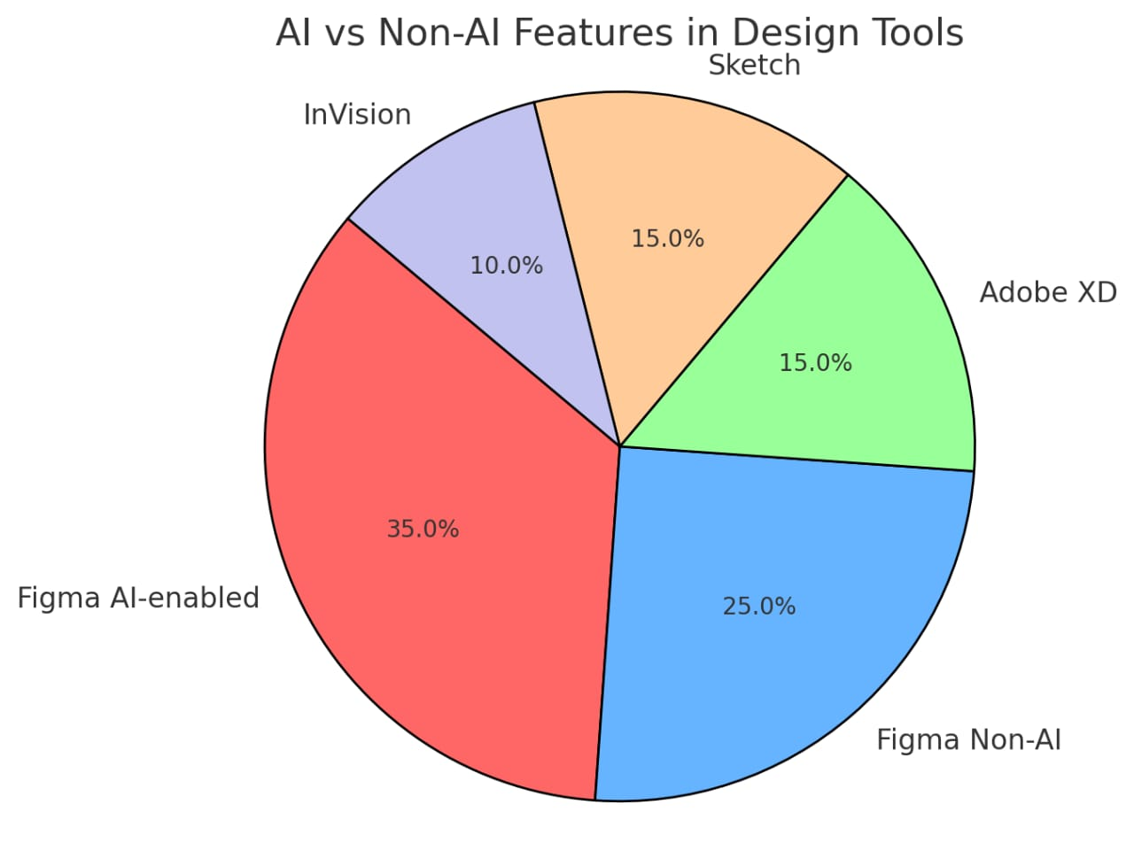

Figma, when integrated with AI, provides the smart benefits of auto-layout adjustment, resizing components, and design suggestions that make designing much simpler. All the AI-based features reduce repetition work and do them manually at their speeds and ease those workflows while increasing the quality of designs significantly. In the absence of AI, Figma still supports manual layout adjustments, component update, and collaboration but requires more time and effort from the designer.

However, Adobe XD, Sketch, and In Vision work without AI-driven automation. The prototyping and collaboration are good in Adobe XD when compared to Figma, however, it misses intelligent automation features. Popularity of Sketch is for flexibility as well as wide plugin support but requires manual effort for most tasks. In Vision is very good in prototyping but does not feature automation or AI assist like that of Figma. The best tool in this case is Figma with AI, as it empowers with intelligent automation and easy usage.

|  |  |  |
| --- | --- | --- |
| Design Tool | Proportion Of Features | Key Features |
| Figma (AI-enabled) | 35% | Automated layout, AI design suggestions, smart component resizing, enhanced collaboration. |
| Figma (non-AI) | 25% | Manual layout adjustments, manual component updates, standard real-time collaboration. |
| Adobe XD | 15% | Basic prototyping, no AI automation, good collaboration features. |
| Sketch | 15% | Manual layout and prototyping, rich plugin ecosystem, no AI assistance. |
| InVision | 10% | Extensive prototyping options, basic design features, no AI integration. |

# Conclusion and Recommendations

"Over the last couple of years, AI has greatly optimized efficiency in Figma, but there is still so much potential for significant future growth. Designers today will take advantage of AI on simple tasks, whereas human input is still much more important for creative workflows. Future growth can make design a thing of the future by empowering AI to aid with complex and creative workflows. Investments need to be key in optimization of predictive algorithms in design, AI-driven content generation, and real-time collaboration tools that predict user needs.".

# LIMITATION

AI excels at minor layout changes but is incompetent at designing intricate illustrations that may get easily outsmarted by designers.

Need for Creativity of the Human Brain

Design has to have a history or emotional relationship which AI cannot. Human instinct is necessary for producing unique meaningful designs.

Idea Generation:

Less Innovation-though it is somewhat of an accepted fact that AI can execute rapid copy-paste routine jobs within no time, which can save lots of time for the designers to put into more important work; it generally suffers when it has to bring innovative solutions to complex projects.

Over-dependence on Training Data:

The significant limitation of AI is that it is limited to training data, which may capture some biases and result in somewhat outdated recommendations. It also does not shift trends as fast as human designers do.

# FUTURE SCOPE

The future of AI in Figma will have gigantic scope in revolutionizing design processes in wide areas by enabling the following:

1. Predictive Design Models

AI could scan market trends and user preferences to suggest design elements that an audience would most likely expect to see, thereby creating user-cantered designs that resonate with particular demographics and ultimately enhance product-market fit.

2. AI-produced Content Material

The AI can create design assets, for example text images, and layouts. For this reason, AI can automate the typical work on content production freeing more time for designers to share their creativity and ideas about the best decisions.

3. Deep personalization

AI may learn individual designers' likes and workflows, tailor the interface, and provide recommendations of tools or design elements that fit their style, thereby making them more efficient and inspiring creativity.

4. AI-Based Collaborative Tools

AI can amplify instant collaboration that will anticipate user needs, suggest design elements, and improve organizing of feedback to ensure that designs come out more coherent and iterate faster.

In a nutshell, future AI upgrades will make Figma much more formidable in streamlining workflow improvement and artistic efficacies with better design for the best user-friendliness.

# RESULT AND DISCUSSION

It appears that the main thrust of AI in Figma today is toward speed and convenience to be able to perform repetitive tasks. However, there are Sample areas for further development. Based on the answers provided, the designers have lesser hours of human-toils due to AI and still look forward to more advanced AI tools that can serve their creative workflow. This conversation implies that future AI for Figma could involve using the machine learning algorithm for the analysis of previous projects to automatically suggest new design approaches.

|  |  |  |  |
| --- | --- | --- | --- |
| **Task** | **Time without AI (minutes)** | **Time with AI (minutes)** | **Time Saved**  **(minutes)** |
| Layout adjustment | 15 | 7 | 8 |
| Colour Matching | 20 | 12 | 8 |
| Image Optimization | 12 | 5 | 7 |
| Text Alignment | 10 | 6 | 4 |
| Prototype Linking | 25 | 15 | 10 |

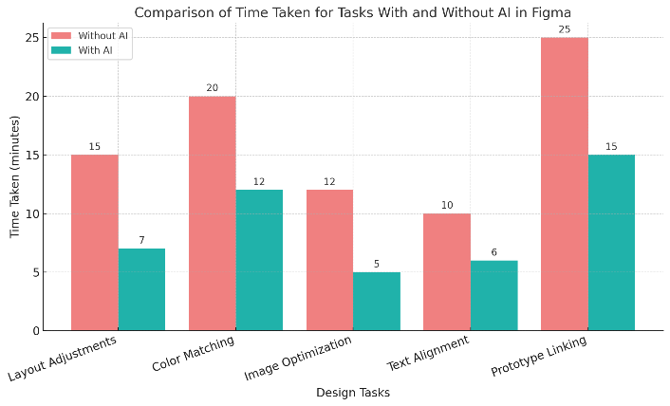

Time Saved Using AI Features in Figma Time Saved Using AI Features in Figma (Auto Layout, Smart Suggestions and Plugins)

The graph compares both time-related variations for the same tasks carried with and without AI. From the graph, it is well noted that there are tremendous efficiency improvements on most design tasks.

So the AI dramatically improves productivity in design tasks. Gains are most paramount for tasks like Prototype Linking and Image Optimization, which are basically tasks where substantial bits of human labour are reduced through the installation of automation. Between all tasks, Figma boasts between 4 and 10 minutes saved through time because of the input AI provides to users working on design work.

The use of AI enables designers to save time, maintaining things uniformly precise, thereby making Figma a very good resource for this modern requirement of design.

# References

**Roberts, K., & Lin, M. (2020). Machine Learning and Design: The Intersection of AI and Creativity. Journal of Artificial Intelligence Research, 67(3), 487-502.**

**Smith, A., & Lee, P. (2022). Design Automation with AI: A Comparative Study of Figma, Adobe XD, and Sketch. User Experience and Design Journal, 12(1), 33-52.**

**Kumar, R., & Malik, S. (2021). AI in Collaborative Design Environments: How Figma is Leading the Way. Digital Design Review, 16(2), 77-91.**

**Parker, L. (2021). The Future of AI in UX/UI Design: Predictions and Challenges. Design Automation Quarterly, 29(4), 58-73.**

**Anderson, M., & Zhang, H. (2022). Leveraging AI to Enhance User Experience in Design Software: The Case of Figma. HCI and Artificial Intelligence Journal, 40(1), 144-160**.

**Martin, T., & Wang, J. (2021). Generative Design and AI: The Next Frontier in Digital Creation. Journal of Emerging Technologies in Design, 19(3), 88-104.**

**Patel, S., & Lee, K. (2022). AI as a Creative Partner: Machine Learning in Design Workflows. Journal of Design Automation and Technology, 33(2), 200-218.**