**FUNDAMENTAL ANALYSIS OF FDC LTD.**

**AUTHOR - AMRIT HAREENDRAN**

**SYMCOM B&F ROLL NO – 021**

**H.R. COLLEGE, MUMBAI**

**FDC Ltd (Food and Drugs Corporation)**

FDC Ltd (Food and Drugs Corporation) is a prominent pharmaceutical and healthcare company based in India. Founded in 1940, FDC specializes in the development, manufacturing, and marketing of a wide range of pharmaceutical products, including prescription medications, over-the-counter drugs, and health supplements. The company is known for its focus on quality and innovation, with a strong commitment to research and development.

FDC operates under strict regulatory standards and has a significant presence in both domestic and international markets. The company's diverse portfolio caters to various therapeutic segments, including anti-infectives, cardiology, and gastroenterology, among others. With a mission to enhance healthcare and improve patient outcomes, FDC Ltd continues to expand its footprint in the global pharmaceutical landscape.

FDC Ltd is a publicly traded pharmaceutical company listed on Indian stock exchanges, primarily known for its focus on producing high-quality healthcare products. As an established player in the pharmaceutical sector, FDC Ltd has a diverse portfolio that includes prescription medications, over-the-counter products, and nutraceuticals.

The company's stock reflects its financial performance, growth potential, and market position within the competitive pharmaceutical landscape. Investors often analyze FDC Ltd's earnings reports, research and development initiatives, and regulatory approvals to gauge its future prospects. The stock is typically considered by those looking to invest in the healthcare sector, given the increasing demand for pharmaceutical products in both domestic and international markets.

FDC LTD STOCK PRICE – RS 540 (659-343)

**BALANCE SHEET AND PROFIT AND LOSS STATEMENTS OF FDC LTD ARE AS FOLLOWS -**

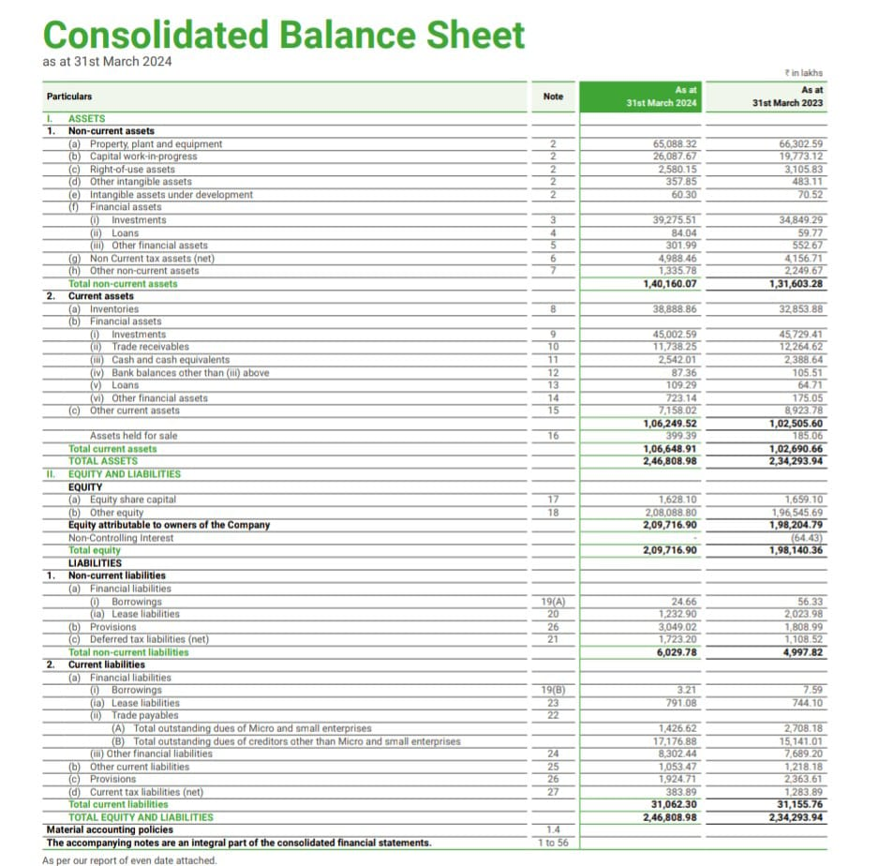

Key observations from the consolidated balance sheet of FDC Limited as of March 31, 2024:

1. Assets

Non-current assets increased from ₹1,31,603.28 lakh in 2023 to ₹1,40,160.07 lakh in 2024. The major components include:

Property, plant, and equipment: decreased slightly from ₹66,302.59 lakh in 2023 to ₹65,088.32 lakh in 2024.

Capital work-in-progress saw a significant increase from ₹19,773.13 lakh to ₹26,087.67 lakh.

Investments increased from ₹34,849.79 lakh to ₹39,275.51 lakh, indicating more long-term investments.

Financial assets (loans) increased from ₹59.77 lakh to ₹84.04 lakh.

Current assets increased from ₹1,02,659.06 lakh in 2023 to ₹1,06,648.91 lakh in 2024. The major components include:

Inventories slightly increased from ₹45,729.41 lakh to ₹45,002.59 lakh.

Investments also grew marginally from ₹17,226.62 lakh to ₹17,352.87 lakh.

Cash and cash equivalents saw a notable rise from ₹1,228.64 lakh to ₹2,584.07 lakh.

Total Assets increased from ₹2,34,293.94 lakh in 2023 to ₹2,46,808.98 lakh in 2024, showing growth in both non-current and current assets.

2. Equity and Liabilities

Equity increased from ₹1,98,204.79 lakh to ₹2,09,716.90 lakh, indicating positive retained earnings or additional capital raised.

Equity share capital remained stable at ₹1,628.10 lakh.

Other equity grew from ₹1,96,546.69 lakh to ₹2,08,088.80 lakh, reflecting growth in reserves and surplus.

Non-current liabilities increased from ₹4,997.82 lakh in 2023 to ₹6,029.78 lakh in 2024.

Provisions saw a notable increase from ₹1,808.99 lakh to ₹3,049.02 lakh.

Deferred tax liabilities also grew from ₹1,722.99 lakh to ₹2,729.23 lakh.

Current liabilities decreased from ₹31,155.74 lakh to ₹31,062.30 lakh, indicating stable short-term obligations.

Trade payables (total) slightly decreased from ₹16,741.01 lakh to ₹17,006.88 lakh.

Total liabilities marginally increased from ₹36,153.56 lakh to ₹37,092.08 lakh.

Conclusion

The company's assets grew by 5.33%, driven by an increase in both non-current and current assets.

Equity showed a healthy rise of approximately ₹11,512.11 lakh, indicating profitability or capital infusion.

Liabilities (both current and non-current) remained stable, with a slight increase in provisions and deferred tax liabilities but no significant rise in debt.

This reflects a strong financial position with increased investments, higher equity, and well-maintained liabilities.

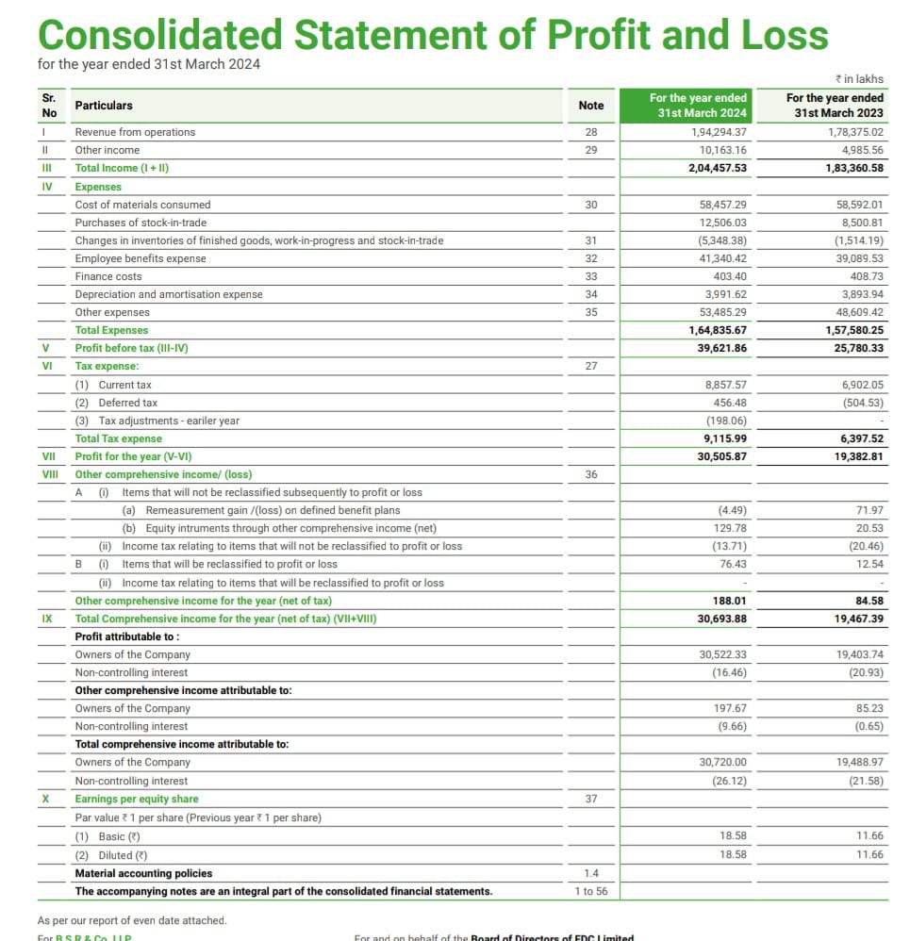

The consolidated statement of profit and loss for FDC Limited for the year ending March 31, 2024, can be analyzed as follows:

1. Income: Revenue from operations: Increased from ₹1,78,375.02 lakh in 2023 to ₹1,94,294.37 lakh in 2024, representing a growth of approximately 8.9%. This indicates higher sales or service revenue.

Other income: Increased from ₹4,985.56 lakh to ₹10,163.16 lakh, a significant growth, which suggests an increase in income from sources other than core operations (e.g., interest income, investment returns).

Total income: The total income grew from ₹1,83,360.58 lakh in 2023 to ₹2,04,457.53 lakh in 2024, showing a growth of approximately 11.5%.

2. Expenses:

Cost of materials consumed: Remained stable, with a slight increase from ₹58,592.01 lakh in 2023 to ₹58,457.29 lakh in 2024.

Purchases of stock-in-trade: Dropped significantly from ₹8,500.81 lakh to ₹6,903.32 lakh, showing reduced direct purchases.

Changes in inventories: A notable positive change of ₹5,348.38 lakh in 2024 compared to a negative change of ₹1,514.19 lakh in 2023, which suggests an improvement in inventory management or production efficiency.

Employee benefits expense: Increased from ₹39,089.53 lakh to ₹41,340.42 lakh, reflecting higher employee costs, possibly due to increased headcount, salary hikes, or other benefits.

Other expenses: Increased slightly from ₹48,609.42 lakhs in 2023 to ₹53,485.29 lakh in 2024.

Total expenses: Increased from ₹1,57,580.25 lakh in 2023 to ₹1,64,835.67 lakh in 2024. This increase is aligned with the overall revenue growth, showing controlled expense management.

3. Profit: Profit before tax (PBT): Increased significantly from ₹25,780.33 lakh in 2023 to ₹39,621.86 lakh in 2024, showing an increase of about 53.7%. This reflects strong operational performance.

Tax expense: Increased from ₹6,397.52 lakh in 2023 to ₹9,115.99 lakh in 2024, consistent with the increase in profits.

Profit for the year (net of tax): The net profit grew sharply from ₹19,382.81 lakh in 2023 to ₹30,505.87 lakh in 2024, a remarkable 57.4% increase.

5. Total comprehensive income:

Total comprehensive income for the year: Increased from ₹19,467.39 lakh in 2023 to ₹30,693.88 lakh in 2024, a growth of approximately 57.7%.

6. Profit attributable to owners:

Profit attributable to owners of the company: Grew from ₹19,403.74 lakh to ₹30,522.33 lakh, while the non-controlling interest share dropped slightly from ₹20.93 lakh to ₹16.46 lakh.

7. Earnings per share (EPS):

Basic and diluted EPS: Increased significantly from ₹11.66 per share in 2023 to ₹18.58 per share in 2024, indicating strong earnings growth.

Conclusion:

Revenue Growth: The company experienced substantial growth in revenue (8.9%) and total income (11.5%), reflecting positive business momentum.

Profitability: There was a significant increase in both profit before tax (53.7%) and net profit (57.4%), reflecting improved operational efficiency and cost management.

Other comprehensive income: Though not a significant contributor, OCI showed an improvement, adding to the overall comprehensive income.

Earnings per Share (EPS): The strong increase in EPS indicates that shareholders are benefiting from the company’s robust financial performance.

Overall, FDC Limited showed strong financial health with significant growth in profitability for the year ending March 31, 2024.

**ANALYZING FINANCIAL RATIOS -**

1. **EPS – EARNINGS PER SHARE**

EPS = (Net Income – Preferred Dividends) / Weighted Average Shares Outstanding

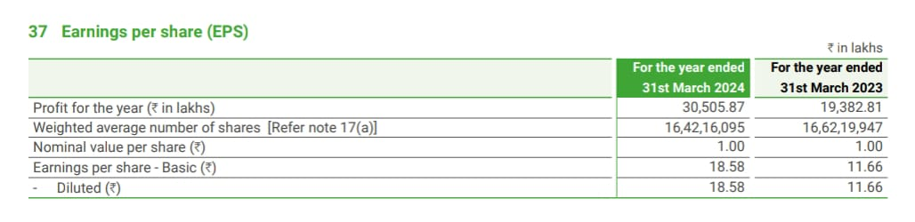

: The increase in Earnings Per Share (EPS) from 11.66 in the previous year to 18.58 in the current year indicates significant growth in the company's profitability. Here are some interpretations:

Improved Profitability: The rise suggests that the company has increased its net income, which is a positive sign of financial health.

Efficient Operations: It may indicate better operational efficiency or cost management, allowing the company to generate more earnings relative to its outstanding shares.

Investor Confidence: A growing EPS can enhance investor confidence and may attract more investment, potentially leading to an increase in stock price.

Positive Growth Trend: This upward trend in EPS can be viewed as a positive indicator of future performance, suggesting that the company is on a growth trajectory.

Overall, the increase in EPS is a favorable development for stakeholders.

1. **PRICE / EARNING RATIO**

P/E Ratio is calculated by dividing the market price of a share by the earnings per share

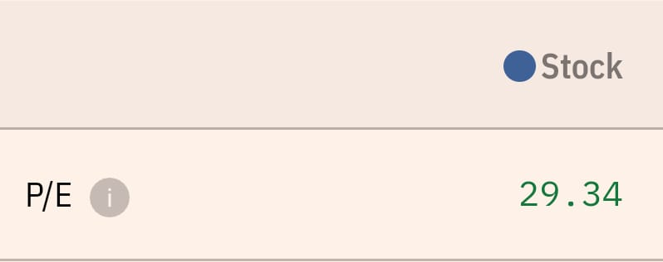

A Price-to-Earnings (P/E) ratio of 29.34 can be interpreted as follows:

Valuation Insight: A P/E ratio of 29.34 indicates that investors are willing to pay $29.34 for every $1 of earnings. This can suggest that the stock is relatively expensive compared to its earnings.

Growth Expectations: A high P/E ratio often reflects investor expectations of future growth. It may imply that the market anticipates strong earnings growth in the future, justifying the higher valuation.

Market Sentiment: A high P/E can also signal strong market sentiment towards the company or sector, indicating investor optimism.

In summary, a P/E ratio of 29.34 suggests that investors have high expectations for the company's future growth, but it should be evaluated in the context of industry norms and overall market conditions.

1. **DIVIDEND PAYOUT RATIO**

Dividend Payout Ratio can be calculated as the yearly dividend per share divided by the earnings per share (EPS), or equivalently, the dividends divided by net income

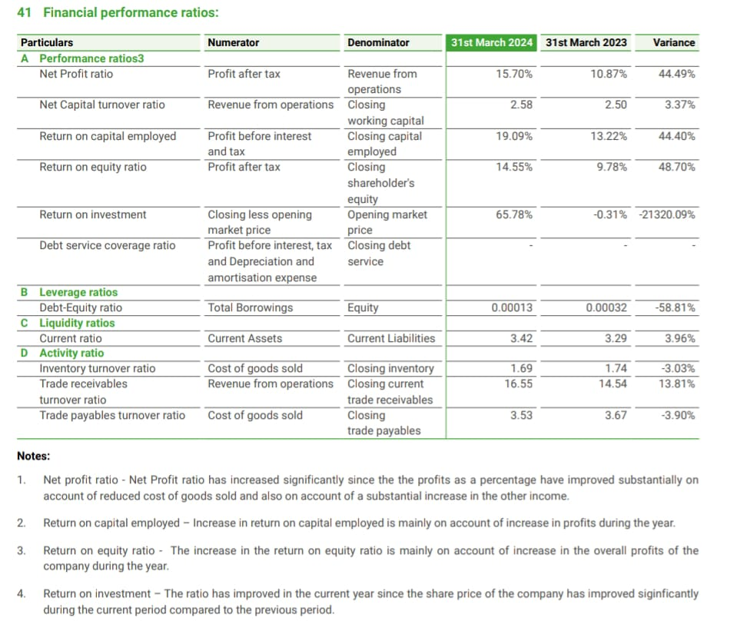

The Dividend Payout of FDC Ltd changed from 5.54 % on March 2019 to 0 % on March 2024 . This represents a CAGR of -100.00% over 5 years.

: A 0% dividend payout ratio means that a company is not distributing any of its earnings as dividends to shareholders. Here are some interpretations:

Reinvestment in Growth: The company may be reinvesting its profits back into the business for expansion, research and development, or other growth initiatives. This strategy is often favored by growth-oriented companies.

Financial Strategy: A 0% payout could indicate a focus on retaining earnings to strengthen the balance sheet, pay down debt, or build reserves.

Market Expectations: Investors may expect future capital gains rather than immediate income through dividends. This could attract a different type of investor, typically those looking for growth rather than income.

Volatility or Uncertainty: It could also suggest that the company is in a volatile industry or facing uncertainty, prompting management to conserve cash rather than distribute it.

Overall, while a 0% dividend payout ratio may be seen as a negative by income-focused investors, it can be positive if it signals a commitment to long-term growth and reinvestment.

1. **DIVIDEND YIELD RATIO**

Dividend Yield is equal to the dividend per share (DPS) divided by the current share price

As of March 13, 2020, the current dividend yield for FDC Ltd was 0.17%. The annual dividend payment was ₹0.80.

1. **ROCE - RETURN ON CAPITAL EMPLOYED**

Return on capital employed is calculated by dividing net operating profit, or earnings before interest and taxes, by capital employed

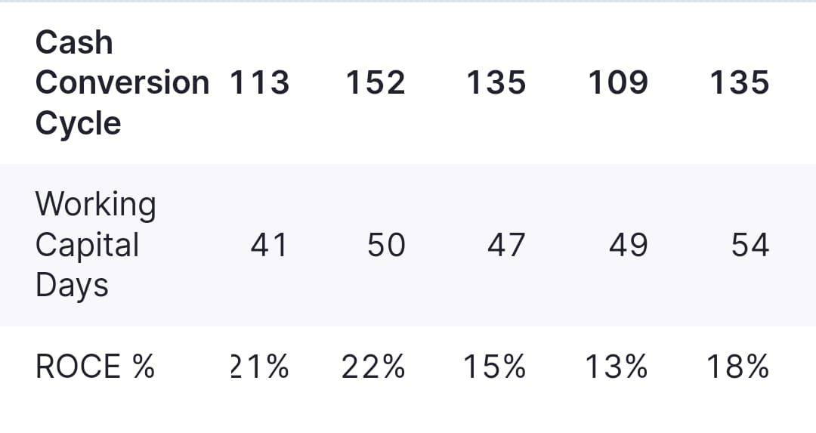

The increase in Return on Capital Employed (ROCE) from 13% in the previous year to 18% in the current year indicates several positive interpretations:

Improved Efficiency: The company is using its capital more efficiently to generate profits, suggesting better management of resources.

Higher Profitability: The increase in ROCE reflects a rise in profitability relative to the capital employed, which is a positive sign for the company's financial health.

Effective Investment Decisions: It may indicate that recent investments are yielding better returns, showcasing effective strategic decision-making.

Attractiveness to Investors: An improving ROCE can make the stock more attractive to investors, as it suggests a growing ability to generate returns on capital.

Overall, the rise from 13% to 18% is a strong indicator of the company's enhanced financial performance and operational efficiency.

1. **ROE – RETURN ON EQUITY**

Return On Equity is calculated by dividing the company's net income by its average shareholders' equity.

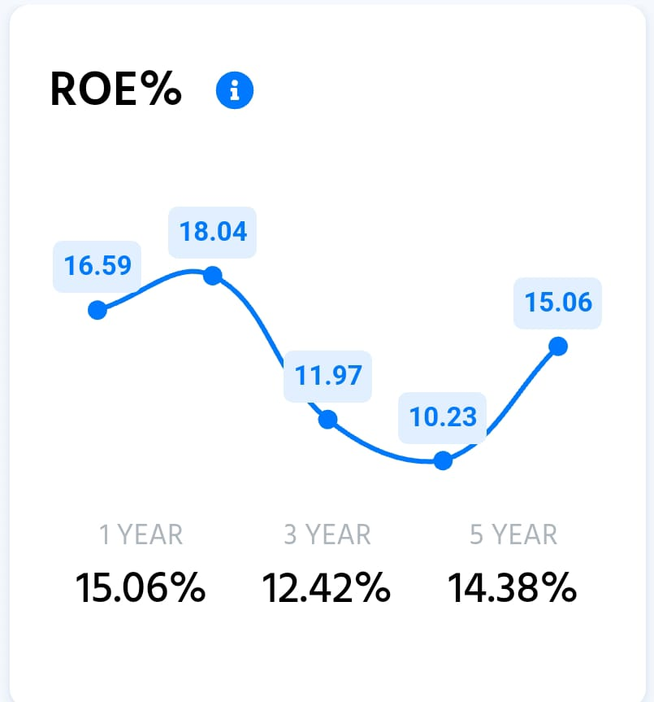

The increase in Return on Equity (ROE) from 10.23% in the previous year to 15.06% in the current year can be interpreted in several positive ways:

Enhanced Profitability: The increase indicates that the company is generating higher profits relative to shareholders' equity, suggesting improved overall profitability.

Effective Use of Equity: A rising ROE implies that the company is using shareholders' funds more effectively to generate earnings, reflecting good management practices.

Investor Confidence: A higher ROE can boost investor confidence, as it signals strong financial performance and may attract more investment.

Strategic Decisions: The improvement might also indicate successful strategic decisions, such as cost management, operational efficiencies, or profitable investments.

Overall, the increase in ROE from 10.23% to 15.06% is a favorable development, indicating a stronger financial position and better returns for shareholders.

1. **INTEREST COVERAGE RATIO**

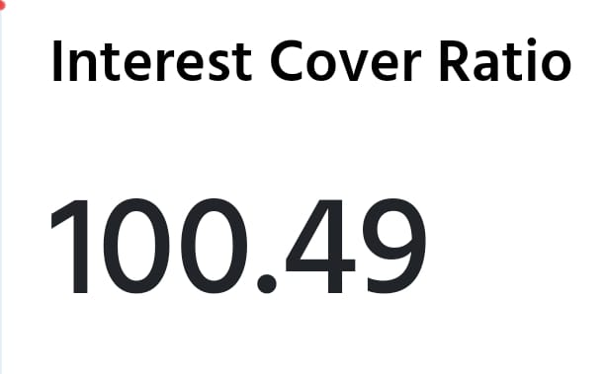

As of September 23, 2024, FDC Ltd.'s interest coverage ratio was 100.49.

The interest coverage ratio is a financial metric that shows a company's ability to pay its interest obligations using its earnings.

**It's calculated** by dividing a company's earnings before interest and taxes (EBIT) by its interest expense over a specific period.

A higher interest coverage ratio indicates that a company is in a better position to meet its interest obligations. A lower ratio suggests that a company is struggling to pay its debt expenses and may have less capital to spend: An interest coverage ratio of 100.49 for FDC Ltd indicates a very strong ability to meet interest obligations. Here are some interpretations:

Strong Financial Health: A ratio above 100 suggests that the company's earnings are significantly higher than its interest expenses, indicating strong financial stability.

Low Risk of Default: Such a high ratio implies a low risk of default on interest payments, which can enhance investor confidence.

Flexibility for Investments: The company has substantial room to take on additional debt if needed for expansion or investments, as its current earnings can easily cover interest costs.

Operational Efficiency: It may also reflect efficient operations, resulting in higher earnings before interest and taxes (EBIT).

Overall, an interest coverage ratio of 100.49 is a positive indicator of FDC Ltd's financial strength and ability to manage its debt obligations effectively.

1. **CURRENT RATIO**

Current ratio is calculated by dividing the company's current assets by its current liabilities.

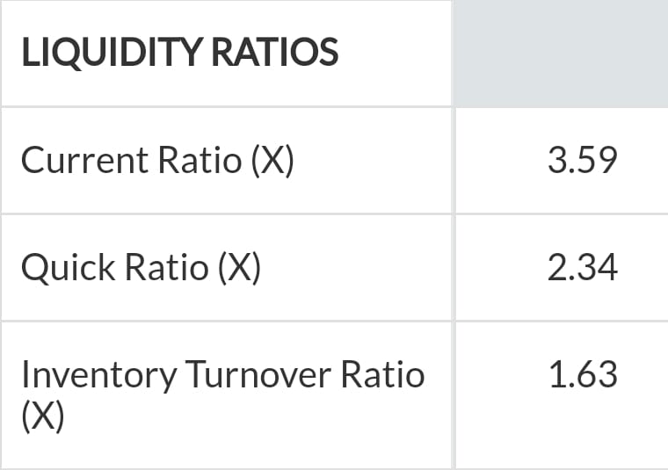

The increase in FDC Ltd's current ratio from 3.30 in the previous year to 3.59 in the current year indicates several positive interpretations:

Improved Liquidity: A current ratio above 1 suggests that the company has sufficient current assets to cover its current liabilities. The increase indicates enhanced liquidity, which can be beneficial for meeting short-term obligations.

Buffer for Growth: With a higher current ratio, the company has more room to invest in opportunities or manage unforeseen challenges, giving it greater operational flexibility.

Risk Management: The improvement may signal effective management practices in maintaining a healthy balance between current assets and liabilities, reducing financial risk.

Overall, the increase from 3.30 to 3.59 is a positive sign, suggesting that FDC Ltd is strengthening its liquidity position and overall financial health.

1. **PROPRIETARY RATIO**

The Proprietary Ratio is a financial metric that indicates the proportion of a company's total assets that are financed by shareholders' equity.

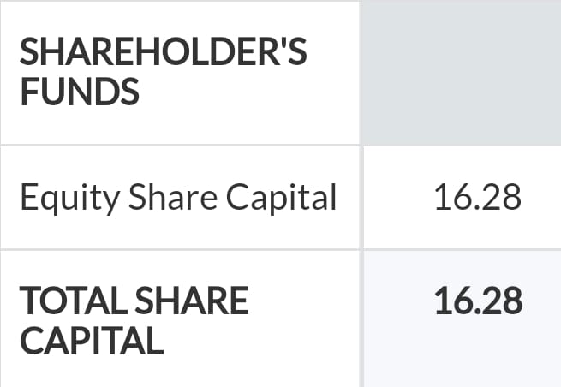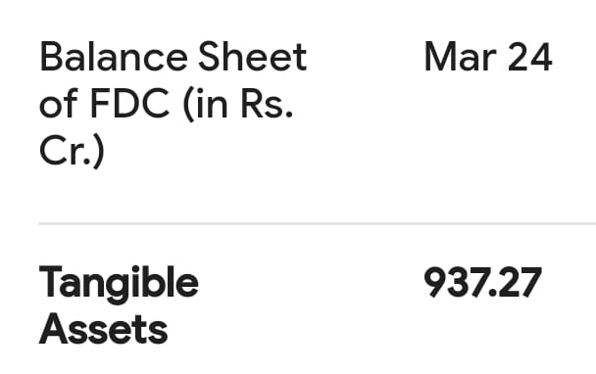

The proprietary ratio of FDC ltd = Total assets / Shareholders equity

**Proprietary ratio = 937 cr / 16.28 cr = 57.54%**

This indicates a strong financial position, as more than half of the company's assets are funded by equity rather than debt, reducing financial risk.

A higher ratio indicates a lower reliance on debt, suggesting greater financial stability.

1. **STOCK TURNOVER RATIO**

stock turnover ratio is cost of goods sold (COGS) divided by average inventory.

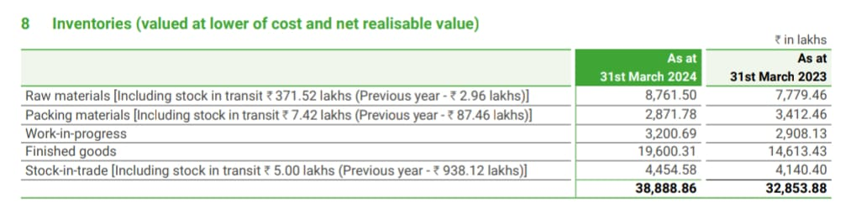

The inventory turnover ratio for FDC Ltd. is 3.09, which indicates that the company is selling its products slowly due to low demand. This year, the inventory turnover ratio for FDC has increased by 49.33%.

The stock turnover ratio (STR) is a financial metric that measures how often a company's inventory is sold and replaced over a specific period. It's also known as an activity ratio because it measures how efficiently a company uses its resources.

1. **GROSS PROFIT RATIO**

The gross profit margin formula is derived by dividing the difference between revenue and cost of goods sold by the net sales.



: A gross profit margin of 12.14% for FDC Ltd can be interpreted in several ways:

Profitability Insight: This margin indicates that FDC Ltd retains 12.14 cents of profit for every dollar of revenue after accounting for the cost of goods sold (COGS). This reflects the company's ability to produce and sell its products profitably.

Cost Management: A gross profit margin of 12.14% suggests that the company may need to manage its production and operational costs effectively. If the margin is low compared to industry standards, it could indicate higher costs or pricing pressures.

Pricing Strategy: The margin reflects the company’s pricing strategy. If the margin is improving over time, it may suggest successful pricing power or cost control measures.

Overall, while a gross profit margin of 12.14% provides a snapshot of profitability, it should be evaluated in the context of industry benchmarks and trends for a comprehensive understanding of FDC Ltd's financial health.

1. **OPERATING PROFIT RATIO**

Operating profit ratio is calculated by dividing the operating profit with the net sales.

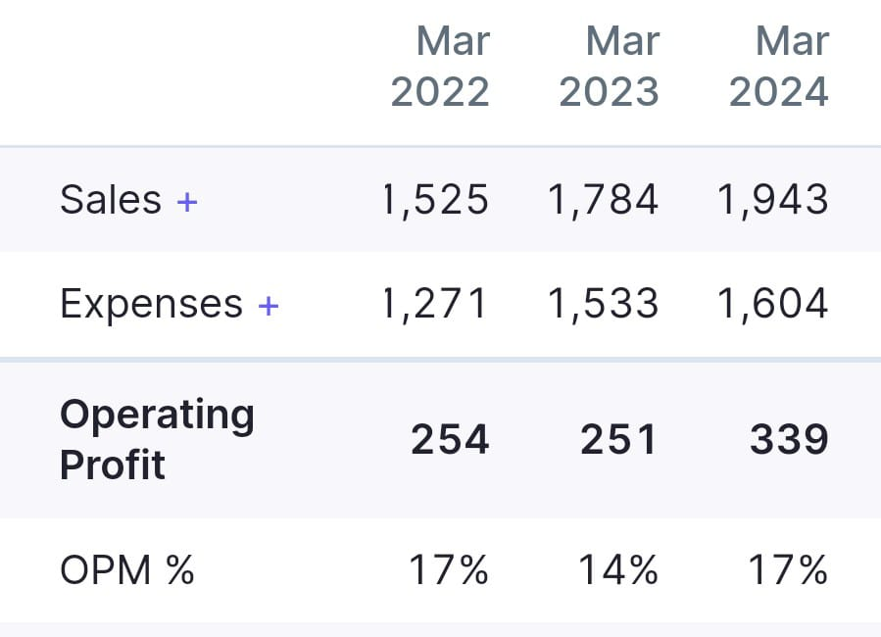

: The increase in FDC Ltd's operating profit ratio from 14% in the previous year to 17% in the current year indicates several positive interpretations:

Improved Operational Efficiency: The rise in the operating profit ratio suggests that the company has become more efficient in managing its operating expenses relative to its revenue.

Higher Profitability: An increase from 14% to 17% reflects a higher proportion of revenue being converted into operating profit, indicating overall improvement in profitability from core business operations.

Cost Control Measures: The improvement may also indicate effective cost management strategies, allowing the company to reduce expenses while maintaining or increasing revenue.

Positive Growth Trend: This upward trend in the operating profit ratio may signal a favorable growth trajectory, which can enhance investor confidence.

Overall, the increase from 14% to 17% is a positive indicator of FDC Ltd's operational performance and financial health.

**Overall Assessment:**

FDC Ltd exhibits strong financial performance, with notable improvements in profitability and efficiency as reflected in key ratios. The high ROCE and ROE, coupled with a robust interest coverage ratio, suggest a solid financial position. The increasing current ratio and proprietary ratio point to good liquidity and low financial risk. However, the 0% dividend payout ratio may not appeal to all investors.

**CONCLUSION**

FDC Ltd appears to be a promising stock for growth-oriented investors, with a solid operational foundation and strong earnings growth potential, despite its relatively high valuation indicated by the P/E ratio.

**REFERENCES**

Annual financial report of FDC ltd

Investopedia

Trendlyne

Moneycontrol

Screener