**A STUDY ON THE ETHICAL ISSUES INVOLVED IN ANIMAL TESTING IN THE BEAUTY INDUSTRY**

**BY: MUSKAAN CHANDRAPOTA**

**M.com – Business Management**

**H.R. COLLEGE OF COMMERCE AND ECONOMICS**

1. **Introduction**

Animal testing has been a practise in the cosmetics and personal care industry for decades which continues to be practised today. Animal testing is still done by beauty corporations all around the world to determine whether a product is safe to use on humans. Any scientific experiment that could endanger the animal by causing it pain, stress, or other injury is considered to be an animal testing activity. The majority of the animals suffer severe injuries, pass away, or are killed right after the experiment.

Around 100 million animals are murdered annually in US laboratories alone, including mice, rats, dogs, cats, rabbits, hamsters, primates, fish, and birds, according to PETA. Several of those animals are used in the testing process for cosmetics.

Even if it is estimated that the global market for cruelty-free cosmetics will reach USD 10 billion by 2024, there is still a long way to go. More and more firms are making the switch to cruelty-free beauty products.

Although the majority of these arguments appear convincing and may even stop businesses from using animals in experiments, fresh arguments have surfaced on related topics in the twenty-first century. Both the utilitarian and the Kantian perspectives are used to debate whether or not cosmetic items should be tested on animals. One of the first actions one can take to effect long-lasting change is to become aware of the suffering done to animals, learn more about the alternatives, and choose items made without using any form of animal testing.

1. **Literature Review**

This paper has been prepared after thorough research from several articles and research pieces. The research pieces and articles are primarily conducted by the PETA org and a research article written by Yue Wang, Yuan Zhao, Fuhui Song, titled— “The Ethical Issues of Animal Testing in Cosmetics Industry”. The research throws light on the Utilitarian vs. Kantian approach in terms of how ethical animal testing is for business corporations. Further research articles by PETA also talk about the animal testing ban and the reliability of animal data for human health research.

* 1. **Utilitarian Vs Kantian**

The Utilitarian vs. Kantian method is debated in the paper "The Ethical Problems of Animal Testing in the Cosmetics Industry" by Yue Wang, Yuan Zhao, and Fuhui Song. Optimal happiness is encouraged by utilitarianism. Everyone affected by an action contributes to happiness, not only those who participated in it. The cosmetics industry violates utilitarian morality since animals used in experiments for the industry suffered excruciating agony and never found satisfaction. Thus, the use of animals in cosmetics business research is wrong. Kantian differs greatly from utilitarianism in that it considers at least certain behaviours to be either right or wrong, regardless of the outcome. In this instance, the use of animals in the cosmetics industry is justified, primarily because it helps safeguard customers from the potential negative effects of the goods' use. Animal testing in the cosmetics business is ethical and advantageous from a Kantian perspective. The conclusion that animal experimentation is a necessary component of the cosmetics industry is based on the aforementioned two justifications. In order to minimise the harm to experimental animals, relevant practitioners should conduct animal experiments according to scientific and ethical protocols and respect the right of experimental animals to survive.

It is crucial to comprehend how the Utilitarian and Kantian perspectives are applied in the economic environment. It's crucial to understand how utilitarian and Kantian ideas both have an impact on the cosmetics business, which is mostly controlled by a small number of multinational corporations that emerged in the 20th century.

* 1. **Reliability of Animal Data for Human Health Research**

According to a 2004 research by the U.S. Food and Drug Administration, 92 percent of medications that go through clinical trials after being tested on animals are rejected. Because to serious or fatal side effects that were missed during animal tests, half of those that are approved are withdrawn or relabeled.

In a statement published in the journal Nature, the National Institutes of Health (NIH) stated that it will require funding applicants to employ both male and female animals in biomedical research. Due to the now debunked premise that hormone cycles affect data, researchers have primarily used male subjects.

According to the article, which was co-written by NIH Director Francis Collins and Janine Clayton, director of the NIH's Office of Research on Women's Health, "the overreliance on male animals and cells in preclinical research obscures significant sex differences that could guide clinical investigations." It then goes on to discuss the negative impacts of depending mostly on study data from male animals and how biological sex differences affect disease and treatment effects in men and women differently. The NIH policy announcement goes on to say that "inadequate processing of data by sex may well contribute to the alarming growth of irreproducibility in preclinical biomedical research" and "inadequate inclusion of female cells and animals in trials." It ignores the more fundamental problem with research, which is the gap between the successes of applying findings from animal studies to benefit humans.

Take into account the rationale before evaluating the facts. Mice or other lab animals are not miniature humans. The Institute of Medicine came to the conclusion that chimpanzees were no longer required for biomedical research in 2011. In response, the NIH retired 90% of its chimpanzees. If chimpanzees, who share up to 98 percent of human genes, are not helpful for human study, then why would any other species be? To safely and predictably extrapolate data, there are too many differences in anatomy, gene expression, metabolism, immunological functioning, etc. between species.

1. **Research Methodology**
   1. **Aim**

The focus of the research paper is to understand the morality behind producing and using cruelly produced beauty products. The paper also delves into willingness to change and adaptability of the Indian audience to make more conscious purchase choices.

* 1. **Research Objectives**
* To understand if consumers are willing to be more conscious with their purchases (i.e. making a choice to buy vegan and cruelty free products) at any price.
* To gauge the awareness of cruelly producing practices within consumers and the growth of the cruelty-free cosmetics market in relation to the current beauty and personal care market.
* To understand the reliability of animal testing data for human health research.
  1. **Research Design**

There has been a use of both primary and secondary sources in conducting the research.

* **Primary Data**

*Sample Size: 114*

*Sampling Method: Random Sampling*

*Sampling Tool: Survey of 16 questions*

A total of 114 people have participated in filling the survey. Simple random sampling was conducted as it was an online survey closed questions have been asked so that it is quick and convenient for respondents and it will help in standardising customer attitude and perceptions for analysis. The questionnaire began with the basic demographics and then moved on to more focused questions which would further help fulfil our research objective.

The questionnaire consists of 16 questions focusing on four major components being:

* Awareness towards purchases
* Animal testing vs. Cruelty Free
* Cost
* Suggestions for improvement
* **Secondary Data**

Secondary Data Secondary data has been collected from journals, articles and published reports, etc. Articles and reports by consulting firms like reports by firms like PETA (People for Ethical Treatment of Animals- largest animal rights organization in the world) and BBC, who have given detailed information on the current scenario of animal testing, emerging cruelty-free beauty brands and practices and alternatives to animal testing.

* 1. **Significance of Study**

The research covers the various aspects required to gauge the awareness of cruelly producing practices in the world within consumers, the growth of the cruelty-free cosmetics market in relation to the current beauty and personal care market. The research also delves into various factors that show the effects of animal testing and various tools and methods by which they can be avoided. The research aims at finding out why the beauty industry isn’t 100% cruelty free yet; if consumer’s reluctance to switch to cruelty free brands is because of their lack of awareness to the problem or for other reasons and solutions to these problems.

1. **Data Analysis and Interpretation**
   1. **Primary Data Analysis**
2. **Demographic Profile: Age**

The majority of people were between the ranges of 18-25 years of age comprising 52.6%, there were 27.2% between the age of 41-50 years, 14% above the age of 50 years, 3.5% between the age of 31-40 years, 1.8% below the age of 18 years and 0.9% between the ages of 26-30 years.

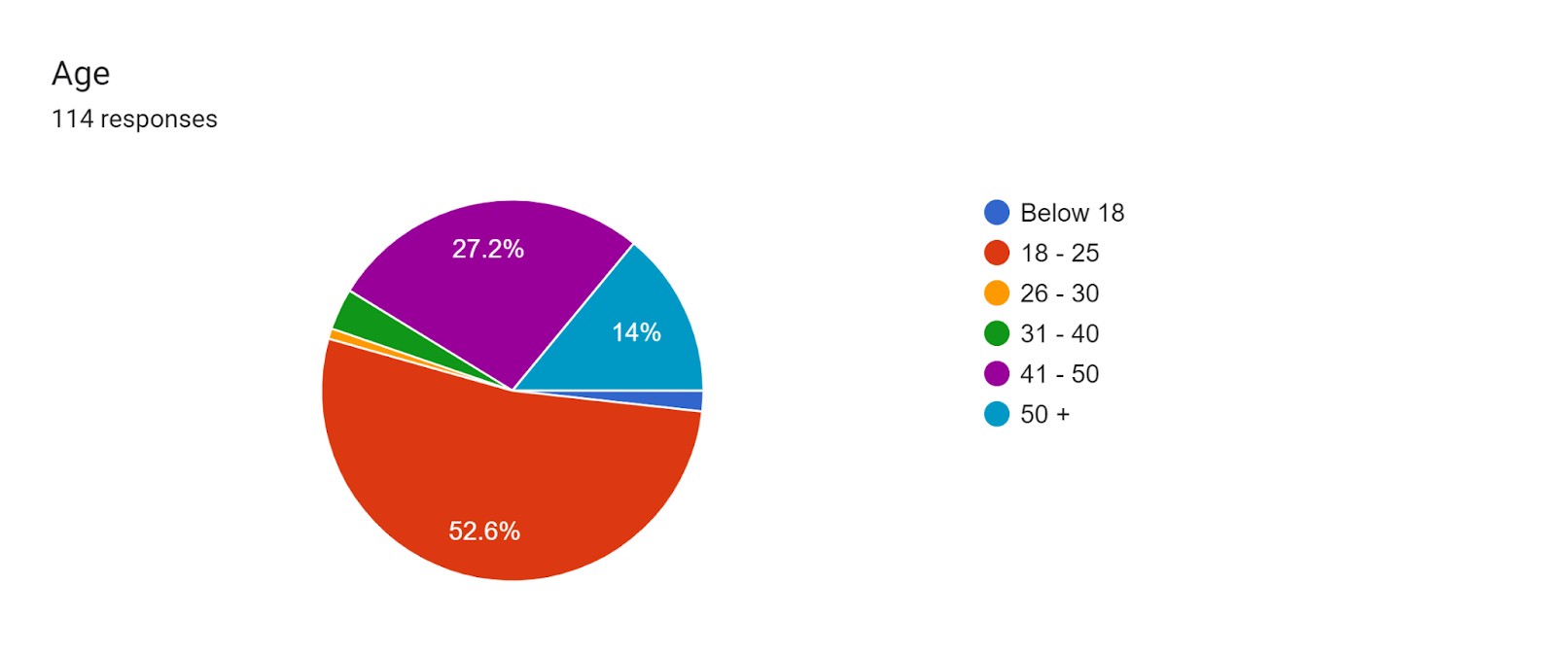

4.1. Figure 1

4.1 Table 1: Demographic Profile

|  |  |  |
| --- | --- | --- |
| Age | Frequency | Percentage |
| Below 18 | 2 | 1.8% |
| 18-25 | 60 | 52.6% |
| 26-30 | 1 | 0.9% |
| 31-40 | 4 | 3.5% |
| 41-50 | 31 | 27.2% |
| 50 + | 16 | 14% |

1. **Understanding Awareness towards purchases**

A question was asked to the respondents with a list of legacy beauty brands that have conducted or still do conduct animal testing in their manufacturing process. The respondents were not told that these brands conduct animal testing, but were just asked to choose whether or not they have used any of these brands.

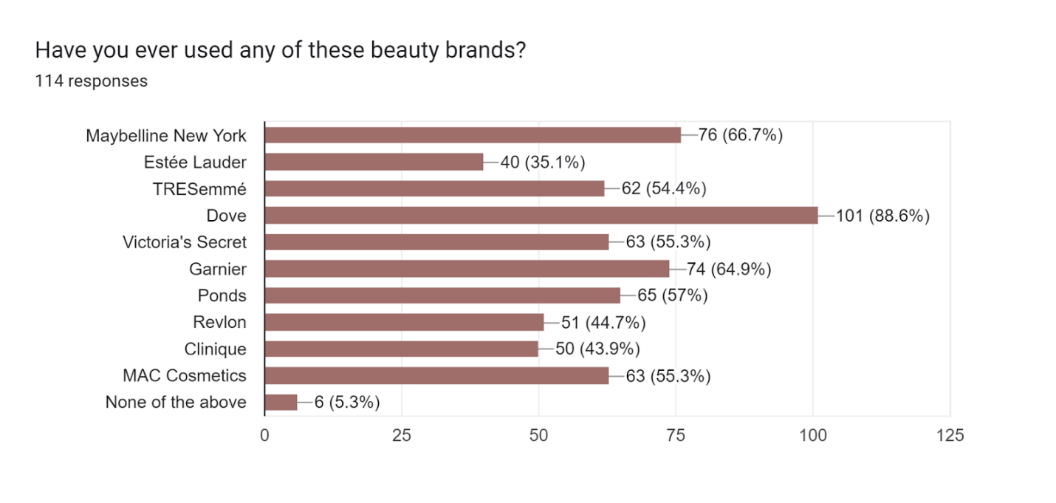4.1 Figure 2

Only 5.3% of the respondents stated that they hadn’t used any of the listed beauty brands.

Furthermore, a question was asked to see if the consumers are consciously aware if their beauty product purchases are cruelty-free or not. Only 11.4% of the respondents were aware of their purchases whereas 44.7% respondents were not aware. 43.9% were aware only about some purchases.

4.1 Figure 3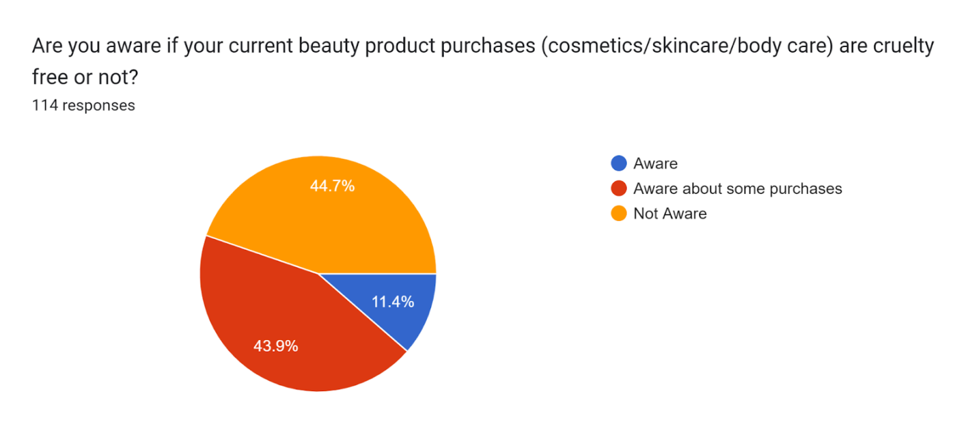

1. **Number of cruelty-free product users**

28.1% of the respondents use products that have not been tested on animals and 8.8% of the respondents use products that have been tested on animals. 63.2% of the respondents are not sure if they use cruelty-free products.

4.1 Table 2: Number of Cruelty-Free Product Users

|  |  |  |
| --- | --- | --- |
| Answers | Frequency | Percentage |
| Yes | 32 | 28.1% |
| No | 10 | 8.8% |
| Maybe | 72 | 63.2% |

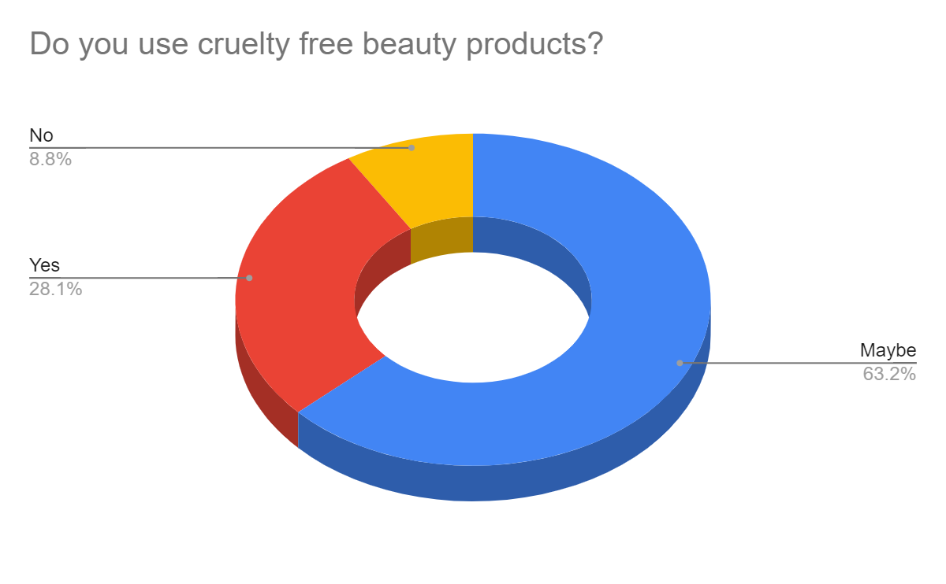

4.1 Figure 4

1. **Views on company practices**

100% of the respondents felt that companies should be required by law to disclose if they test their products on animals

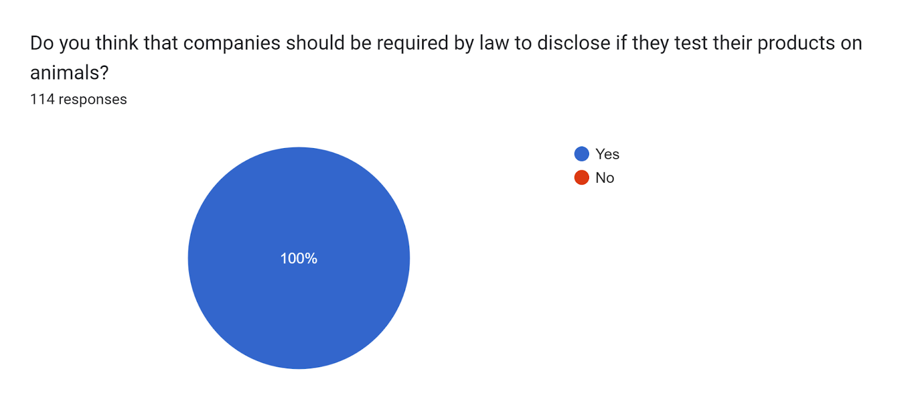

4.1 Figure 5

On a scale of 1-5, 1 being strongly agree and 5 being strongly disagree, if companies have a responsibility to ensure that their products are not tested on animals:

60.5% of the people strongly agree, 14.9% of the people somewhat agree

12.3% of the people are neutral

7.9% of the people somewhat disagree, 4.4% of the people strongly disagree

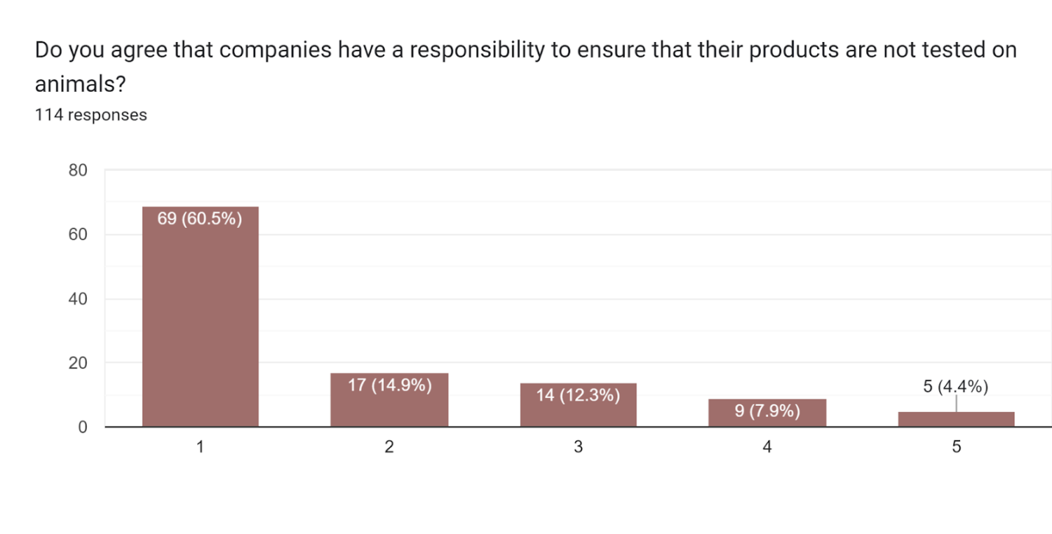

4.1 Figure 6

**5. Reasons why companies have still not changed their practices**

40.4% of respondents believe that some companies have still not changed their practices towards animal testing because alternative methods to testing can be more expensive than animal testing.

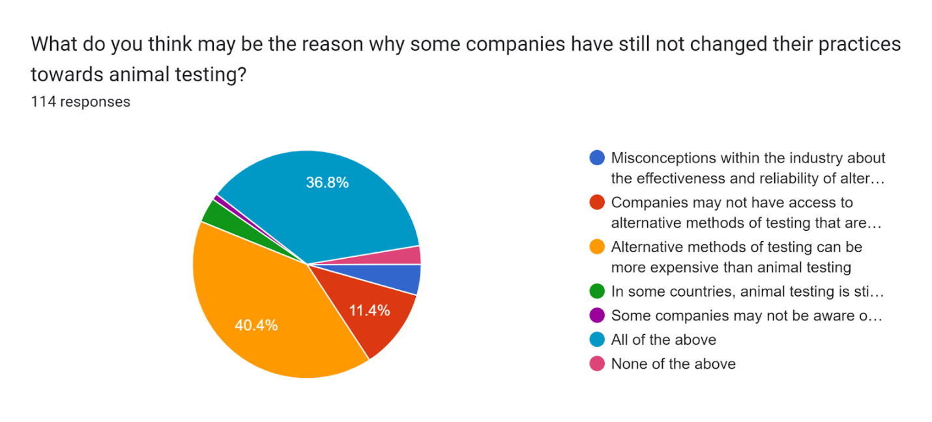

4.1 Figure 7

4.1 Table 3: Reasons why companies have still not changed their practices

|  |  |  |
| --- | --- | --- |
| Answers | Frequency | Percentage |
| Misconceptions within the industry about the effectiveness and reliability of alternative methods | 5 | 4.4% |
| Companies may not have access to alternative methods of testing that are as effective or reliable as animal testing | 13 | 11.4% |
| Alternative methods of testing can be more expensive than animal testing | 46 | 40.4% |
| In some countries, animal testing is still required by law for certain products or in certain stages of development | 4 | 3.5% |
| Some companies may not be aware of the public's opposition to animal testing | 1 | 0.9% |
| All of the above | 42 | 36.8% |
| None of the above | 3 | 2.6% |

**6. Importance given to animal welfare**

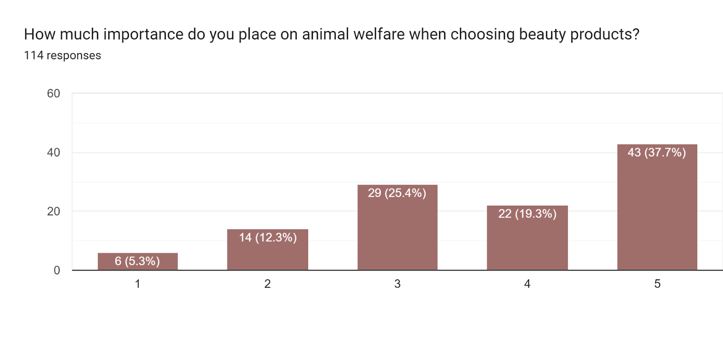On a scale of 1-5, 1 being the least important and 5 being the most important, 37.7% people place most importance on animal welfare when choosing a beauty product. 19.3% people said it was somewhat important, 25.4% people were neutral, 12.3% people said it was somewhat unimportant and only 5.3% people said that it was of least importance to them.

4.1 Figure 8

**7. Impact of marketing on purchase decisions**

55.3% of respondents purchased a beauty product because it was marketed as cruelty-free and not tested on animals. 44.7% of respondents did not purchase a beauty product because it was marketed as cruelty-free and not tested on animals.

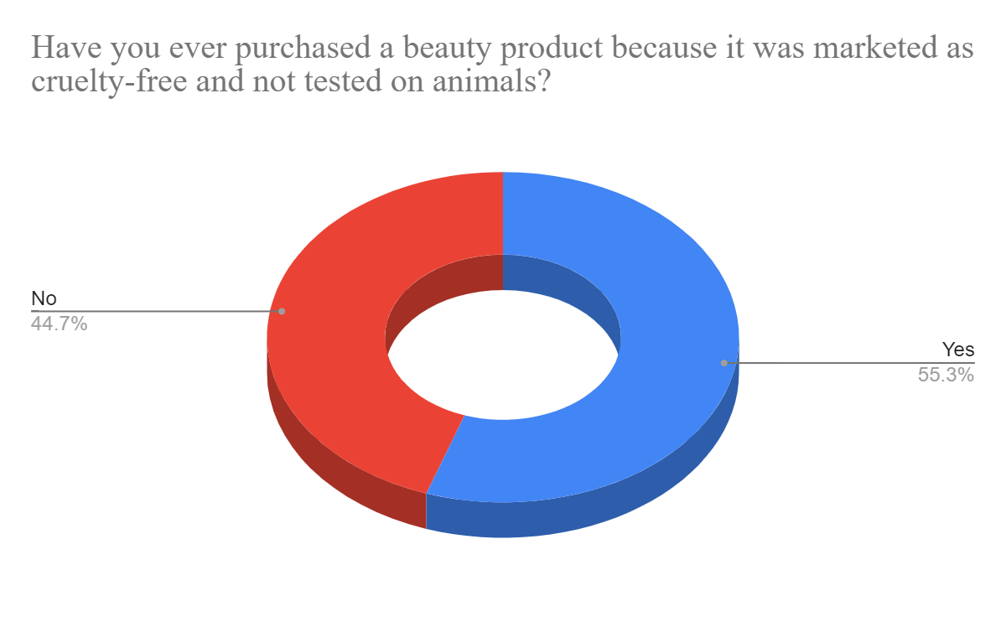

4.1 Figure 9

**8. Ethics in relation to purchase decisions**

53.5% of respondents said that they haven’t refused to make a purchase because they found out it was tested on animals. 46.5% of respondents said that they have refused to purchase a product because they found out it was tested on animals.

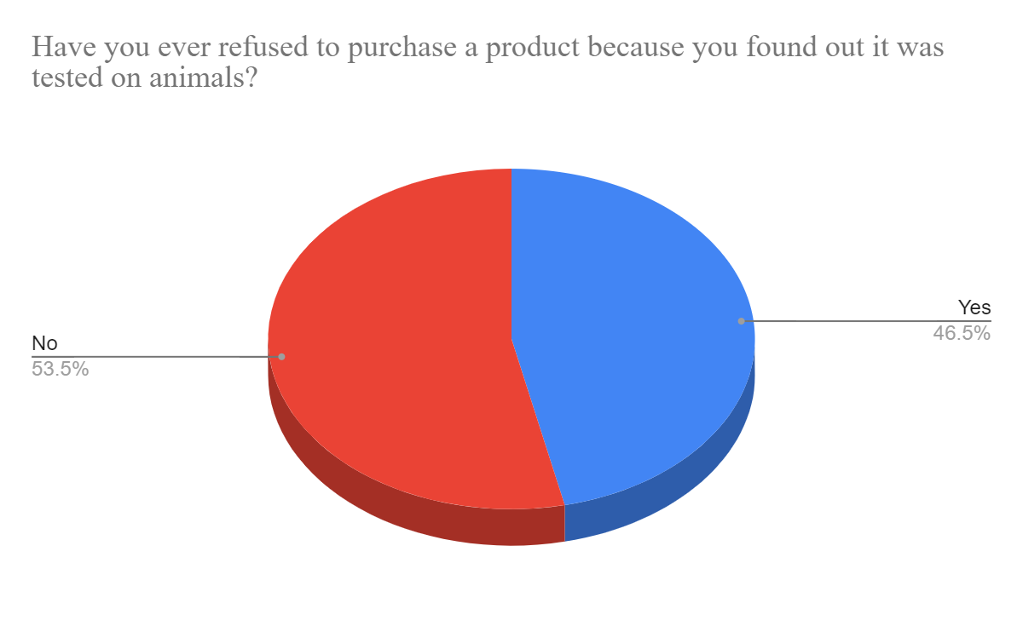

4.1 Figure 10

**9. Price affecting purchase decisions**

42.1% of respondents are willing to pay more for cruelty-free cosmetics only if there is a marginal increase. 28.1% of respondents are willing to pay a higher price for cruelty-free cosmetics. 20.2% of respondents said they might be willing to pay a higher price for cruelty-free cosmetics. 9.6% of respondents are not willing to pay a higher price for cruelty-free cosmetics.

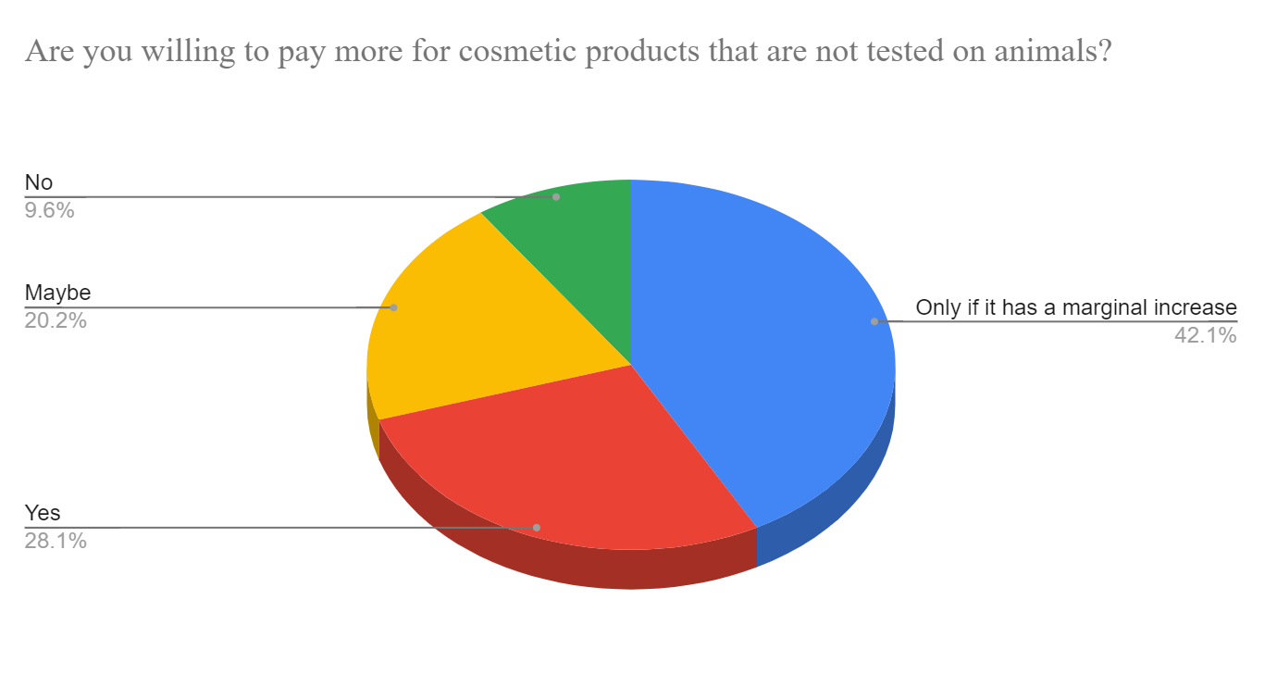

4.1 Figure 11

61.4% of respondents are willing to shift to a cruelty-free brand if it is available at the same price and quality and products that have been tested on animals. 28.9% of respondents are willing to slowly incorporate cruelty-free products in their routine till they make a switch if it is available at the same price and quality and products that have been tested on animals. 9.6% of respondents will stay loyal to the brands they have been using regardless of price and quality.

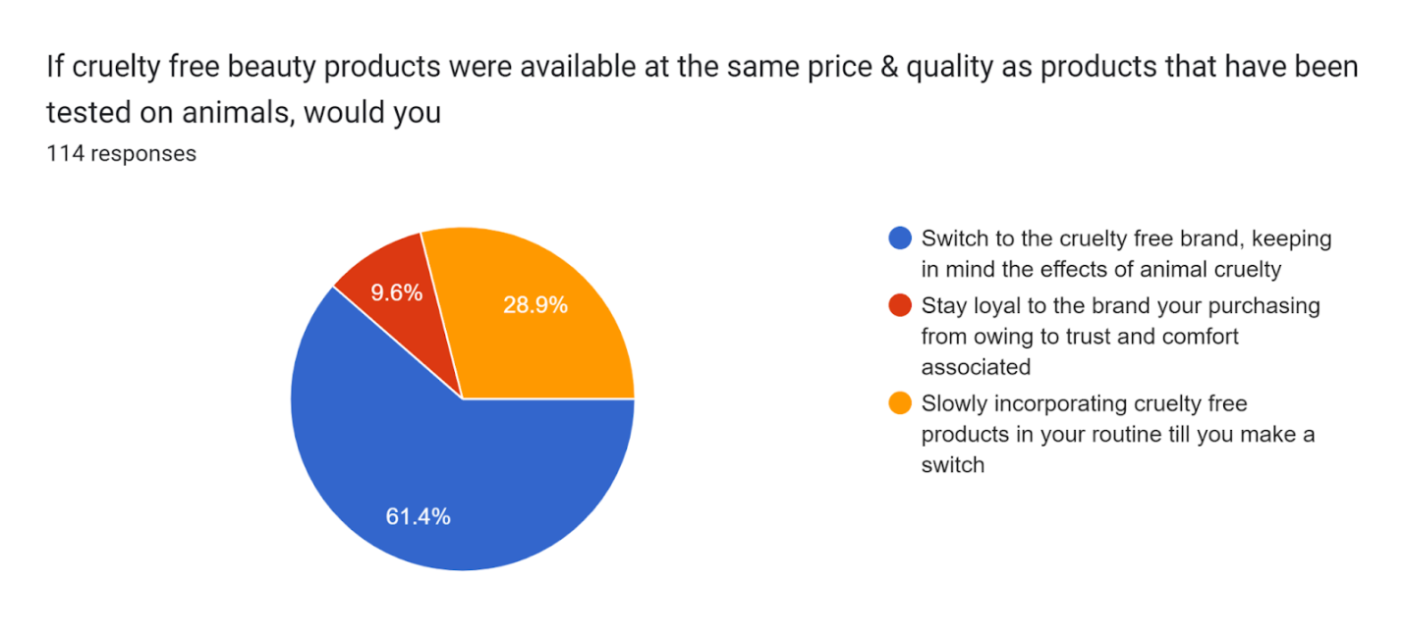

4.1 Figure 12

**10. Reason for Purchase**

An overwhelming 85.1% of the respondents purchase cruelty-free cosmetics to be more conscious about animal rights.

7% of the respondents purchase cruelty-free cosmetics for their low price.

4.4% of respondents purchase cruelty-free cosmetics due to external factors.

2.6% of the respondents purchase cruelty-free cosmetics to keep up with trends.

0.9% respondents purchase cruelty-free cosmetics for other reasons.

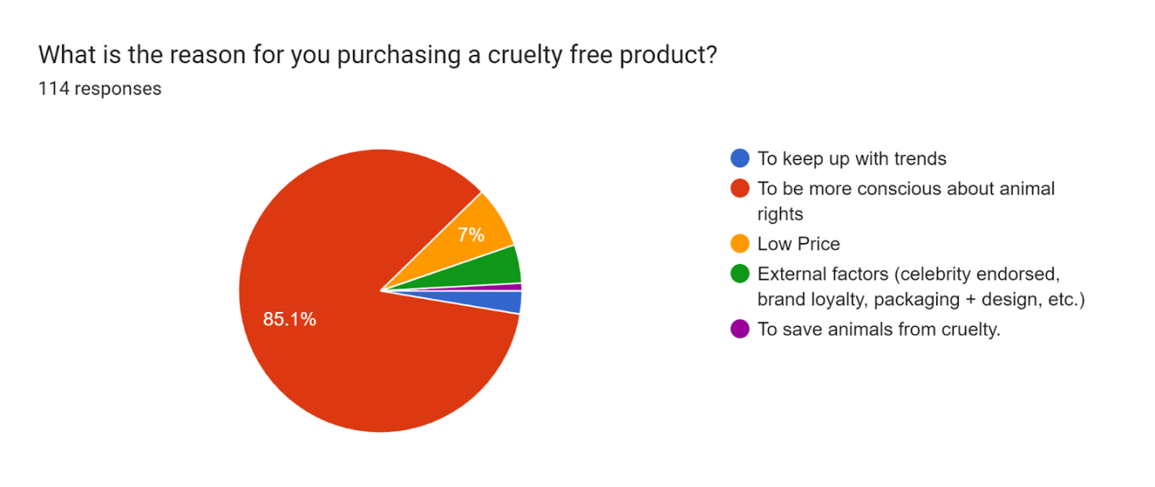

* 1. Figure 13

**11. Views on safety and reliability**

76.3% of respondents feel that alternative methods to animal testing are just as safe and reliable as testing on animals.

23.7% of respondents feel that alternative methods to animal testing are not as safe and reliable as testing on animals.

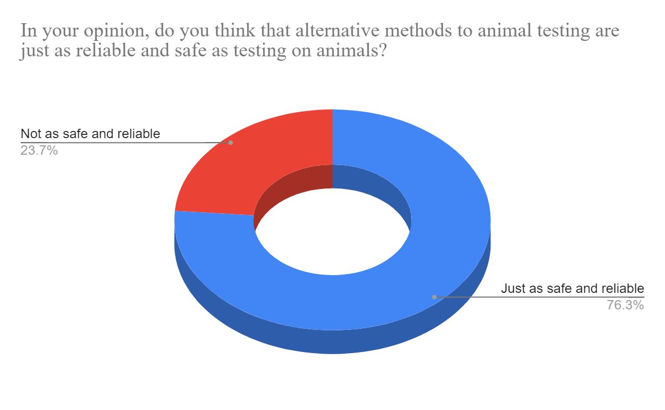

4.1 Figure 14

**15. Consumer Ethics**

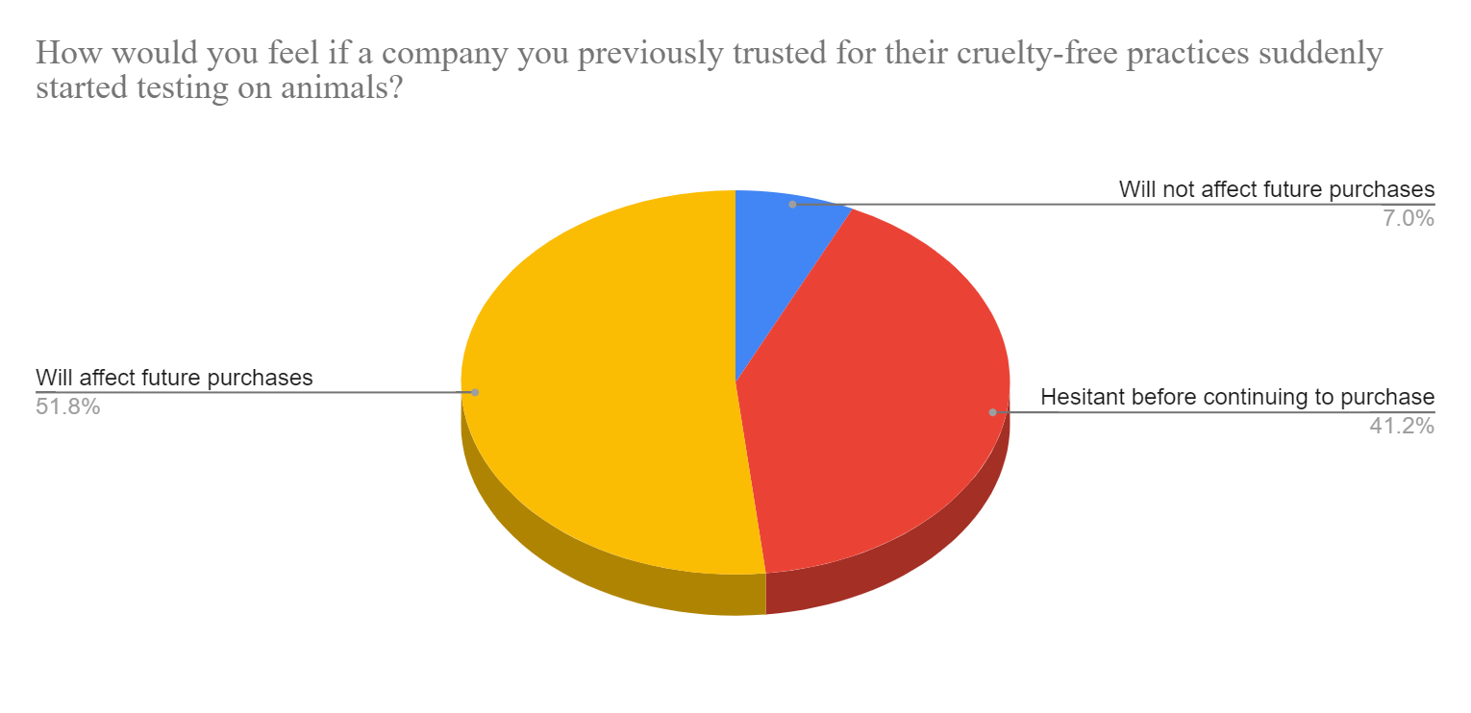If a company previously trusted by the respondents for their cruelty-free practices suddenly started testing on animals, it will affect 51.8% of the respondents’ future purchases, 41.2% will be hesitant before continuing to purchase from the brand and will not affect 7% of the respondents’ future purchases.

4.1 Figure 15

**16. Final Views**

In conclusion, 58.8% of the respondents feel that cosmetic companies that still conduct animal testing should be legally asked to change their practices

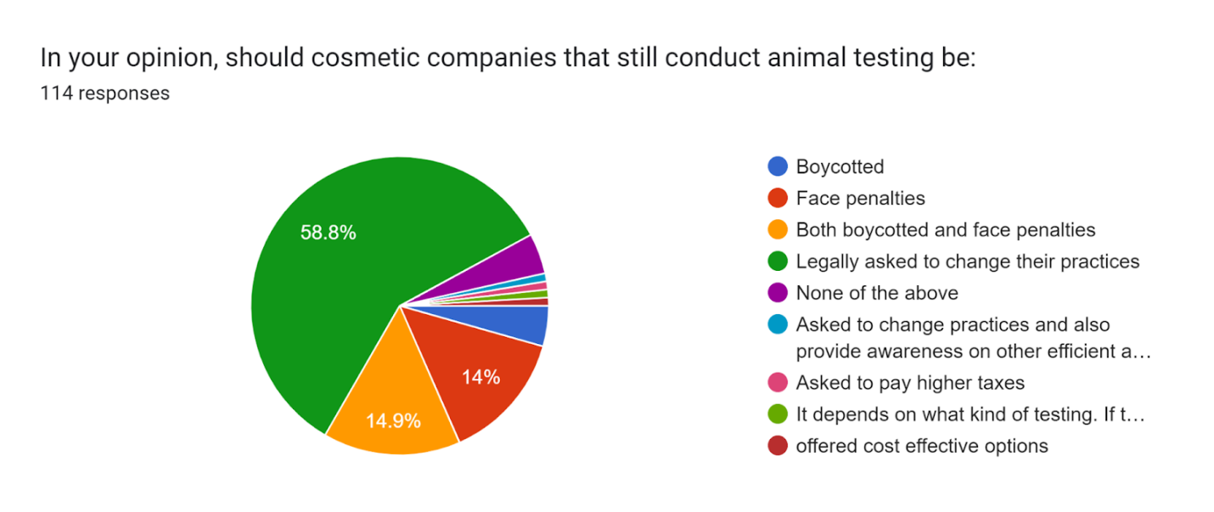

4.1 Figure 16

**Analysis of awareness about cruelty-free purchases with respect to willingness to switch to cruelty-free brands (at the same price and quality)**

4.1 Table 4 – Pivot table analysis of awareness with respect to willingness to switch to cruelty-free products

|  |  |  |  |  |  |
| --- | --- | --- | --- | --- | --- |
| **Row Labels** | **Slowly incorporating cruelty free products in your routine till you make a switch** | **Stay loyal to the brand your purchasing from owing to trust and comfort associated** | **Switch to the cruelty free brand, keeping in mind the effects of animal cruelty** | **Grand Total** | **Majority inclination towards switching** |
| Aware |  | 1 | 12 | 13 | 92% |
| Aware about some purchases | 21 | 3 | 26 | 50 | 52% |
| Not Aware | 12 | 7 | 32 | 51 | 63% |
| **Grand Total** | **33** | **11** | **70** | **114** | **61%** |

Out of the 13 respondents who are aware if their purchases are cruelty-free or not 12 are willing to switch to cruelty-free brands at the same price, which indicates 92% inclination to switch from that group.

Out of the 50 respondents who are aware if their some of their purchases are cruelty-free or not 26 are willing to switch to cruelty-free brands at the same price, which indicates 52% inclination to switch from that group.

Out of the 51 respondents who are unaware if their purchases are cruelty-free or not 32 are willing to switch to cruelty-free brands at the same price, which indicates 63% inclination to switch from that group.

**4.2 Secondary Data Analysis**

4.2 Table 5: Statistics of the Cosmetics and Cruelty-Free Industry

|  |  |
| --- | --- |
| **Fact** | **Findings** |
| Percentage of the top 50 cosmetics brands (by company value) that aren't cruelty-free | 88% (44 / 50) |
| Top 500 beauty and personal care brands: how many are cruelty-free? | 54.4% (272 / 500) |
| Top 500 beauty and personal care brands: how many aren't cruelty-free? | 45.6% (228 / 500) |
| Top 100 beauty and personal care brands: how many are cruelty-free? | 35% (35 / 100) |
| Top 100 beauty and personal care brands: how many aren't cruelty-free? | 65% (65 / 100) |
| Consumers that look for cruelty-free claims on product packaging | 35% |
| Consumers that support cruelty-free brands regardless of parent company policy | 79% |
| Size of global vegan cosmetics market in 2021 | USD $15.1B |
| Cruelty-free consumers that exclusively buy cosmetics that are both cruelty-free and vegan | 28% |
| Estimated future size of the cruelty-free cosmetics market in 2024 | USD $10B |
| Countries that ban animal testing for cosmetics | 22.5% (44 / 195) |
| People worldwide who believe animal testing for cosmetics should be banned | 70% |

*Source: Forbes, Brand Finance, Global Data, Market Research Future, CrueltyFreeKitty, Humane Society International.*

Although the term "vegan beauty," which refers to products without any animal substances, is not new, the desire for it seems to be growing. The market is expected to grow and reach $21.4 billion by 2027.

35% of customers actively search for "cruelty-free" claims on beauty products, according to a 2019 GlobalData research.

According to a survey published by ReportLinker, the global market for vegan cosmetics is projected to reach $15.1 billion in 2020 and $21.4 billion by 2027. According to the report, the U.S. market for vegan cosmetics will be worth $4.1 billion in 2020.

Moreover, 1010data reports that online sales of vegan cosmetics reached $342 million in 2020, an increase of 83% from the year before.

1. **Findings**

The research project has been benefitted by a survey of 114 responses. The findings of the survey are listed below:

1. **Awareness about cruelty-free products**

Consumers are mostly unaware of their beauty product purchases and do not care to check whether animal testing has been used to produce their beloved products. When asked to choose from a list of popular beauty brands, without telling the sample that these brands conduct animal testing, only 5.3% (6/114) of the respondents had not used any of the aforementioned brands.

Furthermore, when asked if consumers are aware whether or not their beauty product purchases are cruelty-free or not, only 11.4% of the sample was aware if their purchases were cruelty free or not.

This indicates that most consumers are ignorant to animal testing practices when it comes to their personal care purchases. With lack of awareness consumers aren’t able to make conscious choices regarding their purchases, and therefore still unknowingly support brands that continue to test on animals. One cannot expect a change at this rate.

1. **Unsurety about alternatives**

One of the primary reasons which may be causing a hindrance in the acceptance of cruelty-free brands is the doubt in the consumers’ minds regarding the safety and reliability the alternatives to animal testing offer when it comes to beauty products.

23.7% of the sample group still believes that alternative methods to animal testing are not as safe or reliable. They get comfort from the fact that the product has been tested on living beings and therefore the chemical composition will be safe for use by humans. However, they do not consider the logic that mice or other animals in labs are not little people.

1. **Reluctance to switch**

Only 28.1% of the sample is willing to pay a higher price to purchase cruelty-free beauty products. 42.1% of the sample will only be willing to pay a higher price for cruelty-free beauty products if it is at a marginal increase. This shows that just the ethical values against animal cruelty aren’t enough to convince consumers to make cruelty-free purchases, there are many other factors behind them, price being one of the most important factors. If cruelty-free products were available at the same price as the ones tested on animals 61.4% of the sample agreed to switch to the cruelty-free brand and 28.9% agreed to slowly make the shift by incorporating the new products into their routine.

Another reason that could lead to this reluctance is the brand loyalty and trust that legacy brands have built among the consumers over multiple years. Regardless of the cruelty-free products being at the same price and quality as the legacy brands 9.6% of the sample said that they would still be loyal to their comfort brands. This shows the need that it’s high time that legacy brands conform to cruelty-free practices.

1. **Animal Testing Statistics**

Of the 50 largest cosmetics companies ranked by market value as per Brand Finance in 2021, it is found that 88% fund animal testing. This indicates that 44 of these 50 businesses use animal products.

At the top, L'Oréal, which will be worth USD $10.2B in 2021, is a business that uses animal testing. Following L'Oréal are non-cruelty-free companies Gillette, Nivea, Guerlain, and Estee Lauder. The well-known companies MAC, Lancôme, Pantene, Maybelline, Benefit, and Shiseido also support animal testing.

Out of the 50 top brands, only 6 are cruelty-free: Garnier, who became Leaping Bunny-certified in March of 2021, Tresemme, who followed Garnier's footsteps in May of 2021, together with Dove, Herbal Essences, and Sunsilk, all of which have signed PETA's cruelty-free pledge, The Body Shop has been cruelty-free since the company's founding in 1976.

1. **Rising demand for cruelty products**

35% of customers actively search for "cruelty-free" claims on beauty products, according to a 2019 GlobalData research.

73% of consumers who support cruelty-free brands in the beauty industry do so regardless of the parent company's stance. These brands include Tarte (owned by Kose) and NYX (owned by L'Oreal), both of which are cruelty-free in contrast to their parent companies.

Also, there is a growing market for vegan cosmetics, which are those without any components originating from animals, such as beeswax or carmine. The market for vegan cosmetics is expected to reach $15.1 billion by 2021. According to research, 29% of shoppers who support animal rights only buy vegan- and cruelty-free cosmetics.

1. **Future of the cruelty-free beauty market**

Market Research Future predicts that the market for cruelty-free cosmetics will grow to $10 billion by 2024. This is largely due to the rise of new and independent brands; however some of the industry giants are making great efforts for their brands to become cruelty-free.

In 2019 Covergirl acquired their Leaping Bunny certification and withdrew from the Chinese market to avoid any potential animal testing. Garnier followed suit in 2021. Obtaining cruelty-free certification for a major company is a difficult procedure. In the case of Garnier, the procedure took two years and involved screening more than 500 vendors.

While many big brands are going cruelty-free, a small minority are taking the opposite route. NARS, a luxury brand owned by Shiseido, stopped being animal-friendly when it entered the Chinese market in 2017. Soon after, Eve LOM and Elemis were also removed from our cruelty-free list for the same reason.

1. **Conclusions**

The analysis of the responses clearly shows that the consumers are against animal testing practices and would like to see a change in the ways of companies that still follow these practices. Majority of the consumers said that legal action should be taken against companies that still follow animal testing to produce their products.

It was observed that even though there are various new up and coming cruelty-free brands in the market consumers are still reluctant to make that shift because of the loyalty and trust that they have formed with the brands they have been using over the years.

The research also shows that ethics is not the only factor that comes into play while making a choice between cruelty-free and cruelly produced products. People also consider other factors like price, quality, trends, marketing influences, brand loyalty, etc before making their choice. However, a change can be seen where people are consciously checking for a cruelty-free label before making their purchase.

After looking at the primary data acquired, it clearly shows the lack of awareness of consumers while making purchases for their personal care products. These purchases have become habitual over time where consumers aren’t even aware what goes into making the products they love to use. While the younger demographic is receptive to change the older demographic still shows a little reluctance to change such purchase habits.

Overall, the issue of animal testing in the beauty industry is one that both companies and customers must address.

One of the first actions one can take to effect long-lasting change is to become aware of the suffering done to animals, learn more about the alternatives, and choose items made without using any form of animal testing.

1. **Bibliography**
2. Yue Wang, Yuan Zhao, Fuhui Song. The Ethical Issues of Animal Testing in Cosmetics Industry, *Humanities and Social Sciences*. Volume 8, Issue 4, July 2020

<https://www.sciencepublishinggroup.com/journal/paperinfo?journalid=208&doi=10.11648/j.hss.20200804.12>

1. *Cruelty in Animal Testing Laboratories*. (2022b, November 30). PETA.

<https://www.peta.org/issues/animals-used-for-experimentation/cosmetic-household-products-animal-testing/>

1. *Alternatives to Animal Testing*. (2022, February 9). PETA.

<https://www.peta.org/issues/animals-used-for-experimentation/alternatives-animal-testing/>

1. *These Beauty Brands Are Still Tested on Animals*. (2023, February 24). PETA.

<https://www.peta.org/living/personal-care-fashion/beauty-brands-that-you-thought-were-cruelty-free-but-arent/>

1. Reddy, A. (2021, January 12). *Say No To Animal Testing: 6 Cruelty-Free Beauty Brands Available In India*.

grazia.co.in. <https://www.grazia.co.in/beauty/say-no-to-animal-testing-6-cruelty-free-beauty-brands-available-in-india-6508-2.html>

1. Capaldo, T. (2014, June 6). *Animal Data Is Not Reliable for Human Health Research (Op-Ed)*.

livescience.com. <https://www.livescience.com/46147-animal-data-unreliable-for-humans.html>

1. *BBC - Ethics - Animal ethics: Experimenting on animals*. (n.d.).

<https://www.bbc.co.uk/ethics/animals/using/experiments_1.shtml>

1. Rose, S. (2021, October 5). *88% of Top Beauty Brands Fund Animal Testing (Animal Testing Statistics)*. Cruelty-Free Kitty. <https://www.crueltyfreekitty.com/news/animal-testing-statistics/>
2. Larson, K. (2021, April 30). *Vegan Beauty Is On The Rise, With Brands Like Typology, The Ordinary And Lune+Aster Leading The Way*.

Forbes. <https://www.forbes.com/sites/kristinlarson/2021/04/30/vegan-beauty--brands-like-typology-the-ordinary-luneaster-lead-the-way/?sh=ff211412e0a4>