**A Study On The Performance of Private Hospitals in India**

**By Arjun Girish**

**M.com – Business Management**

**H.R. COLLEGE OF COMMERCE AND ECONOMICS**

**ABSTRACT**

Private hospitals are more popular than public hospitals nowadays, as it offers a higher level of quality of service it provides to their patients. There are a total of about 69,000 hospitals in India, out of which 43,000 are private hospitals, vastly outnumbering the public hospitals. Although private hospitals charge excessively for a minimal bunch of services, the private healthcare sector is not doing well. Often hospitals find it difficult to even break even, we can say that in a way the hospitals do not do well but the doctors and practitioners do well. The healthcare scenario has transformed over the last few decades, and almost 87% of services are provided in the private sector, making it a major stakeholder. The first decade of this century saw a growth in private sector beds by almost 70%, bringing their total share to nearly 63%. Although healthcare professionals in private enterprises are best suited to provide insights into potential areas of access from the private sector and methods to do so, their voices are seldom heard in the scientific world. Improvements in outcomes and health indicators have been reported after private-public partnerships in previous reports.

In terms of healthcare, quality in the private sector indicated that healthcare providers in the private sector were more likely to spend a longer duration with their patients and conduct physical exams as a part of the visit compared to those working in public healthcare. According to the World Bank, about 46% of India's population had some form of health insurance in 2020.

Keywords: Private Hospitals, Healthcare, Biotech, Patients

## Introduction

The private sector consisted of solo practitioners, small hospitals, and nursing homes until around 20 years ago. Many of the services, particularly those provided by charitable trusts and religious organisations, were of exceptional quality. However, as the practice of medicine has become increasingly technologically driven, smaller businesses have found it more difficult to compete in the private healthcare industry. Large enterprises, such as pharmaceutical and information technology companies, as well as affluent individuals, who are mostly Indian NRIs, have begun to profit from providing health care. They now control the upper tier of the market, with five-star hospitals staffed by foreign-trained doctors offering services at costs only foreigners and the wealthiest Indians can afford. These hospitals are largely unregulated, with no quality or pricing standards. Large profits and the ability to raise capital through foreign investments are indicators of their success.

**1.1 Growth of Healthcare in India:**

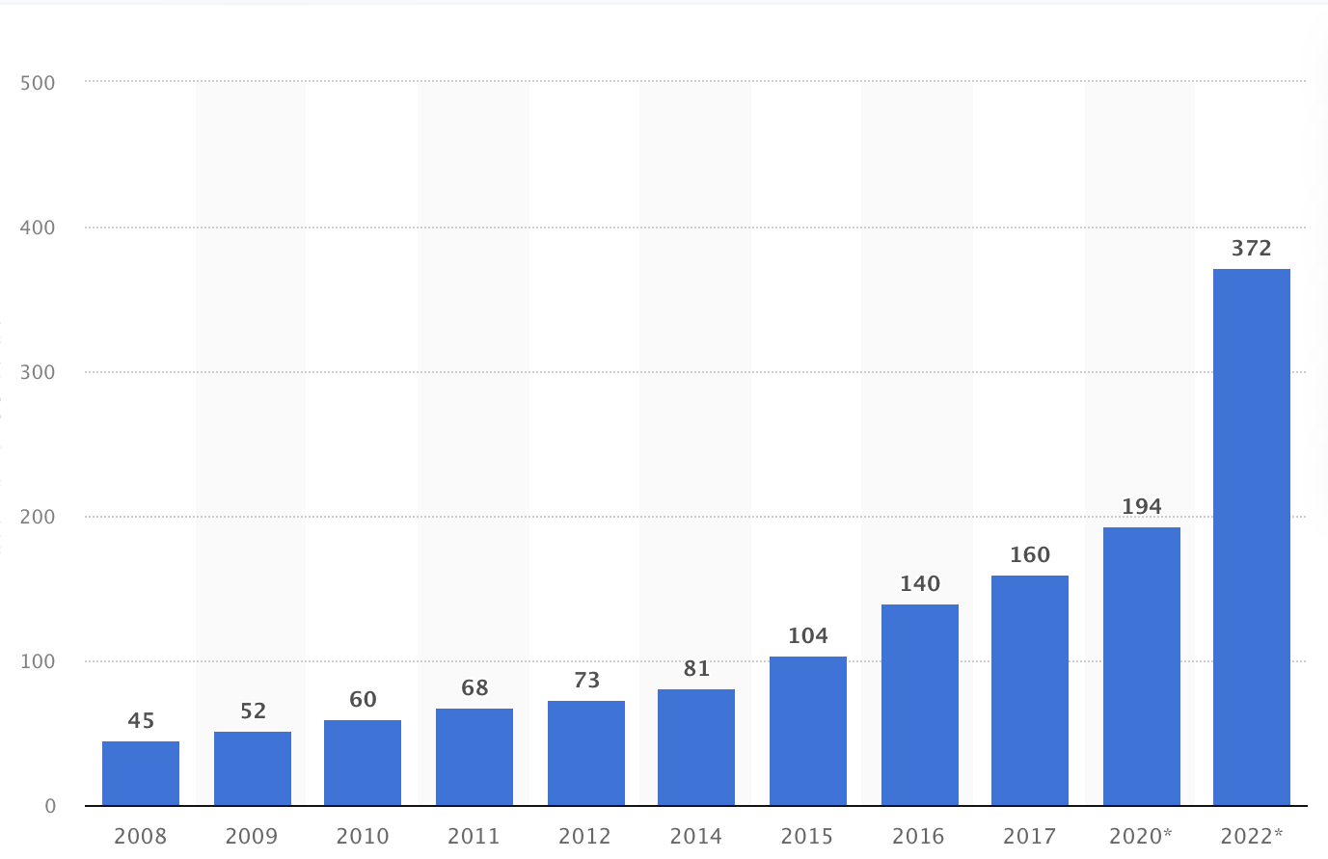

**Size of the healthcare market in India from 2008 to 2022 (in billion USD)**

Foreigners are increasingly coming to India for private health care. They travel from the Middle East, Africa, Pakistan, and Bangladesh to receive specialised paediatric heart surgery or liver transplants not available in their own countries. They also travel from the United Kingdom, Europe, and North America in search of quick, easy, and inexpensive coronary bypass surgery or orthopaedic procedures. In the UK, a shoulder operation would cost roughly 7,00,000 INR if done privately, or many months wait under the NHS. The same operation may be performed in India for less than 2,00,000 INR and within 10 days of the initial email contact.

The healthcare ecosystem's contours, context, and contents are quickly changing around the world. While the state of healthcare differs greatly among developing and developed countries, and even within them, the fundamental theme of change remains the same: minimise disease burden, maximise the reach of quality care, and reduce the cost of care delivery. This has essentially resulted in a fundamental shift in the imperatives for policymakers, providers, and the general public, resulting in the emergence of cost of care, health outcome, and health consumerism as key performance indicators of the health system, all underpinned by a quest for "healthcare" rather than "sick care."

1.2 **Private Healthcare in India:**

In India, the private health sector has undergone significant success, albeit at the expense of the public sector. Regulating it, on the other hand, may just be another chance for bureaucratic inefficiency and corruption. A better way might be to make private providers more socially accountable by making a portion of their services available to the poor.

Domestic General Government Health Expenditure for a billion Indians in 2019 was a startlingly low 1% of GDP. In comparison to other countries, India's health expenditure was quite low. While the Indian population increased by 160 million people (around 13.25 %) between 2011 and 2020, health expenditure increased by only 0.39 %. As a result, government expenditure for the fiscal year 2019-2020 was 1.29 % of GDP. In this scenario, the private sector has stepped in to fill a growing void in the supply of high-quality healthcare. Despite the government's "Modicare" plan, private "quality" healthcare comes at a "quality" price that only the rich can afford.

In 2017, the domestic private health sector, which includes households, non-profit organisations, and corporations, financed 72.1% of India's Current Health Expenditure ("CHE") (such expenditures can be either prepaid to voluntary health insurance or paid directly to healthcare providers). India's domestic private health expenditure per capita in PPP was around three times that of the country's domestic general government health expenditure per capita in PPP in the same year.

**High Costs:**

In urban India, up to 80.9% of people are uninsured, whereas in rural India, up to 85.9% don't have any health coverage. More than 80% of Indians have paid for private healthcare out of their own wallet. During the Covid-19 crisis, when ordinary citizens were forced to seek care at private hospitals, this damaged structure rained down on them. In one case, a patient was charged INR 3,73,000 for a ten-day hospitalisation. Without ventilation support, the standard treatment for Covid-19 costs INR 20-25,000 per day. The cost of a ventilator might range from INR 25-50,000 per day in some private hospitals. Other expenses, such as room rent, equipment, and monitoring, add up. The cost of a Covid-19 bill ranges from INR 3,00,000 every week to INR 16,00,000 per month.

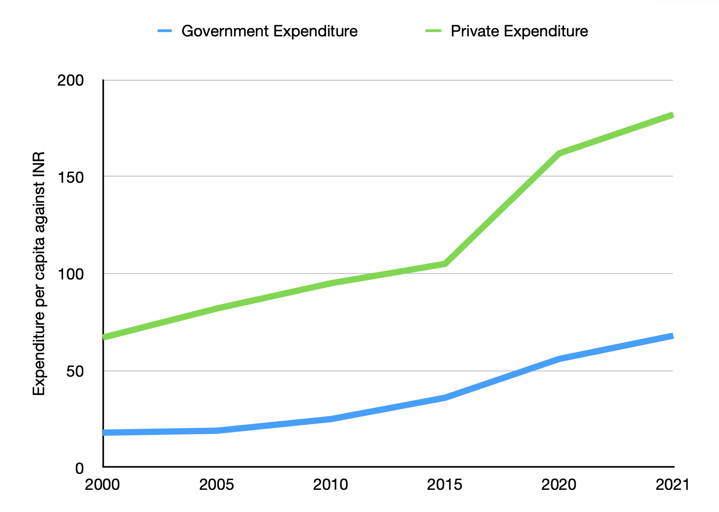

Access to health care is not solely determined by financial means. The divide between urban health infrastructure and rural health infrastructure shows an important facet of India’s healthcare story. In 2018, 72% of rural Indians only had access to one-third of India’s health infrastructure. 32% of rural residents had to travel more than 5 km to seek OPD (first contact between patient and hospital staff) treatment. The Tuberculosis rate was at an all-time high and there were around 200 incidents per 100,000 people. In 2019, India reported 2.4 million tuberculosis cases and many deaths. Similarly, India reported 120,000+ new leprosy cases in 2017, 7,000+ tetanus (that is 48% of globally reported cases), and 9,500+ diphtheria (42% of globally reported cases). While lack of basic healthcare is one side, lack of cleanliness and hygiene is the other.

1. **Literature Review:**

This paper has been prepared after thorough research from several articles and research pieces. Based on past studies conducted in India in the private healthcare sector, there is a clear indication that advocates lots of changes. In India, private hospitals are a subject of concern because they charge a heavy price for most of their services which an average middle-class man in India may not be able to afford without Medical Insurance. Although most private hospitals charge such costs, the revenue that they accrue is very negligible. Due to this disparity, there arises a need to study and analyse the performance of private hospitals in India.

**2.1 Hospitals**

Hospitals, according to the WHO, are a repository of resources and knowledge. They can be classified based on the services they provide, their roles in the health system, and the health and educational services they provide to the patients they serve. To ensure that individuals can be cared for at a reasonable cost, hospitals are constantly looking for innovative methods to assist care outside their boundaries. In a sense, hospitals are system builders; they must oversee all ongoing health and healthcare innovations and ensure that policies and incentives are coherent and aligned.

**2.2 Forecasting and future of the Health Sector**

According to R. Srinivisan (Analyst) in 2020, Individual and population health predictions can be exceedingly undetermined. All health-care projections in India, however, must ultimately be based on overall changes in the country's political economy, including progress in poverty reduction, reduction of inequalities, generation of employment/income streams, public information and development communication, and personal lifestyle changes. It will also be contingent on progress in reducing mortality and disease burden, efficient and fair delivery, and financing systems in the private and public sectors, as well as attention to vulnerable groups such as family planning and nutritional services, as well as women's empowerment, to ensure that just health care is provided to the greatest extent possible. To list them is to recall that Indian planning had attempted to capture this synergistic approach within a democratic framework at its best. It's another case that is now only remembered for its mixed success.

The Indian commitment to health development has been guided by two principles, which are as follows:

The **first principle** was the State would assume responsibility for health care.

The **second principle** was that after independence all medical care should be free for all.

**2.3** **Impact of Covid-19:**

According to an article by Ernst & Young 2020, as shown in a study, the private healthcare sector is experiencing a slowdown as a result of the COVID-19 outbreak in India and the ensuing lockdown. The research is based on a survey of private healthcare providers in the country in order to analyse the economic impact of the COVID-19 pandemic and make recommendations for fiscal stimulus measures that will be required in the coming months. For a quarter, the sector is anticipated to have short-term operating losses of Rs 14,000 to 24,000 crore. The commencement of such losses will cause cash balances to be fully emptied within a month in the hospital sector, which is already financially-strapped.

Unlike other industries, private healthcare providers and laboratories are currently suffering a triple burden, which makes their situation unique:

1. The industry was already in a very fragile state in the pre-COVID state concerning its financial state
2. Extra-ordinary drop in demand impacting cash flow resulting in difficulties in managing payrolls and fixed costs
3. Very limited amount to reduce fixed cost and perhaps accommodate the increase in costs in the context of infection control and need for Personal Protective Equipments

**3. Hypothesis**:

**H1** - People are more likely to visit Private Hospitals over Public Hospitals

**H2** - People find Private hospitals very costly

**H3** - People do not see much transparency in billing at Private Hospitals

**H4** - People feel there is favouring to a certain group of people over others in Private Hospitals

**3.1 Data methodology**

There has been a use of both primary and secondary sources in conducting the research. In terms of primary research, a survey was used to collect responses A total of 12 questions were asked in the survey, the questions have been carefully formulated starting off with basic demographic questions and leading to other detailed questions in order to gain valuable and honest insights. The survey was made in google forms. In February 2022, the survey was distributed via Whatsapp to a portion of Jaihind college students and to personal contacts living in Mumbai. Participation in the survey was completely voluntary, and the questions were in English. Secondary data has been collected from journals, articles, published reports and newspapers, etc. Articles and reports by consulting firms like Ernst & Young and Mckinsey have given detailed information on the current private healthcare scenario and patient behaviour in general in India.

* **Primary Data**

A total of 101 people have participated in filling the survey. Simple random sampling was conducted as it was an online survey closed questions have been asked so that it is quick and convenient for respondents and it will help in standardising patient attitude and perceptions for analysis. The questionnaire began with the basic demographics and then moved on to more analytical questions which would further help fulfill our research objective. The questionnaire consists of 12 questions focusing on four major components being:

* Private vs Public
* Cost
* Favoring to a certain group of people
* Suggestions for improvement

* **Secondary Data**

Secondary data has been collected from journals, articles, published reports and newspapers, etc. Articles and reports by consulting firms like Ernst & Young and Mckinsey have given detailed information on the current private healthcare scenario and patient behaviour in general in India.

**3.2 Limitations**

1. In order to track the performance of Private Hospitals in India, it would be necessary to gain responses nationwide. This is not possible due to the pandemic as well as lack of reach.
2. The survey can only be applicable for a short period of time as the performance of hospitals changes frequently worldwide.
3. Only 101 respondents are representing a population of 1.39 crore as per 2021 can cause inaccuracies, everyone has different perceptions a larger sample size should have been collected.

**4. Data Analysis and Interpretation**

**4.1 Secondary Data Analysis**

According to an EY - FICCI study, India faced two major waves with respect to the pandemic, this drastically hit the nation to the extent that the economy was shattered. Due to this, the private healthcare sector witnessed an unprecedented slowdown. The sector is expected to witness short-term operating losses of approximately Rs 14,000 to 24,000 Crore for a quarter. For the private hospital sector, which is already constrained with liquidity, the chain reaction of such losses will result in cash balances to be depleted within a month. The revenue for the sector in the financial year 2021 is also expected to be lower by 20-35% as compared to the financial year 2020, hence resulting in negative EBITDA for the full year with annual ROCEs estimated at -5 to -15%.

Source EY - FICCI Study

It is estimated that FY21 performance for the sector will be muted with revenue lower by 20-35% and negative EBITDA

Source EY - FICCI Study

The burden of healthcare costs has started to become prohibitive for the masses in urban and rural areas. This has disrupted the equilibrium that prevailed in the past, characterized by governmental neglect, public apathy, and largely unregulated play by private providers. This disruption is quite irreversible as the status quo is unacceptable to the public and consequently to politics of the time and hence change is inevitable.

Statistics show that 52% of India is insured, this is not because of any reason besides the fact that private healthcare in India is simply exorbitant.

Source EY - FICCI Study

**4.2 Primary Data Analysis**

1. Demographic profile: Age

The majority of people were between the range of 18-30 years of age comprising 53.5%, there were 7.9% below the age of 18 and 38.6% above 30.

|  |  |  |
| --- | --- | --- |
| Age | Frequency | Percentage |
| <18 | 8 | 7.9% |
| 18-30 | 54 | 53.5% |
| >30 | 39 | 38.6% |

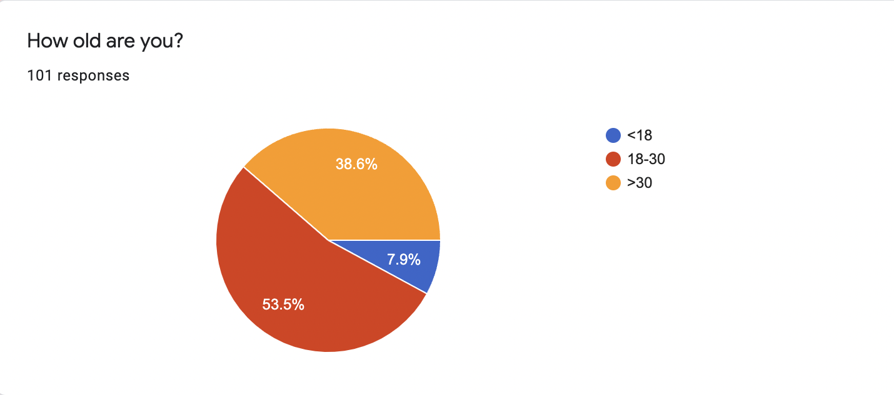

1. Private Hospital vs Public hospital?

86.1% would prefer a private hospital, 10.9% are not phased by the type of hospital and 3% would go to a public hospital.

|  |  |  |
| --- | --- | --- |
| Answers | Frequency | Percentage |
| Public | 3 | 3% |
| Private | 87 | 86.1% |
| Does not matter | 11 | 10.9% |

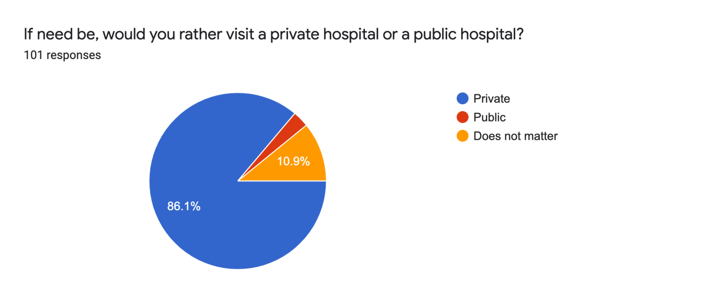

1. Level of Pricing of Private Hospitals

60.4% is more inclined towards costing being high and then there is a descending figure of 31.7%, 6.9%, and 1%. Out of the sample, there are no respondents which felt costing was low.

|  |  |  |
| --- | --- | --- |
| Levels (1 - Low to 5 - High) | Frequency | Percentage |
| 1 | 0 | 0% |
| 2 | 1 | 1% |
| 3 | 7 | 6.9% |
| 4 | 32 | 31.7% |
| 5 | 61 | 60.4% |

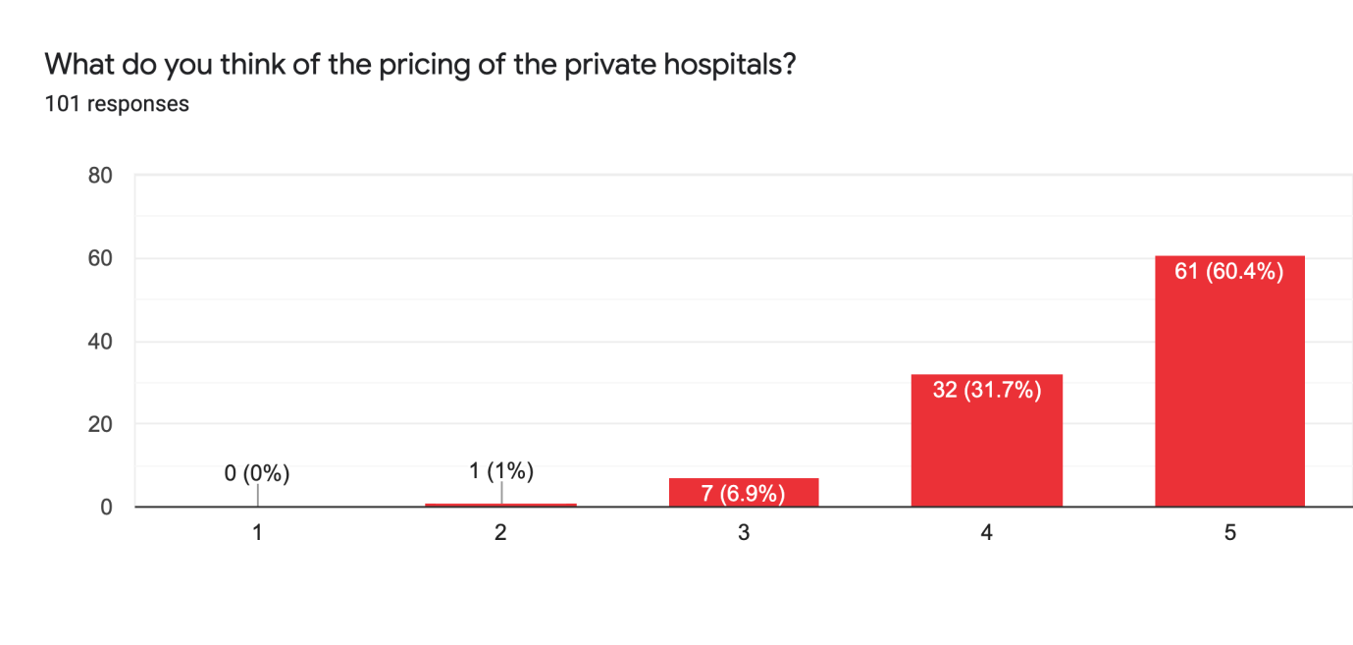

1. International treatment vs National Treatment

23.8% feel they would go abroad for treatment as compared to a higher percentage of 33.7% who feel they would remain in India for treatment.

|  |  |  |
| --- | --- | --- |
| Answers | Frequency | Percentage |
| Yes | 24 | 23.8% |
| No | 34 | 33.7% |
| Maybe | 43 | 42.6% |

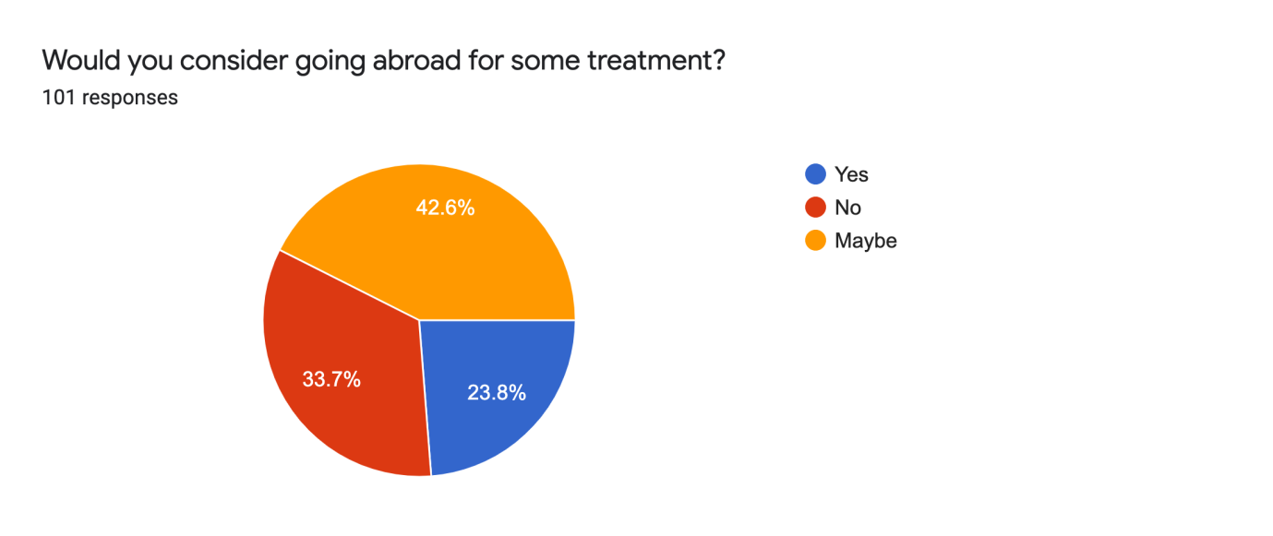

1. Transparency during billing in Private hospitals

66.3% feel there is not sufficient transparency in billing in Private Hospitals as compared to a mere 8.9% who feel there is sufficient transparency. There is also 8.9% who feel both ways.

|  |  |  |
| --- | --- | --- |
| Answers | Frequency | Percentage |
| Yes | 9 | 8.9% |
| No | 67 | 66.3% |
| Maybe | 25 | 24.8% |

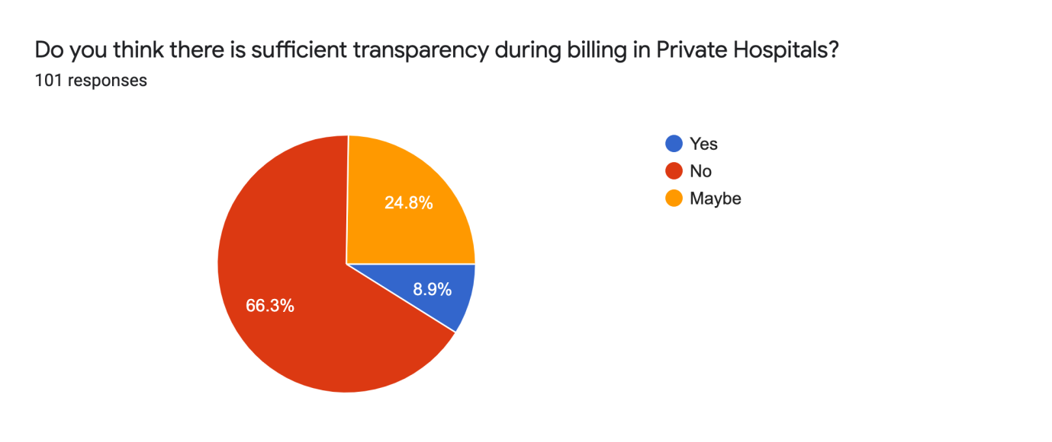

1. Has cost affected the choice of hospital/ not gone in for treatment due to cost?

38.6% has been affected due to the cost of hospitals as compared to a 41.6% which does not let their choice of hospital change due to price.

|  |  |  |
| --- | --- | --- |
| Answers | Frequency | Percentage |
| Yes | 39 | 38.6% |
| No | 42 | 41.6% |
| Maybe | 20 | 18.8% |

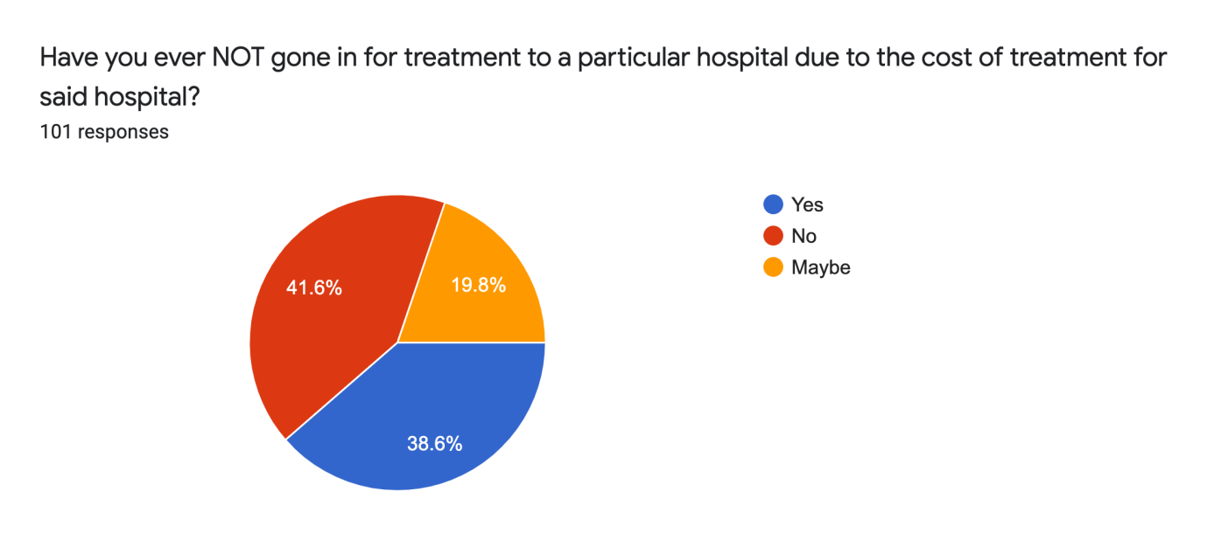

1. Red Tapism in Hospitals

54.5% feels there is Red Tapism in Private Hospitals in India, 17.8% feels there is no Red Tapism and 27.7% is not sure.

|  |  |  |
| --- | --- | --- |
| Answers | Frequency | Percentage |
| Yes | 55 | 54.5% |
| No | 18 | 17.8% |
| Maybe | 28 | 27.7% |

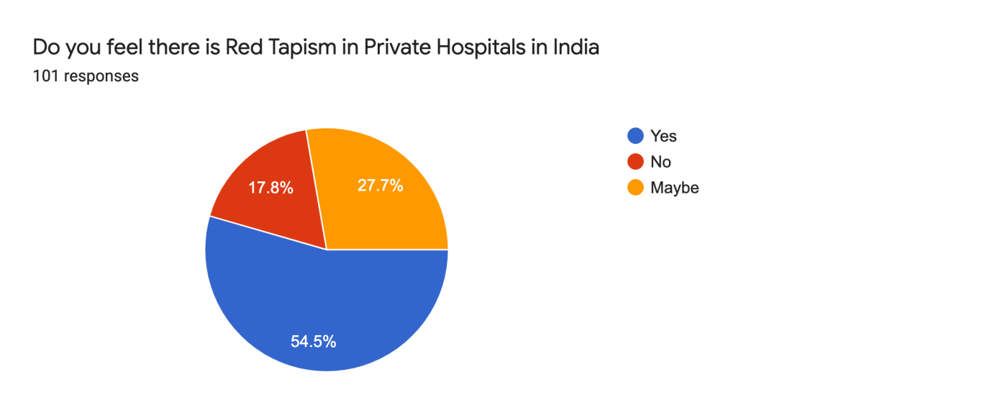

1. Favouring towards a certain group of people

68.3% feels that there is favouring to a certain group of people, whereas 13.9% feels there is no favouring to a certain group or people.

|  |  |  |
| --- | --- | --- |
| Answers | Frequency | Percentage |
| Yes | 69 | 68.3% |
| No | 14 | 13.9% |
| Maybe | 18 | 17.8% |

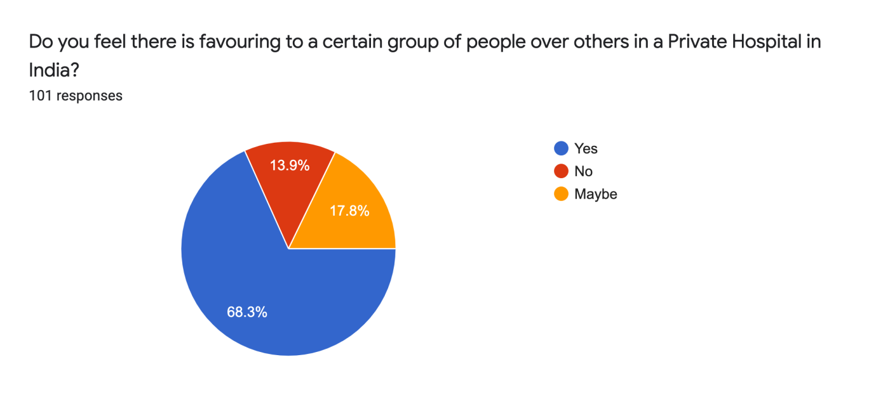

1. Awareness of MediClaim

79.2% know about MediClaim as opposed to the 20.8% who do not know about MediClaim.

|  |  |  |
| --- | --- | --- |
| Answers | Frequency | Percentage |
| Yes | 80 | 79.2% |
| No | 21 | 20.8% |

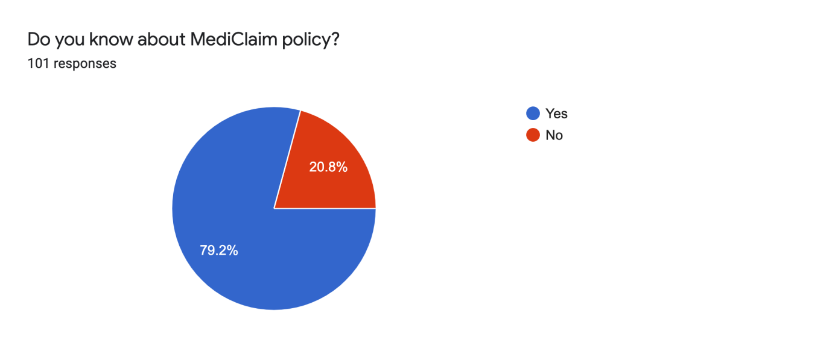

1. Ease of availing MediClaim

41.6% feel it is difficult to avail MediClaim and 24.8% feel it is easy to avail MediClaim, there is also a small amount which does not know about MediClaim and has hence chosen NA.

|  |  |  |
| --- | --- | --- |
| Answers | Frequency | Percentage |
| Yes | 25 | 24.8% |
| No | 42 | 41.6% |
| Maybe | 6 | 5.9% |
| NA | 28 | 27.7% |

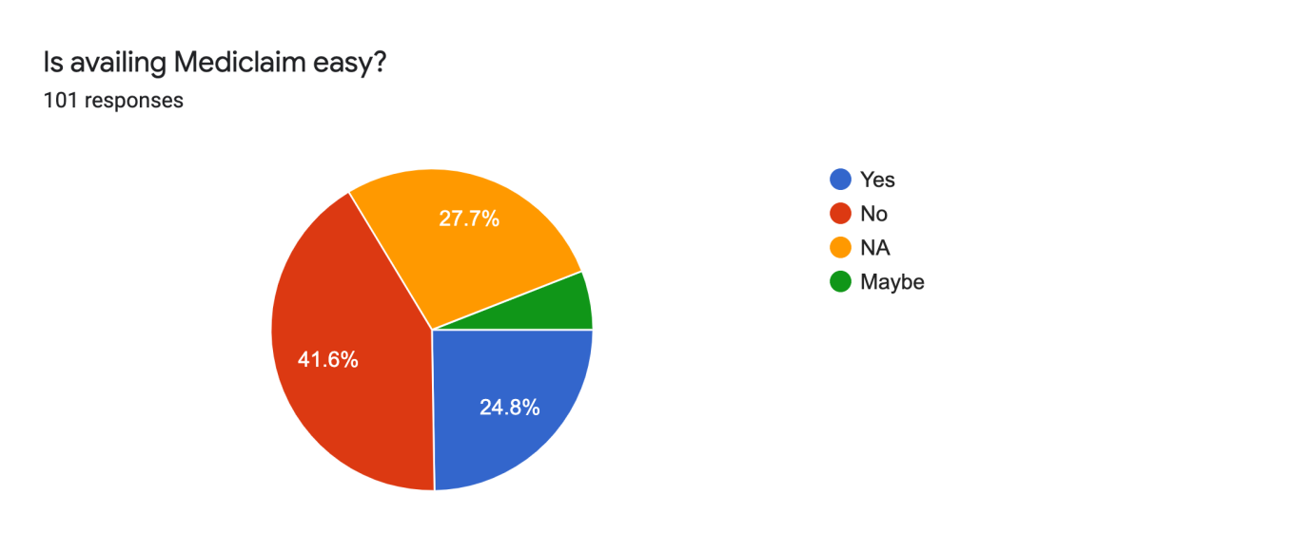

1. Bad experience in Private Hospital

54.5% of the sample felt they had a bad experience in a private hospital as compared to 45.5% who felt they had a pleasant visit.

|  |  |  |
| --- | --- | --- |
| Answers | Frequency | Percentage |
| Yes | 55 | 54.5% |
| No | 46 | 45.5% |

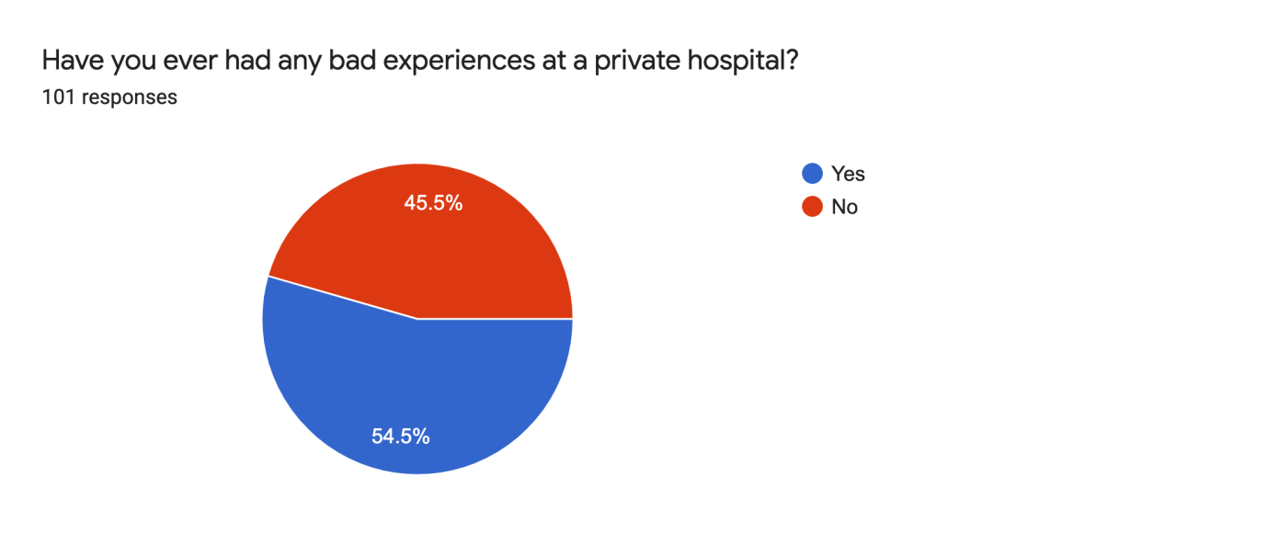

**5. Findings:**

The research project has been benefitted by a survey of 101 respondents. The findings for the survey are listed below:

1. **Private Hospitals or Public Hospitals:**

From the data, it is a clear distinction showing that the sample would choose a private hospital over a public one. This is mainly because consumer behaviour is such that if the price is high, the consumers believe that the product quality is high too. Despite this, in numerous situations, private healthcare has beaten public healthcare in terms of capacity and services.

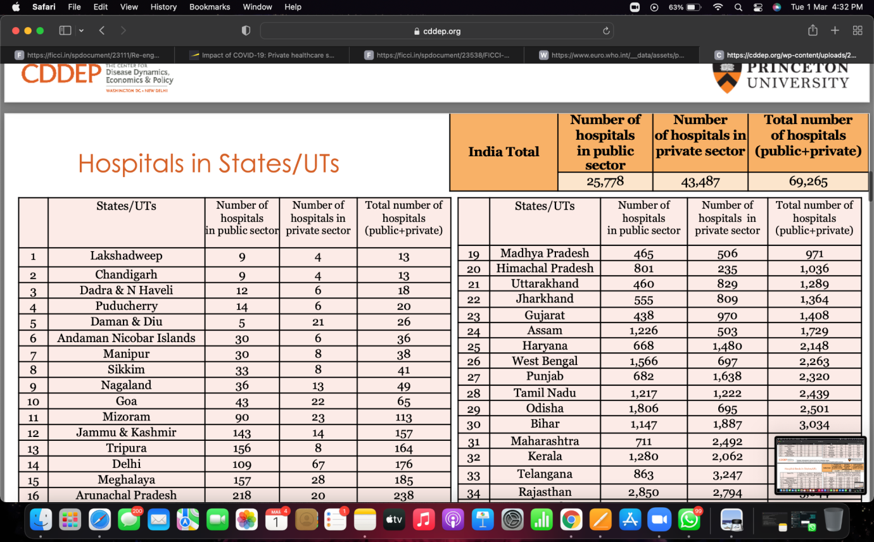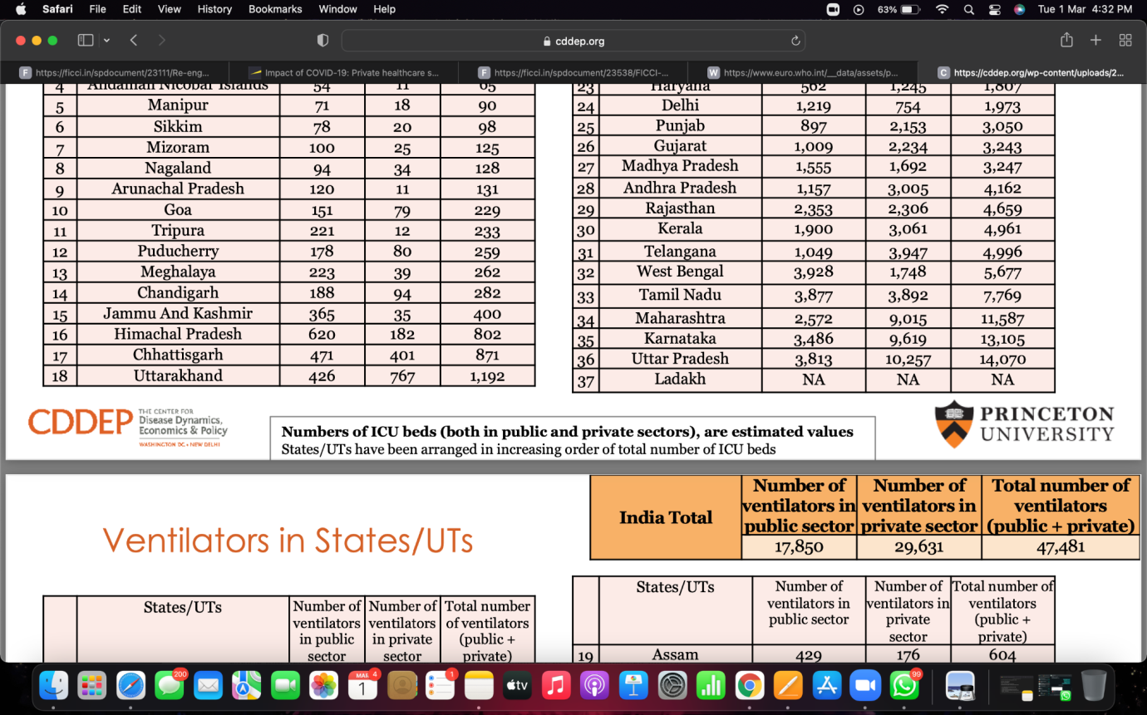

1. **Very High Price**

The majority of the respondents chose the highest level of costing which indicates that the people feel private hospitals charge excessively. As per a survey conducted by the WHO in 2017, 71% of the entire sample felt that Private Hospitals overcharge for their services. Due to the pandemic, medical insurance companies are not able to keep up with the constant rise of prices of private hospitals.

1. **Lack of transparency in billing in Private Hospitals**

A very high percentage of the sample felt that there was a lack of transparency in the billing in Private Hospitals. People either feel their bills were inflated substantially or feel there was a lack of communication between hospital and patient. Significant increases in bankruptcy related to healthcare costs for insured middle-class Indians indicate how perilous this transition has become. As costs increase, market proponents should insist that consumers have access to comparative information, the price and cost of the products or services compared, and an analysis of the possible scenarios relevant to their purchasing decision.

**6. Suggestions for Improvement of Private Hospitals in India**

Under suggestions for improvement of private hospitals in India there would be 2 major suggestions. They are as follows:

**6.1 Revenue enhancement**

India’s Private Hospitals have been at full capacity since the pandemic began until the waves tenacity reduced by a large amount. During this time the Hospitals had brief intervals where they could make changes to their management/ services which many did not. In order to improve revenue and maximise patient satisfaction, private hospitals must evaluate opportunities for improving realization per patient and optimizing capacity utilization.

Under revenue enhancement, a few more suggestions are -

1. Footfalls enhancement
2. Enhancement of revenue per footfall

Enhancing revenue per footfall or patient is achieved by focusing on three key areas:

* Cross-sell or up-sell initiatives
* Pricing optimization
* Conversion management

1. Capacity Optimisation

The key levers to optimize capacity are:

* The average length of stay optimization
* Outpatient department (OPD)
* Intensive care unit (ICU)
* Equipment utilisation

**6.2 Cost optimisation**

As mentioned above, the cost was a major factor for patient dropout as well as patient dissatisfaction, cost optimisation measures focus on reduction of direct and indirect cost heads. Hospitals need to maintain a fine balance between cost rationalization and staff adequacy to maintain patient safety and quality standards. The key aspects that need to be analysed for cost optimization include medical and non-medical consumables cost, clinician cost, other employee cost, sales and marketing cost, and other overheads.

Under Cost Optimisation, a few more suggestions are -

1. Direct costs reduction

The key enablers for reducing direct costs are -

* Package standardisation
* Optimising consumption efficiency
* Enhancing procurement efficiency

1. Overheads Optimisation

While many leading hospital chains in India have worked on improving consumption and procurement efficiency, very few have systematically tackled costs related to physicians, other personnel costs, and other overheads. Optimizing overhead costs would entail improvement initiatives in three key areas:

* Clinician engagement model
* Other personnel cost
* Other major overhead costs – administrative, shared services, power, and utility

**6.3 Some other suggestions for improvement**

* Know exactly what the patient needs and give the patient that itself, nothing more. This would benefit both the hospital as well as people as there will be a lesser disparity.
* Increase branding and promotions for Private Hospitals which are not as well known as the major players. People tend to go to a more well-known hospital over a lesser-known one on the basis of thinking that the more well-known one could offer better treatment.
* Leveraging analytics is a new game-changer when it comes to the growth of private healthcare, collecting relevant data to drive decision-making has to become a cultural theme in the private healthcare sector. Cutting-edge data analytics can impact decisions and outcomes related to positioning, staff optimization, and productivity improvement.
* In order to control costs, it is most important to recognise them first. Once recognised, one can make the necessary changes to improve them.
* Short-term interest-free loans can be given to address the operating losses expected for the quarter and immediate 100% release of dues which are locked with central and state government authorities.

**7. Conclusion**

The analysis of responses clearly indicates that the majority of the sample found private healthcare to be excessively expensive and found the healthcare systems to be lacking in some ways. Although the private healthcare sector has an immense amount of overhead and indirect expenses, should try to reduce pricing in some way. The sector should view a patient as a patient and not view their financial background. The private healthcare sector has changed over the last few decades in many ways. It was observed that people choose private healthcare over public healthcare, knowing this the private sector should not try to monopolise the situation and increase costs making it unaffordable to a large sector of India. Although the pricing is high, people would still pick Indian hospitals over hospitals abroad, this is a big revelation considering the price difference. We can say that people in India trust the service provided by the sector and do not trust the sector due to its pricing. Private healthcare during covid has changed a lot as well, there are now ways to consult a doctor without actually going to a hospital, using “online apps” like Practo. Private hospitals witnessed a slowdown due to these reasons due to Covid - 19. Although one must think that the revenue generated by a private hospital would increase during a global pandemic, this is not the case. The Hospitals generated the greatest proportion of their income from surgeries which people would avoid as much as possible at the time of Covid - 19.

From the research above we can conclude and say that the Private Hospitals of India are not performing at peak performance, despite this we can further go on by saying that the performance of Private Hospitals in India can vastly improve in the coming years. With respect to visible changes statistically, we would be able to see the changes by 2040. They will have different business models, different delivery models and by then there would be “smart hospitals” which would have lesser human touch.

**9. Bibliography**

1. <https://ficci.in/spdocument/23111/Re-engineering-Indian-healthcare-2.0_FICCI.pdf>
2. <https://cddep.org/wp-content/uploads/2020/04/State-wise-estimates-of-current-beds-and-ventilators_24Apr2020.pdf>
3. <https://www.ey.com/en_in/life-sciences/impact-of-covid-19-private-healthcare-sector-calls-for-urgent-financial-stimulus>
4. <https://www2.deloitte.com/global/en/pages/life-sciences-and-healthcare/articles/global-health-care-sector-outlook.html>
5. <https://www.euro.who.int/__data/assets/pdf_file/0009/74718/E82975.pdf>
6. <https://www.mckinsey.com/industries/healthcare-systems-and-services/our-insights/survey-us-hospital-patient-volumes-move-back-towards-2019-levels>
7. <https://www.mckinsey.com/~/media/mckinsey/dotcom/client_service/Healthcare%20Systems%20and%20Services/Health%20International/Issue%2011%20new%20PDFs/HI11_80%20MgmtMatters_noprint.aspx>
8. <https://www2.deloitte.com/cn/en/pages/life-sciences-and-healthcare/articles/china-lshc-investment-and-financing-strategies-for-private-hospitals.html>
9. <https://ficci.in/spdocument/23538/FICCI-EY_Report.pdf>
10. <https://www2.deloitte.com/us/en/insights/industry/health-care/hospital-business-models-of-the-future.html>