**Indian Women in the Digital World**

**Ms. Bhavna Chandrani- Post Graduate Student H.R College, HSNC University - Mumbai**

**Abstract:**

The most popular word in today's era is "Digitalization." Without digitization, development is not possible. We cannot achieve our development goals, which we aspire to as long as we do not digitize.

People all over the world are using the Internet. Internet is also fully used in India. But in India, the number of men in the area of internet usage is much higher than women. The 'Digital India program’ was approved on 20 August 2014 under the chairmanship of Prime Minister Narendra Modi. Most of the Indian women still have not got the facility of digital literacy. It may not prove beneficial for women until they have access to digital literacy. This means that women do not get the benefit of joining the online world. In a developing country like India, men have a monopoly on digital facility. If we look at the data, we find that more than half of the women in the country do not have mobile. For the dream of Digital India, India is moving fast in terms of using internet or mobile, but in this revolution, women are far behind men. As a result, despite the encouragement of digital literacy, a large population of women has not become literate.

The main objective of the study is to focus on women's trends in digital content. This paper analyzes what is the status of Indian women in digital literacy and what is the impact of "Digital India Program” on women empowerment. In this paper, 50 women have been selected to analyze the status of women’s digital literacy.

Keywords: Digital India Program, Gender discrimination, Opportunity Challenges

Digital India is a visionary plan of the Indian Government, under which citizens from Kashmir to Kanyakumari will have access to the home through government services online facility. Digital India is actually a platform built by the coordination of the Internet, networking, hardware, mobile, computer, software, which connects the citizens directly to the government, simplifies the use of facilities and gives information about government services. With this facility no part of the country will be missed, the rural areas of the country will be connected to the fast Internet network. Digital India has three main components to make this plan a success.

1. Establishment of an effective digital infrastructure in the country

2. Digital services of services and facilities

3. Digital Literacy

Digital India is changing the nature of the program in which it is arranged to make all government services available to the public in digital form that is people can be directly involved in availing government services. Under the Digital India program, all government services are ordered to be made available to citizens in digital form. While ensuring the compulsory availability of government services in the digital form, where this program will accelerate public accountability, it will also provide the benefits of the latest information and communication technology to the citizens by providing easy access to government services. For the first time, the Government of India is running an ambitious campaign to bring basic services like education, health, banking and social welfare through door to door through the Digital India program.

The report by McKenzie Global Institute, 'Digital India: Technology to Transform a Connected Nation', reveals the fact that India is moving rapidly towards digitization. The number of Internet subscribers in India has reached 56 million and, in this context, it is now ranked second in the world after China. The contribution of core digital sectors like information technology-business process management (IT-BPM), digital communications, and electronics manufacturing to India's gross domestic product (GDP)may increase from seven per cent in 2017-18 to eight to 10 per cent in 2025, says a new report from McKinsey Global Institute. This is a proof that in the future of India, the digital sector has become more powerful.

**REVIEW OF LITERATURE**

Gupta and Arora (2015) **“Studied the impact of Digital India Program on rural area of India”,** The study found, in rural areas Several schemes have been launched in Digital India to boost agriculture sector and entrepreneurship. The Digital India program has also set the stage for the empowerment of rural Indian women.

Biswas, Suprio (2016) ' **Digital India: A Unique Step towards E-learning in India',** This research paper covers e-learning, e-Governance, mobile connectivity, information and communication technology for change in education. Analysis of this paper concluded that digital India programs help in using modern technology in education and also save time and money.

Shafiullah, Shaik (2016) **“Digital India: the Future of India”,** This research paper analyzes the role of the Digital India program in India's future creation. In this research, it was found that around 40% of the people living below poverty line are living in rural areas who do not have basic facilities, so the Digital India program will not be successful unless it is focused on these facilities.

Khan, Saima (2015) **"Digitization and its impact on Economy”,** in the research paper, has highlighted the impact of digitization on the economy, under which information and communication technology is considered to be the basis of the economy. Through the digitization, social economic change can be done. Increase in employment and improving lifestyle and increasing knowledge can be included.

**OBJECTIVES**

• To study the concept of Digital India program.

• To study the impact of Digital India program on the development of Indian women.

• In this paper it is attempted to study whether there is gender discrimination in the use of digital content?

• To know the challenges and Opportunities of digital world for women.

**RESEARCH METHODOLOGY**

This research paper is based on Primary and secondary data. The secondary data has been collect by various website, articles, journals and reports of various ministries. In this paper 50 women have been taken for the study, who are between 15 and 60 years of age. This research group consists of students, working women and housewives (As in figure No. 1. Is shown). What do you think about these women in terms of digital content? Data has been collected by primary sources to find out. The questionnaire method has been used to collect data. These women belong to diverse social, economic and culture groups.

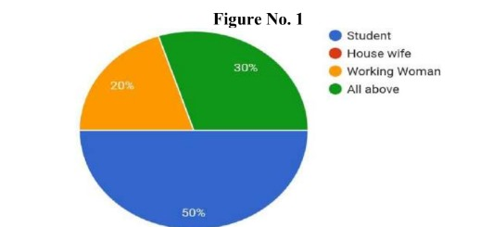

In this paper, we have tried to find out in which activities women use digital resources the most and their answers are given in Table No. 1. It is clear from Table No. 1 that the maximum use of digital resources is done by women for Study and Professional, which makes their allegiance to development clear. Women use equal amounts of digital content for entertainment and shopping. The least digital content is used for other purposes.

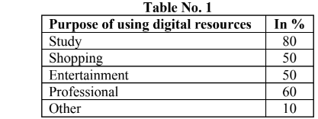

Do you believe that there is gender discrimination in the use of digital content, this question was asked from the women involved in the research, the answers received by them are shown in **Figure No. 2.**

40% of the women involved in the research believe that there is no discrimination of any kind against women. It is a reflection of the developed thinking towards women in the society. 10% of women believe they are discriminated against in using digital content, this research includes people of diverse socio-economic status, so women are still discriminated against using digital content Is confronted, which explains the narrow path towards women. There is a group of 20% women who do not express any definite opinion about this type of gender discrimination.

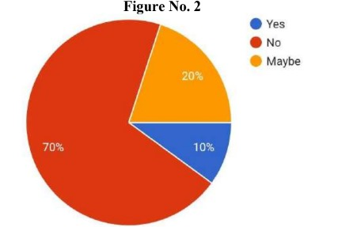

You are aware of the steps taken by the government to create digital literacy among women, in response to what 50 women have said, shown in Figure No. 3. 50% of women are aware of programs designed by the government to increase digital literacy. The same 50% women are also unaware of this type of program.

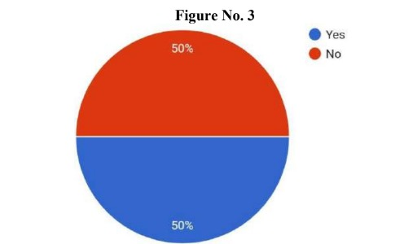

Which of the following components do you find responsible for the lack of digital literacy in women? The answer given by the women included in the research group is shown in Figure No. 4. About 44% of women responsible the economic component to lack of digital literacy. On the other hand, 33% of the women are those who consider the social component responsible in the absence of digital literacy. There is also a group of about 22% women who consider the culture component to be the reason for the lack of digital literacy. In short, we can say that the women involved in the research group considered social, economic and culture all three factors as the reason for the lack of digital literacy.

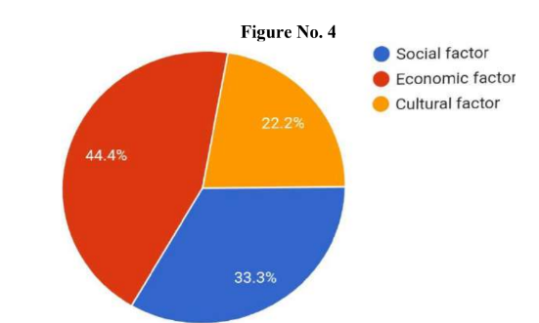

Do women face criminal problems related to digital content? In this context, 90% women believe that as a woman, they have to face this type of problem. This means that while using digital resources by women, there is a need to be alert to this type of problem. There are 10% women who believe that they do not have to face any kind of criminal problems. As we are growing in the field of technology, we are also becoming active in the field of crime. Earlier violence took place in homes, on the streets, which could be controlled in one way or another. But it is impossible to control the Internet world. Online violence and harassment against women become a major problem. Cyber-crime can not only break a woman mentally, but can also harm her physically and financially.

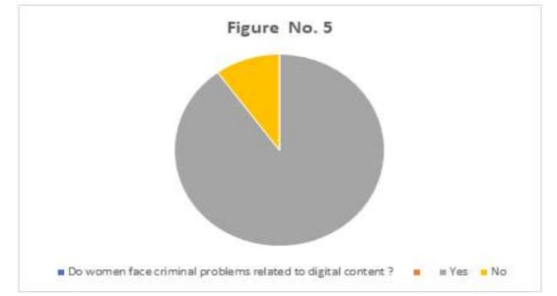

Should women use digital content for full development? 50% of women believe that the use of digital resources will lead to full development of women. 30% of women strongly agree that women should be development through digital resources. 10% women neutral and 10% women respectively disagree that women will develop only through digital resources.

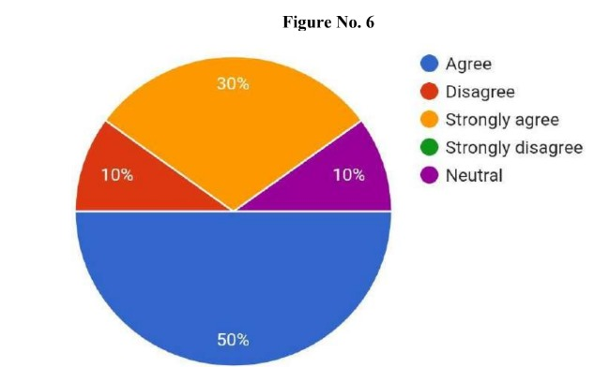

**Opportunities for Women in Digital World**

Digitalization has revolutionized technology and communication, which has never happened before. With worldwide broadcasting capacity, it has changed the lives of billions of people, especially women. It is an important link of ideas, opportunities and resources. It paves the way for women around the world to imagine new possibilities and make the possible ‘We Think Digital' is Facebook's global digital literacy program, launched in 2019 by Facebook, aimed at reducing gender inequality on the Internet. Recently Facebook has launched 'We Think Digital' campaign in Uttar Pradesh in association with National Commission for Women and Cyber Peace Foundation. Under this program digital literacy will be provided to about one lakh women in 7 states of India. This will bring positive changes in the coming days of the progress of Indian women.

Reliance Jio by Mukesh Ambani, the country's largest mobile data network, has joined hands with GSMA to increase digital literacy among women and improve sex ratio. The initiative, called Jio's 'Connected Women Initiative', aims to bridge the digital gap between women in the country and the gender gap of digital literacy and connect more and more women to the digital world. Under this initiative, Jio and GSMA will try to make women use digital services more and more.

The company has said that the use of mobile and internet technology has changed the lives of people in recent times, but the gender gap in the adoption of mobile phones in the country is very much visible. Jio has taken steps towards providing equal opportunities to all with its commitment to reduce this gap from the time of entering the telecom sector.

Launched in partnership with Tata Trust, "Internet Saathi" was launched in 2015 to enable women in rural Indian villages with internet skills. With equal access to information from an effort like "Internet Saathi", women are not only exposed to the knowledge of the world but also have increased possibilities to start new businesses.

Like the real world, digitization can also be an ugly place for women. But it also gives them a powerful tool. The #Me Too campaign showed how women can access their voices and concerns using digitization.

**CHALLENGES OF DIGITAL INDIA PROGRAM FOR WOMEN:**

* Over the years, many government services have been digitized and some of these are only available online, leading to inequality to women who are digitally illiterate
* The digital divide created by the lack of reliable information, infrastructure and digital literacy can lead to social and economic backwardness of women.
* The most prominent problem in the digital revolution will be power. Therefore, we should also consider alternative use of electricity (like solar energy).
* The biggest challenge faced by Digital India Program is slow and delayed infrastructure development.

**FINDINGS**

* With a view to making women strong, independent and self-reliant, the schemes announced by the government should be widely publicized.
* Digital India program has made women aware of their rights due to easy access to information.
* Education in the women category especially technical education training should be included.
* The Digital India program has also opened up the option of better education for women living in remote areas who do not yet have this type of facility.

**CONCLUSION**

The digital revolution in India is important because it has transformed massively in almost all sectors of society. To get the full benefit of this, it is necessary that the barriers facing them like digital literacy and lack of digital infrastructure etc. are removed in time.

**REFERENCES**

• Biswas, Suprio (2016) Digital India: A Unique Step towards E-learning in India A Peer Reviewed

Monthly Research Journal, ISSN: 2394-7969 (Online), ISSN: 2394-7950 (Print) Volume-I,

Issue-XII, January 2016, Page No. 64-70.

• Gupta Neeru and Arora Kirandeep (2015). Digital India: A Roadmap for the development of Rural

India. International Journal of Business Management, vol (2)2, pp1333-1342. Retrieved from

www.ijbm. Co.in

• Shafiullah, Shaik (2016) : Digital India the Future of India, International Research Journal of

Computer Science, Issue 12, Volume 3 (December 2016), ISSN: 2393-9842.

• Khan, Saima (2015) :Digitization and its impact on Economy International Journal of Digital

Library Services, Vol. 5, April-June 2015, Issue-2, ISSN: 2250-1142 (Online)

.