**Identification of Medicinal Plants using Deep Learning**

# ABSTRACT

Medicinal plants have got notable attention in recent years in the field of pharmaceutical and drug research. The high demand of herbal medicine in the rural areas of developing countries and drug industries necessitates correct identification of the medicinal plant species which is challenging in absence of expert taxonomic knowledge**.**

In this project we explore feature vectors from both the front and back side of a green leaf along with morphological features to arrive at a unique optimum combination of features that maximizes the identification rate. A database of medicinal plant leaves is created from scanned images of front and back side of leaves of commonly used medicinal plants. The leaves are classified based on the shape and dimension combination. It is expected that for the automatic identification of medicinal plants this system will help the community people to develop their knowledge on medicinal plants, help taxonomists to develop more efficient species identification techniques and also participate significantly in the pharmaceutical drug manufacturing. Keywords: Classification, feature extraction, morphological features, optimization, plant identification, texture features.

We used d VGG16, VGG19, DenseNet201, ResNet50V2, Xception, InceptionResNetV2, and InceptionV3 deep neural network models.

# Introduction

Almost 70 % people in developing countries directly depend on traditional medicine for primary health care and treating common ailments [1]. Due to limited government medical facilities and the high cost of allopathic medicine in developing countries, many people rely on herbal medicine [2]. Besides, the emerging drug industries in developed countries depend on medicinal plants to some extent for the pharmaceutical products [3]. In the world, 18 % of the top 150 prescription medications, along with 25 % of modern

pharmacopoeia, are plant-based. Asia is one of the major hubs for the world’s bioresources [4], and around 50 % of the world’s traditional medicine exports are made up of Asian medicinal plants [5]. The recognition of plant medicines among the public improved as a result of the positive and reassuring results of several clinical trials. There are studies that shed light on and spur the therapeutic use of plant-based medicines by examining the many active ingredients of herbs along with their clinical functions [6]. In most of the cases, people who are older than 45 years seem to be better knowledgeable about medicinal plants, likely due to their greater experiences in dealing with these plants grown in their surrounding habitats [7]. In fact, ethnobotanical knowledge is gradually eroding among young people, importantly among the educated youth, that poses a threat to transfer of the knowledge to the future generations. The paucity of standardized preparation techniques and scientific evidences about their effectiveness and possible toxicity would resulted in inefficient use of the plants or misidentification of the species, consequently impacting the potential use of herbal medicine in the future generation [8]. Poisoning from medicinal plants is commonly documented as a result of either incorrect identification of the plant when sold or inadequate preparation and administration by untrained individuals. Without any prior botanical knowledge, finding information about medicinal plants from books or internet can be challenging and time-consuming, especially when dealing with diverse local names for the same species. According to Refs. [9,10], there is a significant disparity of herbal knowledge acquired by people in cities or researchers in compared to the knowledge of tribes or villages. Low-cost, efficient, and accurate identification of medicinal plants can drive a revolution in the field of medical research as well as the conservation of these precious natural resources. Leaves of the plants could perform a significant role in plant identification because of their uniqueness and abundance throughout the seasons. Adoption of cutting-edge technology reduces the labor involved in expert inspection for detecting signs of disease, nutrient deficiency, and plant identification [11,12]. Significant progress has been seen in recent decades with a variety of well-known architectures, including InceptionV3, GoogleNet, VGG16, AlexNet, and ReseNet for handling a wide range of image classification tasks with the introduction of deep learning techniques. Numerous studies [11–15] have used these pre-trained models for identification of plants and diseases owing to the outstanding performance of these models. Applications of deep learning pretrained models are more accurate due to the fact that these architectures were designed to identify the 1000 classes in the Imagenet dataset [16]. A number of studies [17–24] have been carried out in recent years to provide tools for the identifications of medicinal plants. Le et al. [25] used modified kernel descriptor and support vector machine for visual identification of Vietnamese medicinal plants. Although, overall performance was

satisfactory in their study, the highest accuracy of identifying individual species was around 80 %. In real-world scenarios, variations in leaf size and shape can significantly impact accurate identification. While a few studies have utilized real field datasets [19,38] with complex backgrounds, there is a need for comprehensive and rigorous investigations to validate and establish models for rapid and precise identification of medicinal plants under different geographic field conditions. Furthermore, a thorough comparative study utilizing advanced deep learning algorithms to assess the performance and predictive capabilities of these models across different species and families has not been conducted yet. This research gap needs to be addressed in order to gain a better understanding of the strengths and limitations of different algorithms in identifying medicinal plants. To bridge this research gap, our study aims to analyze the performance of seven advanced deep learning algorithms (VGG16, VGG19, DenseNet201, InceptionV3, ResNet50V2, Xception,

InceptionResnetV2) in a family-wise manner using various public data sources and our own

real field images of medicinal plants. By utilizing data sources that vary in terms of resolution and contrast, reflecting the challenges encountered in real-world scenarios. These seven DNN algorithms were selected based on their proven performance and success in various image recognition tasks. We also performed their comparative assessment to find out best model for the advancement of drug development whether it be nonpharmacopeial, pharmacopeial, or synthetic drugs or benefiting the local communities.

# B. Motivation

In the ancient past, the Ayurvedic physicians themselves picked the medicinal plants and prepared the medicines for their patients. Today only a few practitioners follow this practice. The manufacturing and marketing of Ayurvedic drugs has become a thriving industry whose turnover exceeds Rs. 4000 crores. The number of licensed Ayurvedic medicine manufacturers in India easily exceeds 8500. This commercialization of Ayurvedic sector has brought in to focus several questions regarding the quality of raw materials used for Ayurvedic medicines. Today the plants are collected by women and children from forest areas; those are not professionally trained in identifying correct medicinal plants.

Manufacturing units often receive incorrect or substituted medicinal plants. Most of these units lack adequate quality control mechanisms to screen these plants. In addition to this, confusion due to variations in local name is also rampant. Some plants arrive in dried form and this make the manual identification task much more difficult. Incorrect use of medicinal plants makes the Ayurvedic medicine ineffective. It may produce unpredictable side effects also. In this situation, strict measures for quality control must be enforced on Ayurvedic medicines and raw materials used by the industry in order to sustain the present growth of industry by maintaining the efficacy and credibility of medicines. A trained Botanist looks for all the available features of the plants such as leaves, flowers, seeds, root and stem to identify plants. Except for the leaf, all others are 3D objects and increase the complexity of analysis by computer. However, plant leaves are 2D objects and carry sufficient information to identify the plant. Leaves can be collected easily and image acquisition may be carried out using inexpensive digital cameras, mobile phones or document scanners. It is available at any time of the year in contrast to flowers and seeds. Leaves acquire a specific colour, texture and shape when it grows and these changes are relatively insignificant. Plant recognition based on leaves depends on finding exact descriptors and extracting the feature vectors from it. Then the feature vectors of the training samples are compared with the feature vectors of the test sample to find the degree of similarity using an appropriate classifier.

# Materials and methods

2.1.(Table-1) were gathered from the data archive of Kaggle [39] with a plain background (PI) and from local field images (FI) with complex real backgrounds (Fig. 1 (d, f, g, h, k, I, m, p)). The images were saved in JPG format with corresponding scientific names. The Pillow library (Version 8.4.0) was used for resizing the images to 224 × 224 pixels before using a pretrained deep learning model. Resizing a large image reduces computational load on the GPU and potentially speeds up the processing of the model. Fig. 1(a–p) shows some representative images that we used to train the DNN models

## Deep convolutional neural networks

The study evaluated seven distinct Deep Convolutional Neural Networks (DCNN) (Fig. 2). DCNN models use convolutional layers to extract features from medicinal plant leaf images in a spatial hierarchy way, where the lower layers can learn simple features such as edges and textures and higher layer learn complex features. Leaf input images (224 × 224) comprised of three matrices or color (IC) channels (RGB). The Convolution Layer plays a crucial role in our Deep Convolutional Neural Network models. It is responsible for extracting and learning features from input images, producing a feature map as its output. After the convolution operation, a non-linear activation function was applied to allow the network to learn more complex representations of the input image. For input image height (IH), width (IW) this CL can be represented according to Eq. (1). dim(image) = (IH, IW, IC) = (224,224,3)

The kernel or filter (k) must have a same iC of the image. Then, the filter dimension can be calculated using Eq. (2).

dim(filter) = (k, k, IC)

For the input image of medicinal plant leaf (I), padding (p) and stride (s) the tensor dimension calculated based on Eq. (3). (IH, IW,IC) x (k, k, IC) = ([IH+2p − k s +1 ] , [ IW +2p − k s +1 ]), for s > 0

Table 1 Medicinal plant species list that used for species identifications with their common name in respect of India.

Scientific name Family Local name Image

number

|  |  |  |  |  |  |  |  |
| --- | --- | --- | --- | --- | --- | --- | --- |
|  | |  |  | Public (PI) Field image (FI) | | | |
| ***Amaranthus viridis* L.** | Amaranthaceae Data shak, Marissag | | 122 | 157 | |
| ***Artocarpus heterophyllus Lam.*** | Anacardiaceae Jackfruit, Kanthal | | 92 | 133 | |
| ***Brassica juncea (L.) Czern*** | Basellaceae | Shorisha, Indian mustard | 85 | 102 | |
| ***Azadirachta indica (L.)*** | Apocynaceae | Neem | 95 | 112 | |
| ***Basella alba (L.)*** | Apocynaceae | Puishaak | 103 | 98 | |
| ***Carissa carandas (L.)*** | Brassicaceae | Koromcha, Kilakkai | 74 | 107 | |
| ***Citrus limon (L.) Burm. f. (pro. sp.)*** | Fabaceae | Lebu, Goranebu | 77 | 115 | |
| ***Ficus auriculata Lour.*** | Fabaceae | Trimmal, Puroi khak | 80 | 90 | |
| ***Ficus religiosa* L.** | Lamiaceae | Ashvattha, Peepal | 73 | 93 | |
| ***Hibiscus rosa sinensis L.*** | Lamiaceae | Joba, China rose | 84 | 100 | |
| ***Jasminum officinale* L.** | Lamiaceae | Jasmine | 71 | 145 | |
| ***Mangifera indica* L.** | Lythraceae | Aam, Mango | 92 | 135 | |
| ***Mentha piperita* L. *(pro. sp.)*** | Malvaceae | Mentha, Pudina | 97 | 97 | |
| ***Moringa oleifera Lam.*** | Meliaceae | Shojne, Moringa | 77 | 120 | |
| ***Alpinia galanga (L.) Willd***  Moraceae | | Kulanjan, Blue ginger 80 | | | 87 |
| ***Muntingia calabura* L.**  Moraceae | | Jamaica cherry, 86  Calabura | | | 105 |
| ***Murraya koenigii (L.) Spreng***  Moraceae | | Curry leaf 60 | | | 113 |
| ***Nyctanthes arbor tristis Linn.***  Rutaceae | | Har singar, Shiuli 79 | | | 100 |
| ***Santalum album* L.**  Rutaceae | | Sandalwood 88 | | | 95 |
| ***Syzygium jambos (L.) Alston***  Rutaceae | | Golapjaam, Mountain 78 apple | | | 139 |
| ***Trigonella foenum-graecum L.***  Santalaceae | | Fenugreek, Methi 66 | | | 92 |
| ***Syzygium cumini (L.) Skeels***  Zingiberaceae | | Jamun 78 | | | 133 |
| ***Tabernaemontana divaricate (L.) R. Br. ex*** Apocynaceae ***Roem. & Schult.*** | | Thoka tagar, Pinwheel 66 flower | | | 89 |
| ***Plectranthus amboinicus (Lour.) Spreng***  Piperaceae | | Indian borage, 85  Mexican mint | | | 94 |
| ***Punica granatum* L.**  Moringaceae | | Dalim 82 | | | 141 |
| ***Psidium guajava* L.**  Muntingiaceae Guava 80 | | | | | 167 |
| ***Nerium oleander* L.**  Myrtaceae Kaner, Rokto korobi 70 | | | | | 143 |
| ***Piper betle* L.**  Myrtaceae Betel, Paan 55 | | | | | 165 |

***Ocimum tenuiflorum***

**L.**

Oleaceae

Kalotulsi, Tulshi

58

119

***Pongamia pinnata (L.) Pierre***

Oleaceae

Karanja

61

98

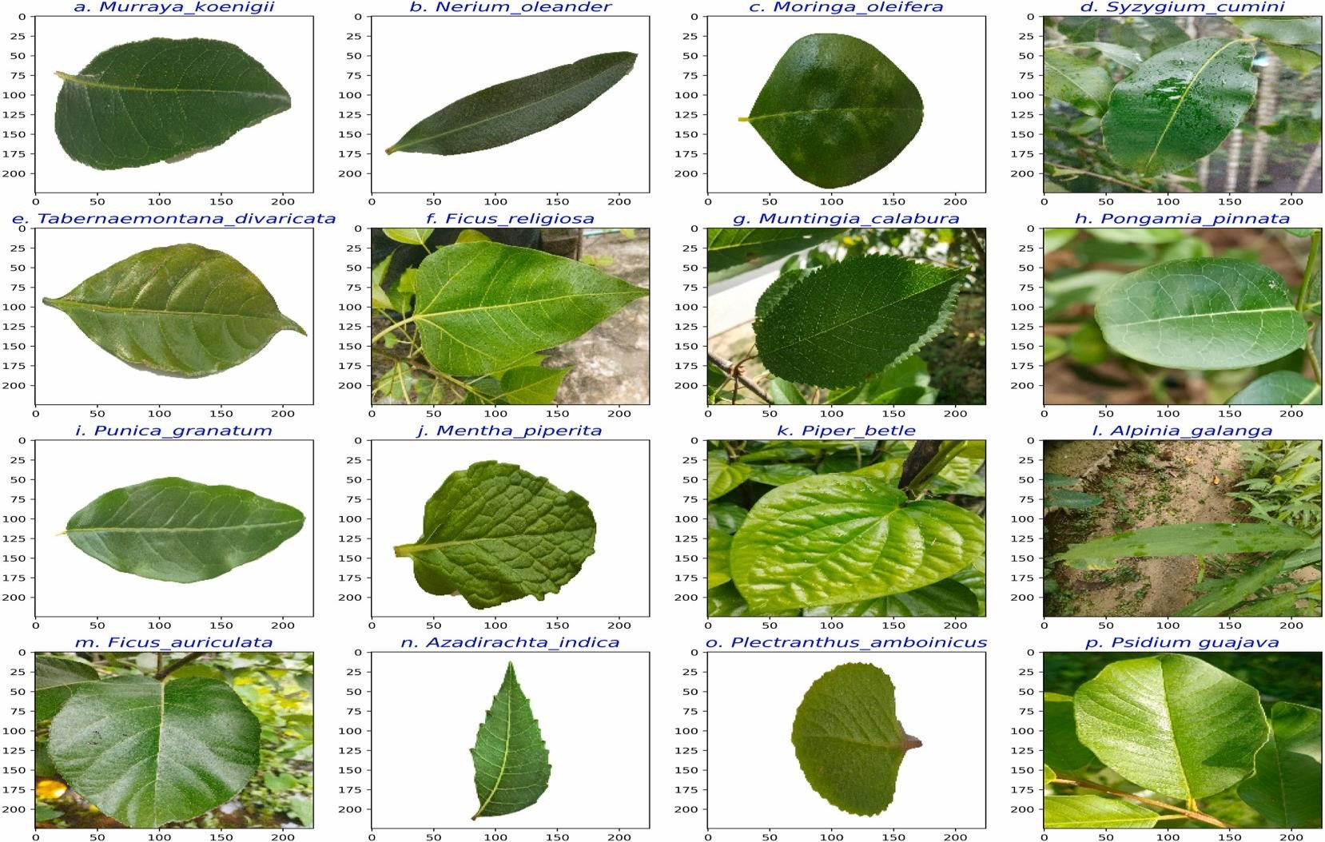

**Fig. 1.** Representative leaf sample images from 30 medicinal plant species used in the study for automated identification. The images denoted by labels d, f, g, h, k, I, m, p represent real field data, while the remaining images represent public data from Kaggle.

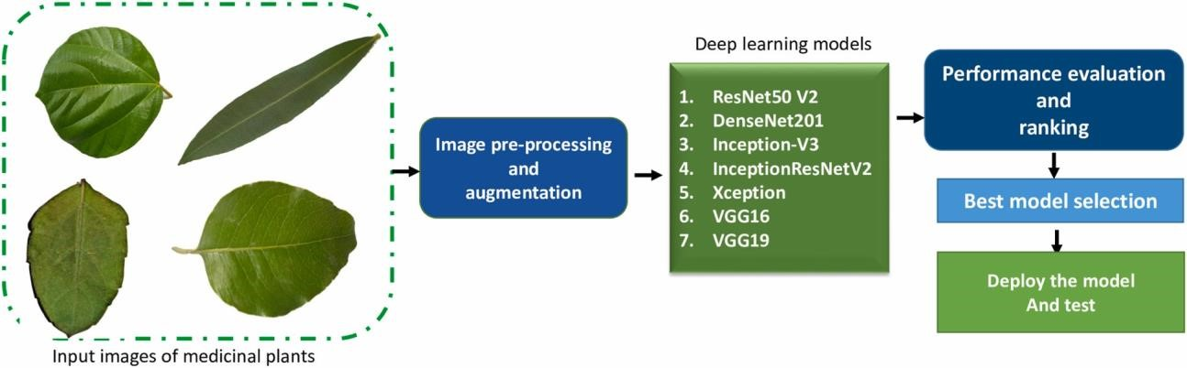

**Fig. 2.** The overall workflow that employed in this study for medicinal plant species identification using leaf.

activation. The ReLU activation was used to handle nonlinearities and ensure efficient activation, as it does not activate all neurons simultaneously. The CL utilized convolutional products with filters and an activation function (ψ) as inputs. The lth layer can be expressed as Eq. (4).

∀n ∈ [1*,*2*,*3*,...,*IC[l] ]*,*

{

( ) ∑[*l*− 1] ∑[*l*− 1] ∑[*l*− 1] (4) con d[l− 1]*,*f(n) x*,*y=ψ[l] *IH IW Ic.* 

*i*=1 *j*=1 *k*=1

Then, in each layer 3 × 3 max pooling was included to prevent overfitting issue and to make efficient and robust performance. For the pooling function φ[l] the pooling layer can be expressed by Eq. (5).

( [l− 1]) *, ,* [l] (*dx*[*l*+− *i*1*,y*]+*j*− 1*,z*) (5)

Pool d x y z =φ (I*,*j) *ϵ* {(1*,*2*,*3*,*4*,*…f[l])}2

The output is finally processed through a flattened layer, followed by a fully connected layer where each neuron is connected to an activation unit and a 40 % dropout is applied. This fully connected layers received input a[i− 1] vector and give back a[i] vector, for the ith layer of jth node, then we can express it by Eq. (6),

∑*ni*− 1

*ZJ*[*I*] = *Wj* *l l*

The input features were then processed through the ReLU function, which classifies the images into specific labels. The softmax activation function makes the final decision on classification based on the output of the neurons’ classification labels.

Besides three fully connected layers (FCL) of VGG 16 (Fig. 3a) and VGG 19 (Fig. 3b), they have 16 layers with 13 convolution layers and 19 layers with 16 convolution layers, respectively. Both models use max-pooling in feature maps for reducing the spatial dimensions and enhance their translation invariance. To reduce the volume size the models modified with pre-trained weights by incorporating max-pool function, as well as a Softmax classifier for the output from the previous fully connected layer. These models differ in their deep layer architecture and the use of small convolutional filters, which enable them to learn detailed features from images.

DenseNet201 is a CNN architecture that is employed for this leaf image classification tasks. Which is a variation of

DenseNet architecture, and dense connections between layers (Fig. 3c). Which contains 201 total layers and a total of 19,628,095 parameters, with both parameters trainable and non-trainable. Additionally, the layers in each block are connected to all preceding layers, facilitating feature learning from all previous layers [12], and enhancing the flow of information and gradients through the network. The model also employs a global pooling and full-connected layer, also implements “transition layers” to decrease the number of channels and spatial resolution between dense blocks.

An Inception model comprises of multiple parallel branches, each with a different convolutional filter size (1 × 1, 3 × 3, 5 × 5) with a max-pool layer. The 36 convolutional layers of model act as the foundation for constructing the network architecture (Fig. 4a). In order to enable the model to learn features at various scales and capture various levels of abstraction, these branches are then concatenated along the channel dimension. This also employs a method known as “factorization,” which lowers the computational cost

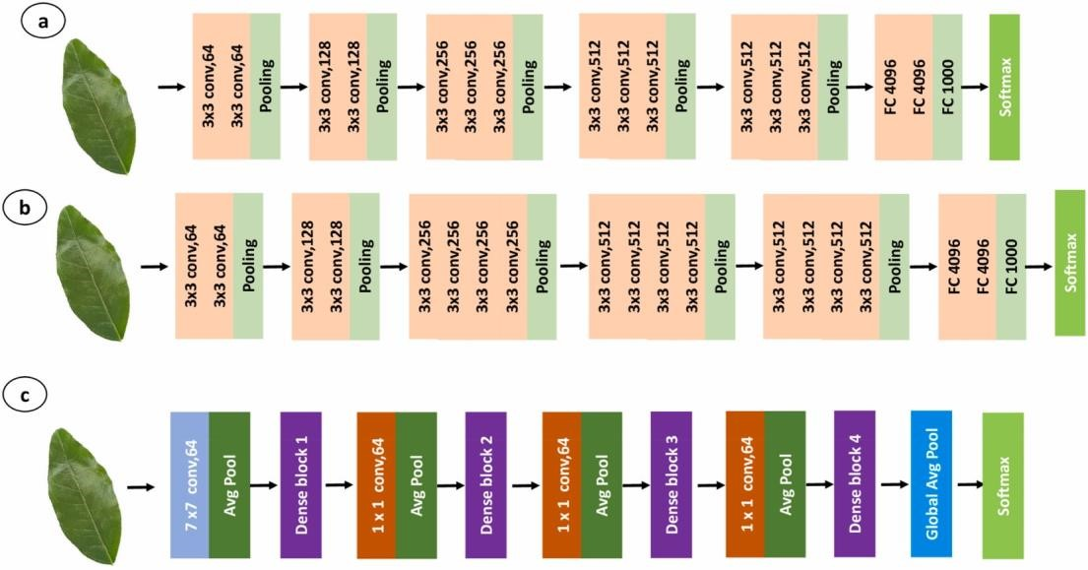

**Fig. 3.** Basic deep neural network architecture of (a) VGG16, (b)VGG19, (c) DenseNet201.

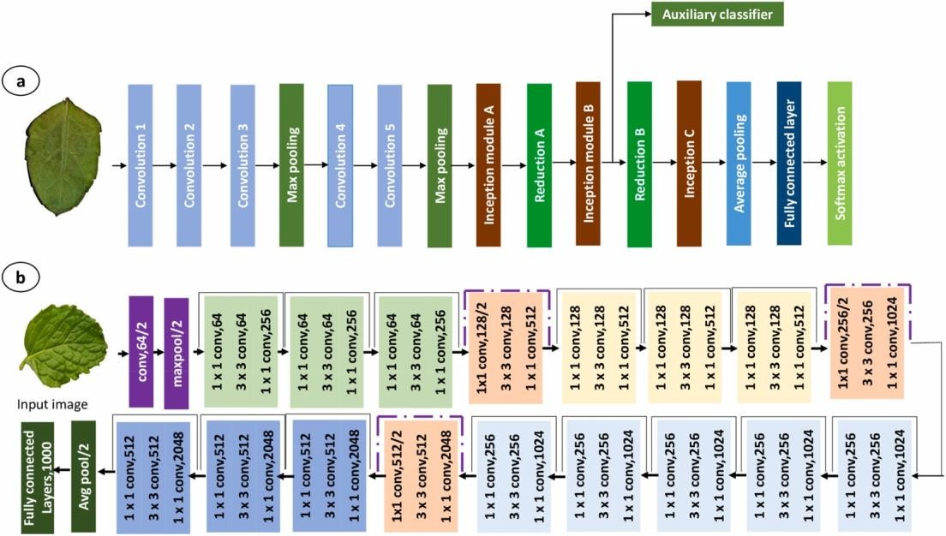

**Fig. 4.** Basic deep neural network architecture of (a) Inception, (b)ResNet50.

of the 3 × 3 and 5 × 5 convolutional filters by utilizing a 1 × 1 convolutional filter to cut down on the number of input channels before the 3 × 3 or 5 × 5 convolutional filter is applied.

ResNet50V2 is a reformed variant of ResNet50, incorporating a new residual-unit and featuring 49 convolutional layers, 1 fully connected layer for classification, one average pooling and one max-pool layer (Fig. 4b). ResNet152V2 is similar to ResNet152 and is a modified version of the latter, which comprises 151 convolutional layers with one maxpool, one average pooling, and one full- connected layer for the classification purpose.

Xception is an effective architecture for classifying images. It is distinguished by its use of residual connections and depth wise separable convolutions, both of which increase computing efficiency. Which enhances the network’s gradients and information flow. This also uses “residual connections”, where the input of a layer is added to its output before passing it through the next layer. This architecture is especially appropriate for embedded and mobile devices because they have constrained processing resources.

**ARCHITECTURE**

*A. Algorithm*

1. *Step 1:* The input is taken in two ways- Using camera and the images.
2. *Step 2:* The front and back side of the leaves are scanned using a scanner that has the maximum possible resolution. These images are stored in leaf image dataset.
3. *Step 3:* These images are pre-processed. The dimensions of the images in the dataset are set to the required size.
4. *Step 4:* Now the pre-processed dataset is divided into testing and training dataset.
5. *Step 5:* Training data set is now driven as input to the Convolutional neural network.
6. *Step 6:* The output of the CNN layer along with the testing dataset is provided as input for the performance assessment. In this step the accuracy and loss of the model and validation set is considered, the accuracy and loss graphs are plotted accordingly using confusion matrix.
7. *Step 7:* The image i.e., the result of the output layer of convolutional neural network is displayed.

*B.* *Flowchart*



Image acquisition



Leaf image dataset



Preprocessing



Training set



CNN



Testing set



Performance assessment



Leaf Image Classification

**SOFTWARE**

Python 3.9 version is used as software and the IDE used is Jupyter Notebook. Keras is used to train the model. It is a high-level neural network library which trains the deep learning model by using epochs and back propagation. Epochs means considering the data into batches and training them through iterations, while training it checks for minimum loss and maximum accuracy. DenseNet is the type of CNN used and the library used for the numerical calculations in DenseNet is Tensorflow. It is an open source software library which performs computations using dataflow graphs and provides multiple application interfaces. The input activation function used in first layer of cnn is ReLU and the output activation function used in last layer of cnn is Softmax. ReLU is a piecewise linear function that will output the input directly if it is positive, otherwise it will output zero. Softmax scales the input values between 0 and 1 i.e., it is used to normalize the output. The optimizer type used is Adam and the learning rate is 0.001. Adam optimizer is a stochastic gradient descent method that is based on the estimation of first order and second order moments.