**Project Report On**

**“FROM TRADITION TO TECHNOLOGY:**

**EXAMINING COMMUTER SATISFACTION IN THE SHIFT FROM KALI PEELI TAXIS TO OLA/UBER SERVICES”**

**Submitted By:**

**RUHI I. R. QURESHI**

**PG Student, H.R. COLLEGE OF COMMERCE AND ECONOMICS**

**VIDYASAGAR PRINCIPAL K.M. KUNDNANI CHOWK, 123, DINSHAW VACHA RD, CHURCHGATE, MUMBAI, MAHARASHTRA 400020**

**ABSTRACT:**

The study delved into the preferences and considerations of individuals regarding their chosen modes of transportation, offering valuable insights into the evolving landscape of urban commuting. Among the participants, 38% expressed a continued affinity for traditional Kaali Peeli taxis, emphasizing the enduring appeal of these iconic vehicles. In contrast, Ola and Uber secured 14% and 24% support, respectively, showcasing the growing significance of app-based services in the transportation market. Additionally, Meru taxis and auto-rickshaws garnered 10% each, underlining the diverse range of choices available to commuters.

The investigation included a pivotal question on whether participants had transitioned from Kaali Peeli Taxis to Ola/Uber services. A substantial 66% affirmed this shift, indicating a significant portion of commuters opting for the convenience offered by app-based services. However, 34% remained loyal to traditional taxis, emphasizing the enduring presence of Kaali Peeli taxis in the transportation choices of many.

In summary, this comprehensive study provides a nuanced understanding of commuter preferences, shedding light on the factors that influence the choice between traditional taxis and modern app-based services. The findings present valuable insights for stakeholders in the transportation industry, policymakers, and service providers,

**INTRODUCTION:**

In the big cities of India, how we get from one place to another has seen a big change. For a long time, the black and yellow taxis, known as "Kali Peeli" taxis, were the go-to choice for many in Mumbai. But now, things have shifted. New-age services like Ola and Uber have taken over, using technology to redefine how people travel.

The Kali Peeli taxis were more than just rides; they were a part of Mumbai's identity. But, like any old system, they had their problems. Pricing was often unclear, and there were worries about safety and the condition of the vehicles. As technology became a big part of city life, Ola and Uber came in as a solution, promising a better, more modern way to travel.

Ola and Uber changed the game by letting people book rides with a tap on their phones. No more standing on the street and waving for a taxi. The new services also brought in real-time tracking of your ride, making it easy to know exactly where your cab was. They also introduced cashless payments and digital receipts, making the whole experience smoother. This shift from traditional to tech-friendly transportation was a big deal.

Now, let's talk about what really matters - what people think about all this. The happiness of commuters is crucial. Does Ola and Uber make people happier than the traditional taxis? We need to look at factors like cost, dependability, safety, and convenience. Things like waiting times, how clean the ride is, the behavior of the drivers, and how easy it is to pay also play a big role.

In this research paper, we want to dive into the shift from Kali Peeli taxis to Ola and Uber. We're not just talking about technology taking over; we're looking at how it changes the way millions of people experience daily life in Mumbai. We want to keep it simple and real, hearing from the people who ride, the drivers, and the experts. It's a journey from the old ways to the new, not just in how we travel but in how our city culture is evolving.

**REVIEW OF LITERATURE**

Prof. Manjunath G (2015) delves into the dynamics of brand awareness and customer satisfaction concerning Ola Cabs in the Bengaluru region, encompassing both South and North areas. According to the study, Ola Cabs has effectively established a positive brand image in the minds of customers seeking personal transportation services, outshining competitors like Uber and Meru cabs in Bengaluru. The author's conclusion emphasizes that the Ola Cabs market hinges on factors such as customer preference, awareness creation, and customer satisfaction. Key influencers in customer decision-making include factors like convenience, brand reputation, cost-effectiveness, speed, safety, ease of booking, and punctual pick-up and drop-off services.

Ashim Gupta and Vivek Singh Tomar (2018) explore the motivations behind people choosing app-based taxi services. Safety, pricing, taxi availability, cashless payment options, and transparent charges emerge as the primary reasons for opting for app-based taxis, particularly Ola. The authors recommend that Ola and Uber focus on these aspects while continuously improving their services, as increasing prices or compromising service quality could lead to customer dissatisfaction and disconnection. Ensuring safety remains a critical factor.

Mr. Ashish Awasthi (2019) sheds light on the intangible aspects of services offered by Ola Cabs and their impact on consumer satisfaction in Delhi NCR. The study underscores the importance of "intangible factors" such as responsiveness, assurance, empathy, etc., in enhancing consumer satisfaction. It suggests that prioritizing consumer satisfaction through improved service quality is crucial for surviving the competitive market landscape.

Dr. Ashok Kumar Panigrahi, Shambhav Shahi, and Amar Singh Rathore (February 2018) explain Ola's strategic shift towards target markets, focusing on providing tailored services to specific demographics. The paper identifies efficient and quick accessibility as a key element in Ola's success. Ola employs both traditional and modern promotional techniques, emphasizing its commitment to social safety, creating awareness, and promoting acts of humanity.

**METHODOLOGY AND DESIGN:**

For this study, a quantitative research design was chosen to investigate commuter satisfaction during the transition from Kali Peeli taxis to Ola/Uber services in Mumbai. A Google Form questionnaire was designed to collect responses from 50 participants who have experienced both traditional and app-based services. The questionnaire covers various factors influencing commuter satisfaction, including cost, convenience, safety, reliability, and technological features. Ethical considerations such as informed consent and confidentiality were prioritized, ensuring participant privacy and data security. The study's limitations include the potential for sampling bias due to convenience sampling and the reliance on self-reported data.

We're going to look closely at the information we gathered. We'll use numbers to give us a general idea of what people think and also find any important connections between different things. Even though this study gives us useful number insights, we might want to explore more in the future. We could talk to people for a longer time to really understand how this change in transportation is affecting them. This could give us a richer, more detailed understanding beyond just the numbers.

**OBJECTIVE OF RESEARCH:**

* To understand commuter satisfaction during the shift from traditional Kali Peeli taxis to Ola/Uber services.
* To identify factors influencing the transition from Kali Peeli taxis to Ola/Uber.
* To analyze the impact of technology adoption on commuter experience in the urban transportation landscape.

**ANALYSIS AND INTERPRETATION**:

In order to conduct research, I have made a google form based on the choices of the customers with regards to the most used online food delivery app. I have collected 50 samples and following are the analysis and responses of the survey.

1. Which transportation service do you prefer for your daily commute?

|  |  |  |
| --- | --- | --- |
| TRANSPORT SERVICE | NO. OF RESPONDERS | % OF RESPONDERS |
| KAALI PEELI | 19 | 38% |
| OLA | 7 | 14% |
| UBER | 12 | 24% |
| MERU | 5 | 10% |
| AUTO RICKSHAWS | 7 | 14% |

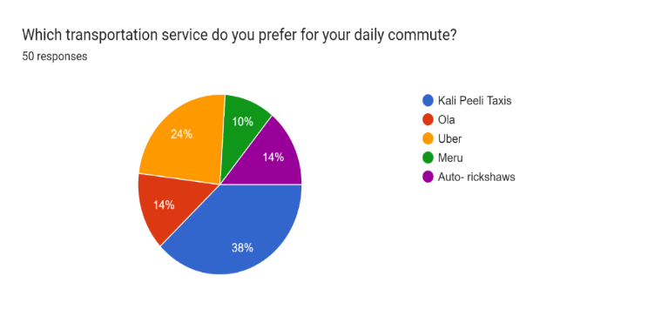

The survey gathered responses from individuals regarding their preferred transport services, revealing interesting insights. Among the responders, 38% favored traditional Kaali Peeli taxis, while Ola and Uber garnered 14% and 24% support, respectively. Meru taxis and auto-rickshaws each secured 10% and 14% of the preferences. This data suggests a diverse preference among commuters, with a significant portion still opting for the iconic Kaali Peeli taxis, while app-based services like Ola and Uber, as well as other modes like Meru and auto-rickshaws, also share a notable portion of commuter choices.

1. How satisfied are you with the affordability of Kali Peeli Taxis?

The following is a chart representing the affordability of Kali Peeli where in 1-4 ranges from SATISFIED TO DISSATISFIED. Here most of the people are not satisfied with a % of 38 with the affordability of Kaal Peeli.

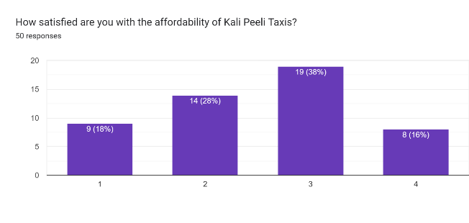

1. What influenced your satisfaction with Kali Peeli Taxis?

|  |  |  |
| --- | --- | --- |
| INFLUENCIAL FACTOR | NO. OF RESPONDERS | % OF RESPONDERS |
| Fair affordability | | 30 | 60% |
| Availability | | 25 | 50% |
| Driver behaviour | | 10 | 20% |
| Cleanliness of the vehicle | | 10 | 20% |
| Safety | | 10 | 20% |

The survey tells us what things matter most to people when they pick their transportation. About 60% think the cost being fair is crucial, and half of them really want the service to be available when they need it. How the driver behaves, the cleanliness of the vehicle, and feeling safe are also important, each with 20% of people saying so. This shows that most people care a lot about affordability and availability, but they also want friendly drivers, clean rides, and a safe experience.Forms response chart. Question title: What influenced your satisfaction with Kali Peeli Taxis? (Select all that apply)
. Number of responses: 50 responses.

1. Have you switched from Kali Peeli Taxis to Ola/Uber services?

|  |  |  |
| --- | --- | --- |
| Options | No. of Responders | % of Responders |
| YES | 33 | 66% |
| NO | 17 | 34% |

Forms response chart. Question title: Have you switched from Kali Peeli Taxis to Ola/Uber services?
. Number of responses: 50 responses. The survey asked if people have switched from Kali Peeli Taxis to Ola/Uber services. Among the responders, 66% said "YES," indicating that they have made the switch, while 34% said "NO," suggesting they have not transitioned to Ola/Uber services. These findings highlight a significant portion of commuters opting for the convenience of app-based services, but a notable percentage still sticking with the traditional Kali Peeli Taxis.

1. If yes, what motivated you to make the switch?

|  |  |  |
| --- | --- | --- |
| INFLUENCIAL FACTOR | NO. OF RESPONDERS | % OF RESPONDERS |
| Cost | 14 | 28% |
| Convenience | 29 | 58% |
| Safety measures | 24 | 48% |
| Technology and app interface | 23 | 46% |
| Better vehicle quality | 20 | 40% |
| availability | 18 | 36% |

Forms response chart. Question title: If yes, what motivated you to make the switch? (Select all that apply)
. Number of responses: 50 responses.

For those who made the switch from Kali Peeli Taxis to Ola/Uber services, the survey delved into their motivations. Among the responders, 58% highlighted convenience as the primary factor, while cost was a significant consideration for 28%. Safety measures played a crucial role for 48% of respondents, and the appeal of technology and app interfaces influenced 46%. Additionally, 40% mentioned better vehicle quality as a motivation, and 36% considered the availability of services. These insights showcase that convenience, safety, and technological advancements are key drivers in the decision to transition from traditional taxis to app-based services.

1. How satisfied are you with the affordability of Ola/Uber services?

The following is a chart representing the affordability of OLA/ UBER ranging from a scale of 1-4 where 1 denotes SATISFIED and 4 denotes DISSATISFIED

Forms response chart. Question title: How satisfied are you with the affordability of Ola/Uber services?
. Number of responses: 50 responses.

1. What features do you appreciate the most in Ola/Uber?

|  |  |  |
| --- | --- | --- |
| INFLUENCIAL FACTOR | NO. OF RESPONDERS | % OF RESPONDERS |
| Cost | 13 | 26% |
| Ease of booking | 31 | 62% |
| Driver Behavior | 18 | 36% |
| Cleanliness of the vehicle | 19 | 38% |
| Safety features | 26 | 52% |
| Ride- sharing options | 12 | 24% |
| Air condition facility | 30 | 60% |

Forms response chart. Question title: What features do you appreciate the most in Ola/Uber? (Select all that apply)
. Number of responses: 50 responses.

The survey asked people what's important to them when choosing transportation. Here's what they said:

62% think it's crucial that booking a ride is easy.

60% really like it when the vehicle has air conditioning.

52% care a lot about safety features.

38% want the vehicle to be clean.

36% say the behavior of the driver matters.

24% like having the option to share a ride.

26% consider cost when making their decision.

These results show that for most people, an easy booking process, air conditioning, and safety features are big factors when they pick their transportation.

1. In your opinion, how do Ola/Uber services compare to Kali Peeli Taxis in terms of:

|  |  |  |
| --- | --- | --- |
| Reason | No. of responders | % of responders |
| Affordability | 6 | 12% |
| Convenience | 7 | 14% |
| Safety | 8 | 16% |
| Vehicle quality | 8 | 16% |
| availability | 10 | 20% |
| Overall satisfaction | 11 | 22% |

Forms response chart. Question title: In your opinion, how do Ola/Uber services compare to Kali Peeli Taxis in terms of:
. Number of responses: 50 responses.

According to the survey responses, opinions on how Ola/Uber services compare to Kali Peeli Taxis vary. A significant 22% of respondents expressed overall satisfaction with Ola/Uber, highlighting positive experiences with these app-based services. Additionally, 20% perceived Ola/Uber as more available, suggesting convenience in terms of accessibility. In terms of safety and vehicle quality, 16% favored Ola/Uber over Kali Peeli Taxis. On the other hand, 14% found Ola/Uber more convenient, and 12% considered them more affordable.

1. Do you like the initiative taken by UBER of UBER AUTO

|  |  |  |
| --- | --- | --- |
| OPTION | NO. OF RESPONDERS | % OF RESPONDERS |
| YES | 24 | 48% |
| NO | 7 | 14% |
| HAVENT USED YET | 19 | 38% |

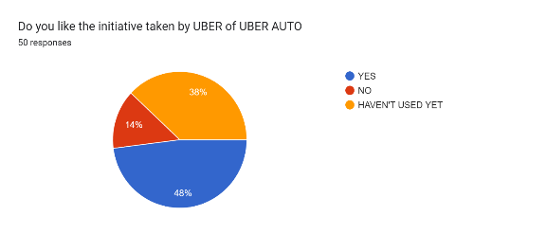

In the survey, 48% of responders liked the Uber Auto option, 14% did not, and 38% haven't used it yet.

1. Would you prefer Ola/Uber services for long distance only?

|  |  |  |
| --- | --- | --- |
| OPTIONS | NO. OF RESPONDERS | % OF RESPONDERS |
| YES | 23 | 46% |
| NO | 11 | 22% |
| MAYBE | 16 | 32% |

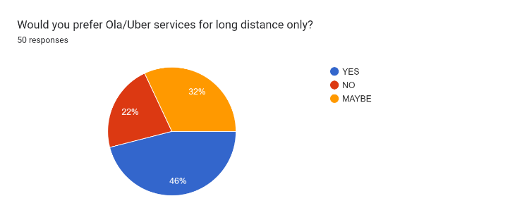

Among the respondents, 46% indicated a preference for using Ola/Uber services specifically for long-distance travel. On the contrary, 22% expressed a preference against utilizing these services for long journeys. A notable 32% remained undecided or open to the possibility, suggesting a willingness to consider Ola/Uber for long-distance travel based on specific circumstances or experiences.

1. Considering your experiences, which type of taxi service are you more likely to choose in the future?

|  |  |  |
| --- | --- | --- |
| Transport Service | No. of Responders | % of Responders |
| Kali- Peeli | 14 | 28% |
| Ola | 8 | 16% |
| Uber | 18 | 36% |
| Meru | 1 | 2% |
| Auto-rickshaws | 9 | 18% |

Forms response chart. Question title: Considering your experiences, which type of taxi service are you more likely to choose in the future?
. Number of responses: 50 responses.

In considering future taxi service preferences based on their experiences, 36% of responders are inclined to choose Uber, making it the top choice. Kali Peeli taxis follow closely at 28%, while auto-rickshaws are favored by 18% of respondents. Ola and Meru hold equal appeal for 16% and 2% of responders, respectively. These insights provide a snapshot of evolving preferences, with Uber emerging as the leading choice among the surveyed individuals.

**FINDINGS:**

1. Diverse Preferences: Respondents show varied inclinations, with a significant group favoring traditional Kaali Peeli taxis, while others lean towards Ola or Uber, illustrating diverse commuter choices.

2. Top Considerations: Key factors influencing transportation choices include fair affordability, availability, and cleanliness, showcasing the pivotal role these aspects play in shaping decisions.

3. Shift to App-Based Services: The survey highlights a notable shift from Kali Peeli Taxis to Ola/Uber, indicating the growing influence of app-based services in the transportation landscape.

4. Motivations for Switch: Convenience stands out as the primary motivator for the shift, alongside considerations for safety measures and the appeal of technology and app interfaces.

5. Influential Factors: Commuters express a strong emphasis on ease of booking, the presence of air conditioning facilities, and safety features, indicating the pivotal role these elements play in shaping transportation choices.

6. Uber Auto Initiative: Uber's initiative, Uber Auto, receives varied feedback, with some expressing positive sentiments, others having reservations, and a significant portion yet to explore this new offering.

7. Future Preferences: Looking ahead, respondents express a likelihood to choose Uber or stick with traditional Kali Peeli taxis, indicating an ongoing diversity in commuter choices.

**CONCLUSION:**

In conclusion, the survey unraveled a varied tapestry of urban transportation preferences. Kaali Peeli taxis maintain a considerable presence, while Ola and Uber represent modern alternatives. Key considerations include fair affordability and accessibility. Safety, driver behavior, and cleanliness also play significant roles. Despite a notable shift to Ola/Uber for convenience, a substantial percentage remains loyal to traditional taxis. Motivations for the switch encompass convenience, cost, safety, technology, and vehicle quality. Ease of booking, air conditioning, and safety features emerge as crucial factors in current choices.

Comparing Ola/Uber with Kaali Peeli, satisfaction varies, and the introduction of Uber Auto is met with positivity. Future preferences lean towards Uber, followed by Kaali Peeli. These insights underscore the complex interplay between traditional and modern transport, emphasizing affordability, convenience, and safety considerations.

**REFERENCES:**

* Hariram ani, S. G. (2016). Acceptance of cab service and popularity of cab brands (a case study of Ahmedabad city). International Journal of Research in Social Sciences, 6(10), 889-900.
* Potluri, R. M., & Tejaswi, S. P. (2018). Challenges of transport sector in India: A dyadic perspective. The Journal of Asian Finance, Economics and Business (JAFEB), 5(3), 95-102.
* Kashyap, R., & Bhatia, A. (2018). Taxi drivers and taxidars: a case study of Uber and Ola in Delhi. Journal of Developing Societies, 34(2), 169-194.
* Devi, S. (2018). Digital Transformation in Indian Taxi Market-wrt. Ola and Uber. Recent Trends and Emerging Techniques in Management, 241-246.
* Muralidhar, S. H. (2016). How Ola disrupted taxi services in India? Review of Management, 6(3/4), 5-17.