A STUDY ON GROWTH OF MOBILE PAYMENT PLATFORM IN THE PAST FIVE YEARS
SRUTHI SUNIL NAIR
STUDENT - HSNC UNIVERSITY MUMBAI
H.R COLLEGE OF COMMERCE AND ECONOMICS CHURCHGATE, MUMBAI 20
EXECUTIVE SUMMARY
This study has been taken up for the purpose of understanding the mobile portmanteau operation and its growth among the users .This study focuses on hand-pointing popular mobile payment platform used by the observation. It seeks to explore the various elements that affect the utilization of smartphone wallets. An attempt has also been made to address the restraints that affects the popularity of mobile wallets. Changes in lifestyle has led to a significant increase in growth and usage of mobile wallets and an effort to study the said increase has been made.
The data collected for the findings of the research primarily consist of wide range of secondary data and primary data. Primary data in this case has been acquired from the sample size via questionnaire method.
From the findings acquired from this study we could conclude there has been a significant increase in usage of mobile wallet before and after the pandemic. This upward trend combined with better accessibility of internet and mobile phones will reach new heights as this growth is not showing any signs of stopping in the near future.

INTRODUCTION
India is steadily paving its way towards a cashless society. Remember those days when we used to carry those bulky wallets full of cash, credit and debit cards with the use of mobile wallets we can have a smooth flow of transaction with less or no use for actual money . Now, we can pay for any product or service, transfer money, make bill payments, book tickets and so on at our comfort. Gone are those days when we had to wait for hours just to get the ‘first day, first show’ ticket of our favourite movie.
In this world, everyone is surrounded by science and technology and every technology we are witnessing now, initially arose with an idle in mind. We all may have brilliant and innovative ideas in our mind, but the thing is that transforming these ideas into reality needs some real courage. We can face massive failures at the time of implementing these ideas, but still, we must try to make them into reality. Less than three decades ago, the idea of money transactions using mobile devices seemed to be odd to us . But today the scenario has changed totally and our perceptions is opposite. The innovative idea of purchasing Coca-Cola with the help of text messages via mobile phone is regarded as the first illustration of using a mobile phone in purchase transaction.
However, this innovation can be considered as a stepping stone towards unlocking the potential of using mobile devices for transactions. Since then, many tech ideas and innovations have been introduced in the field and it has gained great popularity among the users of new technology . The growth of popularity of mobile phones and the internet has positively contributes to the wide use of mobile wallets that have paved the way for economic growth and cashless transactions.
A mobile or digital wallet is a virtual, mobile-based tool for storing funds that can be used for mobile, online, or offline payments. It can be preloaded with a chosen amount from a bank account or credit and debit cards. Mobile wallets simplify transactions with their one-tap functionality and quick processing, all in one place. They are designed to provide a secure and seamless transaction experience, reducing processing time, minimizing fraud, and offering a more economical alternative to traditional physical wallets There are currently over 15 mobile wallets and around 70 million users in India.
The Government of India had announced nationwide lockdown in four phases from 24th of March, 2020 to eradicate COVID-19 spread from our country. The essential services including food industry, petrol pumps, banks and ATMs were exempted from Lockdown. Citizens of the country had no other choice rather than staying at home. Social distancing, in combination with other everyday preventive actions including wearing masks, avoiding touching our face with unwashed hands, and frequently washing our hands with soap and water for at least 20 seconds helps in reducing the spread of COVID-19. The use of digital transactions and electronic cash transfer were encouraged in every nook and corner of the country to create positive attitude among citizens towards adoption of cashless economy.
The mobile wallet can hold reward points, medical report, credit and debit cards, and personal items. Reward points are useful because they will increase brand loyalty and make it extremely simple for customers to conduct transactions with specific company via their mobile device. The mobile wallet can also hold medicals records, which is beneficial for always having importance documents on hand. The mobile wallet also has superior security features to ensure that sensitive information remains secure.
mobile payment platform can be utilized for the following purposes:
- Transfer of funds
- Make purchases online and offline
- Book flight and rail tickets
- Pay fare for transportation
- Pay utility bills
- Recharge your phone
- to make payments on the go while traveling
mobile payment platforms offer increased security and can be a safer alternative to use than swiping your physical debit or credit cards. Magnetic stripes on the card are really easy to read by any magnetic scanner, which can leave them vulnerable to thieves. Stealing the card’s information when you swipe your normal cards is easy for hackers. This means that if a hacker or someone intercepts this, they can manage to have acess to your banking details which in the long run is dangerous. With a digital wallet, each transaction is highly encrypted—when data is transmitted, it doesn’t include your actual card or account number. Instead, a unique sequence of random numbers is generated for each purchase. this series of numbers is even stolen, it would be completely useless to the robber. In addition, to actually use mobile wallets and to access your stored information, you will also need to provide a personal identification format, such as a PIN, fingerprint, or face recognition.
These are the simple steps to be followed to know about the usage of the mobile wallets –
- The first step is to download the application on the android or IOS device and sign up with the service using one’s email id.
- In the next step, load or add-money through one’s debit or credit card or net-banking.
- Then one can use that added amount in a number of ways and can also use other services provided by their mobile-wallet app.
There are several reasons for replacing real wallets with mobile-wallets. Convenience, ease of use, wide range of uses, cash back, discounts and offers are few reasons among them. The usage of mobile wallets has increased a lot, especially in India, in the last two years. It’s now the first and favourite choice for the youth in India. The mobile wallets that have been taken in this study include Paytm, Google pay, Phone PE, Mobikwik, Oxigen, etc The study also considers certain factors that have greater influence in the usage of mobile wallets.

OBJECTIVES
To identify popular e-wallets used by the respondents.
To examine the factors that promote the use of e-wallets.
To identify the factors that hinder the use of e-wallets.
To make forecast about the future growth of e wallet based on emerging trends.
To assess the competitive landscape of e wallet
RESEARCH METHODOLOGY
This study employs a comprehensive research methodology designed to analyze the growth and factors influencing mobile wallets over the past five years.
Data Collection
Primary Data: Primary data may be collected through surveys and interviews with mobile wallet users. Primary data was collected from the respondents through systematically prepared questionnaires in an online form.
Secondary Data: Secondary data is gathered from credible sources such as market research reports, academic journals, industry publications, government reports, and company websites. This provides historical data on market trends, user demographics, and technological developments
Sampling Techniques: For primary data a random sampling technique was used to select mobile wallet user. 54 respondents from the age group of 20-40 have taken part in this research as respondents. Hence this research constitutes for a sample size of 54.
This sample size consists of graduates, postgraduates and professionals.
Data Analysis Methods:
Descriptive Analysis: Statistical methods such as percentages, averages, and growth rates are used to summarize data on mobile wallet adoption and usage
Comparative Analysis: Growth rates, usage patterns, and adoption rates are compared across different users from the sample size. To identify specific growth trends.
Data Interpretation: After analysis, the findings are interpreted to draw meaningful conclusions about the factors contributing to mobile wallet growth, challenges faced, and potential future trends.
Appropriate tools were used for analysis and pie charts have been used to depict the collected data. Hence This study utilizes a combination of primary and secondary data.

SCOPE OF THE STUDY
This study aims to examine the significant growth in trends and development of mobile payment platforms in the past five years. It focuses on the analysis of customer attitudes towards mobile payment platforms in the past 5 years. It also looks into analysing key factors driving this growth, including advancements in digital payment technology, changing consumer behaviours, regulatory impacts, and competitive dynamics among mobile wallet providers. the study provides insights into how mobile wallets or mobile payment platforms has evolved and its impact on the consumers. This study also points to examine the various metrics related to the growth of e-wallets including market share and user adoption rate. This study also aspires to investigate the factors driving the growth of e-wallet. It work towards assessing the competitive landscape of the wallet market including key players, partnerships, and association.
SIGNIFICANCE OF STUDY:
This study is significant as it sheds light on the rapid adoption and impact of mobile wallets, a crucial component of the digital economy. Due to increase in convenience of internet and smartphone a lot of things have become easily accessible to the public. Taking advantage of the said improvements, companies and banks have introduced mobile payment platform so that people can easily make payments, receive money, and undertake transactions within seconds. Understanding the growth and drivers behind mobile wallet usage over the years offers valuable insights for businesses to understand the consumer's point of view. This study intends to know how people have responded to a partial shift from physical to digital money, By identifying trends and shifts in consumer preferences and technology. This study highlights highlight the role of mobile wallets in promoting cashless transactions, enhancing financial inclusion, and fostering economic growth. Overall, this research serves as a foundational reference to guide future innovations and strategies in the digital payment ecosystem, fostering sustainable growth and digital inclusivity and the usage of mobile wallet and how it might change in the coming future.
LIMITATION OF STUDY:
- This study is restricted to Mumbai, specifically Mulund and Thane only, and hence, the result may differ if the study is conducted in some other area.
- Rapidly Evolving Technology
- Variations in consumer behaviour based on cultural, economic, and regional differences may not be fully captured, potentially impacting the applicability of findings across diverse demographics
- The research is based on the responses given by sample size , which may or may not be biased.
- he reliance on publicly available data may limit the depth of analysis, as some proprietary or granular data on mobile wallet usage may not be accessible.

DATA ANALYSIS AND INTERPRETATION
Data interpretation and analysis is the process of reviewing data and arriving at relevant conclusions using various analytical research methods. The data analysis and interpretation involves examining the collected data from the sample to identify patterns, trends, and relationships that provide insights into the growth of mobile wallets. Data analysis helps researchers to organize, process, and summarize information to address key questions.
In a business context, data interpretation involves applying various techniques to review and analyse data, providing insights and identifying emerging trends and patterns. These findings empower business to make informed, data-driven decisions, backed by comprehensive information. Based on number rather on speculation.
From the feedback received, the sample size can be analysed and interpreted as follows:
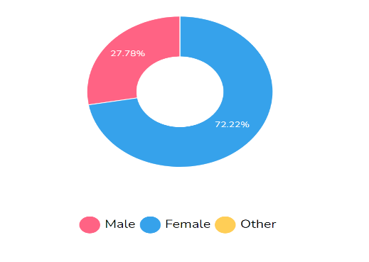
GENDER
Majority respondents were women and about 27.78% of respondents were men.

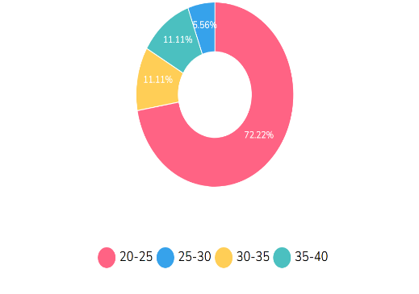
AGE
Most respondents fall between the ages of 20-25.

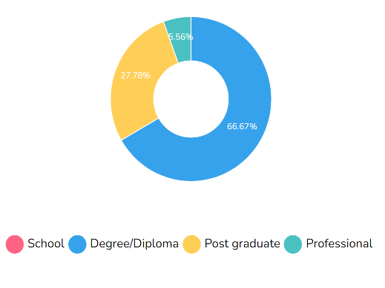
EDUCATION QUALIFICATION
66.67% of respondents have a degree/diploma, 27.78% and 6.56% of respondents are post graduates and professionals respectively.

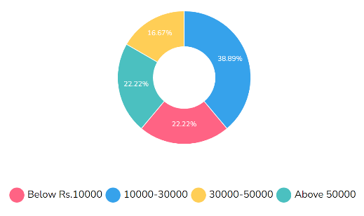
MONTHLY INCOME
38.89% of respondents earn between 10,000-30,000. 22.22% of respondents earn above 50,000 and the percent of respondents earn below 10,000.

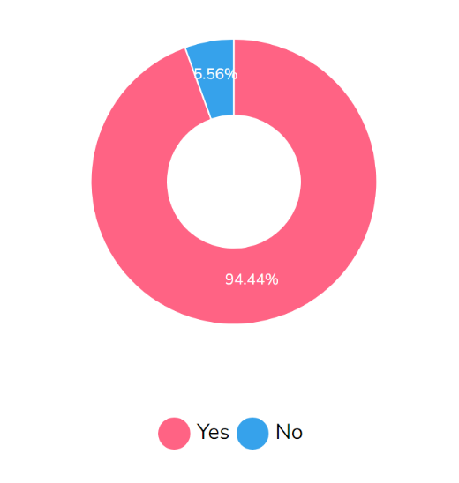
ARE YOU AN AVID USER OF MOBILE WALLETS?
Majority i.e. 94.44% of respondents are avid users of mobile wallet.

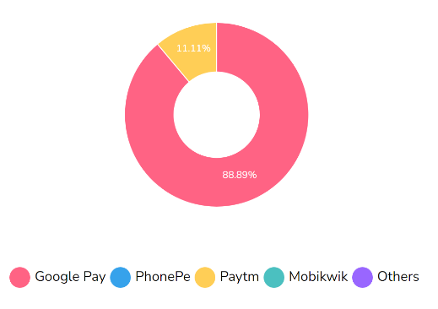
WHICH MOBILE WALLET DO YOU PREFER TO USE THE MOST?
Googlepay is the most preferred mobile wallet among the respondents followed by Paytm.

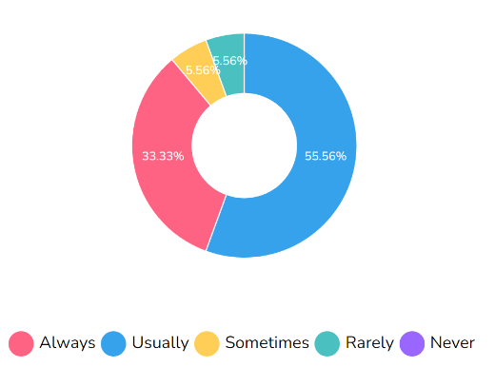
HOW OFTEN DO YOU USE MOBILE WALLET?
More than half of respondents always use mobile wallet whereas only 6.56% of respondents rarely use mobile wallets.

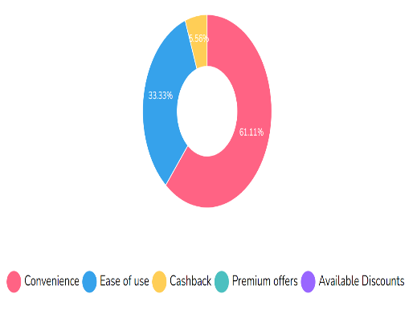
WHAT PRIMARILY INFLUENCED YOU TO START USING MOBILE WALLET?
The respondents mainly started using mobile wallets due to its convenience followed by ease of use.

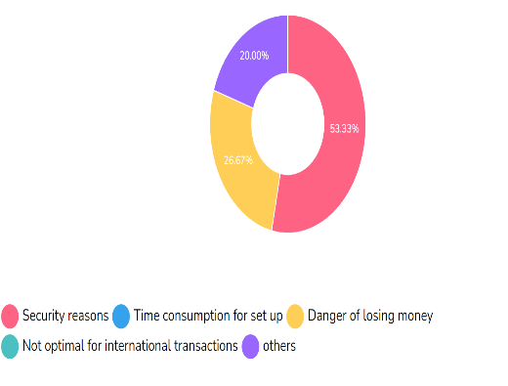
WHAT IS THE MAIN FACTOR THAT DETERS YOU FROM USING MOBILE WALLET?
The main reason that deters respondents from using mobile wallets frequently is security reasons.

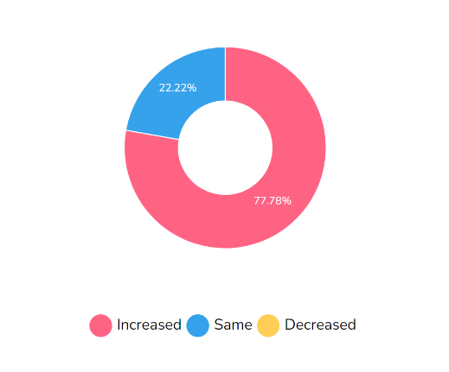
HOW HAS THE PANDEMIC AFFECTED YOUR USAGE OF MOBILE WALLET?
77.78% of respondents have increased their usage of mobile wallets after the pandemic.

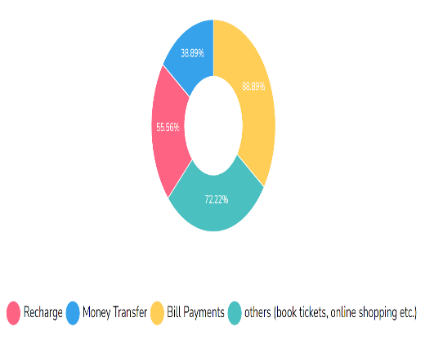
WHAT TYPE OF TRANSACTION DO YOU PRIMARILY USE MOBILE WALLET FOR?
Mobile wallet is mainly used for bill payments followed by other activities such as shopping, booking tickets etc.

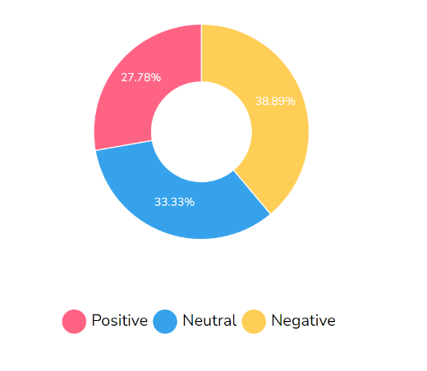
HOW DO YOU PERCEIVE THE IMPACT OF MOBILE WALLETS ON YOUR FINANCIAL HABITS?
The response here is almost equally divided between positive negative and neutral perceptions on usage of mobile wallets.

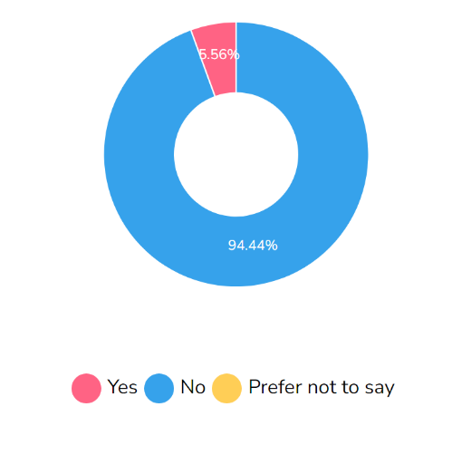

HAVE YOU EXPERIENCED ANY UNAUTHORIZED TRANSACTIONS OR SECURITY BREACHES WITH YOUR MOBILE WALLET ACCOUNT(S)?
Majority respondents have not faced any security breaches but 6.56% of respondents have faced the issue of unauthorized transactions or security breaches.

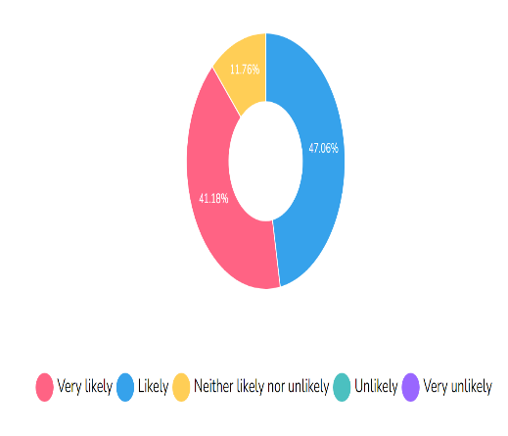
HOW LIKELY ARE YOU TO CONTINUE USING E-WALLETS FOR YOUR FINANCIAL TRANSACTIONS IN THE FUTURE?
Almost 41.18% of respondents would very likely continue using mobile wallets and 47.06% of respondents would likely keep on using mobile wallets, which means majority of the sample will continue to use mobile wallets in the coming future.
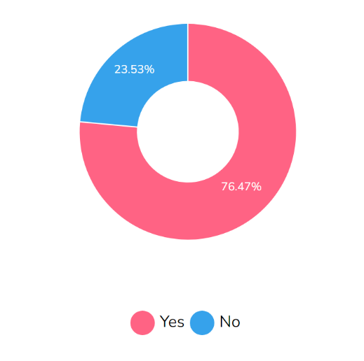
DO YOU BELIEVE THAT MOBILE WALLETS WILL EVENTUALLY REPLACE TRADITIONAL PAYMENT METHODS ENTIRELY?
Most of the respondents believe that mobile wallets are the future and will eventually replace traditional payments entirely

FINDINGS
- Majority respondents are female.
- Almost 72.22% of respondents fall between the age group of 20-25.
- 66.67% of respondents hold a degree or a diploma.
- 30.89% earn between ₨10,000-₨30,000. 22.22% of respondents earn above ₨50,000 and 22.22% of respondents earn below ₨ 10,000.
- Majority respondents are avid users of mobile wallets.
- Increased Adoption Rates
- Pandemic has led to an increase of usage of mobile wallets among the majority respondents.
- Most respondents prefer Google Pay as their primary mobile payment platform.
- Convenience is considered as the most important factor encouraging the usage of mobile-wallets.
- Shift Towards Cashless Economy
- Most of the respondents consider security of mobile payments as a factor limiting the usage of mobile payment platform
- Majority respondents have not experienced any security breaches but 6.56% have faced security breaches /unauthorized transactions.
- 41.18% are very likely and 47.06% are likely to keep on using mobile wallets.
- Most respondents believe mobile wallets will replace traditional payment systems.

CONCLUSION
Globally there is been a shift in the preferred payment methods, it has undergone a drastic change in the recent decade. The emergence of high-tech technology in the electronic world has enabled the invention of new payment methods like mobile payment platforms. The growth of mobile payment platforms over the past years highlights their transformative impact on the financial landscape, accelerating the shift toward a cashless, digital economy. The newly evolved payment method is one of the fastest-growing technologies in the world. The advancement in technology, coupled up with rising smartphone and internet availability and evolving and ever-changing consumer preferences and needs have driven rapid adoption globally The wave of mobile payment systems has spread so far that even banks have started launching their mobile apps with e-wallets. The mobile payment service trend was accelerated by increasing demand for convenience and security. The mobile payment methods have gone far beyond making payments by smartphones it is also about enabling smart and more efficient experiences to the user. The pandemic has contributed to this rapid shift in people’s mindsets, needs, and adoption habits.
However the study reveals that Google Pay is the most preferred mobile payment application. The main factor for using mobile payment app is convenience and the need for digital security . The mobile wallet adoption is influenced by factors such as local infrastructure, consumer behaviour, and regulatory environments. The study discloses that there is relation between the profile of the respondent (i.e. education, occupation, monthly income etc) and mobile wallet usage. The emergence of mobile payment solution and mobile payment technology have integrated various financial services into a single platform , creating a more comprehensive and user-friendly digital experience for the users of the platforms.
It can be concluded via this study that the most significant hurdle that is preventing the sample size from using the mobile payment technology is security concern regarding their private and sensitive banking information. Despite the growth in the popularity in the use of mobile payment service they face challenges like intense competition in market etc. Addressing these issues will be essential for the growth and development of the mobile payment platform. The finding emphasize that mobile wallets are not only reshaping payment habits of the population but also is likely to be the factor influencing the future of financial innovations and digital inclusivity globally.

RECOMMENDATIONS
Majority of the sample size are Fervent users of mobile payment application. The mobile payment service companies should organize certain programs to create awareness about the functionality of various mobile payment applications available in the market today.
Most of the customers use mobile payment applications to recharge and pay utility and make bill payments. The mobile payment technology can be used for various different purposes by the customers as well as various companies. The users can use the technology to redeem loyalty points that can be redeemed , to collect gift cards, and can also use this application to invent etc. The companies can use mobile payment platform for advertising purposes and also collaborate with binks retailers. The providers of the mobile payment service should Expand the popularity of the services by bridging the gap by effective communication and excellent demos that explain the features and the use of the apps to the stakeholders effectively.
The obstacles that consumers face can be addressed by strengthening the partnership with banks and merchants to provide the users with more effective opportunities to utilize their digital wallets more effectively in their everyday transactions. The enhanced security features of mobile payment systems like multi-factor authentication, biometric verification, and AI-driven fraud detection should be communicated among the users to build trust among the users and to facilitate secured truncation on the mobile payment system. The tailoring of mobile payment solution should meet the local needs and preferences of the stakeholders and the features should be adjusted according to local regulations to capture a wide and diverse audience. Focusing on the user experience is the key to developing a good product the mobile payment service provider has to focus on user-friendly design, and simple navigation to improve overall user experience.
Encouraging and providing seamless transactions can promote the user's adoption of mobile payment technology. There are many payment applications and smartphone wallets that are available to users the providers should work closely with the regulators to protect the consumer data and to avoid disruption in the truncations. The mobile payment platforms should employ trusted payment gateways to promote security. The providers can leverage data analytics to understand user behaviour to tailor promotions and increase user engagement and satisfaction.
Implementing these recommendations can help mobile payment service to strengthen their market position, drive adoption, and contribute to a secure, inclusive, and efficient digital financial ecosystem.

BIBLIOGRAPHY
• Semantic Scholar | Research Tool
• International Journal of Business and Management (UBGM)
• International Journal for Innovative Research in Multidisciplinary Field (IJIRMF)
• International Journal of Innovative Research in Management Studies(IJIRMS)
• IUJ Journal of Management
• International Journal of Research and Analytical Reviews(URAR)
• Journal of Modern Management and Entrepreneurship(JIMME)
• IJRDO-Journal of Business Management
• International Journal of Bank Marketing(IJBM)
• International Journal of Scientific and Engineering Research
• International Journals of Advanced Research in Computer Science and Software Engineering
• Journal of Management(JOM)
• International Journal of Basic and Applied Research
WEBSITES
• https://www.socialbeat.in/blog/top-10-mobile-wallets-in-india/
• https://magnetoitsolutions.com/blog/year-of-mobile-wallets-in-india
• https://e2logy.com/blog/pros-and-cons-of-using-a-mobile-wallets/
• https://fcms.kln.ac.lk/dep/dmm/index.php/volume-7-issue-2/277-impact-of-behavioural-intention-on-e-wallet-usage-during-covid-19-period-a-study-from-sri-lanka
ANNEXURE
Questionnaire:
Gender
Age
Education Qualification
Monthly Income
Are you an avid user of mobile wallets?
Which mobile wallet do you prefer to use the most?
How often do you use mobile wallet?
What primarily influenced you to start using mobile wallet?
What is the main factor that deters you from using mobile wallet?
How has the pandemic affected your usage of mobile wallet?
What type of transaction do you primarily use mobile wallet for?
How do you perceive the impact of mobile wallets on your financial habits
Have you experienced any unauthorized transactions or security breaches with your mobile wallet account(s)?
How likely are you to continue using e-wallets for your financial transactions in the future?
Do you believe that mobile wallets will eventually replace traditional payment methods entirely?

