**FORMULATION AND EVALUATION OF LORNOXICAM SUSTAINED RELEASE TABLETS**

Pole Mounika1*, A. Siva Kumar2, K. Jyothi3, A. Yasodha4

1Department of Pharmaceutics, Dhanvanthri College of Pharmaceutical Sciences, Thirumala Hills, Centre City, Appannapally, Mahabubnagar, Telangana 509001

2Associate Professor, Department of Pharmaceutics, Dhanvanthri College of Pharmaceutical Sciences, Thirumala Hills, Centre City, Appannapally, Mahabubnagar, Telangana 509001

3Associate Professor, Department of Pharmaceutics, Dhanvanthri College of Pharmaceutical Sciences, Thirumala Hills, Centre City, Appannapally, Mahabubnagar, Telangana 509001

4Professor & Principal, Department of Pharmaceutical Chemistry, Dhanvanthri College of Pharmaceutical Sciences, Thirumala Hills, Centre City, Appannapally, Mahabubnagar, Telangana 509001

**Corresponding Author:**

**Name:** Pole Mounika

**Department:** Department of Pharmaceutics

**Phone:** 7093061432

**Mail id:** polemounika23@gmail.com

**ABSTRACT**

In the present work, an attempt has been made to develop sustained release tablets ofLornoxicam by selecting Natural and synthetic polymers like Karaya Gum and HPMC K100 asretarding polymers. All the formulations were prepared by Wet granulation method. The blend ofall the formulations showed good flow properties such as angle of repose, bulk density, tappeddensity. The prepared tablets were shown good post compression parameters and they passed allthe quality control evaluation parameters as per I.P limits. Among all the formulations L5formulation showed maximum % drug release i.e., 99.56 % in 12 hours hence it is considered asoptimized formulation L5 which contains HPMC K100 (8mg) . Whereas the formulations withHPMC K100 showed more retarding with less concentration of polymer. The formulations withKaraya gum were unable to produce the desired rug release pattern.

**Key words:** Lornoxicam, Karaya Gum, HPMC K100, Wet granulation and sustained releasetablets.

**INTRODUCTION**

A drug delivery system (DDS) is defined as a formulation or a device that enables the introduction of a therapeutic substance in the body and improves its efficacy and safety by controlling the rate, time, and place of release of drugs in the body. This process includes the administration of the therapeutic product, the release of the active ingredients by the product, and the subsequent transport of the active ingredients across the biological membranes to the site of action. The term therapeutic substance also applies to an agent such as gene therapy that will induce in vivo production of the active therapeutic agent1. Sustained release tablets are commonly taken only once or twice daily, compared with counterpart conventional forms that may have to take three or four times daily to achieve the same therapeutic effect. The advantage of administering a single dose of a drug that is released over an extended period of time to maintain a near-constant or uniform blood level of a drug often translates into better patient compliance, as well as enhanced clinical efficacy of the drug for its intended use. The first sustained release tablets were made by Howard Press in New Jersy in the early 1950's. The first tablets released under his process patent were called 'Nitroglyn' and made under license by Key Corp. in Florida.

Sustained release, prolonged release, modified release, extended release or depot formulations are terms used to identify drug delivery systems that are designed to achieve or extend therapeutic effect by continuously releasing medication over an extended period of time after administration of a single dose2. The goal in designing sustained or sustained delivery systems is to reduce the frequency of the dosing or to increase effectiveness of the drug by localization at the site of action, reducing the dose required or providing uniform drug delivery. So, sustained release dosage form is a dosage form that release one or more drugs continuously in predetermined pattern for a fixed period of time, either systemically or to a specified target organ. Aim of the study is to formulate and evaluate Lornoxicam sustained release tablets using different polymers such as Karaya Gum and HPMC K1003.

**METHODOLOGY**

The materials used in the present investigation were either AR/LR grade or the best possible Pharma grade.

**Materials Used**

**Table-1: List of Materials Used**

|  |  |
| --- | --- |
| **Name of the Material** | **Source** |
| Lornoxicam | Procured From Aristo pharmaceutical. Provided by SURA LABS, Dilsukhnagar, Hyderabad. |
| Karaya Gum | Merck Specialities Pvt Ltd, Mumbai, India |
| HPMC K100 | Merck Specialities Pvt Ltd |
| MCC | Merck Specialities Pvt Ltd |
| Talc | Merck Specialities Pvt Ltd |
| PVP-K30 | Merck Specialities Pvt Ltd |
| Magnesium Stearate | Merck Specialities Pvt Ltd |

**EQUIPMENTS USED**

**Table-2: List of Equipment’s used**

|  |  |
| --- | --- |
| **Name of the Equipment** | **Manufacturer** |
| Weighing Balance | Sartourious |
| Tablet Compression Machine (Multistation) | Lab Press Limited, India. |
| Hardness tester | Monsanto, Mumbai, India. |
| Vernier Callipers | Mitutoyo, Japan. |
| Roche Friabilator | Labindia, Mumbai, India |
| Dissolution Apparatus | Labindia, Mumbai, India |
| UV-Visible Spectrophotometer | Labindia, Mumbai, India |
| pH meter | Labindia, Mumbai, India |
| FT-IR Spectrophotometer | Per kin Elmer, United States of America. |

**IDENTIFICATION TESTS:**

**Analytical Method Development:**

**A) U V Spectra:**

100mg of Lornoxicam pure drug was dissolved in 100ml of Methanol (stock solution) 10ml of above solution was taken and make up with100ml by using 0.1 N HCL (100μg/ml). From this 10ml was taken and make up with 100 ml of 0.1 N HCL (10μg/ml) and pH 6.8 Phosphate buffer UV spectrums was taken using Double beam UV/VIS spectrophotometer4. The solution was scanned in the range of 200 – 400nm.

**B) Preparation Calibration Curve:**

100mg of Lornoxicam pure drug was dissolved in 100ml of Methanol (stock solution)10ml of above solution was taken and make up with100ml by using 0.1 N HCL (100μg/ml).From this 10ml was taken and make up with 100 ml of 0.1 N HCL (10μg/ml). The above solution was subsequently diluted with 0.1N HCL to obtain series of dilutions Containing 2, 4, 6, 8 and 10 μg/ml of Lornoxicam per ml of solution. The absorbance of the above dilutions was measured at 350 nm by using UV-Spectrophotometer taking 0.1N HCL as blank. Then a graph was plotted by taking Concentration on X-Axis and Absorbance on Y-Axis which gives a straight line Linearity of standard curve was assessed from the square of correlation coefficient (R2) which determined by least-square linear regression analysis5. The above procedure was repeated by using pH 6.8 phosphate buffer solutions.

**Preparation of 0.1 N HCl:** Accurately measured 8.5 mL of concentrated hydrochloric acid was added to 1000 mL of distilled water.

**Preparation of pH 6.8 Phosphate Buffer:**

**Preparation of 0.2 M Sodium Hydroxide Solution:** Accurately weighed 8 g of sodium hydroxide pellets were dissolved in 1000 mL of distilled water and mixed.

Dissolved 6.805 g of potassium dihydrogen orthophosphate in to 800mL of Purified water and mixed. Added 112mL of 0.2M NaOH solution in to this solution, diluted to volume with purified water. Then adjusted the pH of this solution to 6.8 with 0.2M NaOH solution.

**Preformulation Parameters**

The quality of tablet, once formulated by rule, is generally dictated by the quality of physicochemical properties of blends. There are many formulations and process variables involved in mixing and all these can affect the characteristics of blends produced6. The various characteristics of blends tested as per Pharmacopoeia.

**Angle of repose:**

The frictional force in a loose powder can be measured by the angle of repose. It is defined as, the maximum angle possible between the surface of the pile of the powder and the horizontal plane. If more powder is added to the pile, it slides down the sides of the pile until the mutual friction of the particles producing a surface angle, is in equilibrium with the gravitational force. The fixed funnel method was employed to measure the angle of repose. A funnel was secured with its tip at a given height (h), above a graph paper that is placed on a flat horizontal surface. The blend was carefully pored through the funnel until the apex of the conical pile just touches the tip of the funnel. The radius (r) of the base of the conical pile was measured. The angle of repose was calculated using the following formula7:

**Tan θ = h / r Tan θ = Angle of repose**

h = Height of the cone, r = Radius of the cone base

**Table-3: Angle of Repose values (as per USP)**

|  |  |
| --- | --- |
| **Angle of Repose** | **Nature of Flow** |
| <25 | Excellent |
| 25-30 | Good |
| 30-40 | Passable |
| >40 | Very poor |

**Bulk Density:**

Density is defined as weight per unit volume. Bulk density, is defined as the mass of the powder divided by the bulk volume and is expressed as gm/cm3. The bulk density of a powder primarily depends on particle size distribution, particle shape and the tendency of particles to adhere together. Bulk density is very important in the size of containers needed for handling, shipping, and storage of raw material and blend. It is also important in size blending equipment. 10 gm powder blend was sieved and introduced into a dry 20 ml cylinder, without compacting. The powder was carefully leveled without compacting and the unsettled apparent volume, Vo, was read8.

The bulk density was calculated using the formula:

**Bulk Density = M / Vo**

Where, M = weight of sample

Vo = apparent volume of powder

**Tapped Density:**

After carrying out the procedure as given in the measurement of bulk density the cylinder containing the sample was tapped using a suitable mechanical tapped density tester that provides 100 drops per minute and this was repeated until difference between succeeding measurement is less than 2 % and then tapped volume, V measured, to the nearest graduated unit9. The tapped density was calculated, in gm per L, using the formula:

Tap = M / V

Where, Tap= Tapped Density

M = Weight of sample

V= Tapped volume of powder

**Measures of Powder Compressibility:**

The Compressibility Index (Carr’s Index) is a measure of the propensity of a powder to be compressed. It is determined from the bulk and tapped densities. In theory, the less compressible a material the more Flowable it is. As such, it is measures of the relative importance of interparticulate interactions. In a free- flowing powder, such interactions are generally less significant, and the bulk and tapped densities will be closer in value10.

For poorer flowing materials, there are frequently greater interparticle interactions, and a greater difference between the bulk and tapped densities will be observed. These differences are reflected in the Compressibility Index which is calculated using the following formulas:

Carr’s Index = [(tap - b) / tap] × 100

Where, b = Bulk Density Tap = Tapped Density

**Table-4: Carr’s Index Value (as per USP)**

|  |  |
| --- | --- |
| **Carr’s index** | **Properties** |
| 5 – 15 | Excellent |
| 12 – 16 | Good |
| 18 – 21 | Fair to Passable |
| 2 – 35 | Poor |
| 33 – 38 | Very Poor |
| >40 | Very Very Poor |

**Formulation Development of Tablets:**

**Preparation of Lornoxicam Matrix Tablets**

All the matrix tablets, each containing 8 mg of Lornoxicam, were prepared by wet granulation method11.

**Procedure:**

**Wet Granulation:** Drug and the diluent (MCC) were sifted through sieve No. 40 manually and mixed well to ensure the uniformity of premix blend. Several drug diluent premixes were then mixed with the selected ratio of polymer(s), previously sifted through sieve No. 40, for 5 minutes. Premix blend was wet granulated with 5% w/v solution of PVP K-90 in a mortar. The wet mass was passed through No.18 sieve. The wet granules were dried at 55°C ± 5°C for 1 hour in a hot-air oven and the dried granules were sieved through No.22 sieve.

These granules were blended with lubrication mixture (Magnesium stearate and Talc) and compressed using 10 station rotary tableting machine, equipped with flat-faced, round punches of 6mm diameter.12

**Table-5: Formulation Composition for Tablets**

|  |  |  |  |  |  |  |  |  |
| --- | --- | --- | --- | --- | --- | --- | --- | --- |
| **INGREDIENTS**  **(MG)** | **FORMULATION CODES** | | | | | | | |
| **L1** | **L2** | **L3** | **L4** | **L5** | **L6** | **L7** | **L8** |
| Lornoxicam | 8 | 8 | 8 | 8 | 8 | 8 | 8 | 8 |
| Karaya gum | 8 | 16 | 24 | 32 | - | - | - | - |
| HPMC K100 | - | - | - | - | 8 | 16 | 24 | 32 |
| MCC | Q.S | Q.S | Q.S | Q.S | Q.S | Q.S | Q.S | Q.S |
| Talc | 4 | 4 | 4 | 4 | 4 | 4 | 4 | 4 |
| PVP-K30 | 8 | 8 | 8 | 8 | 8 | 8 | 8 | 8 |
| Magnesium  Stearate | 3 | 3 | 3 | 3 | 3 | 3 | 3 | 3 |
| Total weight | 100 | 100 | 100 | 100 | 100 | 100 | 100 | 100 |

**\***All the quantities were in mg

Total Tablet Weight = 100 mg

**Evaluation of Post Compression Parameters for Prepared Tablets**

The designed formulation tablets were studied for their physicochemical properties like weight variation, hardness, thickness, friability and drug content13.

**Weight Variation Test:**

To study the weight variation, twenty tablets were taken and their weight was determined individually and collectively on a digital weighing balance. The average weight of one tablet was determined from the collective weight. The weight variation test would be a satisfactory method of deter mining the drug content uniformity. Not more than two of the individual weights deviate from the average weight by more than the percentage shown in the following table and none deviate by more than twice the percentage. The mean and deviation were determined. The percent deviation was calculated using the following formula14.

% Deviation = (Individual weight – Average weight / Average weight) × 100

**Table-6: Pharmacopeial Specifications for Tablet Weight Variation**

|  |  |  |
| --- | --- | --- |
| **Average weight of tablet (mg) (I.P)** | **Average weight of tablet (mg) (U.S.P)** | **Maximum percentage difference allowed** |
| Less than 80 | Less than 130 | 10 |
| 80-250 | 130-324 | 7.5 |
| More than | More than 324 | 5 |

**Hardness:**

Hardness of tablet is defined as the force applied across the diameter of the tablet in order to break the tablet. The resistance of the tablet to chipping, abrasion or breakage under condition of storage transformation and handling before usage depends on its hardness. For each formulation, the hardness of three tablets was determined using Monsanto hardness tester and the average is calculated and presented with deviation15.

**Thickness:**

Tablet thickness is an important characteristic in reproducing appearance. Tablet thickness is an important characteristic in reproducing appearance. Average thickness for core and coated tablets is calculated and presented with deviation16.

**Friability:**

It is measured of mechanical strength of tablets. Roche friabilator was used to determine the friability by following procedure. Reweighed tablets were placed in the friabilator. The tablets were rotated at 25 rpm for 4 minutes (100 rotations). At the end of test, the tablets were re weighed, loss in the weight of tablet is the measure of friability and is expressed in percentage as17

% Friability = [(W1-W2) / W] × 100

Where, W1 = Initial weight of three tablets

W2 = Weight of the three tablets after testing

**Determination of Drug Content:**

Tablets were tested for their drug content. Ten tablets were finely powdered quantities of the powder equivalent to one tablet weight of drug were accurately weighed, transferred to a 100 ml volumetric flask containing 50 ml water and were allowed to stand to ensure complete solubility of the drug. The mixture was made up to volume with media. The solution was suitably diluted and the absorption was determined by UV –Visible spectrophotometer. The drug concentration was calculated from the calibration curve18.

**In Vitro Drug Release Studies Dissolution Parameters:**

Apparatus -- USP-II, Paddle Method

Dissolution Medium -- 0.1 N HCL, p H 6.8 Phosphate buffer

RPM -- 50

Sampling Intervals (hrs) -- 0.5,1,2,3,4,5,6,7,8,10,11,12

Temperature -- 37°c + 0.5°c

**Procedure:**

900ml 0f 0.1 HCL was placed in vessel and the USP apparatus –II (Paddle Method) was assembled. The medium was allowed to equilibrate to temp of 37°c + 0.5°c. Tablet was placed in the vessel and apparatus was operated for 2 hours and then the media 0.1 N HCL were removed and pH 6.8 phosphate buffer was added process was continued from up to 12 hrs at 50 rpm. At definite time intervals withdrawn 5 ml of sample, filtered and again 5ml media was replaced. Suitable dilutions were done with media and analyzed by spectrophotometrically at 350 and 254 nm using UV-spectrophotometer19.

**Application of Release Rate Kinetics to Dissolution Data:**

Various models were tested for explaining the kinetics of drug release. To analyze the mechanism of the drug release rate kinetics of the dosage form, the obtained data were fitted into zero-order, first order, Higuchi, and Korsmeyer-Peppas release model20.

**Zero Order Release Rate Kinetics:**

To study the zero–order release kinetics the release rate data are fitted to the following equation.

F = Ko t

Where, ‘F’ is the drug release at time‘t’, and ‘Ko’ is the zero order release rate constant. The plot of % drug release versus time is linear.

First order release rate kinetics: The release rate data are fitted to the following equation

Log (100-F) = kt

A plot of log cumulative percent of drug remaining to be released vs. time is plotted then it gives first order release21.

**Higuchi Release Model:** To study the Higuchi release kinetics, the release rate data were fitted to the following equation.

F = k t1/2

Where, ‘k’ is the Higuchi constant.

In higuchi model, a plot of % drug release versus square root of time is linear.

**Korsmeyer and Peppas Release Model:**

The mechanism of drug release was evaluated by plotting the log percentage of drug released versus log time according to Korsmeyer- Peppas equation. The exponent ‘n’ indicates the mechanism of drug release calculated through the slope of the straight Line22.

Mt/ M∞ = K tn

Where, Mt/ M∞ is fraction of drug released at time ‘t’, k represents a constant, and ‘n’ is the diffusional exponent, which characterizes the type of release mechanism during the dissolution process. For non-Fickian release, the value of n falls between 0.5 and 1.0; while in case of Fickian diffusion, n = 0.5; for zero-order release (case I I transport), n=1; and for Supercase II transport, n > 1. In this model, a plot of log (Mt/ M∞) versus log (time) is linear.

**Hixson-Crowell Release Model:**

(100-Qt)1/3 = 1001/3– KHC.t

Where, k is the Hixson-Crowell rate constant.

Hixson-Crowell model describes the release of drugs from an insoluble matrix through mainly erosion23. (Where there is a change in surface area and diameter of particles or tablets).

**Drug – Excipient Compatibility Studies Fourier Transform Infrared (FTIR) Spectroscopy:**

The physical properties of the physical mixture were compared with those of plain drug. Samples was mixed thoroughly with 100mg potassium bromide IR powder and compacted under vacuum at a pressure of about 12 psi for 3 minutes. The resultant disc was mounted in a suitable holder in IR spectrophotometer and the IR spectrum was recorded from 4000 cm to 550 cm-1. The resultant spectrum was compared for any spectrum changes.

**RESULTS & DISCUSSION**

The present study was aimed to develop sustained release tablets of Lornoxicam using various polymers. All the formulations were evaluated for physicochemical properties and in vitro drug release studies24.

**Analytical Method**

Standard Graph of Lornoxicam (Table-7) has shown good linearity with R2 values 0.998 and 0.999 in 0.1 N HCl (Fig-1) and pH 6.8 buffer (Fig-2) respectively under λmax of 350nm, which suggests that it obeys the “Beer-Lambert’s law”.

**Table-7: Observations for Graph of Lornoxicam in 0.1N HCL**

|  |  |  |
| --- | --- | --- |
| **Conc. (mcg/mL)** | **Absorbance** | |
| **0.1N HCl**  **(350nm)** | **6.8 pH Buffer**  **(354nm)** |
| 0 | 0 | 0 |
| 2 | 0.144 | 0.146 |
| 4 | 0.282 | 0.279 |
| 6 | 0.399 | 0.412 |
| 8 | 0.518 | 0.539 |
| 10 | 0.638 | 0.673 |

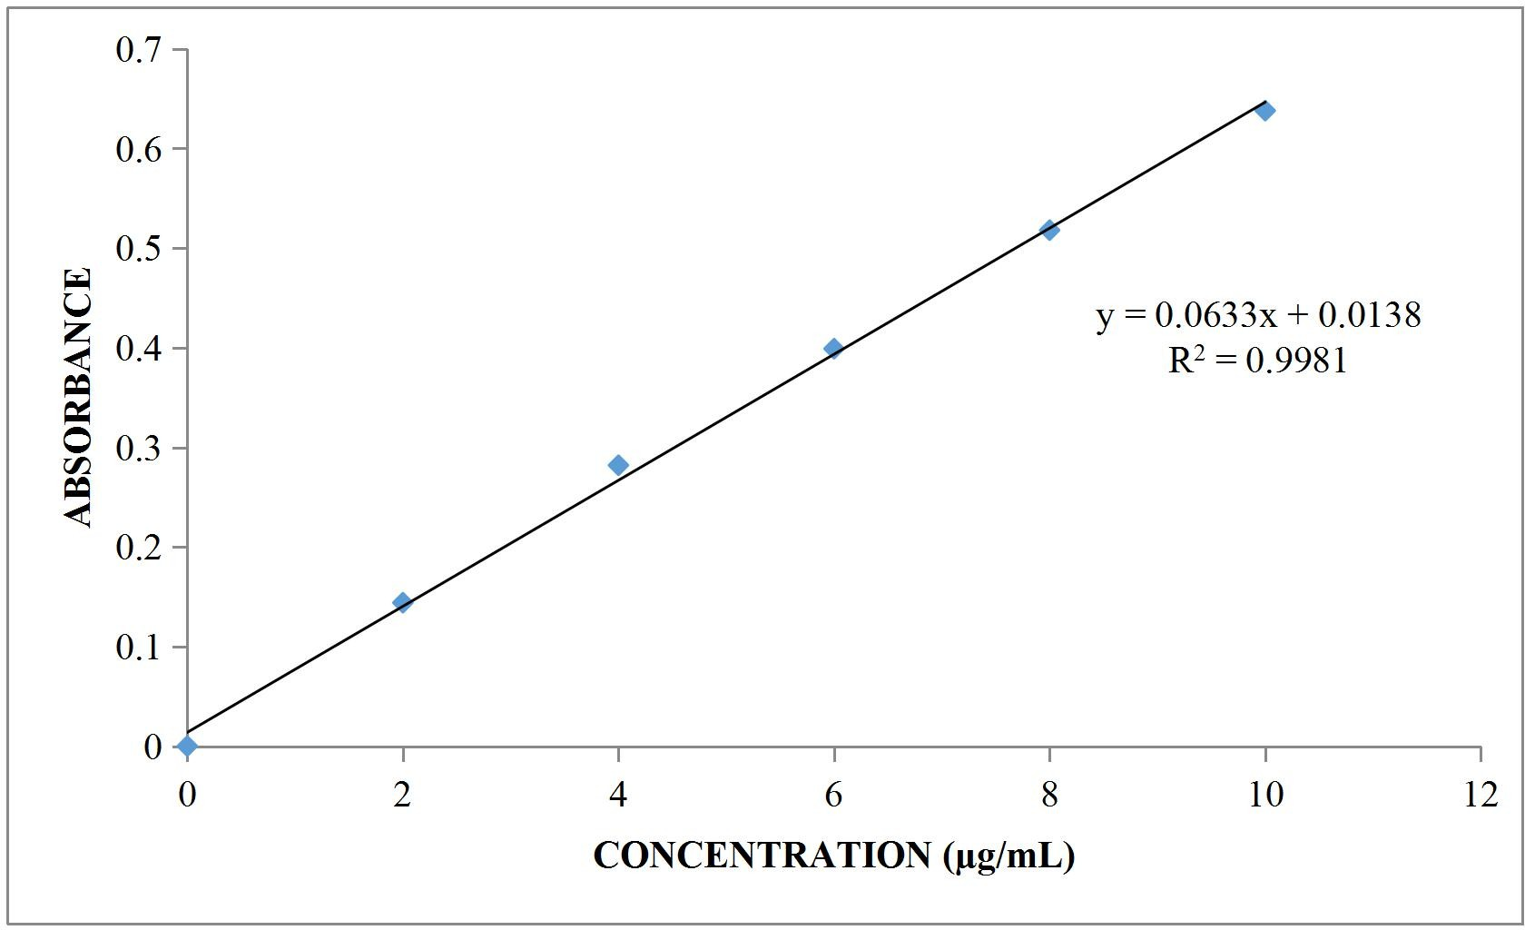

**Fig-1: Standard graph of Lornoxicam in 0.1 N HCl**

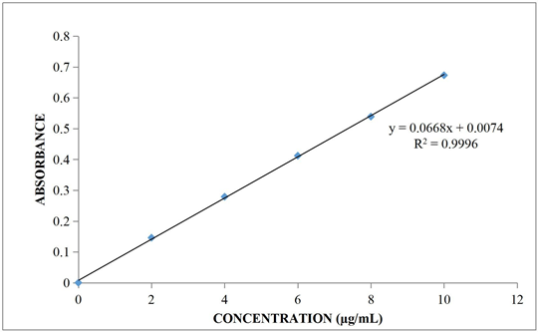

**Fig-2: Standard Graph of Lornoxicam in 6.8 pH buffer**

**Preformulation Parameters of Powder Blend**

**Table-8: Pre-Formulation Parameters of Core Blend**

|  |  |  |  |  |  |
| --- | --- | --- | --- | --- | --- |
| **Formulation**  **Code** | **Angle of**  **repose (Ө)** | **Bulk density**  **(gm/cm3** | **Tapped**  **Density (gm/cm3)** | **Carr’s index**  **(%)** | **Hausner’s**  **ratio** |
| L1 | 23.26±0.11 | 0.301±0.07 | 0.350±0.05 | 14.1±0.06 | 1.16±0.05 |
| L2 | 23.7±0.08 | 0.306±0.09 | 0.341±0.09 | 11.7±0.05 | 1.11±0.07 |
| L3 | 24.7±0.16 | 0.304±0.09 | 0.361±0.11 | 15.5±0.09 | 1.18±0.05 |
| L4 | 24.7±0.12 | 0.314±0.12 | 0.351±0.08 | 10.2±0.06 | 1.11±0.09 |
| L5 | 24.2±0.09 | 0.308±0.14 | 0.350±0.09 | 12.3±0.13 | 1.13±0.06 |
| L6 | 25.1±0.11 | 0.304±0.08 | 0.351±0.08 | 13.3±0.08 | 1.15±0.09 |
| L7 | 24.2±0.12 | 0.318±0.09 | 0.361±0.13 | 11.9±0.11 | 1.13±0.07 |
| L8 | 23.7±0.09 | 0.304±0.12 | 0.343±0.09 | 11.3±0.05 | 1.12±0.05 |

All the values represent n=3

Tablet powder blend was subjected to various pre-formulation parameters. The angle of repose values indicates that the powder blend has good flow properties. The bulk density of all the formulations was found to be in the range of 0.301±0.07 to 0.318±0.09 (gm/ml) showing that the powder has good flow properties. The tapped density of all the formulations was found to be in the range of 0.341±0.09 to 0.361±0.13 showing the powder has good flow properties. The compressibility index of all the formulations was found to be below 15.5 which show that the powder has good flow properties. All the formulations have shown the Hausner’s ratio ranging between 1.11 to 1.18 indicating the powder has good flow properties25.

**Quality Control Parameters for Tablets:**

Tablet quality control tests such as weight variation, hardness, friability, thickness and drug release studies in different media were performed on the compression tablet26.

**Table-9: In Vitro Quality Control Parameters for Tablets**

|  |  |  |  |  |  |
| --- | --- | --- | --- | --- | --- |
| **Formulation Codes** | **Weight variation**  **(mg)** | **Hardness (kg/cm2)** | **Friability (%loss)** | **Thickness (mm)** | **Drug Content (%)** |
| L1 | 98.62 | 4.6 | 0.62 | 2.19 | 99.87 |
| L2 | 96.35 | 4.2 | 0.52 | 2.85 | 97.54 |
| L3 | 100.02 | 4.0 | 0.46 | 2.94 | 98.21 |
| L4 | 99.75 | 5.2 | 0.32 | 2.79 | 100.17 |
| L5 | 98.34 | 4.9 | 0.48 | 2.61 | 99.27 |
| L6 | 97.42 | 5.3 | 0.36 | 2.43 | 98.31 |
| L7 | 100.14 | 4.8 | 0.24 | 2.86 | 99.10 |
| L8 | 99.87 | 4.6 | 0.19 | 2.76 | 97.49 |

**Weight Variation Test:**

Tablets of each batch were subjected to weight variation test, difference in weight and percent deviation was calculated for each tablet. The average weight of the tablet is approximately in range of 96.35 to 100.14 mg, so the permissible limit is ±7.5% (>100 mg). The results of the test showed that, the tablet weights were within limit.

**Hardness Test:**

Hardness of the three tablets of each batch was checked by using Pfizer hardness tester and the data’s were shown in Table 9. The results showed that the hardness of the tablets is in range of 4.0 to 5.3 kg/cm2, which was within IP limits.

**Thickness:**

Thickness of three tablets of each batch was checked by using Micrometer and data shown in Table-9. The result showed that thickness of the tablet is raging from 2.19 to 2.94 mm.

**Friability:**

Tablets of each batch were evaluated for percentage friability and the data were shown in the Table 9. The average friability of all the formulations was less than 1% as per official requirement of IP indicating a good mechanical resistance of tablets.

**Drug Content:**

Drug content studies were performed for the prepared formulations. From the drug content studies it was concluded that all the formulations were showing the % drug content values within97.49 – 100.17 %.

All the parameters such as weight variation, friability, hardness, thickness and drug content were found to be within limits27.

***In Vitro* Drug Release Studies**

**Table-10: Dissolution Data of Lornoxicam Tablets**

|  |  |  |  |  |  |  |  |  |
| --- | --- | --- | --- | --- | --- | --- | --- | --- |
| **TIME** | **CUMULATIVE % OF DRUG RELEASE** | | | | | | | |
| **L1** | **L2** | **L3** | **L4** | **L5** | **L6** | **L7** | **L8** |
| **In dissolution media 0.1 N HCL** | | | | | | | | |
| 0 | 0 | 0 | 0 | 0 | 0 | 0 | 0 | 0 |
| 0.5 | 10.23 | 8.13 | 7.65 | 5.98 | 19.21 | 17.28 | 13.22 | 9.54 |
| 1 | 17.61 | 15.81 | 13.76 | 10.57 | 25.98 | 20.40 | 17.97 | 13.28 |
| 2 | 21.59 | 20.32 | 19.32 | 16.58 | 31.98 | 26.75 | 24.22 | 21.26 |
| **In dissolution media 6.8 Phosphate Buffer** | | | | | | | | |
| 3 | 31.12 | 28.61 | 26.76 | 23.57 | 49.85 | 32.05 | 30.35 | 28.62 |
| 4 | 46.45 | 36.15 | 31.83 | 29.69 | 52.51 | 42.58 | 38.10 | 32.72 |
| 5 | 52.61 | 41.29 | 38.24 | 35.97 | 55.28 | 46.57 | 43.34 | 40.73 |
| 6 | 57.18 | 53.84 | 49.12 | 43.62 | 66.84 | 54.04 | 50.23 | 48.48 |
| 7 | 69.92 | 61.26 | 57.25 | 50.48 | 73.87 | 67.96 | 58.76 | 53.29 |
| 8 | 76.29 | 67.82 | 64.91 | 56.74 | 77.11 | 73.45 | 63.38 | 60.68 |
| 9 | 83.72 | 73.81 | 71.96 | 63.38 | 81.29 | 78.11 | 72.45 | 68.30 |
| 10 | 89.24 | 78.96 | 76.29 | 76.35 | 86.74 | 82.74 | 78.56 | 72.74 |
| 11 | 93.17 | 83.21 | 81.13 | 80.42 | 93.66 | 88.04 | 86.15 | 84.19 |
| 12 | 96.54 | 91.55 | 86.91 | 84.75 | 99.56 | 96.74 | 92.12 | 90.56 |

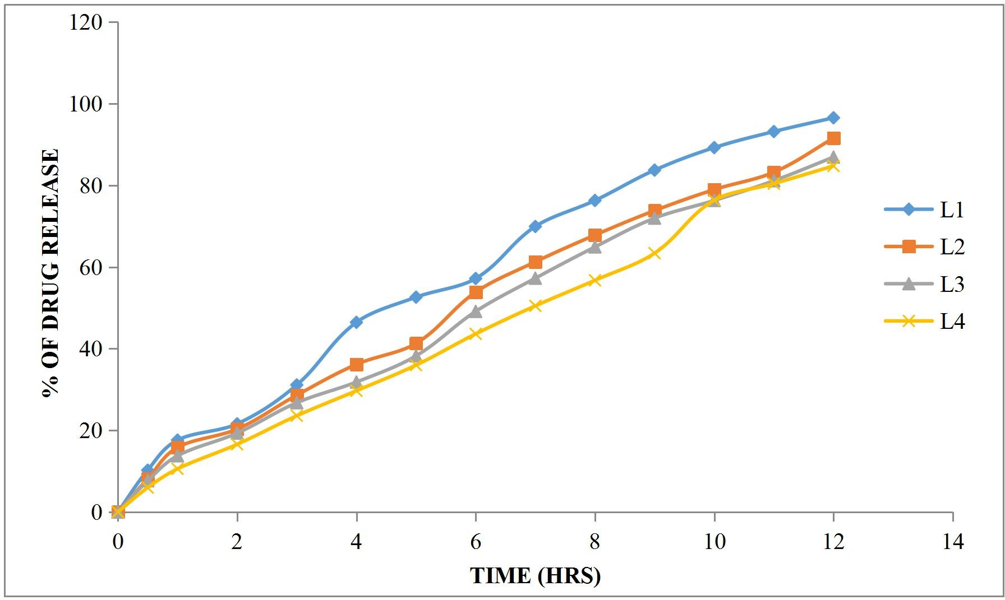

**Fig-3: Dissolution Profile of Lornoxicam (L1, L2, L3, L4 Formulations)**

The results of release studies of formulations L1 to L4 are shown in Table 10 and Figure 4. The release of drug depends not only on the nature of matrix but also upon the drug polymer ratio. As the percentage of polymer increased, the kinetics of release decreased. Formulation L1 composed of drug polymer ratio of 1:1 was sustained release. This formulation underwent erosion before complete swelling could take place. Formulations with drug polymer ratios 1:2 (L2), 1:3 (L3) and L4 have extended the drug release less.

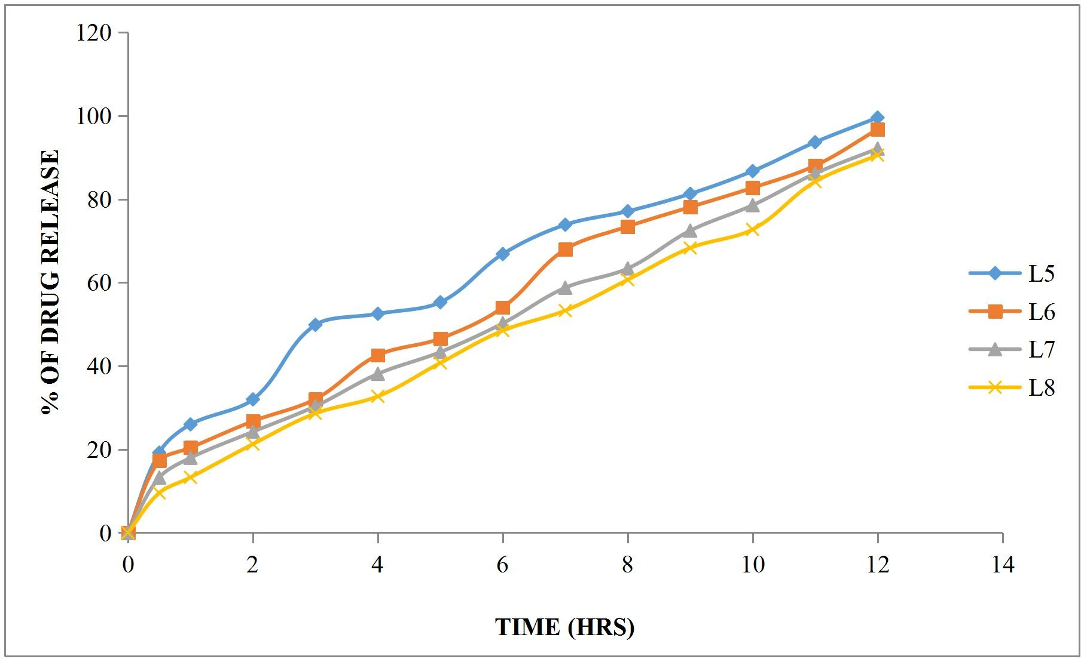

**Fig-4: Dissolution Profile of Lornoxicam (L5, L6, L7, L8 Formulations)**

Synthetic polymer HPMC K100 can be used as a matrix former for the formulation of sustained- release dosage forms. Batches containing HPMC K100 (L5 to L8) as release retardant extended the release up to 12 hours with initial slow release. As drug polymer ratio increased, the release rate was decreased. During dissolution the erosion was observed. The results were shown in Table 10 and Figure 4.

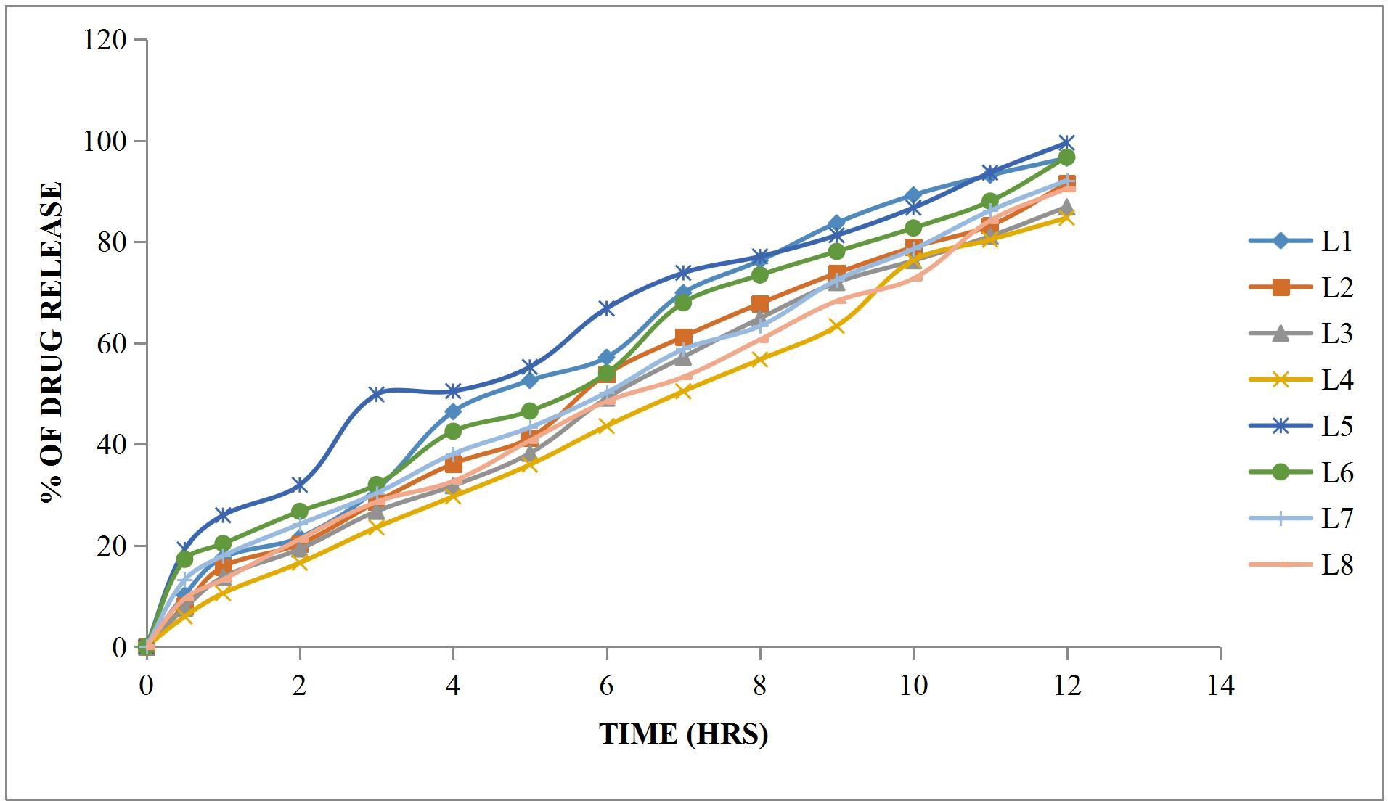

**Fig-5: Dissolution Profile of Lornoxicam (L1 to L8 Formulations)**

Out of total 8 batches, the drug release was extended up to 12 hours showed maximum drug release. So, these formulations selected for further studies like kinetic data analysis28.

**Table-11: Release Kinetics:**

|  |  |  |  |  |  |  |  |  |  |  |  |  |
| --- | --- | --- | --- | --- | --- | --- | --- | --- | --- | --- | --- | --- |
| **CUMULATIVE (%) RELEASE Q** | **TIME ( T )** | **ROOT (T)** | **LOG( %) RELEASE** | **LOG ( T )** | **LOG (%) REMAIN** | **RELEASE RATE**  **(CUMULATIVE % RELEASE / t)** | **1/CUM% RELEASE** | **PEPPAS**  **log Q/100** | **% Drug Remaining** | **Q01/3** | **Qt1/3** | **Q01/3-**  **Qt1/3** |
| 0 | 0 | 0 |  |  | 2.000 |  |  |  | 100 | 4.642 | 4.642 | 0.000 |
| 19.21 | 0.5 | 0.707 | 1.284 | - 0.301 | 1.907 | 38.420 | 0.0521 | -0.716 | 80.79 | 4.642 | 4.323 | 0.319 |
| 25.98 | 1 | 1.000 | 1.415 | 0.000 | 1.869 | 25.980 | 0.0385 | -0.585 | 74.02 | 4.642 | 4.199 | 0.443 |
| 31.98 | 2 | 1.414 | 1.505 | 0.301 | 1.833 | 15.990 | 0.0313 | -0.495 | 68.02 | 4.642 | 4.082 | 0.560 |
| 49.85 | 3 | 1.732 | 1.698 | 0.477 | 1.700 | 16.617 | 0.0201 | -0.302 | 50.15 | 4.642 | 3.688 | 0.954 |
| 52.51 | 4 | 2.000 | 1.720 | 0.602 | 1.677 | 13.128 | 0.0190 | -0.280 | 47.49 | 4.642 | 3.621 | 1.020 |
| 55.28 | 5 | 2.236 | 1.743 | 0.699 | 1.651 | 11.056 | 0.0181 | -0.257 | 44.72 | 4.642 | 3.550 | 1.092 |
| 66.84 | 6 | 2.449 | 1.825 | 0.778 | 1.521 | 11.140 | 0.0150 | -0.175 | 33.16 | 4.642 | 3.213 | 1.429 |
| 73.87 | 7 | 2.646 | 1.868 | 0.845 | 1.417 | 10.553 | 0.0135 | -0.132 | 26.13 | 4.642 | 2.967 | 1.674 |
| 77.11 | 8 | 2.828 | 1.887 | 0.903 | 1.360 | 9.639 | 0.0130 | -0.113 | 22.89 | 4.642 | 2.839 | 1.802 |
| 81.29 | 9 | 3.000 | 1.910 | 0.954 | 1.272 | 9.032 | 0.0123 | -0.090 | 18.71 | 4.642 | 2.655 | 1.987 |
| 86.74 | 10 | 3.162 | 1.938 | 1.000 | 1.123 | 8.674 | 0.0115 | -0.062 | 13.26 | 4.642 | 2.367 | 2.275 |
| 93.66 | 11 |  | 1.972 | 1.041 | 0.802 | 8.515 | 0.0107 | -0.028 | 6.34 | 4.642 | 1.851 | 2.791 |
| 99.56 | 12 | 3.317 | 1.998 | 1.079 | -0.357 | 8.297 | 0.0100 | -0.002 | 0.44 | 4.642 | 0.761 | 3.881 |

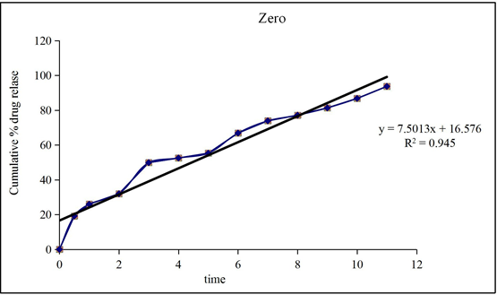

**Figure-6: Zero Order Release Kinetics Graph**

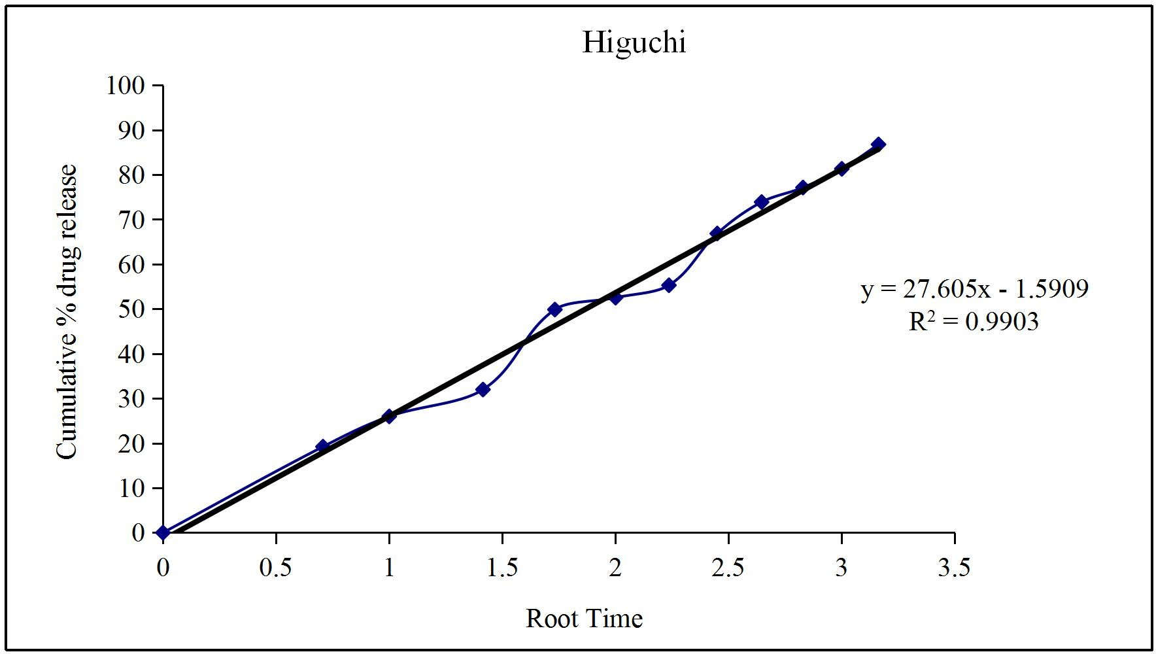

**Figure-7: Higuchi Release Kinetics Graph**

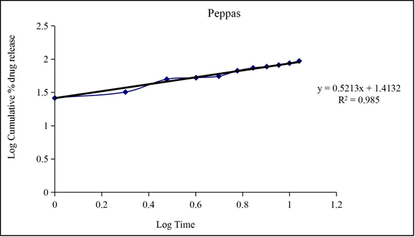

**Figure-8: Peppas Release Kinetics Graph**

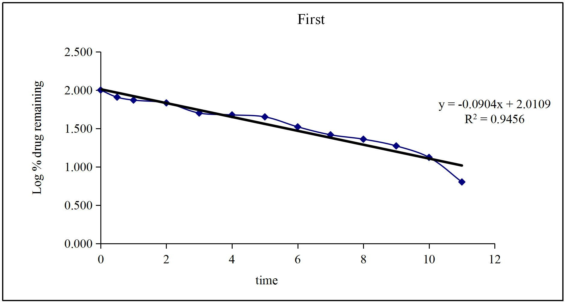

**Figure-9: First Order Release Kinetics Graph**

Optimised formulation L5 was kept for release kinetic studies. From the above graphs it was evident that the formulation L5 was followed Higuchi release kinetics mechanism29.

**Drug – Excipient Compatibility Studies**

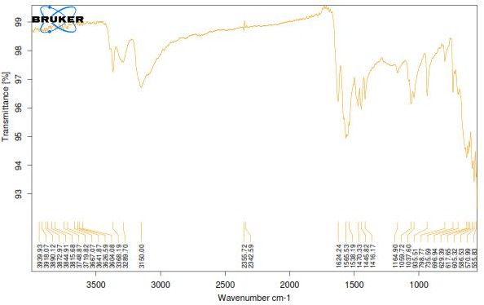

**Figure-10: FT-TR Spectrum of Lornoxicam Pure Drug**

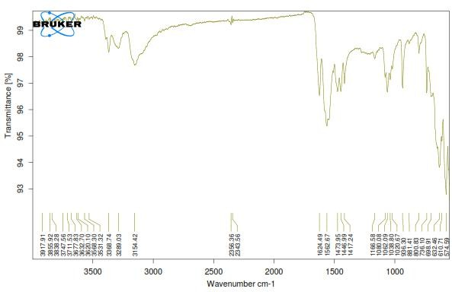

**Figure-11: FT-IR Spectrum of Optimised Formulation**

There was no disappearance of any characteristics peak in the FTIR spectrum of drug and the polymers used. This shows that there is no chemical interaction between the drug and the polymers used. The presence of peaks at the expected range confirms that the materials taken for the study are genuine and there were no possible interactions30.

Lornoxicam is also present in the physical mixture, which indicates that there is no interaction between drug and the polymers, which confirms the stability of the drug.

**CONCLUSION**

In this study sustained release matrix tablets of Lornoxicam were prepared by Wet granulation method, using Karaya Gum and HPMC K100 polymers as retardant. The pre compression and post compression parameters show that the values were found to be acceptable within the range. FT-IR studies revealed that the drug and excipients used weren’t having any interactions. The drug-polymer ratio was found to influence the release of drug from the formulations. Different parameters like hardness, friability, weight variation, drug content uniformity, in-vitro drug release were evaluated.

Among the all Eight formulations L5 formulation containing 8mg of HPMC K100 sustained the drug release up to 12hours. So L5 formulation was considered to be suitable for the formulation of Lornoxicam sustained release tablets at 8mg concentration of HPMC K100. So the drug release kinetics was performed for the L5 formulation. Based on these results formulation L5 was found to be the most promising formulations.

The invitro dissolution data for best formulation L5 were fitted in different kinetic models i.e., zero order, first order, Higuchi and Korsemeyer-Peppas equation. Optimized formulation L5 shows R2 value 0.990. As its value nearer to the ‘1’ it is conformed as it follows the Higuchi release kinetics mechanism.

The results revealed that no significant changes in drug content analysis and in-vitro dissolution study, thus indicating that formulation L5 was stable.

**BIBLIOGRAPHY**

1. Jain KK. Drug delivery systems. 1st edition. Switzerland: Humana Press; 2008. P. 1-51.
2. Reddy KR., Mutalik S, Reddy S. AAPS Pharm. Sci. Tech.2003; 4: 19. 121-125.
3. Chien YW. Novel drug delivery system. 2nd edition revised and expanded. New York: Informa health care; 2009. P. 1-50.
4. Jantzen GM, Robinson JR. Sustained and Controlled- Release Drug Delivery systems Modern Pharmaceutics, 4thed; 2003; 121: 501-502.
5. Salsa T, Veiga F. Drug Develop. Ind Pharm. 1997; 23: 931.
6. Gwen MJ, Joseph RR, In Banker GS and Rhodes CT, Ed. Modern Pharmaceutics, 3rdEd Marcel Dekker Inc. New York. 1996; 72: 575.
7. Jantzen GM, Robinson JR, Sustained and controlled-release drug delivery systems, in Banker GS, Rhodes CT (Eds.) Modern Pharmaceutics, 3rd Ed, Revised and Expanded, Drugs and the Pharmaceutical Sciences., Marcell Dekker, Inc. New York. 1995; 72: 575- 609.
8. Lee BJ, Ryu SG, Cui JH, Drug Dev. Ind.Pharm.1999; 25: 493-501.
9. Vidyadhara S, Rao PR, Prasad JA. Indian J Pharm Sci. 2004; 66: 188-192.
10. Bogner RH. Bioavailability and bioequivalence of extended-release oral dosage forms. US Pharmacist. 1997; 22: 3–12.
11. Rogers JD, Kwan KC. Pharmacokinetic requirements for controlled-release dosage forms. In: John Urquhart, ed. Controlled-release Pharmaceuticals. Academy of Pharmaceutical Sciences. American Pharmaceutical Association. 1979: 95–119.
12. Madan PL. Sustained-release drug delivery systems, part II: Preformulation considerations. Pharm Manu fact. 1985; 2: 41–45.
13. Wani MS, Controlled Release System-A Review, 2008; 6 1: 56-62.
14. Banker GS, Anderson NR. The Theory and Practice of Industrial Pharmacy: Tablet, Lachman, (3rded) Varghese Publishing House, Bombay. 1990; 3: 293-303.
15. Manish R, Jayesh P, Siahboomi AR. Hydrophilic Matrices for Oral Extended Release: Influence of Fillers on Drug Release from HPMC Matrices. Pharma Times. 2010; 42(04): 67-73.
16. Lee VHL, Controlled Drug Delivery Fundamentals and Applications: Influence of drug properties on design, Marcel Dekker, INC, and New York. 1987; 2: 16-29.
17. Kumar KP et al. Innovations in Sustained Release Drug Delivery System and Its Market Opportunities. J Chem Pharm Res. 2010; 2 1: 349-360.
18. Brahmankar DM, Sunil B. Jaishwal. “Controlled release medication” chapter 15th in “Bio pharmaceutics and Pharmacokinetics – A Treatise, 1st Ed, 2010; 1: 347- 353.
19. Mallikarjunarao p1*, Mohan Kumar y1, Kiran Kumar m2, Prathyusha s3, Lavanya d4. Formulation and invitro evaluation of Nevirapine extended release matrix tablets. International journal of research and development in pharmacy and life sciences. 2014; 3(4) 1054-1065.
20. Stanley S. Davis, Formulation strategies for abs windows. Drug Discovery Today, 2005; 10: 249-257.
21. Lieberman HA, Lachman L, Schwartz JB., Pharmaceutical Dosage Forms: Tablets, 2011; 3 (2): 199-287.
22. Modi SA et al. Sustained Release Drug Delivery System: A Review. Int J Pharma. Res Dev. 2011; 2 (12): 147-160.
23. Aulton ME. Pharmaceutics: The Science of Dosage Form Design. 2005; 2: 296-298.
24. Wise DL. Handbook of Pharmaceutical Controlled Release Technology. Inc. 2005; 2: 5-24.
25. Jantzen GM, Robinson JR. Sustained and Controlled- Release Drug Delivery systems Modern Pharmaceutics, 4thed; 2011; 121: 501-502.
26. Bhargava. A et al. Oral sustained release dosage form: an opportunity to prolong the release of drug. Int J ARPB. 2013; 3: 7-14.
27. Heena Farooqui and Prashant Upadhyay. Formulation And Evaluation Of Sustained- Release Tablet Having Genistein. IJPSR, 2022; Vol. 13(2): 810-820.
28. Lateef Gbenga Bakre, Emmanuel Akinyele, Oluyemisi Bamiro, Olutayo Adeleye, Olobayo Kunle. Formulation and Evaluation of Sustained Release Ibuprofen Matrix Tablets Using Starch from Maize Genotypes as Polymer. Seria Medica 2021; 67(2):122- 126.
29. Pawar Simran S., Malpure Prashant S., Surana Santosh S., Bhadane Jayashri S. Formulation and Evaluation of Sustained Release Matrix Tablets of Captopril. Journal of Drug Delivery & Therapeutics. 2019; 9(4-A):260-268.
30. K. Latha, T. Chinni Kranthi and Naseeb Basha Shaik Preparation and Evaluation of Sustained Release Matrix Tablets of Tolterodine Tartrate Using Guggul Resin. Bangladesh Pharmaceutical Journal 21(1): 24-34, 2018.