**COVID 19 AND IT’S IMPACT ON THE INDIAN**

**ECONOMY**

OBJECTIVE: Following a surge in cases of coronavirus disease 2019 (COVID- 19) in June 2020, India became the third-worst affected country worldwide. This study aims to analyse the underlying epidemiological situation in India and explain possible impacts of policy and technological changes.

WHAT IS COVID 19?

Coronavirus disease (COVID-19) is an infectious disease caused by the SARSCoV-2 virus. Most people infected with the virus will experience mild to moderate respiratory illness and recover without requiring special treatment. However, some will become seriously ill and require medical attention.

WHAT IS COVID 19 CALLED?

Covid 19 is the official Name given by the World Health Organization to the disease caused by SARS-CoV-2, the new coronavirus that surfaced in Wuhan, China in 2019 and spread around the globe. WHAT ARE THE EFFECTS OF COVID 19?

Organ damage. People who have severe illness with covid 19 might experience organ damage affecting the heart, kidneys, skin and brain. Inflammation and problems with the immune system can also happen. It also causes respiratory symptoms that can feel much like a cold, the flu, or pneumonia.

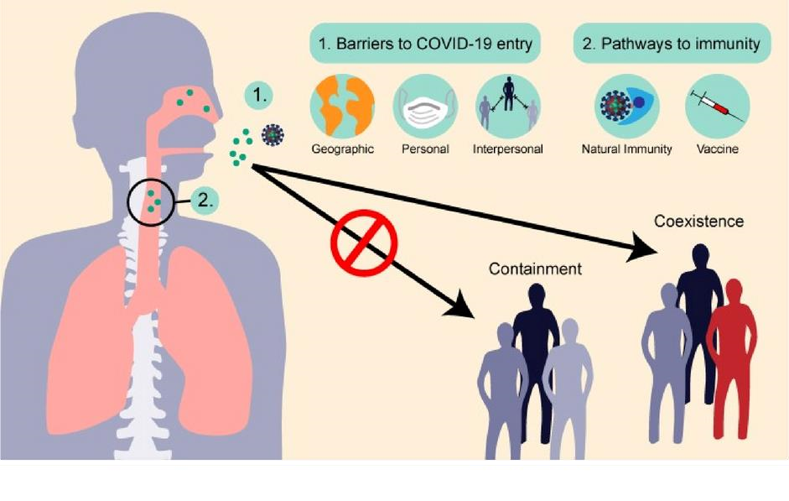

COVID 19 IMPACT IN INDIA:-

Coronavirus disease 2019 (COVID-19) is an infectious disease caused by severe acute respiratory syndrome coronavirus. It was first identified in December 2019 in Wuhan, Hubei, China, and has resulted in an ongoing pandemic. As of 5 July 2020, more than 11.1 million cases have been reported across 188 countries and territories, resulting in more than 528,000 deaths. More than 6.03 million people have recovered. The entire world population currently faces enormous challenges (i.e., social, environmental, health, and economic) due to the impact of COVID19. In this regard, the affected countries are now trying to slow down the virus’s transmission through social-distancing, lockdowns, increasing the number of tests and treatment facilities. There have been four lockdowns (25 March 2020– 31 May 2020), and two unlock periods (1 June–31 July 2020) in India. It was also observed that there was a considerable buildup of AOD during the pre-lockdown period in the year 2020 as compared to the past two years. The spread of COVID-

19 in India was initially characterized by fewer cases and

lower case fatality rates compared with numbers in many developed countries, primarily due to a stringent lockdown and a demographic dividend. However, economic constraints forced a staggered lockdown exit strategy, resulting in a spike in COVID-19 cases. This factor, coupled with low spending on health as a percentage of gross domestic product (GDP), created mayhem because of inadequate numbers of hospital beds and ventilators and a lack of medical personnel, especially in the public health sector. Nevertheless, technological advances, supported by a strong research base, helped contain the damage resulting from the pandemic. Following nationwide lockdown, the Indian economy was hit hard by unemployment and a steep decline in growth. The early implementation of lockdown initially decreased the doubling rate of cases and allowed time to upscale critical medical infrastructure. The spread of COVID-19 in India was initially characterized by lower case numbers and fewer deaths compared with numbers in many developed countries. This was mainly due to a stringent lockdown and demographic factors. However, economic constraints forced a staggered lockdown exit strategy, resulting in a spike in COVID-19 cases in June 2020. Subsequently, India became the thirdworst affected country worldwide. Low spending on health as a percentage of gross domestic product (GDP) meant there was a shortage of hospital beds and ventilators and a lack of medical personnel, especially in the public health sector. Nevertheless, technological advances, supported by a strong research base, helped contain the health and economic damage resulting from the pandemic. In the future, measures such as asymptomatic testing, public-private partnerships, and technological advances will be essential until a vaccine against COVID-19 can be developed and rolled-out in India.

Methodology

The AOD of the year 2020 over entire India and various regions marked was analyzed and compared with previous years (2018, 2019) AOD data. For comparison, anomalies of AOD of the year 2020 have been calculated by subtracting it from the AODs of the years 2018 and 2019 at each grid point.

The analysis is carried out for different time intervals, as shown in Table. The first period, pre-Lockdown, was the period before any lockdown was imposed in India from 1 January 2020 to 24 March 2020. The second period will be called as the lockdown 1.0 (LD1.0) that existed from 25

March 2020 to 14 April 2020. Subsequently, there were three more lockdowns (LD2.0, LD3.0, and LD4.0) between 15 April 2020 and 31 May 2020. After that, the first unlock period (UL1.0) started from 1 June 2020 to 30 June 2020. At present, the second unlock phase (UL2.0) is in progress.

Various lockdown/unlock phases in India due to COVID-19

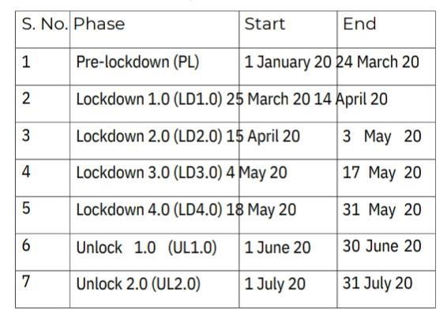

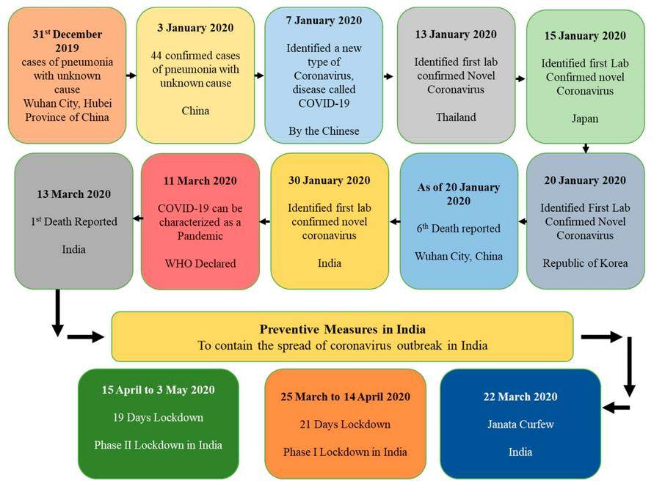

Amidst the lockdown in Indian society, multiple issues related to

social, educational, economical, political, agricultural, psychological levels and many more have been noticed which has created the devastating impact on the lives of the people.If we analyse the act of “social-distancing” sociologically, isn’t it a new form of untouchability? Of course yes, as earlier in the Indian society after the Vedic period, people of the upper caste used to maintain social-distancing with untouchables so that they don’t impure the people of upper caste. On the same pattern, in the contemporary society due to Covid-19 all the constitutional norms eliminating untouchability and promoting integration seems to be failed as people are asked to maintain social-distancing.Of course, it is the only measure to control the influence of Covid-19 and it should be promoted but we need to see the impact of this pandemic on the society how it has revived the social discriminatory practices.Impact of Covid-19 has been multiple and not only limited to society at large. From the perspective of the economy both rural and urban have been impacted adversely. Everyone has seen the issues being faced by migrant workers, will they be the same when Covid-19 ends? Of course not. The migrant workers depend on daily earnings, they barely have savings which they could spend during any emergency.

Many of them have already abandoned this world. Those who didn’t have many resources left with them have started to move to their villages because of the unavailability of jobs and money in the cities. Apart from migrant workers, gig workers have been gone through a similar issue though it has not got much attention in the news. These workers e.g., delivery boys, cab driver etc. Because of Covid-19, the world came to stagnant position, so the online platform which leads to the economic hardship of this section of the urban economy. Moving from the economy, the impact of Covid-19 on education has been cruel and its repercussions will be seen in the upcoming future. As per the report of World Bank titled “Beaten or broken: Informality and Covid”, WB has warned that there will be the lifelong impact of school closures on the productivity of this generation of students. Children being out of school for about eight months might forget some facts as well as impact their learning capacity. So, what is the benefit of nearly 100% enrolment ratio at primary level education? Despite one of the greatest achievements in enrolling the students at primary level Covid-19 is stopping us to reap its benefits in the coming future. With any pandemic or any situation which impact the society at large comes the problem of psychological trauma. The lockdown has proved that “man is a social being” because continuous lockdown for about four months have impacted people psychologically and the burden has been faced by women and children in the form of domestic violence. In the lockdown period, multiple calls have been received on the helpline number made for the people going through domestic violence. As India is recognised as land of diversity, so the impact of Covid-19 is diverse and countless. But, if we see the other side of reality, COVID-19 has impacted our society and that is for sure, but only adversely? That is the thing we need to analyse carefully and can’t be left without a brief discussion. It has been truly said that “crisis gives birth to the changes which were pending for many years”, same has happened during the time of Covid19. Things have been changed to meet the needs of the society what the government were trying hard to implement from past many years. Be it online education or judiciary, Covid-19 (crisis) has allowed making these major transformation in the education and judiciary.But, again the benefits from these transformations will be limited because of the gap in the digital connectivity of our country. At this stage, we should ask a genuine question: What kind of society we’ll see post-Covid-19? Fragmented? Unequal? We don’t know but we’ll have to stand up again support each other. We’ll have to adopt values enshrined in our Preamble of the Constitution i.e. “Equality, Fraternity, Integrity” as well as DPSP to make India a better place on earth for its citizens and the world.

IMPACTS OF COVID 19 ON INDIAN ECONOMY:-

From April to June 2020, India’s GDP dropped by a massive 24.4%. According to the latest national income estimates, in the second quarter of the 2020/21 financial year (July to September 2020), the economy contracted by a further 7.4%. The recovery in the third and fourth quarters (October 2020 to March 2021) was still weak, with GDP rising 0.5% and 1.6%, respectively. This means that the overall rate of contraction in India was (in real terms) 7.3% for the whole 2020/21 financial year. In the postindependence period, India's national income has declined only four times before 2020 – in 1958, 1966, 1973 and 1980 – with the largest drop being in 1980 (5.2%). This means that 2020/21 is the worst year in terms of economic contraction in the country’s history, and much worse than the overall contraction in the world. The decline is solely responsible for reversing the trend in global inequality, which had been falling but has now started to rise again after three decades.

# Economic contraction in India and the world during Covid-19

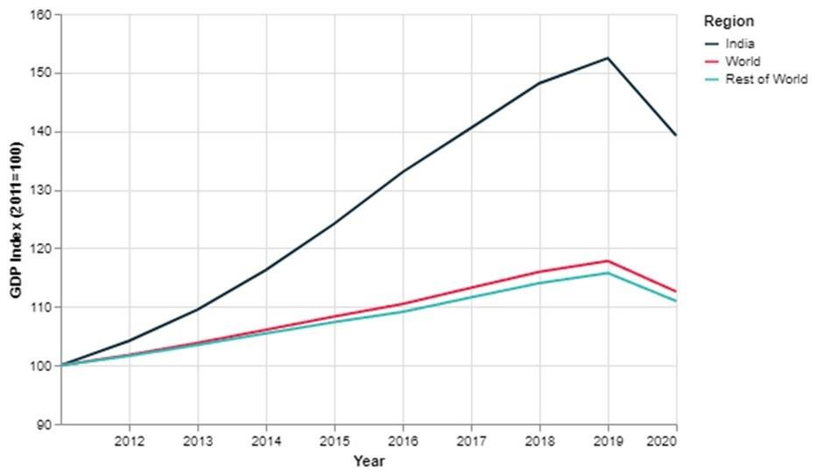

How has Covid-19 changed income, consumption,poverty and unemployment in India?

While the macroeconomic statistics provide a snapshot of India’s economic position, they hide the large and unequal effects on households and workers within the country. Both wealth and income inequality has been on the rise in India. Estimates suggest that in 2020, the top 1% of the population held 42.5% of the total wealth, while the bottom 50% had only 2.5% of the total wealth. Postpandemic, the number of poor in India is projected to have more than doubled and the number of people in the middle class to have fallen by a third. During India’s first stringent national lockdown between April and May 2020, individual income dropped by approximately 40%. The bottom decile of households lost three months’ worth of income. Microdata from the largest private survey in India, CMIE’s ‘Consumer Pyramids Household Survey’ (CPHS), show that per capita consumption spending dropped by more than GDP, and did not return to pre-lockdown levels during periods of reduced social distancing. Average per capita consumption spending continued to be over 20% lower after the first lockdown, and remained 15% lower year-on-year by the end of 2020. Official poverty data are unavailable, and the CPHS data come with a caveat of ‘top’ and ‘bottom exclusions’. For example, official statistics show a rural headcount ratio of 35% in 2017/18. But the CPHS data estimate it at 25%, which suggests exclusions at the lower end of the consumption distribution. Despite these statistical concerns, the CPHS does provide consumption numbers for a large sample of individuals, which can provide insights into changes in consumption levels arising from the pandemic. The percentage of people who have monthly consumption expenditure below different cut-off values. The different cut-offs encompass the official poverty lines. The current rural poverty line is set at 1,600 rupees per month or over, and the urban poverty line is 2,400 rupees per month or over. Based on the latest CPHS data, rural poverty increased by 9.3 percentage points and urban poverty by over 11.7 percentage year-on-year from December 2019 to December 2020. Earlier months of the CPHS show that rural poverty increased by 14.2 percentage points and urban poverty by 18.1 percentage points. Yet the actual increase in poverty due to Covid19 is likely to be higher than what the CPHS data suggest, as indicated by other surveys.

CASE STUDY:- ABSTRACT

Coronavirus disease has spread out across the globe within a span of few months. All economies are facing the problems how to the economy open and functioning during COVID-19. Many industries have been affected by the nation-wide lockdown. Companies are expected to register the poor growth in business. Organization’s financial performance will remain sluggish in the coming few quarters. There are some industries which are impacted positively. On the other hand, there are some industries which are impacted negatively. This paper intends to measure the performance of various industries during the COVID-19. This paper is based on the secondary data collected from the multiple sources.

# INTRODUCTION

Coronavirus disease has impacted all the countries across the globe. All countries have observed the effects of the coronavirus at different levels. China, Italy, Spain, Grace and United State of America have been impacted the most in the recent past. All countries are trying their best to contain the effects of corona virus by taking various measures like nationwide lockdown, permitting companies partially with certain number of employees and adhering the social distancing norms.

Coronavirus is an infectious disease and it spreads very quickly and it impact the life of individuals to a great extent. The first case of the COVID-19 has been detected in the Wuhan province of China. Taking this reference, United States of America blames China for the world wide spread of corona virus which caused deaths of millions of the people. LITERATURE REVIEW

There are thousands of evidence which proves that infectious disease outbreak impact the economic development of a country. Economic cost of the infectious disease is the subsidies given to the poor, health facilities provided to the patient and losses incurred by the business organizations due to non-functional business operations. During the outbreak of infectious disease, workers are not able to work and business organizations are not in the position to run the operations at the full capacity. Millions will lose their jobs and companies will lose their orders taken from their clients from across the globe. The logic to bear this cost is that social security is more important than economic benefits. If the people are secured and healthy; economic growth can be achieved after some time. The influenza virus had proven more dangerous and deadliest in human history. It cost loss of millions and deaths of millions in Spain. Similarly, Corona virus appears to be deadliest and spread person to person at a very fast pace. So far, there is no vaccine developed which could be used for the treatment of the corona virus patients. As of now, nationwide lockdown seems to be the only option to save the lives of people. Impact of COVID-19 in urban areas is more than rural areas. It is because of population density and environmental issues. Large numbers of people are living with fear and uncertainties. People are fearful because they are considering COVID-19 as a major reason for the people’s death. However, this has not been proven but the perception of the people is like this. Viscusi et al. (1997) rank COVID-19 as the third major factor for people death after cancer and cardiovascular. According to the research conducted by the Sunstein (1997) explains that an individual’s willingness to pay increases when they feel that it can cost their life. They will search for best doctors and best treatment to avoid the impact deadly virus. People perception of COVID-19 is very negative as far as its impact on their life, business operation and economy is concerned. Due to COVID-19, business is not able to operate and many other businesses are likely to collapse. Several studies have outlined the effects of COVID-19 on world economy. World GDP is estimated to be reduced drastically due to COVID-19 because consumption and investment activities are very low. People are spending their income on only essential items not luxury one. People want to save their income because they are not very sure that how long this virus will prevail in the world. United States of America, China and India are the three main economies driving the world’s consumption activities. As compare to US and China, India is relatively safe and the virus effects are not as fearful as were in US and China. Lower consumption effects will not only confine to US, China and India but also to other major world economies.

# RESEARCH METHODOLOGY

This paper is based on the secondary data. This is the best time to conducted research on the secondary data since people are not permitted to out from their home. Secondary data has been collected from the various sources containing data related to the performance of GDP and other inflation during the lockdown. Secondary is collected from management libraries, journals, newspaper and magazines. This paper describes in detail the estimated loss/ profit of the business organizations during lockdown. IMPACT OF COVID-19 ON INDUSTRIES

There are several sectors which are impacted by the COVID-19 and the chances of their revival are not in the near future. Their profitability is continuously decreasing and fixed cost is intact. Like media and entertainment industry; all multiplexes are closed and people do not want to visit the multiplexes in the near future. Many organizations have taken loan from the commercial banks and other

financial institutions. They have to pay interest on the loan despite of poor financial position. High debt to equity ratio indicates that companies are raising more funds through debt rather than equity. High debt to equity ratio also indicates about the potential risk associated with the particular organization. However, debt to equity ratio in the manufacturing and financial sector is very high because these organizations use more debt for business purpose. In the above table, information technology and investment banking and brokerage have low debt to equity ratio than other sectors. Impact of COVID-19 is likely to be less on those companies which have taken less debt as compared to those organizations which have taken high debt.

# CONCLUSION

After analyzing the various reports, it is concluded that Indian economy has not been affected as badly as the other economies impacted. However, some industries have been affected badly and hit the financial performance of the companies badly. On the other hand, some industries are performing good and expected to perform well in the coming few quarters.

# REFERENCES

1. World Health OrganizaƟon
2. https://www.irjmets.com/uploadedfiles/paper/volume2/issue_7_july

_2020 /2005/1628083069.pdf

1. https://timesofindia.indiatimes.com/readersblog/covid-19-and-itsimpacton-india/covid-19-and-its-impact-on-indian-society-27565/
2. https://en.wikipedia.org/wiki/COVID-19