**The Dual Impact of Artificial Intelligence: Job Displacement and New Opportunities in the Labor Market**

Munira Bhatia

Masters Of Commerce in Business Management

H.R College of Commerce & Economics

HSNC University, Mumbai

**ABSRACT**

The AI technologies continue to advance rapidly and reshape labor markets and the nature of work. This study synthesizes current research and empirical evidence to provide a comprehensive analysis of both the disruptive and creative impacts of AI on jobs. It discusses the research questions on how AI automates routine jobs, enhances human skills in knowledge-intensive industries, and generates new roles that did not exist previously. The study looks at job displacement possibilities in industries versus emerging opportunities in AI-related fields. The paper looks at differential impacts across multiple levels of skill, industry, and geographic region, along with implications for wage inequality and labor market polarization. In addition, this paper analyses the policy responses with potential strategies for mitigating negative impacts such as reskilling initiatives and changes in education systems as well as in social safety nets. Additionally, it addresses issues related to ethics and responsible AI development for workplace deployment. With the intention of educating policymakers, business leaders, and educators on the challenges of AI in an ever-changing work structure, this paper seeks to produce a balanced assessment of AI's impact on employment.

**OBJECTIVES OF THE STUDY**

* To analyze the impact of AI on various economic sectors, such as manufacturing, finance, healthcare and retail
* To examine the potential impact of AI on employment.
* To investigate the ethical considerations surrounding AI development and deployment.

**HYPOTHESIS OF THE STUDY**

* **Hypothesis 1:** AI will have a net positive impact on economic growth. Hypothesis 2: AI will lead to significant job displacement and income inequality.
* **Hypothesis 3:** The ethical implications of AI will require careful consideration and policy interventions.

**LIMITATION OF THE STUDY**

* The sample size was limited to 70 respondents.
* The time and resources were major constraint.
* The limited knowledge of the respondents regarding the topic may hamper the true conclusion of the study

**DATA COLLECTION METHOD**

**Secondary Data Collection Methods**

Secondary data is the data that has been used in the past. The researcher can obtain data from the sources

* Press releases
* Business journals
* Libraries
* Internet

The secondary data collection methods, too, can involve both quantitative and qualitative techniques. Secondary data is easily available and hence, less time consuming and expensive as compared to the primary data. However, with the secondary data collection methods, the authenticity of the data gathered cannot be verified.

**Primary Data Collection**

Methods Primary data is collected from the first-hand experience and is not used in the past. The data gathered by primary data collection methods are specific to the research’s motive and highly accurate.

Surveys is used to collect data from the target audience and gather insights into their preferences, opinions, choices, and feedback related to their products and services. Wide range of question types to select.

**REVIEW OF LITERATURE**

**Solos, W., & Leonard, J. (2022)**. On the Impact of Artificial Intelligence on Economy. Science Insights. This paper provides a systematic review of the economic impact of AI, focusing on the promotion of AI on productivity and economic growth; the impact of AI on labor employment; and the question of whether AI will increase income inequality. On this basis, a summary of how to implement public policies to reduce the potential negative impacts of AI on the employment structure and income inequality is provided. Finally, a summary and prospective research directions are provided.

**Damioli, G., Roy, V., & Vértesy, D. (2021).** The impact of artificial intelligence on labor productivity. Eurasian Business Review. Recent evidence indicates an upsurge in artificial intelligence and robotics (AI) patenting activities in the latest years, suggesting that solutions based on AI technologies might have started to exert an effect on the economy. Their analysis shows that, once controlling for other patenting activities, AI patent applications generate an extra-positive effect on companies’ labor productivity. The effect concentrates on SMEs and services industries, suggesting that the ability to quickly readjust and introduce AI-based applications in the production process is an important determinant of the impact of AI observed to date.

**Lu, Y., & Zhou, Y. (2019).** A Short Review on the Economics of Artificial Intelligence. ERN Technology (Topic). The rapid development of artificial intelligence (AI) is not only a scientific breakthrough but also impacts on human society and economy as well as the development of economics. Research on AI economics is new and growing fast, with a current focus on the productivity and employment effects of AI. This paper reviews recent literature in order to answer three key questions. First, what approaches are being used to represent AI in economic models? Second, will AI technology have a different impact on the economy than previous new technologies? Third, in which aspects will AI have an impact and what is the empirical evidence of these effects of AI? Our review reveals that most empirical studies cannot deny the existence of the Solow Paradox for AI technology, but some studies find that AI would have a different and broader impact than previous technologies such as information technology, although it would follow a similar adoption path. Secondly, the key to incorporating AI into economic models raises fundamental questions including what the human being is and what the role of the human being in economic models is. This also poses the question of whether AI can be an economic agent in such models. Thirdly, studies on the labor market seem to have reached consensus on the stylized fact that AI would increase unemployment within sectors but may create employment gains at the aggregate level. AI also increases the income gap between low- and medium-skilled workers and high-skilled workers. AI’s impacts on international trade and education have been largely neglected in the current literature and are worth further research in the future.

**Mazilescu, V. (2018).** Artificial Intelligence as a New Factor of Global Economic Growth. Economics and Applied Analytics, outline that Artificial Intelligence (AI) will have a huge impact on the global economy, and global GDP could increase as a result of its implementation, making AI the biggest trading opportunity in the ever-changing economy. Intelligence is the extraordinary ability of a system to reason, calculate, perceive relationships and analogies, classify, generalize, learn from experience, store and retrieve information from memory, adapt new situations, solve planning problems, comprehend complex ideas, use natural language fluently. Software that uses intelligence will most contribute to the growth of AI as an industry in the coming years.

**Introduction to AI**

Artificial Intelligence is the ability of digital computers or computer-controlled robots to perform tasks usually attributed to intelligent beings. The term often describes the activity of producing systemsthat embody intellectual abilities similar to humans, including reasoning, understanding, generalization, and learning from experience. Since the invention of the digital computer in the 1940s, scientists have demonstrated that computers can be programmed to carry out very complex tasks with great efficiency, such as proving mathematical theorems or playing chess. However, despite further increases in processing speed and memory capacity, current AI systems have not been able to match the full range of human cognitive flexibility across broad domains or in tasks requiring extensive everyday knowledge. Yet in restricted areas and narrow domains, AI programs have successfully competed with human experts and professionals. Practical applications of AI are quite widespread: from medical diagnosis to search engines, voice and handwriting recognition, to even the humble chatbots as a conversational interface.

**AI Use and Applications:**

Companies are now using AI and machine learning systems that work independently to gain a competitive advantage. AI is used in most industries and business activities, including customer service, marketing and sales, energy and resources, financial services, government and public administration, life sciences and healthcare, retail, mobility and self-driving cars, human resources, and operations. Such technologies are being used across many sectors to make services efficient, personalized, and result-oriented. Its applications are designed to evaluate and implement business applications using AI. This is redefining industries and startups, with a result of advanced sectors and improved business processes. AI has been contributing to the better efficiency and growth transformation in various industries and sectors. Businesses will definitely benefit from applying AI and automated machine learning. A lot of such applications mean that companies could easily optimize their processes and personalise service delivery to promote business growth. Ever since AI has erupted, and entered India it is seen that the growing proportion of Indian economy follows in tandem with the surge in AI. The war of competition of AI along with Economy in India is against the rest of the world with 'Make in India' among those initiatives that push it for going up the rungs.

**Make in India drive**

“Make in India” is an initiative launched by India's Prime Minister Narendra Modi in 2014, that boosted plans to reignite India's economy and turn the nation into a global design and manufacturing hub, in response to the economic downturn of 2013, partly compared to the Great Depression. The program focuses more on reducing India's reliance on foreign markets, such as Taiwan, to get the supplies and increase self-reliance within the Indian market. To achieve this goal, it has shifted the focus on funding Artificial Intelligence (AI) and semiconductor development through a proposed $1 billion investment in semiconductor companies. In addition, through the "Make in India" initiative, there would be a guaranteed market through government procurement and local content prescription, which mandates local procurement of chips, as this scheme has the potential to induce significant domestic production and deplete dependency on imports from outside, thereby promoting local consumption that will spur the economic benefits of growth in jobs.

**The impact of artificial intelligence on Indian economy**

One such positive approach that the Indian government can use in boosting the creation of jobs for engineers in the country is to provide monetary incentives to the Indian chip manufacturers. This success will further help to develop more comprehensive literature on AI economics in India and further enlighten us about complicated relationships between technological innovation, economic growth, and employment. But it goes beyond the economic growth paradigm. Developing a domestic chip manufacturing capability is also the way forward for India's full technological sovereignty and ceaseless effort at cutting down dependence on foreign suppliers, particularly China. It helps India to reduce risks stemming from reliance on external sources and fosters a self-sufficient and resilient economy. This far-reaching impact of the strategy helps to implement it for more substantial economic development in the Indian economy, and reduce its vulnerability to external shock to better strengthen its ground in the global technology arena. Therefore, this venture could be a step that makes the Indian economy more autonomous and self-sustained enough to drive its economic growth and development.

**Future Outlook**

The continuous innovation in AI and automated machine learning will profoundly impact industries and the future of their business functions. The expectation with regard to AI advancements is that they will be changing numerous sectors and transform how businesses work and deal with stakeholders. However, AI adoption will likely have both positive and negative impacts on the labor market. One the positive side, automation of redundant and routine work will undoubtedly contribute a significant portion of productivity gains as well as efficiency improvements. On the other hand, it may displace some jobs where large percentages of work involved manual effort or is simply repetitive. Another skill gap could arise from working with AI systems, for the nature of skills that would be required would differ from that in traditional employment, resulting in unemployment and underemployment in some areas. The positive effects of AI are more likely to concentrate among various segments of the society, aggravating the inequalities in the distribution of incomes and opening a gap between the haves and have-nots. In general, the impact of AI in the future of work is going to be multifaceted and complex and requires collaboration among policymakers, business leaders, and educators so that negative impacts are averted while all parties will benefit from the use of AI.

**Impact of Technological Advancements on Work and Employment: Trends and Implications for the Future**

**Technological Impact on Paradigms of Work:** Technological innovations have evolved at an unprecedented pace. It has significantly affected every dimension of work, ranging from production methods to economic systems and communication paradigms. The infusion of advanced technologies like the Internet, social networks, mobile devices, big data analytics, cloud computing, cybersecurity measures, robotics, and Artificial Intelligence (AI) has caused a revolution in the paradigm of work in the global arena.

**Technological revolution** has brought about a shift in work relations from being mostly interpersonal interactions to human-machine interfaces. This change has fundamentally altered the modalities of work, consumption patterns, and interpersonal communication.

**Digital Transformation and Future Work Dynamics:** The present trajectory of technology suggests an immediate disruptive transformation of work in conceptualization and execution. For the foreseeable future, the digital transformation is more likely to mold work processes, consumption behaviors, and communication dynamics.

**Cross-Industry Technological Impact:** In all these sectors of the economy, including healthcare, agriculture, education, and trade, it has brought heavy influences in the simple functioning frameworks and service delivery structures. Advanced technologies have seen major efficiency improvements while enhancing innovation across all those industries.

**Future Work Projections** The pace of technological change at the current rate will make the future work environments very turbulent. Changes that profoundly change the nature and dynamics of work as it may be designed and performed in the future will be inevitable.

**Problems and Suggestions**

Other forms of challenges ahead of the navigation of influence technology poses to work comprise employee monitoring, surveillance, and alteration of skills.

**Global Impact:** Reports and opinions from global organizations and forums are emerging to indicate that technology impacts the workplace and nature of work globally. It is acknowledged that technology significantly influences the workplace and nature of work. People realize preparing themselves for jobs that would be framed in response to technological changes in the future.

**Impact on Labor Market:** AI and automation change the face of work, offering new jobs. The interesting fact here is that job destruction can offset the creation of new jobs. AI has transformed economic development, work, and wages primarily in developing countries. This nature of automation led to the creation of the "reserve army" in an economy.

**Hazards to safety and health from digitalization:** The new and emerging risks that will result in occupational safety and health include digitalization. By the year 2025, the hazards have to be envisioned and the workplace needs to become safer in the era of digitalization.

**AI in Education and Well-being:** This means that integration of AI will change procedures in learning. Digitalization relates to the welfare of employees and therefore may affect job satisfaction and productivity.

**Ethical and Social Issues of AI** Ethical considerations in AI have been a way to urge common good and societal challenges. As AI keeps on growing, its impact will have to be continuously determined on society and norms. Issues with the transparency and accountability of AI systems appear in the determination and elimination of possible harms. Threats to privacy and misuses arise from surveillance and data collection by AI. Governing bodies and lawmakers will then have to define standards in which responsible AI could be developed and deployed.

**DATA ANALYSIS AND INTERPRETATION OF QUESTIONNAIRE**

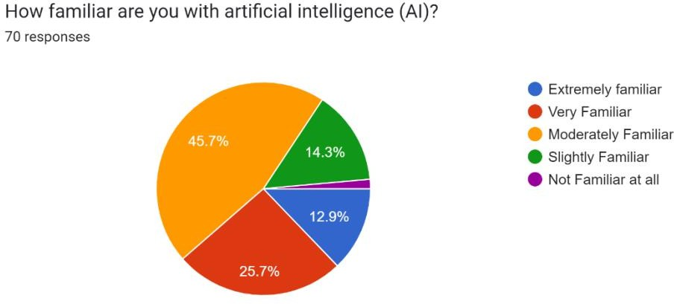

Analysis

This chart shows that the majority of respondents (45.7%) are "Not Familiar at All" with artificial intelligence (AI), indicating limited knowledge of AI among the sample. Only a small portion, 12.9%, reported being "Very Familiar," and even fewer are "Extremely Familiar," highlighting that most respondents have minimal exposure to AI. This suggests a potential need for increased AI awareness or education within this group.

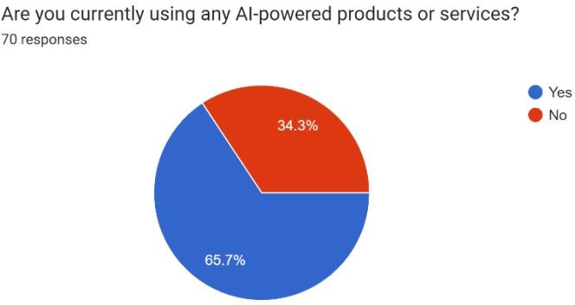

Analysis

Majority (66.7%) use AI powered products whereas the rest (34.3%) of the respondents do not use AI powered products or services. This suggests a strong level of awareness and utilization of AI in the surveyed population.

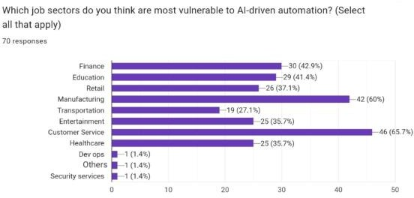

Analysis

The bar chart illustrates the perceived vulnerability of different job sectors to AI-driven automation. Customer service is seen as the most vulnerable, with 65.7% of respondents believing it will be significantly impacted. Manufacturing and education also rank high, with over 40% of respondents anticipating vulnerability in those sectors. On the other hand, sectors like DevOps, security services, and others are perceived as having the least vulnerability to AI-driven automation.

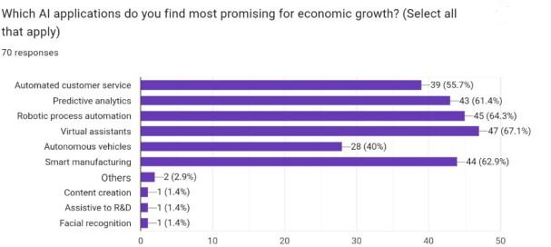

Analysis

The bar chart shows the perceived promise of various AI applications for economic growth. Virtual assistants and robotic process automation are seen as the most promising, with over 65% of respondents selecting them. Predictive analytics and smart manufacturing also rank high, with over 60% of respondents believing in their potential for economic growth. On the other hand, applications like facial recognition, content creation, and assistive to R&D are considered less promising for economic growth by the respondents.

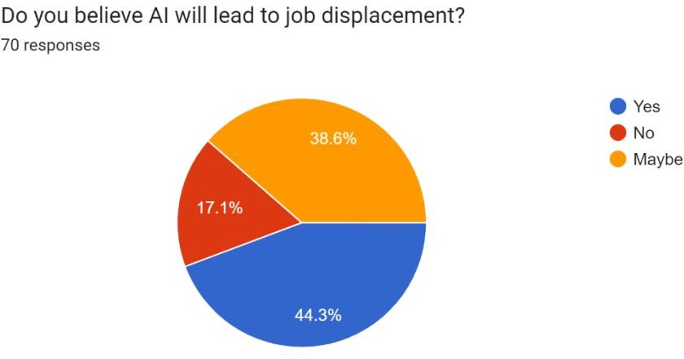

Analysis

A significant proportion of 44.3% believe that AI will indeed lead to job displacement. 38.6% are unsure about the potential impact, while 17.1% do not believe AI will displace jobs. This suggests a mixed sentiment regarding the job market implications of AI, with a notable portion anticipating potential job displacement.

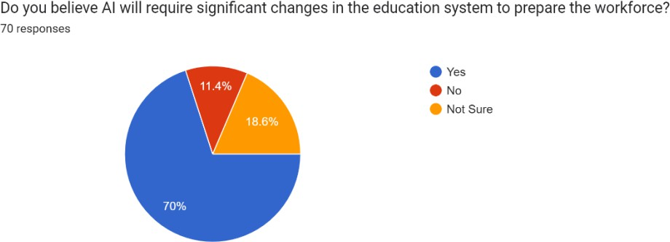

Analysis

A significant majority of 70% believe that AI will indeed require significant changes in the education system. Only 11.4% believe changes are not needed, while 18.6% are unsure about the necessary changes. This suggests a strong consensus that the education system needs to adapt to the evolving landscape of AI to prepare the workforce for the future.

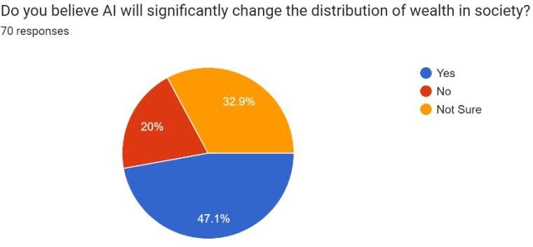

Analysis

A majority of 47.1% believe that AI will indeed significantly change the distribution of wealth. 32.9% are unsure about the potential impact, while 20% do not believe AI will significantly change wealth distribution. This suggests a mixed sentiment regarding the economic implications of AI, with a notable portion anticipating potential shifts in wealth distribution.



Analysis

The bar chart shows the perceived vulnerability of different job sectors to AI-driven automation. Customer service is seen as the most vulnerable, with 65.7% of respondents believing it will be significantly impacted. Manufacturing and education also rank high, with over 40% of respondents anticipating vulnerability in those sectors. On the other hand, sectors like DevOps, security services, and others are perceived as having the least vulnerability to AI-driven automation.

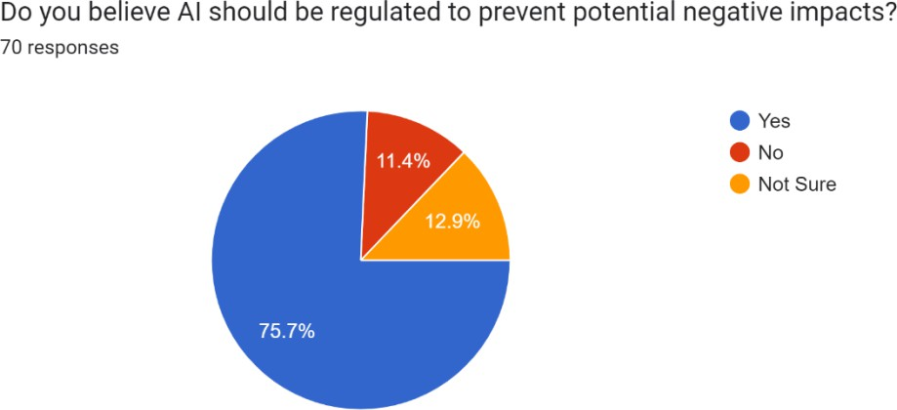

Analysis

A significant majority of 75.7% believe that AI should indeed be regulated. Only 11.4% believe regulation is not needed, while 12.9% are unsure about the need for regulation. This suggests a strong consensus that AI requires regulation to mitigate potential negative consequences.

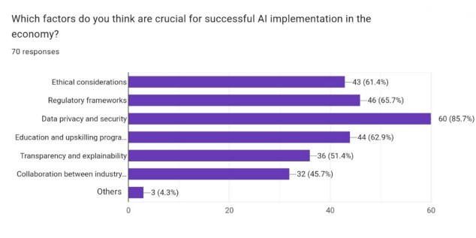

Analysis

The bar chart shows the perceived importance of various factors for successful AI implementation in the economy. Data privacy and security is considered the most crucial factor, with 85.7% of respondents highlighting its importance. Ethical considerations and regulatory frameworks also rank high, with over 60% of respondents emphasizing their significance. Other factors like education and upskilling programs, transparency, and collaboration between industries are also seen as important but with slightly lower perceived importance

**CONCLUSION**

Just like any other big technological change, AI will be going to disrupt most professions and eliminate some. Such changes in the past have largely involved mostly manual labor roles such as in the production line of manufacturing. This is a different AI revolution, though, because it has the ability to take care of tasks that were once typically related to higher-end professions. While the entry of AI into most areas is going to bring in losses in those sectors, they can also bring forth new industries, businesses, lines of skill, and careers. So, it really is a dual impact, which spells the complexity of technological advancement. More broadly, the general availability of sophisticated AI systems such as ChatGPT and other GAI tools raises significant risks, including heightened vulnerabilities to cyberattacks and fraud and heightened concerns about identity theft because AI can mimic human language and generate realistic images. Powerful AI systems also raise new privacy challenges because of their unprecedented capacity to collect, use, and potentially misuse personal data. Hence, the introduction of AI at the workplace will provide challenges and opportunities, but proper management is required to minimize risks while maximizing benefits.

**BIBLIOGRAPHY**

Goyal, A., & Aneja, R. (2020). Artificial intelligence and income inequality: Do technological changes and worker's position matter? Journal of Public Affairs.

2020 Uzun, M. (2020). Eurasian Economic Perspectives, volume 15/1, p. 185.

Hemous, David and Olsen, Morten, The Rise of the Machines: Automation, Horizontal Innovation and Income Inequality (March 1, 2018).

Solos, W. K., & Leonard, J. (2022). On the Impact of Artificial Intelligence on Economy. *Science Insights*, *41*(1), 551–560.

Rickardo, G., & Meiriele, S. (2023). Artificial intelligence: Its impact on employability. *World Journal of Advanced Research*

<https://www.analyticsinsight.net/artificial-intelligence/ai-and-economy-in-india-are-climbing-the-progression-ladder>