**Agri-direct: AI-Powered Platform For Direct Sales, Smart Farming and Support**

Prof. Devki Nandgaye, Rushikesh Mundane 2, Harshad Nakshane 3, Karan Raut4

1Assistant prof., IT, Nagpur Institute of Technology, Nagpur, Maharashtra, India

2UG Student, IT, Nagpur Institute of Technology, Nagpur, Maharashtra, India

3UG Student, IT, Nagpur Institute of Technology, Nagpur, Maharashtra, India

3UG Student, IT, Nagpur Institute of Technology, Nagpur, Maharashtra, India

**Abstract**

The Agri Direct platform is a web-based solution designed to support farmers by providing a direct sales channel to consumers, alongside advanced AI-driven tools for crop yield prediction, disease detection, and weather forecasting. This platform empowers farmers with real-time insights, helping to reduce losses and improve productivity. By eliminating middlemen, Agri Direct ensures better profits for farmers and fresher produce for consumers. The AI features, including predictive analytics and image-based disease diagnosis, aim to address critical agricultural challenges. This paper discusses the platform's components, system architecture, and anticipated impact on the agricultural sector.

1. **Introduction**

Agriculture is the backbone of many economies, yet farmers face persistent challenges, such as unpredictable weather, crop diseases, market fluctuations, and limited access to fair markets. Traditional farming methods often leave farmers reliant on intermediaries, which can reduce their profit margins and limit their control over sales. With the growing advancements in technology, especially in artificial intelligence (AI) and web development, innovative solutions are emerging to address these issues.**Agri Direct** is a web-based platform designed to connect farmers directly with consumers, cutting out intermediaries and enabling fairer transactions. The platform integrates multiple AI-driven features, such as crop yield prediction, disease detection, and weather forecasting, to support farmers in making informed decisions. Farmers can upload images for disease diagnosis, access real-time weather data, and use yield prediction tools, all on a single platform. Additionally, a chatbot provides 24/7 support, assisting users with queries related to crop health and market conditions.By offering a comprehensive suite of tools, Agri Direct aims to empower farmers with actionable insights and create a transparent marketplace that benefits both producers and consumers.

1. **Literature Survey**

* **R. Sharma et al. (2021)**: Proposed an AI-based system for crop disease prediction, highlighting the potential for machine learning to assist in early disease identification. **Limitation**: Lacked a comprehensive solution for market access.
* **A. Patel et al. (2020)**: Developed a web platform for direct farmer sales, reducing middlemen dependency. **Limitation**: Focused primarily on e-commerce, without integrating agricultural decision support.
* **S. Kumar et al. (2019)**: Researched crop yield prediction models using historical data. **Limitation**: Limited accuracy in real-world scenarios due to lack of real-time data.
* **P. Joshi et al. (2018)**: Investigated the impact of weather patterns on crop productivity and developed weather forecasting tools. **Limitation**: Lack of integration with yield prediction models.
* **D. Sen et al. (2022)**: Examined chatbot technology in agriculture for user support and information dissemination. **Limitation**: Basic chatbot unable to handle complex queries.

The literature indicates a gap in holistic platforms that provide direct sales and AI-based crop support in a unified web environment.

1. **Components Required**
2. **Frontend Technologies:**
   * HTML, CSS, JavaScript for responsive design.
   * Frameworks: React.js or Angular for dynamic user interface.
3. **Backend Technologies:**
   * Node.js or Django for server-side processing.
   * Database: Firebase or MongoDB for data management.
4. **AI/ML Tools:**
   * TensorFlow, Keras for crop yield prediction and disease detection models.
5. **APIs:**
   * Weather APIs for real-time forecasting.
   * Payment gateways like Stripe for secure transactions.
6. **Deployment Platforms:**
   * Cloud hosting on AWS, Google Cloud, or Heroku.
7. **Image Processing:**
   * OpenCV for preprocessing images in disease detection.
8. **Proposed System**

The Agri Direct platform provides a centralized web-based interface where farmers and consumers can engage directly. The core features include:

* **Direct Sales System**: Farmers can list products and consumers can purchase directly, reducing reliance on intermediaries.
* **AI-Based Crop Yield Prediction**: Utilizing historical and real-time data, AI algorithms predict crop yields, aiding in resource planning.
* **Disease Detection Using AI**: Farmers upload images of crops; the platform analyzes and detects diseases, offering treatment recommendations.
* **Weather Forecasting**: Real-time weather updates and forecasting tools allow farmers to plan activities around predicted conditions.
* **Chatbot for Support**: A chatbot assists users with inquiries about crop health, market conditions, and platform navigation.

The system architecture integrates these features into a responsive web platform, accessible on any device with an internet connection.

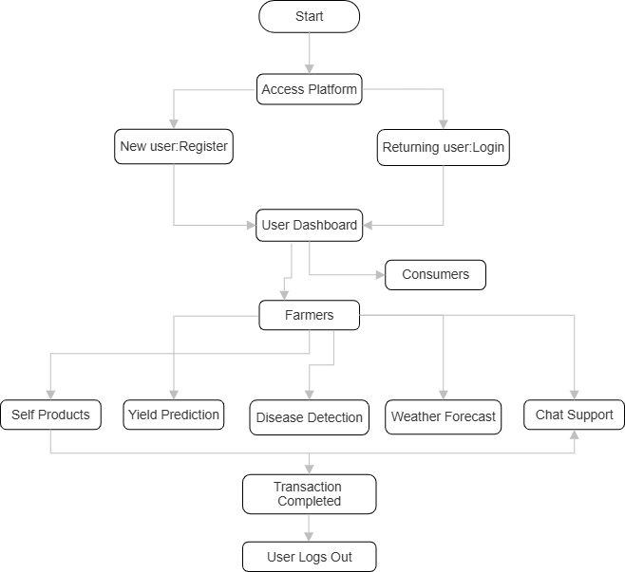

Fig4.1. Flow Chart

1. **Conclusion**

The Agri Direct web platform aims to empower farmers by providing tools that improve productivity and profitability. The direct sales feature ensures fair prices for farmers, while AI-driven insights help in decision-making. Disease detection and yield prediction capabilities reduce crop losses and improve agricultural practices. The platform’s integration of a chatbot and weather forecasting further enhances its utility, making it a comprehensive tool for modern agriculture.

1. **Future Scope**

Agri Direct has the potential for future enhancement in several areas:

* **Advanced AI Models**: Further refinement in AI algorithms for better accuracy in yield predictions and disease detection.
* **Mobile App Version**: Developing a mobile application for offline access and easier usability in rural areas.
* **Multi-Language Support**: To reach a broader demographic, including translation for regional languages.
* **Real-Time Market Price Updates**: Integration with market price APIs to inform farmers of fluctuating prices.
* **Data Analytics for Insights**: Advanced analytics tools for farmers to track trends in sales, crop health, and productivity over time.

1. **References**
2. R. Sharma, A. Gupta, and T. Singh, "AI-Based Crop Disease Detection for Smart Agriculture," Journal of Agriculture Technology, vol. 21, no. 3, pp. 230-245, 2021.
3. A. Patel and M. Desai, "Direct Sales Platforms for Agricultural Products," International Journal of E-commerce, vol. 18, no. 2, pp. 112-128, 2020.
4. S. Kumar et al., "Yield Prediction in Agriculture Using Machine Learning Techniques," Agriculture Data Science Journal, vol. 15, no. 1, pp. 95-104, 2019.
5. P. Joshi, "Weather Forecasting Techniques for Agricultural Planning," Journal of Environmental Studies, vol. 25, no. 4, pp. 311-325, 2018.
6. D. Sen and N. Verma, "Chatbot Implementation in Smart Agriculture Systems," Smart Agriculture Journal, vol. 22, no. 5, pp. 320-335, 2022.