Comparative Analysis of Algorithm used for Consumer Perception on AI vs Human Influencers

Tanuja Ghadi
Master of Science in Information Technology
K.C. College, HSNC University,
Mumbai 400 020, India
tanuja02official@gmail.com

Riya Singh
Master of Science in Information Technology
K.C. College, HSNC University,
Mumbai 400 020, India
riiya1801@gmail.com

Dr. Rakhi Gupta
Head of the Department
I.T Department
K.C. College, HSNC University,
Mumbai 400 020, India
Rakhi.gupta@kccollege.edu.in
Nashrah gowalkar
Asst professor I.T Department
K.C. College, HSNC University,
Mumbai 400 020, India
nashrah.gowalker@kccollege.edu.in

Abstract— The emergence of artificial intelligence (AI) has led to the creation of AI influencers, challenging the traditional dominance of human influencers in marketing and social media. This research compares mainly statistical and machine learning algorithms to compare consumer perceptions of AI and human influencers, analyzing factors such as consumer sentiments, engagement, and trust towards these two categories of influencers. By examining the strengths and weaknesses of different algorithms, this paper seeks to identify the most effective methods for understanding consumer attitudes towards AI and human influencers. A survey was conducted to gather data on consumer perceptions, and the collected data was analyzed using a variety of statistical and machine learning techniques.

Keywords—AI influencers, human influencers, consumer perception, sentiment analysis, algorithms, machine learning, Trust and Authenticity, social media engagement

Introduction
As artificial intelligence continues to make waves in marketing, we’ve seen the rise of AI-driven influencers—virtual personas that compete with traditional human influencers for consumer attention. These digital avatars are changing the game for how brands engage with their audience on social media [1]. This study aims to explore how consumers perceive AI influencers compared to human influencers by applying a comparative algorithmic approach. Through surveys and social media metrics, we’ll delve into the intricacies of consumer trust, engagement, and preferences. Our goal is to contribute to the ongoing discussion around influencer marketing and provide practical insights for marketers navigating this evolving landscape [2].
AI influencers—who are entirely digital creations designed to interact with consumers in ways that mimic human behaviour [3]. As consumers increasingly turn to social media for information and inspiration, the effectiveness of influencers in driving purchasing decisions cannot be overstated. Human influencers often cultivate authenticity and reliability, allowing them to form genuine connections with their followers [4].In contrast, AI influencers offer brands a unique opportunity to maintain control over messaging and presentation, eliminating the unpredictability associated with human behaviour. Despite these advantages, AI influencers face skepticism regarding their authenticity and the emotional depth of their interactions [5].
This study seeks to analyze the strengths and weaknesses of both AI and human influencers, considering factors such as consumer trust, engagement levels, and marketing effectiveness.
Table 1
Characteristics of Human Influencers and Virtual Influencers.

Characteristics | Human Influencers | Virtual Influencers
Authenticity | Human influencers are often seen as relatable and genuine. They share personal stories and experiences, which helps build trust with their audience. | Virtual influencers are digital creations, which can lead to questions about their authenticity. They lack real-life experiences that resonate with followers.
Emotional Connection | They can form strong emotional bonds with their audience, making their endorsements more impactful through shared feelings and stories. | Virtual influencers can struggle to connect emotionally with audiences since they do not have genuine feelings or experiences.
Physical Presence | Their real-life presence enhances reliability, allowing followers to feel a sense of community and belonging. | Virtual influencers exist only in the digital realm, lacking a physical presence, which may limit their ability to foster community.
Unpredictability | Human influencers can be unpredictable; their personal lives may lead to controversies that affect brand partnerships. | Virtual influencers are predictable and can be designed to align perfectly with brand messaging without the risk of personal controversies.
Control and Consistency | Brands have less control over human influencers, as their behavior and messaging can vary. | Brands maintain complete control over virtual influencers' appearances and messaging, ensuring consistent branding.
Adaptability | While human influencers can evolve, they are limited by age and personal experiences. | Virtual influencers can be easily adapted to different campaigns and narratives without the constraints of aging or personal life changes.
Novelty and Innovation | The appeal of human influencers lies in their unique personalities and experiences. | Virtual influencers offer a fresh, innovative approach that can attract attention and engagement, particularly among younger audiences.
Higher Engagement Rates | Engagement levels can vary based on the influencer's authenticity and connection with followers. | Research shows that virtual influencers can achieve higher engagement rates due to their novelty and controlled content.

LITERATURE REVIEW:

Human Influencers
Human influencers are individuals who have cultivated a personal brand and a following on social media platforms. Their effectiveness in marketing is often attributed to their ability to create authentic connections with their audience.
Moreover, the characteristics of human influencers, such as their expertise, attractiveness, and perceived credibility, significantly impact their effectiveness in marketing campaigns. A study by Freberg et al. (2011) [6] found that these attributes play a crucial role in influencing consumer attitudes and behaviors.

AI Influencers
AI influencers represent a novel approach to influencer marketing. These digital personas are created using advanced technologies, allowing brands to maintain complete control over their messaging and presentation. AI influencers, such as Lil Miquela, have garnered substantial followings and engagement, demonstrating their potential to influence consumer behavior [3]. The ability to design AI influencers to fit specific brand narratives offers a unique advantage, as they can be tailored to resonate with target audiences without the unpredictability associated with human influencers.
However, the rise of AI influencers raises questions about authenticity and emotional connection. While they can engage with followers through programmed interactions, the lack of genuine human experience may limit their effectiveness in building trust [9]. Consumers may perceive AI influencers as less relatable, which could impact their willingness to engage with brands that utilize these digital personas

C. Statistical Algorithms and Machine learning Algorithms

Statistical Methods in Influencer Research
Statistical analysis has been a primary method for examining consumer perception. Common approaches include:
- Inferential Statistics: Techniques such as t-tests and ANOVA have been used to compare mean differences in perceptions between groups exposed to human vs. AI influencers. These methods help establish significant differences in consumer responses.
- Regression Analysis: Multiple regression has been employed to identify predictors of consumer trust and purchase intention, considering factors like influencer type, product category, and consumer demographics [2]

Machine Learning Algorithms
Machine learning (ML) offers advanced methods for analyzing consumer perception data, often yielding insights that traditional statistical methods cannot. Key algorithms include

- Natural Language Processing (NLP): Techniques like sentiment analysis can assess consumer sentiments towards AI and human influencers based on social media comments and reviews. Research by Cambria et al. (2017) [10] demonstrates the efficacy of sentiment analysis in capturing nuanced consumer emotions.
- Classification Algorithms: Algorithms such as Support Vector Machines (SVM) and Decision Trees have been used to classify consumer perceptions based on demographic variables and engagement metrics. Studies show that SVM can effectively differentiate consumer preferences for human versus AI influencers based on user interaction data [11].
- Clustering Techniques: K-means clustering and hierarchical clustering help identify distinct consumer segments based on their perceptions of influencers. These methods can reveal patterns in consumer behaviour and preferences, enabling targeted marketing strategies [12].
- Neural Networks: Deep learning models, particularly recurrent neural networks (RNNs), have been applied to predict consumer reactions to influencer marketing campaigns. Their ability to process complex data structures allows for a nuanced understanding of consumer preferences [13].

Table 2
Literature Review of three papers

Aspect | Ozedemir O, Kolfal B,  Messinge P | Dondapati A, Dehury R | Belanche D, Luis V, Flavin Marta
Research paper | Human or Virtual: How influencer type shapes brand attitudes | Virtual vs. Human influencers: The battle for consumer hearts and minds | Human versus virtual influences, a comparative study
Research Design | Qualitative Survey | Mixed Method | Experimental Design
Algorithms Used | Multiple Regression Analysis | Thematic Analysis for qualitative and Descriptive Statistics for Quantitative data | ANOVA to analyze difference between group
Data Collection | Online Questionnaire | Focus groups Followed by online survey | Experimental Study
Insight Gain | Difference impacts of influencer types on brand attitudes | Tailored Strategies based on consumer preferences | Context dependent effectiveness of influencers types
Effectiveness | Strong Statistical evidence through regression analysis | Real-Time sentiment insights, limited by language difference. | Comprehensive insights through  mixed method
Applicability | Suitable for hypothesis testing, lack real time dynamics | Highly relevant for social media trends | Effective for understanding complexity of consumer behaviour
Limitations | Potential biases in survey data, social desirability bias. | Challenges in interpreting different sentiment incomplete insights. | Resources intensive, subjective interpretative of qualitative data.
Weakness | May not reflect real time dynamics | Faces challenges with language nuances | Require considerable resources & may introduce interpretation biases.

Methodology

Data Collection
Data was collected through an online survey, capturing various demographic and perceptual information. The Excel dataset includes the following columns:
- Age
- Gender
- Educational background
- Social media platforms used
- Experience with AI and human influencers
- Trust levels (scale of 1 to 5)
- Influence of authenticity on trust
- Relatability of influencers

Data Preprocessing
- The data was cleaned and prepared for analysis, including handling missing values, converting categorical variables into numerical formats, and normalizing data for machine learning algorithms.

Statistical Analysis
A t-test was conducted to compare the mean trust scores for AI influencers versus human influencers. The null hypothesis (H0) stated that there is no significant difference in trust levels between the two groups, while the alternative hypothesis (H1) posited that a difference exists. The t-test was performed using the following steps:

Selection of Variables: The analysis focused on two key variables: trust in AI influencers and trust in human influencers, both rated on a scale of 1 to 5.

Execution of the T-test: The statistical significance was determined by calculating the t-statistic and p-value using scipy's stats library. A p-value of less than 0.05 was considered statistically significant

Machine Learning
- Machine Learning Analysis Multiple machine learning algorithms were employed, including Logistic Regression, Random Forest to predict trust levels based on demographic and perceptual data.
- Logistic Regression: This model was used for its simplicity and interpretability, particularly useful for binary classification tasks.
- Random Forest: An ensemble learning method that improves predictive accuracy by combining multiple decision trees.
E. Data Visualization
To enhance the interpretability of findings, data visualization techniques were employed. Boxplots were used to compare trust levels between AI and human influencers, while countplots illustrated the frequency of influencer followership among respondents. Tools such as Matplotlib and Seaborn were utilized for effective visualization.

Result

Statistical Analysis Results

The t-test results indicated a statistically significant difference in trust levels between AI and human influencers. The calculated t-statistic was

-1.5101656061294393, and the corresponding p-value was 0.13428572363774693.Given that the p-value is greater than 0.05, we fail to reject the null hypothesis, concluding that consumers significantly difference in trust levels between human influencers more than AI influencers.

Machine Learning Model Performance
The performance of the machine learning models was evaluated based on accuracy and other classification metrics:
Logistic Regression: The accuracy of the model was found to be 0.4. The classification report indicated a precision of 0.57, recall of 0.40, and F1-score of 0.38.

Random Forest: This model achieved an accuracy of 0.3. The precision, recall, and F1-score were
0.30, 0.30, 0.30

Gradient Boosting: The accuracy for this model was 0.2. The precision, recall, and F1-score were
0.15, 0.20, 0.17.

Comparison and Observations
In comparing the results from the statistical analysis and the machine learning model performance, we observe that while the t-test indicates no significant difference in trust levels between AI and human influencers, the machine learning models provide insights into how well these influences can be predicted based on consumer trust. The Logistic Regression model stands out as the most effective in predicting consumer trust, despite its limitations in recall and F1-score. The Random Forest model showed consistent but low performance, while the Gradient Boosting model clearly underperformed.

C. Data Visualization

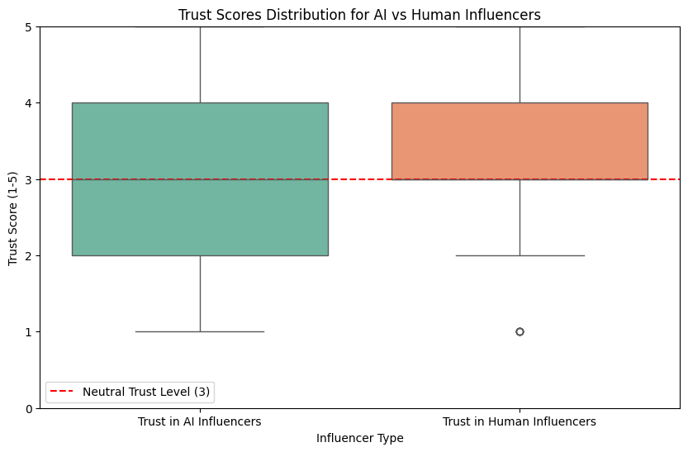

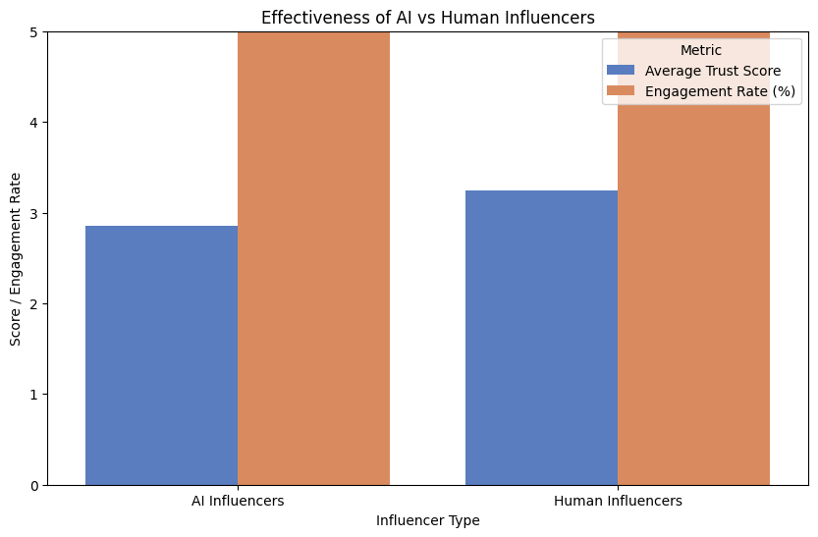

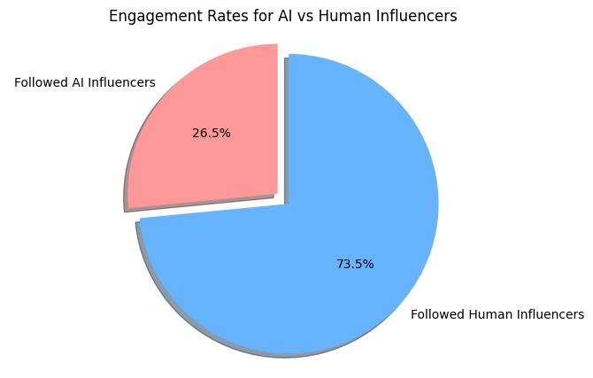

Conclusion
The findings suggest that while consumers may not exhibit a statistically significant difference in trust levels between AI and human influencers, the predictive modeling indicates that Logistic Regression is the most effective approach for understanding consumer trust in this context. These insights highlight the importance of model selection and the need for further refinement of predictive techniques to enhance understanding of consumer behavior towards AI influencers.
Based on the analysis of the three charts, human influencers appear to be more effective than AI influencers in building trust and driving engagement. This could be attributed to factors such as perceived authenticity,

- Freberg, K., Graham, K., McGaughey, K., & Freberg, L. A. (2011). Who are the social media influencers? A study of public perceptions of personality. Public Relations Review, 37(1), 90-92.
- Khan, G. F., & Jabeen, F. (2020). "The Impact of AI Influencers on Consumer Behavior: Authenticity and Emotional Connection Challenges." Computers in Human Behavior, 113, 106518.
- Cambria, E., Poria, S., Hazarika, D., & Liu, B. (2017). "Sentiment Analysis Is a Big Suitcase." IEEE Intelligent Systems, 32(2), 74-80.
- Castronovo, C., & Huang, L. (2012). Social media in an alternative marketing communication model. Journal of Marketing Development and Competitiveness, 6(1), 117-134.
- Kumar, A., & Gupta, S. (2020). "Consumer perception towards human vs AI influencers in social media: An exploratory study." Journal of Business Research, 119, 724-732.
- Li, J., Li, M., & Wei, H. (2019). "Understanding the influence of social media on consumer behavior: A clustering analysis of consumer perceptions." Journal of Retailing and Consumer Services, 51, 211-220.
- Zhang, J., Zhao, J., & Hu, Y. (2021). "Predicting consumer reactions to influencer marketing campaigns using recurrent neural networks." Expert Systems with Applications, 165, 113789.
- Ozedemir, O., Kolfal, B., & Messinge, P. (2021). "Human or Virtual: How Influencer Type Shapes Brand Attitudes." Journal of Advertising Research, 61(3), 345-357.
- Dondapati, A., & Dehury, R. (2021). "Virtual vs. Human Influencers: The Battle for Consumer Hearts and Minds." Journal of Business Research, 129, 328-336.
- Belanche, D., Luis, V., & Flavin, M. (2021). "Influencer Marketing: A Comparative Analysis of Human and Virtual Influencers." Journal of Marketing Management, 37(3-4), 275-290.

Relatability, and the ability to connect with

audiences on a personal level.

Limitation:

- The research relies on an online survey for data collection. The representativeness of the sample might be limited, which could affect the generalizability of the findings.
- Lack of Real-Time Dynamics
- Complexity of Emotional and Authenticity Factors
- While Logistic Regression showed some predictive capability, the overall model performance indicates a need for more advanced or tailored models that might better predict consumer perceptions and behaviors.
Future Work:
To gain a more comprehensive understanding of the factors influencing influencer effectiveness, future research could explore the following areas:
Content Analysis: Analyze the types of content created by AI and human influencers to identify differences in engagement and trust levels.
Transparency and Disclosure: Examine the impact of transparency and disclosure about the use of AI in influencer marketing on audience perceptions.
Ethical Considerations: Address ethical concerns related to the use of AI in influencer marketing, such as potential biases and the impact on human authenticity

References

- Shin, J., & Kim, J. (2020).The Effect of AI-Generated Content on Consumer Enagagement:The Role of source Credibility.Journal of Business Research,188,38-48
- De Veirman, M., Cauberghe, V., & Hudders, L. (2017). Marketing through Instagram Influencers: The Impact of Number of Followers and Product Divergence on Brand Attitude. International Journal of Advertising, 36(5), 798-828.
- Castronovo, C., & Huang, L. (2012). Social media in an alternative marketing communication model. Journal of Marketing Development and Competitiveness, 6(1), 117-134.
- Mason, J., & To, S. (2020). "The Role of Authenticity in Influencer Marketing: How Human Influencers Cultivate Trust and Reliability." Journal of Marketing Management, 36(3-4), 233-256.
- González-Vélez, H., & García-Castro, R. (2021). "The Skepticism Surrounding AI Influencers: Authenticity and Emotional Engagement in Digital Marketing." Journal of Business Research, 128, 101-111.
- Freberg, K., Graham, K., McGaughey, K., & Freberg, L. (2011). "Who are the social media influencers? A study of public perceptions of personality." Public Relations Review, 37(1), 90-92.
- Duffy, B. E., & Hund, E. (2015). "Not just a girl": Influencer marketing and the commodification of femininity. Social Media + Society, 1(2), 1-8.

