H.R. College of Commerce and Economic

Business Management

Subject - International Economics

Topic - Role of India in SAARC

Author – Shravani .R. Surve

**About SAARC**

In the late 1970s, the seven South Asian nations—Pakistan, India, Bangladesh, Nepal, Sri Lanka, Bhutan, the Maldives, and Afghanistan—came together to establish a trade bloc aimed at fostering friendship, trust, and mutual understanding among their citizens.

- The initiative to form this trade bloc was first proposed by Zia Ur Rahman on May 2, 1980.

- The inaugural summit took place in Dhaka on December 8, 1985, and in 2007, Afghanistan became the eighth member of SAARC, a year during which India held the chairmanship and marked the most productive period in the organization's history.

SAARC is a geopolitical and economic organization comprising eight nations situated in South Asia, established in 1985. - The organization's headquarters is based in Kathmandu, Nepal. - The eight member states of SAARC include the following:

1. India
2. Bangladesh
3. Bhutan
4. Sri Lanka
5. Afghanistan
6. Nepal
7. Maldives
8. Pakistan

**SAARC SUMMITS**

The member states of SAARC convene annual meetings at the summit level to advance the SAARC agenda. The inaugural summit took place in Dhaka, Bangladesh, from December 6 to 8, 1985. Since that time, a total of nineteen summits have been conducted in various capitals and cities of the member states. The 19th SAARC Summit was held in Pakistan in 2016; however, India, along with Afghanistan, Bhutan, Bangladesh, Sri Lanka, and the Maldives, chose not to participate due to the terrorist attack in Uri that year. Following this, Pakistan announced a postponement of the summit, indicating that new dates would be provided shortly, yet this announcement did not materialize.

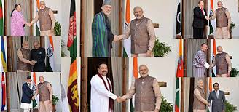

**OBJECTIVES OF SAARC**

- To enhance the well-being of the South Asian populace and elevate their living standards.

- To foster economic advancement, social development, and cultural enrichment within the region, ensuring that every individual has the chance to live with dignity and achieve their full potential.

- To cultivate and reinforce collective self-sufficiency among South Asian nations while promoting collaboration and mutual support across various sectors, including economic, social, cultural, technical, and scientific domains.

**INDIA’S CONTRIBUTION IN THE SAARC**

- From its inception and subsequent development, India has consistently played a significant role in SAARC. - India made earnest contributions towards the establishment of SAARC, notably influencing the inaugural summit that marked the organization's formation and the drafting of its Charter.

- The country's active involvement has been pivotal in shaping the direction and objectives of SAARC since its early days.

- India has hosted the SAARC summits on three occasions: the second summit took place in 1986, the eighth in 1995, and the fourteenth in 2007. At the second summit, the Heads of State or Government endorsed the Memorandum of Understanding for the establishment of the SAARC Secretariat, which was decided to be located in Kathmandu, Nepal, with Abul Ahsan from Bangladesh appointed as the inaugural Secretary-General.

- Due to its substantial size, population, economic strength, and strategic location, India serves as the cornerstone of SAARC. It shares land and maritime borders with six of the seven other member states, thereby solidifying its leadership position within the organization.

- India's geographical advantages, economic influence, international standing, and dedication to regional development render it essential to SAARC. The power dynamics within the region are notably imbalanced, with India accounting for over 75 percent of the region's GDP and more than 70 percent of its population. This significant presence necessitates a special responsibility for India, as it strives to lead the region towards collective progress and prosperity, having already contributed over US$ 530 million to SAARC initiatives aimed at socio-economic development.

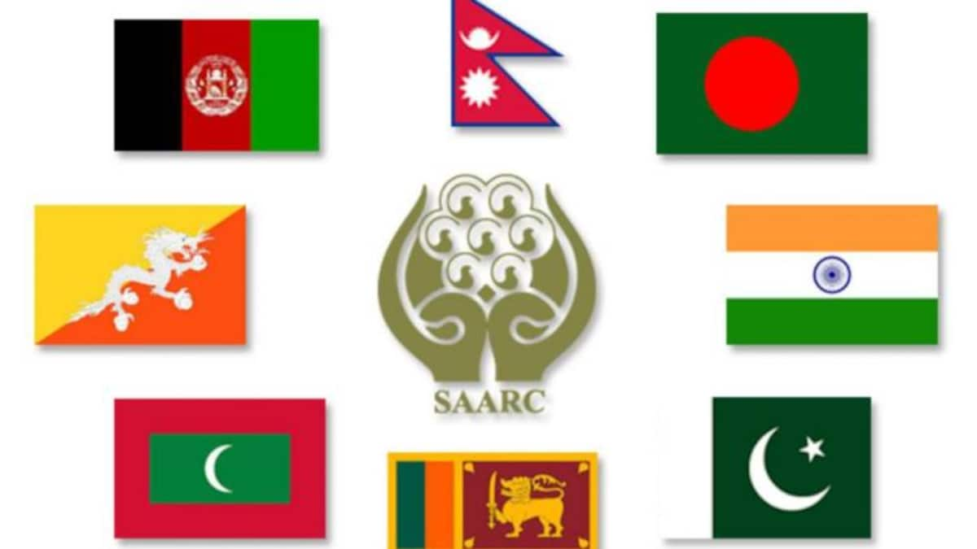

- India's trade with South Asia constitutes approximately 5.5% of its total global trade, with a strong focus on accelerating negotiations and fostering investments and exchanges within the region. The core themes of the South Asian Association for Regional Cooperation (SAARC) include trade, connectivity, and enhancing people-to-people interactions.

- Under the South Asian Free Trade Area (SAFTA) framework, India has unilaterally granted duty-free access to all items for the SAARC Least Developed Countries (LDCs) and has fulfilled its Phase II obligations for non-LDCs, maintaining a zero tariff for goods from LDCs while reducing 455 out of 480 tariff lines in its Sensitive Lists for these nations.

- India has prepared its commitments under the SAARC Agreement on Trade in Services (SATIS), effective since December 2012, aimed at promoting intra-regional investments and liberalizing the services sector, with special provisions for the five LDCs in the region—Afghanistan, Bangladesh, Bhutan, Maldives, and Nepal—reflecting their developmental needs.

India has played a significant role in the South Asian Association for Regional Cooperation (SAARC) in a number of ways, including:

- India has significantly contributed to the South Asian Association for Regional Cooperation (SAARC) by extending its National Knowledge Network (NKN) to neighbouring countries such as Bangladesh, Bhutan, and Sri Lanka, thereby facilitating technological sharing.

- The nation has actively supported cultural organizations aimed at promoting regional integration within SAARC through financial assistance, while also initiating various regional projects focused on solar rural electrification, rainwater harvesting, and seed testing.

- India has established an Endowment for Climate Change to finance environmental initiatives, liberalized its medical visa policies for SAARC nationals, and provided humanitarian aid, including food and shelter, to those affected by conflicts and disasters in the region

**SAARC and Its Impact on Indian Economy**

The South Asian Association for Regional Cooperation (SAARC) includes India along with seven additional nations from South Asia. While SAARC has achieved advancements in specific domains, its influence on the Indian economy has been constrained for a variety of reasons.

- Enhanced economic integration within SAARC has the potential to establish a substantial regional market for Indian products and services, thereby stimulating exports and bolstering the manufacturing sector in India.

- A unified South Asian economy could serve as a magnet for increased foreign investment, benefiting India and the broader region.

- Strengthened regional connectivity through SAARC initiatives in transport and energy infrastructure is likely to yield significant advantages for India's economic landscape.

CONCLUSION

India has extended significant assistance to fellow SAARC nations during times of crisis. For example, it has provided food, medical aid, and shelter to those affected by natural disasters and conflicts. Additionally, India has played a crucial role in the reconstruction of infrastructure in these countries. Furthermore, India has actively sought to enhance cooperation against terrorism within the SAARC framework. It has shared intelligence with other member states and has worked to inhibit the operations of terrorist organizations in the region. A notable initiative in this regard is India's establishment of the SAARC Terrorist Offenses Monitoring Desk, which is tasked with monitoring terrorist activities across the region.