**COVID 19 AND IT’S IMPACT ON THE INDIAN ECONOMY**

**I. ABSTRACT**

The COVID-19 pandemic has impacted global economies and societies on an unprecedented scale, particularly in countries with large populations like India. As COVID-19 spread worldwide, India faced significant challenges in managing public health, economy, and social structure. This paper examines the impact of COVID-19 on the Indian economy, focusing on the effects on various industries, income inequality, unemployment, and social welfare. Data for this study has been collected from secondary sources to analyze both positive and negative impacts across sectors. While some industries experienced growth, others faced severe financial distress, altering the economic landscape of India.

**II. OBJECTIVE**

Following a surge in cases of coronavirus disease 2019 (COVID- 19) in June 2020, India became the third-worst affected country worldwide. This study aims to analyse the underlying epidemiological situation in India and explain possible impacts of policy and technological changes.

**III.** **INTRODUCTION**

The COVID-19 pandemic has been one of the most disruptive global events in modern history, affecting nearly all aspects of life. Originating in Wuhan, China, the virus quickly spread across the globe, leading to stringent lockdowns and social distancing measures. India, with its dense population and economic reliance on both formal and informal sectors, faced unique challenges during this period. Early measures such as a nationwide lockdown were essential for controlling virus spread but had far-reaching consequences for the economy and social structure.

The Indian economy saw a decline in GDP by 24.4% in the April-June 2020 quarter, a contraction that severely impacted consumption, income, and employment. This paper explores the broader socio-economic impact of COVID-19 on India, highlighting the sectors most affected, the exacerbation of income inequality, and the psychological effects of prolonged isolation. Furthermore, it discusses government measures aimed at mitigating economic losses and supporting vulnerable populations.

COVID-19, or coronavirus disease 2019, is an infectious illness resulting from the SARS-CoV-2 virus. The majority of individuals infected with this virus will exhibit mild to moderate respiratory symptoms and typically recover without the need for specialized medical intervention. Nevertheless, a subset of patients may develop severe complications that necessitate medical care. The designation "COVID-19" was officially assigned by the World Health Organization to refer to the disease caused by the SARS-CoV-2 virus, which emerged in Wuhan, China, in 2019 and subsequently disseminated worldwide. The consequences of COVID-19 can include organ damage. Individuals experiencing severe manifestations of the disease may suffer from damage to various organs, including the heart, kidneys, skin, and brain. Additionally, inflammation and immune system dysfunction may occur. Respiratory symptoms associated with COVID-19 can resemble those of a common cold, influenza, or pneumonia.

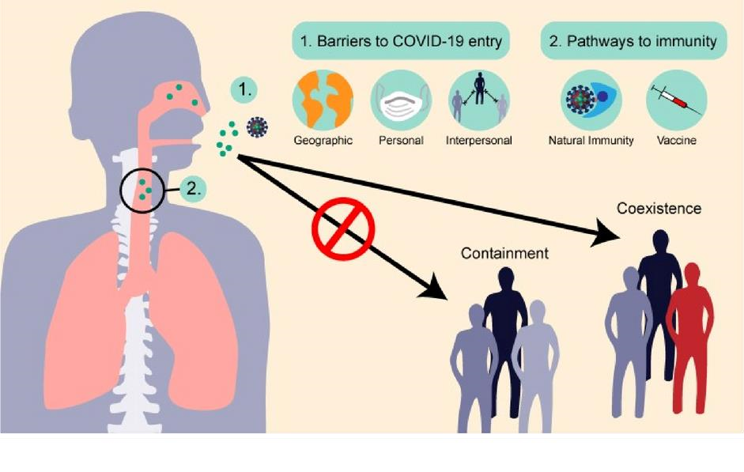

**IV. COVID 19 IMPACT IN INDIA**

The coronavirus disease 2019 (COVID-19) is an infectious illness caused by the severe acute respiratory syndrome coronavirus. It was first detected in December 2019 in Wuhan, Hubei Province, China, and has since led to a global pandemic. By July 5, 2020, over 11.1 million cases had been documented across 188 nations and territories, resulting in more than 528,000 fatalities, while over 6.03 million individuals had recovered. The global population is currently grappling with significant challenges, encompassing social, environmental, health, and economic dimensions, as a consequence of COVID-19. In response, affected nations are implementing measures to mitigate the virus's spread, including social distancing, lockdowns, and enhancing testing and treatment capabilities. In India, there were four lockdown phases from March 25, 2020, to May 31, 2020, followed by two periods of gradual reopening from June 1 to July 31, 2020. Notably, a significant increase in aerosol optical depth (AOD) was recorded during the pre-lockdown phase of 2020 compared to the previous two years. Initially, the spread of COVID-19 in India was marked by relatively low case numbers and lower fatality rates compared to many developed nations, largely due to strict lockdown measures and a favorable demographic profile. However, economic pressures necessitated a phased approach to lifting lockdowns, which subsequently led to a surge in COVID-19 cases. This situation was exacerbated by low health expenditure as a percentage of gross domestic product (GDP), resulting in insufficient hospital beds, ventilators, and medical personnel, particularly within the public health sector. Despite these challenges, advancements in technology, bolstered by a robust research foundation, played a crucial role in mitigating the pandemic's impact. The nationwide lockdown severely affected the Indian economy, leading to increased unemployment and a sharp decline in economic growth. The timely implementation of lockdown measures initially slowed the rate of case doubling and provided an opportunity to enhance critical medical infrastructure.

**V. METHODOLOGY**

The Aerosol Optical Depth (AOD) data for the year 2020 across India and its various regions was examined and juxtaposed with AOD data from the preceding years, specifically 2018 and 2019. To facilitate this comparison, anomalies for the year 2020 were computed by deducting the AOD values of 2018 and 2019 from the corresponding 2020 values at each grid point.

The analysis was conducted over distinct time intervals, as detailed in the accompanying table. The initial phase, referred to as the pre-Lockdown period, spans from January 1, 2020, to March 24, 2020, prior to the implementation of any lockdown measures in India. The subsequent phase, designated as Lockdown 1.0 (LD1.0), occurred from March 25, 2020, to April 14, 2020. Following this, three additional lockdowns (LD2.0, LD3.0, and LD4.0) were enforced between April 15, 2020, and May 31, 2020. The first phase of unlocking (UL1.0) commenced on June 1, 2020, and continued until June 30, 2020. Currently, the second phase of unlocking (UL2.0) is underway.

Various lockdown/unlock phases in India due to COVID-19

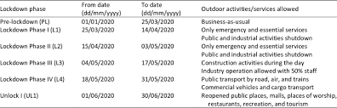

Briefly, the timelines were as under:-

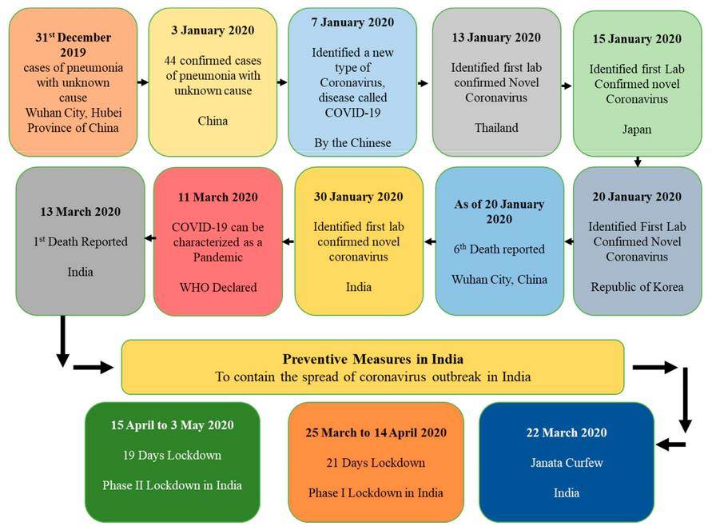 The lockdown imposed on Indian society has unveiled a multitude of challenges across various dimensions, including social, educational, economic, political, agricultural, and psychological spheres, significantly affecting the lives of individuals. When examining the concept of "social distancing" from a sociological perspective, one might argue that it resembles a modern iteration of untouchability. Historically, during the Vedic period, members of the upper caste practiced social distancing from those deemed untouchables to avoid perceived contamination. In a similar vein, the current societal response to the Covid-19 pandemic, which necessitates social distancing, appears to undermine constitutional principles aimed at eradicating untouchability and fostering social integration. While it is essential to recognize that social distancing is a critical public health measure to mitigate the spread of Covid-19, it is equally important to assess its societal implications, particularly how it may have rekindled discriminatory practices.

The ramifications of Covid-19 extend beyond societal concerns, significantly impacting both rural and urban economies. The plight of migrant workers has garnered attention, yet the long-term consequences of the pandemic on their livelihoods remain uncertain. Many migrant workers, reliant on daily wages and lacking substantial savings, have faced dire circumstances, with some tragically losing their lives. Those who have managed to survive are increasingly returning to their villages due to the scarcity of employment opportunities and financial resources in urban areas. Additionally, gig workers, such as delivery personnel and cab drivers, have encountered similar hardships, although their struggles have received less media coverage. The pandemic has brought economic activities to a standstill, adversely affecting this segment of the urban workforce. Furthermore, the impact of Covid-19 on education has been severe, with its long-term effects likely to be felt for years to come.

**VI. IMPACTS OF COVID 19 ON INDIAN ECONOMY**

The economic repercussions of COVID-19 on India have been profound. Between April and June 2020, the nation experienced a staggering GDP decline of 24.4%. Subsequent national income data revealed that during the second quarter of the 2020/21 fiscal year (July to September 2020), the economy further contracted by 7.4%. Although there was a slight recovery in the third and fourth quarters (October 2020 to March 2021), with GDP growth rates of 0.5% and 1.6% respectively, the overall contraction for the entire 2020/21 fiscal year amounted to 7.3% in real terms. Historically, since gaining independence, India has only witnessed a decline in national income on four occasions prior to 2020—specifically in 1958, 1966, 1973, and 1980, with the most significant drop occurring in 1980 at 5.2%. Consequently, the fiscal year 2020/21 stands as the most severe period of economic contraction in India's history, surpassing the global average decline. This downturn has played a critical role in reversing the previously declining trend of global inequality, which has now begun to rise after three decades of improvement. Economic contraction in India and the world during Covid-19.

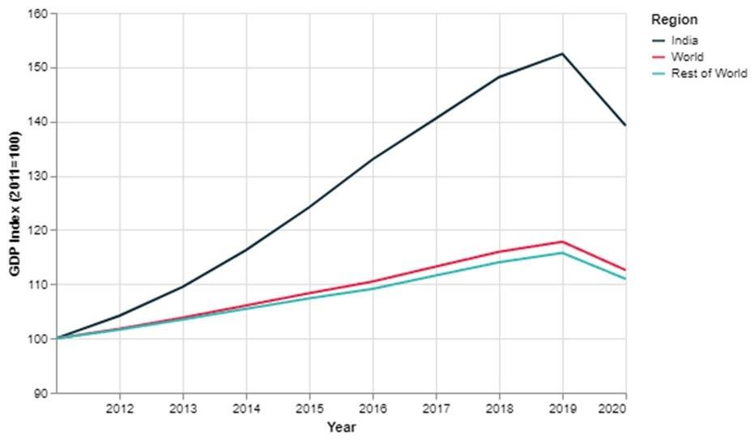

**VII. HOW HAS COVID-19 CHANGED INCOME, CONSUMPTION, POVERTY AND UNEMPLOYMENT IN INDIA?**

Macroeconomic statistics offer a limited view of India's economic landscape, obscuring the significant and disproportionate impacts on households and workers across the nation. Wealth and income inequality have been escalating in India, with estimates indicating that in 2020, the wealthiest 1% of the population possessed 42.5% of the total wealth, while the poorest 50% held a mere 2.5%. Following the pandemic, projections suggest that the number of individuals living in poverty in India has more than doubled, and the middle class has contracted by one-third. During the initial stringent national lockdown from April to May 2020, individual incomes plummeted by around 40%, with the lowest decile of households experiencing a loss equivalent to three months of income. Data from the largest private survey in India, the CMIE’s ‘Consumer Pyramids Household Survey’ (CPHS), reveal that per capita consumption spending declined more significantly than GDP and did not rebound to pre-lockdown levels even during periods of eased social distancing. By the end of 2020, average per capita consumption spending remained over 20% lower than before the first lockdown and was still 15% lower year-on-year. While official poverty statistics are lacking, the CPHS data are subject to limitations due to 'top' and 'bottom' exclusions. For instance, official figures indicated a rural headcount ratio of 35% in 2017/18, whereas CPHS estimates placed it at 25%, implying potential exclusions at the lower end of the consumption spectrum. Despite these statistical limitations, the CPHS offers valuable insights into consumption changes resulting from the pandemic, including the percentage of individuals with monthly consumption expenditures below various thresholds, which include the official poverty lines. Currently, the rural poverty line is established at 1,600 rupees per month, while the urban poverty line is set at 2,400 rupees per month. According to the latest CPHS data, rural poverty has risen by 9.3 percentage points.

**VIII. CASE STUDY: -**

A. ABSTRACT

Coronavirus disease has spread out across the globe within a span of few months. All economies are facing the problems how to the economy open and functioning during COVID-19. Many industries have been affected by the nation-wide lockdown. Companies are expected to register the poor growth in business. Organization’s financial performance will remain sluggish in the coming few quarters. There are some industries which are impacted positively. On the other hand, there are some industries which are impacted negatively. This paper intends to measure the performance of various industries during the COVID-19. This paper is based on the secondary data collected from the multiple sources.

# B. INTRODUCTION

Coronavirus disease has impacted all the countries across the globe. All countries have observed the effects of the coronavirus at different levels. China, Italy, Spain, Grace and United State of America have been impacted the most in the recent past. All countries are trying their best to contain the effects of corona virus by taking various measures like nationwide lockdown, permitting companies partially with certain number of employees and adhering the social distancing norms.

Coronavirus is an infectious disease and it spreads very quickly and it impact the life of individuals to a great extent. The first case of the COVID-19 has been detected in the Wuhan province of China. Taking this reference, United States of America blames China for the world wide spread of corona virus which caused deaths of millions of the people.

C. LITERATURE REVIEW

There are thousands of evidence which proves that infectious disease outbreak impact the economic development of a country. Economic cost of the infectious disease is the subsidies given to the poor, health facilities provided to the patient and losses incurred by the business organizations due to non-functional business operations. During the outbreak of infectious disease, workers are not able to work and business organizations are not in the position to run the operations at the full capacity. Millions will lose their jobs and companies will lose their orders taken from their clients from across the globe. The logic to bear this cost is that social security is more important than economic benefits. If the people are secured and healthy; economic growth can be achieved after some time. The influenza virus had proven more dangerous and deadliest in human history. It cost loss of millions and deaths of millions in Spain. Similarly, Corona virus appears to be deadliest and spread person to person at a very fast pace. So far, there is no vaccine developed which could be used for the treatment of the corona virus patients. As of now, nationwide lockdown seems to be the only option to save the lives of people. Impact of COVID-19 in urban areas is more than rural areas. It is because of population density and environmental issues. Large numbers of people are living with fear and uncertainties. People are fearful because they are considering COVID-19 as a major reason for the people’s death. However, this has not been proven but the perception of the people is like this. Viscusi et al. (1997) rank COVID-19 as the third major factor for people death after cancer and cardiovascular. According to the research conducted by the Sunstein (1997) explains that an individual’s willingness to pay increases when they feel that it can cost their life. They will search for best doctors and best treatment to avoid the impact deadly virus. People perception of COVID-19 is very negative as far as its impact on their life, business operation and economy is concerned. Due to COVID-19, business is not able to operate and many other businesses are likely to collapse. Several studies have outlined the effects of COVID-19 on world economy. World GDP is estimated to be reduced drastically due to COVID-19 because consumption and investment activities are very low. People are spending their income on only essential items not luxury one. People want to save their income because they are not very sure that how long this virus will prevail in the world. United States of America, China and India are the three main economies driving the world’s consumption activities. As compare to US and China, India is relatively safe and the virus effects are not as fearful as were in US and China. Lower consumption effects will not only confine to US, China and India but also to other major world economies.

# D. RESEARCH METHODOLOGY

This paper is based on the secondary data. This is the best time to conducted research on the secondary data since people are not permitted to out from their home. Secondary data has been collected from the various sources containing data related to the performance of GDP and other inflation during the lockdown. Secondary is collected from management libraries, journals, newspaper and magazines. This paper describes in detail the estimated loss/ profit of the business organizations during lockdown.

E. IMPACT OF COVID-19 ON INDUSTRIES

There are several sectors which are impacted by the COVID-19 and the chances of their revival are not in the near future. Their profitability is continuously decreasing and fixed cost is intact. Like media and entertainment industry; all multiplexes are closed and people do not want to visit the multiplexes in the near future. Many organizations have taken loan from the commercial banks and other financial institutions. They have to pay interest on the loan despite of poor financial position. High debt to equity ratio indicates that companies are raising more funds through debt rather than equity. High debt to equity ratio also indicates about the potential risk associated with the particular organization. However, debt to equity ratio in the manufacturing and financial sector is very high because these organizations use more debt for business purpose. In the above table, information technology and investment banking and brokerage have low debt to equity ratio than other sectors. Impact of COVID-19 is likely to be less on those companies which have taken less debt as compared to those organizations which have taken high debt.

# **IX. CONCLUSION**

In conclusion, the COVID-19 pandemic has brought both immediate and long-term challenges to the Indian economy. The impact has been felt across sectors, with industries such as tourism and entertainment facing prolonged downturns, while technology and online services have seen growth. The pandemic has also underscored existing inequalities, with the economically disadvantaged facing greater risks of income loss and food insecurity. Social issues, such as increased domestic violence and mental health struggles, highlight the pandemic’s widespread psychological toll. However, the crisis has also accelerated digital transformations in education and the judicial system, providing new avenues for progress. Moving forward, India’s economic recovery will depend on sustained government intervention, technological adoption, and social cohesion to build a more resilient economy.

# **X. REFERENCES**

1. World Health Organization
2. https://www.irjmets.com/uploadedfiles/paper/volume2/issue_7_july

_2020 /2005/1628083069.pdf

1. https://timesofindia.indiatimes.com/readersblog/covid-19-and-itsimpacton-india/covid-19-and-its-impact-on-indian-society-27565/
2. https://en.wikipedia.org/wiki/COVID-19