**MINISO: FROM GLOBAL EXPANSION TO INDIAN MARKET**

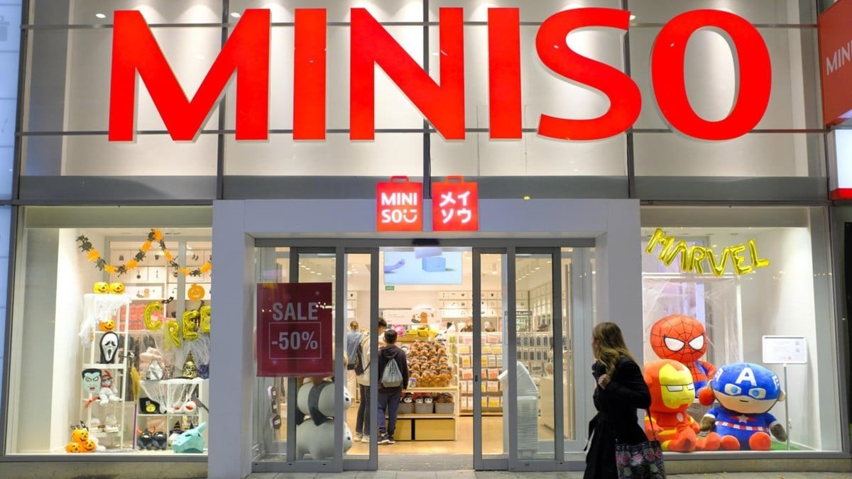

A PROJECT SUBMITTED TO

HSNC UNIVERSITY, MUMBAI FOR THE PARTIAL

COMPLETION OF THE DEGREE OF MASTER IN COMMERCE UNDER

THE FACULTY OF COMMERCE

BY

Vanshika Shivhare

UNDER THE GUIDANCE OF

PROF.DHARTI

HASSARAM RIJHUMAL COLLEGE

123, DINSHAW VACHA ROAD, CHURCHGATE

MUMBAI, MAHARASHTRA- 400 020

November, 2024

**DECLARATION**

I the undersigned Miss Vanshika Shivhare Roll No 65 of Class SYMCOM- Business Management here by, declare that the work embodied in this project work titled **“MINISO: FROM GLOBAL EXPANSION TO INDIAN MARKET”**, forms my own contribution to the research work carried out under the guidance of Prof. Dharti, is a result of my own research work and has not been previously submitted to any other University for any other Degree/ Diploma to this or any other University.

Wherever reference has been made to previous works of others, it has been clearly indicated as such and included in the bibliography. The learner has complied with the provisions of the UGC (Promotion of Academic Integrity and Prevention of Plagiarism in Higher Educational Institution) Regulation 2018.

I, hereby further declare that all information of this document has been obtained and presented in accordance with academic rules and ethical conduct.

Name and Signature of the learner

Vanshika Shivhare

Certified by

Name and Signature of the Guiding Teacher

HASSARAM RIJHUMAL COLLEGE

123, DINSHAW VACHA ROAD, CHURCHGATE

MUMBAI, MAHARASHTRA- 400 020

**CERTIFICATE**

This is to certify that Ms. Vanshika Shivhare, Roll No 65 of Class SYMCOM -Business Management has worked and duly completed her Project work for the degree of Master of Commerce under the Faculty of Commerce in the subject of Marketing Strategies and Practices and her project is entitled, **“MINISO: FROM GLOBAL EXPANSION TO INDIAN MARKET”**, under my supervision. I further certify that the entire work has been done by the learner under my guidance and that no part of it has been submitted previously for any degree or diploma of any University.

It is her own work and facts reported by her/his personal findings and investigations.

Seal of the College Signature of Guiding Teacher

Date of Submission

**ACKNOWLEDGEMENT**

To list who all have helped me is difficult because they are so numerous and the depths so enormous. I would like to acknowledge the following as being idealistic channels and fresh dimensions in the completion of this project. I take this opportunity to thank the **HSNC University** for giving me the chance to do this project. I would like to thank my **Principal**, Dr Pooja Ramchandani for providing the necessary facilities required for completion of this project. I take this opportunity to thank our **Coordinator**, Dr Jasbir Sodi for her moral support and guidance. I would also like to express my sincere gratitude towards my project **Guide**, Prof. Dharti whose guidance and care made the project successful. I would like to thank my **College Library**, for having provided various reference books and magazines related to my project. Lastly, I would like to thank each person who directly or indirectly helped me in the completion of the project, especially **my Parents and Peers** who supported me throughout my project.

**PREFACE**

In the dynamic world of retail, few names have garnered as much attention and acclaim as MINISO. From its humble beginnings as a Japanese startup, MINISO has rapidly expanded globally, redefining the retail landscape with its unique blend of style, affordability, and quality. As the company sets its sights on new horizons—particularly the vibrant and burgeoning market of India—it becomes essential to explore its journey, strategies, and the implications of its entry into this diverse and competitive environment.

This report, "MINISO: From Global Expansion to Indian Market," aims to provide a comprehensive analysis of MINISO's evolution from a global phenomenon to its strategic entry into the Indian retail landscape. Through an in-depth examination of the company's profile, its entry strategy into India, and its growth prospects within the country, this report seeks to illuminate MINISO's trajectory and its potential impact on India’s retail sector.

MINISO's journey is a testament to the power of innovation, adaptability, and consumer-centricity in the retail industry. As we embark on this exploration, we invite readers to delve into the fascinating world of MINISO and witness how a brand can transcend borders to captivate audiences worldwide.

Vanshika Shivhare

**INDEX**

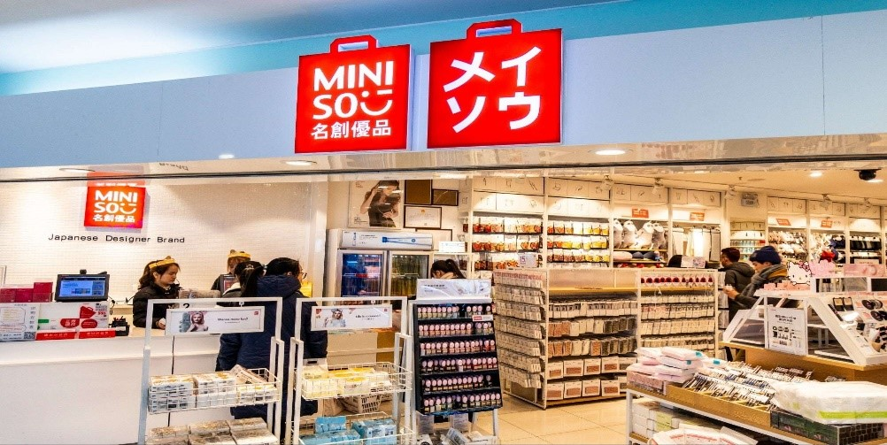

|  |  |
| --- | --- |
| SR.NO | CONTENTS |
| 1. | DECLARATION  CERTIFICATE  ACKNOWLEDGEMENT  PREFACE |
| 2. | CHAPTER1: HISTORY  INTRODUCTION  EXPLORING MINISO  INNOVATIVE PRODUCTS AND UNIQUE OFFERINGS  MINISO ENTRY IN INDIA  PARTNERSHIP AND COLLABORATIONS  STRATEGY EMPLOYED  FUTURE PLANS |
| 3. | CHAPTER 2: CONCLUSIONS  BIBLIOGRAPHY |

**HISTORY**

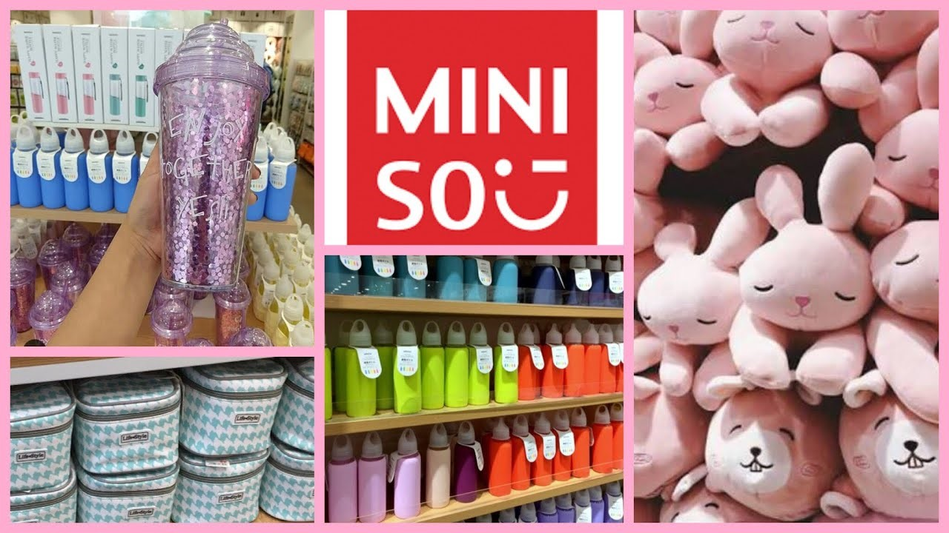

MINISO was founded in 2013 by Japanese entrepreneur Miyake Junya and Chinese entrepreneur Ye Guofu.

* The company's headquarters are in Guangzhou, China.
* MINISO initially started as a Japanese designer brand with a focus on providing consumers with high-quality, affordable products.

**Founders**:

Miyake Junya: Japanese entrepreneur with a background in retail and design. He played a key role in shaping MINISO's brand identity and product development.

Ye Guofu: Chinese entrepreneur known for his expertise in retail operations and management. He contributed to MINISO's expansion strategy and operational excellence.



**Vision**:

* MINISO's vision is to provide consumers worldwide with "high-quality, creative, and low-cost" products that enhance their quality of life.
* The company aims to create a minimalist and modern lifestyle brand that offers value-driven products without compromising on quality or design.
* MINISO seeks to redefine the retail experience by offering a diverse range of trendy and functional products at accessible prices, catering to the needs and preferences of consumers across different demographics and geographies.

**Evolution**:

* Since its inception, MINISO has experienced rapid growth and global expansion, establishing a presence in over 80 countries and regions.
* The company has diversified its product offerings beyond household items to include beauty products, electronics, stationery, accessories, and more.
* MINISO's commitment to innovation, affordability, and customer satisfaction has solidified its position as a leading player in the specialty retail sector, earning it widespread recognition and acclaim.

**INTRODUCTION**

MINISO, a Japanese designer brand co-founded in 2013 by Japanese entrepreneur Miyake Junya and Chinese entrepreneur Ye Guofu, was established with the vision of offering consumers globally high-quality, stylish, and affordable products. The brand's first store opened in Tokyo, quickly gaining popularity for its minimalist design and diverse product range.

Differentiating itself from traditional retailers, MINISO focuses on simplicity, functionality, and affordability. Following its success in Japan, the brand embarked on a rapid expansion strategy, establishing stores across Asia, Europe, North America, Africa, and Australia in a short period. By 2019, MINISO boasted over 4,000 stores worldwide, solidifying its status as one of the fastest-growing retail brands globally.

MINISO's product offerings encompass various categories, including household items, beauty products, electronics, stationery, and accessories. The brand's products are known for their modern design, high-quality materials, and budget-friendly prices, appealing especially to young adults and urban dwellers.

Operating on a franchise model, MINISO partners with local franchisees to establish and manage stores in different markets. This approach has facilitated the brand's rapid global expansion while leveraging the local expertise of its partners.

In recent years, MINISO has embraced innovation, adapting to changing consumer preferences and market trends. The brand has launched online platforms and mobile applications to enhance the shopping experience and facilitate e-commerce sales.

Overall, MINISO's history is characterized by a commitment to innovation, quality, and affordability, making it a beloved brand among consumers and a formidable player in the global retail landscape.

**EXPLORING MINISO: INNOVATIVE PRODUCTS AND UNIQUES OFFEREINGS**

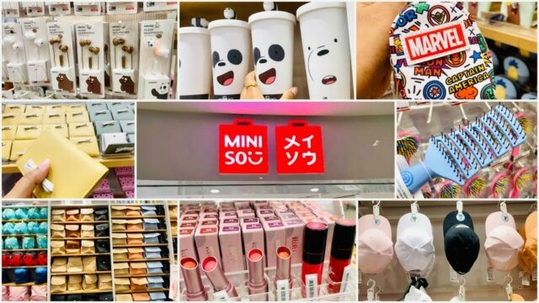

**Product Range**

MINISO offers a diverse selection of lifestyle products across various categories, catering to a wide array of consumer needs and preferences.

Categories include:

* **Household Items**: Kitchenware, storage solutions, home decor, and more.
* **Beauty Products**: Skincare, cosmetics, and personal care essentials.
* **Electronics**: Headphones, chargers, gadgets, and other tech accessories.
* **Stationery**: Notebooks, pens, office supplies, and creative tools.
* **Accessories**: Bags, wallets, sunglasses, and trendy fashion items.

**Unique Selling Points**

* **Affordability**: MINISO’s competitive pricing strategy makes quality products accessible to a broad audience. The brand operates on a low-cost business model, allowing it to offer attractive prices without compromising quality.
* **Minimalist Design**: Products are distinguished by their modern, minimalist aesthetic. Clean lines, simple shapes, and subtle colors create a stylish look that appeals to consumers who appreciate contemporary design.
* **Quality Assurance**: Despite its affordability, MINISO maintains a strong commitment to quality. The company carefully selects materials and suppliers, ensuring that its products meet high standards of durability, functionality, and safety. This dedication reassures customers about the value and reliability of MINISO products.
* **Trendy and Fashionable**: MINISO stays current with the latest trends in fashion, design, and technology, regularly refreshing its product lineup to reflect contemporary tastes. This focus on trendiness resonates with consumers seeking stylish lifestyle products.
* **Wide Product Range**: MINISO’s extensive selection caters to various consumer needs, offering something for everyone. Whether customers seek practical household items, beauty essentials, tech gadgets, or fashionable accessories, they will find a wide array of options in MINISO stores.
* **Innovative Collaborations**: MINISO frequently partners with renowned brands, designers, and artists to create limited-edition collections and exclusive products. These collaborations infuse excitement and exclusivity into MINISO’s offerings, attracting fans and collectors alike.

**MINISO ENTRY IN INDIA TIMELINE, STRATEGIC APPROACH, COLLABORATIONS**

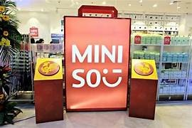

### **2017: Entry Announcement and Expansion in India**

**Entry Announcement**  
In 2017, MINISO announced its plans to enter the Indian market, marking a significant milestone in its global expansion strategy as it set its sights on one of the world's largest consumer markets.

**First Store Opening**  
MINISO opened its inaugural store in India in August 2017 at Ambience Mall, Gurugram, officially establishing the brand within the Indian retail landscape.

**Rapid Expansion Across India**  
Following the successful launch in Gurugram, MINISO swiftly expanded its footprint in major Indian cities, including Delhi, Mumbai, Bangalore, Chennai, Kolkata, and Hyderabad. The company implemented an aggressive expansion strategy, opening multiple stores in prime locations to enhance visibility and accessibility.

### **Entry Strategy Adopted by MINISO in India**

**Franchise Model**  
MINISO adopted a franchise model to enter the Indian market, partnering with local franchisees to establish and operate its stores. This approach enabled MINISO to leverage the expertise and insights of its franchise partners while minimizing operational risks and capital investment.

**Localization**  
Understanding the importance of cultural relevance, MINISO customized its product offerings to align with Indian consumer preferences and market trends. The brand introduced products tailored to Indian festivals, culture, and lifestyle, ensuring strong appeal to local consumers.

**Focus on Urban Centres**  
Strategically targeting major metropolitan areas and urban centres, MINISO focused on locations with high consumer traffic. This strategy allowed the brand to capitalize on the purchasing power and lifestyle preferences of urban Indian shoppers.

### **Partnerships and Collaborations in MINISO's Indian Entry**

**Franchise Partners**  
MINISO collaborated with local franchisees and business partners, who played a crucial role in establishing the brand’s presence in India. These partners were instrumental in securing prime retail locations, managing store operations, and driving brand awareness in their respective regions.

**Retail Partnerships**  
The brand forged alliances with prominent retail developers and mall operators to secure high-traffic spaces for its stores. These collaborations facilitated MINISO's rapid expansion and significantly enhanced its visibility in the competitive Indian market.

Through these strategic initiatives, MINISO successfully navigated its entry into India, laying a strong foundation for future growth.

**STRATEGIES EMPLOYED BY MINISO IN INDIA`S SPECIALITY SEGMENT**

### **Franchise Model**

MINISO adopted a franchise model to establish its presence in India's specialty store segment. Partnering with local franchisees allowed the brand to leverage their expertise and understanding of the local market. Franchisees took on the responsibility of setting up and operating MINISO stores, facilitating rapid expansion across the country.

### **Strategic Store Locations**

MINISO carefully selected prime locations for its stores, focusing on high-traffic areas such as malls, shopping centers, and commercial districts. By positioning its stores in prominent locations, MINISO significantly enhanced visibility and accessibility for its target consumers.

### **Product Localization**

To cater to the preferences and tastes of Indian consumers, MINISO customized its product offerings. The brand introduced items tailored to Indian festivals, cultural events, and lifestyle needs, ensuring strong relevance and appeal in the local market.

### **Affordable Pricing Strategy**

MINISO implemented an affordable pricing strategy designed to attract price-sensitive Indian consumers. By offering high-quality products at competitive prices, the brand made its merchandise accessible to a diverse range of consumers across different income segments.

### **Minimalist Design Aesthetic**

MINISO's minimalist design aesthetic resonated with Indian consumers who valued simplicity and functionality. The brand's clean, modern design approach distinguished it from competitors and enhanced its overall appeal in the Indian market.

### **Strategic Partnerships**

To facilitate its expansion in India, MINISO forged strategic partnerships with retail developers, mall operators, and other stakeholders. Collaborating with established players in the Indian retail ecosystem allowed MINISO to secure prime real estate locations and tap into new customer segments.

### **Marketing and Branding Initiatives**

MINISO executed targeted marketing and branding initiatives to raise awareness and build brand equity in India. The brand leveraged social media, influencer partnerships, and promotional campaigns to engage consumers and drive foot traffic to its stores.

### **Digital Marketing Campaigns**

MINISO launched focused digital marketing campaigns across various online platforms, including social media channels like Facebook, Instagram, and Twitter. Engaging content, such as visually appealing images and videos showcasing products, attracted and connected with Indian consumers. The brand also utilized social media influencers and brand ambassadors to amplify its reach and promote products to their followers.

### **In-Store Promotions and Events**

To enhance brand visibility and drive customer engagement, MINISO organized in-store promotions and events. Activities included product launch events, exclusive previews, and promotional sales aimed at encouraging customers to explore its offerings. Collaborations with popular local artists, designers, and celebrities to create limited-edition collections generated buzz and excitement among consumers.

### **Focus on Tier 2 and Tier 3 Cities**

Recognizing the growth potential in tier 2 and tier 3 cities, MINISO has prioritized expansion into these markets. The brand strategically targets smaller cities and towns with emerging consumer bases and increasing purchasing power. Its expansion efforts in these areas involve adapting strategies to suit local market dynamics and consumer preferences.

By employing these tailored retail strategies, MINISO successfully established itself in India's specialty store segment, achieving rapid growth and gaining significant traction among Indian consumers.

**FUTURE PLANS OF MINISO**

As of my last update in January 2022, Miniso, the global retail brand known for its affordable and stylish lifestyle products, has been steadily expanding its presence worldwide. With its focus on offering quality goods at competitive prices, Miniso continues to strategize for future growth and development. Looking ahead, Miniso is likely to pursue several key initiatives to maintain its momentum and enhance its market position. This may include further expansion into new markets, both domestically and internationally, leveraging its successful business model and strong brand identity. Additionally, Miniso may continue to diversify its product offerings, exploring new categories and partnerships to meet evolving consumer preferences and trends. Furthermore, the company might prioritize digital innovation and e-commerce capabilities to enhance customer experience and reach a broader audience in an increasingly digital-centric retail landscape. Overall, Miniso's future plans are expected to revolve around sustained expansion, product innovation, and digital transformation to solidify its position as a leading player in the global retail market. Looking ahead, MINISO has ambitious plans for further expansion and consolidation of its presence in the Indian market. The brand aims to continue its trajectory of growth by strategically focusing on several key areas. Firstly, MINISO intends to further penetrate into tier 2 and tier 3 cities, tapping into the immense potential of these emerging markets and reaching a wider audience. Additionally, the brand plans to enhance its e-commerce capabilities, capitalizing on the increasing trend of online shopping and leveraging digital channels to reach consumers across the country. Moreover, MINISO is committed to continuously innovating its product offerings, introducing new and exciting collections that resonate with Indian consumers while maintaining its hallmark of affordability and quality. Furthermore, the brand aims to strengthen its brand presence through impactful marketing campaigns, collaborations with local influencers, and community engagement initiatives, thereby reinforcing its connection with Indian consumers. By executing these strategic initiatives, MINISO is poised for sustained growth and success in Furthermore, the brand aims to strengthen its brand presence through impactful marketing campaigns, collaborations with local influencers, and community engagement initiatives, thereby reinforcing its connection with Indian consumers. By executing these strategic initiatives, MINISO is poised for sustained growth and success in India's dynamic retail landscape, solidifying its position as a leading lifestyle brand in the years to come.

**CONCLUSION**

Looking ahead, MINISO has ambitious plans for further expansion and consolidation in the Indian market. The brand aims to sustain its growth trajectory by strategically focusing on several key areas.

Firstly, MINISO intends to deepen its presence in tier 2 and tier 3 cities, tapping into the immense potential of these emerging markets to reach a broader audience. Additionally, the brand plans to enhance its e-commerce capabilities, capitalizing on the growing trend of online shopping and leveraging digital channels to connect with consumers across the country.

Moreover, MINISO is committed to continuously innovating its product offerings, introducing new and exciting collections that resonate with Indian consumers while maintaining its hallmark of affordability and quality. The brand also aims to strengthen its presence through impactful marketing campaigns, collaborations with local influencers, and community engagement initiatives, thereby reinforcing its connection with Indian shoppers.

By executing these strategic initiatives, MINISO is poised for sustained growth and success in India's dynamic retail landscape, solidifying its position as a leading lifestyle brand in the years to come.

MINISO stands out as a formidable international retail organization with a unique approach to offering affordable and stylish lifestyle products to consumers worldwide. Through its commitment to quality, innovation, and competitive pricing, the brand has successfully carved a niche in the global retail landscape. As it looks toward the future, MINISO is well-positioned for continued growth and expansion, fuelled by its strategic initiatives and strong brand reputation.

Despite challenges in the global economic landscape, MINISO's growth prospects remain promising. The company's adaptability to changing consumer preferences and market dynamics, coupled with a disciplined expansion strategy, positions it for sustained success. With a growing footprint across multiple countries and regions, MINISO has demonstrated resilience and agility in navigating diverse markets.

A key focus of MINISO's expansion strategy is its entry into the Indian market. Recognizing India's burgeoning retail sector and the increasing demand for specialty stores that offer affordable yet trendy products, MINISO has tailored its retail strategies to suit this unique market. By leveraging its expertise in product innovation, supply chain management, and brand marketing, MINISO aims to establish a strong foothold in India’s specialty retail segment.

Through a combination of physical store expansion and strategic partnerships, MINISO plans to penetrate key cities and urban centres, catering to local consumer preferences while staying true to its core brand values. Furthermore, the company intends to capitalize on the rise of digital commerce in India, enhancing its omnichannel capabilities to reach a wider audience and drive sales.

In conclusion, MINISO's international retail success story is a testament to its ability to innovate, adapt, and capitalize on emerging opportunities. With a focus on sustainable growth, product excellence, and customer-centric strategies, MINISO is well-positioned to thrive in the competitive global retail landscape, including its strategic efforts to establish a strong presence in India's specialty store segment.

**BIBLIOGRAPHY**

* <https://edtimes.in/how-did-miniso-gain-its-popularity-in-india/>
* <https://startupyo.com/miniso-franchise-india/>
* <https://www.prnewswire.com/news-releases/miniso-celebrates-milestone-of-200-local-stores-in-india-at-its-fifth-anniversary-of-entering-indian-market-301615327.html>
* <https://www.foundingfuel.com/article/how-variety-store-miniso-became-a-megasuccess/>
* <https://www.prnewswire.com/news-releases/minisos-rapid-store-expansion-continues-apace-in-india-with-number-of-new-store-openings-reaching-new-highs-since-pandemic-began-301712296.html>