**A Study On Students Awareness And Perception Towards Investment In Mutual Funds**

**MR PRATHAM SALECHA - prathamsalecha@gmail.com**

**ABSTRACT**

**The Indian financial market is becoming competitive day by day. It is important that**

**the various financial instruments needs to be in equilibrium to the demand**

**perspectives of the investors. The prime drive of any investment is to get maximum**

**return with a minimum risk and mutual funds provides the opportunity for the**

**investors. The mutual fund sector is one of the quickest growing sectors in Indian**

**Economy and has great potential for sustained future growth. Mutual funds make**

**saving and investment easy, accessible, and affordable. Mutual funds are most**

**appropriate investment for an investor as it offers a chance to invest in a diversified,**

**professionally managed basket of securities at a reasonably low cost. Financial**

**markets have become more intensive with wide-ranging financial merchandise**

**attempting innovations in planning mutual funds portfolio however these changes**

**would like unification in correspondence with investor’s expectations and objectives.**

**It is essential to study mutual funds from a different angle, that is to emphasize on**

**investor’s perception. The major concern of the present study is to determine the**

**awareness and perception about mutual funds among the students. This study aims to**

**understand younger generations’ investing behaviors in mutual funds in order to help**

**wealth advisors and other financial institutions understand how better to work with**

**younger generations.**

**1. INTRODUCTION**

**A mutual fund is a type of financial investment vehicle which is formed when as asset**

**management company (AMC) or a fund house pools investments from several**

**individuals and institutional investors with common investment. A finance**

**professional that is the fund manager manages the pooled investment by purchasing**

**securities such as stocks and bonds that are in line with investment objective.**

**Mutual funds are investment companies that collect funds from the individual**

**investors and invest those funds in a potentially wide range of securities or other**

**assets. Mutual funds is one of the famous financial instrument of Indian markets.**

**Over the years with advancement in technology, more and more people have become**

**aware about mutual funds and have started investing in it according to their**

**preferences. With the reforms in financial sector and the developments in the Indian**

**financial markets, Mutual Funds (MFs) have emerged to be an important investment**

**avenue for retail (small) investors. Mutual funds issue units to the investors in**

**accordance with the quantum of the money invested. These investors are known as**

**unit holders. The income earned by way of dividends, bonus, etc. through these**

**investments and capital appreciations realized are shared by its unit holders in**

**proportions to the number of units owned by them. Mutual funds have gained huge**

**popularity in the last few years and are emerging as the favourite investment vehicle**

**because it has many advantages that have attracted the common of India. It is one of**

**the fastest growing sectors in the Indian economy and has great potential for sustained**

**future growth. These mutual funds are handled by Asset Management Companies**

**(AMC). Asset management companies in India are broadly categorised into three**

**types; bank-sponsored mutual funds, mutual fund institutions, and the private sector**

**mutual funds. The wide array of funds often make it a little difficult for investors to**

**choose the best scheme for them.**

**Aspects that Attract Investors Towards Mutual Funds**

**1. Professional Management**

**Management of a portfolio involves continuous monitoring of various**

**securities and the innumerable economic and non-economic variables that**

**affects the portfolio’s performance. This requires a lot of time and effort on**

**the part of the investor, along with in-depth knowledge of the functioning of**

**the financial markets. Mutual funds are generally managed by knowledgeable,**

**experienced professionals whose time is solely devoted to tracking and**

**updating the portfolio. Thus, investment in a mutual fund not only saves time**

**and efforts of the investor but is also likely to yield better results.**

**2. Diversification Benefit**

**Diversified investment improves the risk-return profile of the portfolio. Small**

**investors may not have the amount of capital that would allow optimal**

**diversification. Since the corpus of a mutual fund is substantially big as**

**compared to individual investments, optimal diversification becomes possible.**

**As the individual investors; capital gets pooled into a mutual fund, all of them**

**are able to derive the benefits of diversification.**

**3. Low Transaction Costs**

**The transactions of a mutual fund are generally very large. These large**

**volumes attract lower brokerage commissions (as a percentage of the value of**

**the transaction) and other costs, as compared to the smaller volumes of the**

**transactions entered into by individual investors. The brokers quote a lower**

**rate of commission due to two reasons. The first is competition for the**

**institutional investors’ business. The second reason is that the overhead costs**

**for executing a trade do not differ much for large and small orders. Hence, for**

**large order, these costs spread over a large volume, enabling the broker to**

**quote a lower commission rate.**

**4. Flexibility**

**Mutual funds possess features such as regular investment plan (i.e one can**

**invest in instalments), regular withdrawal plans and dividend reinvestment**

**plans. Because of these features, one can systematically invest or withdraw**

**funds according to one’s needs and convenience. Some mutual funds have**

**permitted the investors to switch over their units from one scheme to another.**

**It is always depends on the scripts which is backed by the investment. The**

**investment climate may be some times good for one fund and bad for the**

**other. So an intelligent investor can switch over his units in one fund to**

**another depending up on the performance of the funds. One cannot find such**

**flexibility in any other investments.**

**5. Tax Benefit**

**In India, dividend received by the investor is tax free. This enhances the yield**

**on mutual funds marginally as compared to income from other investment**

**options. Also, in case of long terms capital gains, the investor needs not to pay**

**tax for all equity purchases after March 1, 2003. Other than many tax benefit**

**schemes, according to the new section 80C introduced in the we can invest a**

**maximum of Rs.100000 in investment options like Equity-linked Savings**

**Schemes, Infrastructure Bonds, Unit linked Insurance Plans etc. and the entire**

**sum can be deducted from one&#39;s taxable income.**

**Limitations of Mutual Funds**

**1. Fluctuating returns:**

**Mutual funds do not offer fixed guaranteed returns in that you should always**

**be prepared for any eventuality including depreciation in the value of your**

**mutual fund. In other words, mutual funds entail a wide range of price**

**fluctuations. Professional management of a fund by a team of experts does**

**not insulate you from bad performance of your fund.**

**2. Subject to Market Risks**

**Mutual fund investments are subject to market risk involved or systematic**

**risk. This is because there is no way to predict what will happen in the future**

**or whether a given asset will increase or decrease in value. Because the**

**market cannot be accurately predicted or completely controlled, no**

**investment is risk-free. This caution (warning) can be checked with the offer**

**document where it is clearly mentioned as follows:**

**“Mutual-Funds investments are subject to market risk.**

**Please read the offer document carefully before investing”**

**3. Lock-in periods**

**Many mutual funds have long-term lock-in periods, ranging from five to**

**eight years. Exiting such funds before maturity can be an expensive affair. A**

**specific portion of the fund is always kept in cash to pay out an investor who**

**wants to exit the fund. This portion cannot earn interest for investors.**

**4. Diversification:**

**Diversification is often cited as one of the main advantages of a mutual fund.**

**However, there is always the risk of over diversification, which may**

**increase the operating cost of a fund, demands greater due diligence and**

**dilutes the relative advantages of diversification.**

**5. No Control:**

**All types of mutual funds are managed by fund managers. In many cases, the**

**fund manager may be supported by a team of analysts. Consequently, as an**

**investor, you do not have any control over your investment. All major**

**decisions concerning your fund are taken by your fund manager. However,**

**you can examine some important parameters such as disclosure norms,**

**corpus and overall investment strategy followed by an Asset Management**

**Company (AMC).**

**2. RESEARCH METHODOLOGY**

**Research is the scientific investigation of a specific field with definite**

**objectives. It helps in reaching out from known to unknown facts. Research is used to establish or confirm facts, reaffirm the result of previous work, solve**

**new or existing problems, support theorems or develop new theorems.**

**According to Martyn Shuttleworth, in the broadest sense of the word, the**

**definition of research includes any gathering of data, information and facts for**

**the advancement of knowledge. The research work is primarily associated with**

**the collection of data, sequencing and quantifying it, to spot the problem and**

**solution. Validity and credibility of information is based upon method adopted**

**in research work. The reliability, credibility and academic value of research**

**work is determined by the scale utilized in research methodology .**

**2.1 Introduction**

**The present chapter talks about the various types of data used to collect the**

**information and its advantages and disadvantages .The present chapter covers,**

**the need of the study, the scope of the study and objectives of study, the research**

**design, data collection method, limitation of the study etc .**

**2.2 Research Design**

**It is the basic frame work which provides guidelines for the rest of the research**

**process. It is a map or blueprint according to which the research is to be**

**conducted. It provides an empirical and logical basis for drawing conclusions**

**and gaining knowledge. The research design specifies the methods for data**

**collection and data analysis. For research to be carried out properly the research**

**has to specifically pinpoint -**

**a) How would the data be collected.**

**b) Which instrument would be used for collecting the data**

**c) What sampling plan would be used**

**2.3 Data Collection Method**

**Data can be obtained from primary or secondary sources. Primary data refers to**

**information obtained first hand by the researcher on the variables of interest for the specific purpose of the study. Secondary data refers to information gathered**

**from sources already existing. For the purpose of the research undertaken both**

**primary and secondary data have been used.**

**2.4 Data Analysis and Interpretation**

**It is the process of assigning meaning to the collected information and**

**determining the conclusion, significance and implications of the findings. The**

**purpose of data analysis and interpretation is to transform the data collected into**

**credible evidences about the development of the intervention and its**

**performance. Data analysis and interpretation in this project has been done**

**through pie charts and bar diagrams.**

**i) Pie chart: It is a circular chart divided into sectors, illustrating numerical**

**sproportion. In a pie chart, the arc length of each sector is proportional to the**

**quantity it represents. Pie charts are based on percentage figures and not absolute**

**figures. In case where absolute figures are given, the same are first converted into**

**percentage values**

**ii) Bar Diagrams: It is a chart with rectangular bars with lengths proportional to**

**the values that they represent. A bar graph is a chart that uses either horizontal or**

**vertical bars to show comparison among categories. One axis of the chart shows**

**the specific categories being compared, and the other axis represents a discrete**

**value.**

**2.5 Need Of The Study**

**The Indian financial system has undergone a number of changes over the last**

**three decades. Since the opening of the economy in 1991 a new kind of**

**investment pattern started emerging in the country. New schemes were launched**

**for attracting investments in different sectors of the economy. These initiatives of**

**the government changed the perception of the investors regarding investment**

**decisions. They started looking for new avenues of investment. People are**

**becoming aware of the latest investment plans and returns on these plans.**

**Foreign direct investment changed the whole scenario and attractive schemes**

**were launched by the government in order to attract a larger number of investors.**

**During this period one of the most important schemes emerged in the form of**

**mutual funds. Almost all financial institutions and banks started exploring the**

**possibility of pushing investments towards mutual funds, with some of them**

**preferring to float a few mutual funds themselves.**

**The present work is an attempt to study the perception and awareness of graduate**

**and post graduate students towards investment in mutual funds and the various**

**factors that affect their investment decision with respect to mutual fund. The**

**study has been necessitated as more and more people are investing in mutual**

**fund schemes launched by a number of financial institutions and its important to**

**know that how aware the youth is about this investment avenue.**

**2.6 Scope Of The Study**

**There has been a continuous change in the economic and business environment**

**leading to the emergence of new opportunities to the new and established mutual**

**fund players. Investment in mutual fund instruments have shown phenomenal**

**growth during the recent past. Numerous categories of investors are participating**

**in this growth. The geographical coverage of the respondents is confined to the**

**students residing Mumbai who are currently graduating or have already**

**graduated and the students who are pursuing their post graduation.**

**● Number of people who received the survey – 120**

**● Number of respondents – 110**

**● Location of Respondents – Mumbai**

**● Age of respondents – 18-25 years and above**

**● Method of collecting data – Survey by Google form containing 16 questions.**

**Telephonic interview of some of the respondents.**

**● The sample was chosen by keeping the age and education qualification of the**

**respondents in mind.**

**2.7 Objectives Of The Study**

**The objectives to carry out this research include –**

**1.‌To understand the concept of Mutual**

**2. To study the financial awareness of mutual fund investment amongst graduate**

**and post graduate students**

**3.‌To analyse the perception and knowledge of students about different mutual**

**fund options and factors affecting their investment behaviour**

**4.‌To determine the different options available and preferred by students for**

**investment purposes with respect to mutual funds**

**2.8 Limitations Of The Study**

**1. The study is confined to students living in Mumbai only.**

**2. The sample size for the primary research is limited that is 120 students.**

**3. The age group of the sample is 18-25 years and above.**

**4. The study is based on the views expressed by individuals based on their**

**experience/perceptions.**

**5. Primary data collected through the sample survey is not free from bias and**

**inaccuracies.**

**6. Thus, data processed for analysis is also subject to errors particularly as**

**the respondents may have lacked perceptual clarity about the key issue**

**involved and also due to natural inhibitions to impart correct information.**

**2.9 Hypothesis of the study**

**H0 - People are aware about the term Mutual Funds**

**H1- People are not aware about the term Mutual Funds.**

**H0 - People have invested in Mutual Funds**

**H1- People haven&#39;t invested in Mutual Funds.**

**H0 - People have mutual funds as their preferred form of investment.**

**H1- People do not have mutual funds as their preferred form of**

**investment.**

**HO - People invest in mutual funds with growth in mind.**

**H1- People do not invest in Mutual Funds with growth in mind**

**H0 People who use advisers and consultants before investing in Mutual**

**fund**

**H1 people invest in Mutual funds based on their own analysis**

**3. REVIEW OF LITERATURE**

**Review of literature plays an important role in any research. The review of literature**

**gives a broad outlook of the various research studies made in the past and the details**

**of such studies throw light on the future studies to be made. It also strengthens the**

**theoretical base of the research study. Literature on mutual fund performance**

**evaluation is enormous. The review of literature helps to identify the research gap in**

**the study on investors&#39; perception and which has given rise to the present study. Some**

**of the research studies that have influenced the preparation of this study substantially**

**are discussed in this section.**

**Rajesh Trivedi, Prafulla Kumar Swain and Manoranjan Dash3( 2017 ) in their**

**study examined the effect of gender difference and age factors on investment**

**decision. They found that males are more interested in mutual fund investments than**

**the females and the elderly people are less aware about the mutual fund information .**

**Sudarmathi.j, dr. Ch. Bala nageshwara roa (2017) conducted a study on investor**

**behaviour towards mutual funds. From the research it was found out that most of the**

**investors were males and businessmen. The research involves a primary research of 60 respondents and suggested that more people were aware of mutual funds through**

**advertisement campaigns and social media. Besides primary data secondary data was**

**collected through websites and books. This analysis denoted that there was a frequent**

**investment in mutual funds compared to alternative investment sectors.The study**

**suggested that most of the people were male. So, the mutual fund companies should**

**concentrate to create more awareness about mutual fund on females. The company**

**should concentrate more on businessmen, entrepreneurs and private firms and**

**companies. The majority of the investors belong to the age group of 20 to 30.**

**CHI- square tests, ANOVA one way and two way were the statistical methods used.**

**Questions asked were relating to the age, gender, profession, expected returns, risk**

**appetites, income levels etc.**

**Priyanka Sharma and Payal Agrawal (2015) in their study made an attempt to**

**understand the effect of demographic factors in mutual fund investment decisions.**

**The study reveals that the investors’ perception is dependent on their demographic**

**profile. Investor’s age, marital status and occupation has a direct impact on investors’**

**choice of investment.**

**Vipin Kumar and Preeti Bansal, Haryana, India (2014)**

**International Journal of Engineering and Management Research**

**Kumar and Bansal conducted a study on the Investors’ behaviour in Mutual funds in**

**Rohtak, Hrayana. Their research paper focused on number of factors that highlights**

**investors’ perception about mutual funds. They collected data through structured**

**questionnaire which was designed to collect all required information from mutual**

**fund investors. They had a sample size of 125 respondents who were from Rohtak.**

**Secondary data was collected through related research works, journals, etc.**

**Questions asked were relating to the age, preferred form of investments, risk**

**appetites, a number of yes or no questions that tested the knowledge of the investor**

**about mutual funds, time holding of investments, etc. Based on these questions**

**suggestions and conclusions were made.**

**The data and information collected was classified, tabulated and processed and its**

**findings were presented in a systematic manner. Statistical tools as Chi-square test,**

**mean and median were used.**

**It was found that mutual funds were not so known to investors, still traditional**

**investor rely upon bank and post office deposits. Most of the investor used to invest in**

**mutual fund for not more than 3 years and they used to quit from the fund which were**

**not giving desired results. They also found that most of the investors did not analyse**

**risk in their investment and they were depended upon their agent or broker for this**

**work.**

**But since this work was published in 2014 which was earlier than the “Mutual Funds,**

**Sahi hai” ad campaign which was launched in 2017, many investor must not have**

**been aware about mutual funds and/or its benefits.**

**Prathabetal (2013) in a study examined the understanding level and fulfillment of**

**citizens concerning to factor rate of return, liquidity, protection and security, tax**

**deliberation, and challenge faced by Indian mutual fund business. This study exposed**

**that in students have high level of attentiveness towards mutual funds in India and**

**they think about mutual fund as safe selection for their investment which not only**

**give them high returns but improve their capital at a minimum level of threat.**

**Kumar Manoj (2013) critically examined the investors’ behaviour and preferences**

**towards various investment alternatives and investors’ preference between shares and**

**mutual funds. Another objective of the study was to identify the major attributes of**

**the investment avenue to lure the investors to investment. The study was performed**

**on investors in the Agra city. The author concluded that real estate and gold were the**

**most favourable investment options of the investors. The study further tested the**

**hypothesis that investors have same level of preference for the share and mutual fund**

**for investment, the chi-square test revealed that investors have not same preference**

**for both of the investment avenues. Investors more preferred to mutual funds compared to shares. Chi-square test further indicated that investors have different**

**preference for risk, return and liquidity for different investment options.**

**PRIMARY RESEARCH**

**It is a matter of common understanding that the investor while taking investment**

**decisions in financial assets in general and risky assets in particular are highly**

**influenced by social, economic and political reasons. The demographic factors also**

**play an important role in the process of investment decisions. In addition to this the**

**income, life cycle of age, personality characteristics and life styles also influence the**

**process of investment decisions.**

**In the present study we have taken into account the variables like gender, age, and**

**education profile which influence the investment decision of the investors. These are**

**important to know because it helps in the understanding that which class of people**

**have a deeper understanding about the subject**

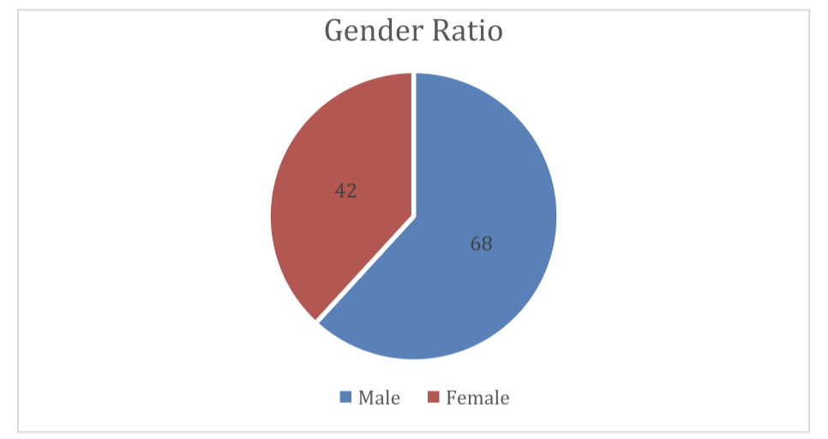

1. **Gender Ratio**

**The above graph shows the gender distribution amongst the sample of 110**

**respondents.**

**● 68 respondents were male - 61.81 %**

**● 42 respondents were female - 38.81 %**

**No respondent belonged to the third gender nor preferred not to say.**

**2. Age Distribution Of The Respondents**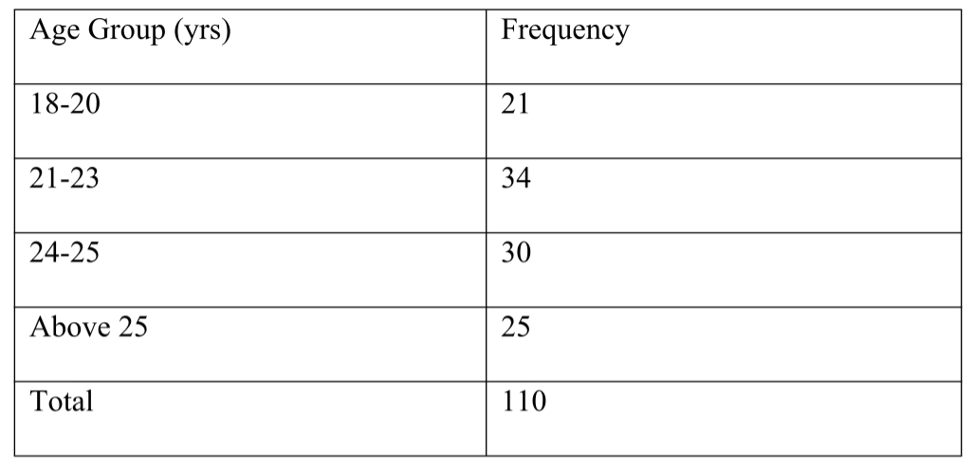

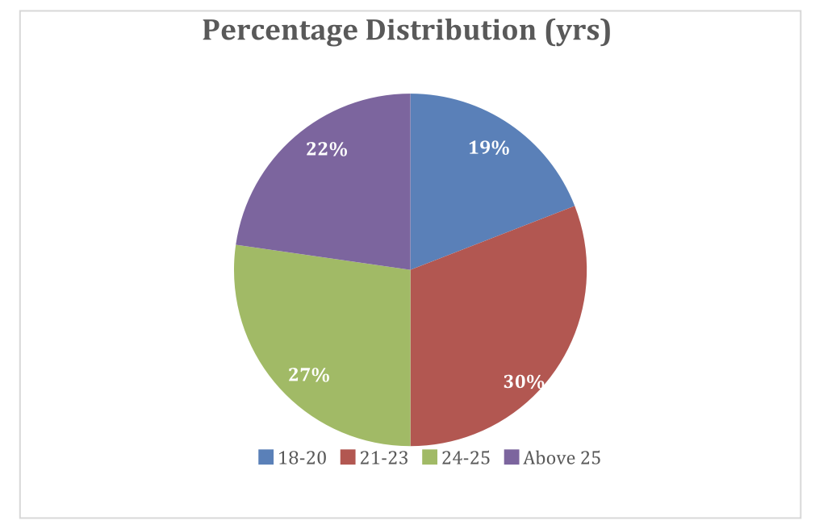

**The information given in the above graph presents the age wise distribution of**

**the respondents living Mumbai. It is clear from the above table that 19.09% of**

**the respondents are belonging to the age group of 18-20 years of age, 30.90 %**

**percent of respondents belong to age group of 21-23 years, 27.27 % of the**

**respondents are having the age between 24-25 and 22.72% are above 25 years of**

**age .**

**3. Educational Qualification**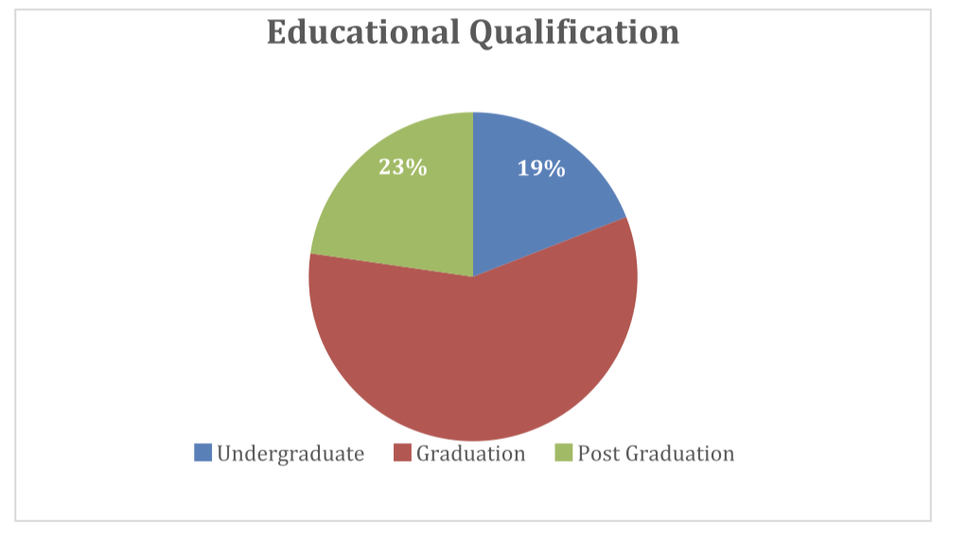

**From the above graph it can be seen that 19.09% of the respondents are still**

**graduating that is are undergraduate , 58.18% of the respondents have completed their**

**graduation, and 22.72% of the respondents are pursuing post graduation or are already**

**post graduates. Educational qualification definitely has an impact on investment in**

**mutual fund and in general.**

**4. Aware About Mutual Funds**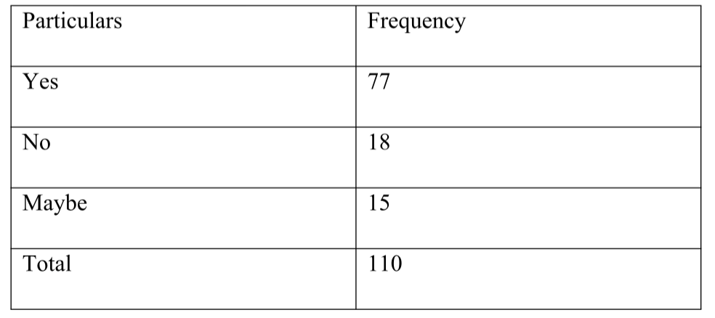

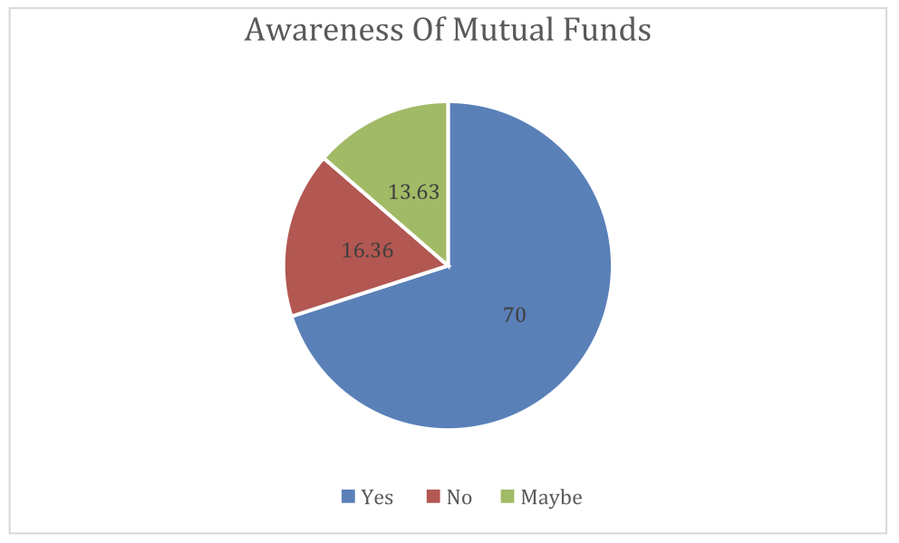

**The above graph shows that majority of the respondents that is 70% are atleast aware**

**about mutual funds as an investment. 16.36% of the respondents don’t know anything**

**about mutual funds and 13.63% of the people may or may not know about mutual**

**funds**

**5. Invested in Mutual Fund**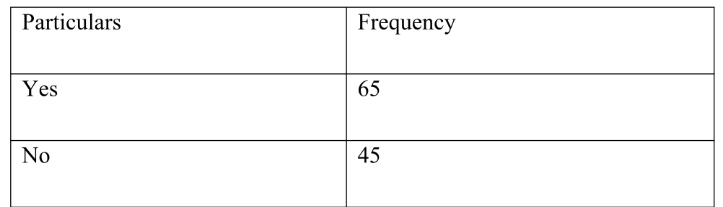

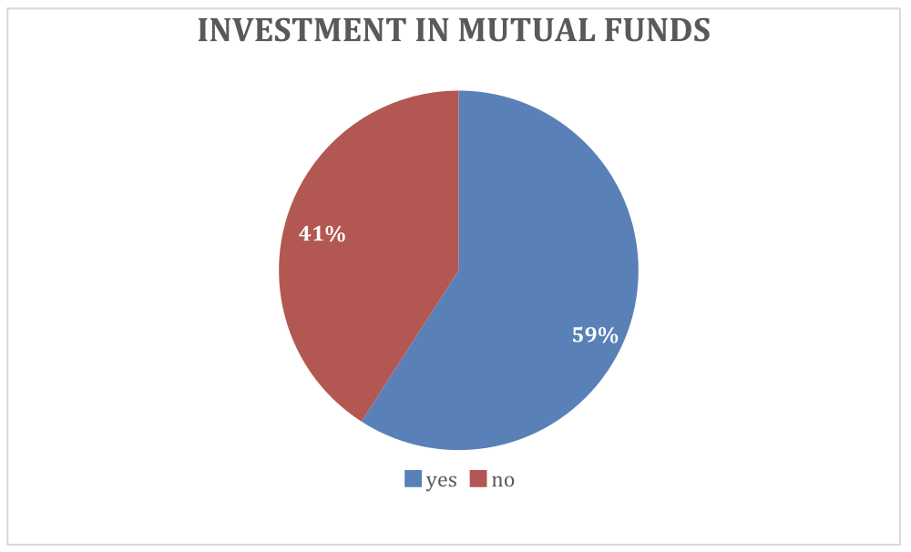

**The above graph shows that 59.09 % of the people that is 65 respondents have**

**invested in mutual funds and 40.90 % of the respondents that is 45 people have not**

**yet invested in mutual funds. Of course the people of the upper age group are more**

**aware of mutual funds and so have invested in it.**

**6. Intend To Invest In Mutual Fund**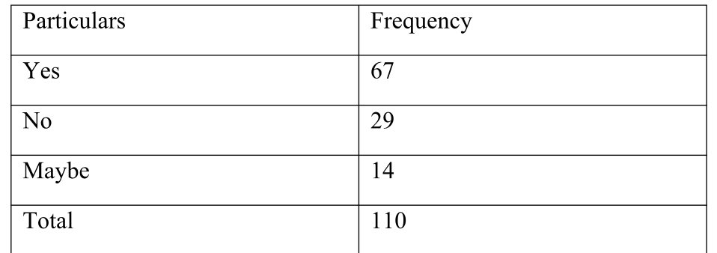

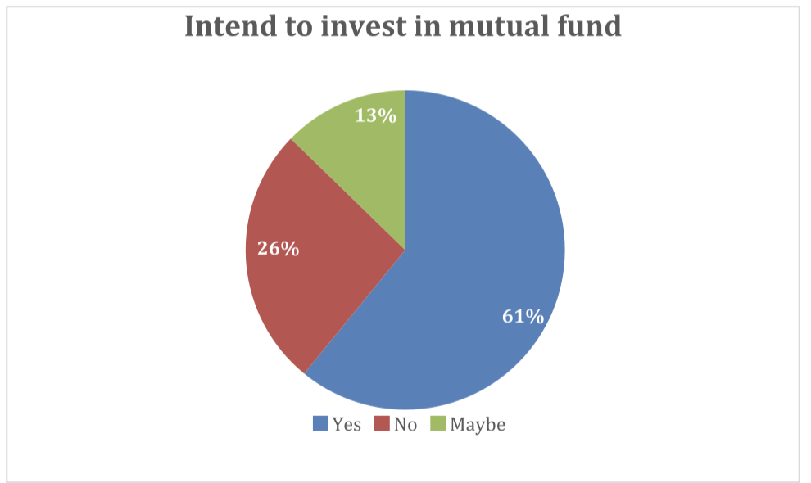

**In the above graph we can see that 60.90 % of the respondents have intend to invest in**

**mutual funds whereas 26.36% of the respondents do not intend to invest in mutual**

**fund. As investment in mutual funds is very relative, 12.72 % of the people may or**

**may not invest in mutual funds as they need to have proper understanding of mutual**

**funds since mutual funds are subject to market risk. There are various personal**

**reasons for not investing in mutual funds such as high cost, no time, no expertise etc.**

**7. Knowledge on Investment in Mutual Funds**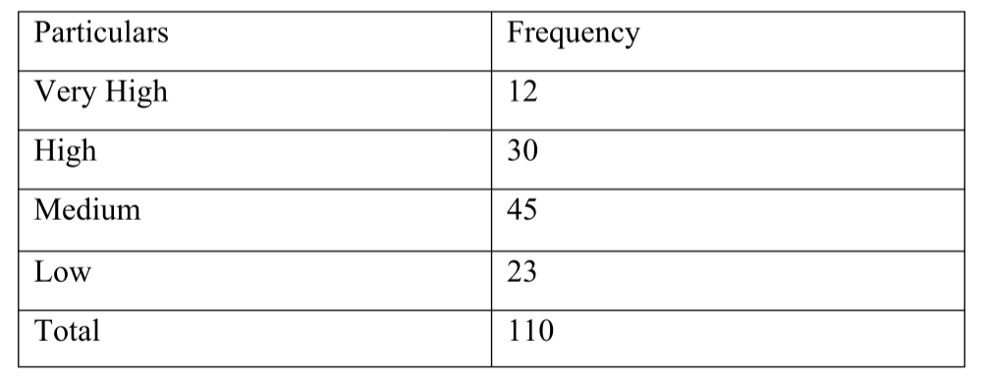

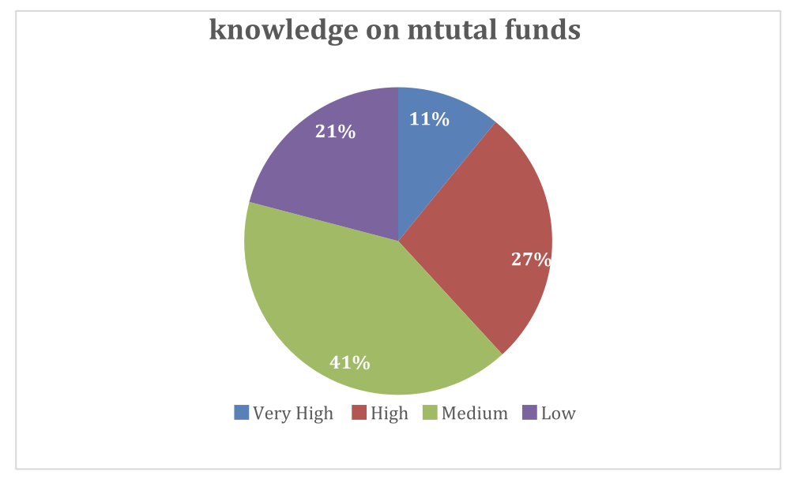

**From the above graph we can see that 10.9 % of the respondents have very high**

**knowledge of mutual funds. These mainly include the graduate and post graduate**

**students as they have better knowledge on mutual funds. 27.27% of the respondents**

**have high knowledge and 40.9% respondents have medium knowledge. 20.9% of the**

**respondents have low knowledge and these mainline include the people of age group**

**18-20 years**

**8. Self Analysis Before Investing**

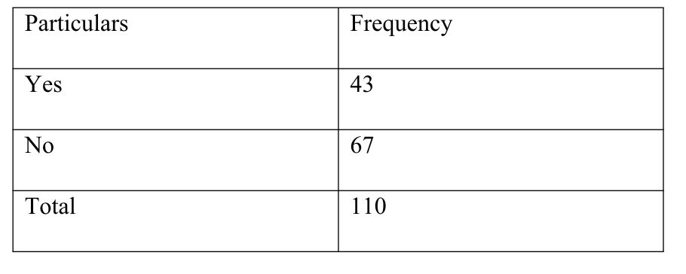

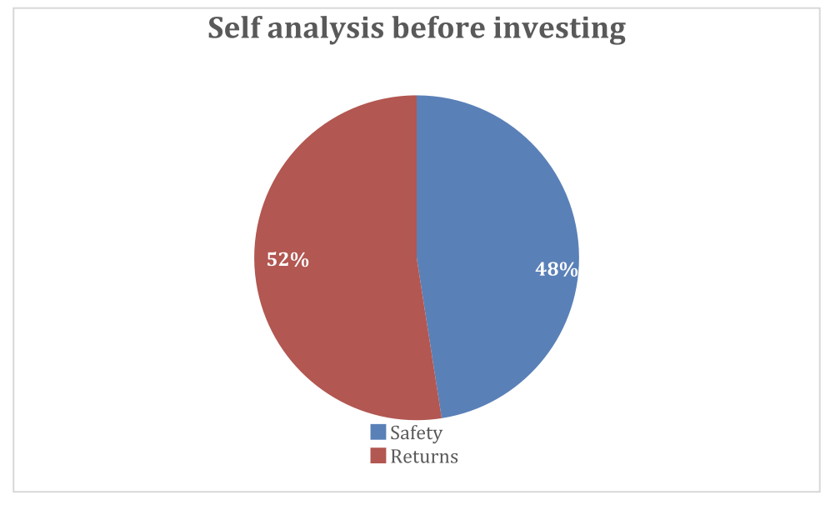

**The above graph shows that 39.09 % of the people themselves do proper analysis or**

**atleast take efforts to study on particular schemes they want to invest in which is very**

**important. We can also see that more than 50% of the respondents that is 60.90% of**

**the people don’t do self analysis of a particular scheme or company before investing**

**in mutual funds. Again there may be several reasons for this such as no time, lack of**

**knowledge, dependency on brokers, relatives etc.**

**9. Preferred Form Of Investment**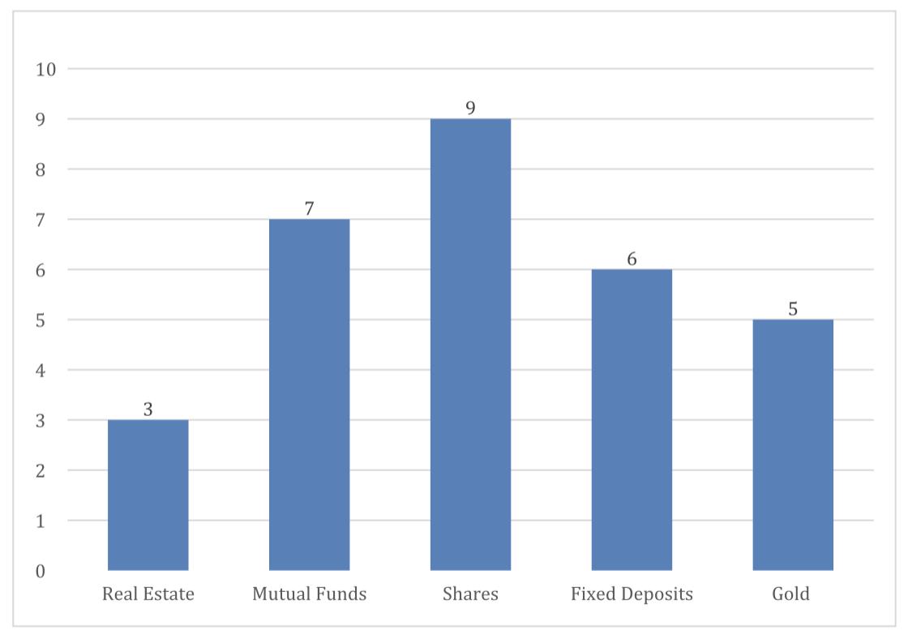

**The above graph shows the ratings given by majority of the respondents according to**

**their preferred form of investment (10 being the most preferred to 1 being the least**

**preferred). The most preferred option is shares with a rating of 9 as there are many**

**graduation courses available to supplement the knowledge of share markets. You also**

**don’t need a huge amount of capital for investing in shares. Mutual funds comes with**

**a rating of 7 since it diversifies one’s portfolio. But on the other hand you need a**

**thorough understanding of the segments it invests in which becomes a bit**

**complicated. Fixed deposited rated 6 implies that it’s a very safe option to park your**

**money but at the same time the returns are very less as its said higher the risk , higher**

**the return. Gold rated the second least with a rating of 5 as you can easily avail loan**

**against it but at the same time there is a lot of risk in storing gold. Real estate being**

**the least rated being 3 as you need a huge capital to invest in real estate.**

**10. Objective of Investment In Mutual Fund**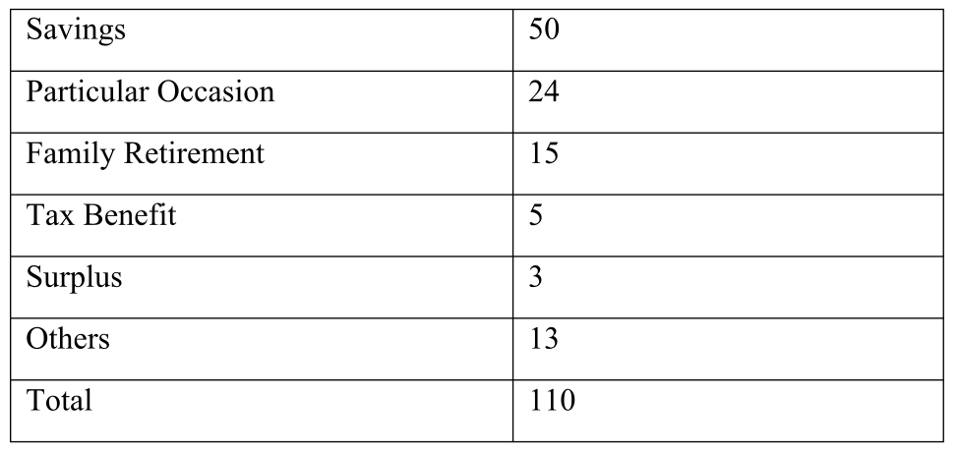

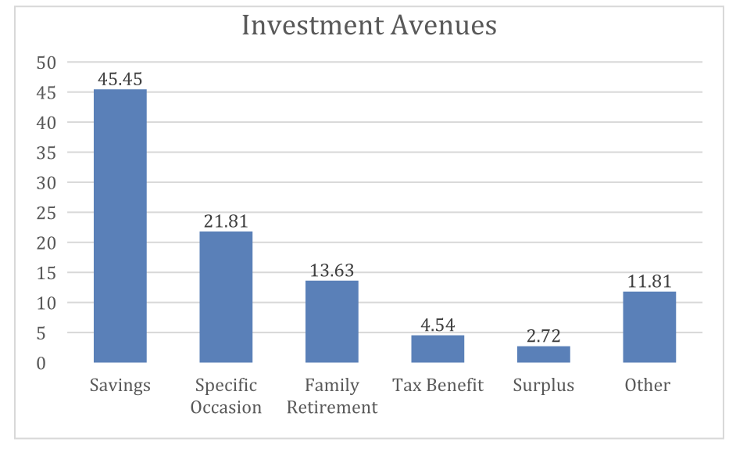

**We can see from the above graph that there are various reasons for investing in**

**mutual funds. This differs from person to person. The graph shows that 45.45% of the**

**respondents invest in mutual funds with a perspective of savings where as 21.81% of**

**the respondents do it for specific occasions such as buying a house or car, educational**

**purpose, capital appreciation, starting a business, vacation, marriage etc. 13.63 % of**

**the respondents invest with the objective of retirement planning . The can invest in**

**various pension fund schemes. For the people with higher income, mutual funds is a**

**very good option to get tax benefit and 4.54% of the people invest in mutual fund to**

**get this advantage. 2.72% respondents invest to park their surplus income and 11.81**

**% invest for other reason such as diversification, professional management etc.**

**Conclusions**

**People had the traditional mindset of investing in banks, post offices and**

**governmental securities. The role of Indian mutual fund industry as a**

**significant financial service in the financial market has really been**

**noteworthy. In fact the mutual fund industry has emerged as an important**

**segment of the financial market of India specially in channelizing the saving**

**of millions of individuals into investment in equity and debt instruments.**

**In any mutual fund industry investors perception plays an important role. With**

**an increasing number of mutual fund organizations there is a need for every**

**company to educate investors and the general public on various aspects**

**concerned with the mutual fund investments which in turn reveals their**

**perception and attitude towards such investments.**

**This project sought to study the student’s perception and awareness towards**

**mutual funds and their preferred form of investments. The research provided**

**that investment behaviour could be explained with awareness, perception and**

**socioeconomic characteristics of individual investors. Better awareness related**

**to various aspects of mutual funds will have a positive effect on investment in**

**mutual funds It was found that the knowledge of respondents about mutual**

**funds was average.**

**Many of the undergraduate students are not even aware**

**about mutual funds. The study revealed that the preferred option of respondent**

**was shares and stock markets when compared to mutual funds. The time**

**horizon for investment differed from people to people and many respondents**

**were not satisfied with their investment in mutual funds for the various**

**reasons mentioned above.**

**Financial literacy among youths will definitely bring a huge success to this**

**industry. In Indian market where financial instruments are capturing almost**

**every unit of society, mutual fund industry has a great scope if it gives more**

**attention to some factors which will ultimately lead to satisfaction of investors**

**which will help the mutual fund industry to boom up. Majority of the students**

**prefer mutual funds with the low risk. There is lot of scope in Mutual funds**

**provided the students have the knowledge of Mutual funds.**