***October 2024***

**The Greenhouse Effect: Understanding Its Mechanisms and Mitigating Climate Change**

**Abitha S.1, Zeal Polytechnic, Pune, India**

**Pranjal Rohankar2, Zeal Polytechnic, Pune, India**

**Shruti Yamjal3, Zeal Polytechnic, Pune, India**

**Sakshi Warade4, Zeal Polytechnic, Pune, India**

**Prof. Kritika Goswami, Zeal Polytechnic, Pune, India**

**ABSTRACT** *The greenhouse effect is a fundamental natural process that warms the Earth’s surface, enabling the existence of life as we know it. This phenomenon occurs when solar radiation is absorbed by the Earth and then re-radiated as infrared energy, which is subsequently trapped by greenhouse gases in the atmosphere. Key gases such as carbon dioxide, methane, and nitrous oxide play a crucial role in this process. While the greenhouse effect is essential for maintaining the planet's temperature, human activities, particularly fossil fuel combustion and deforestation, have significantly increased the concentration of these gases, leading to an enhanced greenhouse effect and global warming. This paper examines the mechanisms of the greenhouse effect, distinguishes between natural and anthropogenic influences, and highlights the resulting impacts on climate and ecosystems. Additionally, it discusses mitigation strategies aimed at reducing greenhouse gas emissions and emphasizes the urgency of collective action to address climate change. Understanding the greenhouse effect is critical for developing effective policies and practices to ensure a sustainable future for the planet.*

# INTRODUCTION

The greenhouse effect is a natural phenomenon that plays a crucial role in regulating the Earth's climate and supporting life. It occurs when the Sun's energy reaches the Earth's atmosphere, where a portion of this energy is absorbed by the surface, while the remainder is reflected back into space. The absorbed energy is then re-emitted in the form of infrared radiation. Certain gases in the atmosphere, known as greenhouse gases (GHGs), including carbon dioxide (CO₂), methane (CH₄), nitrous oxide (N₂O), and water vapor, trap this infrared radiation, preventing it from escaping into space and thereby warming the planet.

This process is essential for maintaining a habitable climate; without the greenhouse effect, the Earth's average temperature would be significantly lower, making it inhospitable for most forms of life. However, the rapid increase in greenhouse gas emissions due to human activities—such as burning fossil fuels, industrial processes, and deforestation—has intensified the greenhouse effect, leading to global warming and climate change.

The consequences of an enhanced greenhouse effect are profound, impacting weather patterns, sea levels, and biodiversity, and posing significant challenges to ecosystems and human societies. Understanding the greenhouse effect is vital for developing strategies to mitigate climate change and adapt to its impacts. This paper will explore the mechanisms of the greenhouse effect, its importance in the Earth’s climate system, and the urgent need for collective action to address its human-induced alterations.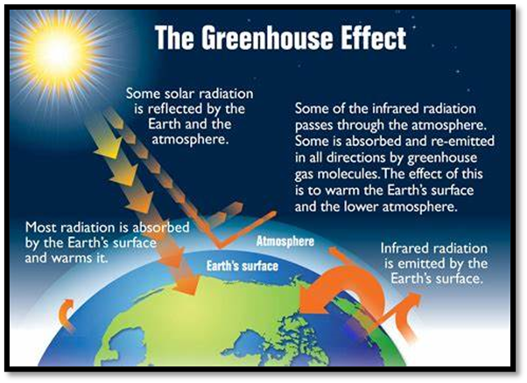

# Mechanism of the Greenhouse Effect

The greenhouse effect is a complex process that involves several steps to regulate the Earth's temperature. Here’s a detailed explanation of how it works:

**Solar Radiation**:

The process begins when solar energy from the Sun reaches the Earth. About 30% of this incoming solar radiation is reflected back into space by clouds, atmospheric particles, and the Earth's surface (particularly bright surfaces like ice and snow).

The remaining 70% of solar radiation is absorbed by the Earth’s surface, warming the land, oceans, and atmosphere.

**Infrared Radiation**:

After absorbing solar energy, the Earth's surface emits this energy back into the atmosphere as infrared radiation (heat).

This infrared radiation is longer in wavelength compared to the incoming solar radiation.

**Greenhouse Gas Absorption**:

Greenhouse gases (GHGs) in the atmosphere, such as carbon dioxide (CO₂), methane (CH₄), nitrous oxide (N₂O), and water vapor, have the ability to absorb infrared radiation.

These gases contain molecular structures that vibrate and rotate, allowing them to capture and retain heat.

**Re-radiation of Heat**:

After absorbing infrared radiation, greenhouse gases do not simply hold onto the heat; instead, they re-radiate it in all directions, including back towards the Earth's surface.

This re-radiation increases the overall temperature of the lower atmosphere and the Earth’s surface.

**Balance of Energy**:

This continuous cycle of absorption and re-radiation creates a balance in the Earth’s energy budget. The greenhouse effect keeps the planet warm enough to support life.

In a stable climate, the amount of energy absorbed from the Sun is roughly equal to the amount of energy emitted back into space.

**Enhanced Greenhouse Effect**

**Human Influence**: Human activities, particularly the burning of fossil fuels, industrial processes, and deforestation, have increased the concentration of greenhouse gases in the atmosphere.

**Impact on Climate**: This enhanced greenhouse effect leads to additional warming, disrupting the natural balance and contributing to global climate change, with consequences such as rising sea levels, more frequent extreme weather events, and changes in ecosystems.

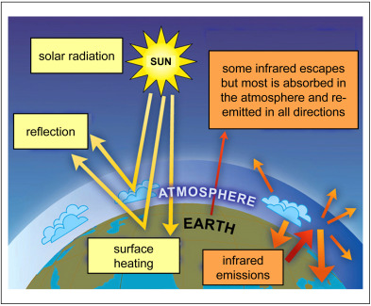

# Key Greenhouse Gases

Greenhouse gases (GHGs) are vital for the greenhouse effect, as they trap heat in the atmosphere. Here are the key greenhouse gases, along with their sources and impacts:

**Carbon Dioxide (CO₂Sources**:

Combustion of fossil fuels (coal, oil, natural gas) for energy and transportation.

Deforestation and land-use changes.

Industrial processes (e.g., cement production).

**Impact**: CO₂ is the most significant greenhouse gas emitted by human activities and is responsible for approximately three-quarters of GHG emissions. Its long atmospheric lifetime (over 100 years) contributes to long-term climate change.

**Methane (CH₄)**

**Sources**:

Agriculture (especially livestock digestion and manure management).

Landfills (decomposition of organic waste).

Natural gas production and transportation.

**Impact**: Methane is over 25 times more effective than CO₂ at trapping heat over a 100-year period, making it a potent greenhouse gas. Its atmospheric lifetime is about 12 years, but it contributes significantly to short-term warming.

**Nitrous Oxide (N₂O)**

**Sources**:

Agricultural activities (use of synthetic fertilizers).

Industrial processes.

Combustion of fossil fuels and solid waste.

**Impact**: Nitrous oxide is approximately 298 times more effective than CO₂ at trapping heat over a 100-year period. It has a long atmospheric lifetime of around 114 years.

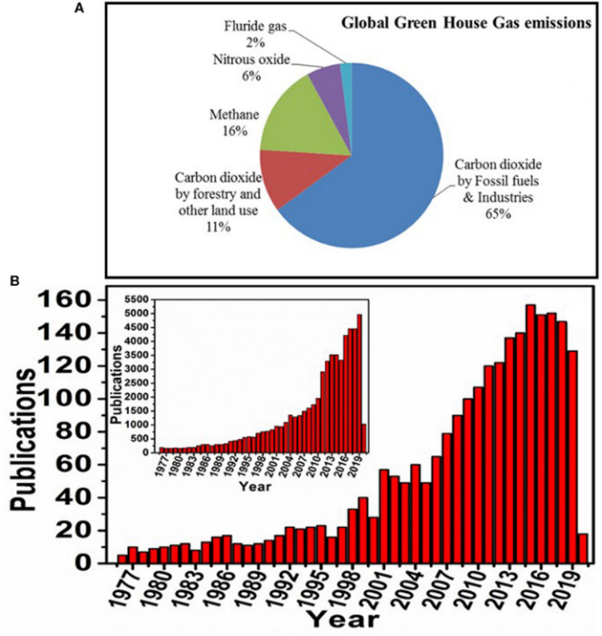

**Water Vapor (H₂O)**

**Sources**:

Evaporation from oceans, lakes, and rivers.

Transpiration from plants.

**Impact**: Water vapor is the most abundant greenhouse gas in the atmosphere, but its concentration is largely controlled by natural processes. It amplifies the effects of other greenhouse gases, contributing to the overall warming.

**Ozone (O₃)**

**Sources**:

Formed from chemical reactions between volatile organic compounds (VOCs) and nitrogen oxides (NOₓ) in the presence of sunlight.

**Impact**: Tropospheric ozone (ground-level) is a powerful greenhouse gas and contributes to warming. Stratospheric ozone protects against harmful UV radiation, but changes in its levels can impact climate.

**Hydrofluorocarbons (HFCs)**

**Sources**:

Used in refrigeration, air conditioning, and aerosol propellants.

**Impact**: HFCs are synthetic gases that can be thousands of times more effective than CO₂ in trapping heat. They have a shorter atmospheric lifetime but are still significant contributors to warming.

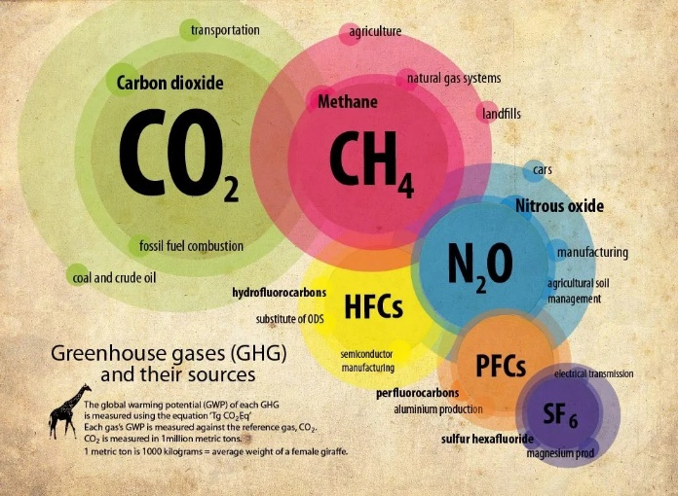

# Natural vs. Anthropogenic Effects of the Greenhouse Effect

The greenhouse effect can be categorized into two primary types: natural and anthropogenic (human-induced). Understanding the distinctions between these two effects is crucial for grasping their impacts on the climate.

**Natural Greenhouse Effect**

**Definition**:

The natural greenhouse effect is a fundamental Earth process that has existed for millions of years. It is essential for maintaining the planet’s temperature and creating a habitable environment.

**Mechanism**:

Solar radiation enters the Earth’s atmosphere and warms the surface. Greenhouse gases naturally present in the atmosphere (such as water vapor, carbon dioxide, and methane) absorb some of this heat and re-radiate it, preventing it from escaping back into space.

**Importance**:

Without the natural greenhouse effect, the Earth’s average temperature would be significantly lower (around -18°C or 0°F), making it uninhabitable for most life forms. This effect creates a stable climate that supports ecosystems and agriculture.

**Variability**:

The natural greenhouse effect is influenced by various factors, including volcanic eruptions, solar radiation variations, and natural carbon cycle processes. However, these fluctuations occur over long geological timescales.

**Anthropogenic Greenhouse Effect**

**Definition**:

The anthropogenic greenhouse effect refers to the enhancement of the natural greenhouse effect due to human activities. This has led to an increase in the concentration of greenhouse gases in the atmosphere.

**Sources**:

Major human activities contributing to this effect include:

**Burning fossil fuels** (coal, oil, and natural gas) for energy and transportation.

**Deforestation** and land-use changes, which reduce carbon sequestration.

**Industrial processes** that release greenhouse gases.

**Agriculture**, especially through livestock digestion (methane) and fertilizer use (nitrous oxide).

**Impact**:

The anthropogenic greenhouse effect is the primary driver of recent global warming and climate change. This has led to severe environmental consequences, including:

Increased global temperatures.

Rising sea levels.

More frequent and intense extreme weather events (hurricanes, droughts, floods).

Disruption of ecosystems and biodiversity loss.

**Short-term vs. Long-term Effects**:

The impacts of anthropogenic greenhouse gas emissions are felt more immediately compared to natural variations. For example, the sharp increase in CO₂ levels since the Industrial Revolution has been linked to accelerated climate change within a few decades.

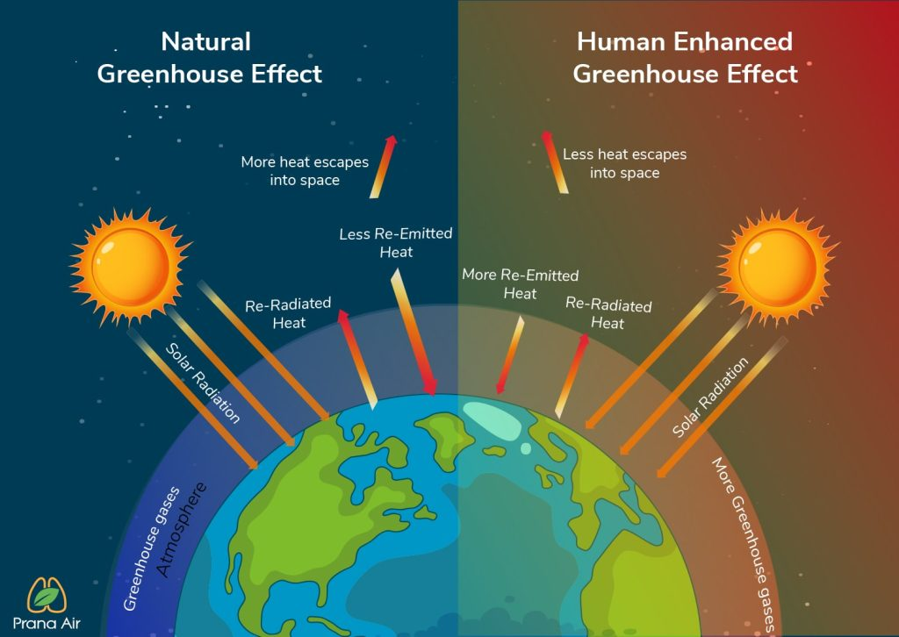

# Impacts of Climate Change

Climate change, primarily driven by the enhanced greenhouse effect due to human activities, has far-reaching consequences for the environment, society, and the economy. Here are some of the most significant impacts:

**Rising Temperatures**:

Average global temperatures have increased, leading to more frequent and intense heatwaves. This can cause heat-related illnesses and strain energy resources due to higher demand for cooling.

**Melting Ice and Rising Sea Levels**:

The warming climate contributes to the melting of glaciers and polar ice caps, resulting in rising sea levels. This threatens coastal communities with flooding and erosion, leading to displacement and loss of habitat.

**Extreme Weather Events**:

Climate change is linked to an increase in the frequency and severity of extreme weather events, such as hurricanes, droughts, floods, and wildfires. These events can cause significant damage to infrastructure, ecosystems, and human lives.

**Changes in Precipitation Patterns**:

Altered rainfall patterns can lead to both increased flooding in some areas and droughts in others. This affects water availability for drinking, agriculture, and sanitation, impacting food security.

**Impact on Ecosystems and Biodiversity**:

Many species are unable to adapt to rapidly changing climates, leading to habitat loss and extinction. Ecosystems, such as coral reefs, are particularly vulnerable to temperature changes and acidification from increased CO₂ levels.

**Ocean Acidification**:

Increased CO₂ absorption by oceans leads to acidification, affecting marine life, particularly organisms with calcium carbonate structures, like corals and shellfish. This threatens marine biodiversity and fisheries.

**Food Security Threats**:

Climate change impacts agricultural productivity through altered growing seasons, increased pests and diseases, and water scarcity. This can lead to food shortages and higher prices, exacerbating hunger and poverty.

**Public Health Risks**:

Changes in climate can exacerbate health issues, including heat-related illnesses, respiratory problems due to poor air quality, and the spread of vector-borne diseases like malaria and dengue fever.

**Economic Consequences**:

The costs of adapting to climate change and recovering from extreme weather events can strain economies. Industries such as agriculture, tourism, and insurance are particularly affected.

**Social and Political Implications**:

Climate change can exacerbate existing social inequalities and lead to resource conflicts, migration, and displacement. As certain regions become less habitable, pressures on resources may increase tensions between communities and nations.

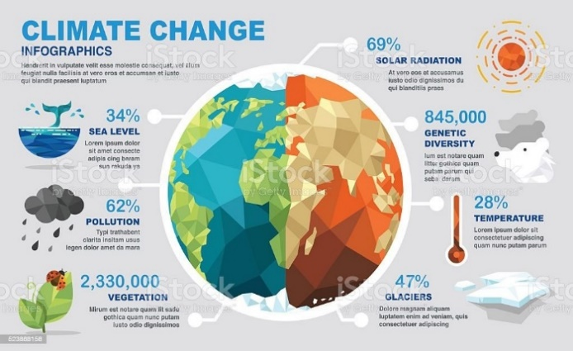

# Mitigation Strategies for the Greenhouse Effect

Mitigating the greenhouse effect involves reducing greenhouse gas emissions and enhancing natural processes that absorb carbon. Here are some key strategies:

**Transition to Renewable Energy**:

**Solar and Wind Power**: Investing in solar panels and wind turbines reduces reliance on fossil fuels, which are the largest source of carbon dioxide emissions.

**Hydropower and Geothermal Energy**: Utilizing these renewable sources can provide clean energy and lower emissions.

**Energy Efficiency**:

**Building Standards**: Implementing energy-efficient building codes and retrofitting existing structures can significantly reduce energy consumption.

**Appliance Efficiency**: Promoting the use of energy-efficient appliances and lighting (e.g., LED bulbs) can lower overall energy demand.

**Sustainable Transportation**:

**Public Transit and Non-Motorized Transport**: Expanding public transportation options and encouraging walking and cycling can reduce reliance on cars.

**Electric Vehicles (EVs)**: Promoting the use of electric and hybrid vehicles can help decrease emissions from the transportation sector.

**Carbon Capture and Storage (CCS)**:

Developing technologies that capture carbon dioxide emissions from power plants and industrial processes and store it underground can help mitigate emissions.

**Afforestation and Reforestation**:

Planting trees and restoring forests can absorb significant amounts of CO₂, helping to offset emissions. Protecting existing forests is also critical for maintaining biodiversity and carbon storage.

**Agricultural Practices**:

**Sustainable Agriculture**: Implementing practices such as crop rotation, agroforestry, and reduced tillage can enhance soil health and reduce emissions.

**Livestock Management**: Improving livestock feed efficiency and waste management can lower methane emissions from enteric fermentation and manure.

**Waste Management**:

**Reduction and Recycling**: Minimizing waste generation and increasing recycling can reduce emissions from landfills, where organic waste produces methane as it decomposes.

**Composting**: Encouraging composting of organic waste can help reduce landfill emissions and provide nutrient-rich soil amendments.

**Policy and Regulation**:

Governments can implement policies such as carbon pricing, emissions trading systems, and renewable energy incentives to encourage lower emissions.

Setting regulatory standards for emissions in key sectors (energy, transportation, industry) can drive significant reductions.

**Public Awareness and Education**:

Raising awareness about climate change and the importance of individual actions (e.g., reducing energy use, conserving water) can motivate communities to adopt sustainable practices.

**International Cooperation**:

Climate change is a global challenge requiring coordinated efforts. Participation in international agreements, such as the Paris Agreement, encourages countries to commit to emissions reductions and share technologies.

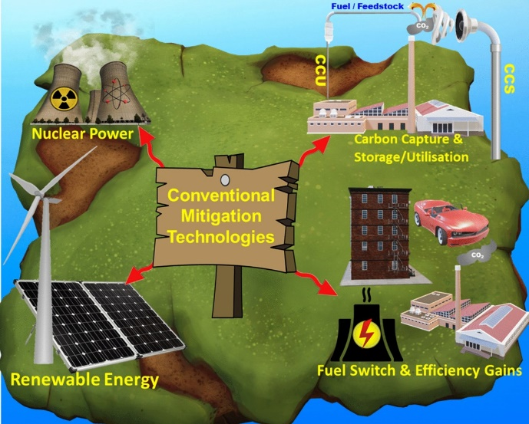

# Conclusion

The greenhouse effect is a critical natural process that sustains life on Earth by regulating the planet's temperature. However, the intensification of this effect due to human activities has led to significant climate change, with far-reaching consequences for ecosystems, human health, and global economies.

This paper has explored the mechanisms of the greenhouse effect, identified key greenhouse gases, and differentiated between natural and anthropogenic influences. The impacts of climate change—ranging from rising temperatures and extreme weather events to threats to biodiversity and food security—underscore the urgency of addressing this global challenge.

Mitigation strategies play a vital role in combating the enhanced greenhouse effect. Transitioning to renewable energy, improving energy efficiency, adopting sustainable agricultural practices, and implementing effective policies are crucial steps in reducing greenhouse gas emissions. Additionally, public awareness and international cooperation are essential to foster collective action against climate change.

In conclusion, understanding the greenhouse effect and its implications is essential for developing effective responses to climate change. By prioritizing mitigation efforts and promoting sustainable practices, we can work toward a healthier planet and a more resilient future for generations to come. Addressing the challenges posed by climate change requires commitment and collaboration at all levels, making it imperative for individuals, communities, businesses, and governments to take action now.

# REFERENCES

[1] Marco Aurelio dos Santosa, Luiz Pinguelli Rosaa, Bohdan

Sikard,Elizabeth Sikarb, Ednaldo Oliveira dos Santosa (2006), “Gross

greenhouse gas fluxes from hydro-power reservoir compared to thermo-

power plants’’, Energy Policy, 34, 481-488 [1].

[2] Arman Shehabi, Ben Walker and Eric Masanet (28 May 2014), “The

energy and greenhouse-gas implications of internet video streaming in

the United States”, Environ. Res, 1-11 [2].

[3] Bjorn Kustermann, Maximilian Kainz, and Kurt-Jurgen Hulsbergen (30

July 2007), “Modeling carbon cycles and estimation of greenhouse gas

emissions from organic and conventional farming systems’’, Renewable

Agriculture and Food Systems: 23(1); 38–52 [3].

[4] Y.S. Mohammed, A.S. Mokhtar, N. Bashir, U.U. Abdullahi, S.J. Kaku,

U. Umar (10, October 2012), “A Synopsis on the Effects of

Anthropogenic Greenhouse Gases Emissions from Power Generation

and Energy Consumption” , International Journal of Scientific and

Research Publications, ISSN 2250-3153,1-7 [4].