**F.Y.M.COM (BUSINESS MANAGEMENT)-RESEARCH AND METHODOLOGY**

**SUBMITTED TO: PROF MAMTA**

**SUBMITTED BY:-**

**NAME:- SAYED ABIYA FATIMA**

**ROLL NO:-HFPMCBM055**

**TOPIC : A STUDY ON THE CSR ACTIVITIES OF**

**HINDUSTAN UNIVERSAL LTD**

**DATE:- 11th  DECEMBER 2023**



PROJECT TITLE

A STUDY ON THE CSR ACTIVITIES OF HINDUSTAN

lUNILEVER LTD.

REPORT BY

SAYED ABIYA FATIMA

#### DECLARATION

I Ms.SAYED ABIYA FATIMA the student of FIRST YEAR ( Master in BUSINESS Management Studies) HR college. Hereby Declare that I have completed the project on ‘A STUDY ON THE CSR ACTIVITIES OF HINDUSTANUNILEVER LTD.’ The information submitted is true and original to the best of our knowledge.

SAYED ABIYA FATIMA

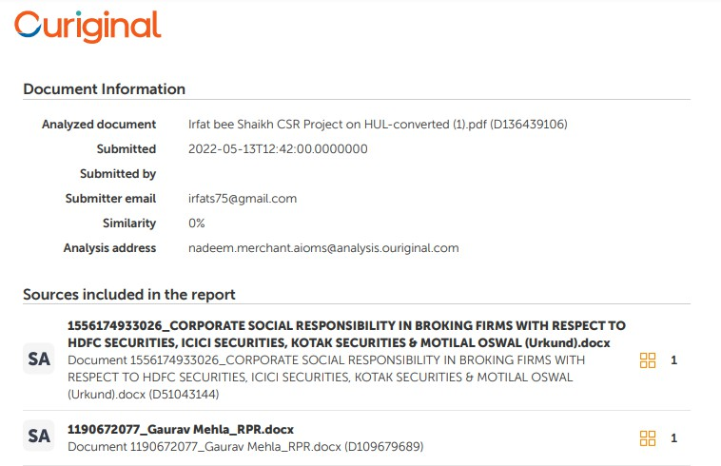

#### 

Contents

EXECUTIVE SUMMARY 10

What is CSR? 12

INTRODUCTION 13

Brands and Items of HUL 15

Origin of CSR in India 18

Doing Great by Accomplishing something useful 19

CSR Foundation 20

Principle & Purpose of CSR 22

HISTORY OF HINDUSTAN UNILEVER LTD 23

Activities Done by HUL in Past 25

Current Activities of HUL 26

Education and Scholarships 30

Healthcare 32

Sanitation 33

Rural lDevelopment. 36

LITERATURE REVIEW 37

Roles of CSR committee in HUL 39

Policy of HUL 39

CORPORATE GOVERNANCE 40

COMPANY PROFILE 41

Objective of the Research 42

Method of information/data assortment 42

Mission, Vision, Objectives 42

SWOT Analysis 43

Recommendation to HUL 46

Project Shakti 50

Conclusion 52

Reference 53

# EXECUTIVE SUMMARY

Corporate Social Responsibility (CSR) is an idea that proposes that it is the obligation of the partnerships working inside society to contribute towards financial, social and ecological improvement that makes positive effect on society at large. In spite of the fact that there is no decent definition, but the idea rotates around that reality the enterprises need to concentrate past procuring simply benefits. The term became well known during the 1960s and presently is considerable piece of business activities.

According to as Corporate Social Obligation is concerned, the Organizations Act, 2013 is a milestone regulation that made India the main country to order and evaluate CSR use. The consideration of CSR is an endeavor by the public authority to draw in the organizations with the public advancement plan. The CSR exercises in India ought not be attempted in the ordinary course of business and should be concerning any of the exercises referenced in Timetable VII of the demonstration.

The accompanying venture contains point by point data about the organization for example Hindustan Unilever. Beginning from the presentation of the FMCG business. Additionally, justification for choosing HUL as examination point in view of its exhibition.

HUL is likewise known for its Strong Distribution network in India. To additionally reinforce its dissemination in the rustic regions and to enable the neighborhood ladies, HUL sent off a Venture Shakti in 2000 in a locale in Andhra Pradesh. The thought behind this venture was to make ladies business visionaries and furnish them with miniature credit and preparing in big business the board, which would empower them to make self improvement gatherings and become immediate to-home wholesalers of HUL items. Today Task Shakti is available across 80,000 towns in 15 states and is assisting numerous oppressed ladies with procuring their business. A portion of the inspirational and initiative practices followed by the organization causes it exceptional from others and they to use to its ideal level. Discussing the Initiative advancement at HUL is tied in with building pioneers through a mix of trained schedules and cycles: an aggregate aptitude, sharpened through training, in perceiving and creating ability. HUL is frequently alluded to as a 'CEO Factory ' having offered north of 450 CEO inside the corporate world.

As the per-capita pay of India is expanding alongside the Indian populace. In this way, the future for the FMCG Organizations is splendid. To investigation the previous exhibition and the future interest of HUL, FMCG items we have

thought about following focuses:

1. We have a recorded the different FMCG product offerings of HUL.
2. We have done contender's investigation in which the piece of the pie of top FMCG organizations are examined and the portion of the overall industry of HUL'S various classifications item are broke down with correlation with its rivals.
3. Then, at that point, execution investigation is made by requiring long term monetary information from 1998-2007. The benefit and deals development is examined.
4. We have done SWOT investigation to know the danger and chances of HUL inpresent market.
5. The future open doors for FMCG items are thought about by examining the expanded per capita pay and expanded discretionary cashflow to estimate the futureinterest of HUL.

## What is CSR?

Most definitions depict CSR as an idea by which organizations incorporate social andecological worries in their business tasks and in their collaboration with their partnerson a deliberate premise. (CEC: Green Paper for Advancing an European Structure forCorporate Social Obligation)

The World Business Board for Supportable Turn of events (WBCSD) characterizes CSR as "The proceeding with responsibility by business to act morally and add to monetary improvement while working on the personal satisfaction of the work force and their families as well as of the nearby local area and society in general".

Corporate social drives are significant exercises attempted by an enterprise to help social causes and to satisfy responsibilities to corporate social obligation. The end would be that there is no unanimity on the meaning of what comprises Corporate Social Obligation (CSR). Nonetheless, what could be considered CSR is for the most part used to depict business' endeavors to accomplish reasonable results by focusing on great strategic policies and principles.

Changing Patterns in CSR from "Noble cause to Liability"

An understanding into the historical backdrop of CSR uncovers that till 1990s it was exclusively overwhelmed by the possibility of magnanimity. Considering CSR as a demonstration of generosity, organizations frequently confined themselves to onetime monetary award and didn't submit their assets for such tasks. Besides, organizations never remembered the partner while getting ready for such drives, in this way decreasing the viability and effectiveness of CSR drives. Notwithstanding, throughoutrecent years, the idea of CSR has been evolving.

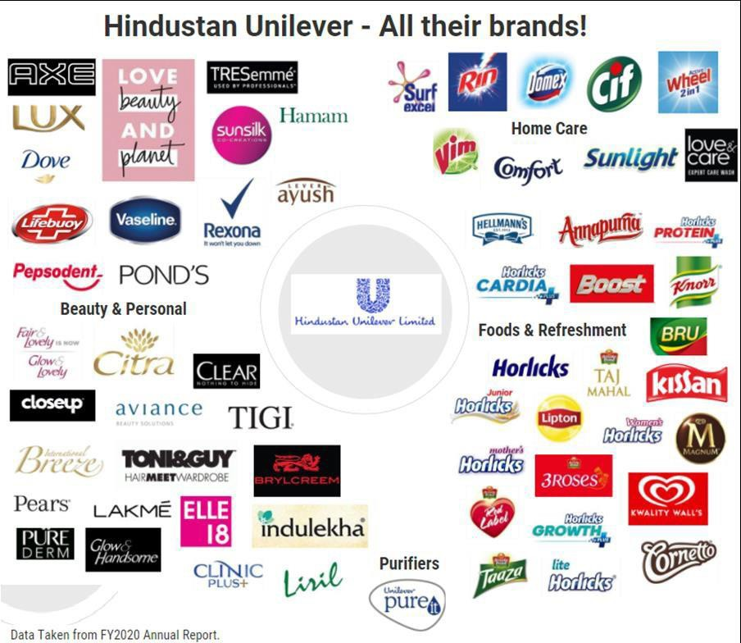

# INTRODUCTION

Hindustan Unilever Limited(HUL) is a customer merchandise organization settled in Mumbai, India. It is an auxiliary of Unilever, an English organization. Its items incorporate food sources, drinks, cleaning specialists, individual consideration items, water purifiers and other quick purchaser products.

HUL was laid out in 1931 as Hindustan Vanaspati Assembling Co. also, following a consolidation of constituent gatherings in 1956, it was renamed Hindustan Switch Restricted. The organization was renamed in June 2007 as Hindustan Unilever Restricted.

Starting at 2019, Hindustan Unilever's portfolio had 44 item marks in 14 classes. The organization has 18,000 representatives and timed deals of

₹34,619 crores in FY2017-18.

In December 2018, HUL declared its obtaining of GlaxoSmithkline's India's purchaser business for $3.8 billion in an all value consolidation manage a 1:4.39 proportion.

Anyway the joining of GSK's 3,800 representatives stayed dubious as HUL expressed there was no condition for maintenance of workers in the arrangement. In April 2020, HUL finished its consolidation with GlaxoSmithKline Shopper Medical services (GSKCH India) subsequent to finishing every legitimate technique.

Base camp

Hindustan Unilever's corporate base camp are situated at Andheri, Mumbai. The grounds is spread over 12.5 sections of land of land and houses more than 1,600 workers. A portion of the offices accessible for the representatives incorporate an odds and ends shop, a food court, a word related wellbeing place, a rec center, a games and entertainment focus and a day care focus. The Grounds is planned by Mumbai-based design firm Kapadia Partners.

The grounds got a confirmation from LEED (Administration in Energy and Ecological Plan) Gold in the 'New Development' class, by Indian Green Structure Board (IGBC), Hyderabad, under permit from the US Green Structure Gathering (USGBC)

The organization's past base camp was situated at Backbay Recovery, Mumbai at theSwitch House, where it was housed for over 46 years

Practical LIVING

Unilever sent off Practical Living Arrangement on 15 November 2010 in London,Rotterdam, New York and New Delhi all the while.

## Brands and Items of HUL

HUL is the market chief in Indian customer items with presence in more than 20 shopper classifications, for example, cleansers, tea, cleansers and shampoos among others with north of 700 million Indian buyers utilizing its items. Sixteen of HUL'sbrands included in the ACNielsen Brand Value rundown of 100 Most Confided in Brands Yearly Review (2014), completed by Brand Value, an enhancement of TheMonetary Times.

FOOD

* Annapurna salt and Atta (previously known as Kissan Annapurna)
* Bru espresso
* Brooke Bond (3 Roses, Taj Mahal, Taaza, Red Mark) tea
* Kissan squashes, ketchups, squeezes and sticks
* Lipton ice tea
* Knorr soups and dinner creators and soupy noodles
* Kwality Divider's frozen sweet
* Magnum (frozen yogurt) Horlicks (Wellbeing Drink)

HOME Consideration

* Dynamic Wheel cleanser
* Cif Cream More clean
* Solace cleansers
* Domex sanitizer/latrine more clean
* Rin cleansers and dye
* Daylight cleanser and variety care
* Surf Succeed cleanser and delicate wash
* Vim dishwash
* Wizardry - Water Saver

Individual Consideration

* Aviance Magnificence Arrangements
* Hatchet antiperspirant and aftershaving moisturizer and cleanser
* Switch Ayush Treatment ayurvedic medical services and individualconsideration items
* Worldwide breeze
* Brylcreem hair cream and hair gel
* Clear enemy of dandruff hair items
* Facility In addition to cleanser and oil
* Close Up toothpaste
* Dove skin purging and hair care range: bar, moisturizers, creams and againstperspirant antiperspirants
* Denim shaving items
* Shine and Wonderful, skin easing up cream
* Hamam
* Indulekha ayurvedic hair oil
* Lakmé magnificence items and salons
* Lifebuoy cleansers and handwash range
* Liril 2000 cleanser
* Lux cleanser, body wash and antiperspirant
* Pears cleanser, body wash
* Pepsodent toothpaste
* Lake's powders and creams
* Rexona
* Sunsilk cleanser
* Sure enemy of perspirant
* Vaseline petrol jam, healthy skin creams
* TRESemmé
* TIGI

WATER PURIFIER

* Pureit

HUL is an auxiliary of Unilever, one of the world's driving suppliers of speedy customer stock with strong area lays out more than 100 countries across the globe with yearly arrangements of €40.5 billion of each 2008. Unilever has around 52% shareholding in HUL.

Hindustan Unilever was actually assessed among the super four associations generally in the summary of "Overall Top Associations for Trailblazers" by an audit upheld by Hewitt Accomplices, in relationship with Fortune magazine and the RBL Social occasion. The association was situated number one in the Asia-Pacific area and in India.

The mission that rouses HUL's more than 15,000 laborers, including in excess of 1,400 chiefs, is to "add vitality to life". The association resolves standard issues for food, neatness, and individual thought, with brands that help with peopling feel improved, look incredible and get more out of life. It is a mission HUL bestows to its parent association, Unilever, which holds around

52 % of the worth.

Industry financial execution in the country

* Fast-moving consumer goods (FMCG) area is the fourth biggest area in the Indian economy with Family and Individual Consideration representing half of FMCG deals in India. Developing mindfulness, more straightforward access and changing ways of life have been the key development drivers for the area.
* The metropolitan portion (represents an income portion of around 40%) is thebiggest supporter of the general income created by the FMCG area in India and recorded a market size of around US$ 29.4 billion out of 2016- 17.
* Nonetheless, over the most recent couple of years, the FMCG market has developed at a quicker pace in rustic India contrasted and metropolitan India. Semi- metropolitan and provincial sections are developing at a fast speed and FMCG items represent 50% of all out rustic spending.

## Origin of CSR in India

The idea of CSR has been soaked up in Indian culture all along. Gandhi's way of thinking of trusteeship is like CSR of the cutting edge world; organizations like Goodbye and BIRLA have been assimilating the situation for social great in their activities for a really long time well before CSR become famous reason. The ardent interest in local area government assistance among the Goodbye Gathering dates to the 1860s when the organization was established by Jamshedji Goodbye. This makes sense of why almost 66% of the value of Goodbye Children, the Goodbye Gathering's advertiser organization, is held by altruistic trusts, which have made a large group of public foundations in science and innovation, clinical exploration, social investigationsand the performing expressions.

Dr.Kurien's Amul-drove Activity flood had spearheaded comprehensive development through work with dairy ranchers at grass-root level, evolving lives, improving pay, enabling ladies and simultaneously receiving rewards to the business

At Indian Oil, corporate social obligation (CSR) has been the foundation of accomplishment right from origin in the year 1964. The Partnership's targets in this key execution region are cherished in its Statement of purpose: "to assist with enhancing the personal satisfaction of the local area and safeguard biological equilibrium and legacy through a solid climate heart."

Before Corporate Social Obligation observed a spot in corporate vocabulary, it was at that point finished into the Birla Gathering's worth frameworks. As soon as the 1940s, the organizer G.D Birla embraced the trusteeship idea of the executives. Essentially expressed, this involves that the abundance that one produces, and holds is to be held as in a trust for our various partners. As to, this implies effective money management part of our benefits past business, to bring about some benefit for society.

Throughout the long term CSR has acquired significance in India as organizations are understanding the significance of putting resources into CSR for accomplishing advantages of making investor esteem, expanded income base, vital marking, functional proficiency, better admittance to capital, human and scholarly capital and lower business chances has arisen as a successful apparatus that synergizes the endeavors of Corporate and the social area towards economical development and advancement of cultural targets overall.

## Doing Great by Accomplishing something useful

HUL accepts that an association's worth is likewise in the help it renders to the local area. HUL centers around cleanliness, nourishment, upgrade of vocations, decrease of ozone harming substances and water footprint.It is likewise engaged with instruction and recovery of exceptional or oppressed youngsters, HUL has additionally answered if there should be an occurrence of public catastrophes/difficulties and contributes through different government assistance measures, latest being the help and restorationof individuals impacted by the Tidal wave debacle, in India.

HUL's Task Shakti is a country drive that objectives little towns populated by under 5000 people. Through Shakti, HUL is setting out miniature undertaking open doors forcountry ladies, along these lines working on their vocation and the way of life in rustic networks. Shakti likewise gives wellbeing and cleanliness schooling through the Shakti Vani programme.The program currently covers 15 states in India and has more than 45,000 ladies business visionaries in its overlap, connecting with 100,000 towns and straightforwardly coming to north of 3,000,000 country purchasers.

HUL additionally runs a country wellbeing program, Lifebuoy Swasthya Chetana. The program attempts to initiate reception of clean practices among country Indians and intends to cut down the frequency of looseness of the bowels. It has proactively contacted 120 million individuals in roughly 50, 676 towns across India.

Assuming that Hindustan Unilever rides the Indian corporate world, it is a direct result of being resolute in distinguishing itself with Indian goals and requirements in varyingsocial statuses.

## CSR Foundation

Hindustan Unilever foundation: In 2008 HUL appointed Maintainability to completean essential partner commitment. In view of the discoveries, a thorough and nitty gritty activity was completed with the HUL Board to make the Hindustan Unilever Establishment (HUF) as its vehicle for social interest in India. Appropriately, HUL has been set up as a Part 25 not revenue driven Organization in India. It works as an auxiliary to HUL. Water for Public Great with explicit spotlight on livelihoods was recognized as the vital push for the Establishment. The Establishment has cooperatedwith five driving worldwide associations Oxfam, Populace Administrations Global (PSI), Save the Kids, UNICEF, and the World Food Program. The Establishment mission is to work on personal satisfaction through the arrangement of cleanliness, disinfection, admittance to clean drinking water, fundamental sustenance and upgrading confidence. Past Activities embraced by establishment: Hand washing, Further developing Wellbeing and Cleanliness, Sterilization for All Water works, Further developing admittance to safe drinking water**.**

Unilever items contact the existences of north of 2 billion individuals consistently - whether that is through feeling extraordinary on the grounds that they have glossy hairand a splendid grin, keeping their homes new and clean, or by partaking in an incredible cup of tea, fulfilling dinner or solid tidbit.

A reasonable course

The mainstays of our vision set out the drawn out bearing for the organization

- wherewe need to go and how we will arrive:

* + We assist with peopling feel much better, look great and get more out of existencewith brands and administrations that are great for themselves and really great for otherpeople.
  + We will motivate individuals to make little regular moves that can amount to a major contrast for the world.
  + We will foster better approaches for carrying on with work that will permit us totwofold the size of our organization while decreasing our natural effect.

We've generally had faith in the force of our brands to work on the nature

of individuals' lives and in making the best choice. As our business develops, so do ourobligations. We perceive that worldwide difficulties, for example, environmental change concern every one of us.

Considering the more extensive effect of ouractivities is installed in our qualities and is a major piece of what our identity is.

## Principle & Purpose of CSR

Our corporate reason expresses that to succeed requires "the best expectations of corporate way of behaving towards everybody we work with, the networks we contact,and the climate on which we have an effect."

Genuinely trustworthy continuously working

Directing our tasks with uprightness and with deference for the many individuals, associations and conditions our business contacts has generally been at the core of ourcorporate obligation.

Positive effect

We plan to have a constructive outcome in numerous ways: through our brands, ourbusiness activities and connections, through willful commitments, and through the different alternate manners by which we draw in with society.

Consistent responsibility

We're additionally dedicated to constantly further developing the manner in which we deal with our ecological effects and are pursuing our more drawn out term objective oflfostering a practical business.

Setting out our yearnings

Our corporate reason sets out our yearnings in maintaining our business. It's supported by our code of business Standards which depicts the functional guidelines that everybody at Unilever keeps, any place they are on the planet.

Working with others

We need to work with providers who have values like our own and work to similarguidelines we do. Our Colleague code, adjusted to our own Code of business standards, includes ten standards covering business trustworthiness and obligations connecting with representatives, customers and the climate.

# HISTORY OF HINDUSTAN UNILEVER LTD

In the mid year of 1888, guests to the Kolkata harbor saw boxes loaded with Daylight cleanser bars, embellished with the words "Made in Britain by Siblings". With it, started a time of showcasing marked(FMCG).

Not long after followed Lifebuoy in 1895 and other renowned brands like Pears, Luxand Vim. Vanaspati was sent off in 1918 and the popular Dalda brand came to the market in 1937.

In 1931, Unilever set up its first Indian auxiliary, Hindustan Vanaspati Assembling Organization, trailed by Switch Siblings India Restricted (1933) and Joined MerchantsRestricted (1935). These three organizations converged to frame HUL in November 1956; HUL offered 10% of its value to the Indian public, being the first among the unfamiliar auxiliaries to do as such. Unilever presently holds 52.10% value in the organization. The remainder of the shareholding is disseminated among around 360,675 individual investors and monetary establishments.

The recent Brooke Bond's presence in India traces all the way back to 1900. By 1903,the organization had sent off Red Mark tea in the country. In 1912, Brooke Bond and Co. India Restricted was shaped. Brooke Bond joined the Unilever overlap in 1984 through a global securing. The recent Lipton's connections with India were produced in 1898. Unilever obtained Lipton in 1972 and in 1977 Lipton Tea (India) Restricted was integrated.

Pond's (India) Restricted had been available in India starting around 1947. It joined the Unilever overlay through a global procurement of Chesebrough Lake's USA in 1986.

Since the early years, HUL has enthusiastically answered the boost of monetary development. The development cycle has been joined by wise broadening, generally inaccordance with Indian assessments and goals.

The advancement of the Indian economy, began in 1991, obviously denoted an expression in HUL's and the Gathering's development bend. Expulsion of the administrative system permitted the organization to investigate each and every item and opportunity section, with next to no requirements on creation limit.

At the same time, liberation allowed coalitions, acquisitions and consolidations. In one of the most apparent and discussed occasions of India's corporate

history, the recent Tata Oil Mills Company (TOMCO) converged with HUL, viable from April 1, 1993. In 1996, HUL but another Tata organization, Lakme Restricted, shaped a 50:50 joint endeavor, Lakme Unilever Restricted, to advertise Lakme's market-driving beauty care products and other suitable results of both the organizations. Along these lines in 1998, Lakme Restricted offered its brands to HUL and stripped its half stake in the joint dare to the organization.

Finally, BBLIL united with HUL, with sway from January 1, 1996. The inside remaking completed in the solidification of Lakes (India) Confined (PIL) with HUL in 1998. The two associations had enormous covers in Private Things, Speciality Engineered mixtures and Wares associations, other than an ordinary flow structure beginning around 1993 for Individual Things. The two moreover had a run of the mill organization pool and a development base. The mix was done to ensure for the Social occasion, benefits from scale economies both in local and convey business areas and engage it to sponsor adventures expected for strongly developing new orders.

In January 2000, in an eminent development, the public authority decided to allow74% worth in Current Food sources to HUL, thusly beginning the divestment of government esteem in open region attempts (PSU) to private region accessories.

HUL's entry into Bread is a fundamental development of the association's wheat business. In 2002, HUL acquired the public power's extra stake in Current Food sources.In 2003, HUL acquired the Cooked Shrimp and Cleaned Crabmeat business of the Mix Social affair of Associations, a harbinger in regard added Marine Things conveys.

## Activities Done by HUL in Past

In 2007, Hindustan Unilever was appraised as the most regarded organization in India for the beyond 25 years by Business world, one of India's driving business magazines.The rating depended on an accumulation of the magazine's yearly overview of India's most rumored organizations throughout the course of recent years.

In 2010, The Organization was congratulated for getting the largest number of licensesin the year 2009 at Yearly Protected innovation Grants 2010.

In 2011, HUL was named the most inventive organization in India by Forbes and positioned sixth in the main 10 rundown of most imaginative organizations on theplanet.

In 2012, Hindustan Unilever arose as the No. 1 boss of decision for B-School understudies who will graduate in 2012. Moreover, HUL additionally held the 'Fantasy Manager' status for the third year running.

In 2014, HUL was positioned 47th in The Brand Trust Report distributed by Trust Exploration Warning. 36 HUL marks additionally highlighted in the rundown including Lux, Pigeon, Lipton, Vim, Kissan, Bru, Rexona, Close Up, Facility Besides,Lake's, Knorr and Pepsodent among others.

In 2015, According to Nielsen Grounds Track-business college review, HindustanUnilever arose among the top managers of decision for B-school understudies graduating that year. It has frequently been known as a 'Fantasy Business' for application by B-School understudies in India.

## Current Activities of HUL

1. ASHA DAAN (2020-2021)

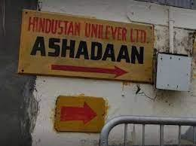

Project of INR 0.70 Cr

PROJECT Area - MUMBAI MAHARASHTRA

Asha Daan is a home in Mumbai for deserted and in an unexpected way abled youngsters, HIV-positive patients and dejected individuals. Since the origin of Asha Daan in 1976, the Organization has been caring for the support and upkeep of the premises. Whenever, there are more than 400 prisoners at Asha Daan. The venture for redevelopment of Asha Daan is supposed to initiate when the legal endorsements are gotten for development

1. SANJEEVANI (2020-2021)

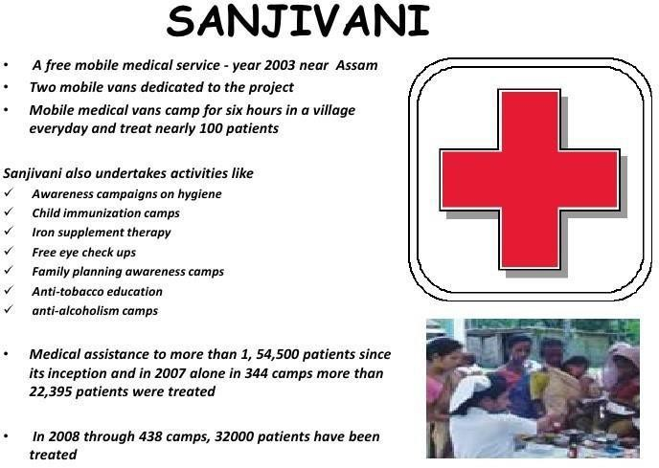

Project OF INR 0.61 Cr

PROJECT Area TINSUKIA ASSAM

The organization runs a free portable clinical benefit camp 'Sanjeevani' for the neighborhood local area close to Destine Dooma manufacturing plant in Assam. Thereare two flexible vans devoted to the task. Every vehicle has one male and one female specialist, two medical caretakers, a clinical orderly and a driver. The vans are furnished with essential packs, for example, indicative pack, pulse estimating unit, drugs and a versatile cot. In excess of 3,57,828 patients have been treated in these assistance camps since its initiation in 2003.

1. PROJECT ANKUR (2019-2020)

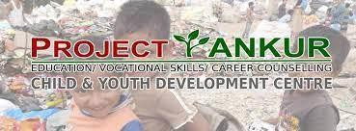

An Undertaking OF INR 0.37 CrPROJECT Area - ASSAM

Ankur project was set up in 1993 as a middle for a custom curriculum for youngsters with inabilities at Destruction Dooma in Assam. Ankur has given instructive and professional preparation to 359 kids with inabilities

The Company intends to concentrate its CSR drives and take on an organized way todeal with the accompanying center areas of mediation.

* Education

This would remember drives for the field of essential and optional schooling, formal and Non-formal proficiency programs, grants, advanced education drives, instructors preparing &skills up degree, professional preparation and other comprehensive training drives for provincial &urban youth.

* Medical care:

This would incorporate drives to help reasonable medical care, including mindfulness &preventive programs for different transferable and non- transmittable sicknesses, public &community wellbeing drives for the oppressed areas of society, tending to hunger among ladies and youngsters, arrangement of clean and safe drinking water tonetworks and so forth.

* Sterilization:

This would incorporate associations with associations having space skill in the field of giving extensive sterilization programs in schools, metropolitan ghettos and rustic regions, including social change and mindfulness towards cleanliness and disinfectionpropensity

## Education and Scholarships

Project-Glow and Lovely Foundation Projects



Project Description-The Foundation distinguishes scholastically extraordinary young ladies from monetarily provoked foundations and offers grants to the applicants. To keep up with respectability and decency the determination is finished by a board of famous characters from assorted fields.

It is a drawn out attempt of the Company to assist extraordinarily splendid young ladies with grants allowed through FAL Foundation. The objective for giving grants in the monetary year 2014-2015 is Rs.1 crore to meriting understudies.

Project-Rin Career Ready Academy

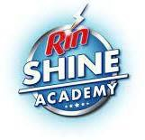

Project Description-The program expects to motivate, teach and prepare the adolescent from unassuming foundations with abilities in English preparation, Office Dressing and Interviewing. The program permits every one of the members to take the course by basically giving a missed call. Meriting people will be set up for an additional concentrated eye to eye 3-week course, intended to suit their requirements

## Healthcare

Project-Ashadaan

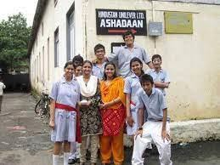

Project Depiction The drive started in 1976, when HUL upheld Mother Teresa and the Evangelists of Noble cause to set up Asha Daan, a home in Mumbai for deserted, tested kids, the HIV-positive and the desperate. Asha Daan has been set up on a 72,500-square feet plot having a place with HUL, in the core of Mumbai city. Since the initiation of Asha Daan in 1976, HUL has been caring for the support of the premises. Anytime of time, HUL deals with north of 400 newborn children, desperatepeople and HIV-positive patients at Asha Daan. It is a continuous and long haul beneficent movement. Our yearning is to give asylum to the oppressed individuals from the general public; these incorporate deserted, tested kids, the HIV positive and the desperate. While HUL supports the yearly upkeep of the premises, the Teachers oflGood cause take care of the prisoners.

## Sanitation

Project-Water Preservation Task

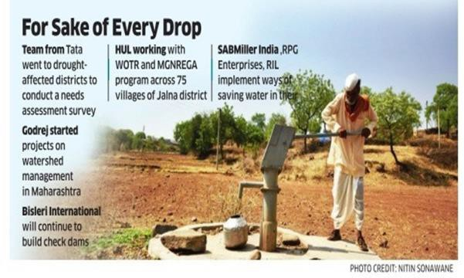

Project Portrayal Guaranteeing ecological manageability, biological equilibrium, assurance of verdure, creature government assistance, agroforestry, protection of normal assets and keeping up with nature of soil, air and water. Different drives like reusing treated emanating water for planting, introducing reverse assimilation innovation at different utilities, gathering and reusing of downpour water, capturing significant spillage and loss of water at the assembling locales prompted this decrease. In 2013, of all out 38 locales, 33 destinations became zero-release locales, an expansion of 3 destinations contrasted with that of the year before. During the year, six additional locales executed water collecting taking the absolute to 28 destinations. The endeavors have brought about making a capability of 371,000 kilo liters water for every annum. Water reaping and utilization of RO for reusing emanating water has assisted your Organization's locales with lessening new water reflection by north of 86,000 kilo liters. Your Organization's industrial facilities at Amli and Destruction Dooma embraced the water reaping and reusing model followed by the production line in Goa where water on the porch region of the plant is gathered and reused for use indifferent cycles in the production line.

Project-Swachh Aadat Swachh Bharat

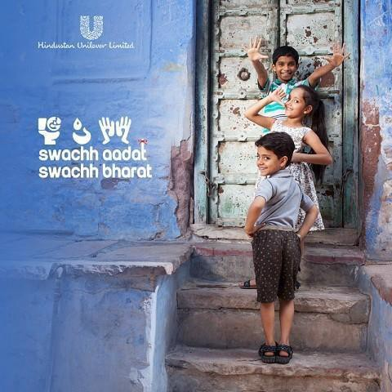

Project Hindustan Unilever Restricted (HUL) declared the send off of 'Swachh Aadat, Swachh Bharat' program in accordance with Legislature of India's Swachh Bharat Abhiyan (Clean India Mission) to advance great wellbeing and cleanliness rehearses. Given the size of difficulties that India faces in the space of water, sterilization and cleanliness (WASH), this program is a work to assist India with understanding the objectives of Clean India Mission by 2019.

This is a first-of-its-sort multi-brand conduct change program synergizing the endeavors of HUL's driving brands Lifebuoy, Domex and Pureit. The Swachh Aadat, Swachh Bharat program has two key pushes: An on-ground conduct change model and a broad communications mission to drive commitment and mindfulness. To makea country of a 'Playing Billion'.

Destroying appetite, neediness and unhealthiness; advancing medical services including preventive medical care and disinfection including commitment to the 'Swachh Bharat Kosh' set up by the Focal Government for the advancement

Killing yearning, destitution and hunger; advancing medical services including preventive medical care and disinfection including commitment to the 'Swachh Bharat Kosh' set up by the Focal Government for the advancement of the water

The venture is in accordance with Legislature of India's Swachh Bharat Abhiyan to advance great wellbeing and cleanliness practices and means to accomplish the Swachh Bharat objectives by 2019. The objective is to promote the reception of 3 clean propensities:

1. Wash hands before suppers and after poop,
2. Adopt safe drinking water rehearses and
3. Stop open crap.

Haath, Munh Aur Bum is a very much planned whoop to enhance reality with regards to unhygienic propensities that are pervasive in the public arena. Ends up on the off chance that left to the children, cleanliness counsel can end up being far more tomfoolery! Through this new "Haath, Munh Aur Bum" crusade, kids transform into problem solvers and proliferate the reception of three Swachh Aadats. The reception of the three Swachh Aadats will go quite far in achieving the ultimate objective of Swachh Bharat - a clean and ailment free country. Except if we change and embrace Swachh Aadats, Swachh Bharat won't be a reality. Haath, Munh Aur Bum lets you know how to get it done. #Swachh Aadat Swachh Bharat.

The mission was sent off by film entertainer Kajol Devgan, the recently delegatedbacking minister for the drive.

**Rural Development.**

Project-Prabhat

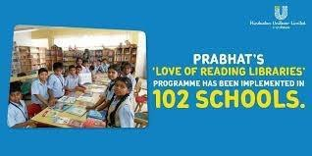

Project Portrayal Prabhat (First light) is a program which centers around networks around organization industrial facilities. The areas of mediation are Wellbeing and Cleanliness, raising vocations and rationing water. The Water Preservation drive is driven by Hindustan Unilever Establishment, a completely claimed auxiliary of HUL which checks out at further developing the water security in chose locales. The Business program means to engage the present youth by giving them employable abilities accordingly upgrading their vocations. HUL has teamed up with NGOs to carry out the undertaking. The task means to make a positive social effect in the existences of 1 million individuals. It is a rustic advancement project.

Kappagam:

Energized by Ankur's prosperity, Kappagam ("cover"), the second place for a specialized curriculum of tested youngsters, was set up in 1998 on HUL Manors in South India. It has 17 youngsters. The focal point of Kappagam is equivalent to that oflAnkur.

Anbagam:

One more day care focus, Anbagam ("safe house of adoration"), has been begun in 2003 likewise in the South India Manors. It deals with 11 youngsters. Other than clinical consideration and suppers, they also are being shown abilities with the end goal that they can become confident and rudimentary investigations.

# LITERATURE REVIEW

Teach for India: 'One day all youngsters will achieve phenomenal training'- a dream that characterizes Educate for India, an Educate to Lead project that supports youthfulschool graduates and experts to require up two years of full- time showing meetings in under resourced schools. To give quality training to all, instruct for India right now works in 5 primary urban areas of India- Mumbai, Delhi, Pune, Hyderabad and Chennai and is exceptional for certain 700 Colleagues who are running after destroying the high imbalance present in Indian school system.

Hopkins, 2004: The creator centers in his conversations around corporate social obligation on the biggest organizations, the transnational companies (TNCs). As a result of their frequently gigantic size, choices about the area of ventures, creation andinnovation by TNCs not just impact the dispersion of element blessings, prominently of capital, gifted work and information, between the nations wherein they run their exercises, yet additionally accept urgent significance for their political and social outcomes.

Jayati Sarkar, 2015: The paper contends that despite the potential financial costs that might go with ordered CSR, the arrangements of the new Demonstration are planned insightfully to adjust the goals of the partnership and its investors from one perspective and that of the general public and its partners on the other

The National Wildlife Federation: NGO is attempting to protect the rich biodiversity existing on our earth today NWF is one of the biggest non- benefit associations on the planet working for the said cause. However its essential base situates at the USA, it has coordinated efforts with a few other in like manner groups and nearby associations working on untamed life issues on grass root level. The association was established byJay Dear in 1936 and right now has 4 million dynamic individuals taking an interest in it in different projects and drives.

Kang, 2008: Tracked down proof of overflow of reputational punishments between firms. Among the examinations on unambiguous components of CSR, the natural aspect is by all accounts the most often analyzed two factors that might make sense of the developing revenue in unambiguous elements of CSR.

Olar, 2012: This paper looks at the subject of quantifiability of the effect of CorporateSocial Obligation on Business Execution. It begins with depicting more up to date patterns of estimating business execution, demonstrating the

way that one can notice ashift from the old style transient examination with specific spotlight on pointers like investor worth, income and piece of the pie toward considering additionally delicate markers, for example, worker and consumer loyalty that add to the drawn out outcomeof an organization.

## Roles of CSR committee in HUL

The job of CSR Committee as per the following:

* Forming and prescribing to the Board the CSR Strategy and exercises to beattempted by the Organization
* Prescribing how much consumption to be caused on CSR exercises of theorganization
* Assessing the presentation of the Organization in area of CSR
* Giving outer and autonomous oversight and direction on the ecological andsocial effect of how the Organization leads its business
* Observing CSR Strategy of the Organization now and again
* Observing the execution of the CSR tasks or projects or exercises embraced bythe Organization

## Policy of HUL

HUL is resolved to work and develop its business in a socially mindful manner. Our vision is to develop our business while lessening the ecological effect of our tasks andexpanding our positive social effect.

This arrangement frames our Corporate Social Obligation plan. Our point is to accomplish capable development and we will motivate to rejuvenate this by empowering individuals to make little ordinary moves that will amount to have amajor effect.

We have embraced Unilever Maintainable Living Arrangement (USLP) which adds to exercises recorded in the Timetable VII of Segment 135 of the Organizations Act, 2013. The USLP has three worldwide objectives in particular assist in excess of a billion group with making a move to work on their wellbeing of individuals as we develop our business.

Also, considering India as a water scant locale and the water accessibility is supposed to go down further, HUL has recognized water as a critical area of mediation. We will concentrate around here by making limits in monitoring water through huge interests in association with pertinent partners with the target of water protection.

# CORPORATE GOVERNANCE

We follow organized administration strategies to screen CSR exercises. Our CSR Strategy is represented by the Governing body of the Organization. The Load up has established a CSR Advisory group containing an Autonomous Seat and most Free Chiefs to screen the Strategy and the projects every once in a while.

The exercises depicted in Annexure an added hereto are covered under Timetable VII (as corrected) of the Demonstration that rundowns down allowed exercises that comprise such exercises. These exercises embraced by the Organization are not supposed to prompt any extra excess past what might gather to the Organization over ordinary tasks.

# COMPANY PROFILE

* 1. **Name of the organization:** HINDUSTAN UNILEVER LTD
  2. **Form of ownership:** Public limited company

#### SHAREHOLDING PATTERN (%)

|  |  |
| --- | --- |
| **Promoters** | **67.20** |
| **FIs & Local Mfs** | **5.66** |
| **FPIs** | **13.26** |
| **Public**  **and others** | **13.88** |

## Objective of the Research

* Investigation of Organization Profile of HINDUSTAN UNILEVER Ltd.
* Investigation of General Administration practices of HINDUSTANUNILEVER Ltd.
* Proposing reasonable measures for upgrading the effect of CSR exercises did byHUL

## Method of information/data assortment

Research Approach: Secondary Data Contact Strategy: N.A

## Mission, Vision, Objectives

* Mission: To add Imperativeness to life. We meet consistently needs for sustenance, cleanliness and individual consideration with brands that assist withpeopling feel quite a bit better and get more out of life.
* Vision: We work to make a superior future consistently.
* Objectives: To assist in excess of billion individuals with making a move to work on their wellbeing and prosperity. and not exclusively to regard common liberties yet to propel them across all region of the business effectively.

## SWOT Analysis

Strength

HUL partakes in a considerable appropriation network covering north of 3400 merchants and 16 million outlets. This assists them with keeping up with weighty volumes, and henceforth, fill the racks of most outlets. The new deals association named 'One HUL' brings "Family and Individual Consideration" and food varieties dissemination networks together, accordingly adjusting every one of the units towards the shared objective of making progress. HUL has been ceaselessly ready to develop at a rate more than development rate for FMCG Area, accordingly reaffirming its future fortification in Indian market.

Project Shakti (Discussed later in Detail)- Provincial India is spread across 627,000 towns and has a genuine conveyance challenge for FMCG Cos. HUL has thought of a one of a kind and fruitful drive wherein the ladies from the country area market HUL items, and henceforth, can arrive at a similar frequency as of the everyday person in town. Aside from item come to, the drive additionally makes brand mindfulness among the lower layers of society. This has achieved marvelous outcomes.

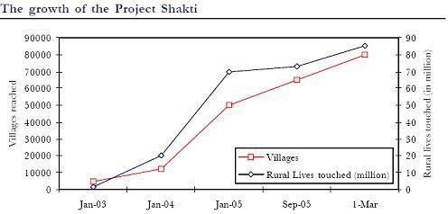

Weakness of HUL

HUL's market predominance, beginning from its broad reach and solid brand presence, permitted it to raise the costs even as unrefined substances were getting less expensive. Subsequently, however the volumes diminished, the edges developed, and organization had the option to acquire more benefits. In any case, higher edges pulled in contest in areas of tasks. HUL's

methodology stayed centered around making powermarks and procuring higher edges. It was not left with some other choice but rather to take a stab at reducing down the expenses to safeguard volumes, in the event that not increment it.

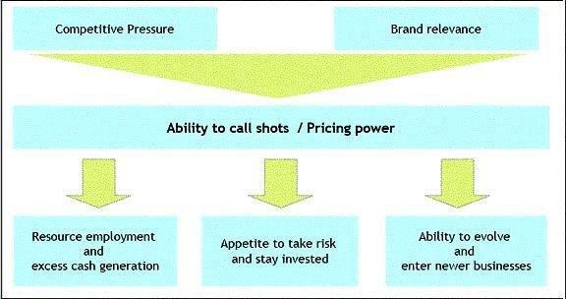

As displayed in above figure, the critical differentiators for a FMCG player are capacity to call shots and valuing power, and HUL has shown shortcoming over boththese elements.

HUL's shortcoming was its failure to change its techniques with perfect timing. They went on with the normal, worn out technique which assisted them with acquiring benefits however were not authentic in this changed climate. HUL's hazard avoidance and market nearsightedness prompted stagnation of business, and fierceness of contest constrained it into a guarded mode. Absence of estimating power in center business and nonappearance of development drivers have placed HUL on a deflationary mode.

Opportunities

India is one of the world's biggest maker of FMCG merchandise however its commodities are miniscule when contrasted with creation. However Indian Cos. have been going worldwide, their center is more towards Asian nations on account of the comparative inclinations. HUL is one of the top organizations trading FMCG products from India. A development of skylines towards an ever increasing number of nations would assist HUL with developing its buyer base and consequently the incomes

Opportunity in Food Area - The approach of current exchange has opened up

more prominent open doors for HUL to enhance its image and strength its food division. It could take a gander at presenting items from its folks stable like margarines and could likewise take a gander at growing its Knorr scope of items

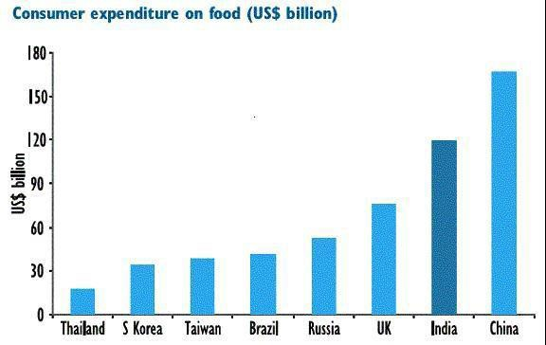

All around set to exploit future FMCG Development - HUL connect 80% of 207 million families in the country through different brands. It has a very clear cut itemportfolio spread across numerous item classifications.

Entrance levels for some, significant classifications like skin-cream (22%), cleanser (38%), toothpaste (48%) and handled food sources, keep on leftover low contributionshowever extraordinary learning experiences items.

Threats

ITC has diminished its reliance on the cigarettes business - Commitment of the centerbusiness in incomes has descended from 87% in FY99 to 70% in FY'05. Over a time of five years, ITC has expanded its presence into regions like food varieties, retailing, lodgings, good tidings, agribusiness, paper, and so forth. These are organizations that can give it development driving force over the long haul. With ITC picking up speed in every one of these organizations, it is transforming into a buyer stone monument, and subsequently, the best danger to HUL's Business.

SSKI India has proceeded to say, "We keep up with Out entertainer on ITC with a value focus of Rs. 2200, while our Under entertainer approach HUL stays unaltered(value focus of Rs. 160)."

## Recommendation to HUL

Market Methodology: As we have seen before that HUL's shortcoming was its powerlessness to change its techniques brilliantly. They went on with the standard, worn out technique which assisted them with acquiring benefits yet were not certifiable in this changed climate. HUL's hazard avoidance and market nearsightedness prompted stagnation of business, and fierceness of contest constrained it into a protective mode. Absence of estimating power in center business and nonattendance of development drivers have placed HUL on a deflationary mode.

So as indicated by us, HUL needs to anticipate the market in a more effective manner that it is following till yet. Since the market circumstances has changed, the organization (HUL) which was once the market chief and had forceful market approaches is presently safeguarding itself among the contenders like ITC, Dabur, Marico, Cadbury and so on. The contenders cover all the product offering of HUL, so the market system must be proficient to recapture the market strength. In addition point with HUL here is, it has long confidence of buyers in India since it is the most established among the competitors.

If there should be an occurrence of risk taking capacity, HUL has been a gamble averter. Been a major association, with such great specialists in its administration, it can plan new approaches and begin confronting gambles as opposed to deflecting it. Indeed, the opposition is incensed yet hazard avoidance isn't the way which will prompt be the market chief. Estimating strategy should be possible appropriately to guarantee overall revenue.

At HUL, the interest in notices have expanded which is supposed to show positivechanges in the turnover of the organization.

Future Possibilities: India is a quick non-industrial nation with a colossal populace whose for every capita pay is developing quickly and there is immense chance for FMCG organizations.

The potential open doors are as per the following:

* Expanding per capita pay is driving FMCG development in India
* India's consuming class is developing quickly
* Changing utilization design: Per capita pay of Indian client is expanding and FMCG items are somewhat flexible in nature henceforth the normal deal ought to increment.

#### CATEGORY WISE THE SALE GROWTH OF FMCG SECTOR OF THEHINDUSTAN UNILEVER LTD IN INDIA

|  |  |
| --- | --- |
| **CATEGORY** | **%AGE GROWTH** |
| Soaps & Detergents | 19.3 |
| Personal Products | 22.4 |
| Ice Cream | 15.7 |
| Processed Foods | 13.7 |
| Beverages | 13.6 |
| Others | 19.4 |

25

22.4

20

19.3

19.4

15.7

15

13.7

13.6

10

5

0

Soaps &

personal

Ice cream Processed Beverages

Others

detergents % G products F DIFFERENT FMCG

foods

##### (Above graph shows the data of MAR Quarter %growth of different

##### products oflHUL)

With the assistance of the diagrams given above, we can investigate these realities:

The Indian working class is flourishing with around 70 million families acquiring anyplace among Rs80,000 and Rs 18 lakh for each annum. These involve34% of the somewhat more than 200 million working class families.

Indian Buyer is not generally Cost Fixated, with the ascent in Per- capita Pay; a shopper is prepared to address greater expenses for the better quality items.

Indian buyer products market is supposed to reach $400 billion

Higher dispensable livelihoods, there is cash left over for everyday items evensubsequent to spending on durables**.**

According to the Future Plans of HUL:

HUL has drawn up an exhaustive arrangement to grow its portfolio in the spaceof Medical care and Contraceptives.

Synthetic compounds business (enveloping Flavors, Aromas and other Specialty Synthetics), as well as a few non-FMCG send out organizations like Thermometers and Mushrooms.

HUL has been energizing its country conveyance frameworks and has sent off low unit value variations of its well known brands to attract new clients in the provincial regions

## Project Shakti

With the metropolitan market immersed, FMCG organizations are currently focusing on the provincial business sectors. Disregarding the pay unevenness among metropolitan and country India, provincial holds extraordinary potential since 70% of India's populace lives there. Because of the new government estimates like waiver of advances, public rustic work ensure conspire and expanding least help cost, discretionary cashflow in country India has been quickly expanding. Be that as it may, country markets present their own arrangements of issues. These incorporate unfortunate framework, scattered settlements, absence of training and a for all intents and purposes nonexistent mechanism for correspondence. Besides, retailers can't be available in every one of the focuses as a considerable lot of them are little to such an extent that it makes them monetarily impractical.

Hindustan Unilever Restricted (HUL) to tap this market considered Undertaking Shakti. This venture was begun in 2001 determined to expand the organization's country conveyance reach as well as giving provincial ladies pay creating potential open doors. Here the social objectives are accomplishing business objectives.

The enlistment of a Shakti Business person or Shakti Amma (SA) starts with the chiefs of HUL distinguishing the uncovered town. The delegate of the organization meets the panchayat and the town head and recognize the one who they accept will be reasonable as a SA. Subsequent to preparing she is approached to set up Rs 20,000 asventure which is utilized to purchase items for selling. The items are then offered house to house or through frivolous shops at home. On a normal a Shakti Amma makes a 10% edge on the items she sells

A drive which assists support With projecting Shakti is the Shakti Vani program. Under this program, prepared communicators visit schools and town assemblies to drive messages on sterilization, great cleanliness practices and ladies strengthening. This fills in as a country correspondence vehicle and helps the SA in their deals.

The fundamental benefit of the Shakti program for HUL is having more feet on the ground. Shakti Ammas can reach remote, which were financially unviable for the organization to tap all alone, other than being a brand diplomat for the organization. Also, the organization has prepared buyers in the SAs who become clients of the itemsother than selling them.Even though the organization has been effective in the drive and has been increasing, it deals with issues every once in a while for which it concocts creative

arrangements. For instance, an issue looked by HUL was that the SAs were more disposed to remain at home and sell as opposed to going from one way to another since there is a shame connected to coordinate selling. Additionally, men were not responsible to go to a lady's home and purchase items. The organization

countered this issue by facilitating Shakti Days. Here a counterfeit commercial centerwas made with music and advancement and the women had the option to sell their items in a couple of hours without experiencing any shame or inclination.

This model has been the development driver for HUL and as of now about portion of HUL's FMCG deals come from rustic business sectors. The Shakti network toward the end was 45,000 Ammas covering 100,000+ towns across

15 states arriving at 3 m homes. The drawn out point of the organization is to have 100,000 Ammas covering 500,000 towns and contacting 600 m individuals. We feel that with this drive, HUL has been fruitful in keeping up with its dissemination arrive at advantage over its rivals. This program will assist with furnishing HUL with a developing client base which will help the organization for quite a long time into the future.

## Conclusion

Hindustan Unilever ltd. Is a main FMCG organization in India and from last three successive years has shown sped up development in FMCG portfolio. Clients in India are additionally spending more in FMCG as their way of life is developing. HUL has put itself effectively in the place of market pioneer in FMCG items. However there was a few defeat in deals and benefit of the organization in the start of this decade yet after that HUL has shown extensive ascent in the two deals and benefit. The fate of the organization is additionally looking brilliant as FMCG market in India is as yet extending thus we can securely infer that HUL will actually want to get its main situation in FMCG item.• Its prosperity is to a great extent credited to its corporatemethodologies and the administration choice.

HUL has likewise begun project SHAKTI that has given it direct reach to provincial market. This might be viewed as a progressive advance since the metropolitan market is arriving at its immersion level and there is an enormous degree investigating rustic market. This will likewise be useful expanding its portion of the overall industry as well as battle rivalry.

* They additionally naturally attempt to do least misfortune/hurt because of theircreation processes.
* It reliably makes a point to have innovations update and interaction consenting every one of the regulations and guidelines subsequently ensure that its moral obligations are met with.
  + As we look at the Corporate Social obligation exercises of the organization to its unfriendly impacts which were brought about by various or indiscreet activities taken by the organization, the positive CSR strategies overweight the equilibrium as the organization is arranging and undertaking more ventures onthe most proficient method to work on their CSR

## Reference

<http://www.hul.co.in/citizen_lever/Communication_of_progress_08.pdf> Full details at: <http://www.hul.co.in/citizen_lever/happy_homes.asp>

<http://www.hul.co.in/citizen_lever/fair_lovely.asp> <http://www.hul.co.in/citizen_lever/lifebuoy_chetna.asp> [www.hul.co.in/citizen_lever/project_shakti.asp](http://www.hul.co.in/citizen_lever/project_shakti.asp) <http://www.hul.co.in/citizen_lever/greening.asp>

Wikipedia: <http://en.wikipedia.org/wiki/Hindustan_Unilever> Coolavenues, [http://www.coolavenues.com](http://www.coolavenues.com/)

Authorstream, [http://www.authorstream.com](http://www.authorstream.com/)