

HR College of Commerce & Economics (Year – ‘24)

# A PROJECT REPORT ON

**Impact of Employee Engagement on the Performance of Employee and Organization**

## SYMCOM (Banking and Finance)

**Roll No - HSPMCBF012**

## SUBMITTED BY : RADHIKAA JAGDISH DABRAI

HR College of Commerce & Economics Vidyasagar Principal K.M. Kundnani Chowk, 123, Dinshaw Vacha Rd, Churchgate, Mumbai, Maharashtra 400020

TABLE OF CONTENTS

|  |  |  |
| --- | --- | --- |
| **Sr. No** | **Title** | **Pg. No** |
| 1 | ABSTRACT | 03 |
| 2 | RESEARCH METHODOLOGY | 03 |
| 3 | INTRODUCTION | 04 |
| 4 | RESEARCH PROBLEM | 05 |
| 5 | RATIONAL OF RESEARCH | 05 |
| 6 | OBJECTIVES OF STUDY | 05 |
| 7 | HYPOTHESIS | 06 |
| 8 | NEED OF STUDY | 06 |
| 9 | REVIEW OF LITERATURE | 07 |
| 10 | SECONDARY DATA | 09 |
| 11 | PRIMARY DATA & ANALYSIS | 13 |
| 12 | FINDINGS/LIMITATIONS/SUGGESTIONS | 20 |
| 13 | CONCLUSION | 22 |
| 14 | BIBLIOGRAPHY | 23 |
| 15 | APPENDIX | 24 |

## Abstract

Employee Engagement refers the level of commitment and involvement of the employees towards their organization and its values.

The aim of this study is to study the impact of employee engagement on employee performance and also to study the factors affecting employee engagement. The factors are performance of the company, work life balance, organizational events, communication, training, leadership, grievance procedure, career development and other non-monetary factors.

The research design of the study is causal and descriptive in nature. The data are collected through structured questionnaire and the sample size is 55 employees. The result of the study discovered that employees are satisfied with overall performance of the company. All the factors of Employee engagement are affecting the employee performance in the positive way at the organization.

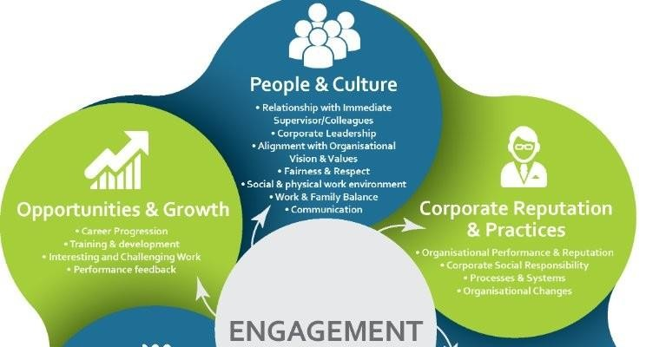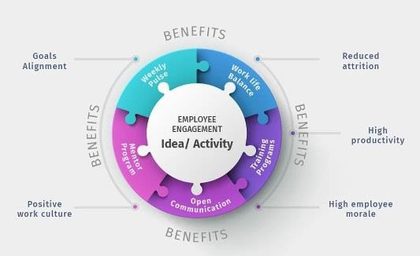

## Research Methodology

The methodological aspects used for information is done through the structured questionnaire. In this study the population targeted is employees of Consulting organization. For collecting the response from the employees convenience sampling method which is a classification of Nonprobability sampling method is used, and the selected sample size is 55 employees. Questionnaire is used as the tool for data collection. Questionnaire is a self-report data collection instrument that each research participant fills out as part of a research study. Primary and Secondary both sources are used for data collection in this study. A broad range of instruments were used for measuring the impact of Employee engagement. It is related to overall Employee engagement which rate item based on 5 points. A rating scale from 1 (strongly disagree) to 5 (strongly agree) was used. 1= strongly disagree, 2= disagree, 3=neutral, 4= agree, 5= strongly agree and a yes/no/neutral options were given for other questions.

## Introduction

Employee engagement is a vast concept and has a wide area of interpretation and thus each organisation interprets the meaning of employee engagement on its own terms, knowledge, and culture.

Employee engagement is a relationship between the employee and the enterprise, an engaged employee is the one who is entirely engrossed in and ardent about their work and so takes positive steps to further the organisation's prestige and interests. The construct employee engagement is built on the foundation of concepts like organisation citizenship behaviour, employee commitment, and job satisfaction.

Though it relates to and besets these concepts, but employee engagement is broader

in scope.

In today's scenario organisations have started looking out for ways more stronger than only monetary incentives to keep employees involved and work towards goals, hence comes the role of employee engagement which helps the employees realise they are a part of the organisation and thus employees are emotionally connected to their organization and highly involved in their job with a great enthusiasm for the success of their employer, going an extra mile beyond the employment contractual agreement assuming all their efforts leads to the growth of what already belongs to them.

Since Employee engagement is a fairly novel concept thus a lot of measurement metrics are not present to find out direct relationship between employee engagement and its impact on the performance of employees thus the purpose of this paper is to find out an Impact of employee engagement on the performance of the employees.

Employee engagement is a part of employee motivation activity which is assumed to lead the employees to enthusiastic work dealing and achieving organisational objectives. It is absolutely important to keep the employees motivated to work and complete their jobs with utmost dedication and reach the goals.

There is no general or universally accepted approach to describe the terminology employee engagement. It has various aspects to it like a relationship between employee and organisation, belongingness of employees towards their work and the employer, leadership consideration of workers is the main area of consideration for carrying out the work effectively and efficiently.

## Research Problem: How does Employee Engagement impact the Employee’s and Organization’s Performance and Productivity?

**Rationale of Research:** The concept of employee engagement has appeared fairly recently in the literature. Because of its relative infancy, there is a lack of information about the relationship between known employee engagement factors and job satisfaction. Not only is there a lack of information, but there are also discrepancies between studies that cloud our understanding of the relationships of the aforementioned variables. Because of this lack of information, there exist missed opportunities for growth, development, and change that could essentially affect the performance of an organization



## Objectives of the Study

* The objective of this study is to understand the benefits of employee engagement as far as personal, professional development is concerned and how employee engagement creates a win-win situation for the companies and employees in terms of better performance.
* To identify the key drivers of employee engagement and their predictability of the concept.
* The importance of non-financial factors in motivating the employees and building higher levels of employee engagement.

## Hypothesis

### The Null and Alternative Hypotheses

**The null hypothesis H0**, is where you assume that the observations are statistically independent i.e. no difference in the populations you are testing. If the null hypothesis is true, it suggests that any changes witnessed in an experiment are because of random chance and not because of changes made to variables in the experiment

**The alternative hypothesis H1,** is a theory that the observations are related (not independent) in some way. We only adopt the alternative hypothesis if we have rejected the null hypothesis.

## Given below is the hypothesis for the study undertaken

**H0:** Employee Engagement has no Impact on the performance of the Employees and the Organization

**H1:** Employee Engagement has an Impact on the performance of Employees and the Organization

**H0**: Non-financial factors do not play a role in motivating the employees and building higher levels of employee engagement.

**H1**: Non-financial factors play a major role in motivating the employees and

building higher levels of employee engagement.

**H0:** Employees do not prefer to work in organizations with higher levels of employee engagement

**H1:** Employees prefer to work in organizations with higher levels of employee engagement

## Need of Study

This will help to reduce the attrition and to increase the productivity and profit. It will examine and focus on how to make the employee more engaged and committed towards the organizational growth.

## Harvard business review (2013)

### Analysis

Employee engagement has become a high business priority among senior executives.in the rapidly growing economy and cutthroat competition, the management realizes that having highly engaged employees is utmost necessary for improving the performance and bringing out innovative, creative ideas, increasing productivity and at the same time reducing the cost of retention, acquisition in a competitive labour market.

The study has divided the organisations into high prioritizers and low prioritizers, high prioritizers are those who give high priority to employee engagement in organisations and low prioritizers are those who place employee engagement at a lower level in the organisation. The top management reviews when analysed resulted in an assumption of having high employee engagement in their organisation but the middle-level management to whom the employees are more proximal have a view of low employee engagement in their organisation. This shows that senior executives in spite of being in favour and understanding the importance of employee engagement are not able to incorporate the same in their organisation.

The study also reveals that among the factors which are most likely to bring success in the organisation are -High level of customer service (80%), High level of employee engagement (71%) Strong executive leadership (71%), Effective communication (73%), Efficient productivity (68%), Ability to innovate (59%) and Strong sales and marketing capabilities (58%). Thus, employee engagement holding 71% importance in the success of an enterprise being the 3rd most important factor in the success of the organisation. The study also suggests some best practices in tying the employee engagement activities to business performance. The author measures the impact of employee engagement on customer satisfaction and employee satisfaction.

### Swanlatha and Suresh krishna (2013) Analysis

According to Swanlatha and Suresh krishna (2013) there are three factors which foster employee engagement and productivity

**Achievement**: The vast majority of employees want to achieve something important and meaningful at work. They want to learn and develop their skills and capabilities and they want to be rewarded and recognized for their efforts;

**Camaraderie**: Employees enjoy working productively with others while developing healthy interpersonal relationships. How manager interact with his/her team is very important in motivating employees to go above and beyond;

**Equity**: Employees want to be treated fairly when it comes to pay and benefits, daily treatment given to them and physical and psychological safety. When these basic needs are met, employees were highly engaged and enthusiastic at work.

Performance orientation mediates the relationships between intention to quit and organizational citizenship as per study. Engagement has the potential to significantly affect employee productivity loyalty and retention as well as a key link to customer satisfaction.

The study suggests that a performance-oriented culture mediates the relationship between the intention to quit and organizational citizenship. This implies that when employees feel engaged and motivated, they are more likely to exhibit positive behaviors that benefit the organization beyond their basic job requirements.

Engagement, as highlighted in the study, has far-reaching implications. It impacts not only employee productivity but also influences their loyalty and retention within the organization. Moreover, it serves as a crucial link to customer satisfaction, indicating its ripple effect across various facets of business success.

In conclusion, fostering a work environment that addresses achievement, camaraderie, and equity is vital for enhancing employee engagement and, in turn, positively impacting productivity, loyalty, retention, and customer satisfaction.

## Secondary Data

### Drivers of Engagement

There are a variety of factors that can drive or inhibit employee engagement. Determining which areas to focus on to improve engagement will help you craft the right strategies to engage employees in your organization.

Here are some of the drivers of employee engagement that seem to have the greatest impact:

* **Leadership:** Leaders affect employee engagement the most. A leader’s ability to build authentic relationships with employees can have a significant impact on employee engagement. Strong leaders who care about employees will be committed to creating a satisfying work environment. Because of this, they will be more likely to engage employees.
* **Culture:** Organizational culture is important because it is the primary factor for determining how well an organization executes on every other aspect of its performance. Culture may also be the most important competitive advantage because it is so difficult to copy.

The 2021 Job Seeker Nation Report indicates that, despite the increase in remote work over the course of the pandemic, company culture has remained very important for employees. According to the report, 86% of job seekers say culture is a “somewhat or very important” factor, with 48% rating it as “very important” (up from 37% in 2019), in their job search.

* **Meaningful Work:** Another powerful driver of employee engagement is to work for an organization that helps workers find purpose. When employees go to work with a sense of purpose, it increases motivation, boosts morale, increases productivity, and improves overall job satisfaction.
* 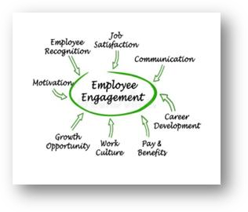**Development:** Investment in development and learning opportunities helps fulfill employees’ needs to grow and develop professionally. This can help them become better at their jobs or to take on new roles and responsibilities within the organization.

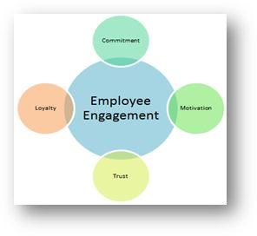

9

* + **Autonomy:** Employees need to be given the tools they need to be successful and empowered to take ownership of responsibilities and projects. Employee autonomy is vital for building and maintaining a highly engaged team. When employees are allowed and encouraged to work autonomously, they feel valued and trusted, which improves engagement.

### Inclusion

More [diversity](https://www.entrepreneur.com/article/425157), within a culture of inclusiveness, promotes higher levels of employee engagement. Employees need to feel a sense of belonging and connection with co- workers, and they need to be comfortable in their work environment.

Inclusion meets an employee’s need for psychological safety, and it helps engagement by fostering an environment where all employees can express concerns, ask questions, or make suggestions without fear, shame, or negative repercussions.

### Recognition

Recognizing the accomplishments and contributions of employees reinforces the sense of purpose employees need to feel to be engaged; rewarding them and showing them, and the team, how their contributions have an impact in the organization is important for engagement.

### Feedback

Feedback shouldn’t just be in the form of recognition; employees need regular feedback on their performance and should also feel comfortable providing feedback to leadership.

### Trust

Employees need to have a trust-based relationship with leadership. Leaders should continually work to build and maintain trust by providing clarity and transparency about employees’ roles and responsibilities.

### Job Clarity

This may seem like a no-brainer, but in some organizations where change is constant and turnover is high, a lack of clarity on job roles and expectations can hurt engagement if there is any confusion about who is doing what and for whom.

### Work/Life Balance

Providing flexibility, supporting autonomy, and avoiding a culture of “toxic productivity,” which can lead to burnout and disengagement, helps with work/life balance for on-site and remote workers.

10

### What does Employee Engagement in an Organization lead to?

Employee engagement is a critical part of organizational success. Employee engagement predicts the employee outcomes, organizational success, and financial performance. The impact of engagement or disengagement can manifest itself through productivity and organizational performance, outcomes for customers of the organization, employee retention rates and organizational culture.

**Higher profits and productivity**: Proper employee engagement will help in incurring higher profits and at the same the productivity also increases. Engagement allows for the possibility that organisations with growth and profit increases bring about a very engaged workforce, not the other way around. As profits go up, the potential for pay or bonus rises also increases which is likely to elicit a positive feeling in employees and may thus increase their feeling of attachment to the organisation.

1. **Improved Quality**: The quality can be improved when proper opportunities are given the employees. Employee engagement helps in maintaining the improved quality of the organisation and this will be influenced on the customer satisfaction. When the organisation commits towards effective engagement the quality levels also increases.
2. **Customer Loyalty:** The employees who are happy in their work are more likely to create loyal customers. Engaged employees tend to have a better understanding of how to meet customer needs and as a result, customer loyalty tends to be better in organisations where the employees are engaged. Ultimately, this may lead to what is sometimes termed ‘customer engagement’, where there is a mental and emotional connection between the organisation and the customer.
3. **Financial Success:** Effective employee engagement will be having a higher effect on the organization’s financial success. Employee engagement predicts the employee outcomes, organizational success, and financial performance.
4. **Employee Performance:** Engagement affects employee performance. ‘Engaged employees work harder, are more loyal and are more likely to go the ‘extra mile’ for the corporation. Engagement is an ‘illusive force’ that motivates an individual to

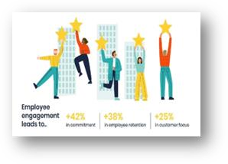

achieve higher levels of performance.

11

1. **Commitment & Motivation:** High levels of engagement at work support employees in ‘taking initiative and pursuing learning. Individual level engagement is too complex to be able to reliably explain much performance and that engagement surveys measure the symptoms of performance rather than the causes. By providing incentive plans the employees are motivate towards the increase in productivity.
2. **Employee Retention:** Employee retention policies have received the lion's share of the spotlight. This focus on retention however has spawned several studies on engagement, since retaining employees is dependent upon the need to engage them. Hence, engagement studies are beginning to take center stage. Many researchers have suggested that employees who are happy in their work are more likely to stay in the organisation.
3. **Organisation Culture:** Organizational culture is a significant driver of employee engagement, where employees must be expected to work together and provide a voice for the customer within the organization. Engaged employees are more likely to advocate the organisation as a place to work and actively promote its products and services
4. The employees who are engaged in their organisation and their work are more likely to respond positively to their managers, demonstrate good performance and achieve success. This then helps their manager to be more effective and successful, which in turn increases the manager’s self‐efficacy.
5. **Successful organizational change:** Employee engagement might play a key role in aiding the successful implementation of organizational change and may be particularly important to enabling organizational agility in companies forced to adapt to the changing market. It is found that their engagement improvement initiatives had led to time savings when introducing new policies and implementing change

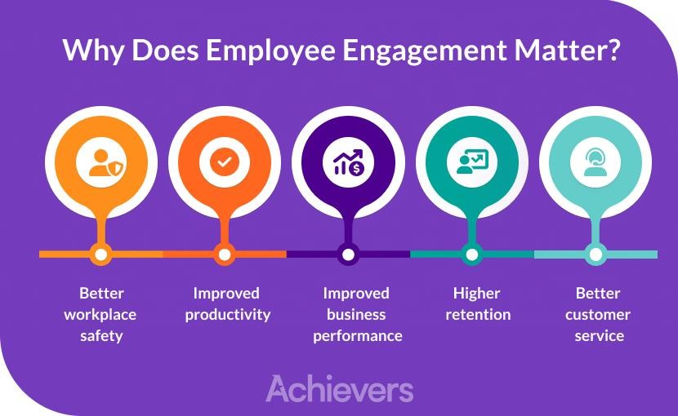

12

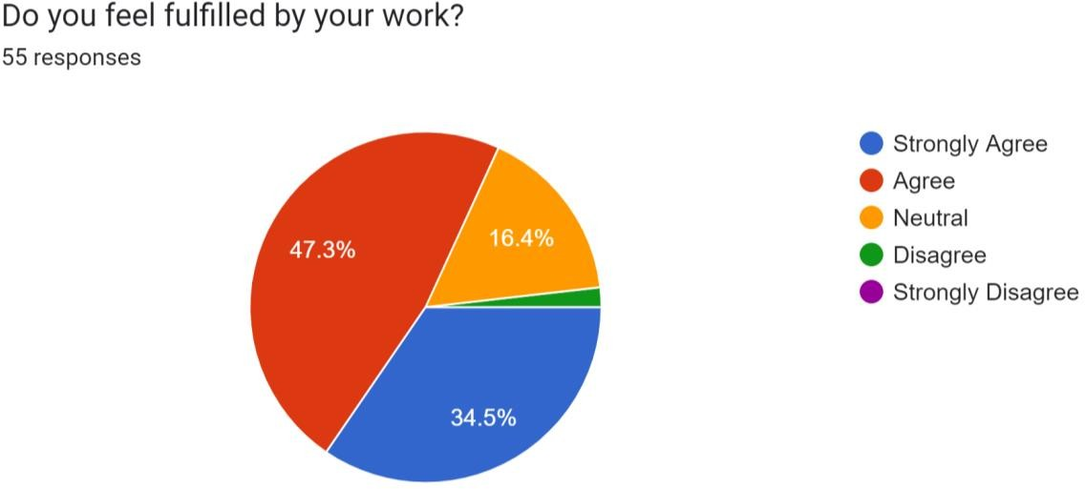

The questionnaire was directed towards **55 employees** to provide valuable insights into the employees' sentiments regarding their work fulfillment. A significant proportion, approximately **47.3%**, expressed agreement with feeling fulfilled in their roles, reflecting a positive aspect of job satisfaction. Moreover, a noteworthy **34.5%** of employees strongly affirmed their fulfilment. On the other hand, the **16.4%** of employees providing a neutral response indicates a portion of the workforce that may have mixed feelings towards their work fulfillment. This group could represent an area for further exploration to understand the factors influencing their perceptions and identify potential areas for improvement.

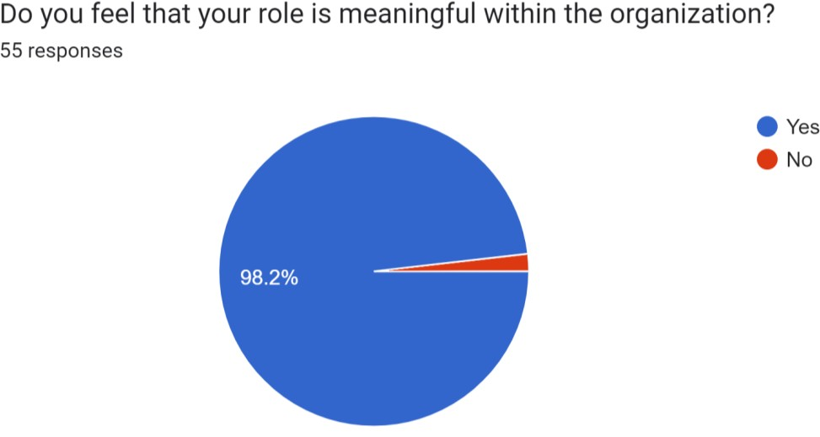

Out of **55 Employees, 98.2%** of the employees feel that their role is meaningful in the organization. Around **1.8%** of the employees feel that their role isn’t meaningful in the organization. The overwhelmingly positive response regarding the perceived meaningfulness of their roles is an encouraging indicator of a workforce largely engaged and connected to the purpose of their work.

13

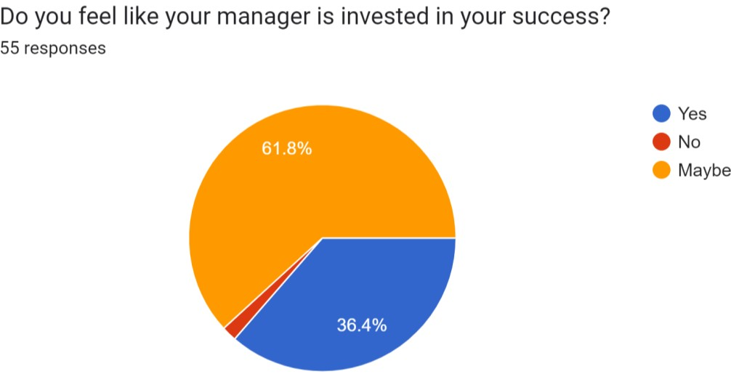**36.4%** of employees express a positive affirmation that their managers are indeed invested in their success which reflects a substantial portion of the workforce experiencing a supportive and encouraging managerial relationship.

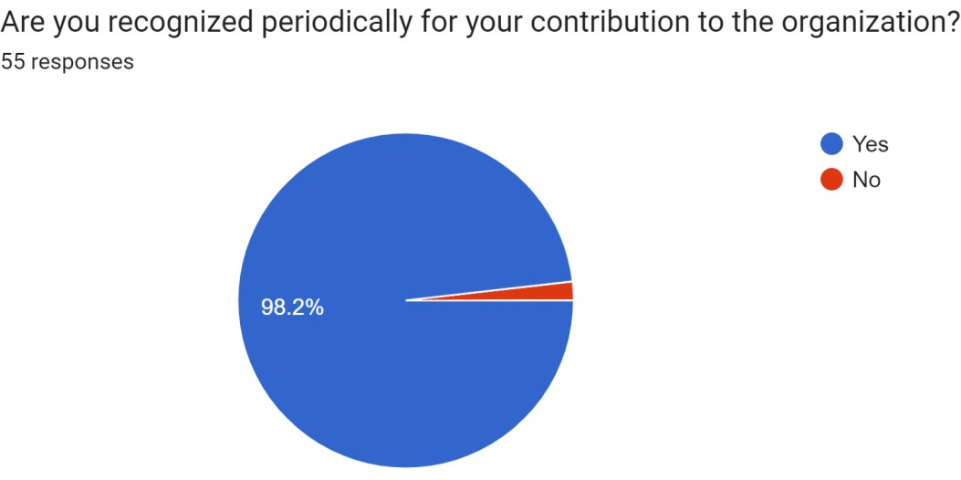Moreover, the **61.8%** of employees who believe their manager "might" be invested in their success indicates that a significant majority sees potential or hints of managerial support but may not be entirely convinced or certain about the extent of that investment. **1.8%** of employees who feel that their manager is not invested in their success highlights an area that warrants attention. Understanding the reasons behind this perception is crucial for organizations to identify potential gaps in leadership, communication, or support systems.

Out of **55 Employees,** when questioned on if they are periodically recognized for their contribution to the organization, **98.2%** of the employees answered positively stating that they are recognized periodically for their performance. **1.8%** of the employees aren’t recognized periodically for their contribution to the organization. the overwhelmingly positive response demonstrates the effectiveness of the organization's

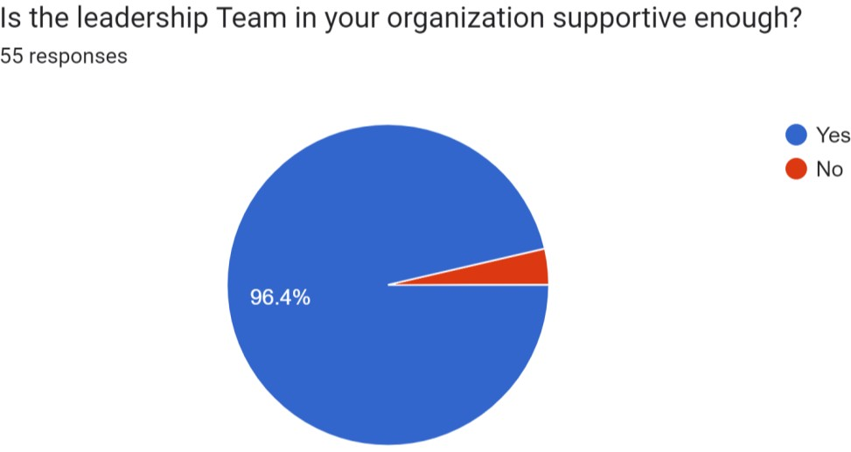

Out of **55 Employees,** around **96.4%** of the employees have a supportive leadership team in their organization. This overwhelming affirmation reflects a culture where leaders actively contribute to fostering a supportive and conducive workplace, offering guidance, mentorship, and assistance to their teams. However **3.6%** of the employees don’t have a supportive leadership team in their organization. Understanding the reasons behind this sentiment is crucial to address any potential gaps in leadership approach, communication, or support mechanisms.

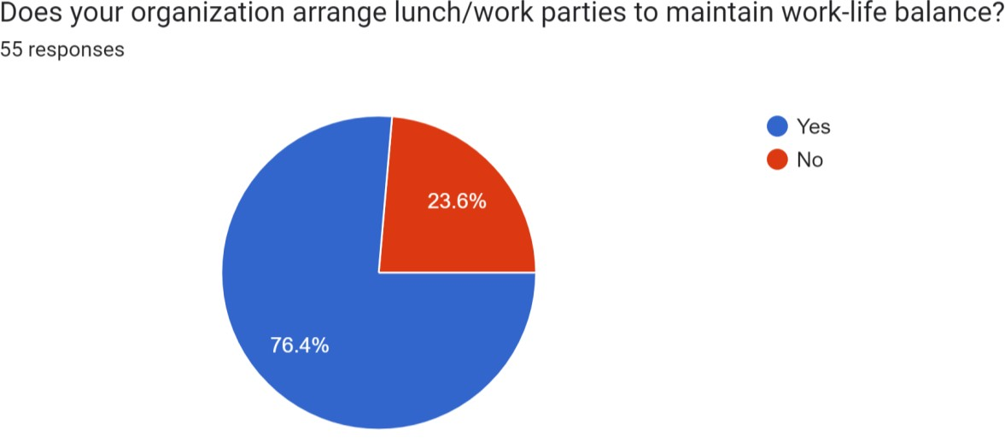

Out of **55 Employees, 76.4%** of the employees do have lunch/work parties organized to maintain work life balance. However, **23.4%** of the employees don’t have any lunch/work parties to maintain work-life balance. while a significant majority benefits from organized lunch or work parties to enhance work-life balance, addressing the needs of the minority without access to such events could contribute to a more inclusive approach in promoting employee well-being and engagement across the board.

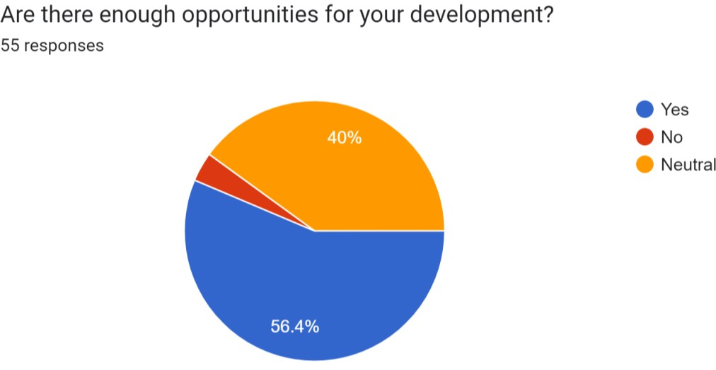

Out of **55 Employees,** when questioned if there were enough opportunities for their development in their organization, around **56.4%** of the employees answered in affirmative stating that there are enough opportunities for their development, around **40%** of the employees have chosen neutral and the remaining have said that there aren’t enough responsibilities for their development. Tailoring and communicating developmental pathways more effectively, addressing individual needs, and providing clarity about growth prospects could enhance the overall employee experience and satisfaction regarding professional development.

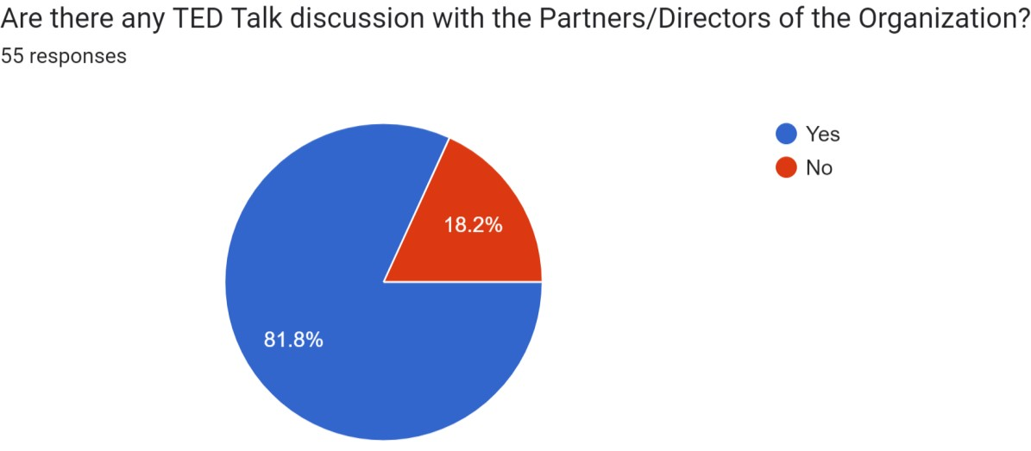

Out of **55 Employees, 81.8%** of the employees do TED talk discussion with the partners/CEOs or Directors of the company. Around 18.2% of the employees don’t have any TED talk discussion with their Higher Level Authority. Encouraging more widespread access to TED talk discussions or similar forums with higher-level authorities could foster a more cohesive and informed workforce, contributing to a stronger sense of connection and shared vision within the company.

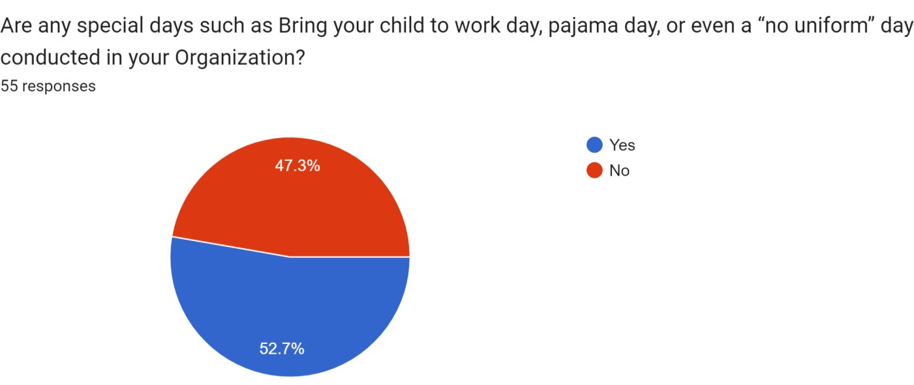

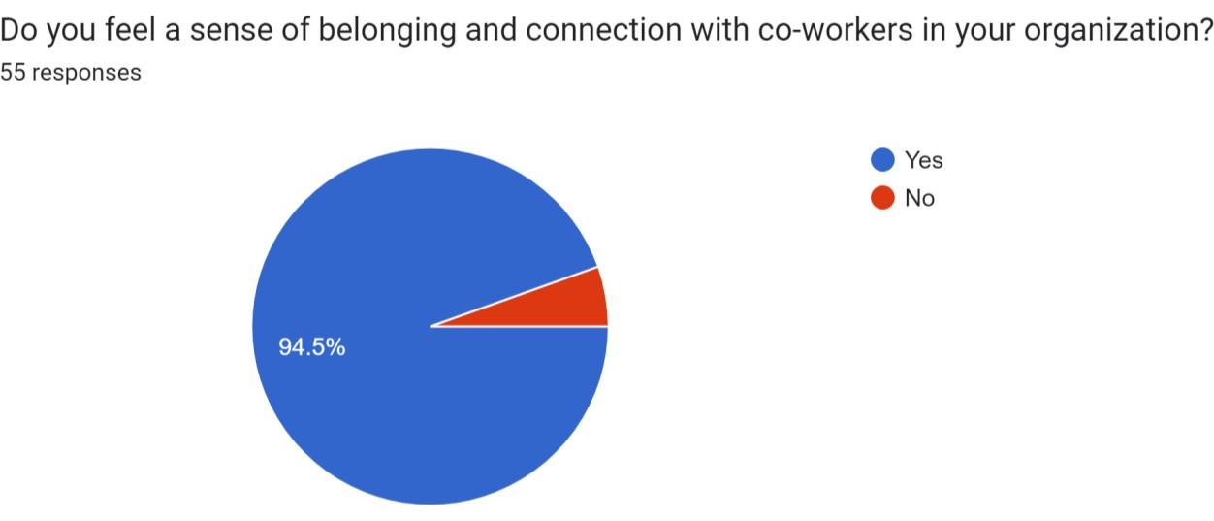Out of **55 Employees,** when questioned if there were any special days such as bring your child to workday/ pajama day or no uniform day conducted in their organization, **52.7%** employees have answered in affirmative stating that their organization does have days such as the aforementioned. However **47.2%** of the employees have said that their organization does not have such days. Understanding the reasons behind the absence of these events for the employees who haven't experienced them could be beneficial. It might present an opportunity for the organization to explore more inclusive and engaging activities tha1t7 foster a more cohesive and enjoyable workplace culture.

Out of **55 Employees** as a sample set, they were question on whether they feel a sense of belonging and connection with co-workers in their organization. Around **94.5%** of the employees feel the sense of belonging and connection with their coworkers but the remaining don’t. Efforts to bridge this gap could further strengthen teamwork, productivity, and overall employee satisfaction within the organization.

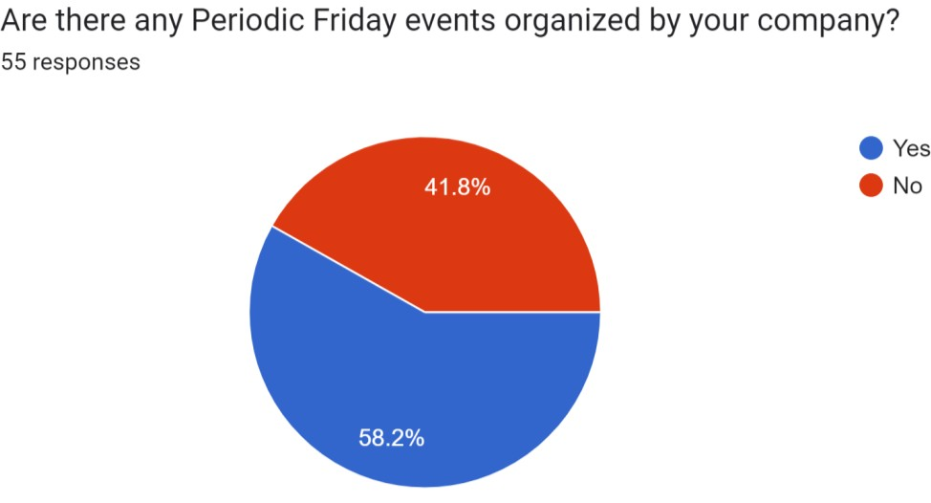

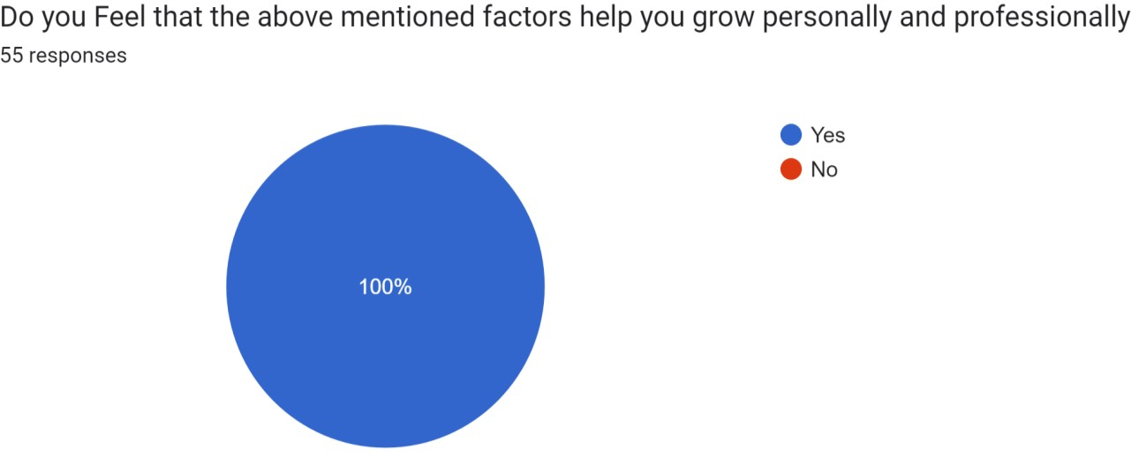Around **58.2%** of employees have periodic Friday events organized by their company. **41.8%** of the employees don’t have any Periodic Friday Events in their organization. Ensuring that all employees have access to such events, or providing alternative engagement opportunities, could contribute to a more cohesive and enjoyable work culture across the organization.

Out of **55** Employees questioned on whether the above mentioned factors help them grow professionally and personally, **all of them** agree that the factors are necessary for their growth. This consensus underscores a cohesive understanding among employees regarding the vital role played by these factors in their overall growth. It signifies that the organization's initiatives, events, or practices, such as recognition, development opportunities, social events, or leadership support, are widely acknowledged and valued by the entire workforce.

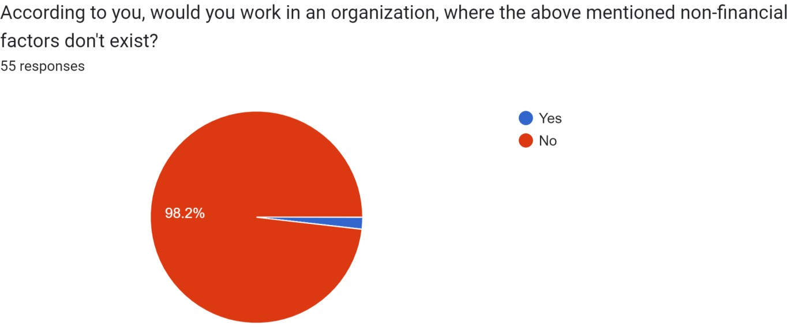

When questioned if the employees would work in an organization where the above mentioned factors don’t exist, majority of employees that is **98.2%** wouldn’t work in such an organization. However, **1.8%** of the employees would still prefer to work in an organization which does not provide the above mentioned factors. Overall, the overwhelmingly strong aversion towards working in an organization without these crucial factors emphasizes the significance of these aspects in shaping employees' perceptions, happiness, and commitment to their workplace. This highlights the pivotal role that these factors play in attracting, retaining, and satisfying employees within an organization.

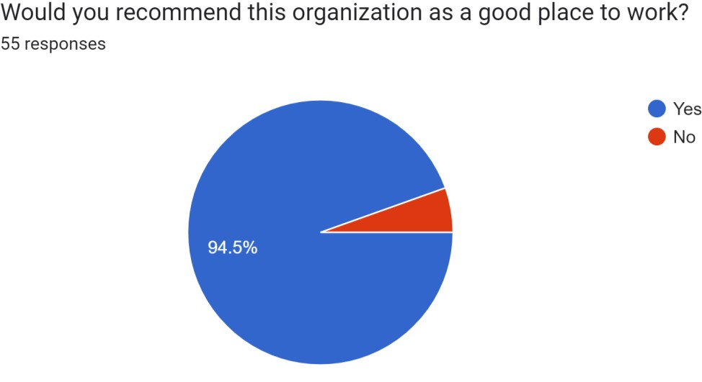

When questioned if the employees would recommend their current workplace as a good place to work, around **94.5%** of the employees would recommend that their organization is a good place to work. The remaining **5.5%** wouldn’t recommend their organization to be a good working place

### Findings

* The researchers state that components such as Leadership, career and development, work culture, inclusion and recognition are the crucial drivers of the employee engagement process.
* According to this study, employees who have possibilities for personal development and professional advancement inside an organization are more engaged and conscientious in their work, which eventually boosts the organization's productivity.
* According to this study, a positive work environment fosters a sense of belonging in employees, which naturally motivates them to contribute to the success of the company. Work culture and environment also operate as a catalyst to increase employee engagement.
* According to this study, staff members tend to be more involved and invested in the success of the firm when they feel that their efforts are respected and appreciated.
* According to this survey, employees feel educated and valued when there is open and honest communication within the company which lead to increased participation and investment in the success of the organisation.
* This study concluded that by giving employees a clear idea of what is expected of them and how their performance will be judged, regular feedback enhances accountability among workers. This can give people a sense of ownership and responsibility, which can assist to improve participation.
* Research also finds that if the employees feel enthusiastic in their workplace and belief that their opinions matter to their peers, then it will improve their perception towards their organization and also increase the organization’s brand value.

### Limitations

* Since the research is based on only 55 employees working in consulting firm, there is a significant possibility that it will be influenced by the perspectives and prejudices of the chosen samples.
* The study covered a very narrow area because it was carried out during a brief period of time—roughly 15 days.
* There is a potential that respondents concealed information or gave incorrect information, or that they were not fully receptive to the survey.
* The study's findings might alter if other variables, such as the respondents' location, age group, or economic situation, which all have a significant impact

### Suggestions

* Establishing a culture that encourages cooperation, communication, and

respect among employees should be a top priority for businesses.

* The development and training of leaders who can provide employees with clear direction, inspire them, and foster a healthy work environment should be a priority for organizations. Ensuring that all employees experience support and guidance from their leadership can significantly contribute to a more cohesive, engaged, and productive work environment.
* To aid employees in strengthening their abilities and advancing their careers,

organizations should provide training, education, and mentoring programs.

* Businesses should periodically assess their reward programs to make sure they are equitable, open, and in line with the requirements and expectations of their workforce.
* This disparity between those experiencing Friday events and those who do not suggests an opportunity for the organization to consider more inclusive practices or explore alternative activities that appeal to a broader range of employees.
* The small percentage, who do not feel this sense of belonging and connection, raises important concerns. Understanding the reasons behind their lack of connection could uncover opportunities to enhance team dynamics, communication, or inclusivity within the organization.
* Encouraging more widespread access to TED talk discussions or similar forums with higher-level authorities could foster a more cohesive and informed workforce, contributing to a stronger sense of connection and shared vision within the company.
* Tailoring and communicating developmental pathways more effectively, addressing individual needs, and providing clarity about growth prospects could enhance the overall employee experience and satisfaction regarding professional development.
* While a significant majority benefits from organized lunch or work parties to enhance work-life balance, addressing the needs of the minority without access to such events could contribute to a more inclusive approach in promoting employee well-being and engagement across the board.

## Conclusion

After reviewing the various research and survey findings of employee engagement, it can be certainly concluded that high levels of employee engagement will lead to improved employee commitment & involvement towards job and thus creating a motivated workforce, that will work together to achieve the common goals of the organization .

Acquiring skilled workforce is just not enough in today's changing economy like ours; instead a lot needs to be done to retain, involve and make them committed to the organization and its goals. Thus, engagement is a state where an individual is not only intellectually committed but has great emotional attachment with his/her job that goes above and beyond the call of duty so as to further the interest of the company.

The organizations should not only provide their employees with great infrastructure and other facilities but also freedom to make their work exciting and also are providing them an environment wherein they can say good-bye to a monotonous work. They should focus on retention as an outcome of three HR focus areas such as employee motivation, career growth & remuneration, and compensation. Thus working in a safe and cooperative environment adds to the engagement level of an employee.

Due to rapid economic development and dynamism of technology the competition among the firms is getting fierce with every passing day. Dealing with such fierce competition by only taking in account the financial factors of improving performance will not suffice and therefore the organisations are moving toward the non-financial factors of performance development one of them being employee engagement.

Employee engagement is the most important factor to be considered to keep the employees motivated, enthusiastic and completely absorbed in their work. It can also be concluded that employee engagement not only is helpful in keeping the employees satisfied and motivated towards giving their best efforts and to go an extra mile for improving the performance of the organisation but it is also woven together with other positive results in performance like improvement in productivity, profitability, customer satisfaction and customer loyalty lower employee turnover and absenteeism. The study suggests that better employee engagement could improve team performance in organizational contexts.

Employee engagement is closely linked with organizational performance outcomes. Companies with engaged employees have higher employee retention. On the other hand, companies with disengaged employees suffer from waste of effort and bleed talent, earn less commitment from the employees, face increased absenteeism and have less customer orientation, less productivity, and reduced operating margins and net profit margins.

## Bibliography

<https://files.eric.ed.gov/fulltext/ED501235.pdf>

[https://d1wqtxts1xzle7.cloudfront.net/53287422/16_Impact_of_Employee_Engagement](https://d1wqtxts1xzle7.cloudfront.net/53287422/16_Impact_of_Employee_Engagement_on_Performance-libre.pdf?1495809438&response-content-disposition=inline%3B%2Bfilename%3D16_Impact_of_Employee_Engagement_on_Perf.pdf&Expires=1700398885&Signature=JH1O4BA-~AxZu~I6A9g8I7CbZFENCcxU0snI2rIt2umzfoMBdnm5GVTyx3pWAbQoRsZa8mO-dGRSauo-DgbYnrdPCJRpddnnzrxoBXEhHj71P-aBLrcPjjpbCKED0rjtMxo8iWvMt9Vm8BwEqG3Zezg6c7TZmvurLtpq~iVjJsrwTV9uueWDyvboSqqufMNyKVlr3npKbsSAfpT5l8yXJauG0~Ejl5R3fE~4RGDHhjz~ro9aMEqRZQ0I8aG2AT88MekqOtTPxg~Hxew5rXD5euKIkqABxCiM0nr8zs3A8XrNquLYAossz8GqAbgX29MUEbJxMBUmn3mKmcVritd9HA__&Key-Pair-Id=APKAJLOHF5GGSLRBV4ZA)

[_on_Performance-libre.pdf?1495809438=&response-content](https://d1wqtxts1xzle7.cloudfront.net/53287422/16_Impact_of_Employee_Engagement_on_Performance-libre.pdf?1495809438&response-content-disposition=inline%3B%2Bfilename%3D16_Impact_of_Employee_Engagement_on_Perf.pdf&Expires=1700398885&Signature=JH1O4BA-~AxZu~I6A9g8I7CbZFENCcxU0snI2rIt2umzfoMBdnm5GVTyx3pWAbQoRsZa8mO-dGRSauo-DgbYnrdPCJRpddnnzrxoBXEhHj71P-aBLrcPjjpbCKED0rjtMxo8iWvMt9Vm8BwEqG3Zezg6c7TZmvurLtpq~iVjJsrwTV9uueWDyvboSqqufMNyKVlr3npKbsSAfpT5l8yXJauG0~Ejl5R3fE~4RGDHhjz~ro9aMEqRZQ0I8aG2AT88MekqOtTPxg~Hxew5rXD5euKIkqABxCiM0nr8zs3A8XrNquLYAossz8GqAbgX29MUEbJxMBUmn3mKmcVritd9HA__&Key-Pair-Id=APKAJLOHF5GGSLRBV4ZA)

[-](https://d1wqtxts1xzle7.cloudfront.net/53287422/16_Impact_of_Employee_Engagement_on_Performance-libre.pdf?1495809438&response-content-disposition=inline%3B%2Bfilename%3D16_Impact_of_Employee_Engagement_on_Perf.pdf&Expires=1700398885&Signature=JH1O4BA-~AxZu~I6A9g8I7CbZFENCcxU0snI2rIt2umzfoMBdnm5GVTyx3pWAbQoRsZa8mO-dGRSauo-DgbYnrdPCJRpddnnzrxoBXEhHj71P-aBLrcPjjpbCKED0rjtMxo8iWvMt9Vm8BwEqG3Zezg6c7TZmvurLtpq~iVjJsrwTV9uueWDyvboSqqufMNyKVlr3npKbsSAfpT5l8yXJauG0~Ejl5R3fE~4RGDHhjz~ro9aMEqRZQ0I8aG2AT88MekqOtTPxg~Hxew5rXD5euKIkqABxCiM0nr8zs3A8XrNquLYAossz8GqAbgX29MUEbJxMBUmn3mKmcVritd9HA__&Key-Pair-Id=APKAJLOHF5GGSLRBV4ZA)

[disposition=inline%3B+filename%3D16_Impact_of_Employee_Engagement_on_Perf.p](https://d1wqtxts1xzle7.cloudfront.net/53287422/16_Impact_of_Employee_Engagement_on_Performance-libre.pdf?1495809438&response-content-disposition=inline%3B%2Bfilename%3D16_Impact_of_Employee_Engagement_on_Perf.pdf&Expires=1700398885&Signature=JH1O4BA-~AxZu~I6A9g8I7CbZFENCcxU0snI2rIt2umzfoMBdnm5GVTyx3pWAbQoRsZa8mO-dGRSauo-DgbYnrdPCJRpddnnzrxoBXEhHj71P-aBLrcPjjpbCKED0rjtMxo8iWvMt9Vm8BwEqG3Zezg6c7TZmvurLtpq~iVjJsrwTV9uueWDyvboSqqufMNyKVlr3npKbsSAfpT5l8yXJauG0~Ejl5R3fE~4RGDHhjz~ro9aMEqRZQ0I8aG2AT88MekqOtTPxg~Hxew5rXD5euKIkqABxCiM0nr8zs3A8XrNquLYAossz8GqAbgX29MUEbJxMBUmn3mKmcVritd9HA__&Key-Pair-Id=APKAJLOHF5GGSLRBV4ZA) [df&Expires=1700398885&Signature=JH1O4BA-](https://d1wqtxts1xzle7.cloudfront.net/53287422/16_Impact_of_Employee_Engagement_on_Performance-libre.pdf?1495809438&response-content-disposition=inline%3B%2Bfilename%3D16_Impact_of_Employee_Engagement_on_Perf.pdf&Expires=1700398885&Signature=JH1O4BA-~AxZu~I6A9g8I7CbZFENCcxU0snI2rIt2umzfoMBdnm5GVTyx3pWAbQoRsZa8mO-dGRSauo-DgbYnrdPCJRpddnnzrxoBXEhHj71P-aBLrcPjjpbCKED0rjtMxo8iWvMt9Vm8BwEqG3Zezg6c7TZmvurLtpq~iVjJsrwTV9uueWDyvboSqqufMNyKVlr3npKbsSAfpT5l8yXJauG0~Ejl5R3fE~4RGDHhjz~ro9aMEqRZQ0I8aG2AT88MekqOtTPxg~Hxew5rXD5euKIkqABxCiM0nr8zs3A8XrNquLYAossz8GqAbgX29MUEbJxMBUmn3mKmcVritd9HA__&Key-Pair-Id=APKAJLOHF5GGSLRBV4ZA)

[~AxZu~I6A9g8I7CbZFENCcxU0snI2rIt2umzfoMBdnm5GVTyx3pWAbQoRsZa8mO-](https://d1wqtxts1xzle7.cloudfront.net/53287422/16_Impact_of_Employee_Engagement_on_Performance-libre.pdf?1495809438&response-content-disposition=inline%3B%2Bfilename%3D16_Impact_of_Employee_Engagement_on_Perf.pdf&Expires=1700398885&Signature=JH1O4BA-~AxZu~I6A9g8I7CbZFENCcxU0snI2rIt2umzfoMBdnm5GVTyx3pWAbQoRsZa8mO-dGRSauo-DgbYnrdPCJRpddnnzrxoBXEhHj71P-aBLrcPjjpbCKED0rjtMxo8iWvMt9Vm8BwEqG3Zezg6c7TZmvurLtpq~iVjJsrwTV9uueWDyvboSqqufMNyKVlr3npKbsSAfpT5l8yXJauG0~Ejl5R3fE~4RGDHhjz~ro9aMEqRZQ0I8aG2AT88MekqOtTPxg~Hxew5rXD5euKIkqABxCiM0nr8zs3A8XrNquLYAossz8GqAbgX29MUEbJxMBUmn3mKmcVritd9HA__&Key-Pair-Id=APKAJLOHF5GGSLRBV4ZA) [dGRSauo-DgbYnrdPCJRpddnnzrxoBXEhHj71P-](https://d1wqtxts1xzle7.cloudfront.net/53287422/16_Impact_of_Employee_Engagement_on_Performance-libre.pdf?1495809438&response-content-disposition=inline%3B%2Bfilename%3D16_Impact_of_Employee_Engagement_on_Perf.pdf&Expires=1700398885&Signature=JH1O4BA-~AxZu~I6A9g8I7CbZFENCcxU0snI2rIt2umzfoMBdnm5GVTyx3pWAbQoRsZa8mO-dGRSauo-DgbYnrdPCJRpddnnzrxoBXEhHj71P-aBLrcPjjpbCKED0rjtMxo8iWvMt9Vm8BwEqG3Zezg6c7TZmvurLtpq~iVjJsrwTV9uueWDyvboSqqufMNyKVlr3npKbsSAfpT5l8yXJauG0~Ejl5R3fE~4RGDHhjz~ro9aMEqRZQ0I8aG2AT88MekqOtTPxg~Hxew5rXD5euKIkqABxCiM0nr8zs3A8XrNquLYAossz8GqAbgX29MUEbJxMBUmn3mKmcVritd9HA__&Key-Pair-Id=APKAJLOHF5GGSLRBV4ZA) [aBLrcPjjpbCKED0rjtMxo8iWvMt9Vm8BwEqG3Zezg6c7TZmvurLtpq~iVjJsrwTV9uu](https://d1wqtxts1xzle7.cloudfront.net/53287422/16_Impact_of_Employee_Engagement_on_Performance-libre.pdf?1495809438&response-content-disposition=inline%3B%2Bfilename%3D16_Impact_of_Employee_Engagement_on_Perf.pdf&Expires=1700398885&Signature=JH1O4BA-~AxZu~I6A9g8I7CbZFENCcxU0snI2rIt2umzfoMBdnm5GVTyx3pWAbQoRsZa8mO-dGRSauo-DgbYnrdPCJRpddnnzrxoBXEhHj71P-aBLrcPjjpbCKED0rjtMxo8iWvMt9Vm8BwEqG3Zezg6c7TZmvurLtpq~iVjJsrwTV9uueWDyvboSqqufMNyKVlr3npKbsSAfpT5l8yXJauG0~Ejl5R3fE~4RGDHhjz~ro9aMEqRZQ0I8aG2AT88MekqOtTPxg~Hxew5rXD5euKIkqABxCiM0nr8zs3A8XrNquLYAossz8GqAbgX29MUEbJxMBUmn3mKmcVritd9HA__&Key-Pair-Id=APKAJLOHF5GGSLRBV4ZA) [eWDyvboSqqufMNyKVlr3npKbsSAfpT5l8yXJauG0~Ejl5R3fE~4RGDHhjz~ro9aMEq](https://d1wqtxts1xzle7.cloudfront.net/53287422/16_Impact_of_Employee_Engagement_on_Performance-libre.pdf?1495809438&response-content-disposition=inline%3B%2Bfilename%3D16_Impact_of_Employee_Engagement_on_Perf.pdf&Expires=1700398885&Signature=JH1O4BA-~AxZu~I6A9g8I7CbZFENCcxU0snI2rIt2umzfoMBdnm5GVTyx3pWAbQoRsZa8mO-dGRSauo-DgbYnrdPCJRpddnnzrxoBXEhHj71P-aBLrcPjjpbCKED0rjtMxo8iWvMt9Vm8BwEqG3Zezg6c7TZmvurLtpq~iVjJsrwTV9uueWDyvboSqqufMNyKVlr3npKbsSAfpT5l8yXJauG0~Ejl5R3fE~4RGDHhjz~ro9aMEqRZQ0I8aG2AT88MekqOtTPxg~Hxew5rXD5euKIkqABxCiM0nr8zs3A8XrNquLYAossz8GqAbgX29MUEbJxMBUmn3mKmcVritd9HA__&Key-Pair-Id=APKAJLOHF5GGSLRBV4ZA) [RZQ0I8aG2AT88MekqOtTPxg~Hxew5rXD5euKIkqABxCiM0nr8zs3A8XrNquLYAoss](https://d1wqtxts1xzle7.cloudfront.net/53287422/16_Impact_of_Employee_Engagement_on_Performance-libre.pdf?1495809438&response-content-disposition=inline%3B%2Bfilename%3D16_Impact_of_Employee_Engagement_on_Perf.pdf&Expires=1700398885&Signature=JH1O4BA-~AxZu~I6A9g8I7CbZFENCcxU0snI2rIt2umzfoMBdnm5GVTyx3pWAbQoRsZa8mO-dGRSauo-DgbYnrdPCJRpddnnzrxoBXEhHj71P-aBLrcPjjpbCKED0rjtMxo8iWvMt9Vm8BwEqG3Zezg6c7TZmvurLtpq~iVjJsrwTV9uueWDyvboSqqufMNyKVlr3npKbsSAfpT5l8yXJauG0~Ejl5R3fE~4RGDHhjz~ro9aMEqRZQ0I8aG2AT88MekqOtTPxg~Hxew5rXD5euKIkqABxCiM0nr8zs3A8XrNquLYAossz8GqAbgX29MUEbJxMBUmn3mKmcVritd9HA__&Key-Pair-Id=APKAJLOHF5GGSLRBV4ZA) [z8GqAbgX29MUEbJxMBUmn3mKmcVritd9HA &Key-Pair-](https://d1wqtxts1xzle7.cloudfront.net/53287422/16_Impact_of_Employee_Engagement_on_Performance-libre.pdf?1495809438&response-content-disposition=inline%3B%2Bfilename%3D16_Impact_of_Employee_Engagement_on_Perf.pdf&Expires=1700398885&Signature=JH1O4BA-~AxZu~I6A9g8I7CbZFENCcxU0snI2rIt2umzfoMBdnm5GVTyx3pWAbQoRsZa8mO-dGRSauo-DgbYnrdPCJRpddnnzrxoBXEhHj71P-aBLrcPjjpbCKED0rjtMxo8iWvMt9Vm8BwEqG3Zezg6c7TZmvurLtpq~iVjJsrwTV9uueWDyvboSqqufMNyKVlr3npKbsSAfpT5l8yXJauG0~Ejl5R3fE~4RGDHhjz~ro9aMEqRZQ0I8aG2AT88MekqOtTPxg~Hxew5rXD5euKIkqABxCiM0nr8zs3A8XrNquLYAossz8GqAbgX29MUEbJxMBUmn3mKmcVritd9HA__&Key-Pair-Id=APKAJLOHF5GGSLRBV4ZA) [Id=APKAJLOHF5GGSLRBV4ZA](https://d1wqtxts1xzle7.cloudfront.net/53287422/16_Impact_of_Employee_Engagement_on_Performance-libre.pdf?1495809438&response-content-disposition=inline%3B%2Bfilename%3D16_Impact_of_Employee_Engagement_on_Perf.pdf&Expires=1700398885&Signature=JH1O4BA-~AxZu~I6A9g8I7CbZFENCcxU0snI2rIt2umzfoMBdnm5GVTyx3pWAbQoRsZa8mO-dGRSauo-DgbYnrdPCJRpddnnzrxoBXEhHj71P-aBLrcPjjpbCKED0rjtMxo8iWvMt9Vm8BwEqG3Zezg6c7TZmvurLtpq~iVjJsrwTV9uueWDyvboSqqufMNyKVlr3npKbsSAfpT5l8yXJauG0~Ejl5R3fE~4RGDHhjz~ro9aMEqRZQ0I8aG2AT88MekqOtTPxg~Hxew5rXD5euKIkqABxCiM0nr8zs3A8XrNquLYAossz8GqAbgX29MUEbJxMBUmn3mKmcVritd9HA__&Key-Pair-Id=APKAJLOHF5GGSLRBV4ZA)

<https://businessleadershiptoday.com/what-are-examples-of-employee-engagement/>

http://dspace.dtu.ac.in:8080/jspui/bitstream/repository/20213/1/Shikha%20Joshi%20DM BA.pdf

<https://scholarworks.waldenu.edu/cgi/viewcontent.cgi?article=1239&context=ijamt>

http://dspace.dtu.ac.in:8080/jspui/handle/repository/20213

file:///C:/Users/Admin/Downloads/1673-8662-1-PB.pdf

[https://citeseerx.ist.psu.edu/document?repid=rep1&type=pdf&doi=3bb6eb4ecad7978c4c](https://citeseerx.ist.psu.edu/document?repid=rep1&type=pdf&doi=3bb6eb4ecad7978c4cbe4e9402480b738c58e78d)

[be4e9402480b738c58e78d](https://citeseerx.ist.psu.edu/document?repid=rep1&type=pdf&doi=3bb6eb4ecad7978c4cbe4e9402480b738c58e78d)

**Form Link** [https://docs.google.com/forms/d/e/1FAIpQLSd8Ce9gKKS8hE4DkVWSE1g0z3OKUfydYuBp_lsYbaeO3NKgsg/vie](https://docs.google.com/forms/d/e/1FAIpQLSd8Ce9gKKS8hE4DkVWSE1g0z3OKUfydYuBp_lsYbaeO3NKgsg/viewform?usp=sf_link) [wform?usp=sf_link](https://docs.google.com/forms/d/e/1FAIpQLSd8Ce9gKKS8hE4DkVWSE1g0z3OKUfydYuBp_lsYbaeO3NKgsg/viewform?usp=sf_link)

