**3D Printing Technology: Innovations, Mechanisms, and Future Prospects**

Hardial Singh 1* , Ravi Kant2

1, 2 Department of Mechanical Engineering, Amity University Haryana, 122413.

**ABSTRACT**

In the rapidly advancing field of technology, 3D printing has revolutionized the manufacturing landscape by introducing a layer-by-layer additive approach, offering an innovative alternative to traditional manufacturing systems. This article presents a comprehensive study comparing 3D printing with conventional manufacturing methods for producing components and complex objects across a vast array of applications. Known for its versatility and speed, 3D printing accelerates innovation, reduces energy consumption, minimizes material waste, and streamlines supply chains. The paper also details the feed mechanisms, process-related insights, support materials, and software utilized in 3D printing, along with recent advancements in the field.

**Keywords:** 3D printer, manufacturing, printing technology, software

**1. INTRODUCTION**

In manufacturing, a transformative technology known as rapid prototyping, or additive manufacturing, has emerged with substantial promise and impact [1-2]. This technology has evolved significantly, becoming an indispensable tool for researchers, manufacturers, designers, engineers, and scientists across multiple fields. Integrating diverse areas—such as design, manufacturing, electronics, materials, and business—3D printing enables the creation of objects by adding material layer by layer, forming three-dimensional structures.

Unlike traditional manufacturing, which primarily relies on subtractive methods like grinding, bending, forging, molding, cutting, gluing, welding, and assembly, 3D printing employs an additive approach. Initially, 3D printing was primarily viewed as a tool for creative and artistic expression. However, recent advancements have pushed this technology to new heights, enabling the production of functional mechanical components and essential parts [3]. This evolution is not only transforming the industrial and manufacturing sectors but also has the potential to reshape various aspects of daily life by allowing entire models to be built in a single, continuous process.

For consumer-level additive manufacturing, two primary techniques dominate: Fused Deposition Modelling (FDM) and Stereolithography (SLA). Both methods build objects by adding material layer by layer. SLA uses ultraviolet (UV) light to selectively cure liquid resin, while FDM extrudes semi-liquid plastic to form the desired structure [4]. The rapid growth of 3D printing technology, particularly the FDM technique, has led to significant reductions in manufacturing costs, production times, and object weight, while minimizing waste compared to traditional processes. This accessibility has brought 3D printing within reach for the average consumer. Figure 1 illustrates the comparative reductions in manufacturing costs and time achieved with 3D printing relative to conventional manufacturing methods.

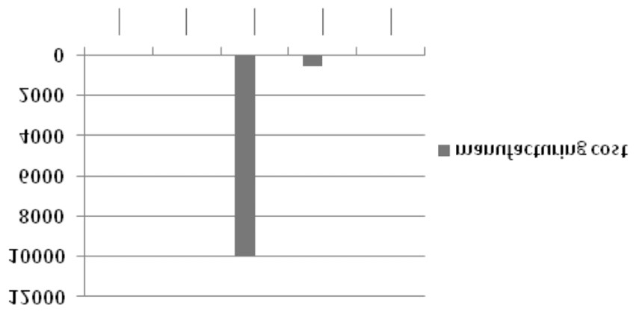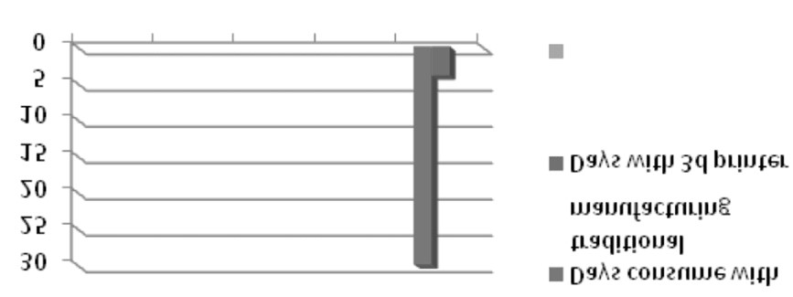

Figure 1: Reduction of manufacturing cost, and build time of object consume in 3D printing as compared to the traditional manufacturing techniques.

**2. LITERATURE REVIEW**

Charles W. (Chuck) Hull credited with inventing the first functional robotic 3D printer in 1984, initiating a transformative impact on manufacturing and prototyping. Since the late 1980s, 3D printing has progressively reshaped these industries, though it wasn’t until 2009 that "desktop" 3D printers—smaller, more affordable models accessible to consumers—became available. "Desktop" 3D printers refer to compact, lower-cost 3D printers that are within reach for the general public.

In 1989, S. Scott and Lisa Crump patented Fused Deposition Modeling (FDM) and co-founded Stratasys, Ltd., a leading 3D printer manufacturer. This technology, also known more broadly as Fused Filament Fabrication (FFF), involves feeding a plastic filament into a heated extruder that precisely deposits the material layer by layer. When crucial patents expired in 2005, this technology served as the foundation of the RepRap movement, which aimed to democratize 3D printing technology through open-source sharing.

The RepRap project gained momentum when Adrian Bowyer published open-source designs for 3D printer parts, encouraging users to improve upon them and share their modifications. Bowyerleased their first 3D printer model, Darwin, in March 2007, followed by Mendel in 2009, laying the groundwork for affordable, DIY 3D printing. The open-source and DIY communities drove rapid advancements in 3D printing technology, with MakerBot’s Thing-O-Matic released in 2010 as a notable milestone. Initially constructed with laser-cut wooden and 3D-printed parts, MakerBot eventually evolved into a major consumer 3D printer company and was acquired by Stratasys in 2013.

Fused Deposition Modeling remains one of the most accessible and cost-effective 3D printing technologies. Figure 1 illustreductions in manufacturing costs and build times achieved through 3D printing, compared to traditional manufacturing methods.

**METHODOLOGY**

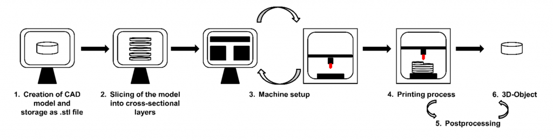

Figure 2. Scheme of the general 3D printing process

**3. Feed Mechanisms and Types of 3D Printing Technologies**

**A. Binder Jetting**  
This process creates objects by binding powdered materials through the deposition of a liquid binder. Common materials include metal, polymer, and ceramic.  
**Notable Developers (Country):** ExOne (US), Voxeljet (Germany), 3D Systems (US).

**B. Material Jetting**  
Material Jetting builds parts by depositing small droplets of photopolymer or wax, which are then cured by UV light, achieving a high resolution of about 16 microns per layer.  
**Notable Developers (Country):** Stratasys (US), LUXeXcel (Netherlands), 3D Systems (US) [5-8].

**C. Direct Energy Deposition (DED)**  
In DED, focused thermal energy (laser or electron beam) fuses material as it is deposited onto a substrate, using powder or wire.  
**Notable Developers (Country):** DM3D (US), NRC-IMI (Canada), Irepa Laser (France), Trumpf (Germany) [9-10].

**D. Powder Bed Fusion (PBF)**  
PBF creates objects by using thermal energy to fuse regions of a powder bed. Common materials include metal, polymer, and ceramic.  
**Notable Developers (Country):** EOS (Germany), Renishaw (UK), Matsuura Machinery (Japan), ARCAM (Sweden), 3D Systems (US), Phenix Systems (France) [11-12] .

1. **Direct Metal Laser Sintering (DMLS):** Uses a focused laser to melt and fuse metal powder in an inert gas chamber.
2. **Electron Beam Melting (EBM):** Uses an electron beam to melt metal powder within a vacuum.
3. **Selective Heat Sintering (SHS):** Applies thermal print heads to fuse layers of thermoplastic powder.
4. **Selective Laser Melting (SLM):** Melts metal powder using a laser to form a melt pool, adding material in layers within an inert gas chamber.
5. **Selective Laser Sintering (SLS):** Similar to SLM but heats the powder below melting to sinter particles together.

**E. Sheet Lamination**  
This method builds parts by cutting sheets of material and bonding them layer by layer. Materials include metal, hybrid composites, and ceramics.  
**Notable Developers (Country):** Fabrisonic (US), CAM-LEM (US).

1. **Laminated Object Manufacturing (LOM):** Layers of adhesive-coated paper, plastic, or metal are cut to shape with a laser and glued together.
2. **Ultrasonic Additive Manufacturing (UAM):** Thin metal sheets are joined by ultrasonic welding, followed by CNC milling to shape the object.

**F. Light Photopolymerization**  
This process uses light to selectively cure layers of photopolymer in a vat. Materials include photopolymer resins and ceramics.  
**Notable Developers (Country):** 3D Systems (US), EnvisionTEC (Germany), DWS (Italy), Lithoz (Australia).

1. **Digital Light Processing (DLP):** Projects an image of each layer into a vat of photopolymer, curing it layer by layer.
2. **Stereolithography (SLA):** A UV laser cures liquid photopolymer resin by solidifying it at specific points.

**G. Extrusion**  
Also known as Fused Deposition Modeling (FDM), extrusion creates objects by depositing heated material through a nozzle in layers, which harden to form the structure.  
**Material:** Polymer  
**Notable Developers (Country):** Stratasys (US), Delta Micro Factory (China), 3D Systems (US).

**Classification of Materials for 3D Printing**

Table 1 provides an overview of the most common 3D printing materials, categorized by material type.

**A. Wire Filament Materials**

1. **ABS (Acrylonitrile Butadiene Styrene):**  
   ABS is a cost-effective and versatile co-polymer of Acrylonitrile, Styrene, and Butadiene. It produces mild fumes during printing, which may be bothersome to sensitive individuals. ABS can be sanded, and treated with acetone for a smooth, glass-like finish. It is prone to warping and shrinking during printing, requiring a stable build platform. However, it has a higher heat tolerance than PLA due to its higher glass transition temperature [13-15].
2. **PLA (Polylactic Acid or Polylactide):**  
   PLA is a biodegradable plastic typically derived from corn or potatoes, emitting a sweet, toasted scent when heated. PLA is stiffer than ABS and doesn’t require a heated bed, though using one can reduce warping during cooling. A variant, flexible PLA, produces soft, elastic objects but is more challenging to work with.
3. **PVA (Polyvinyl Alcohol):**  
   PVA is a specialty, water-soluble plastic primarily used for support structures in dual-extruder printers. It readily absorbs moisture, which can make it difficult to handle in humid environments. PVA works best with PLA, as PLA’s lower extrusion temperature minimizes degradation during printing [16].
4. **TPE (Thermoplastic Elastomer):**  
   TPE, or “soft PLA,” is a flexible, rubber-like material. Due to its flexibility, the extruder must be rigid, and the extruder idler pressure carefully adjusted to avoid flattening the filament.

**B. Powder Materials**

A range of powder materials is available, which can be printed by fusing or binding with other agents (often water with color additives). Powder materials are typically mixtures of plaster and polymers, such as PVA. Some materials include:

* **Wood Filament:** A blend of ground wood and PLA or similar plastic. Wood filament prints with a 0.6 mm nozzle, producing soft, weaker objects with properties similar to PLA.

**C. Printable Waxes**

Certain waxes, such as those used in ThermoJet printers, are printable. These waxes, made from hydrocarbons, amides, and esters, are classified as thermoplastics, suitable for applications requiring precision molds and casting.

**D. Liquid Materials**

Stereolithography (SLA) and inkjet printers utilize UV-curable resins, a type of thermosetting plastic distinct from thermoplastics. These resins offer specific mechanical properties, including high tensile and impact strengths and defined glass transition temperatures, making them suitable for high-resolution, durable prints.

**4. Software Requirements for 3D Modeling**

Creating 3D models for printing typically involves three types of software:

1. **Computer-Aided Design (CAD):**   
   CAD software is used to design and prototype physical objects digitally, allowing precise control over shapes, dimensions, and details of the model. It forms the basis of the digital design process for 3D printing.
2. **Computer-Aided Manufacturing (CAM):**  
   Also known as slicing software, CAM software translates the CAD model into mechanical instructions for the 3D printer. It breaks the model into layers and generates toolpaths and specific commands for the printer’s movement, temperature, and material flow.
3. **Printer Control Software:**  
   This software manages the printing process by sending instructions to the 3D printer in real time. It allows for control over the printer’s functions and settings, providing an interface to monitor and adjust printing parameters during the print process (as shown in Figure 3).

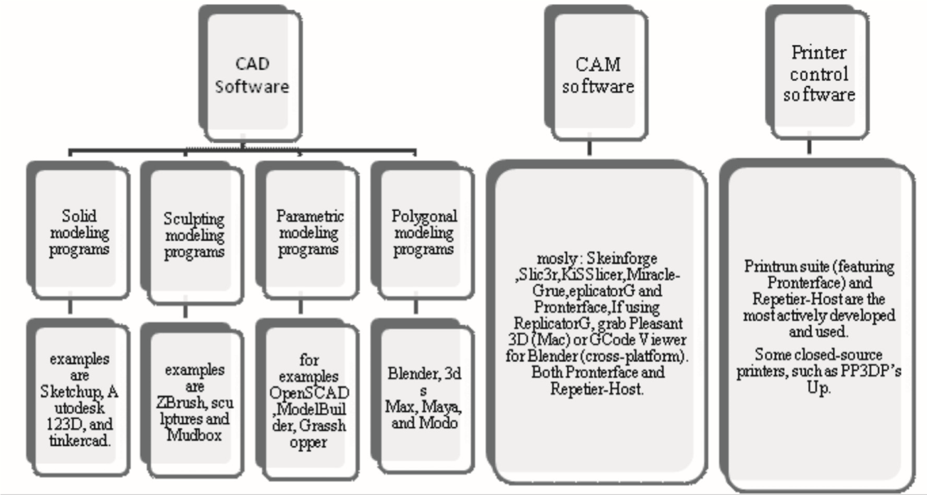

Fig. 3: Software hierarchy used in 3d printing

**Hardware and Software Control in 3D Printing**

3D printing with filament-based printers relies on a series of commands known as G-code. Figure 4 illustrates the interaction between hardware and software components. G-code commands are sent to the printer from a source computer, typically through a USB connection, although some printers support reading G-code directly from an SD card.

The printer’s firmware interprets each G-code command in sequence and executes it accordingly, directing the printer’s movements, extrusion, and temperature settings. Real-time status information, such as temperature and print progress, is sent back to the user’s computer via USB. In some systems, G-code interpretation is handled on the host computer, which then sends direct control signals to the printer for immediate execution.

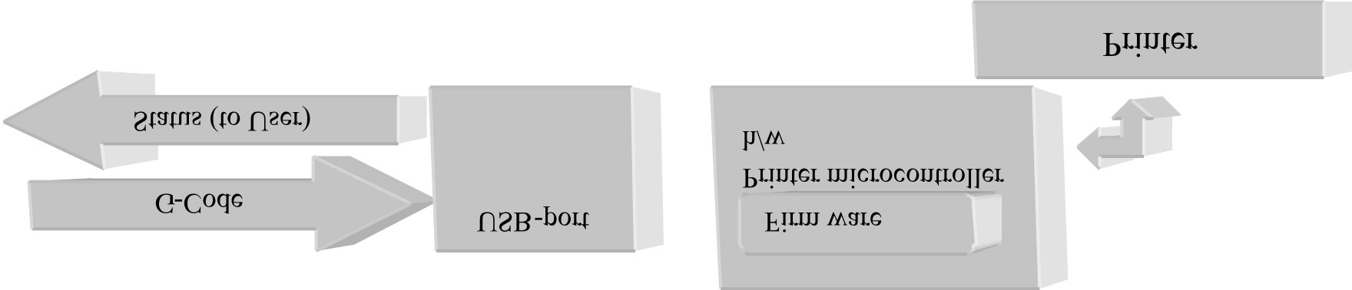

Figure 4: Controlling of 3D printing

**Table 1: most common 3D printing materials, categorized by material type.**

|  |  |  |  |
| --- | --- | --- | --- |
| **Material Type** | **Material** | **Description** | **Common Applications** |
| **Filament** | PLA (Polylactic Acid) | Biodegradable, easy to print, and low-warp; available in many colors | Prototyping, consumer products, educational models |
|  | ABS (Acrylonitrile Butadiene Styrene) | Durable and impact-resistant, but requires a heated bed and ventilation due to fumes | Mechanical parts, automotive components, toys |
|  | PETG (Polyethylene Terephthalate Glycol) | Strong, flexible, and chemical-resistant; good for functional parts | Food-safe containers, mechanical parts, outdoor equipment |
|  | TPU (Thermoplastic Polyurethane) | Flexible and rubber-like, highly durable and impact-resistant | Wearables, flexible parts, phone cases, grips |
|  | Nylon | Strong, wear-resistant, and flexible; low-friction, good for high-strength applications | Industrial parts, gears, tool prototypes |
|  | PVA (Polyvinyl Alcohol) | Water-soluble filament used for support structures in dual-extruder printers | Support material for complex or intricate prints |
| Powder | Nylon Powder | Used in powder bed fusion (SLS); provides high strength and flexibility | Functional prototypes, aerospace and automotive parts |
|  | Aluminum Powder | Mixed with polymers for SLS and metal printing | Lightweight metal parts, automotive and aerospace applications |
| Resin | Standard Resin | Used in SLA and DLP printers; offers fine detail but is brittle | Detailed models, miniatures, prototyping |
|  | Flexible Resin | Flexible and soft, can be stretched or compressed without breaking | Wearable items, grips, special effects |
| Metal Filament or Composite | Metal-Filled PLA | PLA mixed with fine metal powder, giving a metallic appearance and slight density increase | Artistic models, decorative parts |
|  | Wood-Filled PLA | PLA mixed with wood particles, providing a wood-like finish | Decorative objects, artistic and aesthetic parts |

1. **Recent Developments in 3D Printing Technology**

3D printing has experienced transformative advances across multiple sectors, including medicine, aerospace, and sustainable manufacturing [17-24]. Some key developments include:

1. **Bioprinting**: 3D bioprinting now enables the creation of complex tissues, such as cartilage for knees and ears, and custom implants tailored to patients. Successful tests in animal models have demonstrated the potential for future human applications.
2. **Metal Printing**: New high-performance alloys allow 3D printing of durable, lightweight metal parts for aerospace and automotive industries, while binder jetting technology offers cost-effective mass production.
3. **4D Printing**: This innovative technology enables materials to change shape over time in response to stimuli (heat, moisture, etc.), finding applications in adaptive building materials and soft robotics.
4. **Space Manufacturing**: NASA has successfully tested 3D printing on the International Space Station, marking a step toward in-space manufacturing for long-term missions.
5. **Construction Printing**: Large-scale 3D printers are used for rapid construction of buildings and emergency shelters, contributing to low-cost housing solutions.
6. **Eco-Friendly Materials**: Biodegradable and recyclable materials, including those made from organic waste, are increasingly used to make 3D printing more sustainable.
7. **Embedded Electronics**: 3D printing now enables the integration of sensors and circuits directly into objects, supporting wearable electronics and customized medical devices.

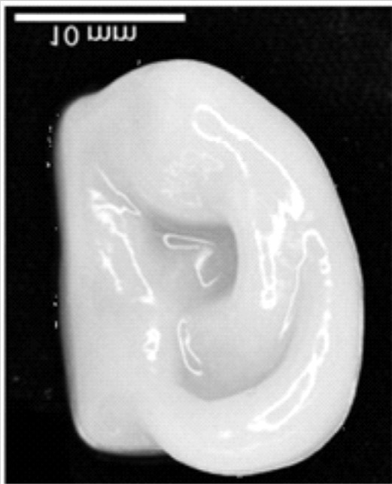

Figure 5: Scientist can 3D bio-print the shape of an ear using human cells that build up cartilage. 3-D printing of Heterogeneous materials could be a milestone to create biological structures [25-29].

**CONCLUSION**

This paper encapsulates the concept of 3D printing technology, including a comparative analysis of cost and build time against traditional manufacturing methods for part construction. Following a brief historical overview in the introduction, the second section explores additive manufacturing technology and its feed mechanisms, with emphasis on the most essential wire filaments in 3D printing. The third section provides a classification and survey of firmware used in 3D printing, alongside an outline of its controller process flow.

In conclusion, 3D printing is reshaping and revolutionizing industries, combining multiple technologies into a powerful, economically beneficial, and socially impactful tool. This transformative technology is improving the manufacturing sector and enhancing quality of life, as it finds applications across medicine, manufacturing, aerospace, biotechnology, and space research. 3D printing’s capability to produce complex structures on-demand and tailored to specific needs highlights its substantial potential to advance multiple fields and change global lifestyles.

**REFERENCES**

1. ISO/PRF 17296-1,"Additive manufacturing -- General principles -- Part 1: Terminology", 2015.
2. Bernard, A. and Fischer, A., New trends in rapid product development, CIRP Annals - Manufacturing Technology, Vol. 51, pp. 635- 652, 2002.
3. Birtchnell, T. and Urry, J., “3D, SF and the Future”, Futures ,2013, Vol. 50, pp. 25-34.
4. L. Ze-Xian, T.C. Yen, M. R. Ray, D. Mattia, I.S. Metcalfe, & D. A. Patterson, “Perspective on 3D printing of separation membranes and comparison to related unconventional fabrication techniques,” Journal of Membrane Science, Vol 523, No.1, pp. 596-613, 2016.
5. P. Holzmann, J. Robert, A. Aqeel Breitenecker, Soomro, & J. S. Erich, “User entrepreneur business models in 3D printing,” Journal of Manufacturing Technology Management, Vol. 28, No. 1, pp. 75-94, 2017.
6. Bob Hayward, David Moschella, Jon Schreiber, Simon Wardley, Howard Smith, “3D printing and the future of manufacturing” CSE, the rise of 3D printing.
7. A. Pirjan & D. M. Petrosanu, “The impact of 3D printing technology on the society and economy,” Journal of Information Systems & Operations Management, pp. 1-11, 2013.
8. A. M. T. Syed, P. K. Elias, B. Amit, B. Susmita, O. Lisa, & C. Charitidis, “Additive manufacturing: scientific and technological challenges, market uptake and opportunities,” Materials today, Vol. 1, pp. 1-16, 2017.
9. M. Lang, “An overview of laser metal deposition,” A publication of the Fabricators & Manufacturers Association, 2017. [Online]. Available: https://www.thefabricator.com/article/additive/an-overview-of-laser-metal-deposition. [Accessed 2019].
10. M. D. Ugur, B. Gharehpapagh, U. Yaman, & M. Dolen, “The role of additive manufacturing in the era of Industry 4.0,” Procedia Manufacturing, Vol. 11, pp. 545-554, 2017.
11. S.K. Tiwari, S. Pande, S. Agrawal, & S. M. Bobade, “Selection of selective laser sintering materials for different applications,” Rapid Prototyping Journal, Vol. 21, No.6, pp.630-648, 2015.
12. C. L. Ventola, “Medical Application for 3D Printing: Current and Projected Uses,” Medical Devices, Vol. 39, No.10, pp. 1-8, 2014.
13. S. Vikayavenkataraman, Y.H.F. Jerry, & F.L. Wen, “3D Printing and 3D Bioprinting in Pediatrics,” Bioengineering, Vol. 4, No.63, pp. 1-11, 2017.
14. P. Reddy, “Digital Light Processing (DLP),” Think 3D. 2016. [Online]. Available: https://www.think3d.in/digital-light-processing-dlp-3d-printing-technology-overview/. [Accessed 2019]
15. Chris Anderson, Makers: The new industrial revolution (New York: Crown Business, 2012), p. 210.
16. Joan Horvath, Mastering 3D printing technology.
17. Singh, H., & Bhushan, G. (2012). Finite Element Analysis of a Front Lower Control Arm of LCV Using Radioss Linear. In National conference in NCAMT-2012 held in NITTTR, Chandigarh, NITTTR, Chandigarh.
18. Gupta, A., Sharma, A., Singh, H., & Raghav, A. K. (2018). Experimental and numerical investigation of taper helical and spiral tube thermal performance. International Journal of Energy Research, 42(14), 4417-4428.
19. Singh, H. (2020). Flow performance comparison along the centerline in straight and s-shaped diffuser. Journal of Thermal Engineering, 6(1), 58-71.
20. Singh, H., & Kumar, D. (2020). Effect of face width of spur gear on bending stress using AGMA and ANSYS. International Journal for Simulation and Multidisciplinary Design Optimization, 11, 23.
21. Singh, H., & Kumar, D. (2020). Effect of face width of spur gear on bending stress using AGMA and ANSYS. International Journal for Simulation and Multidisciplinary Design Optimization, 11, 23.
22. Verma, A., & Singh, H. (2024). CFD and artificial neural network‐based modeling approach for the annual performance assessment of single slope single basin solar still. *Heat Transfer*.
23. Verma, A., El‐Bayeh, C. Z., Buddhi, D., Amir, M., Ahmad, F., & Singh, H. (2024). Socio‐economic impact of solar cooking technologies on community kitchens under different climate conditions: A review. *Engineering Reports*, e12998.
24. Gupta, A., & Singh, H. (2022). Experimental and computational study of performance characteristics in S-shaped diffuser.
25. Sharma, Ravikant, Vinod Kumar Mittal, and Vikas Gupta. "Homogeneous modelling and analysis of hip prosthesis using FEA." Journal of Physics: Conference Series. Vol. 1240. No. 1. IOP Publishing, 2019
26. Joshi, Tanuj, et al. "Design and analysis of metal-to-metal contact bolted flange joint using FEA tool." Advances in Engineering Design: Select Proceedings of FLAME 2020. Springer Singapore, 2021.
27. Mittal, Vinod Kumar, and Vikas Gupta. "Dry and wet lubrication analysis for multi-material hip assembly." International Journal of Automotive and Mechanical Engineering 19.1 (2022): 9606-9622.
28. Joshi, Tanuj, et al. "Dynamic fatigue behavior of hip joint under patient specific loadings." International Journal of Automotive and Mechanical Engineering 19.3 (2022): 10014-10027.
29. Ravikant, Vinod Kumar Mittal, and Vikas Gupta. "Homogeneous and heterogeneous modeling of patient-specific hip implant under static and dynamic loading condition using finite element analysis." Journal of The Institution of Engineers (India): Series D 105.1 (2024): 1-20.