**A STUDY ON CONSUMER’S PERCEPTION OF ELECTRONIC PAYMENT SYSTEMS**

**Aaria Parekh**

**Masters student at H.R College of Commerce and Economics, Mumbai, Maharashtra, India.**

**ABSTRACT**

The present paper attempts to examine the risks associated with Electronic Banking and Mobile Wallets and how that affects its usage. As individuals are becoming more receptive to such services, it speaks of the country's progress toward digitalization, signifying a bigger stride towards becoming a developed economy but also raises questions on what hazards prevent them from using such services and what challenges they are confronted with while using them. This research also aims to determine the level of understanding amongst people of the risks involved and educates people about the security steps they can take to avoid incurring such risks. A survey has been conducted from a sample audience of 122 respondents in the city of Mumbai and the findings indicate that people do prefer a cashless economy over a cash economy & the general trend and frequency of usage of electronic banking over physical banking is greater however, while people are still vary about the associated risks, the awareness of these risks and security measures adopted to combat them is also quite high and keeping in mind the many benefits which come along with it they are unlikely to abandon the use of these services.

**Keywords:** E-Banking, Mobile-Wallets, Online Payments, Security Threats, Cashless Economy

1. **INTRODUCTION**

Demonetization and the Covid 19 Pandemic has made the world shift online and with everything becoming digital, a whole new dynamic has evolved in people’s banking preferences as they have progressed to electronic banking services. Online Banking and Mobile wallets have seen a great rise in its user base & continues to grow as a source of payments because of its cost-effectiveness, ease of use and hassle-free approach.

However, the internet is a mixed blessing. Along with reduction in time and cost of transactions, it has brought about a new orientation to risks and with the ever-developing technology users are exposed to newer forms of risks and will continue to face these perils as long as they expose themselves to internet banking and the associated activities. Regulators all over the world are dealing with this conflict that while banks and digital payment providers should remain efficient and cost effective, one cannot turn a blind eye to the growing threats and security risk users are being exposed to especially since majority of the users unknowingly become vulnerable to these attacks.

With electronic banking becoming an indispensable aspect of our everyday lives, these risks need to be identified and curtailed in order to ensure a more effective & safe system is put in place.

1. **METHODOLOGY**
   1. **Objectives of the Research**

* To determine the variables which influence use of electronic banking and its perceived security risks .
* To determine which variables, encourage the use of Mobile wallets and determine how secure it is.
* To understand the various risks that prevent customers from using electronic banking and the use of mobile wallets
* To learn about the security precautions taken to reduce the dangers risks associated with electronic banking.

**2.2 Review of Literature**

**A Study on Impact of Demonetization on E-Banking in India- Asst. Prof. Mrs. Suman T D & Dr. A C Kiran Kumar (October, 2024)**

Demonetization had been implemented by India two times prior to this i.e. in 1946 and 1978. Success of demonetization depends on its implementation. For effective implementation banks play a strategic and vital role. During the 2016 demonetization Indian Banks faced numerous problems right from physical cash crunch at the outset to even more challenging issues such as withdrawal limits, insufficient withdrawal points etc. This led to heavy crowd in banks and ATMs leading to outrage amongst bank’s customers. This paved way for the development of the E-Banking system. Many started to transact on E-Banking system like NEFT, RTGS, and so on. On the other hand, the Government of India has also encouraged electronic banking transactions as a part of Prime Minister Narendra Modi’s Digital India concept. This study tries to analyze the impact of demonetization on E-Banking system. Banks are core part of any economy for channelizing the money to the smooth functioning of different sectors and are the key contributors to the overall economic growth of any country and thus the importance, growth and implication of E-Banking is significantly reflected.

**Research on INTERNET BANKING: Challenges & Opportunities in Indian Context - Vikas Chauhan & Dr. Vipin Choudhary (June, 2021)**

With the changing times it has been observed that the way banks used to operate has changed due to the advent of internet in banking institutions. Implementing the electronic banking approach has benefited the both the consumers as well as banks. Considering the benefits of electronic banking, banks all over the globe have implemented electronic banking and banking organizations in India are no exception. Still the concept of electronic banking is a fairly new one to Indian consumers as compared to its developed counterparts and the risks associated are substantial in number and the digital India Model is still in the nascent stage. In summary, the paper attempts to understand the concept of internet banking as well as study the benefits of electronic banking from perspective of consumers as well as banks. Further, the paper discusses the challenges and opportunities associated with electronic banking. The discussion concludes that electronic banking is slowly gaining acceptance in Indian scenario however significant efforts still need to be made to improve its overall acceptance.

**2.3 Research Methodology**

This research has been conducted using an online structured questionnaire answered by 122 individual respondents selected on basis of random sampling in the city of Mumbai. The design used descriptive tools such as pie chart and bar graphs to highlight the data analysis. The design also includes a secondary data expressed through an analysis of the available Literature Reviews and a study of the existing data and information found in the concerned area through various online and offline sources indicating that a certain segment of the study was exploratory in nature.

1. **SECONDARY DATA**

**3.1. What is Electronic Banking and Mobile Wallets**

With the increase in the Digital India movement, making online payments has become a part of our everyday routine and this transition became even more necessary in the post demonetization era and more so after the Covid 19 pandemic where everything was taking place on a contactless basis. While we are talking about digital payments, two online banking services have played a major role for making the country as cashless economy: Electronic Banking and Mobile Wallets.

*Electronic Banking –* is basically carrying out all banking services online digitally through the bank’s website or the bank’s mobile applications. It includes every banking activity and covers the whole range of net banking facilities, or internet fund transfer services such as IMPS (Immediate Payment Services), NEFT (National Electronic Fund Transfer), and RTGS (Real-time Gross Settlement), monitoring account balances etc.

*Mobile Wallets –* they refer to the digital platform where a person’s money is stored and payments can be effected through a simple scan of a QR Code or through mobile number based payments. It is either linked to one’s bank account or alternatively a person can add a balance to that account and facilitate payments. Paytm, Google Pay, Amazon Pay Balance etc. are some of the most popular mobile wallets in India and facilitates a one clicks payment through UPI.

**3.2. Growth in Usage of Electronic Banking and Mobile Wallets**

By 2025, India's mobile payment sector is predicted to grow at a rate of 22.0 percent, reaching US$1.25 billion. In India, digital payments have seen rapid development. Policy measures to promote digitalization and the demonetization initiative and the bold move by the Indian government allowing mobile- wallet interoperability and the enhanced the mobile wallet ecosystem's competitiveness have all contributed to this.

The Indian mobile payment sector has seen rapid development in both proximity and non-proximity payments, making it one of the world's fastest growing marketplaces. With more than one billion subscribers, India is the world's second biggest market for mobile payments. Improved mobile bandwidth,low-cost smart phone pricing and affordable data plans have made the electronic banking climate conducive.

**3.3. How has it benefited the Customers/ Banks?**

#### **Perks To Customers**

* *Conserves time and money*

When compared to the traditional banking system, it offers less waiting time and more convenience as well as a much cheaper cost structure than traditional delivery routes.

#### Convenience and Ease of Use:

It allows customers to do business through the internet from the convenience of their homes or workplace and allows customers to monitor their transactions instantly.

#### Self-service Path:

Electronic banking offers customers a self-service channel for a variety of banking services reducing the reliance on bank employees or other time-consuming processes.

#### **Perks To Banks**

* *Increased Profitability:*

Internet use aids banks in increasing their profits due to lowering operating costs and enhances profitability.

#### Improves Relationship With Customers:

By providing access to efficient banking services, it helps banks create a foundation of strong relations with customers and enhances goodwill long term relationships.

#### Environmentally Friendly Image:

Electronic banking minimizes paper consumption and carbon emissions by eliminating the need of in person banking and thus demonstrates the bank's care for the environment, which will aid the banks in projecting an environmentally friendly image.

**3.4. Risks associated with Electronic Banking and Mobile Wallets**

While the E-banking and mobile wallet system of carrying out financial transactions has been a boon to people, it has its own flip side! Users of these services are exposed to varied risks which shakes users’ confidence in the use of these platforms:

| **Risk** | **Electronic or E- Banking** | **Mobile Wallet** |
| --- | --- | --- |
| **Phishing attacks** | Phishing attacks are a common threat to E- banking users, where fraudsters create fake websites that look like legitimate bank sites to steal login credentials and other sensitive information. | Mobile wallets are also vulnerable to phishing attacks, where scammers send fraudulent messages or emails that appear to be from the wallet provider to trick users into providing login credentials or personal information. |
| **Hacking and malware attacks** | E-banking accounts are susceptible to hacking and malware attacks, which can result in unauthorized access to sensitive information and financial transactions. | Transactions from mobile wallets are also prone to attacks by hacking and malware, which can lead to unauthorized transactions. |
| **Identity theft** | E-banking users may fall victim to identity theft, where scammers steal personal information to open new accounts or obtain credit in the user's name. | Mobile wallet users may also be at risk of identity theft, as personal information such as name, address, and phone number are stored in the wallet. |

**3.5. Measures to Combat these Risks**

***For E-Banking:***

* Using a strong and unique password and regularly monitoring your account transactions and reporting any unauthorized transactions immediately to the bank
* Avoiding the using public computers or networks for accessing net banking and ensuring the validity of the bank's website/mobile application URL before logging in.

***For Mobile Wallets:***

* Choosing a reputable digital wallet provider with robust security measures and two factor authentication and encryption.
* Using strong passwords for the account and exercising caution before opening phishing emails or text messages and avoiding the use of public wi-fi.

1. **PRIMARY DATA**

Primary data was collected through an online survey comprising 11 questions with 122 respondents

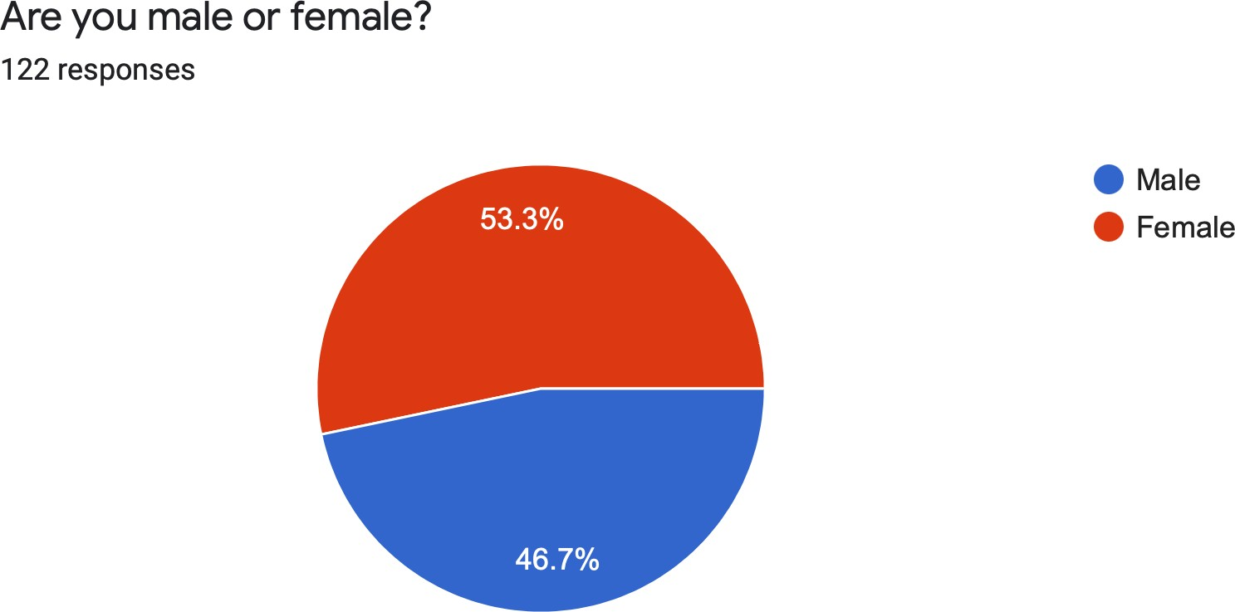**Q1. What is your gender?**

|  |  |
| --- | --- |
| **Gender** | **Response in Number** |
| Male | 57 |
| Female | 65 |

**Analysis:** 122 respondents answered this question from which the majority of responses were filled by women (53.3% or 65 numerically) and the remaining (46.7% or 57 numerically) were men. It is pertinent to note that there isn’t a distinct majority in either sex, the responses from both males and females are fairly equal.

**Q2. What is your age?**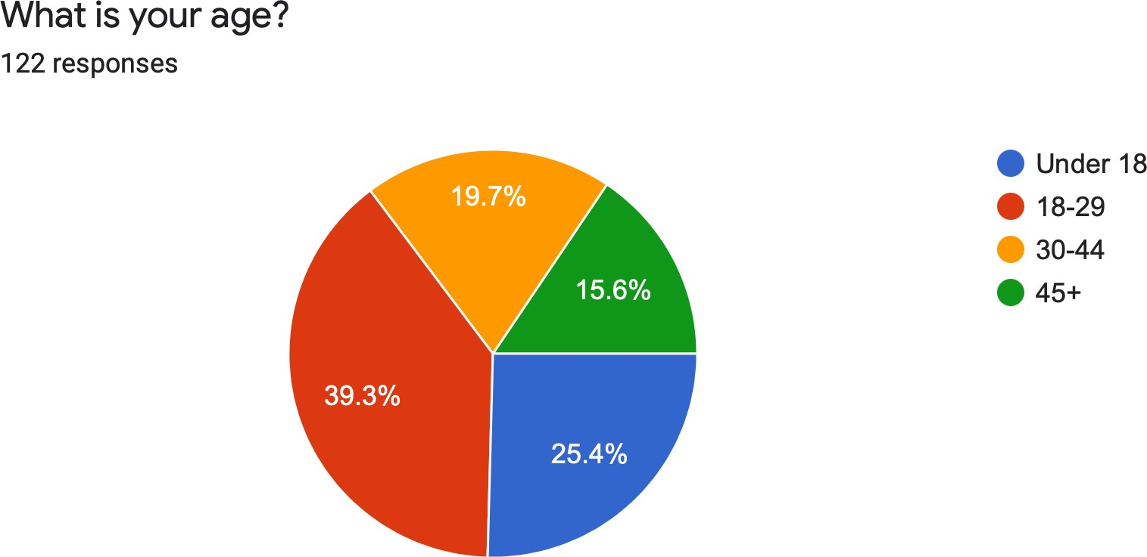

|  |  |
| --- | --- |
| **Age** | **Response in Number** |
| Under 18 | 31 |
| 18-29 | 48 |
| 30-44 | 24 |
| 45+ | 19 |

**Analysis:** Most of the respondents were from the age group 18-29 (39.3% or 48 numerically), followed by the under 18 category (25.4% or 31 numerically) and 30-44 group (19.7% or 24 numerically) and the least percentage of respondents were recorded from the 45+ group (15.6%. or 19 numerically). The diversification in the age group highlights the different perceptions of citizens of various age groups ensuring that it covers as many differentiations of opinions between the age groups.

**Q3. Do you use electronic banking?**

|  |  |
| --- | --- |
| **Yes/No** | **Response in Number** |
| Yes | 80 |
| No | 42 |

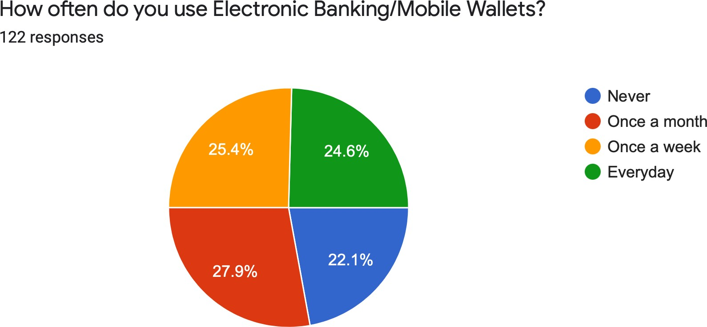

**Analysis**: a large number of the respondents ie 65.6% do indeed use electronic banking, while the remaining 34.4% do not use electronic banking. As it can be seen, a sizeable majority do use electronic banking, and it is assumed that they must be aware of the risks. Those that do not, may either be unaware of the system or may have security concerns , which is possibly why they do not use it.

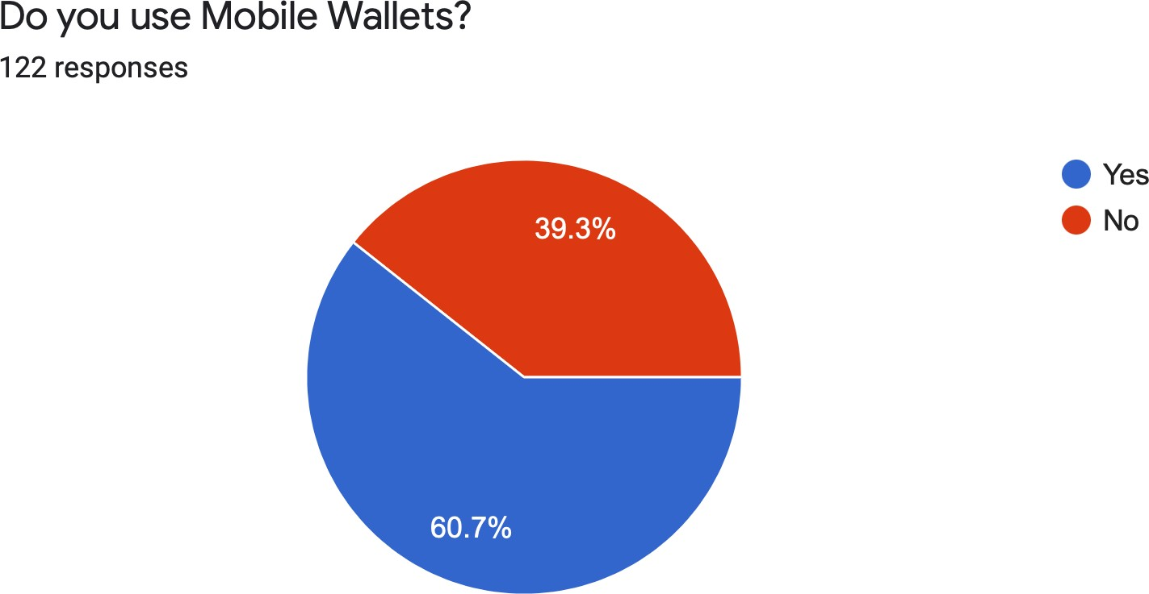**Q4. Do you use Mobile Wallets?**

|  |  |
| --- | --- |
| **Yes/No** | **Response in Number** |
| Yes | 74 |
| No | 48 |

**Analysis:** 60.7% of the respondents do indeed use mobile wallets, while the remaining while 39.3% do not use mobile wallets. As it can be seen, a sizeable majority do use mobile wallets, and must be aware of the risks. Those that do not, may either be unfamiliar with it or may have a perceived security risk.

**Q5.** **How often do you use electronic banking/mobile wallets?**

|  |  |
| --- | --- |
| **Regularity** | **Response in Number** |
| Never | 27 |
| Once a Month | 34 |
| Once a Week | 31 |
| Everyday | 30 |

**Analysis:** 27.9% respondents were from the once a month group, followed by respondents from the once-a-week category at 25.4% and 24.6% respondents belong to the everyday group. The least percentage of respondents were from the never group at 22.1%. This proves that electronic banking and mobile wallets do form an integral part of people’s financial lives. 77.9% of respondents use these services a minimum of once a month.

**Q6. Do you think Electronic Banking/Mobile-wallets are secure?**

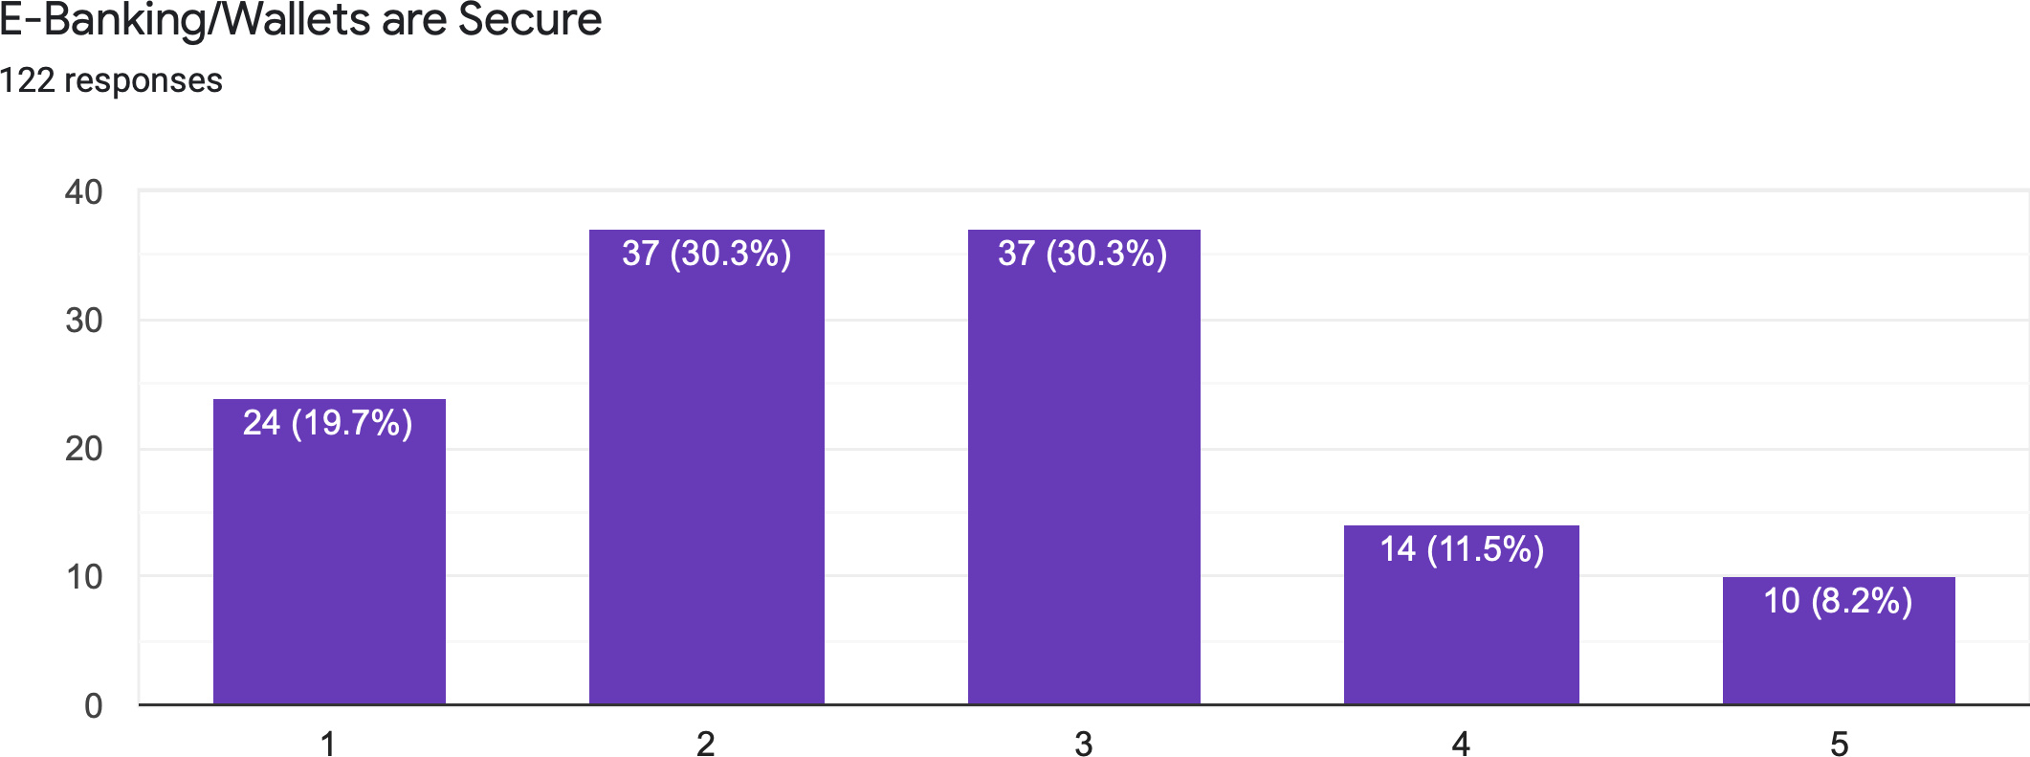

|  |  |
| --- | --- |
| **Opinion** | **Response in Number** |
| Strongly Agree | 24 |
| Agree | 37 |
| Neutral | 37 |
| Disagree | 14 |
| Strongly Disagree | 10 |

**Analysis:** 30.3%, and a tied majority of the respondents agree/ are neutral about the security of digital payment systems. 19.7% strongly agree with the premise that E-Banking/Mobile -Wallets are secure. Followed by respondents who disagree at 11.5%, and then the least chosen response is strongly disagree at 8.2%. Overall, the scale is tilted to agreement about the electronic payment systems being secure, with agree and neutral being more preferred than strongly agree.

**Q7. Do you think electronic banking/mobile wallets are safer than cash?**

|  |  |
| --- | --- |
| **Yes/No** | **Response in Number** |
| Yes | 74 |
| No | 48 |

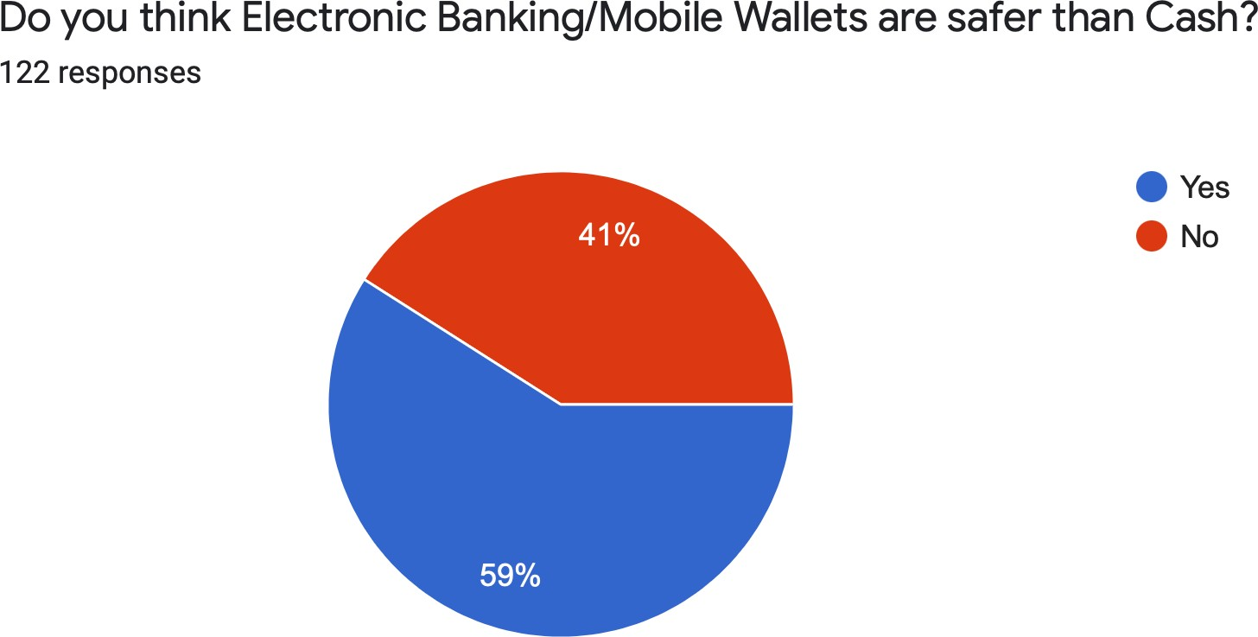

**Analysis:** 59% of the respondents do indeed think electronic banking is safer, while the remaining 41% respondents believing in the safety of cash over digital payment methods. This proves that there is a majority belief in the safety of digital payment methods, even over cash. However, a sizeable amount are still vary of the risks they possess.

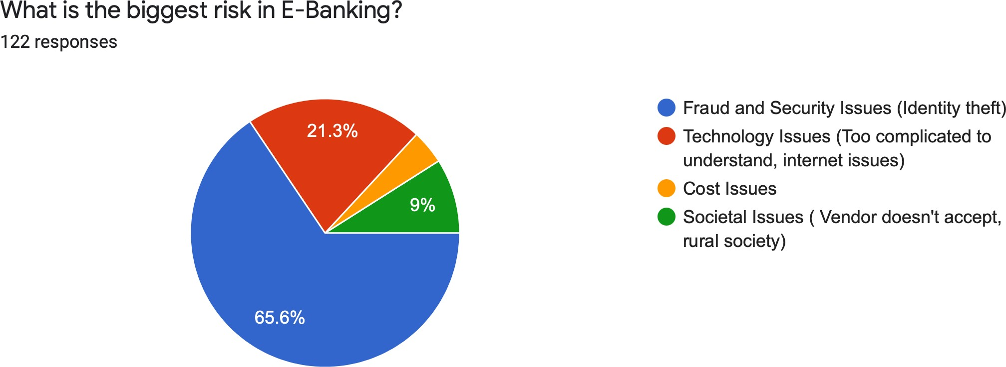**Q8.** **What is the biggest risk in e-banking?**

|  |  |
| --- | --- |
| **Risk** | **Response in Number** |
| Fraud and Security Issues | 80 |
| Technology Issues | 26 |
| Cost Issues | 5 |
| Societal Issues | 11 |

**Analysis:** 65.6% of the respondents find fraud and security issues to be the biggest risks, followed by 21.3% of the respondents who find technological issues to be a risk. Only 9% of the respondents find cost to be an issue followed by a very small 4.1% of the respondents find societal issues as a risk in e-banking

**Q9. Have you ever lost money to e-banking fraud?**

|  |  |
| --- | --- |
| **Yes/No** | **Response in Number** |
| Yes | 31 |
| No | 40 |
| No, but I know of people who have | 51 |

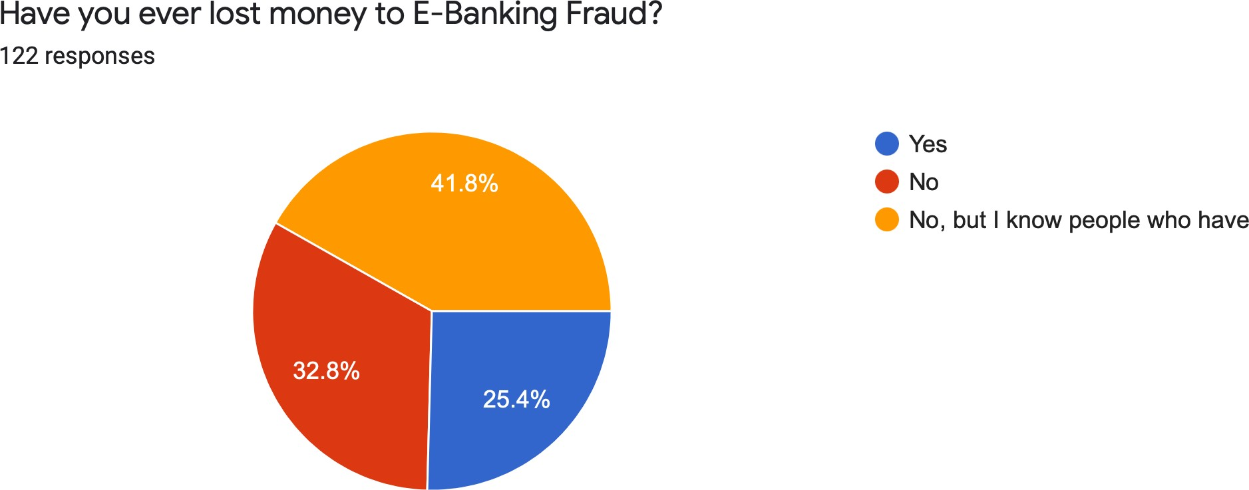

**Analysis:** 32.8% respondents haven’t lost money to e-banking fraud , however 41.8% know of some people who has/have lost money to e-banking fraud while 25.4% respondents have been a victim e- banking fraud. Relatively, a majority of the respondents have used e-banking without falling prey to fraud.

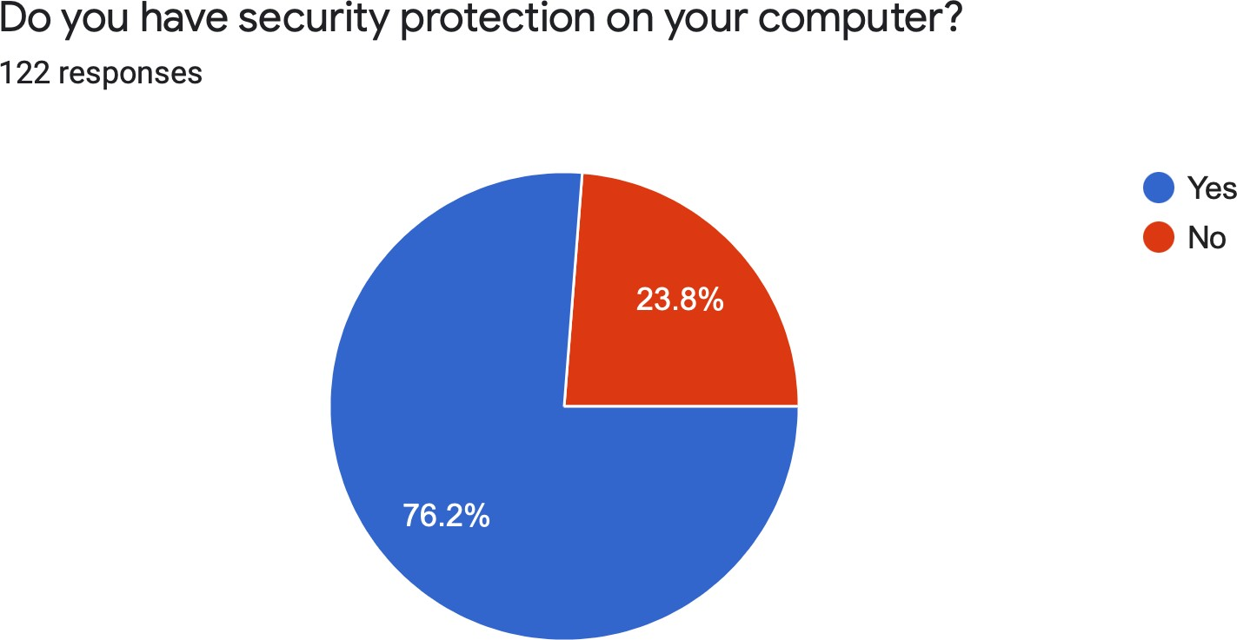**Q10. Do you have security protection on your computer?**

|  |  |
| --- | --- |
| **Yes/No** | **Response in Number** |
| Yes | 93 |
| No | 29 |

**Analysis:** 76.2% of the respondents do indeed have security protection, while the remaining 23.8% do not. This shows that a majority believe in the risks of digital payments to the point that they feel the need to secure their devices.

**Q.11 If yes, what security protection do you have?**

|  |  |
| --- | --- |
| **Yes/No** | **Response in Number** |
| Anti-virus Software | 63 |
| Firewall | 22 |
| Ad-block | 11 |

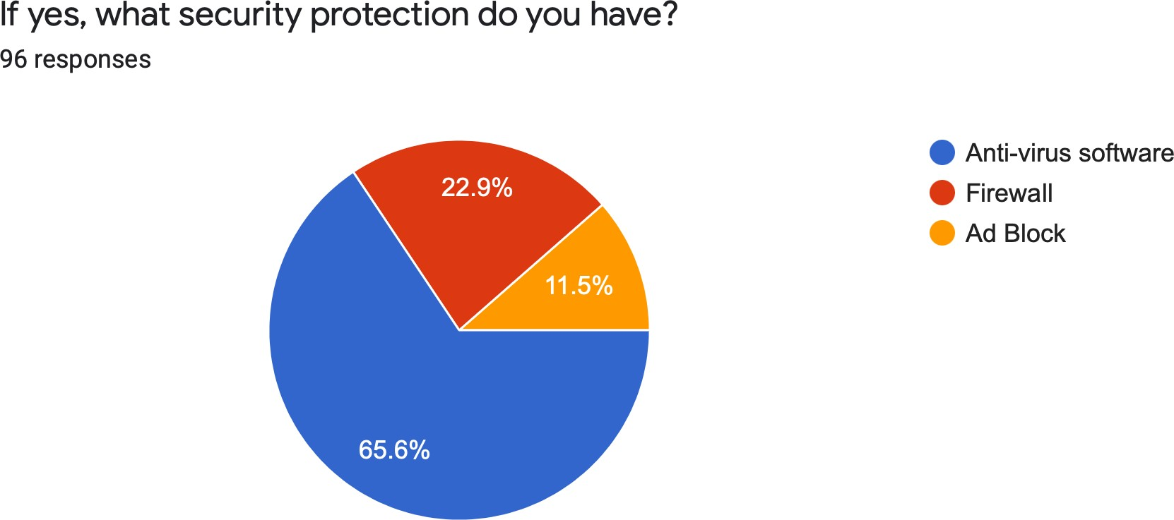

**Analysis:** Out of 96 respondents, 65.6% of the respondents use anti-virus software, followed by 22.9% using firewall. The least chosen response, ad block was used by only 11.5% people. Thus, it is evident that a good anti-virus software helps secure the device.

1. **FINDINGS**

* Almost an equal mix of Male & Female respondents responded to the survey conducted.
* Age group is quite well represented except the 45 plus age group at 15.6%. The diversification in the age group highlights the different perceptions of citizens of various age groups
* 65.6% of the respondents do indeed use electronic banking, while those who don’t are at 34.4% who may have concerns on the security, which is possibly why they do not use it.
* As it can be seen, a sizeable majority i.e., 60.7% do use mobile wallets, and it is presumed that they must be aware of the risks and are still trusting it.
* 77.9% of respondents use these services a minimum of once a month and only 22.1% of have never used these services. Hence, we conclude electronic banking/ mobile wallets form an integral part of people’s financial lives.
* There is a tied majority at 30.3% of the respondents who agree/ are neutral about the security of digital payment systems while 19.7% strongly agree that E-Banking/Mobile -Wallets are secure while 11.5% disagree and 8.2% strongly disagree to its safety we can see a tilted scale on the overall towards agree/neutral.
* 59% of the sample believes that electronic banking is safer than cash as opposed to the remaining 41% which goes to prove that the majority find these transactions secure.
* Most of the respondents i.e., 65.6% believe Fraud and Security is the major risk, followed by technology issues at 21.3% and societal issues at 9%. The least percentage were facing cost issues at 4.1%. Thus, concluding that fraud and security issues are the highest perceived threats.
* 74.6% of the sample has not lost money to E-Banking Fraud which proves that it is not always a risky option.
* 76.2% of the respondents do indeed have security protection, while the remaining 23.8% do not. This shows that a majority are wary of the associated risks and have found methods to secure their devices.
* Out of 96 respondents (sample which have security protection), 65.6% use anti-virus software, followed by 22.9% using firewall. The least chosen response, ad block at 11.5%. Thus, it is evident that a good anti-virus software is the most trusted choice to ensure device security.

1. **SUGGESTION**

Over the last decade, electronic banking has grown in popularity and the rate at which it is continuing to expand is phenomenal, and as technology continues to progress, its influence will be seen in its enhanced application in the electronic banking field. However, with each passing year and every development in technology the risks involved with electronic banking are only going to surge and so are the concerns of the users. Thus, the suggestions are focused on creating increased awareness of the security risks amongst users and focusing in discovering ways of limiting and mitigating the risks that occur through the use of online payment systems, as the core focus of the research was to understand how safe users find electronic banking and their response to the risks. So, what can be done?

E-Banking and mobile wallet service providers can ensure transaction safety for users by building in a robust security system such as user authentication methods like biometrics, multifactor authentication and strong password, reducing the risk of unauthorized access. Service providers should also aim at reducing system defaults and quick recovery of money wrongly routed to other accounts to ensure they retain user trust and confidence. Another important facet is continuously providing user education and making users alert on scams and tricks and preventing them from revealing sensitive data.

In terms of users, it is recommended that they recognize that each technological change will come with its own set of hazards. The suggestion for users is to be alert and aware, know of the scams and frauds taking place and they should be quick to report them if a fraud or phishing attack or any such security breach takes place with them so others in the society can become cautious and it is the duty of every individual dealing with electronic banking or mobile wallet or simply carrying out any financial transaction to be familiar and updated with every relevant guideline issued by the Reserve Bank of India and ensure they invest in the best data protection and security softwares to mitigate risks.

Lastly the government should take stringent measures and ensure strict legal provisions are in place to deal with such scenarios and punish the individuals who are guilty of such offences. It is only then that electronic banking and use of mobile wallets will become an absolute safe space.

1. **CONCLUSION**

The rise of electronic banking and mobile wallets has revolutionised the traditional banking industry. With the convenience and accessibility it offers, online banking and payment systems have become increasingly popular. It is not just a financial evolution but a cultural and technological transformation in the way we manage our financial transactions. This revolution has ushered into our lives a new era defined by absolute convenience and any time accessibility (24/7) saving individuals of the long hours spent in the bank queues. This convenience factor has been a major driver behind the growing popularity of digital banking.

As banking and payments becomes digital, the risk of cyber-attacks and data breaches no doubt increase and concerns about cybersecurity are valid, but banks and mobile wallet service providers are implementing measures to safeguard user information and transactions.Encryption technologies, multi-factor authentication, and real-time fraud monitoring systems have significantly reduced the risks associated with online banking and payments Moreover, digital banking allows users to keep track of their transactions in real-time, making it easier to detect any suspicious activity and take immediate action. There is no doubt that these come with associated risks and there have been times where people have fallen victims to the scams associated with electronic banking and mobile wallets ,but with time, several safeguard mechanisms have evolved and the study conducted indicates that users are aware of these risks and have also adopted security measures to ensure safety of their financial dealings thus a robust environment has been created and is only going to progress with the times to come.

As electronic banking and payment systems continues to evolve , users can look forward to a personalised banking and financial transaction experience with A-1 driven insights that will guide their financial decisions and strategies in a more wholistic way. Electronic banking will no longer be a static service, it will be dynamic and customised to meet the needs and expectations of an increasingly tech-savvy and digitally connected world.

1. **REFERENCES**
2. Suman T.D, A.C Kiran Kumar, Kavya T.K & Vimla, A study on impact of Demonetisation on E-Banking in India, Journal of Emerging Technologies and Innovative Research, Volume 11, Issue 11, October 2024
3. Vikas Chouhan, Vipin Choudhary, Internet Banking: Challenges and Opportunities in the India Context, Apeejay-Journal of Management Sciences and Technology, Volume 2, Issue 3, June 2015
4. Shuaib Azam, What are the risks associated with Net banking and Digital Wallets & How to Mitigate them, 10 March 2024 retrieved from <https://www.myhubble.money/blog/what-are-the-risks-associated-with-netbanking-and-digital-wallets-how-to-mitigate-them>
5. Bhavna Bajpai (2016). Banking Management: Impact, Risks, Security retrieved from <https://www.academia.edu/324780/E_BANKING_MANAGEMENT_IMPACT_RISKS_SECURITY>
6. Naresh, N. (2017, May 1). Are mobile wallets the answer for cashless economies? retrieved from https://www.inventiva.co.in/trends/mobile-wallets-answer-cashless-economies/
7. Dhillon, D. (2018, May 29). India has the highest rate of online banking frauds in the world: report <https://www.businessinsider.in/india-has-the-highest-rate-of-online-banking-frauds-in-the-%20world-report/articleshow/64369651.cms>
8. How to safely manage your mobile wallet account , retrieved from, [How to Safely Manage Your Mobile Wallet Account](https://trustdecision.com/resources/blog/how-to-safely-manage-your-mobile-wallet-account-guide)
9. Digital Revolution in Banking: Adapting, retrieved from [The Digital Revolution in Banking: Adapting to the New Norm](https://www.jindalx.com/blog/the-digital-revolution-in-banking-adapting-to-the-new-norm/)