**H.R. COLLEGE OF COMMERCE AND ECONOMICS, CHURCHGATE 2023-24**

**S.Y.M.COM SEMESTER 3 - BUSINESS MANAGEMENT**

**HSPMCBM 030**

**NAME: GAURI BHASKAR KATKAR**

**RESEARCH METHODOLOGY**

**TOPIC : CLIMATE CHANGE**

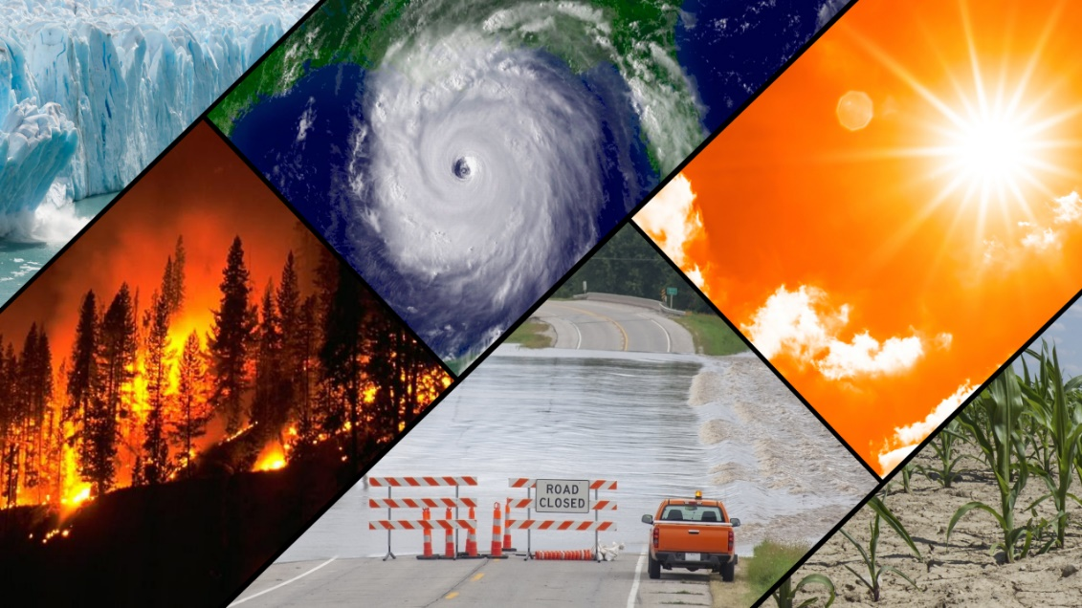

LIST OF CONTENTS

* Introduction
* Objectives
* Hypothesis
* Review of literature
* Research methodology
* Primary and secondary data
* Data analysis
* Suggestions and Findings
* Conclusion
* Bibliography

INTRODUCTION

Climate change is an area of science that has been studied for many years. The fossil record has taught humankind much about conditions on Earth long prior to our arrival. We now live in a unique time in that our scientific abilities have not only given us a precise age of the planet, but of the universe itself. Yet there are many things we do not understand, and some of the questions that remain before us may have a significant impact on the quality of our lives in the future. As our current civilization observes an unquestioned period of warming on Earth, the issue of the nature of this change remains a topic of discussion for both scientists and the public at large. It is important, therefore, for those of us in the educational community to help our students get the best information with which to guide their own thoughts and decisions in a changing world. This paper analyzes educational resources for climate change and applies concepts from these resources to research-focused curriculum for secondary school students.

OBJECTIVE

My purpose is to develop curriculum that uses the topic of climate change as a context for teaching standards-based research skills to secondary school students. Students are better able to understand scientific issues if they have developed research skills.

HYPOTHESIS

* Do they think that there are climate change skeptics within the scientific community?
* Do they believe that temperature change is the result of human activity?
* Are there other possible causes?
* How many students have watched movies or documentaries about climate change?
* How many students have read books or other research on the subject?
* Are there any students who have gleaned all they know about climate change from newspapers, TV, and radio?
* What evidence suggests that our climate is changing?
* What observations have the students made?
* Are they convinced that the earth’s climate is warming?

My research is focused on teaching students about two important topics; climate, which is a necessary area of science for young people to be familiar with, and research skills, which are abilities that are relevant to many areas of students’ lives. In order to ensure that students have a thorough understanding of the content discussed herein, I have developed a unit which is partly project-based in nature.

Therefore, my first theoretical rationale for approaching this project recognizes constructivist ideas in interdisciplinary and project-based learning for improving student knowledge and its applications. The research component of my curriculum stems from a second theoretical rationale. This would be the theory of knowledge, one of the main ideas used by the International Baccalaureate program, an international education program for secondary school students. As stated by the International Baccalaureate Organization, (2005-2008) this area of study focuses on how we know what we know. “It offers students and their teachers the opportunity to:

• reflect critically on diverse ways of knowing and on areas of knowledge

• consider the role and nature of knowledge in their own culture, in the cultures of others and in the wider world.

In addition, it prompts students to:

• be aware of themselves as thinkers, encouraging them to become more acquainted with the complexity of knowledge Research on Climate Change 8

• recognize the need to act responsibly in an increasingly interconnected but uncertain world.”

REVIEW OF LITERATURE

**A Short History of Climate Change Science**

Climate change and global warming are terms that are sometimes used synonymously, but they have different meanings in the sense that a ‘warming” is only one phase of the larger climate system on Earth that naturally features change. Physical evidence on Earth and in space has helped scientists understand that there are many factors that can contribute to the changing of the planet’s climate on a long-term basis. Examples of these factors are solar radiation levels, Earth’s orbit around the sun, volcanic activity, ocean currents, and even plate tectonics.

The periods of warming and cooling are referred to as interglacials and glacials, respectively, with the latter being partly characterized by enormous sheets of ice extending from the poles.

Recent periods of change within human history include the Medieval Warm Period (A.D.1000-1270) and the Little Ice Age (A. D. 1270-1850) (Singer & Avery, 2007) The history of climate change discussion among people goes farther back in time than one might think. Weart (2007) notes that climate change was conceptualized in ancient times, with knowledge of the subject growing as the technology to study it improved over time.

An important figure in climate science history who warned of possible problems was Guy Stewart Callendar, whose idea of carbon dioxide as a heat trapping agent was indeed borne out by computer climate simulations in the 1970s- “Even subtle changes in the Earth's orbit could make a difference. To the surprise of many, studies of ancient climates showed that astronomical cycles had partly set the timing of the ice ages. Apparently the climate was so delicately balanced that almost any small perturbation might set off a great shift” (Weart, 2007. Para. 10). More recently, Earth’s climate has been studied by the Intergovernmental Panel on Climate Change, an organization made up of many scientists who specialize in climate studies.

The IPCC has issued four reports over recent years that have studied the connections between human activity and climate change. The most recent report, “Climate Change 2007”, declared that the consensus of the group is that there is 90% certainty that global warming is directly related to human greenhouse gas emissions. The IPCC was awarded with the Nobel Peace Prize for their efforts in raising world-wide attention to this issue.

**RESEARCH METHODOLOGY**

Despite the growing body of knowledge about the dynamics of Earth’s climate, and the statements of global warming consensus in the scientific community, there are those who question the “anthropogenic” warming concept. There are also many unanswered questions about climate regardless of which side of the issue one is on. In a study written by Leiserowitz, (2007), the point is made that people’s understanding of climate change is critical to addressing the issue because it is in the public domain that political pressure emerges. “Public opinion is critical because it is a key component of the socio-political context in which policy makers operate. Public opinion can fundamentally compel or constrain political, economic, and social action to address particular risks. (p. 3) Although there is not a substantial amount of data from which to draw conclusions about American citizens’ perception of climate change risk, various surveys in recent years can inform questions on current thought in the country.

PRIMARY DATA

Climate change is the long-term progression of patterns in the world's climate. These changes are commonly related to human activities such as the use of certain nonrenewable resources like fossil fuels. Once burned, these energy sources help raise the Earth's temperature by releasing greenhouse gases into the atmosphere. Climate finance is a way for individuals and nations to help fight climate change.

In the most general sense, climate finance refers to any type of financing used to tackle climate change. Financing normally takes place on the municipal, national, or international level and comes from various sources—both public and private.

The topic of climate finance is growing in international importance, as countries and companies become increasingly aware of the [risks](https://www.investopedia.com/terms/r/risk.asp) and opportunities associated with [climate change](https://www.investopedia.com/articles/investing/051514/preparing-your-portfolio-climate-change.asp). For instance, the United Nations Environment Programme (UNEP) reported in September 2019 that between 2010 and 2019, global investments in renewable energy technologies exceeded $2.5 trillion, roughly quadrupling the global energy capacity associated with renewable sources.

Various [financial institutions](https://www.investopedia.com/terms/f/financialinstitution.asp) and technologies played an essential role in facilitating this shift in global energy infrastructure. Among the examples of how finance plays a role in this process include the use of:

* [Banks](https://www.investopedia.com/terms/b/bank.asp) and other intermediaries to transfer capital overseas.
* Financial markets to price energy [commodities](https://www.investopedia.com/investing/commodities-trading-overview/).
* [Derivative](https://www.investopedia.com/terms/d/derivative.asp) markets to [hedge](https://www.investopedia.com/terms/h/hedge.asp) and exchange risks related to energy prices.
* [Stock exchanges](https://www.investopedia.com/terms/s/stockmarket.asp) and investment vehicles to facilitate investment in renewable energy companies.

Climate finance encompasses all of these activities, which are likely to accelerate even further in the coming years.3

U.S. Department of Treasury. “[Remarks by Under Secretary for International Affairs Jay Shambaugh at the Institute of International Bankers’ Annual Washington Conference](https://home.treasury.gov/news/press-releases/jy1323).”

As noted above, the term also has a more narrow meaning. In this sense, it relates to the question of how developed countries should support developing ones in their transition toward energy sources and other technologies with improved environmental footprints. These discussions are frequently contentious and raise a slew of morally ambiguous questions.

**OECD Climate Finance Forecasts**

The OECD presented two scenarios for future levels of climate finance provided and mobilized by developed countries for 2021-2025. These scenarios are based on a OECD analysis of forward-looking public climate finance information submitted by developed countries. The information on future levels of climate finance is inherently uncertain with factors such as legislative processes, macroeconomic conditions, and project pipelines in partner countries affecting future spend expectations.

When forecasting climate finance, the OECD prepared one scenario based on countries and development banks fully delivering on their climate finance commitments. As has been the case with the original agreement from COP15, the second scenario is rooted in delays in scaling up climate finance due the variety of variables and constraints discussed below.

**Example of Climate Finance**

Let's look at an example to show how climate finance works in the real world. A common demand from developed countries, such as those in North America and Europe, is that developing nations, such as those in Asia or sub-Saharan Africa, should refrain from relying on new coal-fired power plants. On the other hand, these developing countries often contend that this demand is hypocritical since developed countries were able to exploit coal and other inexpensive fossil fuels during their own periods of [industrialization](https://www.investopedia.com/terms/i/industrialization.asp).

For this reason, many believe that developed countries have a moral obligation to subsidize developing countries by helping them invest in more environmentally friendly energy sources such as wind, solar, and hydroelectric power.

SECONDARY DATA

The debates around climate change become increasingly difficult when one seeks to find the exact definition of a developing country and to determine how much responsibility each country has for carbon emissions.

Should the United States provide [subsidies](https://www.investopedia.com/terms/s/subsidy.asp) to China, for example, due to the fact that its [per capita income](https://www.investopedia.com/terms/i/income-per-capita.asp) is still far below that of the United States? Many Americans are likely to consider this politically unacceptable, citing China’s rapid development in recent years.

Political discussions surrounding climate finance can also prove contentious around the question of which investments should be considered eligible for funding under the climate finance programs. For example, some would argue that child education should receive funding, on the grounds that it would reduce population growth and therefore help curb emissions. However, others may wish to restrict climate finance initiatives to projects with a more direct and [near-term](https://www.investopedia.com/terms/n/nearterm.asp) association with climate change.

**How Is Blended Finance Used for Climate Issues?**

Blended finance is a funding strategy that seeks to attract investments from both public and private actors. It is often used to attract commercial capital to support development projects, thereby increasing funding for these projects and providing investors with a profitable return. Blended finance can also be used to combat climate change, according to the World Economic Forum. This model can attract money from private investors to support mitigation projects when public funds alone are not sufficient.6

**How Does Climate Change Affect Finance?**

Because the economic effects of climate change are difficult to predict, climate change is likely to increase the uncertainties facing capital markets. For example, increased risks of wildfires, floods, and droughts will increase the potential losses for insurers and investors. These uncertainties are likely to result in higher long-term costs for the financial sector.

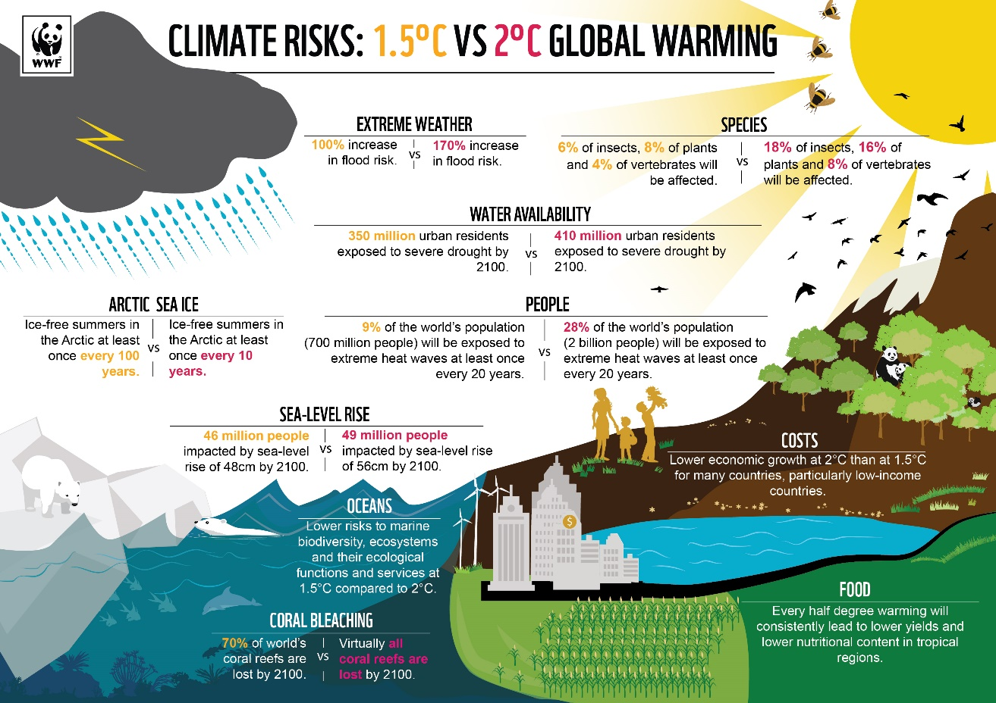

**What Role Do International Financial Institutions Play in Climate Finance?**

International financial institutions (IFIs) play a significant role in climate finance. They provide funding, technical assistance, and policy support to help countries implement climate projects. IFIs like the World Bank, regional development banks, and the Green Climate Fund channel finance to developing countries, enhance access to capital, and facilitate the integration of climate considerations into national development strategies.

**The Bottom Line**

Climate finance refers to the financial resources allocated to address climate change challenges. It supports mitigation projects, such as renewable energy and emissions reduction, as well as adaptation efforts, including resilient infrastructure and community resilience. More specifically, climate finance may outline strategic forecast spend on international agreements such as Conference of Parties mobilizations.

DATA ANALYSIS

RIMES is developing tools, models and methods to enhance the scale and relevance of climate information from global scale (coarse resolution) to regional and local level (finer resolution) for assessing potential climate impacts among Member States. The demand and need for climate downscaling at higher resolution is increasing because of its importance in estimating the potential impacts of climate change, and will be useful in national planning.

Following are the techniques employed at RIMES

1. Dynamical: a nested regional climate model (RCM)
2. Statistical: statistical relationships between the large-scale climatic state and local variations derived from historical data records.
3. Climate control: Approach for modulating GCM output with high resolution topographic layers and parameters that act as local climate controls using GIS tools
4. Analogue Method: Using examples from historical information to anticipate future extremes of climate states

Standard global datasets like the Climatic Research Unit (CRU) of low and high resolutions are used to compute correlation statistics and climate diagnostics to profile the GCMs. Other observed global datasets, including satellite derived data-sets of precipitation, sea-surface temperature and sea-levels.

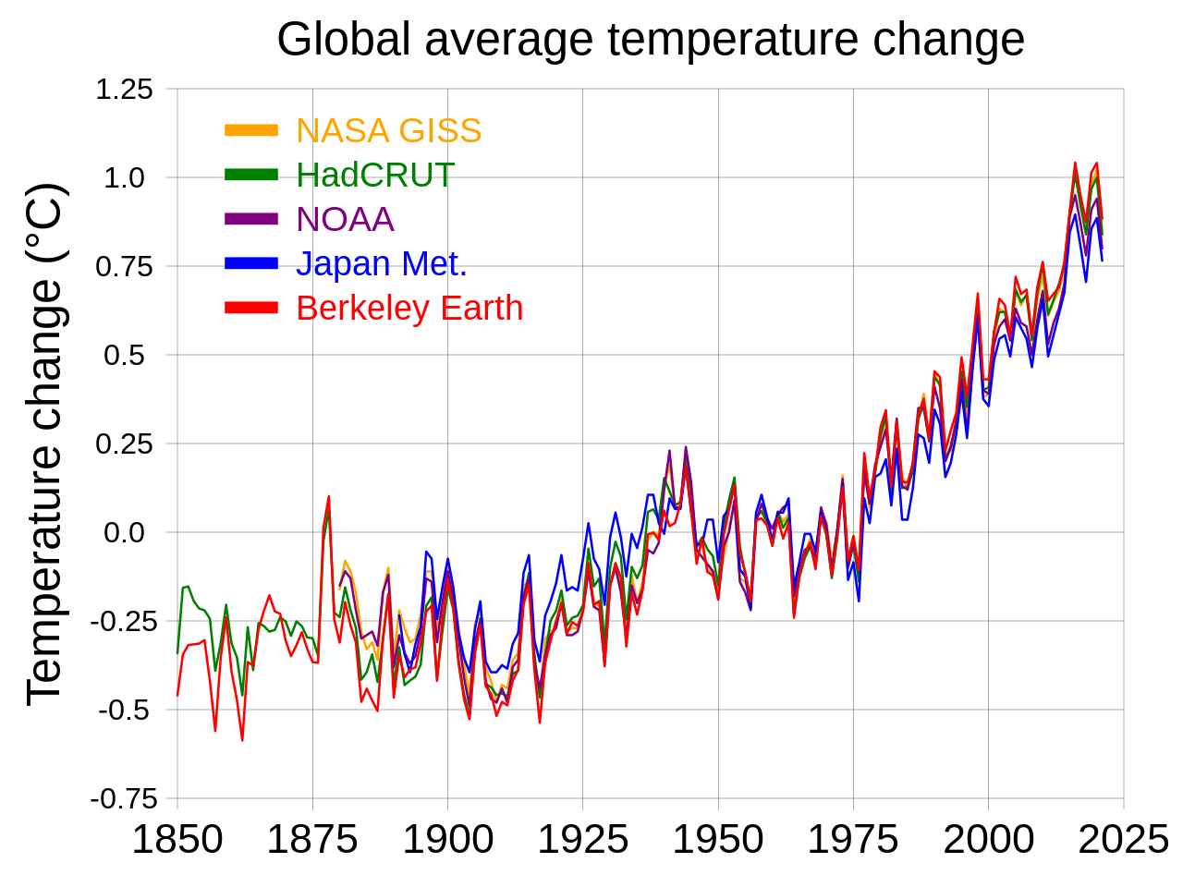

SUGGESTIONS ( Actions for healtier planet )

**Save energy at home**

Much of our electricity and heat are powered by coal, oil and gas. Use less energy by reducing your heating and cooling use, switching to LED light bulbs and energy-efficient electric appliances, washing your laundry with cold water, or hanging things to dry instead of using a dryer. Improving your home’s energy efficiency, through better insulation for instance, or replacing your oil or gas furnace with an electric heat pump can reduce your carbon footprint by up to 900 kilograms of CO2e per year.

**Change your home's source of energy**

Ask your utility company if your home energy comes from oil, coal or gas. If possible, see if you can switch to renewable sources such as wind or solar. Or install solar panels on your roof to generate energy for your home. Switching your home from oil, gas or coal-powered energy to renewable sources of energy, such as wind or solar, can reduce your carbon footprint by up to 1.5 tons of CO2e per year.

**Walk, bike or take public transport**

The world’s roadways are clogged with vehicles, most of them burning diesel or gasoline. Walking or riding a bike instead of driving will reduce greenhouse gas emissions -- and help your health and fitness. For longer distances, consider taking a train or bus. And carpool whenever possible. Living car-free can reduce your carbon footprint by up to 2 tons of CO2e per year compared to a lifestyle using a car.

**Switch to an electric vehicle**

If you plan to buy a car, consider going electric, with more and cheaper models coming on the market. In many countries, electric cars help reduce air pollution and cause significantly fewer greenhouse gas emissions than gas or diesel-powered vehicles. But many electric cars still run on electricity produced from fossil fuels, and the batteries and engines require rare minerals which often come with high environmental and social costs. Switching from a gasoline or diesel-powered car to an electric vehicle can reduce your carbon footprint by up to 2 tons of CO2e per year. A hybrid vehicle can save you up to 700 kilograms of CO2e per year.

**Consider your travel**

Airplanes burn large amounts of fossil fuels, producing significant greenhouse gas emissions. That makes taking fewer flights one of the fastest ways to reduce your environmental impact. When you can, meet virtually, take a train, or skip that long-distance trip altogether. Taking one less long-haul return flight can reduce your carbon footprint by up to almost 2 tons of CO2e.

**Reduce, reuse, repair and recycle**

Electronics, clothes, plastics and other items we buy cause carbon emissions at each point in production, from the extraction of raw materials to manufacturing and transporting goods to market. To protect the climate, buy fewer things, shop second-hand, and repair what you can. Plastics alone generated 1.8 billion metric tonnes of greenhouse gas emissions in 2019 – 3.4 per cent of the global total. Less than 10 per cent is recycled, and once plastic is discarded, it can linger for hundreds of years. Buying fewer new clothes – and other consumer goods – can also reduce your carbon footprint. Every kilogram of textiles produced generates about 17 kilograms of CO2e.

**Throw away less food**

When you throw food away, you're also wasting the resources and energy that were used to grow, produce, package, and transport it. And when food rots in a landfill, it produces methane, a powerful greenhouse gas. So purchase only what you need, use what you buy and compost any leftovers. Cutting your food waste can reduce your carbon footprint by up to 300 kilograms of CO2e per year.

**Eat more vegetables**

Eating more vegetables, fruits, whole grains, legumes, nuts, and seeds, and less meat and dairy, can significantly lower your environmental impact. Producing plant-based foods generally results in fewer greenhouse gas emissions and requires less energy, land, and water. Shifting from a mixed to a vegetarian diet can reduce your carbon footprint by up to 500 kilograms of CO2e per year (or up to 900 kilograms for a vegan diet). [Learn more](https://www.un.org/en/climatechange/science/climate-issues/food) about the connections between food and climate change.

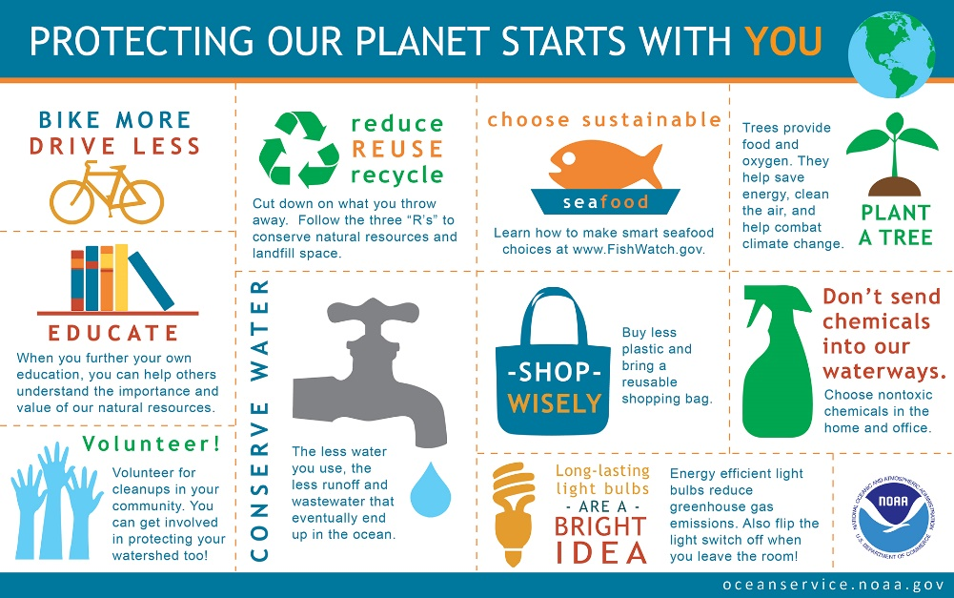

**Plant native species**

If you have a garden or even just a plant or two outside your home, check for native species. Use a plant identification app to help. And then think about replacing non-natives, especially any considered invasive. Plants, animals and insects depend on each other. Most insects will not eat non-native plants, which means birds and other species lose a food source. Biodiversity suffers. Even a single tree or shrub can offer a refuge – just remember to skip insecticides and other chemicals.

**Clean up your environment**

Humans, animals and plants all suffer from land and water contaminated by improperly discarded garbage. Use what you need, and when you have to throw something out, dispose of it properly. Educate others to do the same, and participate in local clean-ups of parks, rivers, beaches and beyond. Every year, people throw out 2 billion tons of trash. About a third causes environment harms, from choking water supplies to poisoning soil.

**Speak up**

Speak up and get others to join in taking action. It's one of the quickest and most effective ways to make a difference. Talk to your neighbors, colleagues, friends, and family. Let business owners know you support bold changes – from plastics-free products and packaging to zero-emissions vehicles. Appeal to local and world leaders to act now. Climate action is a task for all of us. And it concerns all of us. No one can do it all alone – but we can do it together.

**Make your money count**

Everything we spend money on affects the planet. You have the power to choose which goods and services you support. To reduce your environmental impact, choose products from companies who use resources responsibly and are committed to cutting their gas emissions and waste. If you have money that is being invested for you, through a pension fund for instance, it may be supporting fossil fuels or deforestation. Making sure your savings are invested in environmentally sustainable businesses can greatly reduce your carbon footprint.

CONCLUSION

Climate change is an area of science that has been studied for many years. The fossil record has taught humankind much about conditions on Earth long prior to our arrival. We now live in a unique time in that our scientific abilities have not only given us a precise age of the planet, but of the universe itself. Yet there are many things we do not understand, and some of the questions that remain before us may have a significant impact on the quality of our lives in the future. As our current civilization observes an unquestioned period of warming on Earth, the issue of the nature of this change remains a topic of discussion for both scientists and the public at large. It is important, therefore, for those of us in the educational community to help our students get the best information with which to guide their own thoughts and decisions in a changing world. This paper analyzes educational resources for climate change and applies concepts from these resources to research-focused curriculum for secondary school students.

BIBLIOGRAPHY

* [www.un.org](http://www.un.org)
* [www.greenpeac.org](http://www.greenpeac.org)
* [www.activesustainability.com](http://www.activesustainability.com)
* [www.nrdc.com](http://www.nrdc.com)
* [www.onetreeplanted.org](http://www.onetreeplanted.org)
* [www.unglobalcompact.org](http://www.unglobalcompact.org)
* [www.nature.org](http://www.nature.org)
* [www.worldwidelife.org](http://www.worldwidelife.org)

THANKYOU !!!