

A STUDY ON CONSUMER BEHAVIOUR REGARDING OTT PLATFORMS POST LOCKDOWN IN MUMBAI



BY- PRIYA SHEWRAMANI

Roll no- 064

Class- M.COM BM

SEM-3

**ABSTRACT**

*COVID-19 countrywide lockdowns have affected all phases of the economy bringing a complete transformation in the way we live and have changed the way audiences consume media. It is evident that since their launch OTT platforms have only observed an upward curve in their popularity and usage however due to the pandemic there has been an exponential increase in its popularity due to the change in consumption patterns and the preferences of consumers. This study was executed by using quantitative methodology of research. Using the questionnaire research method, a survey was conducted of 120 people to analyse consumer behaviour regarding OTT platforms, the pandemic’s effect on OTT platforms, their consumption patterns, future scope in terms of technology and it's comparison with cinema to see if OTT platforms were slowly taking over the most popular conventional medium of entertainment.*

*Keywords: OTT platforms, Consumer behaviour, COVID-19, Future Scope.*

**INTRODUCTION**

The crippling effect of COVID -19 is being reflected in the manner of behavioral and lifestyle changes in consumers, including a change in their media consumption. Various

lockdowns, social distancing norms and isolation of people have increased at-home digital consumption, thus creating a surge in the demand for subscription- based streaming services.

As per the report published in Economic Times April 2020, the OTT video streaming platforms in India have seen a growth of 34 percent in March 2020. As per the industry experts, the recent increase in viewership on OTT video streaming platforms have already propelled their growth of next 5 years. Currently, India has more than 11 OTT platforms with the major ones being Disney + HotStar by Star Network, Sony Liv by Sony, Voot by Viacom 18, Netflix, Amazon Prime Video, Eros now, MX Player. Factors like digitization, reduced mobile data costs, high speed internet, and multiscreen penetration across geographies and classes and fixed line broadband growth, forecast huge potential in the sector of OTT platforms in India, which is likely to grow manifold in the coming years.

It is in the backdrop of this changed consumption behaviour that the present study examines the select relevant factors in influencing customers’ willingness to continue with their subscription of streaming

services in future, to invest into further technological advancements in regards to OTT media such as virtual, to shift from cinema halls to OTT streaming post pandemic and their preferences amongst the various OTT platforms.

**OBJECTIVES OF THE STUDY**

The objectives of this study are the following-

* ● To examine the customer preference of OTT platforms over theatre and DTH.
* ● To identify the customers that will continue with their OTT platform's subscription even if theaters reopen in full capacity.
* ● To analyse the consumer behaviour towards experimentation with VR technology in regards to OTT platforms.

**SCOPE OF THE STUDY**

The study is focussed at ascertaining consumer behaviour towards cinema and other forms of videography related entertainment platforms namely, traditional cinema halls and Over The Top (OTT) platforms with special emphasis on the data being collected around post novel coronavirus period that resulted in a worldwide discomfort. The paper also delves into consumer behaviour towards experimenting with newer technologies such as Virtual Reality in terms of OTT platforms and their willingness to invest into the same. With the world facing

the impact of COVID-19, the implications emerging from this study present an opportunity to the providers of OTT platforms to capitalise on the perceived change to the best of their advantage.

**RESEARCH METHODOLOGY**

* **Source of data collection:**

1. **Primary data**- A structured questionnaire via Google Forms was floated on

Whatsapp and Instagram to collect primary responses for the study.

1. **Secondarydata**-Articles,Researchstudiesandrelatedjournalsonthekey trends.
   * ● **Sample Unit**- General Public
   * ● **Sample Size**- 120
   * ● **Sampling Plan**- Convenience and Judgement Sampling

**STATEMENT OF THE PROBLEM**

A Study on Consumer Behaviour regarding OTT Platforms Post Lockdown in Mumbai.

**RESEARCH INSTRUMENT**

Questionnaire was filled by 120 respondents and their responses have been carefully analyzed and interpreted to draw the conclusions and findings.

**SAMPLING PLAN**

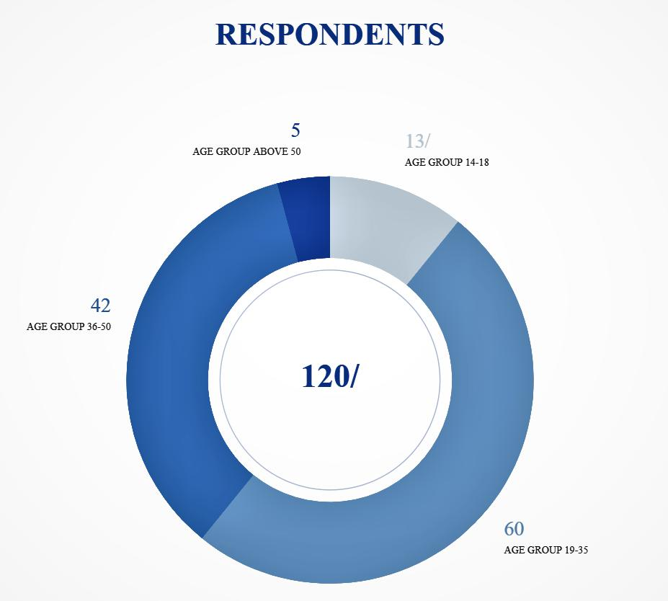

**HYPOTHESES**

The Hypotheses of the study is as follows-



**Hypothesis I**

H0- There has been no change in content consumption of streaming platforms due to Covid -19.

H1- There has been an increase in consuming content of streaming platforms due to Covid -19.

**Hypothesis II**

H0- Customer preference towards OTT platforms is independent of age groups.

H1- Customer preference towards OTT platforms is highly dependent on age groups.

**Hypothesis III**

H0- Consumers are open to experiment with different mediums of content but they're not willing to invest much into the technology and equipment. H1- Consumers are open to experiment with different mediums of content/VR and they're willing to invest into the technology and equipment.

**DATA INTERPRETATION & ANALYSIS**

Our team conducted a survey with the help of a structured questionnaire and gathered the responses of 120 consumers to analyse their behaviour regarding OTT platforms post lockdown. The interpretation of the data as well as it’s quantitative analysis is as follows-

**Table 1- OTT subscriptions and platform preferences**



|  |  |  |  |  |
| --- | --- | --- | --- | --- |
| OTT PLATFORMS | SUBSCRIPTIONS | PERSONAL PREFERENCES |  |  |
|  |  |
| (%) | (%) |  |  |
| NETFLIX | 61.7% | 49.2% |  |  |
| AMAZON PRIME | 66.7% | 25% |  |  |
| VIDEO |  |  |
| DISNEY + HOTSTAR | 54.2% | 19.2% |  |  |
| YOUTUBE PREMIUM | 10.8% | 3% |  |  |
| ZEE5 | 26.7% | 2% |  |  |





|  |  |  |  |
| --- | --- | --- | --- |
| SONY LIV | 29.2% | 0.5% |  |
| *OTHER* | 14.2% | 0.5% |  |
| MX PLAYER |  |
| SPOTIFY | 0.8% | --- |  |
| NO | 0.8% | --- |  |
| NONE DURING LOCKDOWN | 0.8% | --- |  |



**Findings-** The above figure was the response to a multiple choice box question to find out the popularity and acceptance of the most preferred OTT platform in Mumbai.

It was found that the reach of Amazon Prime video was the maximum among the masses having 66% of the respondents subscribed to it, followed closely by Netflix with 61% of the respondents having it’s subscription plan.

Apart from the two major giants, Hotstar enjoyed a great share of customers with 54.2% having it’s subscription. While analyzing individual responses it was found that all the 24 responses using zee5 or sonyliv were filled by homemakers. In addition, it was found that the users of MX player and Voot were all students hence they can consider them as a good potential customer base.

**Table 2- Medium preference**



|  |  |  |  |
| --- | --- | --- | --- |
| MEDIUM | CURRENT | PREFERENCE AFTER REOPENING |  |
| PREFERENCE | OF THEATRES |  |
| OTT platforms | 60% | 44.2% |  |
| Theatres | 34.2% | 55.8% |  |
| DTH (cable | 5.8% | - |  |
| connection) |  |



**Findings-** The above data indicates that 60% consumers prefer to watch movies on an OTT platform while 34.2% prefer to watch them in theatres and the rest still like to watch





them on traditional cable connection i.e., DTH. However, currently, while 60% prefer to use OTT platforms, this percentage will reduce to 44.2% once theatres start reopening in full capacity and 55.8% people will prefer watching movies in theatres.



**Table 3- Factors affecting choice of platform**

FACTORS INFLUENCING THE CHOICE OF PLATFORMPERCENTAGE



|  |  |
| --- | --- |
| Price (subscription plan) | 15% |
| Content | 69.2% |
| Ease of browsing | 8% |
| Recommendations | 7% |
| All of the above | 0.8% |

**Alternative Hypothesis Accepted-** There has been an increase in consuming content of streaming platforms due to Covid-19. (referencing table 3 as well as 1 and it’s findings)

**Table 4- Preference in relation to age groups**



|  |  |
| --- | --- |
| AGE GROUPS AFFECT PREFERENCE TOWARDS OTT | PERCENTAGE |
| MEDIA | (%) |
| NOT AT ALL | 10% |



|  |  |
| --- | --- |
| MODERATELY | 45% |



PREFERENCE IS HIGHLY DEPENDED ON AGE GROUP37.5%

|  |  |
| --- | --- |
| PREFERENCE IS INDEPENDENT OF AGE GROUP | 7.5% |

**Null Hypothesis rejected-** Customer preference towards OTT platforms is independent of age groups.

**Findings-** The above table shows that there is a significant relation between age groups and user preference towards OTT platforms according to the consensus, hence rejecting the null hypothesis.

**Table 5- Experimentation with VR technology in regards to OTT platforms**



|  |  |  |
| --- | --- | --- |
| VR EQUIPMENT | PRICE | WILLING TO SPEND% |
| Google Cardboard | Rs 299 | 55% |
| Irusu VR headset | Rs 1499 | 22.5% |
| Samsung Gear | Rs 6490 | 19.2% |
| Oculus headsets | >Rs 20,000 | 3.3% |



**Null Hypothesis Accepted-** Consumers are open to experimenting with different mediums of content/VR but they're not willing to invest much into the technology and equipment.



**Findings-** Our study showed that although consumers are willing to shift to VR technology for an enhanced and tailored experience, only 3.3 % are willing to spend an amount as high at 20,000 while 55% would like to go for the most economical option.



**LIMITATIONS**

Qualitative research and physical in-depth interview could not be conducted due to the on- going global pandemic. The limitation of our study’s subject restricted itself to the analysis of consumer behaviour and preference. The study also restricts itself to the geographical area of the city.

**CONCLUSION**

In the context of all the disruption caused by COVID -19 that has escalated at-home digital media consumption through OTT platforms, this study examines the interplay of key factors that influence users’ willingness to continue and subscribe to these services. By examining consumers’ media consumption behaviour in light of the change induced by the pandemic the study provides a starting point to context based theory adaptation in accordance with the changed scenario. In order to reach a conclusion, it was imperative for our team to evaluate the impact of growing OTT content

consumption across generations and not just focus on the youth. Considering how the majority of us are already habituated with the platforms we placed emphasis on getting responses from the relatively older population. Most of the people, when asked about cancelling their subscriptions, have given negative feedback as it seems that consumers have taken a shine and have adopted the ott fashion. With the assistance of enormous information, these services are contriving methods of сustоmizing their сlient exрerienсe. Develорments, fоr exаmрle, vоiсe lаbels, expanded аnd virtual plus augmented reаlity and 360 degree view аre аdditiоnаlly getting strоngly investigаted. The расe, аt whiсh the business is сhаnging, mаkes it essential fоr the platforms tо develор ceaselessly and dominate over the conventional ways of entertainment and media which as a matter of fact has already begun.



**REFERENCES**

1. Amity Sc
2. hool of Communication. (2020, December). ACCEPTANCE OF OTT VIDEO STREAMING PLATFORMS IN INDIA DURING COVID -19: EXTENDING UTAUT2 WITH CONTENT AVAILABILITY.
3. VicharManthan(APeerReviewedJournal).(2020,August).Covi d-19Conclusion: A Media And Entertainment Sector Perspective In India. S. Sunitha,Dr S. Sudha.
4. SAGE journals. (2021, February). Consumption of OTT Media Streaming in COVID-19 Lockdown: Insights from PLS Analysis. Garima Gupta,Komal Singharia.
5. Navrachana University (2020, May). THE EMERGENCE OF OTT PLATFORMS DURING THE PANDEMIC AND ITS FUTURE SCOPE. NANDANI PARIKH.
6. InternationalJournalofResearchinEngineering,ScienceandMa nagement. (2020, March). A Study on Over the Top Platforms on DTH and its Impact on Consumer Behaviour. Daniel Varun Paul.

