**A Study on Inventory Management at Mann Hummel Pvt Ltd Tumkur**

**Dr. Prathap B N**

Associate professor, Department of MBA, Shridevi Institute of

Engineering and Technology, Tumkur, Karnataka, India

( [prathap.bn@gmail.com](mailto:prathap.bn@gmail.com) )

**Mr. Dhanush H U**

2nd Year MBA Student, Department of MBA, Sridevi Institute of

Engineering and Technology. Tumkur, Karnataka, India

( [h.udhanush2001@gmail.com](mailto:h.udhanush2001@gmail.com) )

**ABSTRACT:**

Inventory management systems can assist business owners maintain accurate sales and purchase data. Ineffective inventory management can result in dissatisfied consumers, slower sales, and surplus cash sitting in inventory. Businesses that deploy a strong inventory management system can save manual work, limit human error, and eliminate delays, streamlining processes.

The Inventory Management System, an online application for Windows, focuses on improving inventory levels and decreasing sales inefficiencies. It has a variety of capabilities that allow customers to determine optimal inventory levels and conduct automated replenishment plans. Furthermore, the system automatically tracks sales data and alerts to any supply shortages, ensuring that fast-moving items are always available. This proactive technique reduces delays while increasing overall inventory management efficiency.

**INTRODUCTION:**

Inventory control and management are critical components of business operations. This technique is critical for striking the proper balance between having enough inventory to meet consumer demand and reducing surplus stock, which can tie up capital and occupy storage space. Effective inventory management is critical for overall success and profitability in every business, regardless of size or industry.

**Key Goals of Inventory Management:**

Optimizing Stock Levels: Businesses strive to strike a balance between having enough inventory to fill client requests and avoiding overstocking, which can result in increased carrying costs, obsolescence, and depleted financial resources.

Meeting Customer Demand: Effective inventory management ensures that products are easily available to meet customers' needs. To avoid stockouts (insufficient inventory) and overages, accurate demand forecasts and careful stock level management are required.

Reducing Holding Costs: Excess inventory incurs a variety of costs, including warehousing, insurance, and possible depreciation. Efficient inventory management tries to reduce these holding expenses.

Reducing Stockouts: Stockouts can result in lost sales and disgruntled consumers. Inventory management systems guarantee that products are available when they are needed, reducing the likelihood of these events.

Streamlining Operations: Proper inventory management procedures can improve the overall efficiency of a company's operations and supply chain.

It may lead to shorter lead times, improved order fulfilment, and better resource management.

Inventory management, including:

Just-In-Time (JIT): This method entails purchasing inventory only as needed, eliminating the need for large warehouses and excess stock.

ABC Analysis: This method divides inventory items into three categories (A, B, and C) based on their value and usage, allowing for more focused control and monitoring.

Economic Order Quantity (EOQ): This technique calculates the optimal order size to minimize total inventory costs by balancing ordering and holding expenses.

Safety Stock: Keeping a buffer stock reduces the risk of stockouts by accommodating fluctuations in demand or lead times.

Inventory Turnover: This metric tracks how quickly inventory is sold or used, providing information about inventory management effectiveness.

To achieve effective inventory management, businesses must use technology, data analysis, forecasting, and a strong inventory control system. This allows them to improve cash flow, customer satisfaction, and competitive positioning. In contrast, poor inventory management can result in financial losses, operational disruptions, and missed opportunities for growth. As a result, businesses of all sizes must focus on improving their inventory management practices in order to meet strategic objectives and maintain a competitive advantage.

**COMPANY PROFILE:**

MANN+HUMMEL is a global filtration company that provides solutions for clean air and water. Adolf Mann and Erich Hummel founded the family business in 1941, and it is based in Ludwigsburg, Germany.

MANN+HUMMEL specializes in filtration solutions for a variety of industries, including automotive, industrial, and environmental. Their product offerings include cabin air filters, fuel filters, oil filters, and vehicle air filters.

Global Presence: The company has a significant international presence, with manufacturing and R&D facilities as well as sales offices in Asia, North America, and Europe.

Focus on Innovation MANN+HUMMEL is committed to advancing filtration technology and invests heavily in research and development to meet the growing demand for clean air and water across a wide range of industries.

Environmental Commitment: The company prioritizes sustainability and environmental responsibility, developing products and processes that reduce emissions and improve air and water quality.

Their main products are water filtration systems, industrial filters, automotive filters for both personal and commercial vehicles, and specialized filters for a variety of applications.

MANN+HUMMEL serves a diverse range of clients, including public utility companies, industrial firms, and automobile manufacturers.

Strategic Acquisitions: The company has increased its market presence through acquisitions, such as the purchase of Tri-Dim Filter Corporation in 2018, which strengthened its position in the North American filtration sector.

**OBJECTIVE OF THE STUDY:**

* Determine inventory holding period.
* Evaluate working capital and net profit.
* Evaluate safety stock levels.
* Model stock management procedures based on corporate structures.
* Evaluate quality of Asian artistic works in inventory.
* Determine if the company can improve its stock exchange performance.

**RESULT ANALYSIS METHODS:**

This study's research methodology takes a systematic approach to investigating Asia Colors Company's inventory management practices. The primary goal is to assess the effectiveness of the company's strategies and inventory management system, as well as analyze its financial ratios from 2017 to 2021. Below is an outline of the research methodology:

Designing the research

The research design establishes the study's framework. This study will use a descriptive and analytical design. Descriptive research will describe the characteristics of the phenomenon, whereas analytical research will seek to comprehend the relationships between various variables.

1. Primary data

Primary data will be gathered using tools such as questionnaires, interviews, and direct observation. Surveys and interviews with relevant Asia Colours Company employees will be conducted to gain insight into their inventory management practices, strategies, and challenges.

1. Secondary data

Secondary data will consist of pre-existing information, such as the company's financial reports, balance sheets, income statements, and other relevant documents from 2017 to 2021. This information is critical for analysing financial ratios and performance trends.

1. Sampling

To ensure that the data collected is representative of the company's inventory management practices, a suitable sampling technique will be used for surveys or interviews. The sampling strategy and sample size will be determined by the study's objectives and the available resources.

**LIMITATIONS OF THE STUDY:**

* The availability of advanced data limits the scope of the analysis.
* The study relies primarily on secondary data from financial statements.
* This analysis is based on past data and does not forecast future outcomes.
* Accounting ratio variations may not be fully addressed.
* Time constraints prevented a comprehensive temporal analysis.

**DATA ANALYLIS AND INTERPRETATION:**

**INVENTORY TURNOVER RATIO:**

The inventory turnover ratio is calculated by dividing the cost of goods sold (COGS) over a given time period by the average inventory level. This ratio shows how efficiently inventory is converted into sales, which contributes to the company's profits.

To calculate inventory turnover ratio, use the formula: Cost of Goods Sold / Average Inventory.

COGS is calculated as sales minus depreciation and opening stock.

Average inventory = (opening + closing stock) / 2

|  |  |  |  |
| --- | --- | --- | --- |
| **YEAR** | **COGS** | **AVERAGE INVENTORY** | **RATIO** |
| 2017 | 2960 | 39 | 75.89744 |
| 2018 | 3093 | 42 | 73.64286 |
| 2019 | 3221 | 34 | 94.73529 |
| 2020 | 2874 | 23 | 124.9565 |
| 2021 | 3215 | 49 | 65.61224 |

Analysis; In the table above, the inventory turnover ratio was 75.89 times in 2017, 73.64 times in 2018, 94.73 times in 2019, 124.95 times in 2020, and 65.61 times in 2021.

**INVENTORY TURNOVER RATIO:**

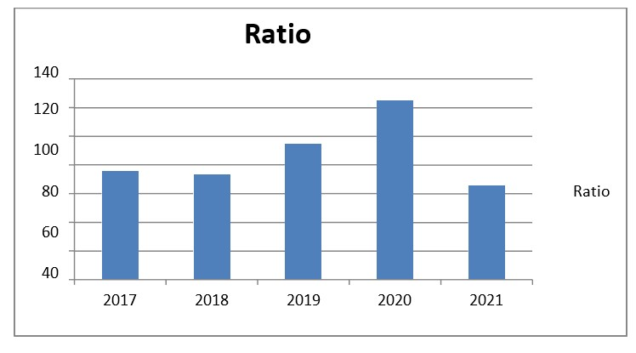

Interpretation: In the table above, the inventory turnover ratio was 75.89 in 2017, 73.64 in 2018, 94.73 in 2019, 124.95 in 2020, and 65.61 in 2021.

**INVENTORY HOLDING PEROID:**

A High number of days inventory indicates that there is a lack of demand for the product being sold.

Inventory Holding Period = Number of days in a Year / Inventory turnover ratio

|  |  |  |  |
| --- | --- | --- | --- |
| Year | No of days | Ratio | Holding Days |
| 2017 | 365 | 75.8974359 | 4.809121622 |
| 2018 | 365 | 73.6428571 | 4.956353055 |
| 2019 | 365 | 94.7352941 | 3.852840733 |
| 2020 | 365 | 124.956522 | 2.921016006 |
| 2021 | 365 | 65.6122449 | 5.562986003 |

Analysis: The above table shows that the inventory holding period in 2017 was 4.8 days. It was 4.9 days in 2018, 3.8 days in 2019, 2.9 days in 2020, and 5.5 days in 2021.

**INVENTORY HOLDING PERIOD (DAYS):**

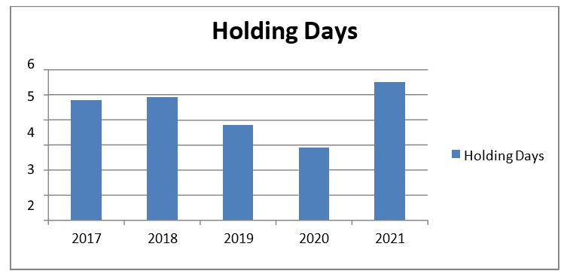

Interpretation: The table above shows that the inventory holding period in 2017 was 4.8 days. In 2018, it was 4.9 days; in 2019, it was 3.8 days; in 2020, it was 2.9 days; and in 2021, it was increased to 5.5 days.

**RAW MATERIALS TURNOVER RATIO:**

If this ratio is high, it indicated the efficiency of management in converting stock into cash quickly.

Raw Materials Turnover ratio = Raw Materials / Net Sales

|  |  |  |  |
| --- | --- | --- | --- |
| Year | Raw Materials | Sales | Ratio |
| 2017 | 2104 | 3223 | 0.652808 |
| 2018 | 2113 | 3955 | 0.53426 |
| 2019 | 2188 | 4213 | 0.519345 |
| 2020 | 2221 | 3839 | 0.578536 |
| 2021 | 2524 | 4200 | 0.600952 |

Analysis: According to the table above, the raw materials turnover ratio was 0.62 in 2017, 0.53 in 2018, 0.51 in 2019, 0.57 in 2020, and 0.60 in 2021.

**RAW MATERIALS TURNOVER RATIO:**

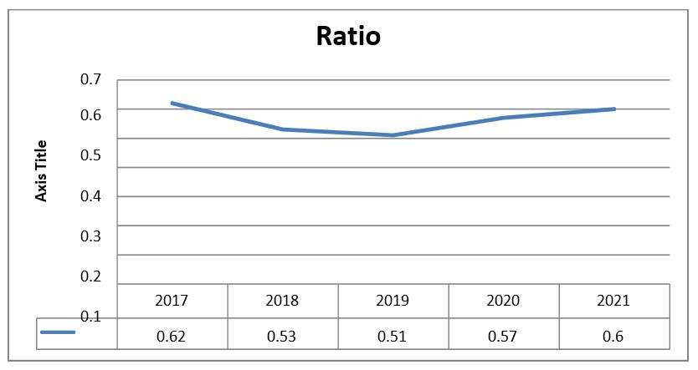

Interpretation: Increasing raw material consumption leads to higher production and sales. This form allows goods to be delivered on time. We can also see that the company's raw material turnover ratio is shifting from increasing to decreasing year after year due to demand for certain products.

**FINISHED GOODS TURNOVER RATIO:**

It indicates the number of times the average finished goods turned into sales during a Year. This Ratio indicates the efficiency of the firm in selling the Products.

Finished goods turnover ratio = Closing Stock of Finished goods/Sales

|  |  |  |  |
| --- | --- | --- | --- |
| Year | Closing stock | Sales | Ratio |
| 2017 | 934 | 3223 | 0.289792 |
| 2018 | 998 | 3955 | 0.252339 |
| 2019 | 1012 | 4213 | 0.240209 |
| 2020 | 1145 | 3839 | 0.298255 |
| 2021 | 1432 | 4200 | 0.340952 |

Analysis: shows that the value decreased from 0.28 in 2017 to 0.25 in 2018, 0.24 in 2019, 0.29 in 2020, and 0.34 in 2021.

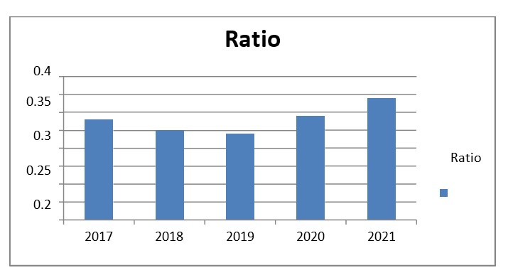

Interpretation: As we know, increasing the finished goods turnover ratio is beneficial to the company, and we can see that the increasing trend in finished goods turnover ratio is due to the sudden demand we can observe. The company's finished goods ratio has decreased year after year, and in 2021 it increased by 0.34.

**FIXED ASSETS TURNOVER RATIO:**

Higher the ratio indicates that effective utilization of the fixed assets lower the ratio indicates in effective utilization of fixed assets.

Fixed assets turnover ratio = Sales/ Fixed assets

|  |  |  |  |
| --- | --- | --- | --- |
| Year | Sales | Fixed Assets | Ratio |
| 2017 | 3223 | 2006 | 1.60668 |
| 2018 | 3955 | 2134 | 1.853327 |
| 2019 | 4213 | 2236 | 1.884168 |
| 2020 | 3839 | 2346 | 1.636402 |
| 2021 | 4200 | 2484 | 1.690821 |

Analysis: The sales to fixed assets ratio increased from 1.60 in 2017 to 1.85 in 2018, 1.88 in 2019, and 1.63 in 2020, as shown in the table. And in 2021, it was raised to 1.69.

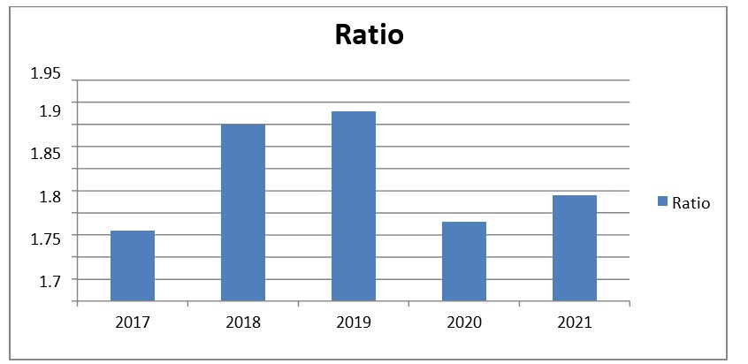**FIXED ASSETS TURNOVER RATIO:**

Interpretation: The chart shows that the ratio increased from 1.61 in 2017 to 1.85 in 2018, 1.88 in 2019, and then decreased to 1.63 and 1.69 in 2020 and 2021.

**WORKING CAPITAL TURNOVER RATIO:**

This ratio is calculated to study the efficiency of the working capital is utilized in the business. This ratio is also called as “Net Current assets turnover”

Working capital turnover ratio = Net Sales / Net working Capital

|  |  |  |  |
| --- | --- | --- | --- |
| Year | Sales | NWC | % |
| 2017 | 3223 | 1998 | 1.613113 |
| 2018 | 3955 | 2012 | 1.965706 |
| 2019 | 4213 | 2116 | 1.991021 |
| 2020 | 3839 | 2226 | 1.724618 |
| 2021 | 4200 | 2306 | 1.821336 |

Analysis: The table shows a working capital turnover ratio of 1.61 in 2017, 1.96 in 2018, 1.99 in 2019, 1.72 in 2020, and 1.82 in 2021.

**WORKING CAPITAL TURNOVER RATIO:**

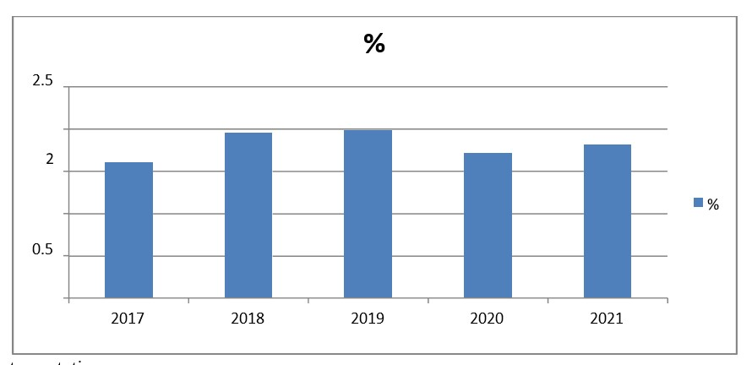

Interpretation: The graph shows that MANN HUMMEL is experiencing both increasing and decreasing trends. This could be due to poor cash management. To improve working capital utilization, measures can be implemented to increase the ratio and meet daily expenses.

**TOTAL ASSETS TURNOVER RATIO:**

Asset turnover ratio indicates of how efficiently the firm utilizes its assets. They sometimes are referred to as efficiency ratios, asset utilization ratios or asset management ratios. A high is an indicator of total assets while a low ratio reveals idle capacity.

Total assets turnover ratio = Net Sales / Total assets

|  |  |  |  |
| --- | --- | --- | --- |
| Year | Sales | Total assets | % |
| 2017 | 3223 | 3446 | 0.93528729 |
| 2018 | 3955 | 3937 | 1.00457201 |
| 2019 | 4213 | 4127 | 1.02083838 |
| 2020 | 3839 | 3855 | 0.99584955 |
| 2021 | 4200 | 4346 | 0.96640589 |

Analysis: The table shows that the assets turnover ratio was 0.93 in 2017, 1.00 in 2018, 1.02 in 2019, 0.99 in 2020, and 0.96 in 2021.

**TOTAL ASSETS TURNOVER RATIO:**

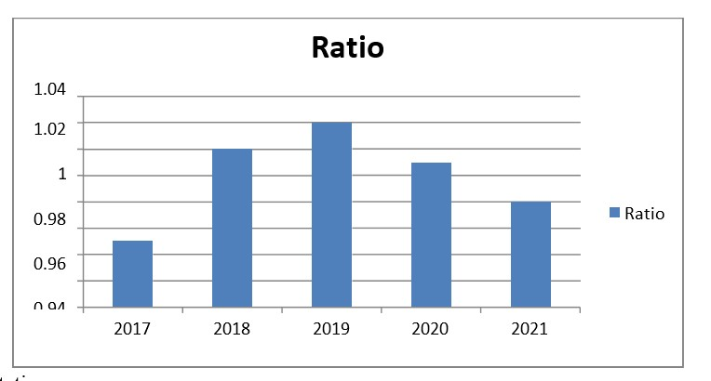

Interpretation: The company has effectively utilized its assets, resulting in both increasing and decreasing trends. However, there has been a negligible decrease over the last two years. It demonstrates the efficiency of the company. Still, steps can be taken to improve it.

**FINDINGS**

* The company has a favourable inventory turnover ratio.
* Inventory holding periods fluctuate over time.
* The company maintains a favourable inventory holding period with consistent flow year after year.
* Neither raw materials nor finished goods were idle throughout the year.
* Economies of scale have not been realized.
* The company has incurred reasonable expenses, resulting in a fluctuating trend in the net profit ratio, with both increases and decreases recorded.

**CONCLUSION**:

MANN HUMMEL PVT LTD keeps inventory in a systematic manner. Based on the findings of the study, it is possible to conclude that by avoiding over- and under-investment in inventories, the company maximizes results while minimizing waste, resulting in efficient and effective outcomes.

To ensure smooth production, the company should put in place preventive measures for machinery maintenance to avoid stoppages. MANN HUMMEL uses a Just-In-Time (JIT) inventory technique to make better decisions about raw material procurement and manufacturing processes.

Effective stock management is critical for meeting production objectives. Successful inventory management significantly improves overall business performance. Current inventory management practices employ advanced and refined methods for optimizing stock levels, thereby lowering costs and improving service delivery.

**RESOURCES:**

1] S. Angel Raphella, S. Gomathi Nathan, and G. Chitra, "Inventory Management: A Case Study," International Journal of Emerging Research in Management & Technology, e-ISSN: 2278-9359, Vol. 3, No. 3, June 2014, pp. 94–102.

[2] Aditya A. Pande and S. Sabihuddin, "A Study of Material Management Techniques in Construction Projects," International Journal of Informative and Futuristic Research, Vol. 2, No. 3, May 2015, ISSN 3479-3486.

[3] Dipak P. Patil, Pankaj P. Bhangale, and Swapnil S. Kulkarni, "Cost Control in Construction Projects," International Journal of Advanced Engineering Research and Studies, Vol. 2, April 2014, e-ISSN: 2249-8974.

[4] P. G. Matsebatlela and K. Mpofu, "An Inventory Management Framework to Address Supply and Demand Mismatch in a Production Organization," International Federation of Automatic Control, Vol. 3, No. 48, March 2015, pp. 260–265.

[5] Punam Khobragade, Prof. Manjusha Tamale, Roshni Selokar, Rina Maraskolhe, et al., "Research Paper on Inventory Management Systems," International Journal of Research and Technology, e-ISSN 2395-0056, Vol. 5, No. 5, April 2018, p-ISSN 2395-0072.

[6] Professor Daniel Atnafu, Assefa Balda, and Shaofeng Liu, "The Effect of Inventory Management Practices on Firm Competitiveness and Organizational Performance: Empirical Evidence from Micro and Small Enterprises in Ethiopia."