**CONTRACT BASED AGRICULTURE FOR STABLE MARKET ACCESS**

**Dr.M.Deepa , Logu Ajith Kumar R, Poobesh M, Naveen K, Manisha K, Magizh Oviya S**

Student, Information Technology, Sri Shakthi Institute of Engineering and Technology, Coimbatore, Tamil Nadu, India

**ABSTRACT**

"Assured Contract Farming for Stable Market Access" is an innovative web platform that connects farmers and buyers through secure contract agreements, ensuring predictable pricing and dependable market access for farmers. By utilizing HTML, CSS, JavaScript, Firebase, and SQL, the platform delivers a seamless and efficient experience, allowing both parties to interact, negotiate, and manage contracts in real time. This project seeks to mitigate market risks for farmers, streamline produce procurement for buyers, and create a more stable agricultural economy by leveraging technology for transparency and trust.

**Keywords:** contract agreements, real time negotiations, mitigate market risks.

1. **INTRODUCTION**

The entire world is depending on the food but it is a type of agricultural product . But the products bought from the farmers are very less according to the market rate. Efforts to develop agricultural marketing have, particularly in developing countries, intended to concentrate on a number of areas, specifically infrastructure development; information provision; training of farmers and traders in marketing and post-harvest issues; and support to the development of an appropriate policy environment. In the past, efforts were made to develop government-run marketing bodies but these have facilitates tended to become less prominent over the years .Up-to-date information on prices and other market factors enables farmers to negotiate with traders and also spatial distribution of products from rural areas to towns and between markets.

1. **METHODOLOGY**

Method and analysis which is performed in your research work should be written in this section. A simple strategy to follow is to use keywords from your title in first few sentences.

**2.1 Subheading**

Subheading should be Font Size- 10pt, Font Type- Times New Roman, justified.

**2.2 Subheading**

Subheading should be 10pt Times new Roman,

1. **MODELING AND ANALYSIS**

Fluid and Material which are used is presented in this section. Table and Fluid should be in prescribed format.

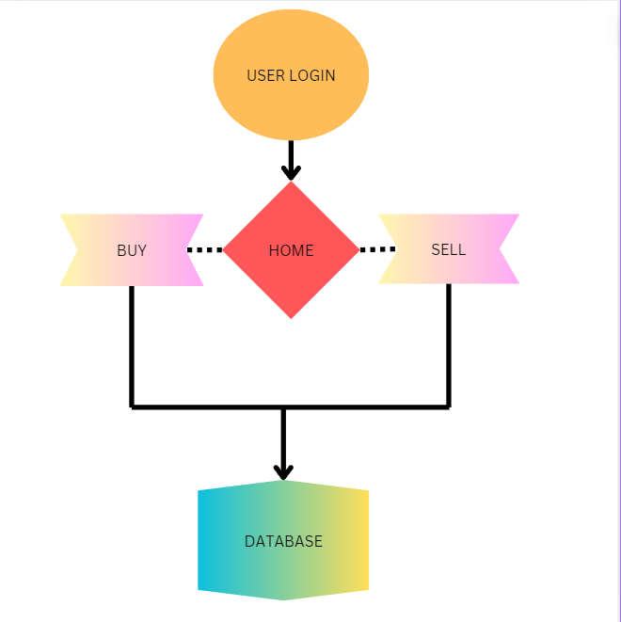

**Fig-1: Concept Map**

1. **RESULTS AND DISCUSSION**

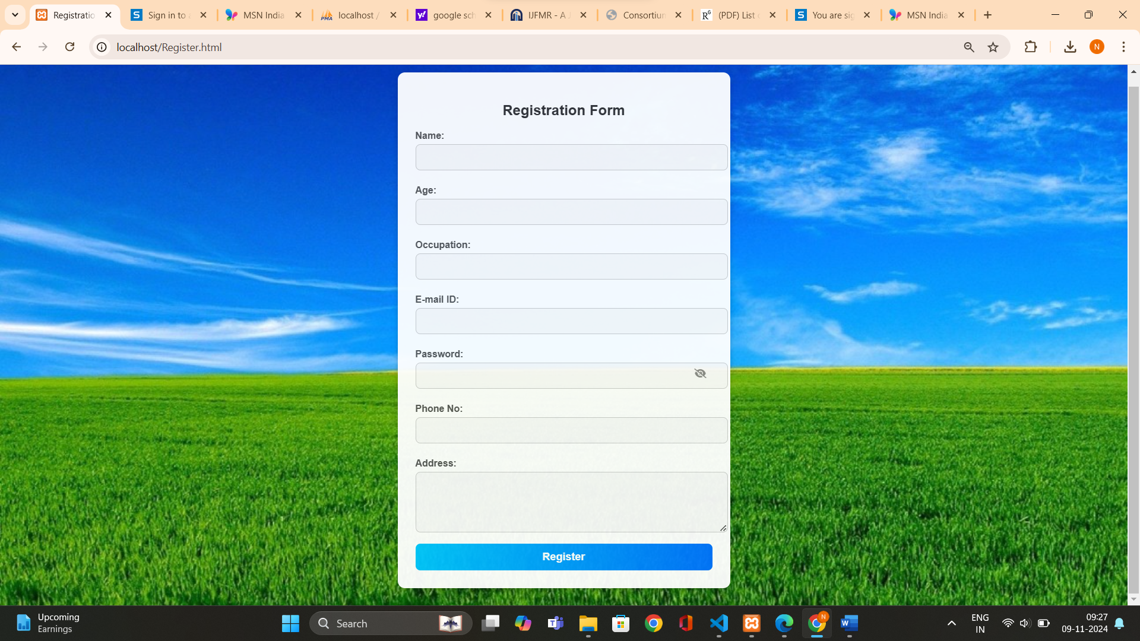

**Fig-2: Login page**

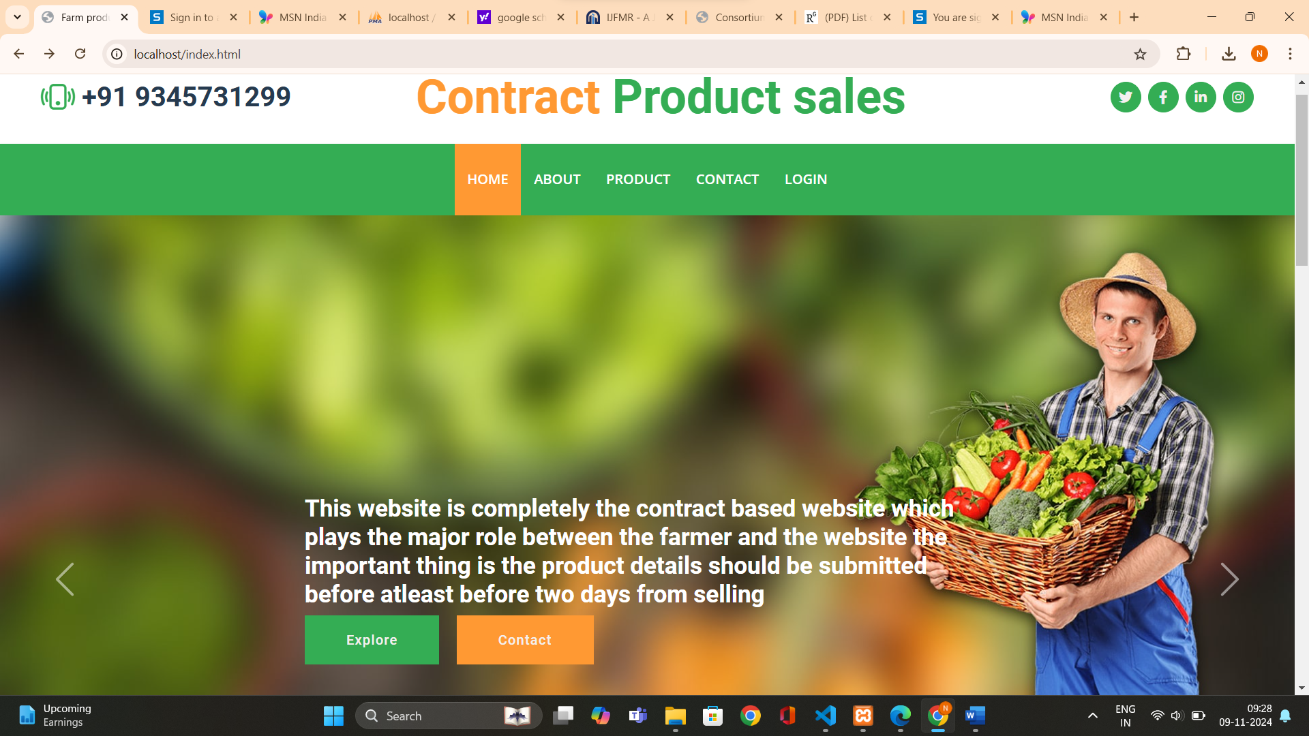

**Fig-3: Main page**

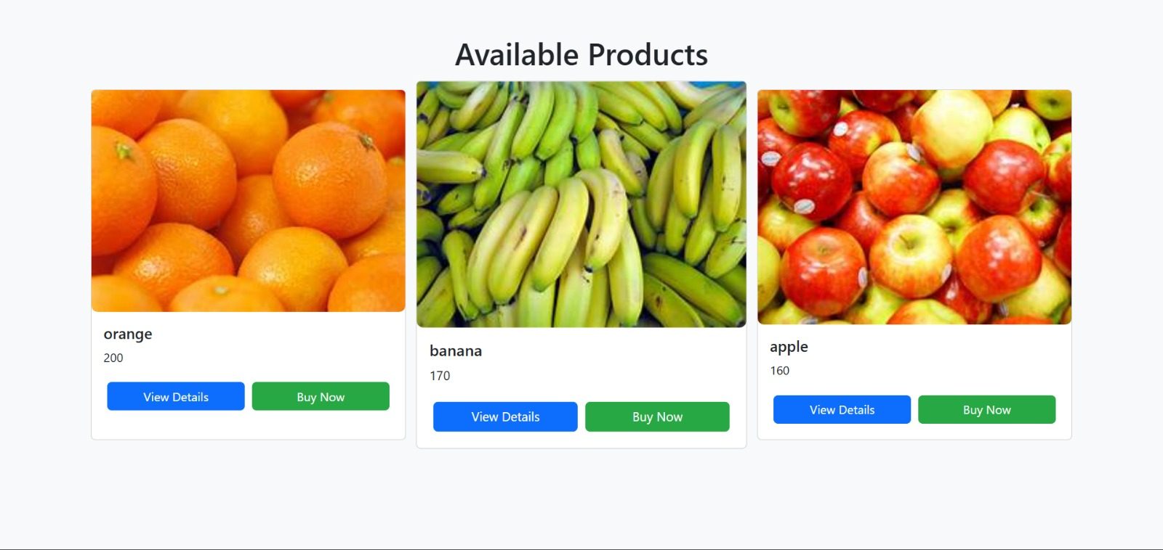

1. **CONCLUSION**

By eliminating the intermediates our website Directly contacts with the farmers and our website .By creating profit for the farmers .Accessing with Online website so no intermediate or broker involves .Each and every farmer can easily access and it user friendly.

**ACKNOWLEDGEMENTS**

We extend our heartfelt gratitude to our honorable Chairman, **Dr. S. Thangavelu** for providing a wonderful platform to educate our minds, inculcate ideas and implement the technological changes in the real-world environment.

Deepest thanks to our dynamic Joint Secretary, **Mr. T. Sheelan** for monitoring the infrastructure and for providing the work atmosphere to implement the project and providing an excellent and maintaining the decorum and discipline of the students.

We are tremendously thankful to our beloved Principal, **Dr.N.K.Sakthivel M.Tech.,Ph.D** for his incredible

support to make us follow ethics and morality in our life and also for allocating sufficient time and resources.

A big salute to our vibrant Head of the Department, **Dr. S. Prakash** for imbibing scope of the project and systematic procedure in execution. We express our genuine thanks for encouraging us throughout the project period to complete it successfully.

Our great thanks to the Project mentor, **Dr. M. Deepa** for her ever lasting contribution in making the project a smooth journey and also for her valuable guidance and for making us realize our potential and be successful.

Our great thanks to the Project Co-Ordinator, **Dr. M. Deepa** for her ever lasting contribution in making the final year project phase a smooth journey and also for her valuable guidance and for making us realize our potential and be successful. We also thanks for her kind help and Cooperation throughout the research period to make us a grant successful completion of project

1. **REFERENCES**

1. "Marketing for Farmers: A Guide to Business Skills" by Jules Pretty.

2. "Agricultural Marketing and Price Analysis" by Bailey Norwood and Jayson L. Lusk.

3. "Principles of Agricultural Marketing" by Richard Kohls and Joe Uhl.

4. "Farm Marketing from the Heart: How to Attract Your Dream Customers and Build Your Profit" by Charlotte Smith.

5. "Agricultural Marketing: Structural Models for Price Analysis" by Ronald A. Schrimper.

6. "The New Food Activism: Opposition, Cooperation, and Collective Action" by Alison Hope Alkon and Julie Guthman.

7. "Agricultural Marketing and Consumer Behavior in a Changing World" by Zuzana Bednářová, Jana Mazancová, and Vladimír Rychetský.

8. "Agricultural Markets and Prices" by David Colman and Trevor Young.

9. "Value Chain Struggles: Institutions and Governance in the Plantation Districts of South India" by Jeff Neilson and Bill Pritchard.

10. "Agricultural Product Prices" by World Bank Group.