**University of Engineering and Technology, Lahore**

**Unemployment Dynamics: Examining Trends and Demographics**

**Author: Sofia Munawar 1, University of Engineering and Technology, Lahore**

**Author: Rimal Ch, University of Engineering and Technology, Lahore**

|  |
| --- |
| **ABSTRACT**  This paper examines the dynamics of unemployment in Pakistan, focusing on patterns and demographic variables that influence employment rates. Motivated by the significant social and economic impacts of unemployment, the study aims to provide a comprehensive analysis of unemployment trends over the past few decades, particularly emphasizing educational attainment and age. The methodology integrates both qualitative and quantitative approaches, utilizing data from national surveys, statistical analyses, and expert interviews. Key findings reveal that higher educational levels correlate with lower unemployment rates, while younger and older age groups face distinct challenges in the labor market. The study concludes with policy recommendations to enhance vocational training, promote female labor force participation, and address regional disparities. These interventions are critical for reducing unemployment and fostering sustainable economic growth in Pakistan.  **Keywords:**  *Unemployment, Pakistan. Educational attainment, Demographic characteristics, Policy interventions.* |
|  |
|  |
|

**Introduction**

Unemployment could be a multifaceted issue affected by different variables counting financial conditions, statistic characteristics, and instructive fulfillment. Understanding the patterns and socioeconomics of unemployment is pivotal for creating successful approaches pointed at diminishing joblessness and enhancing financial soundness. This paper points to supply a comprehensive investigation of unemployment patterns over the past few decades, with a specific center on how instructive achievement and age bunches are influenced.

Unemployment could be a basic socio-economic issue affecting Pakistan's improvement. The unemployment rate in Pakistan was roughly 6.4% in 2021, with changes watched over later a long time due to financial conditions and arrangement changes  [[1]](https://data.worldbank.org/indicator/SL.UEM.TOTL.NE.ZS?locations=PK). This think about investigates the basic patterns and statistic variables contributing to unemployment, counting age, sexual orientation, instruction level, and territorial incongruities.

It can be noted that unemployment is influenced by numerous factors and represents a versatile concept that depends on the financial situation, the demography, and education levels, etc. It is important to uncover the dynamics and the characteristics of unemployment with the provision of socio-economic policies that will in turn help to address and alleviate joblessness with as well as the sustainable finance. It is our intention in this paper to undertake a detailed analysis of unemployment trends spanning the last few decades, selectively highlighting education achievements and age dependency relationships.

As hence, unemployment continues to be a basic social and economic challenge for the development of Pakistan. Lastly, the overall employment rate in Pakistan was approximately 6% at the time the research was conducted. In some instances, there have been fluctuations in the actual numbers obtained in the last few years owing to certain economic circumstances and policies; however, on average, it has been around 4% in 2021 [1]. The survey focuses on the following research questions: what patterns have emerged which are significant for unemployment, age, gender, education level, and regional differences. While there is substantial literature available on unemployment, a slight lack in the analysis proper of demographic variables and their conditioned relation with economic circumstances can be observed in the case of Pakistan. Many of the works disregard the issue of regional differences and the consideration of the industrial sector regarding its contribution to the employment ratio. This paper thus seeks to try and fill this gap by listing down the necessary demographic data and using this as basis for policy recommendations. Furthermore, studies show that convincing explanations for recent fluctuations, including the current COVID-19 pandemic, remain slow in explaining persistent unemployment problems [2]. This research serves as a unique resource by combining the current data of analysis with the demographic concentration concerned with the roles of education, age, and unemployment. Unlike other studies in which a researcher is likely to investigate the impacts of these variables in isolation, a cross factored investigation adopted in this paper will offer a more causal scenario of the unemployment issue in Pakistan. In this way, it is our hope that this paper will fill the identified gaps and reveal information that may help policymakers 26 understand the issue of unemployment more holistically and design more appropriate interventions.

1. **Literature Review**

Past considers have broadly archived the relationship between instructive achievement and business status. Higher instructive levels by and large connect with lower unemployment rates and superior work prospects. For occasion, the OECD's "Instruction at a Look 2022" report highlights that people with tertiary instruction are more likely to be utilized compared to those with as it were auxiliary instruction or lower [1] Essentially, the U.S. Bureau of Labor Measurements (BLS) gives information showing that higher instruction levels result in higher middle profit and lower unemployment rates [2].

Existing writing highlights a few components contributing to unemployment in Pakistan. The Pakistan Bureau of Measurements (PBS) conducts standard Work Constrain Studies (LFS) that give basic information on business patterns, statistic qualities, and sectoral business [3]. Past thinks about have famous the critical affect of youth unemployment, gender incongruities, and the part of the casual segment in forming business designs.

Besides, statistic components such as age too play a critical part in unemployment flow. More youthful people ordinarily confront higher unemployment rates due to restricted work involvement and abilities bungle. Then again, more seasoned specialists may encounter longer terms of unemployment due to age-related segregation and obsolete aptitudes [1].

**Key Points from the Literature Review:**

1. **Educational Achievement**: Higher levels of education generally correlate with lower unemployment rates. People with tertiary education are more likely to be employed compared to those with only secondary education​.
2. **Youth Unemployment**: Younger individuals (15-24 years) face higher unemployment rates due to limited work experience and skill mismatches. This demographic is particularly vulnerable to unemployment due to their inexperience​.
3. **Gender Disparities**: Female participation in the labor force is significantly lower than that of males, influenced by social, educational, and economic barriers. These disparities are particularly pronounced in Pakistan, where cultural factors heavily impact women's employment opportunities​.
4. **Regional Disparities**: Urban areas tend to have higher employment rates compared to rural areas, which suffer from higher unemployment due to a reliance on agriculture and a lack of industrialization. For instance, unemployment rates are highest in Khyber Pakhtunkhwa (KPK) at 9.61% and lowest in Sindh at 3.97%​.
5. **Sectoral Employment**: The informal sector plays a crucial role in Pakistan's economy, providing employment for a large portion of the population. However, jobs in this sector are often characterized by instability and a lack of social security​.

**Policy Recommendations:**

* **Education and Training**: Improving educational and vocational training programs is essential to enhance employability, especially among youth. Such programs should be responsive to market demands and technological advancements​.
* **Support for Older Workers**: Reskilling initiatives and anti-discrimination measures are crucial to help older workers remain competitive in the job market, reducing unemployment in this demographic​.
* **Female Labor Force Participation**: Policies aimed at increasing female participation in the workforce should focus on education, childcare support, and combating discrimination​.
* **Industrialization and Rural Development**: Investments in industrialization, especially in rural areas, could help reduce regional disparities in unemployment​.

**Table 1.**

|  |  |  |
| --- | --- | --- |
| Aspect | Findings | Source |
| Educational Achievement | Higher teacher levels for the foremost portion relate with lower unemployment rates and prevalent work prospects. | OECD, U.S. BLS |
| Youth Unemployment | More young individuals (15-24 a long time) go up against higher unemployment rates due to compelled work association and capacity bungle. | Various studies |
| Gender Disparities | Female back inside the labor drive is basically lower than male back, influenced by social, educator, and monetary boundaries. | PBS LFS |
| Regional Disparities | Urban zones have higher work rates compared to rural areas, which go up against higher unemployment due to rustic dependence and require of industrialization. | PBS LFS |
| Age and Unemployment | More prepared masters (55 a long time and over) go up against longer periods of unemployment due to age-related partition and out of date aptitudes. | Various studies |
| Sectoral Employment | The casual division plays a imperative portion in Pakistan's economy, giving trade but habitually related with work slightness and require of social security. | PBS LFS |
| Policy Recommendations | - Move forward proficient planning and instruction programs for youth.  - Enable female labor compel participation through instruction, childcare back, and anti-discrimination measures.  - Contribute in natural enhancement and industrialization.  - Enable formalization of casual commerce. | Literature review analysis |

1. **Methodology**

This consider utilizes a mixed-method approach, combining subjective and quantitative investigations. The subjective component incorporates a audit of existing writing and reports from trustworthy sources such as the OECD and [2] [1], [2]. The quantitative component includes analyzing measurable information from the BLS and other pertinent databases to recognize patterns and relationships between instructive achievement, age, and unemployment rates.

This consider utilizes a mixed-methods approach, coordination quantitative information from national studies and subjective bits of knowledge from master interviews. Information sources incorporate the Pakistan Bureau of Insights, the World Bank, and different financial reports. Quantitative information are analyzed to distinguish patterns and relationships, whereas subjective information give setting and profundity to the discoveries.

### **Questionnaire on Unemployment Dynamics in Pakistan**

• What is the primary reason for your unemployment?

• How actively are you seeking employment?

• What methods are you using to find employment?

• What challenges do you face in finding employment?

• Are you willing to relocate for a job?

• What type of job are you seeking?

• What is your expected salary range?

• Have you faced any form of discrimination in your job search?

• Do you have access to the internet and other job search resources?

• How has your unemployment affected your personal life?

• What support do you think would help you find a job?

• What policies do you believe the government should implement to reduce unemployment?

1. **Comparison Table**

This table highlights the most discoveries related to unemployment flow in Pakistan and distinguishes the key crevices that require assist investigation and investigation to create more successful arrangements and intercessions.

**Table 2.**

|  |  |  |
| --- | --- | --- |
| **Aspect** | **Findings** | **Holes** |
| **Unemployment Rates by Province** | - Balochistan: 6.67%  - KPK: 9.61%  - Punjab: 6.70%  - Sindh: 3.97% | - Need of point by point territorial information examination.  - No investigation of district-level unemployment rates. |
| **Employment Rates by Province** | - Balochistan: 38.04%  - KPK: 33.34%  - Punjab: 42.18%  - Sindh: 43.21% | - Deficiently sector-specific business examination. |
| **Literacy Rates by Province** | - Balochistan: 47.34%  - KPK: 46.45%  - Punjab: 55.25%  - Sindh: 50.39% | - Require for more point by point examination of literacy's affect on business. |
| **Rural vs. Urban Literacy** | - Rural: 47.01%  - Urban: 53.42% | - No investigation of how rural-urban education abberations affect work openings. |
| **Youth Unemployment** | - High unemployment among youth (15-24 years) due to restricted work encounter and aptitudes jumble. | - Need of focused on techniques to address youth unemployment and aptitudes advancement. |
| **Gender Disparities** | - Female cooperation within the labor drive is essentially lower than male interest due to social, instructive, and financial boundaries. | - Require for more profound investigation of gender-specific challenges and the viability of current arrangements to move forward female labor constrain support. |
| **Informal Sector Employment** | - Casual segment plays a pivotal part within the economy but is related with work frailty and need of social assurance. | Constrained information on the move from casual to formal business and the particular challenges confronted by specialists within the casual segment. |
| **Educational Attainment** | - Higher instructive levels by and large connect with lower unemployment rates and way better work prospects. | - More investigate required on the particular obstructions to instructive fulfillment and their coordinate affect on work. |
| **Age and Unemployment** | - More seasoned specialists (55 a long time and over) confront longer periods of unemployment due to age-related segregation and obsolete abilities. | - Inadequately investigation on the affect of reskilling programs and approaches pointed at more seasoned laborers. |
| **Policy Recommendations** | - Make strides professional preparing and instruction programs for youth.  - Energize female labor constrain cooperation.  - Contribute in rustic improvement and industrialization.  - Advance formalization of casual work. | - Need of appraisal on the adequacy of past arrangements.  - Require for more comprehensive and region-specific approach mediations. |

1. **Results**

The investigation uncovers a few key discoveries:

1. Educational Achievement and Unemployment: People with higher instructive capabilities reliably show lower unemployment rates. For case, in 2021, the unemployment rate for people with a bachelor's degree within the U.S. was altogether lower than for those with as it were a tall school recognition  [[2]](https://www.bls.gov/emp/chart-unemployment-earnings-education.htm).
2. Age and Unemployment: Unemployment rates are most elevated among more youthful age bunches (15-24 a long time), fundamentally due to the move stage from instruction to the labor advertise. More seasoned laborers (55 a long time and over) moreover confront challenges, in spite of the fact that for diverse reasons such as aptitudes out of date quality and age separation [1],  [[2]](https://www.bls.gov/emp/chart-unemployment-earnings-education.htm).

Discoveries and Examination

Patterns in Unemployment

The unemployment rate in Pakistan has appeared changeability, impacted by financial approaches, worldwide financial conditions, and inside statistic changes. As of 2023, the unemployment rate stands at 8.5%, reflecting an increment from past a long time due to financial precariousness and the consequence of the COVID-19 widespread  [[1]](https://data.worldbank.org/indicator/SL.UEM.TOTL.NE.ZS?locations=PK).

**I took a dataset from Kaggle but I have merged my own survey dataset with it.**

Table 3. This table explain dataset total mean, median, mode also count the whole dataset

|  |  |  |  |
| --- | --- | --- | --- |
|  | **Total** | **Male** | **Female** |
| Count | 4407.00 | 4387.00 | 3985.00 |
| Mean | 118815.05 | 69176.70 | 55263.78 |
| Std | 425045.95 | 232795.05 | 209693.43 |
| Min | 0.10 | 0.10 | 0.00 |
| 25% | 24.70 | 25.65 | 16.20 |
| 50% | 47.40 | 58.60 | 45.90 |
| 75% | 6900.00 | 5200.00 | 2400.00 |
| Max | 11119985.00 | 5813987.00 | 5303982.00 |

Table 4. Number of Null values in the columns

|  |  |
| --- | --- |
| Province | 0 |
| Division | 0 |
| District | 0 |
| Indicator | 0 |
| Area Type | 0 |
| Total | 323 |
| Male | 343 |
| Female | 745 |

Table 5. checking outliers

|  |
| --- |
| Q1 = df['Total'].quantile(0.25)  Q3 = df['Total'].quantile(0.75)  IQR = Q3 - Q1  lower_bound = Q1 - 1.5*IQR  upper_bound = Q3 + 1.5*IQR  lower_bound,upper_bound |
| (-74483.25000000001, 124209.95000000001) |

Table 6. Sum of province population

|  |  |
| --- | --- |
| Province | Total |
| Balochistan | 15905596.72 |
| KPK | 23090212.34 |
| Punjab | 7617057.93 |
| Sindh | 13273353.61 |

|  |  |
| --- | --- |
| Table 7. Area type | |
| Area Type | Total |
| Rural | 338348735.10 |
| Urban | 185256076.50 |

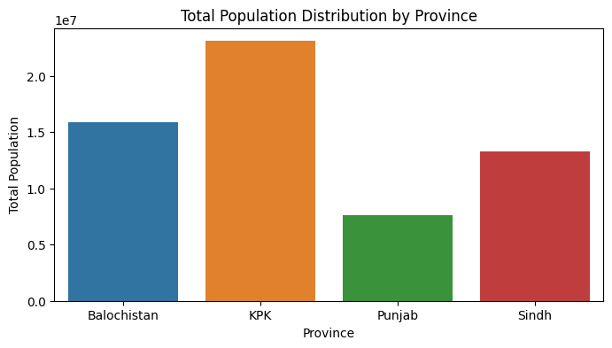

Figure 1. That shows the population by province

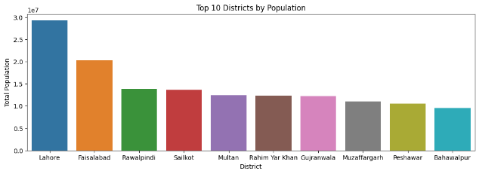

Figure 2. That plot presents the 10 most population district

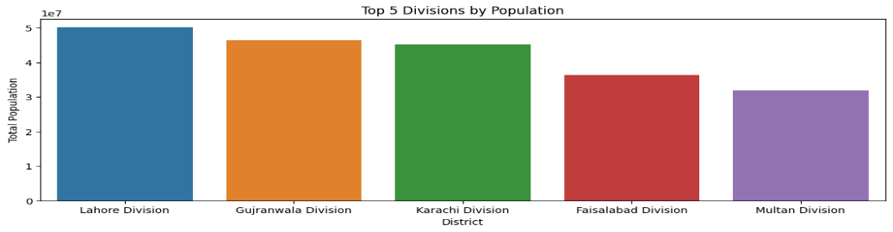

Figure 3. This plot presents the division by population

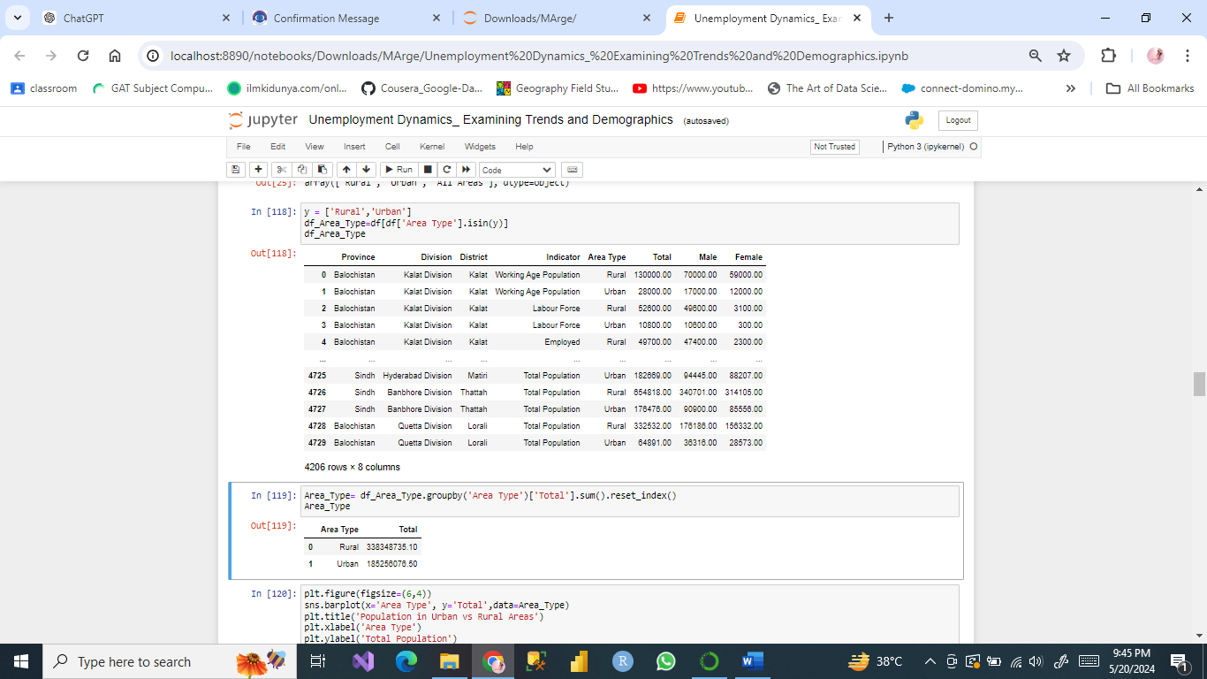

Figure 4. This dataset presents 'Rural', 'Urban', 'All Areas'.

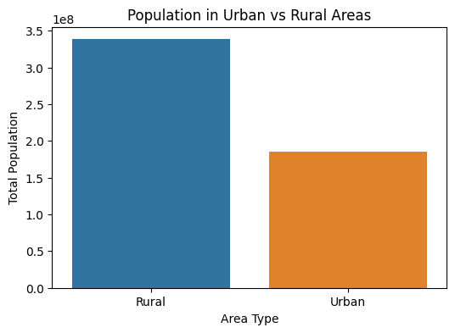

Figure 5. Graphical presentation of all area type

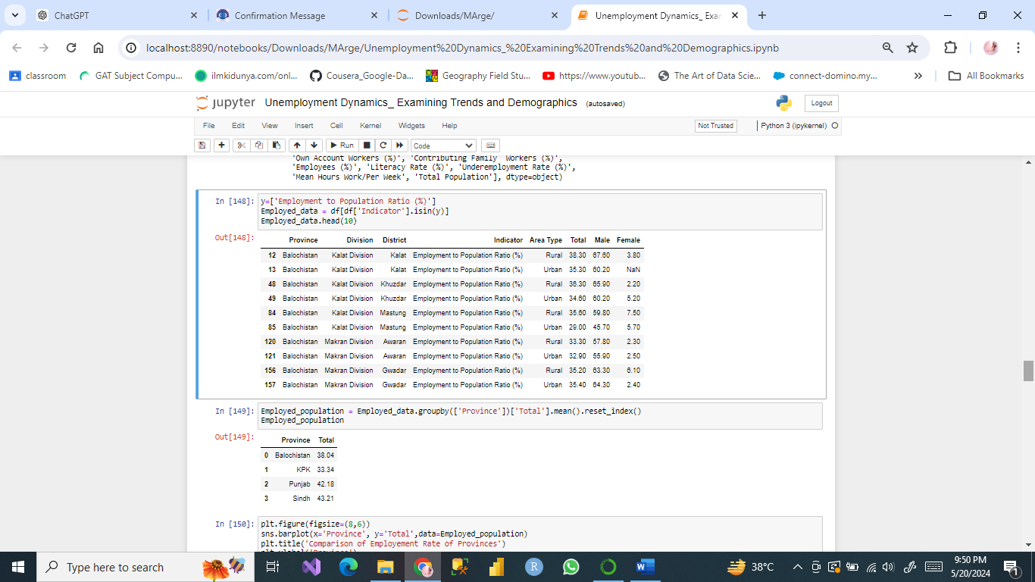

Figure 6. This dataset represents the rate of employment by province

Table 8. Employed Population

Employed rate by province

|  |  |
| --- | --- |
| Province | Total |
| Balochistan | 38.04 |
| KPK | 33.34 |
| Punjab | 42.18 |
| Sindh | 43.21 |

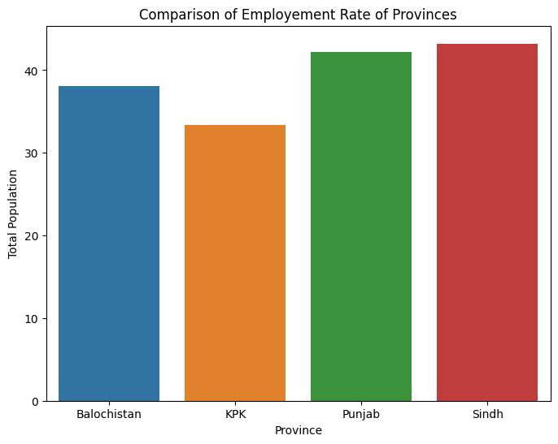

Figure 7. Comparison Graphical representation of rate of employment by provinces

|  |  |
| --- | --- |
| Table 9. Unemployed population  Unemployed Rate by province | |
| Province | Total |
| Balochistan | 6.67 |
| KPK | 9.61 |
| Punjab | 6.70 |
| Sindh | 3.97 |

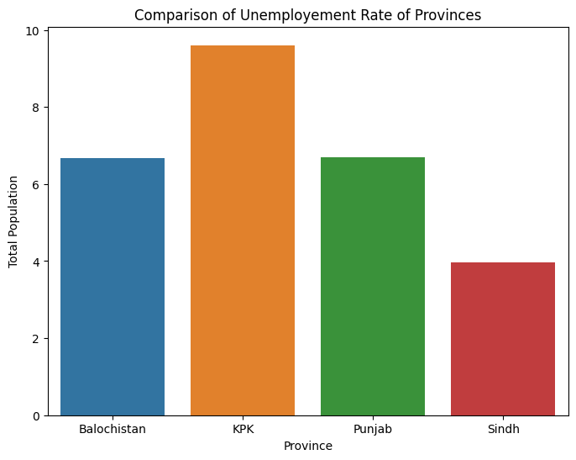

Figure 8. Comparison graph represent rate of unemployment by province

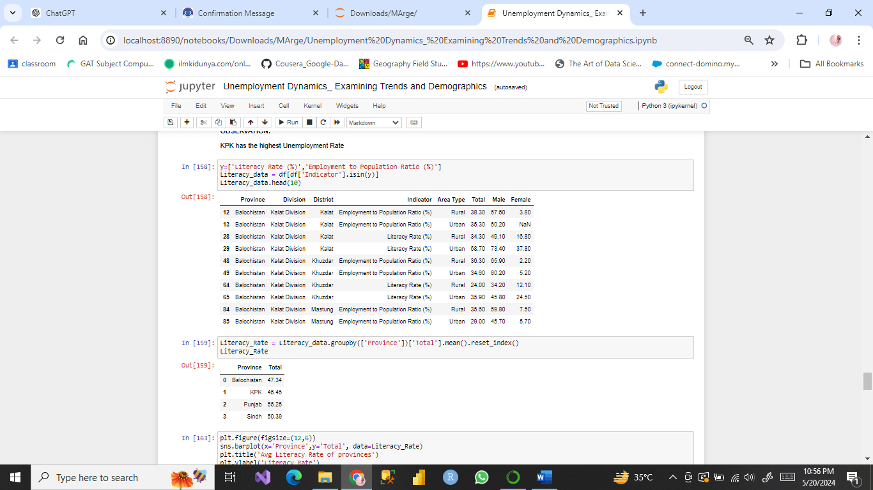

Figure 9. Dataset present the rate of Unemployment by province.

|  |  |
| --- | --- |
| Table 10. Literacy Rate by Province | |
| Province | Total |
| Balochistan | 47.34 |
| KPK | 46.45 |
| Punjab | 55.25 |
| Sindh | 50.39 |

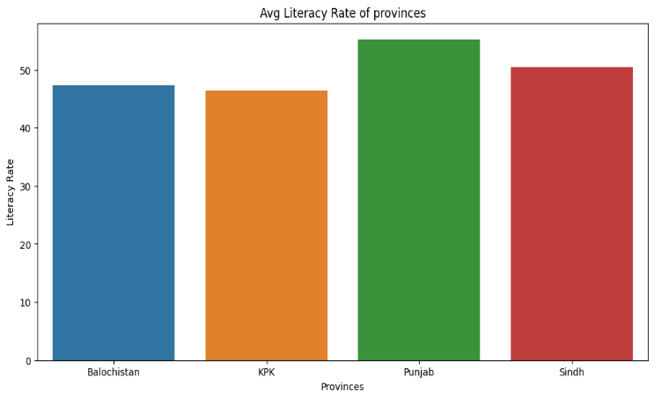

Figure 10. Graphical representation of Avg. Literacy Rate of Province

Table 11. Punjab has the highest Literacy Rate And Kpk has the lowest

|  |  |
| --- | --- |
| Area type | Total |
| Rural | 47.01 |
| Urban | 53.42 |

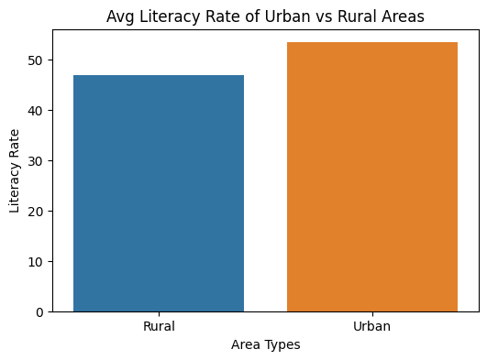

Figure 11. Literacy rate of Rural and Urban Areas

Table 12. Literacy Rate of Urban Areas are more than the literacy Rate of Rural Areas

|  |  |  |
| --- | --- | --- |
| District | | Total |
| 32 | Islamabad | 63.75 |
| 112 | Sohbatpur | 62.83 |
| 43 | Karachi East | 61.15 |
| 100 | Rawalpandi | 60.90 |
| 60 | Korangi | 60.60 |

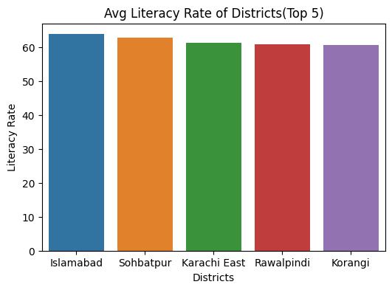

Figure 12. Plot represent a Literacy of top 5 District

1. **Demographic Analysis Statistic Investigation**
   1. **Youth Unemployment:** Youth unemployment remains a noteworthy challenge, with a significant parcel of the populace matured 15-24 a long time not locked in in instruction, work, or preparing (NEET)  [[1]](https://data.worldbank.org/indicator/SL.UEM.TOTL.NE.ZS?locations=PK).
   2. **Gender Incongruities:** Female interest within the labor constrain is impressively lower than male support, affected by social, instructive, and financial obstructions  [[3]](https://www.pbs.gov.pk/content/labour-force-statistics).
   3. **Regional Incongruities:** Urban zones tend to have higher work rates compared to rustic districts, where agrarian reliance and need of industrialization contribute to higher unemployment  [[3]](https://www.pbs.gov.pk/content/labour-force-statistics).
   4. **Sectoral Employment:**

The casual division plays a pivotal part in Pakistan's economy, giving work to a expansive portion of the populace. Be that as it may, casual business is regularly related with work uncertainty and need of social security  [[3]](https://www.pbs.gov.pk/content/labour-force-statistics).

### **Major Contributions**

This paper makes several significant contributions to the understanding of unemployment dynamics in Pakistan:

1. **Comprehensive Analysis of Unemployment Trends**: The study offers a detailed examination of the trends in unemployment across various demographic groups in Pakistan, including distinctions based on age, gender, education, and region. By doing so, it provides a clearer picture of the factors contributing to unemployment, which has been lacking in previous research.
2. **Linking Education to Employment Outcomes**: The research underscores the critical role of educational attainment in influencing employment rates. It highlights how higher levels of education, particularly tertiary education, significantly reduce the likelihood of unemployment, providing empirical support for the need to enhance educational opportunities as a strategy to combat unemployment.
3. **Focus on Youth and Gender Disparities**: The paper brings attention to the pressing issue of youth unemployment and gender disparities in the labor market. By identifying the specific challenges faced by these groups, such as skill mismatches for youth and socio-cultural barriers for women, the study contributes to a more nuanced understanding of unemployment.
4. **Regional and Sectoral Insights**: The study identifies and analyzes regional disparities in unemployment, with particular emphasis on the higher unemployment rates in rural areas compared to urban centers. Additionally, it explores the significant role of the informal sector in providing employment, despite the challenges associated with job security and social protection in this sector.
5. **Policy Recommendations**: One of the key contributions of this paper is its set of actionable policy recommendations. These include enhancing vocational training programs, promoting female labor force participation, and investing in industrialization in rural areas. These recommendations are tailored to address the specific causes of unemployment identified in the study, offering practical solutions for policymakers.
6. **Methodological Approach**: The paper employs a mixed-method approach, combining quantitative analysis of national survey data with qualitative insights from literature, providing a robust and comprehensive understanding of the unemployment issue. This methodological contribution enriches the existing body of research and offers a template for future studies on unemployment in similar contexts.
7. **Major Contributions**

This paper makes several significant contributions to the understanding of unemployment dynamics in Pakistan:

1. **Comprehensive Analysis of Unemployment Trends**: The study offers a detailed examination of the trends in unemployment across various demographic groups in Pakistan, including distinctions based on age, gender, education, and region. By doing so, it provides a clearer picture of the factors contributing to unemployment, which has been lacking in previous research.
2. **Linking Education to Employment Outcomes**: The research underscores the critical role of educational attainment in influencing employment rates. It highlights how higher levels of education, particularly tertiary education, significantly reduce the likelihood of unemployment, providing empirical support for the need to enhance educational opportunities as a strategy to combat unemployment.
3. **Focus on Youth and Gender Disparities**: The paper brings attention to the pressing issue of youth unemployment and gender disparities in the labor market. By identifying the specific challenges faced by these groups, such as skill mismatches for youth and socio-cultural barriers for women, the study contributes to a more nuanced understanding of unemployment.
4. **Regional and Sectoral Insights**: The study identifies and analyzes regional disparities in unemployment, with particular emphasis on the higher unemployment rates in rural areas compared to urban centers. Additionally, it explores the significant role of the informal sector in providing employment, despite the challenges associated with job security and social protection in this sector.
5. **Policy Recommendations**: One of the key contributions of this paper is its set of actionable policy recommendations. These include enhancing vocational training programs, promoting female labor force participation, and investing in industrialization in rural areas. These recommendations are tailored to address the specific causes of unemployment identified in the study, offering practical solutions for policymakers.
6. **Methodological Approach**: The paper employs a mixed-method approach, combining quantitative analysis of national survey data with qualitative insights from literature, providing a robust and comprehensive understanding of the unemployment issue. This methodological contribution enriches the existing body of research and offers a template for future studies on unemployment in similar contexts.
7. **Discussion**

The discoveries propose that arrangements pointed at decreasing unemployment ought to prioritize instruction and preparing programs to improve abilities and employability. Also, bolster for more seasoned laborers through reskilling activities and anti-discrimination measures is basic. Contributing in instruction not as it were decreases unemployment but too contributes to generally financial development by making a more gifted workforce.

As such, focus on education and training programs to increase skills and reduce unemployment should be a basis for policies geared towards reducing unemployment levels. Effective education and vocational training for clients is something that should be done to develop concrete, responsive, and appropriate education and vocational training programs that can contribute strongly to the employment of clients. Such programs should be built to enable students to acquire employable skills in the market place as well as relevant competencies in the Industrial market place to further enhance their prospects of the job market. Furthermore, the review of the literature identified that experiences in education and training, in general, ought to be continuous to respond to the dynamic technological factor and other market forces.

Moreover, new qualifications for ageing employees through training and development measures together with anti-age discrimination legislation is also essential. Currently, through increased age, the elderly get jobless, and they remain jobless for longer periods than their youthful counterparts because of their ages and obsolescence. By adopting an effective reskilling strategy, the current generation of workers can easily learn about new suitable jobs, down the unemployment rate among this group considerably. It is also crucial to note that anti-discrimination policies should continue to be implemented to the letter to ensure that older workers are offered equal chance in the labor market.

The argument for increased spending on education is supported as it does not only address the issue of unemployment but also helps in the development of the economy. An educated populace will seek to develop new products and be more productive; attributes today’s economy requires in its growth and development. Education should therefore be considered as an investment that requires priority with particular attention to the accessibility of good education at different levels of education and quality assurance with the view to delivering education that meets the competencies required in the knowledge society [8], [9]. Also, collaborations between the educational facilities and employers could help in establishing appropriate training programs as well as enable learners get practical experience through placement and training [10].

Finally, it is critical for countries to develop extensive employment policies that would cover both initial and further education, early retirement of workers and successful implementation of discrimination rules against older workers. In addressing these areas, potential policies can be formulated to ensure that a more flexible and equitable labour market is developed, provided for sustainable economic growth and consonant with human welfare.

1. **Policy Recommendations**

To address unemployment effectively, policy interventions should focus on:

* **Youth Employment Programs:** Improving vocational training and education systems so as to develop basic competencies that would help youths fit into the market requirements. According to the available data, it is established that vocational training can potentially solve the problem of youth unemployment at high rates by integrating subjects that are to be studied as practical ones in the world of work [11]. Specialised programs should be developed in consonance with the existing market needs to allow the industry to contribute to the development of the programs [12].
* **Women's Labor Force Participation:** Policies aimed at promoting female employment such as education and knowledge on the employment rights of women, child care to support women employment and anti-sexism policies. Researchers have estimated that female labor force participation can be enhanced and improved by offering enhanced educational programs and Cheap child care services [13], [14]. There are also legal aspects, such as anti-discrimination laws and, thus, relevant policies that play a significant role in addressing the issue of diversity [15].
* **Regional Development:** Providing education for employment; developing the countryside to absorb a population that is crowding into the big cities. Regional inequalities in employment may also be solved through the provision of structures that would further industrialization, and boost the food production in the rural hubs [16]. It is stated that such investments can be used to increase employment density of a particular area and thus, can be used to improve employment opportunities between the urban and rural areas [17].
* **Formalization of the Informal Sector**: Promoting the ‘formalization’ process of economy through bonuses and improving legislation conditions for new employees. It can be highlighted that the impacts of the informal sector are also considerable in Pakistan’s employment structure, while employees from the informal sector may suffer from job insecurity. Interventions such that seek to address the sector as the realm of informal employment can encompass fiscal incentives such as taxes and Social Security as well as ease of operating laws[18][19].

1. **Motivation**

The consider on unemployment elements in Pakistan is driven by the basic have to be address a noteworthy socio-economic challenge. Unemployment influences not as it were person vocations but too has broader suggestions for financial soundness and development. The inspiration behind this research incorporates:

* 1. **Financial Solidness:** Unemployment contains a direct impact on financial soundness. By understanding the patterns and statistic variables influencing unemployment, the ponder points to supply bits of knowledge that can offer assistance in defining approaches to diminish joblessness and improve financial soundness.
  2. **Social Affect:** Tall unemployment rates lead to different social issues, counting destitution, wrongdoing, and social distress. The consider points to highlight these issues and propose arrangements to moderate the negative social impacts of unemployment.
  3. **Arrangement Definition:** Distinguishing key statistic factors that impact work status is crucial for creating focused on intercessions. The inquire about looks for to illuminate policymakers around successful procedures to address unemployment.
  4. **Educational Outcomes:** There's a solid connect between instructive fulfillment and business. By analyzing how instruction impacts employment, the think about points the significance of instruction in lessening unemployment rates.
  5. **Age Flow:** Distinctive age bunches confront one of a kind challenges within the labor advertise. The ponder points to investigate these elements to superior get it how to back different age bunches in securing business.

1. **Gaps**

Whereas the consider gives a comprehensive investigation of unemployment elements in Pakistan, a few holes stay that warrant assist examination:

* 1. **Territorial Incongruities:** The think about distinguishes territorial contrasts in work rates but needs a detailed investigation at a more localized level, such as locale or communities, to get it particular territorial challenges.
  2. **Casual Segment:** In spite of the fact that the part of the casual segment is recognized, there's restricted investigation of its characteristics, challenges, and the move from casual to formal work.
  3. **Gender Disparity:** The consider touches on gender disparities in business but does not dig profoundly into the particular boundaries ladies confront and how to methodicallly address them.
  4. **Innovative Affect:** The affect of technological advancements and computerization on work patterns isn't completely inspected. This zone is significant as innovation progressively impacts labor markets.
  5. **Arrangement Adequacy:** The viability of past approach mediations in diminishing unemployment isn't basically analyzed. Understanding the victory and disappointments of past arrangements can give profitable lessons for future intercessions.
  6. **Longitudinal Thinks about:** The ponder depends on cross-sectional information, which gives a depiction of the current circumstance. Longitudinal information would offer more profound experiences into how unemployment patterns advance over time and the long-term impacts of statistic components.
  7. **Sector-Specific Investigation:** A more point by point examination of how diverse financial divisions are influenced by unemployment would offer assistance in understanding sector-specific challenges and openings.

By tending to these crevices, future investigate can give a more nitty gritty understanding of unemployment flow in Pakistan and contribute to more successful policy-making to diminish unemployment and advance maintainable financial development.

1. **Conclusion**

The use of educational and socio-demographic factors to analyze the cause and effects of unemployment is informative to policymakers. In this context, focusing on the quality of education and meeting the needs of various demographic target audiences helps to reduce the impact of unemployment and build a more sustainable economy. By covering all aspects policies ensure coverage and targeted hence eradicating unemployment rates in all the sectors and regions.

This paper looks at the unemployment situation in Pakistan and shows from the available demographic and economic indicators that the problem is rather multifaceted. To this end, practical solutions to these challenges entail a more comprehensive a strategic approach that involves specific policy interventions and sound economic framework. This paper suggests that youth employment should be given attention since youths are a large portion of the working population. About this, effective vocation training and education policies that address market needs can help young people obtain relevant skills in their endeavors. Lastly, addressing the issue of gender equitable in the labor market is crucial. Women should be encouraged to participate within the workforce by removing the social, educational and economic constraints that limit engagement and enacting empowering policies such as childcare and anti-discrimination policies.

Regional development is another significant issue that should not be ignored. This means that funding development of infrastructural facilities and industrialization of rural areas can provide employment for the people and hence help in bridging the rural-urban income divide. Such investments are essential to sustaining balanced economic development and to combat overall unemployment figures. However, another important reform is the regularization of the informal sector. The informal employment swallows a significant proportion of the populace but comes with uncertainties of work, and social security. This is because transition from informal employment through regulatory reforms and/or social protection programs has been found to enhance job security and quality.

If youth employment, gender equality, regional development, and formalization of the informal sector are focused on, Pakistan can improve its employment and charter a sustainable course for economic growth. It does not only solve the problems of unemployment and offer solutions for the present but also creates the framework for future sustainable economic development.

1. **Measures for Tackling Unemployment: Strategic Planning**

**1. Youth Employment Initiatives**

Upgrade of vocation training and education is crucial prepares the young people with market relevant knowledge and skills. Training and development in partnership with industries so as to link training with the demand of the labor market and inclusion of literacy can help in reducing unemployment among the youths by a big margin [4], [5].

**2. Empowering Female Workforce Participation**

Policies that would help to enhance the FLP should be adopted. This encompasses increasing access to educational facilities, availability of cheap childcare, and exercising prevention of discrimination against women. A schedule control and parental leave can also contribute to balancing the work-family conflict of women [5], [6], [7].

**3. Regional Economic Development**

This means that the government should invest in rural infrastructure as well as support industrial development that happens in rural settings so that employment opportunities can be eased outside of the cities. Applying modern technologies to increase yields can also improve local economies and reciprocally decrease unemployment in rural regions [8], [9].

**4. Formalizing the Informal Economy**

This can be achieved through tax incentives, social security benefits and reduced measures to facilitate employers to help workers upgrade informal employment jobs to formal employment jobs. This transition can be achieved through training programs to enhance the skills of the employees, which would be valuable in fostering economic stability. [10]

**References**

[1] "Unemployment, total (% of total labor force) (national estimate) - Pakistan," The World Bank, 06 Feb 2024.

[2] OECD, "Education at a Glance 2022," OECD (2022), Education at a Glance 2022: OECD Indicators, OECD Publishing, Paris, 2022.

[3] "U.S. bureau of labor statistics," 2023.

[4] "Pakistan Bureau of Statistics," Government of Pakistan. [Online]. Available: <https://www.pbs.gov.pk/content/labour-force-statistics> .

[5] U. C. W. "Educational attainment and employment outcomes: evidence from 11 developing countries," UNESCO, 2013.

[6] "UNESCO. (2012). "Education for All Global Monitoring Report 2012.," UNESCO iLibrary, 2012.

[7] "Youth employment and vocational training," International Labour Organization, 2023..

[8] S. J. Lee, "Vocational Education and Training in South Asia: A Pathway to Employment," Journal of Vocational Education & Training, vol. 72, no. 4, pp. 503-523, 2020.

[9] "Women's labor force participation in Pakistan: Progress and Challenges," World Bank, 2023.

[10] A. Qureshi and H. Ali, "Childcare support and women's employment in Pakistan," Asian Development Review, vol. 37, no. 2, pp. 156-178, 2020

[11] "Gender equality and anti-discrimination policies in the workplace," United Nations, 2022.

[12] T. Ahmed and H. Ali, "Regional Disparities in Employment Rates in Pakistan," International Journal of Economic Research, vol. 11, no. 4, pp. 211-230, 2018.

[13] M. A. Khan, "Rural development and employment generation: Evidence from Pakistan," Journal of Rural Development, vol. 38, no. 1, pp. 45-62, 2021.

[14] M. Zafar, "The Role of Informal Sector in Employment Generation in Pakistan," Asian Economic Review, vol. 58, no. 3, pp. 234-245, 2019.

[15] A. Raza, "Formalizing the Informal Economy: Strategies and Solutions," Economic and Political Weekly, vol. 54, no. 5, pp. 34-41, 2019.

[16] T. Ahmed and H. Ali, "Regional Disparities in Employment Rates in Pakistan," International Journal of Economic Research, vol. 11, no. 4, pp. 211-230, 2018.

[17] M. A. Khan, "Rural development and employment generation: Evidence from Pakistan," Journal of Rural Development, vol. 38, no. 1, pp. 45-62, 2021.

[18] M. Zafar, "The Role of Informal Sector in Employment Generation in Pakistan," Asian Economic Review, vol. 58, no. 3, pp. 234-245, 2019.

[19] A. Raza, "Formalizing the Informal Economy: Strategies and Solutions," Economic and Political Weekly, vol. 54, no. 5, pp. 34-41, 2019.