**Sentiment Trends in News Channels: Analyzing Reporting Bias and Public Impact**

**Er. Shaweta Mahey1, Er. Manpreet Singh2**

**1Assistant Professor, Rayat Bahra Institute of Engineering and Nano Technology, Hoshiarpur**

**2Assistant Professor, Sant Baba Bhag Singh University, Jalandhar**

**Abstract**

*Social media serves as a medium for communication, enabling the sharing of news, posts, and other content. It acts as a platform to convey messages and gather public reactions. This research aims to analyze public responses to different news channels using sentiment analysis. By assessing the audience’s emotional feedback on social media, news channels can better understand how their content is perceived. This helps them improve the quality of information provided, ensuring they become more reliable sources for the public. Sentiment analysis, as a tool, processes user opinions expressed on social media to identify positive, negative, or neutral sentiments toward news content. The study contributes to bridging the gap between media platforms and their audiences by evaluating how effectively news channels communicate and engage. With insights from public reactions, news providers can align their content with audience expectations, ultimately fostering trust and transparency.*

Keywords: Tweets, News, Sentiment Analysis, social media

**Introduction**

Social media has become a primary medium for communication, offering a platform for individuals to share opinions, news, and ideas in real-time. Among various platforms, Twitter plays a significant role in disseminating information and shaping public discourse, especially concerning news events. News channels leverage these platforms to engage with their audience and receive instant feedback. This research focuses on analyzing public sentiment toward three prominent news channels—Zee News, Aaj Tak, and BBC News using tweets as the primary data source.

The objective of this study is to explore how audiences respond to these news channels on Twitter and to assess the nature of the sentiment associated with their coverage. Sentiment analysis, a powerful tool in natural language processing, is applied to categorize the tweets into positive, negative, or neutral sentiments. This approach helps gauge public perception, offering insights into how well the news channels align with the expectations and trust of their audience.

A total of 3,000 tweets have been collected for this analysis, with approximately 1,000 tweets extracted for each news channel. These tweets were gathered using Twitter’s API, ensuring an unbiased and real-time sample of public opinions. This research provides a comparative overview of audience reactions toward the three selected news channels, offering insights into the reliability and credibility they convey through their news content.

By applying sentiment analysis, the study aims to bridge the gap between news providers and their audience by identifying areas of improvement in news delivery. The findings will highlight how each channel is perceived in terms of trust and reliability, helping media outlets tailor their strategies to foster a better relationship with their viewers. Ultimately, this research underscores the role of sentiment analysis in enhancing the quality of news communication in the digital age.

**Literature Survey**

Traditional lifestyles have undergone significant changes due to the current technological era. With advancements in information technology (IT), news and events are disseminated at an unprecedented speed. The sheer volume of data generated by millions of users every minute—through blogs, social media posts, comments, and news articles—can be overwhelming. Manually navigating this vast information is challenging, prompting the development of advanced techniques for efficient and automated processing. News often covers events that evoke a range of emotions—positive, negative, and neutral. To analyze these sentiments expressed in textual data, sentiment analysis is employed. This research introduces a lexicon-based approach for sentiment analysis of news articles, using the BBC news dataset to demonstrate the methodology's validity and applicability [1].

Sentiment analysis refers to the automatic comprehension, extraction, and processing of textual data to derive sentiment information from individual comments on YouTube videos. Utilizing text mining techniques is the most effective way to interpret the meaning of each comment. It is essential to categorize both positive and negative content, allowing YouTube users to assess the relevance of the published material based on their perspectives. While Naïve Bayes and Support Vector Machines are commonly used as foundational methods in text-related tasks, their effectiveness can vary significantly depending on the versions, features, and size of the datasets. Support Vector Machines perform well when classifying larger datasets or complete documents, while Naïve Bayes is more effective with smaller datasets or fragments of text. A data split of 70% for training and 30% for testing leads to improved accuracy and performance when combining Naïve Bayes with Support Vector Machines, achieving optimal test results of 91% accuracy, 83% recall, and an F-score of 87% [2].

Opinion mining from user reviews is an emerging field of study. Sentiment analysis of natural language content allows for the assessment of customer opinions. These reviews can be written in various languages, including English, Chinese, Arabic, Japanese, Urdu, and Hindi. This research presents a model for categorizing the polarity of reviews in Roman Urdu. To achieve this, a new dataset consisting of 24,000 Roman Urdu reviews was created by collecting raw data from reviews of 20 songs from the Indo-Pak music industry. Nine machine learning algorithms were tested: Naïve Bayes, Support Vector Machine, Logistic Regression, K-Nearest Neighbors, Artificial Neural Networks, Convolutional Neural Networks, Recurrent Neural Networks, ID3, and Gradient Boost Tree. Among these, Logistic Regression achieved the highest performance, with testing and cross-validation accuracies of 92.25% and 91.47%, respectively [3].

The aim of this study is to explore the polarity and emotions present in various sports feeds, as these factors may influence the evolution of sports news. The primary objective of this approach is to generate a range of text analytics that assess the sentiments of all relevant and current sports news available to the public. The significance and applicability of sentiment analysis of RSS feeds in this research lie in the ability to distinguish between positive and negative sports-related feeds, which can shape readers' or users' perceptions and enhance the effectiveness of messaging in RSS feeds. The study employs sentiment analysis methodologies, utilizing two distinct online open-source tools to analyze the sentiment of Rich Site Summary (RSS) news feeds that affect sports broadcasting values [4].

Recent advancements in social media, web content, and microblogs have led to a significant increase in online customer reviews (OCRs), presenting challenges that traditional methods cannot address. In the realm of big data analytics, sentiment analysis (SA) has emerged as a valuable technique for improving decision-making. This study introduces a novel method that combines SA, multi-attribute decision-making (MADM), and neutrosophic set (NS) theory to rank products based on multiple online reviews. The approach employs an adapted Valence Aware Dictionary and sEntiment Reasoner (VADER) alongside a newly developed neutral lexicon to calculate sentiment scores, resulting in a method called Neutro-VADER. A case study utilizing Twitter datasets demonstrates the method's effectiveness in managing neutral data and producing consistent rankings compared to other techniques like PROMETHEE II and TOPSIS[5].

Short texts' limited qualities need the extraction of features from many viewpoints and the use of different combinations of sentiment features in order to reveal buried sentiment information. The multi-channel convolutional neural network with a multi-head attention mechanism (MCNN-MA) is the basis for the novel sentiment analysis model proposed in this study. By combining word features with location, dependence, and part-of-speech grammar information, the model creates three new combined feature sets that are then fed into the multi-channel convolutional neural network. To improve the learning of sentiment information in the text, the multi-head attention method is also included. The MCNN-MA model outperforms other baseline models in terms of classification accuracy and training time when tested on two Chinese short text datasets [6].

A significant number of individuals now obtain much of their daily news through social media, making it a crucial platform for news communication. Consequently, traditional news organizations are leveraging social media to attract audiences and boost engagement. This study investigates how news organizations utilize sentiment to engage followers on social media. We analyze the tone of news articles across print, radio, and television to highlight differences in coverage. Additionally, we examine user attitudes and responses to posts with varying sentiments. Our research employs a dataset of 150,000 news posts and 1.13 billion user reactions gathered from the Facebook pages of five prominent news networks. The findings reveal a strong correlation between the sentiment of news posts and user opinion sentiment, showcasing differences among various media types [7].

Urdu is still regarded as a low-resource language even though it is the tenth most spoken language in the world, with around 230 million speakers. In order to overcome the dearth of benchmark datasets, researchers have turned to creative solutions, such as using language translation services to duplicate datasets from resource-rich languages like English. However, utilizing programs like Google Translate to translate words can change their meanings, causing polarity changes that impair performance on tasks like emotion detection and sentiment categorization. This study identifies terms that trigger polarity shifts in five categories and investigates how translation affects sentiment categorization from a resource-rich language to a low-resource language. According to our research, these changes result in a 2-3 percentage point drop in classification performance[8].

In this study, we present a novel approach Cov-Att-BiLSTM for sentiment analysis of COVID-19 news headlines using deep neural networks in an attempt to create an effective model that can elicit public sentiment on COVID-19 news. To improve the accuracy, we use semantic level data tagging, embedding techniques, and attention processes into the prediction process. We evaluated the suggested method against a number of deep and machine learning classifiers using several measures of prediction quality and classification efficiency, and the experimental findings show that it is superior with a testing accuracy of 0.931. Additionally, the suggested method examined 73,138 tweets on the pandemic that were posted on six international networks, properly reflecting coverage of COVID-19 news and vaccination around the world [9]

NLP and machine learning classifiers have been used in this work to analyze the sentiment of tweets made by Indian citizens. A total of 12741 tweets with the keywords "Indialockdown" are extracted between April 5, 2020, and April 17, 2020. Data was preprocessed using the Python natural language toolkit, annotated using the TextBlob and VADER lexicons, and extracted from Twitter using the Tweepy API. The data has been categorized using eight distinct classifiers. The experiment's maximum accuracy of 84.4% was attained using unigrams and the LinearSVC classifier. According to the study's findings, the majority of Indians accept the government's decision to impose a lockdown during the Corona eruption [10].

YouTube is a widely accessible video-sharing platform where users can upload and share video content, making it one of the most frequently visited sites on the internet. It functions as a social media platform, allowing users to interact through likes, comments, and shares, with content popularity often gauged by views and ratings. However, sometimes irrelevant or lower-quality videos rank highly due to sheer view or like counts, which can detract from the reliability of search results. To address this, we propose a sentiment analysis approach using natural language processing (NLP) based on user feedback. This study aims to identify trending, high-quality, and popular YouTube videos through refined user input analysis. Testing has confirmed that this method enhances accuracy in identifying significant, well-liked content [11].

When integrating Kansei engineering into ridesharing services, online ratings are becoming more and more important. Kansei engineering is crucial for businesses looking to improve their offers since it employs client feedback to improve products and services. Sentiment analysis methodically collects opinions from social media customer reviews, which are usually unstructured. Reviews in India and Pakistan are frequently in English and Roman Urdu/Hindi, necessitating translation for a useful analysis. The purpose of this research is to support Kansei engineering for ridesharing services by doing aspect-based sentiment analysis on translated reviews. Sentiment analysis uses unsupervised machine learning to classify customer feedback under the key service elements of Driver, Company, Service, and Ride, which are determined by frequency. Businesses can enhance services to meet client expectations by analyzing these categories by sentiment polarity [12].

To find out what people think about services or products, sentiment analysis is utilized. With millions of views and user comments, YouTube, a well-known platform for sharing videos, offers insightful information for raising content ratings. Machine learning and natural language processing methods examine these comments. Numerous methods have been examined, with classifications ranging from two (positive or negative) to three (positive, negative, and neutral) as well as various emotions such as fear, rage, surprise, happiness, and sadness. It's still difficult to choose the most exact model, though. In order to determine polarity, this research study examines sentiment analysis techniques applied to YouTube comments. It presents and classifies methods that are useful for data mining and sentiment analysis research. By doing so, models that are useful for evaluating and enhancing material in response to viewer feedback are better understood [13].

In order to comprehend variations in reporting, this study will examine COVID-19-related news from different geographical areas. Lockdowns, vaccinations, and preventive measures were implemented after the COVID-19 pandemic started in January 2020. There hasn't been a thorough examination of COVID-19 press coverage, particularly looking at the elements that are prioritized in various political and economic circumstances. Semantic diversity in global news frequently causes traditional LDA models to struggle with coherence. To solve this, we employed a pooling technique using 1–6 ngrams for LDA topic modeling and TF-IDF for data processing. To investigate sentiment variations among areas, VADER sentiment analysis was used. This study looks at media reporting trends in a novel way, demonstrating how newspapers' political stance and economic environment affect the tone and focus of their coverage of COVID-19 [14].

**Methodology**

This research utilizes Twitter, a popular microblogging platform, as the primary data source to collect public opinions on three news channels Zee News, Aaj Tak, and BBC News. The Twitter API v2 was employed to fetch tweets, enabling access to real-time data and historical tweets that reflect audience sentiment toward these channels. The aim was to collect approximately 1,000 tweets per news channel, resulting in a dataset of 3,000 tweets.

The data collection process began by identifying relevant keywords, hashtags, and official Twitter handles associated with each news channel. For example, queries included terms like “#ZeeNews,” “#AajTak,” “#BBCNews,” and mentions of their official handles. To ensure data relevance, tweets were filtered by specific parameters, such as language (English and Hindi), and limited to recent dates to capture current public sentiment. Duplicate tweets, retweets, and promotional posts were excluded to maintain the quality and relevance of the dataset.

Once the tweets were extracted, the data was stored in structured formats such as CSV and JSON for easy handling and analysis. Preprocessing was carried out to remove noise from the text, such as unnecessary symbols, emojis, and URLs, ensuring that the analysis focuses only on meaningful content. This step also involved converting text to lowercase, tokenizing sentences, and eliminating stop words that do not contribute to sentiment (e.g., “the,” “is,” “a”).

For sentiment analysis, the Natural Language Processing (NLP) tools and libraries like Text Blob or VADER were used. These tools assign sentiment polarity scores to each tweet, classifying them as positive, negative, or neutral. The classification helps quantify how the public perceives the content shared by each news channel.

Through this methodological approach, the research ensures a comprehensive, unbiased, and structured analysis of public opinions. The final dataset reflects audience sentiment toward Zee News, Aaj Tak, and BBC News, enabling a comparative assessment of how well these channels align with public expectations. This methodology not only provides insights into audience reactions but also highlights the effectiveness of social media as a tool for monitoring public sentiment toward news media.

**Text Preprocessing**

Once the tweets were collected from Twitter, text preprocessing was performed to prepare the data for sentiment analysis. Preprocessing is essential to eliminate irrelevant elements and ensure the text is suitable for analysis. The steps involved were as follows:

1. Lowercasing:  
   All text was converted to lowercase to maintain consistency (e.g., “News” and “news” are treated the same).
2. Removing URLs, Mentions, and Hashtags:

URLs, user mentions (e.g., “@BBCNews”), and hashtags (e.g., “#AajTak”) were removed since they do not contribute to sentiment.

1. Eliminating Special Characters and Emojis:

Symbols, punctuation, emojis, and non-alphanumeric characters were removed to reduce noise in the data.

1. Tokenization:  
   Tweets were split into individual words (tokens) for easier analysis, allowing each word to be evaluated independently.
2. Stop word Removal:

Common words that do not add meaningful value to sentiment (e.g., "the," "is," "at") were removed using a predefined stop word list.

1. Lemmatization/Stemming:  
   Words were reduced to their base form (e.g., "running" becomes "run") to ensure that similar words are treated uniformly.

These preprocessing steps ensured that the cleaned text was concise and meaningful, ready for sentiment classification using NLP tools such as VADER or Text Blob. This process enhanced the accuracy and relevance of the sentiment analysis by focusing only on the core content of the tweets.

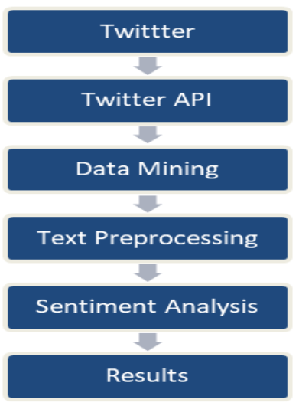

Fig. 1. Research Model Chart

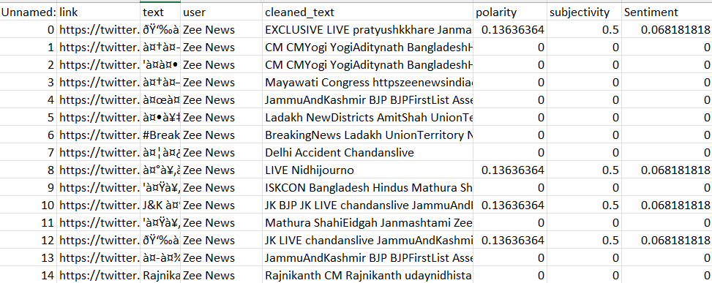

Fig. 2. Zee News Cleaned Tweet

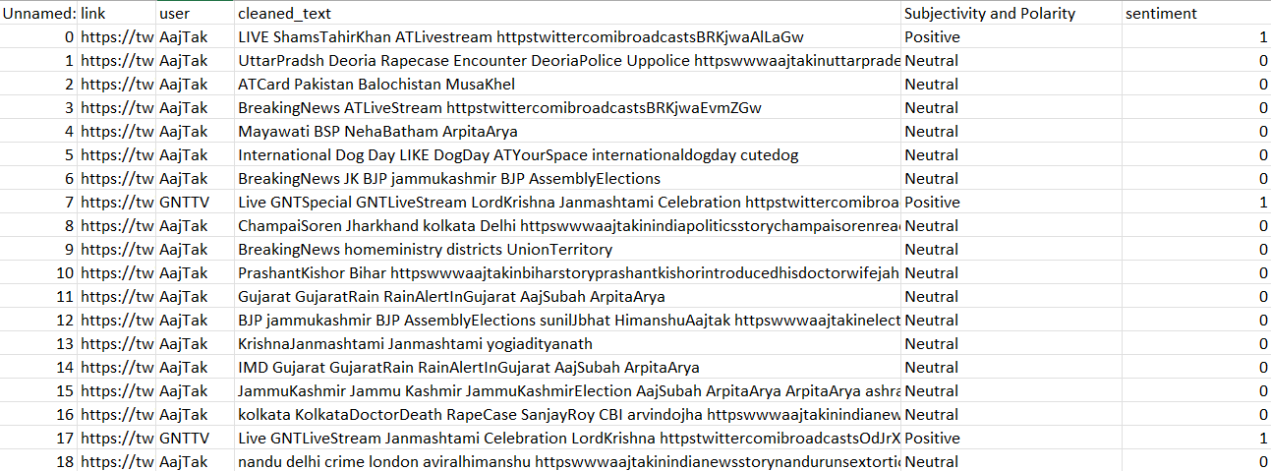

Fig. 3. AajTak News Cleaned Tweet

**RESUTLS**

The analysis of 3,000 tweets indicates that most people have embraced the news. A large portion of responses reflects positive sentiment, pointing to widespread support and agreement. However, despite the general optimism, a small fraction of the audience has expressed dissatisfaction or disagreement. While these dissenting opinions are not strong enough to shift the overall sentiment, they do highlight some level of opposition. This suggests that although the majority views the news favorably, it hasn’t resonated equally with everyone, underscoring the presence of diverse opinions within the discussion. Keeping track of these differing viewpoints could offer valuable insights into potential challenges or areas that may need further consideration. In summary, public sentiment leans toward acceptance, with only a small minority expressing disapproval.

# **CONCLUSIONS**

An analysis of 3,000 tweets reveals that the majority of people reacted positively to the news, reflecting strong public support. While most individuals seem to align with the news, a small group has expressed opposition or dissatisfaction. Although these differing opinions are not enough to alter the dominant sentiment, they highlight the presence of varied perspectives within the conversation. This suggests that, despite the news being well-received by many, it may not resonate equally with everyone. Tracking these diverse viewpoints could offer valuable insights into potential challenges or issues that may need further attention. In conclusion, public opinion leans toward acceptance, with only a small minority expressing disagreement, indicating that most people support the news despite some opposing views.

**References**

[1] Areej Fatemah Meghji, *2019 2nd International Conference on Computing, Mathematics and Engineering Technologies (iCoMET) : January 30-31, 2019*. [IEEE], 2019.

[2] A. N. Muhammad, *Sentiment Analysis of Positive and Negative of YouTube Comments Using Naïve Bayes-Support Vector Machine (NBSVM) Classifier*.

[3] M. A. Qureshi *et al.*, “Sentiment Analysis of Reviews in Natural Language: Roman Urdu as a Case Study,” 2022, *Institute of Electrical and Electronics Engineers Inc.* doi: 10.1109/ACCESS.2022.3150172.

[4] K. Mahboob, F. Ali, and H. Nizami, “Sentiment Analysis of RSS Feeds on Sports News – A Case Study,” *International Journal of Information Technology and Computer Science*, vol. 11, no. 12, pp. 19–29, Dec. 2019, doi: 10.5815/ijitcs.2019.12.02.

[5] I. Awajan, M. Mohamad, and A. Al-Quran, “Sentiment Analysis Technique and Neutrosophic Set Theory for Mining and Ranking Big Data from Online Reviews,” *IEEE Access*, vol. 9, pp. 47338–47353, 2021, doi: 10.1109/ACCESS.2021.3067844.

[6] Y. Feng and Y. Cheng, “Short Text Sentiment Analysis Based on Multi-Channel CNN with Multi-Head Attention Mechanism,” *IEEE Access*, vol. 9, pp. 19854–19863, 2021, doi: 10.1109/ACCESS.2021.3054521.

[7] N. Kumar, R. Nagalla, T. Marwah, and M. Singh, “Sentiment dynamics in social media news channels,” *Online Soc Netw Media*, vol. 8, pp. 42–54, Dec. 2018, doi: 10.1016/j.osnem.2018.10.004.

[8] A. Ghafoor *et al.*, “The Impact of Translating Resource-Rich Datasets to Low-Resource Languages through Multi-Lingual Text Processing,” *IEEE Access*, vol. 9, pp. 124478–124490, 2021, doi: 10.1109/ACCESS.2021.3110285.

[9] W. Ahmad, B. Wang, P. Martin, M. Xu, and H. Xu, “Enhanced sentiment analysis regarding COVID-19 news from global channels,” *J Comput Soc Sci*, vol. 6, no. 1, pp. 19–57, Apr. 2023, doi: 10.1007/s42001-022-00189-1.

[10] P. Gupta, S. Kumar, R. R. Suman, and V. Kumar, “Sentiment Analysis of Lockdown in India during COVID-19: A Case Study on Twitter,” *IEEE Trans Comput Soc Syst*, vol. 8, no. 4, pp. 939–949, Aug. 2021, doi: 10.1109/TCSS.2020.3042446.

[11] Hanif Bhuiyan, *2017 IEEE International Conference on Signal and Image Processing Applications (ICSIPA)*. IEEE, 2017.

[12] S. Ali, G. Wang, and S. Riaz, “Aspect based sentiment analysis of ridesharing platform reviews for kansei engineering,” *IEEE Access*, vol. 8, pp. 173186–173196, 2020, doi: 10.1109/ACCESS.2020.3025823.

[13] R. F. Alhujaili and W. M. S. Yafooz, “Sentiment Analysis for Youtube Videos with User Comments: Review,” in *Proceedings - International Conference on Artificial Intelligence and Smart Systems, ICAIS 2021*, Institute of Electrical and Electronics Engineers Inc., Mar. 2021, pp. 814–820. doi: 10.1109/ICAIS50930.2021.9396049.

[14] A. Sittar, D. Major, C. Mello, D. Mladenic, and M. Grobelnik, “Political and Economic Patterns in COVID-19 News: From Lockdown to Vaccination,” *IEEE Access*, vol. 10, pp. 40036–40050, 2022, doi: 10.1109/ACCESS.2022.3164692.