Survey Paper on Android Based Academic Performance Monitoring System for Parents/Guardians

Author Name:1. Vaishnavi Paithankar 3. Sanket Gudghe

2. Saurabh Bhatude 4 . Raghunath Thombre

Guide Name: Prof. Sameena Ansari

# 1. Introduction

Academic feedback is essential in secondary schools to keep a rap-Port between students, teachers, and parents and guardians. There Are three main factors that contribute towards a student’s progress: Attitude, attendance and aptitude. Monitoring their progress is keyTo a student’s development in school and allows both teachers andParents or guardians to support them to a greater extent. AnnualReports are sent to a student’s home to summarise their performanceOver the academic year, following set criterion from the government.One aspect of a student’s report is the teacher’s written comment, Providing more details on a student’s attitude towards their learnIng. However, families whose primary language is not English may Struggle to interpret this information. Working in schools has demon-Strated the diversity of students and their wide range of backgrounds, Including– but not limited to– language barriers. This work pro-Poses a system called SENSE (Student pErformance quaNtifier usIng Sentiment analysis) for improving the information conveyed in Secondary school reports through means of natural language proCessing. By combining the three key features which contribute to-Wards a student’s progress, a numerical representation is producedfor an easier interpretation. This reduces the likelihood of a tarnished relationship between home and schools through better meansof conveying information and maintains communication between students, teachers and parents or guardians.

**Keywords**: Student Monitoring , Parents , Academic Result, Android, Performance

# 2. Literature Survey

1.Paper Name: Design and Implementation of Early Warning System Based on EdUcational Big Data

Author:Zhuping Wang, Chenjing Zhu, Zelin Ying, Ying Zhang, Ben Wang*, XinyuJin, Huansong Yang

2.Paper Name: :- Monitoring of Large-Area IoT Sensors Using a LoRa Wireless Mesh Network System: Design and Evaluation

Author: Huang-Chen Lee , Senior Member, IEEE, and Kai-Hsiang

3.Paper Name:SENSE: a Student Performance Quantifier using Sentiment Analysi

Author name:Johanna Watkins

4.Paper Name:CTU Mobile by Colorado Technical University How Can UniversiTies Use Mobile Moments to Help Students Achieve Their Higher Education Goals

Author::-Dr. Connie Johnson of Colorado Technical University Provost Chief AcaDemic Officer

5.Paper Name:Technology-Needs Assessment Data Analysis using PCA for the DeSign of a WLAN-based Hybrid Classroom Response and Learning Management SysTem Android Application

Author:Joseph Bryan Ibarra1, Meo Vincent Caya1, Arnold Paglinawan1

# 3. Problem Statement

Problem Statement:Problem Statement for the Android-Based Academic Performanc Monitoring System for Parents/Guardians:In today’s educational environment, parental involvement plays a crucial role in Student’s academic success. However, many parents struggle to stay informed about Their child’s progress, due to the lack of effective communication channels between Home and school. This disconnect can lead to missed opportunities for timely interVention, resulting in academic setbacks, disengagement, and lack of motivation in Students.Despite the increasing use of digital tools in education, there remains a gapIn the availability of user-friendly, real-time academic monitoring systems that emPower parents to be active participants in their child’s educational journey. TradiTional methods of communication, such as school reports or parent-teacher meetings,Often lack the immediacy and convenience necessary to provide parents with timelyFeedback on their child’s academic performance, attendance, behavior, and engageMent Furthermore, students, particularly those struggling academically or in needOf emotional and motivational support, can feel disconnected from their educationalGoals, resulting in a lack of motivation, declining grades, and disengagement. The Absence of positive reinforcement and goal-setting features in many traditional systems makes it difficult for students to visualize their progress and stay motivated

Thus, the problem is clear:Parents and guardians face difficulties in regularly accessing up-to-date infor-Mation on their child’s academic performance and engagement, resulting in missed Opportunities for timely support or intervention.Students often lack personalized, consistent motivation and reinforcement to help Them stay focused, improve performance, and achieve academic goals

# 4. Project Requirements

User Interface:

Based Academic Performance Monitoring system For Parents /Guardians

Hardware Interfaces:

RAM : 8 GB As we are using Android And Various High Level Libraries Laptop RAM minimum required is 8 GB.

Hard Disk : 40 GB

Processor : Intel i5 Processor

Android IDE that Integrated Development Environment IDE : Android Studio

Coding Language : Java,kotlin

Operating System : Windows 10,11 Latest Operating System that supports all type of installation and development EnVironment

Software Interfaces

Operating System: Windows 10,11

IDE: Spider ,Spyder

Programming Language : Python,Ml,Dl

NON FUNCTIONAL REQUIREMENT :

PerformanceRequirements:

Accuracy: Performance Requirements for the Android-Based Academic Performance Monitoring System for Parents/Guardians The Performance Requirements for the system outline the key characteristics, capabilities, and technical specifications that the system must meet to function efficiently, Effectively, and reliably. These requirements ensure that the system provides an optiMal user experience, meets stakeholder expectations, and performs well under varyIng conditions.

1. System Responsiveness Real-Time Data Syncing

The app should provide instantaneous updates of academic data (grades, at-Tendance, assignments) to both parents and students. Changes made on the backend(e.g., teacher enters a new grade or updates an attendance record) should be reflectedOn the app within seconds.Use Firebase Realtime Database or Firestore for real-time syncing, ensuring there isMinimal delay (under 2 seconds) in updating the data for the parent/guardian viewIng the academic records.

Push Notifications:

The system should send real-time push notifications to parents about important updates (e.g., grade changes, homework deadlines, attendance updates, teacher Feedback). Notifications should be delivered within 3 seconds of the event triggerIng them (e.g., when a teacher grades an assignment or the system detects a missed Class).

UI Response Time:

The load time for opening the app or navigating between screens (e.g., from The dashboard to grades or attendance pages) should be less than 2 seconds.When opening a data-heavy screen, such as academic reports or performance trends,The system should load relevant information within 3-5 seconds.

Safety Requirement

The Safety Requirements for the Android-based Academic Performance Monitoring System ensure the protection of sensitive data, the safety of users, and compliance With regulatory standards. Since the system will be handling personal information Academic records, and potentially other sensitive data, it is critical to implement Strong safety measures to protect both the users and the platform.

Here are the key Safety Requirements:

1. Data Security and Encryption

End-to-End Encryption:All data transmitted between the app and the backend (e.g., academic data,Grades, parent communications) must be end-to-end encrypted using strong encryption protocols (e.g., TLS/SSL for data in transit, AES for data at rest).Ensure that any sensitive data (e.g., student records, grades, attendance, personal contact information) is encrypted both during transmission over the network andWhen stored in the database.

Secure Data Storage: Personal and academic data (e.g., grades, assignments, attendance) must beStored securely on the cloud server or local storage. The system should use database Encryption and ensure that no sensitive information is stored in plain text.Sensitive data should be segmented into isolated containers or databases, and Different types of data should be accessed via strict role-based access controls toAvoid unauthorized access.

Software Quality Attributes

Ease of Use:The system should provide an intuitive and user-friendly interface for all stakeholder (parents, students, and teachers). This includes easy navigation, clear labels,Simple workflows, and minimal complexity.

Accessibility:The system should be accessible to users with disabilities by adhering to accessibility standards (e.g., WCAG 2.0). This might include features like text-to-speech,High-contrast themes, and screen reader compatibility.Onboarding and Help:New users should be able to easily onboard with the app, and helpful tutorials orFAQs should be available to guide users through basic features. Context-sensitiveHelp and tooltips should also be available.

Multilingual Support:If applicable, the system should support multiple languages for users from diverseBackgrounds, providing translations of key sections of the app.

# 5. System Analysis and Design

The system is designed with a multi-tier architecture supporting real-time updates, secure data transmission, and user-friendly navigation. Key diagrams include Data Flow Diagrams (DFD) and Unified Modeling Language (UML) diagrams for the overall system structure.

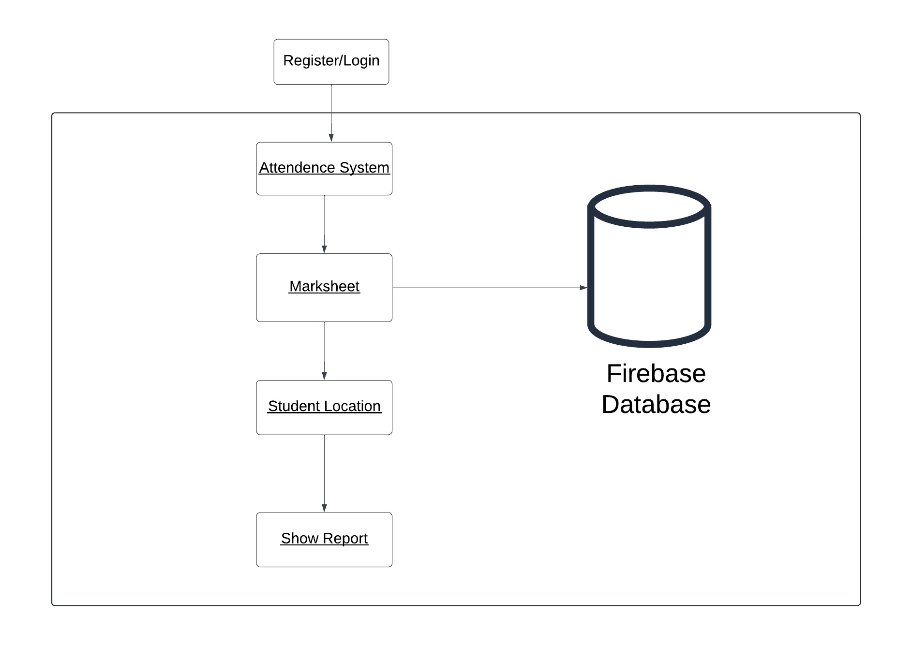 Fig:System Architecture Diagram

# 6. Advantages and Limitations

Advantages:  
Real-time access to academic data.  
- Improved communication between parents and teachers.  
- Enhanced student performance monitoring.  
  
Limitations:  
- Dependence on Internet connectivity.  
- Data privacy and security concerns.

# 7. Applications and Conclusion

Order Fulfillment Centers:

Automated sorting systems streamline the process of picking and packing orders,Increasing efficiency and reducing delivery times.

Inventory Management:

AI systems monitor stock levels in real-time, helping retailers maintain optimal inventory and reduce stockouts or overstock situations

# 8. Conclusion:

With the results of the technology-needs assessment and the principal component Analysis, the research gap was identified. The proposed solution to address the research gap was to develop and configure of a Wireless LAN-based Hybrid Classroom Response and Learning Management System secondary schools in rural areas where There is little or no internet connectivity. As observed on the ANOVA results, there Was a significant effect in the performance of the study group as compared to the Control group which is indicative of the effectiveness of the web/android app for use In actual teaching and learning activities. With the system being made available for Use, the researchers are looking forward to an increase in the students’ performanceEspecially in areas where a reliable internet connection is not in place.

# 9.References

[1] Zhibing Liu, Huixia Wang, Huizan (2010). “Design and implementation of Student Information management system”. International symposium On Intelligence information processing and trusted computing. 978-0-7695- 4196-9/10 IEEE

[2] Norasiah M. A. and A. Norhayati. (2003). “Intelligent student information system”.4th International conference on telecommunication technology proceedings, Shah Alam, Malaysia, 0-7803-7773-7/03 IEEE.

[3] Adene, G., Ezeano, V. N., Adannaya, S. I., & Ogbunude, F. O. (2021, November). Student’s Academic Result Alert System Using Short Service Message (SMS). 2nd ASUP Unwana International Conference, AIFPU, Nigeria.

[4] Kassem A., M. Hamad, Z. Chalhoub and S. El Dahdaah, (2010) “An RFIDAttendance and Monitoring System for University Applications”, in International Conference on Electronics and Communication Systems.

[5] Marshal H. Mercer, (2003). Extending Student Information to the Palm!! Schools are using Hand-Base to get critical student information into the hands of Deans, counsellors and teachers. DDH Software Inc.