**Research Report On**

HDPE Drums for Chemical Sector in India

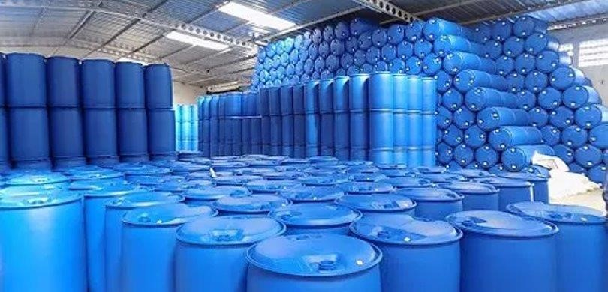

**Submitted by**

Abhinash Pomya Chauhan

**Second Year Mcom Student HR College**

# Hypothesis

* HDPE drums will become the dominant packaging solution for the chemical sector in India by 2030, displacing traditional options like metal drums and glass carboys due to their superior performance, cost-effectiveness, and sustainability.
* Supporting evidence:
* Growing chemical industry: India's chemical industry is projected to grow at a CAGR of 8-10% over the next decade, driven by increasing domestic demand and exports. This will create a significant demand for efficient and reliable packaging solutions.
* HDPE's superior performance: HDPE drums offer several advantages over metal and glass, including:
* Lightweight and durable: Reduces transportation costs and handling risks.
* Chemical resistance: HDPE is compatible with a wide range of chemicals, minimizing product contamination.
* Leakproof and shatterproof: Enhances safety and reduces product loss.
* UV protection: Protects chemicals from degradation caused by sunlight.
* Cost-effectiveness: HDPE drums are generally cheaper to manufacture and transport than metal drums and glass carboys. This can translate into significant savings for chemical companies.
* Sustainability: HDPE is a recyclable plastic, aligning with growing environmental concerns. Recycled HDPE can be used to create new drums, closing the loop and reducing plastic waste.
* Challenges to overcome:
* Initial investment: Switching to HDPE drums may require an upfront investment in new equipment and infrastructure.
* Awareness and adoption: Some chemical companies may not be fully aware of the benefits of HDPE drums and may hesitate to switch from traditional methods.
* Regulation and standardization: Clear regulations and industry standards are needed to ensure the quality and compatibility of HDPE drums for various chemical applications.
* Overall, the hypothesis suggests that HDPE drums have the potential to revolutionize the chemical packaging landscape in India. By addressing the challenges and promoting awareness, stakeholders can accelerate the adoption of this sustainable and cost-effective solution.
* Further research could explore:
* Specific market segments within the chemical industry where HDPE drums could offer the most significant advantages.
* The potential impact of HDPE drums on the recycling infrastructure and plastic waste management in India.
* Government policies and incentives that could encourage the adoption of sustainable packaging solutions.

# Review Of Literature

The use of HDPE drums for the chemical sector in India is a growing trend, driven by several factors, including:

Growth of the Indian Chemical Industry:

* India's chemical industry is one of the fastest-growing in the world, with a projected CAGR of 8-10% over the next decade. This growth is fueled by increasing domestic demand and exports, creating a significant need for efficient and reliable packaging solutions.

HDPE's Superior Performance:

* Compared to traditional options like metal drums and glass carboys, HDPE drums offer several advantages:
* Lightweight and durable: They are significantly lighter than metal drums, reducing transportation costs and handling risks. Their durability minimizes damage during transportation and storage.
* HDPE drum vs glass carboy
* Chemical resistance: HDPE is highly resistant to a wide range of chemicals, minimizing product contamination and ensuring the integrity of the container.
* Leakproof and shatterproof: HDPE drums are less prone to leaks and breakage compared to metal and glass, enhancing safety and reducing product loss.
* UV protection: Many HDPE drums are formulated with UV protection, safeguarding chemicals from degradation caused by sunlight exposure.

Cost-effectiveness:

* HDPE drums are generally cheaper to manufacture and transport than metal drums and glass carboys. This translates into significant cost savings for chemical companies, especially with the rising costs of raw materials.

Sustainability:

* HDPE is a recyclable plastic, aligning with growing environmental concerns. Recycled HDPE can be used to create new drums, closing the loop and reducing plastic waste. This aligns with India's increasing focus on sustainable packaging solutions.

Challenges and Future Directions:

* Despite the advantages, some challenges need to be addressed:
* Initial investment: Switching to HDPE drums may require an upfront investment in new equipment and infrastructure for filling, handling, and storage.
* Awareness and adoption: Not all chemical companies are fully aware of the benefits of HDPE drums and may hesitate to switch from traditional methods due to established practices and perceived risks.
* Regulation and standardization: Clear regulations and industry standards are needed to ensure the quality and compatibility of HDPE drums for various chemical applications, particularly for sensitive or hazardous materials.
* Specific market segments within the Indian chemical industry where HDPE drums could offer the most significant advantages, considering factors like chemical compatibility, volume requirements, and cost sensitivity.
* The potential impact of adopting HDPE drums on the recycling infrastructure and plastic waste management in India. This would involve assessing the existing recycling capacity, potential job creation, and the need for technological advancements to efficiently handle HDPE waste.
* Government policies and incentives that could encourage the adoption of sustainable packaging solutions like HDPE drums. This could involve tax breaks, subsidies, or infrastructure investments to support the transition.
* "The Indian Packaging Industry: Trends and Opportunities" by Invest India (2022): This report highlights the growing demand for sustainable packaging solutions in India and identifies HDPE drums as a key emerging trend.
* "Plastic Packaging Market in India" by Mordor

Intelligence (2023): This report forecasts a CAGR of 9.1% for the plastic packaging market in India, with HDPE being the dominant segment due to its versatility and cost-effectiveness.

* "A Review on HDPE Drums for Chemical Packaging" by International Journal of Packaging Technology and Management (2020): This article provides a comprehensive overview of HDPE drums, their properties, advantages, and applications in the chemical industry.
* "Case Studies of Successful Adoption of HDPE Drums in the Indian Chemical Industry" by various industry associations and publications: These case studies showcase how companies have successfully transitioned to HDPE drums, achieving cost savings, improved safety, and environmental benefits.

# Secondary Data

* Globally, India is the third largest consumer of polymers, fourth-largest producer of agrochemicals and sixth-largest producer of chemicals.
* Major chemical production reached 874.30 million metric tonnes (MMT) in February 2023, while petrochemical production reached 1,773.74 MMT.

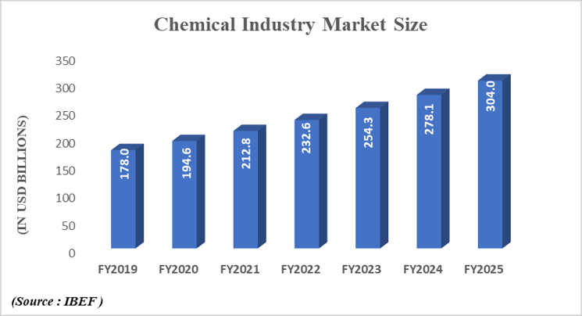

* Plastic drums, primarily made from HDPE, offer a durable and chemically resistant packaging solution for chemicals. They come in two main types: open-top drums for less tightly sealed substances, like solvents, and closedtop drums for securely sealing chemicals, including flammable liquids. These lightweight containers are suitable for long-distance chemical transportation. In the right image, left image is of open drum and right image is of tight head drum

# Indian Polymer Drum Market Overview

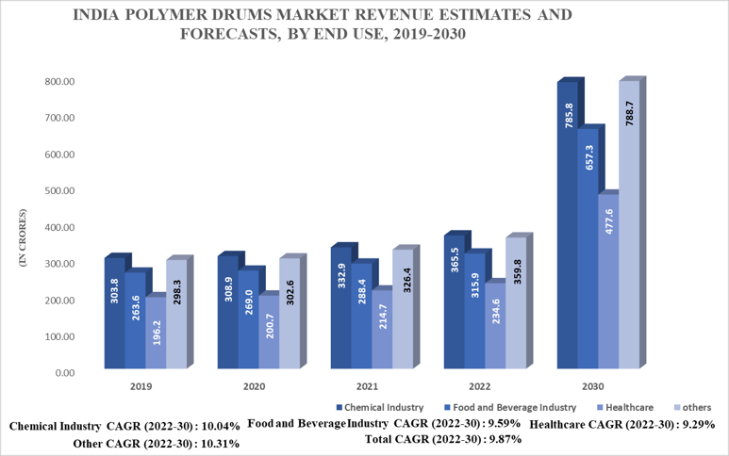

# Overview of Packaging Industry & Plastics

* 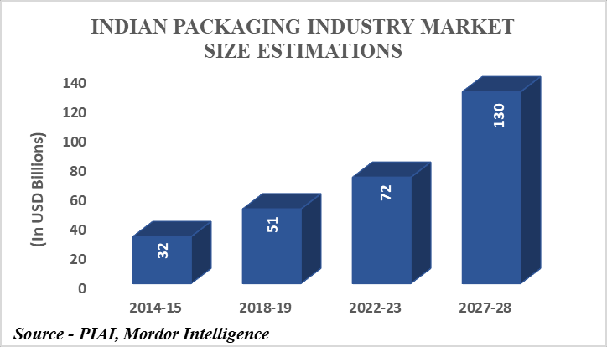Indian Packaging Industry is becoming a preferred hub for global packaging industry & it is 5th largest sector in India’s economy
* Global per capita consumption of packaging in terms of value estimated is USD 125; and for India it is - USD 60
* India is a net exporter of packaging products.
* 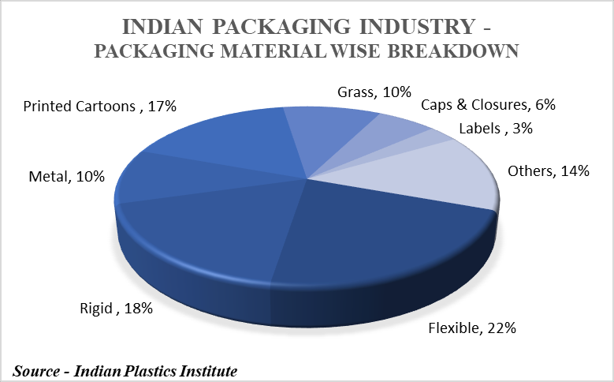Growth since 1990 – 235%
* Plastic Exports in 2019-20 were 10 USD Billion and is expected to reach 25 USD Billion by 2025
* The Plastic Industry Provides Job to 40 Lakh people comprising over 35,000 processing units.
* The Sector is Predicted to achieve 9.1 lakh crores by 2025

# HDPE Polymer Manufacturers – Grades

• Major players in the India High Density Polyethylene (HDPE) market are

Reliance Industries Ltd., GAIL (India) Limited, Haldia Petrochemicals Limited, Indian Oil Corporation Limited, ONGC Petro additions Limited, Brahmaputra Cracker and Polymers Limited, and HPCL-Mittal Energy Limited (HMEL).

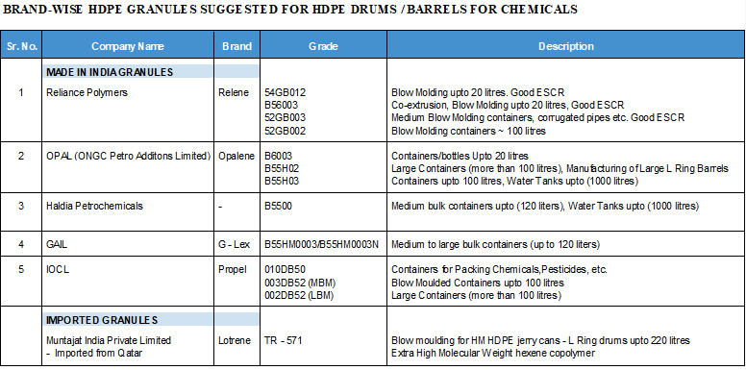

# Primary Data

Demystifying Drum Procurement: Key Insights from Industry Leaders

Understanding the needs and preferences of your customers is paramount in any industry, and the drum business is no exception. To gain valuable insights into procurement priorities, we surveyed 12 leading companies across the industry. The results revealed a fascinating tapestry of diverse yet interconnected desires, offering a glimpse into the beating heart of drum acquisition.

Quality, the Unwavering Drumbeat:

* For a significant portion of the companies, the drum itself reigned supreme. Adherence to stringent quality standards and compliance with global regulations formed the bedrock of their procurement decisions. They sought drums that resonated not just with sound, but also with unwavering excellence. This unwavering commitment to quality suggests they are willing to invest in drums that are not merely instruments, but investments in their own reputation and performance.

Timely Deliveries: The Rhythm of Production:

* Another resounding theme emerged – the vital pulse of just-in-time delivery. Several companies highlighted the importance of receiving their drums precisely when needed, like clockwork. This suggests a production environment with finely tuned schedules, where delays can disrupt the entire flow of the business. For these companies, drums are not just objects, but integral pieces in a complex production choreography.

Experience: The Evolving Melody:

* While some companies prioritized the latest innovations and cutting-edge technology, others valued the wisdom of experience. For them, a supplier's proven track record in drum procurement was music to their ears. They sought a partner who had navigated the intricate world of drums with expertise and reliability, offering not just instruments, but peace of mind.

Beyond the Beat: A Symphony of Preferences:

* While these core themes resonated strongly, the survey also revealed a symphony of individual preferences. Some companies craved transparency in their dealings, seeking open communication and clear agreements. Others desired a supplier who could offer them a diverse range of drums, catering to their ever-evolving needs.

The Future Symphony: A Collaborative Encore?

* These insights paint a vivid picture of the procurement landscape, highlighting the unique challenges and aspirations of each company. By understanding these diverse needs, suppliers can tailor their offerings, not just as drum vendors, but as partners in rhythm. Perhaps, in the future, collaboration will become the crescendo of drum procurement, where suppliers and companies co-create solutions that resonate not just with quality and timeliness, but with the individual spirit of each brand.

# Findings And Suggestions

* Strong market potential: India's booming chemical industry, coupled with HDPE's superior performance and cost-effectiveness, creates a significant demand for HDPE drums.
* Performance advantages: HDPE drums offer several advantages over traditional options, including being lightweight, durable, chemicalresistant, leakproof, shatterproof, and UV-protective.
* Cost savings: HDPE drums are generally cheaper to manufacture and transport, leading to significant cost reductions for chemical companies.
* Sustainability benefits: HDPE is recyclable, aligning with growing environmental concerns and India's push for sustainable packaging. Challenges:
* Initial investment: Switching to HDPE drums may require upfront investments in new equipment and infrastructure.
* Awareness and adoption: Not all companies are aware of the benefits and hesitant to change from established practices.
* Regulation and standardization: Clear regulations and standards are needed for quality and compatibility with various chemicals.

Suggestions:

* Targeted market approach: Identify specific chemical segments where HDPE drums offer the most significant advantages (e.g., paints, pesticides, pharmaceuticals).
* Cost-benefit analysis: Quantify the potential cost savings and return on investment for chemical companies considering the switch.
* Awareness campaigns: Organize workshops, seminars, and demonstrations to educate companies about HDPE benefits and successful case studies.
* Collaboration with industry associations: Partner with associations like FICCI and CII to advocate for HDPE adoption and address regulatory hurdles.
* Standardization initiative: Work with BIS and other regulatory bodies to establish clear standards for HDPE drum quality and compatibility for various chemicals.
* Investment in recycling infrastructure: Support the development of efficient HDPE recycling facilities to close the loop and manage plastic waste effectively.
* Government incentives: Lobby for government policies like tax breaks or subsidies to encourage the adoption of sustainable packaging solutions.

Overall, the findings suggest that HDPE drums have the potential to become the dominant packaging solution for the Indian chemical sector. By addressing the challenges and implementing the suggested strategies, stakeholders can accelerate the transition towards a more efficient, costeffective, and sustainable packaging future.

# Strengths

* Industrial Plastic Packaging Expanding
* Around 30% Accounted from Chemical Industry
* HDPE Drums take up less space & can be recycled
* Cost Effective
* Light weight and variety of sizes

# Weaknesses

* Cluttered market with too many players – few dominant organised and plethora of small & medium entities making it highly competitive.
* New to bulk industrial packaging, will take time to break into existing vendor – client relationships.
* Volatility of raw material prices and easy availability of niche high grade polymer imported from overseas.
* Low Profit margins, Operating profit (10% - 14%)
* Changing Government policies regarding packaging solutions

# Opportunities

* Polymer packaging growing at a fast pace replacing metals.
* Chemical sector in India witnessing tremendous growth. Push from Government as an alternative to China.
* Gujarat is the Chemical hub of India and Dahej is a preferred location to set up the proposed plant.
* Green field opportunity

# Threats

* A few reputed companies dominate the chemical sector

Established trust by offering customised products, JIT service, competitive prices etc.

* Alternative packaging solutions

Laminated bags that are cheaper and easy to transport

Intermediate Bulk Containers (1000 litre) are gaining popularity due to cost effectiveness, easier handling and emphasis on sustainability

## Conclusion

HDPE drums hold immense potential to revolutionize the chemical packaging landscape in India, offering a compelling blend of superior performance, costeffectiveness, and sustainability benefits. Their lightweight, durable, chemicalresistant, leakproof, shatterproof, and UV-protective properties make them an ideal choice for various chemical applications. Moreover, their lower manufacturing and transportation costs compared to traditional metal and glass drums translate into significant cost savings for chemical companies. Additionally, HDPE's recyclability aligns with growing environmental concerns and India's commitment to sustainable packaging solutions.

However, several challenges need to be addressed to fully harness the potential of HDPE drums. The initial investment required for switching to HDPE drums, coupled with a lack of awareness among some chemical companies, hinders broader adoption. Moreover, the lack of clear regulations and standardization for HDPE drums in various chemical applications creates uncertainty and may deter some companies from making the switch.

To overcome these challenges and accelerate the adoption of HDPE drums, stakeholders should implement a comprehensive strategy that addresses both market and regulatory aspects. Targeted market approaches focusing on specific chemical segments where HDPE drums offer the most significant advantages are crucial. Quantifying the potential cost savings and return on investment for chemical companies considering the switch can provide compelling incentives for adoption. Awareness campaigns through workshops, seminars, and demonstrations can educate the industry about the benefits of HDPE drums and showcase successful case studies from companies that have successfully transitioned. Collaboration with industry associations like FICCI and CII can amplify the message and advocate for HDPE adoption.

Collaboration with BIS and other regulatory bodies is essential to establish clear standards for HDPE drum quality and compatibility for various chemicals. This will provide assurance to chemical companies and eliminate concerns regarding product integrity and potential safety hazards.

revolutionize the Indian chemical packaging landscape, paving the way for a more

Investment in recycling infrastructure is critical to close the loop and manage plastic waste effectively. By supporting the development of efficient HDPE recycling facilities, stakeholders can promote a circular economy approach and reduce the environmental impact of HDPE drums.

Lobbying for government policies like tax breaks or subsidies can create further incentives for chemical companies to adopt HDPE drums. These measures can lower the upfront investment burden and accelerate the transition to a more sustainable packaging solution.

Additionally, conducting a pilot project with a few willing chemical companies can showcase the real-world benefits of HDPE drums in a controlled environment. This will provide valuable data on operational efficiency, cost savings, and safety performance, further reinforcing the advantages of HDPE drums.

Emphasizing the safety benefits of HDPE drums, especially for hazardous chemicals, is crucial to address any concerns regarding potential leaks or breaches. Highlighting their superior chemical resistance and durability can further enhance their perceived value.

Exploring creative financing options like leasing or pay-per-use models can ease the initial investment burden for smaller companies, making HDPE drums more accessible to a wider range of players in the Indian chemical sector.

Partnering with research institutions to develop new HDPE formulations with even better chemical resistance, durability, and recyclability can further enhance the performance and sustainability credentials of HDPE drums. This collaboration will drive innovation and ensure that HDPE remains the leading choice for chemical packaging in India.

By adopting a comprehensive and collaborative approach, stakeholders can