RESEARCH STUDY ON IMPACT ON THE COVID-19 PANDEMIC ON THE INDIAN ECONOMY

A Project Submitted to

HSNC University,

Master Of Commerce (banking & finance) By
SRIJAN NATH

H. R. College of Commerce & Economics, Mumbai.

ROLL NO-047

THE IMPACT ON THE COVID-19 PANDEMIC ON THE INDIAN ECONOMY

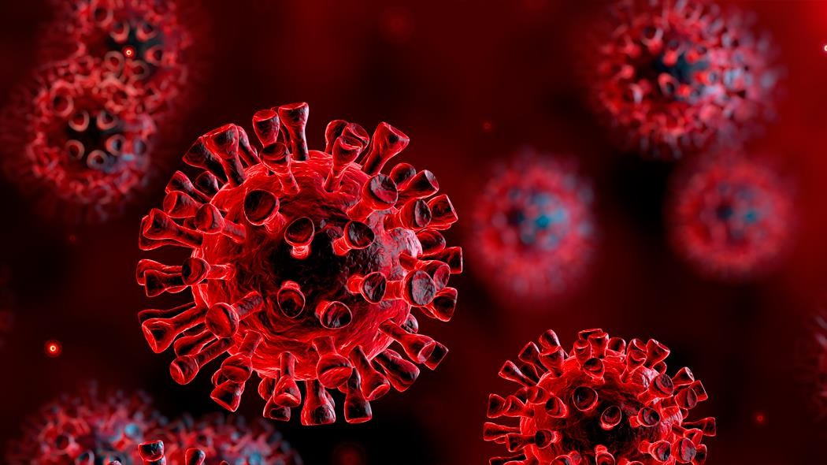

- TABLE OF CONTENTS

NO | TOPICS | PG
B | ABSTRACT
1 | OBJECTIVE
2 | HYPOTHESIS
3 | REVIEW OF LITERATURE
4 | SECONDARY DATA
5 | PRIMARY DATA
6 | DATA ANALYSIS
7 | CONCLUSION
8 | BIBLIOGRAPHY

- ABSTRACT
The world is still witnessing adverse effects of the COVID-19 pandemic that is shattering the entire world. The virus ripped apart the global economy like never before leading to low growth rates in the largest economies of China, the United States (US), Japan, India, and in many others. The world has come out of the great lockdown, but the pandemic hit the global economy so hard that it will probably take nearly a decade to restore the normality worldwide. Reports show that China is getting cornered by multinational companies, many of which have signalled intention of shifting their production base from China and are now in search for alternative locations. This research paper explores the effects of the pandemic on the global society, with particular focus on India and the measures taken by its government in response to pandemic-related challenges. The paper claims that if India manoeuvres its foreign policy by properly balancing its domestic and external priorities, it will play a most prominent role in the emerging international order.
In this project I have mentioned the effects of the pandemic, whether are there improvements, the major sectors affected by the pandemic as well as the future projections.

OBJECTIVES
The main objectives of the study are as follows,
  - To understand the various economic impacts of the covid-19
  - To understand the effects on economic sectors.
  - To understand the future effects on GDP and economy

HYPOTHESIS
Hypothesis is a testable prediction which is expected to occur. It can be a false or a true statement that is tested in the research to check its authenticity. The hypothesis should be clear and precise. It should be limited in scope and must be specific.
There are two types of hypothesis, they are:
- Null Hypothesis (Ho)
- Alternate Hypothesis (Ha)

Following are the hypothesis of the study:

  - Ha: the economic effects of covid-19 were significant. Ho: the economic effects of covid-19 were insignificant.

  - Ha: the economic sectors were adversely affected due to covid-19 pandemic. Ho: the economic sectors were not adversely affected due to covid-19 pandemic.

  - Ha: the economy and GDP will stabilize in the future. Ho: the economy and GDP will not stabilize in the future.

REVIEW OF LITERATURE

The economic impact of the COVID-19 pandemic in India has been largely disruptive. India's growth in the fourth quarter of the fiscal year 2020 went down to 3.1% according to the Ministry of Statistics.

The Chief Economic Adviser to the Government of India said that this drop is mainly due to the coronavirus pandemic effect on the Indian economy. Notably India had also been witnessing a pre-pandemic slowdown, and according to the World Bank, the current pandemic has "magnified pre-existing risks to India's economic outlook".

ARTICLE 1
PUBLISHED BY FINANCIAL EXPRESS

Impact on Indian economy after the COVID-19 second wave
In the first wave, we went through a prolonged national lockdown and a significantly lower number of peak cases. Manufacturing and the urban economy had come to a grinding halt while the rural economy continued to move because of less strict lockdowns. As a result, agriculture, which is the primary driver of our rural economy providing employment to 58% of our population, continued to grow. Agriculture further benefited from good monsoon and cheaper and higher availability of labor. Reflecting on the GDP figures, our agricultural economy grew by 3.4% while the overall economy contracted with 7.7% in FY21. The first wave was primarily urban in its spread. Urban areas reported more cases than rural areas for the first five months of the spread. In the second wave rural areas started reporting more cases than urban ones from the second month itself. An analysis of more than 50 most severely hit districts, 26 were in rural areas. Rural areas in the state of Maharashtra, Andhra Pradesh and Kerala were the worst
impacted. The situation was further aggravated, due to the inadequacy of medical infrastructure in the rural areas and the rush of patients from villages and smaller towns to urban centers.

The overall impact on GDP

On May 31, the Indian government released the data for GDP that during the financial year
2020-21, GDP contracted by 7.3 percent. It is the most severe contraction from the time India got its independence. The reasons behind this trajectory are obvious – lockdown leading to the closing of business units, increasing unemployment rate and a significant decline in domestic consumption.
For the current financial year, the Reserve Bank of India has anticipated growth of 10.5 percent. But the rating agencies across the globe have downgraded it due to the impact of the second wave of COVID-19. Moody’s initially projected 13.7 percent of growth for FY 2021-22, but later lowered it to 9.3 percent. The same goes with S&P Global Rating. They have lowered the 11 percent growth to 9.8 percent in case of moderate impact of the second wave, but for a worst- case scenario, it would be 8.2 percent.

To summarize on the macroeconomic numbers of GDP, I expect a less severe impact of the second wave due to less strict, localized lockdowns and practically a lesser number of days in reaching the peak number of infections. Agriculture will see a deeper cut from the second wave compared to the first wave where it grew. Our hopes of economic revival are pinned to us having an express vaccination drive, which takes away the fear of a third wave and a revival of consumer confidence and spending

ARTICLE 2
PUBLISHED BY TIMES OF INDIA
Impact of Covid-19 on Employment in India
Several state governments have been compelled to clamp lockdown around April this year in different modes and schedules to contain the onrushing pandemic. Almost all the commercial establishments, industrial units, transport systems, school colleges even government offices except emergency services, have come under lockdown. Though good results have started coming in due to these lockdowns, on the other hand, the industries have started bleeding.
According to Mahesh Vyas, CEO, Centre for Monitoring Indian Economy (CMIE), the unemployment rate will be around 12% at the end of May 2021 which translates into a loss of job by 1 crore people during the period due to the 2nd wave of corona pandemic. He also said that income of 97% households have declined since the outbreak of the pandemic last year. The unemployment rate stands at 12.4%, urban 15.1% and rural 11.2% on 3rd June 2021.

We noted that small towns and rural areas were not very affected by COVID 19 pandemic last year. But during the 2nd wave, it has spilt over these areas also affecting employment situation. The manufacturing and engineering sectors have largely been affected by the lockdown during the 2nd wave. The index of actual hiring has come down from 132 in July-September, 2020 to 60 in January-March, 2021. Though the automotive and FMCG sectors in tier-2 cities have performed poorly, the recruitment situation in IT, Outsource, Technology, E-commerce, Pharma
and Health Care sectors in metro and tier-1 cities have started showing some improvements (HR Firm, CIEL). Sri Aditya Mishra, CEO, CIEL, has said that though the companies have the intent to hire in tier 2-3 cities, they have not been able to actually hire due to the spread of pandemic to these markets also. According to him, the gap between the intent of hiring and the actual hiring in these markets is 50%.

The Azim Premji University revealed in its study that the 1st wave of COVID 19 pandemic has pushed 23 crore people below the poverty line (below the national minimum wage threshold of Rs. 375.00 per day as recommended by the Anoop Satpathy committee). The report said that there has been a rise of 15% in poverty in rural India and a rise of 20% in urban India during the last one pandemic year.

“Had the pandemic not occurred, poverty would have declined by 5 percentage points in rural areas and 1.5 percentage points in urban areas between 2019 and 2020, and 50 million would have been lifted above this line,” it added. It further stated that “Mobility curbs resulted in income losses because of decreased economic activity. A 10% decline in mobility was associated with a 7.5% decline in income,” suggesting the situation could get worse if more lockdowns are imposed in the future. The study found that nearly half of formal salaried workers moved into informal work, either as self-employed (30 per cent), casual wage (10 per cent) or informal salaried (9 per cent) workers, between late 2019 and late 2020 and there was a decline in their income level as well.

In April and May, the poorest 20 per cent of households lost their entire income and the richer households suffered losses of less than a quarter of their pre-pandemic incomes, the report said.(Source: Business Today, May, 06, 2021)

We want the government machinery to rise to the occasion to check the 2nd wave giving priority to the vaccination process instead of lockdown. We hope, very soon the people will rush for buses and trains, shops and markets will be buzzing, the hooters of the factories will blow again and the smoke coming out of the tall chimneys will mark the sky with sign of victory!

ARTICLE 3
PUBLISHED BY ECONOMIC TIMES
“Indian economy showed resilience, but recovery from Covid pandemic shock not complete: RBI report’’
The Indian economy exhibited robust resilience in the previous fiscal, emerging among the fastest- growing economies among major nations. However, weakening consumption in the second half of FY23, subdued rural demand and sustained cost pressures remained a drag, the Reserve Bank of India said in its annual report released Tuesday.

The Indian economy could face downside risks amid slowing global growth, protracted geopolitical tensions and a possible upsurge in financial market volatility following new stress events in the global financial system, the RBI said.
RBI highlighted the subdued nature of private investment in India in an atmosphere of lingering uncertainty. “Inflation pressures and effects of fragmentation on world trade may be lowering aggregate consumption demand, a slow-moving drag on growth,” it warned.

The Indian economy witnessed a moderation in growth in the second half of the fiscal. The RBI has attributed this to unfavourable base effects, weakening private consumption demand caused by high inflation, a slowdown in export growth and sustained input cost pressures.

This uneven recovery in consumption could be in the sluggish growth in the price-sensitive entry-level cars as compared to the recovery in passenger cars. Rural demand too remained subdued, flagged by the continued lag in two-wheeler sales, 40 per cent of which caters to rural India.

Wage growth for agricultural and non-agricultural labourers remained subdued during FY23, averaging 5.8 per cent and 4.9 per cent, respectively.

RBI noted that rural demand, which was affected deeply by the second wave of the Covid-19 pandemic a year ago, recovered, even if at a slower pace in comparison to the urban economy. However, it said that that the real rural wage growth virtually stagnated in FY23, despite a visible uptick in economic activity.

Job demand under the Mahatma Gandhi National Rural Employment Guarantee Scheme (MGNREGS) declined on an annual basis, but still prevailed above the pre-pandemic level in the previous fiscal. This indicates that the recovery, especially in the unorganised segment of the economy is not yet complete, RBI said.

The RBI expects the Indian economy to have recorded a growth of 7 % in real GDP in the previous fiscal amidst strong global headwinds. India has contributed more than 12 per cent to global growth on average during the last five years.

RBI opined that India's domestic economic activity does face challenges from external factors. “(However), resilient domestic macroeconomic and financial conditions, expected dividends from past reforms and new growth opportunities from global geo-economic shifts place India at an advantageous position,” it wrote.

"With a stable exchange rate and a normal monsoon -- unless an El Nino event strikes -- the inflation trajectory is expected to move down over 2023-24, with headline inflation edging down to 5.2 per cent from the average level of 6.7 per cent recorded last year," the report said.

SECONDARY DATA

The Impact of Covid-19 on Indian Economy
As per the official data released by the ministry of statistics and program implementation, the Indian economy contracted by 7.3% in the April-June quarter of this fiscal year. This is the worst decline ever observed since the ministry had started compiling GDP stats quarterly in 1996. In 2020, an estimated 10 million migrant workers returned to their native places after the imposition of the lockdown. But what was surprising was the fact that neither the state government nor the central government had any data regarding the migrant workers who lost their jobs and their lives during the lockdown.

The government extended their help to migrant workers who returned to their native places during the second wave of the corona, apart from just setting up a digital-centralized database system. The second wave of Covid-19 has brutally exposed and worsened existing vulnerabilities in the Indian economy. India’s $2.9 trillion economy remains shuttered during the lockdown period, except for some essential services and activities. As shops, eateries, factories, transport services, business establishments were shuttered, the lockdown had a devastating impact on slowing down the economy.

The informal sectors of the economy have been worst hit by the global epidemic. India’s GDP contraction during April-June could well be above 8% if the informal sectors are considered. Private consumption and investments are the two biggest engines of India’s economic growth. All the major sectors of the economy were badly hit except agriculture.

The Indian economy was facing headwinds much before the arrival of the second wave. Coupled with the humanitarian crisis and silent treatment of the government, the covid-19 has exposed and worsened existing inequalities in the Indian economy. The contraction of the economy would continue in the next 4 quarters and a recession is inevitable. Everyone agrees that the Indian economy is heading for its full-year contraction.

The surveys conducted by the Centre For Monitoring Indian Economy shows a steep rise in unemployment rates, in the range of 7.9% to 12% during the April-June quarter of 2021. The economy is having a knock-on effect with MSMEs shutting their businesses. Millions of jobs have been lost permanently and have dampened consumption. The government should be ready to spend billions of dollars to fight the health crisis and fast-track the economic recovery from the covid-19 instigated recession.

How have different sectors been affected due to Covid-19?
- Hospitality Sector:
As many states have imposed localised lockdowns, the hospitality sector is facing a repeat of 2020. The hospitality sector includes many businesses like restaurants, beds and breakfast, pubs, bars, nightclubs and more. The sector that has contributed to a large portion of India’s annual GDP has been hit hard by restrictions and curfews imposed by the states.

- Tourism Sector:
The hospitality sector is linked to the tourism sector. The sector that employs millions of Indians started bouncing back after the first wave, but the second wave of covid was back for the devastation! The tourism sector contributes nearly 7% to India’s annual GDP.
It comprises hotels, homestays, motels and more. The restrictions due to the second wave have crippled the tourism sector, which was already struggling to recover from the initial loss suffered by the businesses in 2020.

- Aviation and Travel sector:
Aviation and other sector establishments faced a massive struggle during the second wave of the pandemic. The larger travel sector is also taking a hit as people are scared to step out of their homes. For airlines and the broader travel sector, its recovery will depend on whether people in future will opt for such services. At present, the outlook for the aviation and broader travel sector does not look good.
- Automobile sector:
The automobile sector is expected to remain under pressure in the near term due to the covid- 19 situation in India.

- Real Estate and Construction sector:
The real estate and construction activities have started facing a disruption during the second wave as a large number of migrant workers have left the urban areas. The situation has not been grave as of 2020 for this sector.

The impact of the lockdowns and restrictions:
The extent to which localised lockdowns and restrictions have been imposed in the past have impacted the economic recovery timeliness.

- There is a scope for sustained fiscal stimulus going throughout the year. To some extent, if credit is made available to businesses at low-interest rates, then monetary stimulus is also possible.

- The second wave has pushed back India’s fragile economic recovery. Rising inequality and strained household balance sheets have constrained the recovery. From growing only 4% in 2019-20 to contracting 7-8% in 2020-21 to staring at another low economic growth recovery in 2021, India has been virtually stopped in all its tracks
- Therefore, fiscal policy must lend a generous helping hand to lead vulnerable businesses and households towards economic recovery.

FUTURE PROJECTIONS

An important factor influencing the GDP projections for the next 5 years is the likely recovery rate. Three such scenarios with equal probabilities can be considered as strong, moderate and weak recovery. For a strong recovery, a positive average growth rate of 2% per year can be assumed. For a moderate recovery, a positive average growth rate of 1% per year can be assumed. For a weak recovery, a positive average growth rate of 0.50% per year can be assumed. If the recovery is strong, in the year 2024–2025, the growth rate might reach up to 4.04%. If the
recovery is moderate, in the year 2024–2025, the growth rate might reach up to 0.04%. If the recovery is weak, in the year 2024–2025, the growth rate might reach up to −1.96%

PRIMARY DATA
DATA ANALYSIS AND INTERPRETATION OF QUESTIONNAIRE

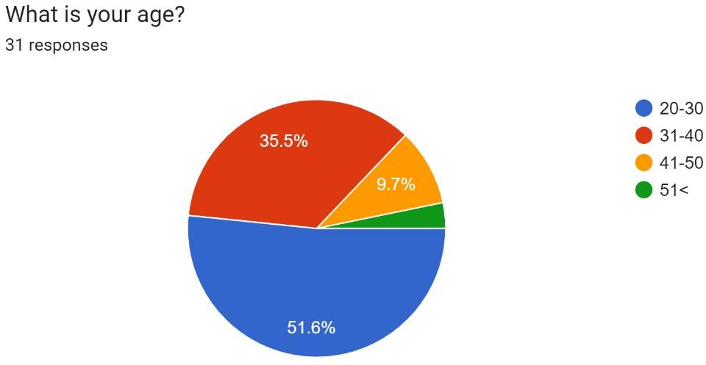

ANALYSIS- Most of the respondents who were surveyed are in the age group of 21-30years, Followed by respondents in the age group 31-40 years. The least percentage of respondents are in the age group of 50+

This diversification in the age group highlights the different perceptions of the respondents of various age groups ensuring it covers the different opinions of the different age groups.
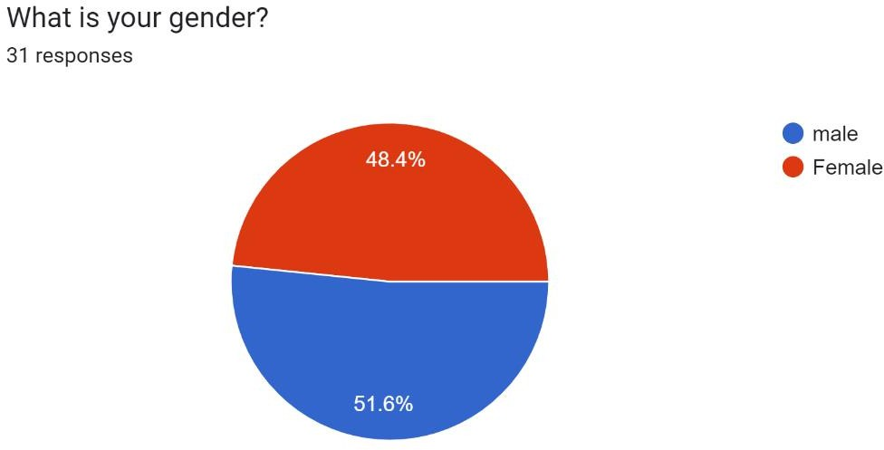
ANALYSIS-
Around 31 people were asked to fill the questionnaire , out of which majority of the people are males(48.4%) and about (51.6%) of the females participated in the survey . There isn’t a vast difference in the sample set.

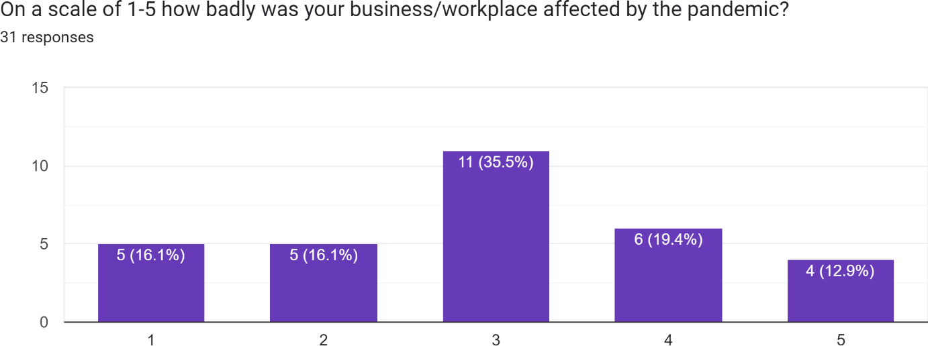

Analysis- the above line chart shows how the respondents were affected by the pandemic. As the survey shows, median 3 was the most popular choice, followed by the degree of 4 and 1 and 2 being tied at the same percentage. This shows that most samples did believe that there were some significant changes in their workplace.

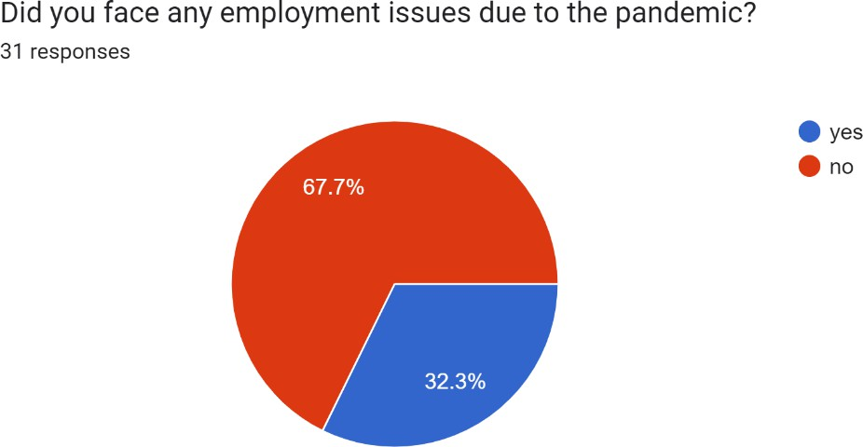

ANALYSIS- The above stated pie chart shows that population of the sample set being affected the unemployment angle as 32.3%. even though the majority were unaffected, we can see that a
significant portion of the population was impacted. It is also worth noting that my sample set mainly included a good economic strata, and even then the results were significant.

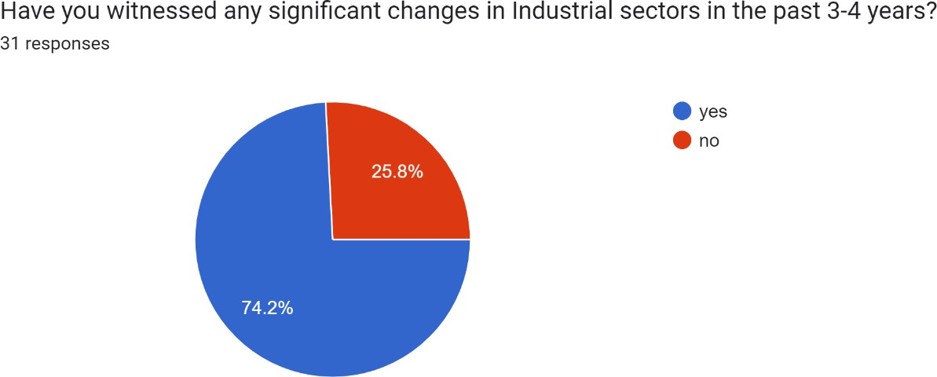

Analysis- this figure portrays how, 74.2% of the population set has witness significant changes in the sectors due to the pandemic. This is a very resounding figure, and thus as I’ve stated in secondary data, the changes in the sectors were noteworthy.

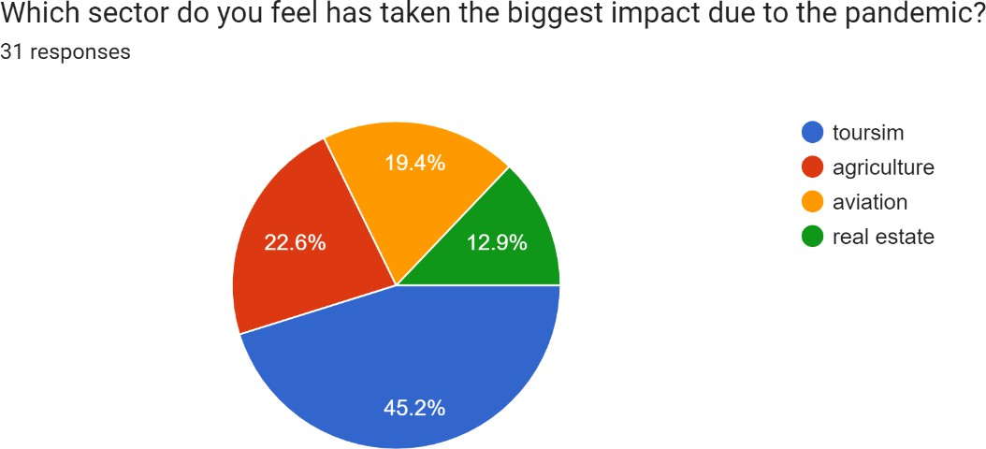

Analysis- the survey shows how a significant portion of the population feels (45.2%) that the sector impacted the most was toursim followed by agriculture, and the least impacted was aviation. I’ve stated all these sector impacts in my secondary data.
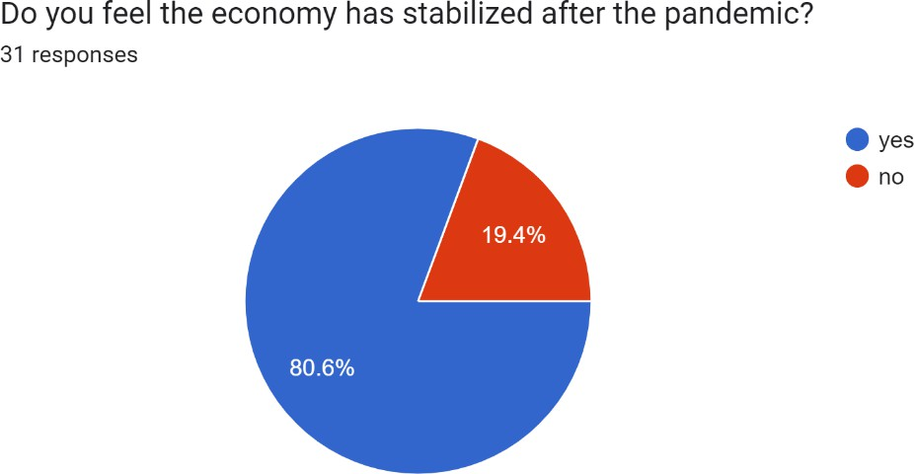

Analysis-most of the sample set around 81% feel that economy now in 2023, has stabilized after the initial downturns that followed with the pandemic. This notion is felt after seeing the rise in employment and economic reforms.

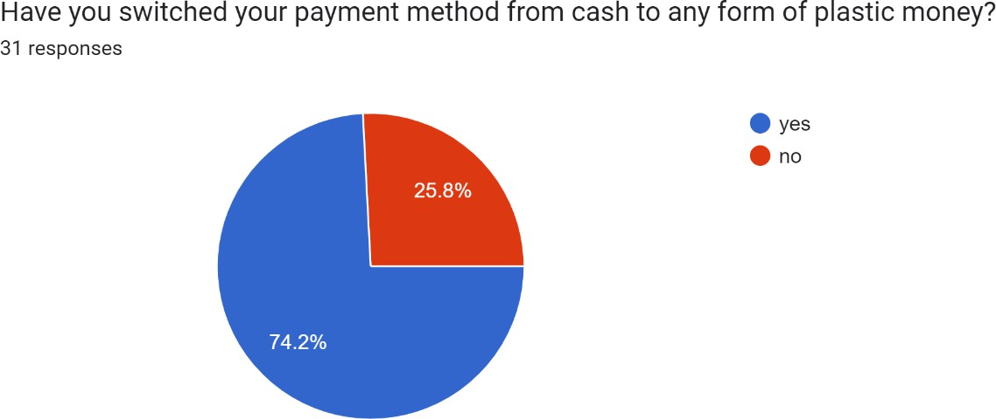

Analysis- 74.2% of the sample set has switched to using cashless or plastic form of money after the start of pandemic. This is extremely obvious as more and more people switched to the same after social distancing and lack of contact. This has now become an innovation in the industry.
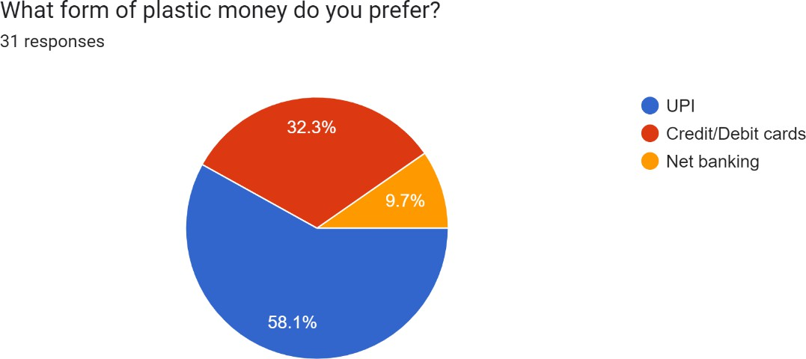

Analysis- the sample set shows that 58.1% of plastic money payment, UPI is the most popular choice. This is the most obvious choice as it’s the most popular form of payment we see in our day to day lives. There is also an increase in the use of debit/credit cards as compared to the period before the pandemic.

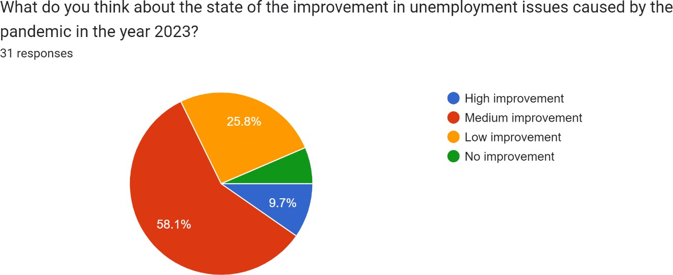

Analysis- when it comes to the topic of unemployment, 58.1% of the sample set believes that there has been a steady or medium improvement since the pandemic. Followed by this is low unemployment, which shows that even though the pandemic is in it’s twilight days, employment is yet to recover fully.

CONCLUSION
On 26 February 2021, India's GDP was back to pre-lockdown levels. Due to low base effect a number of infrastructure sectors such as natural gas and cement saw high double digit growth in March 2021; a number of related sector such as coal were still in recession. In April the output of the core infrastructure sectors again saw high growth, again a consequence of the low base effect.
During the COVID year of FY21, India’s real GDP contracted sharply by (-)5.8%. However, there was considerable disparity in the growth experience of individual states with only three states, namely Assam, Sikkim and Tamil Nadu, posting low but positive growth in FY21. In order to combat the deleterious impact of COVID-19, both the Government of India and states deviated sharply from their respective fiscal deficit and debt-GDP benchmarks. Since then, both the Indian economy and individual state economies and their corresponding government finances have improved, although with significant inter-state variation.
Policymakers must now prioritize reducing the debt and fiscal deficit relative to GDP of both central and state governments to align with sustainability norms, establishing a firm base for consistent and robust medium-term growth. This would be crucial for achieving India’s ambitious goal of becoming a US$5 trillion economy in the next few years. In this endeavor, states would have a significant role to play.
The combined size of the five largest states namely, Maharashtra, Tamil Nadu, Gujarat, Karnataka, and Uttar Pradesh are projected to reach US$2.6 trillion by FY28 (for details, see the In-focus section of the March 2023 issue of the Economy Watch)5. However, for reaching the US$5trillion target, other larger states such as West Bengal, Rajasthan, Andhra Pradesh, Telangana, Madhya Pradesh, and Kerala would also make a significant contribution.
In the beginning of May, Duvvuri Subbarao, a former RBI governor, said that India could look forward to a V-shaped recovery. A V-shaped recovery is the best outcome. Arthur D. Little, an international consulting firm, has suggested that India will most probably see a W-shaped recovery. Mythili Bhusnurmath writes in The Economic Times that U- shaped recovery is the most likely followed by an L-shaped recovery. CRISIL chief economist says if things go well, that if the virus is contained, we can expect a V- recovery, otherwise it will end up as a U- recovery.
With the challenges of a new recession and economic crisis, vital situations such as these are calling for powerful and effective policy making in Health, industry, government and community. Instant, but well-planned support measures have to be initiated and adapted for those who can drop through the cracks. Mid- and long-term strategies are required to stabilize and motivate the economy during this recession. A comprehensive social-economic development strategy that consists of infrastructure and sector-by-sector schemes that supports business to ensure the success of those with reliable and sustainable business models.

BIBLIOGRAPHY
APPENDIX- THE LINK FOR THE QUESTIONNAIRE-
https://docs.google.com/forms/d/e/1FAIpQLScgC_UpK9YWIw-ghCkWRlvtz0NCBt- sPyF6nC0RZKsq9UWJXA/viewform?usp=sf_link
https://brics-econ.arphahub.com/article/99441/
https://www.ey.com/en_in/tax/economy-watch/covid-19-and-beyond-growth-recovery-and- fiscal-challenges-across-indian-states
https://loksabhadocs.nic.in/Refinput/New_Reference_Notes/English/06072020_125312_102120 5239.pdf
https://timesofindia.indiatimes.com/readersblog/blogwithmeg/how-many-of-you-miss-the- school-life-35041/

https://www.financialexpress.com/economy/impact-on-indian-economy-after-the-covid-19- second-wave/2275353/

https://thediplomat.com/2021/06/indias-economy-and-the-pandemic-key-risks/ https://timesofindia.indiatimes.com/readersblog/small-thoughts/impact-of-covid-19-on- employment-in-india-33336/
https://www.indiatoday.in/diu/story/how-coronavirus-outbreak-will-impact-indian-economy- 1648507-2020-02-20/

https://www.bloombergquint.com/opinion/coronavirus-the-economic-impact-of-covid-19-on- india

