**HR COLLEGE OF COMMERCE AND ECONOMICS**

**Are Startups disrupting the Retail & HORECA industry in Mumbai**

**By Pratyasha Das**

**Table of contents**

1. Exploratory Table: Impact of Startups on HORECA & Retail Industries in Mumbai 5

2. Executive Summary 13

3. Research Question 14

4. Research Aim & Objectives 14

5. Problem Statement 15

6. Research Gap 16

7. Research Methodology 16

8. Brief Literature Review 18

9. Theoretical Framework 20

10. How has the framework been tested? 25

11. Case study 27

12. Survey Analysis 30

13. Insights using Data Analysis 44

14. Limitations of the research 52

15. How did we achieve the objectives? 53

16. Research Findings 54

17. Our recommendations 55

18. Future scope 57

19. Conclusion 58

Works Cited 59

# **1. Exploratory Table: Impact of Startups on HORECA & Retail Industries in Mumbai**

|  |  |  |  |  |  |  |  |
| --- | --- | --- | --- | --- | --- | --- | --- |
| **Title of the Paper** | **Authors** | **Problem Statement** | **Year of Publication** | **Paper Type** | **Methodology used** | **Important Findings** | **Take away as a reader** |
| Middlemen versus middlemen in agri-food supply chains in Bengaluru, India: Big data takes a byte. | Natasha Susan Koshy  Keerthana Jagadeesh  Shwetha Govindan  Neha Sami | How Middlemen and retail chains dominate markets to disenfranchise farmers, small retailers and consumers. | December 2021. | A peer-reviewed article published on ScienceDirect | Qualitative research and Opinion polls. | Based on qualitative research of seven food-based Business to Business (B2B) e-commerce firms in Bengaluru, India, this paper integrates scholarship on agro-food geographies, digital technologies, and embeddedness in economic activity to unpack the rise of modern FSCs in India, with the greater emphasis on the integration of data technologies into their operational processes. | The digital and physical market sectors are strongly intertwined, with digital technologies ingrained in their functioning via processes running of network and territorial embedding by B2B organizations. |
| Market Basket Analysis using FP growth and Apriori Algorithm: A case study of Mumbai Retail Store. | [Venkatachari, Kavitha](https://www.proquest.com/indexinglinkhandler/sng/au/Venkatachari,+Kavitha/$N;jsessionid=6AFC1B3A2976936F66072E28B7F0FF3D.i-0a0fbc70736fc2843); [Chandrasekaran, Issac Davanbu](https://www.proquest.com/indexinglinkhandler/sng/au/Chandrasekaran,+Issac+Davanbu/$N;jsessionid=6AFC1B3A2976936F66072E28B7F0FF3D.i-0a0fbc70736fc2843). | To study how various products in a retail shop selection interact with one another and how to benefit from these relationships through marketing efforts. | April 2016 | Journal Research paper. | Quantitative research. | Some customers may buy a single item during a shopping excursion out of interest or boredom, but others may buy many items for efficiency reasons.  Also, with the introduction of electronic point-of-sale terminals, the consumption of and use of transactional data in market basket analysis grew. | Consumers are slowly increasing their purchase rates from retail joints. This is happening because of a wide variety of products.  In a local shop, consumers do not have more options which leads to reduces the purchasing amount. |
| Factors Influencing Online Buying Behavior of College Students: A Qualitative Analysis. | [Jadhav, Vilasini](https://www.proquest.com/indexinglinkhandler/sng/au/Jadhav,+Vilasini/$N?accountid=162730); [Khanna, Monica](https://www.proquest.com/indexinglinkhandler/sng/au/Khanna,+Monica/$N?accountid=162730). | An attempt was made in this study to investigate the factors impacting the online purchasing behaviour of college students in Mumbai. The most important elements affecting online buying were identified as availability, cheap price, promotions, comparison, convenience, customer service, perceived ease of use, attitude, time consciousness, trust, and variety seeking. | Jan 4, 2016. | Peer-reviewed article. (ProQuest) | Qualitative research. | Retail strategies could well be established while keeping the many impacting elements highlighted in this study in mind. It is the first research to investigate in depth the elements impacting college students' online purchasing habits in Mumbai. | Qualitative research is unstructured, exploratory in nature, and based on small samples, the findings of exploratory research should be treated as provisional or as input to additional study. |
| SeeFood: Building a startup for augmented reality restaurant menus | Dorus van den Oord   (TU Delft Industrial Design Engineering) | This project started from an initial idea to use augmented reality for a new innovative restaurant menu, to validate and build this idea as a startup. An exploration of the augmented reality market and the 3D scanning market was done to establish the technical feasibilities needed to realise this idea. Further, a deep understanding of restaurant visitors and restaurant owners was gained through interviews and user testing. | November 2011 | Master Thesis | Quantitative research | The impact of technology and the way it’s being adopted by Startups is one of the major reasons for its success.  By using AR in HORECA, upcoming businesses are staying one step ahead of local and existing stores and significantly increased their sales. | To make continuing as a startup feasible, funding options  should be considered. As it likely could take months or  years before the startup would reach profitability.  AR is gaining momentum and becoming a factor of interest among consumers. |
| Amazon Go: Disrupting retail? | Blake Ives, Kathy Cossack, Dennis Adams | Reduction of time wasted by each customer while checking out. And promoting digital transactions in cashless times. | Article first published online: March 26, 2019; Issue published: May 1, 2019 | Research Paper | Quantitative method | This strategy of removing the whole checkout counter is brilliant and has proved to be advantageous to amazon in many ways. It can now use the extra space of checkout counters to keep and include more products on display.  People resort to spending more when they don't have to calculate the money while checkout. | This disruption allows amazon to get a good hand over other rival. this technology provides add on per square foot range more to amazon to display more items. The technology is attractive and cashless in a way that will be suited in situations of pandemics too where there will be no physical interaction with any salesmen. |
| Customer-Related Digitization of the Horeca Industry | Supervisor: Prof. Paolo LANDONI  S248218, Aslı ÜREM | ‘Digitization" is a highly preferred method and it is frequently encountered in all areas related to the Horeca industry. Understanding the point of view of both customers and Startups/enterprises on these digital applications, their ways of using them and their experiences through research, studies, questionnaires and interviews are of great importance in terms of creating a source for future implementations. | 2019/2020 | Academic dissertation | Quantitative research | Thanks to  digitalization, companies had the chance to establish an interactive network with them  customers and enterprises are now able to provide a communication channel that them  customers can easily reach with only one click. | The desire to turn  people's ideas into practice and share this with the world as a new business model have  accelerated the realization of Startups and similar breakthroughs. |
| A study on emerging trends in the Indian startup ecosystem: big data, crowdfunding, shared economy | Sagar Lotan Chaudhari;  Sinha, Manish | The study focuses on emerging trends like big data, crowdfunding, and the sharing economy and their impact on the Indian startup ecosystem | 2021 | Research Paper | Quantitative Method | Ten major trends which are helping the Indian startup ecosystem to progress and how these trends can be leveraged | Big data is one of the major trends helping the Indian startup ecosystem to progress.  A sharing economy is a trend that can offer lots of business opportunities but is currently in distress due to pandemic |
| Impact of In-store Retail Technologies on Enhancing Retail Footfall Among [physical Retail Formats in India. | Devanesan, Mark  David  Venkatesh, R | Using technology in retail stores could enhance footfall in retail stores pan India | 2021 | Research Paper | Quantitative and qualitative method | Due to the convergence of retail technologies, the line between retail and online shopping is disappearing  Retail technologies can be used for two purposes, increasing operational efficiencies and enhancing the customer experiences by implementing them. | Technology is embedded in every possible aspect of life in the modern world.  Retail technologies can determine the competitiveness of physical stores against e-commerce.  Early adopters of retail technologies will have a competitive advantage and can decide more profitability in the long run |
| Indian retail is at a crossroads and technology will be a great enabler. | Aashish Chandorkar  Shraddha Khambhayata | How has the rise in online shopping affected the organised retail industry? | 2021 | A peer-reviewed article published in economic times | Quantitative and qualitative data | Online shoppers in India are expected to reach 300 million by 2025. A report indicates an 85%rise in online shopping mainly in 2020 alone, mainly attracted by huge discounts, convenience and safety of shipping.  More consumers are using mobile devices for the in-store shopping experience, pushing retailers to launch special mobile apps for online shopping and attracting new customers. | Despite urbanization, retail stores will continue to be relevant. They have proven to be robust having survived the growth of modern trade. These stores make up more than 95% share of the grocery market in India. With the help of technology, offline stores can also run their businesses online. |
| CRITICISMS, VARIATIONS AND EXPERIENCES WITH BUSINESS MODEL CANVAS | Prof Hong , Y Ching , Clemens Fauvel | As easy and convenient as to use BMC, what are its key negatives of it? | December 2013 | Journal research paper | Qualitative and quantitative | Many problems were found when the researchers conducted their study and the most important one being that many users are unable to understand or grasp the full meaning of a BMC unless they have come across it before this study. | Understanding both the positive and negative aspects of a method to be used for research is important. The study gave the conclusion that entrepreneurs and business owners should consider using the BMC initially and then, later on, switch to different methods according to their reach and need. |

# **2. Executive Summary**

Mumbai is currently India's third-largest startup hub. More than 500 startups, as well as multiple accelerators, incubators, and investors, are based in Mumbai. The purpose is to identify the impact it has on local establishments by peeking into the minds of both consumers and merchants., in the recent years, the Food and Beverage industry, also known as HoReCa industry is one of the fastest growing markets across the world. Start-ups from around the world have played a vital role in the development of the retail sector in India. Startups like Rebel Foods have been setting up a benchmark in the HoReCa industry. The brand is a Provider of virtual restaurant network for food businesses. The company owns and operates a chain of restaurants. Some of its brands include Faasos, Oven story, Lunch box, The Good Bowl, etc. The company delivers a variety of food from wraps to rice and starters to desserts. All of the kitchens are cloud-based kitchens which has been a brilliant idea saving loads of money in the seating of the customers and the shoe and leather costs associated with it. It offers an operating system of culinary innovation, robust supply chain, cooking equipment & patented machinery, and technology for food businesses to increase sales, and revenue. According to the German Wholesale Giant Metro Cash and Carry, the HoReCa segment accounts for nearly 1.3 crore organizations against 1.2 crore kirana stores across the country. The statistic is not only surprising but also showing new trends to market analysers because local grocery stores have been in India for a very long time. We will analyse how new restaurants and cafes are affecting the established restaurants and cafes along with the local/street food vendors. The organised Indian retail market has increased by ~50% between 2012-2020 to its current value of nearly 12% of total retail. The modern Indian retail industry is expected to grow at a 15% CAGR to reach 18% by 2025.

We plan to use a mix of several techniques to achieve the findings for the study.

We have identified the Business Model Canvas for our research and explained it further in the report in detail. Not only have we analysed the BMC but also have touched upon the limitations of the previous researches and the topic we have taken up. The problem statement before taking up the research has been stated. We have decided on using Qualitative, Quantitative and survey methods of consumers and stakeholders to take a deeper dig into the topic.

For the Survey part of our research, we conducted a survey wherein we asked the consumers about whether they know about the startups that have emerged in the retail industry. We got also almost 26% each of those who were either associated to either an established local business or a startup. For those who were associated with any 1 of them, the survey included questions on consumerism and what were their reviews on the same. Going on further in our research we used 2 case studies on Big Bazaar and Zomato to know the effects of how disruptive the startups have been recently. For the quantitative part of our study, we have analysed the responses that we gathered by applying all the algorithms that we have learned in all of our subjects. We will also be talking about the loss of market share by the local retail stores and the increase in market share by start-ups in Mumbai. While talking about the gain of market share by startups we also aim to touch upon on the strategies that the local grocery stores are using to bounce back in the game and regain market share that they used to have.

# **3. Research Question**

**Research Question:** Are Startups disrupting HORECA & Retail Industries in Mumbai?

# **4. Research Aim & Objectives**

**Research Aim-**

- This study aims to **explore and understand** the impact created by various Startups on retail and HORECA businesses in the Mumbai region.

- To **provide suggestions** for the **problems/issues** which have been **identified** during the course of the research.

The influence of various Startups from HORECA and retail sectors will be investigated to understand if the local businesses are crumbling or getting more support through this potential increase in the startup world.

Even while Startups are often discussed, little study has been done on them. This research attempts to investigate and comprehend the influence of various Startups in the Mumbai region on retail and HORECA enterprises. For a thorough investigation of the problem, a broad survey and interviews will be done. The impact of various Startups from the HORECA and retail sectors will be examined to determine whether local firms are collapsing or benefiting from this possible increase in the startup world. The problems/issues that were discovered throughout the research will be used to develop solutions and ideas.

**Research Objectives:**

The primary objective of this research is to analyse the effect of new and current Startups on Mumbai's local markets and propose recommendations. Mumbai is currently India's third-largest startup hub. More than 500 Startups, as well as multiple accelerators, incubators, and investors, are based in Mumbai. The purpose is to identify the impact it has on local establishments by peeking into the minds of both consumers and merchants. The research also has the following co-objectives:

- To estimate the disruption by the Startups in the HORECA & Retail Industries in Mumbai and how it is affecting the local and existing businesses.

- To understand how consumer preferences lead to business decisions.

- Reach out to the local businesses and gather data and perform a descriptive analysis on the same.

- To understand if the Startups are helping or affecting the local & existing businesses.

- How have the Startups disrupted the supply chain in the retail industry.

The findings will aid in a better understanding of how disruptive Startups might be, as well as the relevance of local markets in today's world, particularly in a hustling metropolitan city like Mumbai.

# **5. Problem Statement**

Startups from around the world have played a vital role in the development of the **retail sector in India**. Mumbai being the **financial capital** has been affected to a larger extent due to the **innovative** and **disruptive technologies** that the Startups have implemented. Local retail stores and even giant retail stores have been leading the segment of customer buying products for the last 100 years**. With the help of Artificial Intelligence, Startups have been successful in integrating methods to make the customers go all online in modes of purchase.**Mumbai is also a hub for the HORECA industry. Mumbai & Delhi together generated 42% of the revenue in the FY2020 of the chain food services. The frequency of new cafes and restaurants is high for almost one decade. Moreover, Mumbai being the financial hub and also a major tourist attraction for Indians as well as for foreign travellers, the hospitality industry benefits a lot.

The problem that we are researching on is **the impact of Startups on the local and established businesses in the Retail and HORECA industry in Mumbai.** Since we are now witnessing a startup boom in every industry; it **is creating a disruption** in all the sectors and industries. Our goal is to understand the impact quantitatively as well as understand the consumer perception towards Startups and established local businesses.

This research aims for us to know about are these **Startups making it difficult for the local retail stores** and **even giant retail stores to survive**. Additionally, we will also analyse how **new restaurants and cafes are affecting the established restaurants and cafes along with the local/street food vendors.** We want to understand the consumer sentiments about physically visiting the mom-and-pop stores in Mumbai to buy all the necessary goods and products. The pandemic had given a tough time to the local mom and pop stores in Mumbai where they could not cope with the sudden surge in the demand of the people who were panic buying. The main reason was due to the lack of resources to supply the people in their vicinities due to the local rules and regulations. It was at that time that the Startups came in with a 10-minute delivery period. Anything you order will show up at your doorstep in 10 minutes. These operational changes were observed in the HORECA industry as well with **Zomato & Swiggy**. The Startups came in with technologies where the consumer could choose anything from their platform and get it delivered to them with a single click. **The local grocery stores faced a lash on their sales when they were not able to provide the same.** This research aims to provide a deeper insight into the local general stores and how did the technological advancement of Startups impact them and in what ways did they feel aback by the situation. Moreover, there is a common thread in between

In order to find a **solution** for this problem and to explore the current situation; We plan to use a mix of several techniques to achieve the findings of the study. We have decided on using **Qualitative, Quantitative and survey methods of consumers and stakeholders to take a deeper dig into the topic**. In the Qualitative research method, we have planned to use case studies of companies like Big Bazaar & Fisco who have been successfully able to disrupt the market nationally and in Mumbai respectively. Quantitative research will be all about the number of sales, the increase, decrease and what % of Startups entered the retail sector by identifying niche market gaps during and after the pandemic. We will also be talking about the loss of market share by **the local retail stores** and the **increase in market share by Startups in Mumbai**. Additionally, we will also understand the impact of **Startups like Zomato** on the HORECA industry.

# **6. Research Gap**

**Theoretical Gap-** No comparative study highlights the **disruptive strategies of new Startups** to those of existing giants. The outcome of this study will examine how the new Startups using disruptive technologies and strategies are changing the business competitiveness of both existing giants as well as regional businesses.

**Knowledge Gap-** There is a knowledge gap as well because there is a **discrepancy when it comes to the knowledge about the impact of Startups on local or regional businesses specifically in Mumbai.** Since there are not enough research papers this issue has not been recognized or promoted enough.

# **7. Research Methodology**

To fulfil the research’s aim and objectives, it’s needed to obtain enough data from the survey to represent the variables of research; Additionally, it is also equally important to read research papers and information or statistics that we can obtain related to our topic. Following are the research methods adopted in this research-

**A. Quantitative-**

**Secondary data analysis & surveys** are the key research methods that will be used in this study. The survey results will be used to conduct a statistical analysis to determine the movement in consumer buying habits (from local to Startups or vice versa), and interviews will be conducted to determine what scale local firms have regained market share while competing with Startups. We'll use secondary data analysis to locate hypotheses and publications that **either support or contradict our findings.** Finally, once the purchasing habits and data have been discovered, various solutions to the problem will be presented. This research will take place between February and April of 2022.

**Survey/Questionnaire-**

**Sample selection and size:** The sample size would consist of 150 respondents. These respondents would be either consumers, working with a startup or working with an existing business.

**Data collection method:** The variables in the study will be derived from the online survey presented to the participants. Before conducting the survey, a pilot of the questionnaire will be conducted to obtain accurate input on whether the questions need to be revised.

**Questionnaire:** The questionnaire will have more of a quantitative approach. Having a majority of closed-end questions to confirm data.

**Instrumentation and tools:** We will be using Microsoft Excel and other data analysis tools such as weka for the descriptive statistics.

**B. Qualitative-**

Qualitative research is critical in this research because it **answers "how" and "why" research** **questions** and allows for more in-depth knowledge of understanding the impact of Startups on local businesses in the Mumbai region. Additionally, the Qualitative approach is also very crucial because it helps us to **understand aspects that cannot be answered using numeric data**. Qualitative research will also help us to find insights about a particular industry (HORECA & Retail) in detail. Moreover, as researchers, the qualitative approach gives us the **liberty of being open-ended during the research**. Using the qualitative research approach, we will identify theories and papers that either support our findings or counter them.

**C. Case Study-**

To understand both the industries in detail we have adopted a case study method. Where we have selected two organisations-

1. **Retail- Big Bazaar**
2. **HORECA- Fisco Restobar**

We have used secondary research for collecting information and data to understand the Retail industry and the positioning of Big Bazaar. Moreover, we have used primary research, i.e., Interviews, for understanding the HORECA industry and Fisco Restobar in the case study.

# **8. Brief Literature Review**

India has made a strong name for itself in the **global startup community**. India ranks amongst the top five countries in the world in terms of the number of Startups founded. It is estimated that India houses around 4200 Startups, creating more than 85,000 employment opportunities. It is projected that the number of Startups in India will increase to more than 11,500 by 2020, with job creation from these entrepreneurs reaching 250-300 thousand by 2020. While this has been the Startup ecosystem in general, the food processing Startups are not far behind. The Food processing sector currently valued at USD 260 Bn and food services & retail at USD 400 Bn provide immense opportunities for enterprising Startups to address the challenges and fill in the gaps existing in the food value chain, and in the process develop robust, scalable and replicable models which can transform the food processing economy of India. Numerous Government initiatives and incentives apart from private investment ecosystems development are also playing a vital role in boosting the Startup community in the sector. For nurturing innovations in the country, the Startup India Action Plan was launched in January 2016 by the Government of India under the flagship Invest India initiative of DIPP. The Government through this initiative aims to empower Startups to grow through innovation and design and to accelerate the spreading of the Startup movement on a mass scale (YES BANK & Federation of Indian Chambers of Commerce and Industry (FICCI), February, 2018).

A study done by Anticommerce and Kearney on e-commerce trends shows that a rising number of consumers started shopping online after the lockdown was announced. E-commerce companies and e-tailers left no stone unturned to cover up the losses in other channels. The last quarter of the year is always special for India's e-commerce industry with high sales volume due to the festive season. FMCG and personal care which were predominantly offline are now considering online and Direct-to-consumer platforms. The report that focused on the e-commerce growth in Q4 2020 saw the rise of Tier II and Tier III cities. The biggest gainers were FMCG and healthcare which saw volumes grow by 95% and 46% YOY. The electronics segment witnessed 12% YOY growth in AOV in addition to 27% YOY growth in volumes and has the highest share of e-commerce value. New consumers from Tier II and Tier III cities are driving the e-commerce growth accounting for 90% YOY incremental volume and value growth. The growth is supported by multiple factors like the rising adoption of social commerce, faster and timely deliveries, content in vernacular language, and rising adoption of digital payment coupled with greater internet penetration. The consumers in Tier III cities were the biggest shoppers in Q4 2020 with value growth of 178% in Q4 2020 from 66% in Q4 2019.

One of the segments that suffered the most during the pandemic was the food and hospitality industry. Anurag Ketria, president, of the National Restaurant Association of India (NRAI) feels that no one thought the crisis would last for so long and it completely shattered the industry. Retail sales plunged 20 per cent from February to April, with very large declines in categories like clothing and accessory stores (down 89 per cent) and department stores (down 45 per cent). During the first months of the COVID-19 crisis, there has been an acceleration of digital retail: Those retailers with strong platforms and sophisticated data analysis have succeeded in connecting with consumers and offering them additional services and value. Consumers are willing to embrace and explore new digital experiences due to public health concerns—telemedicine, online learning, virtual payments, and online grocery ordering and delivery (The Economic Times, 2021).

**Retail Industry-** India’s retail industry has evolved at an incredible pace—from pan shops peppered across the country, to local Kirana stores, to modern trade and e-commerce. COVID-19 has only accelerated the rate of change, as lockdowns and store closures prompt retailers and consumers to pivot to digital faster than anticipated. Since then, consumer expectations and behaviours have shifted. Our [State of the Connected Customer Report](https://www.salesforce.com/in/resources/research-reports/state-of-the-connected-customer/?d=7013y0000025rx3AAA&nc=7013y0000025rwVAAQ) suggests that customers use about nine channels to browse inventory, seek advice, and make purchases. Meanwhile, 80% of customers say that the experience a company provides is as important as its products or services. What’s more, 83% of customers expect flexible shipping and fulfilment options such as buy-online-pick-up-in-store. According to [McKinsey’s consumer pulse survey](https://www.mckinsey.com/business-functions/marketing-and-sales/our-insights/survey-indian-consumer-sentiment-during-the-coronavirus-crisis), 94% of Indian consumers have tried a new shopping behaviour since COVID-19, and most intend to continue with it. Some are exploring new digital shopping methods or different retailers/brands/websites, while others are experimenting with private labels/ store brands. These behavioural changes are impacting customer loyalty, making it imperative for retailers to rethink customer retention strategies. The biggest trends impacting retail in India are Contactless engagements (mobile payments, no-contact deliveries, virtual tours, AR/VR-led consultations, and home visits). Shift to D2C as brands understand the importance of staying close to the consumer amidst intense competition. The focus will be on building consumer awareness and feeding insights back into new product development and e-commerce strategies (TYAGI, 2021).

According to an article by Economic Times; the writer Varun Jain said that from his study he understood that when it comes to the development of modern retail in India., Mumbai has the highest potential. Furthermore, he also mentions that the penetration of modern retail is set to increase from 13.5% to 50% by 2036 (Jain). Retail stores are also trying to portray themselves as more than a normal store in Mumbai. Maximum stores are trying to create experiences for the customers through on-site cafes for encouraging interaction or great storytelling. This method is gaining a lot of momentum in Mumbai (Stratten, 2019).

**HORECA Industry-** Hotels, restaurants and cafes are CAPEX heavy businesses, with high fixed costs like rents that comprise almost 60% of the cost. The hospitality industry often witnesses 70% to 100% occupancy by the end of February in India, however, this year, with the outbreak accelerating, the occupancy has gone down to a minimum. This is leading to hotels towards a shutdown or to operate in a very limited cash-crunched manner (Mittal, 2020).

The restaurant business worldwide was one of the hardest hits by the Covid-19 pandemic. The Indian [food services market](https://www.business-standard.com/topic/food-services-market) was no exception, as it witnessed 53 per cent degrowth in FY2021 compared to the previous fiscal, a report by the National Restaurant Association of India (NRAI) said on Monday. The contraction in the food services industry led to the permanent closure of over 25 per cent of food business operators, which resulted in job losses of nearly 2.4 million in India. Revenue and profitability also took a significant hit due to Covid-19, with average revenue post-lockdown seeing a de-growth of 46 per cent compared to pre-Covid levels, and average profitability falling 88 per cent, said the report that was released at a flagship roundtable of the industry body (Sharma, 2021).

However, when we are observing a massive growth and entry of new Startups in the retail and the HORECA industry the local or the regional retail stores are getting impacted by the same. Their market share is decreasing every day and because of the pandemic, they have been affected drastically. The supply chain has been disrupted by these Startups and the local businesses find it difficult to compete with the Startups. The toll on local business owners in the HORECA industry is unimaginable. They have been hit by the pandemic which raised hygiene concerns for the consumers and when consumers saw alternative food services, they are not visiting that local business frequently. Thus, we will be exploring the impact of Startups on these local businesses in Mumbai in the report.

# **9. Theoretical Framework**

**Introduction**:

The theory we have applied in our project is the Business model canvas. The Business Model Canvas (BMC) is a strategic management tool to quickly and easily define and communicate a business idea or concept. The BMC helps in coherently structuring an idea. The BMC helps in quickly drawing a picture of what the idea would look like. It allows us to get an understanding of the research topic and to go through the process of making connections between what the problem statement is and how it can be applied in the research. It also tells us about what kind of customer decisions influence the use of Kirana stores or retail Startups in their daily use. BMC helps in the formulation of surveys and interviews as specific questions can be made in nine different segments in the BMC.

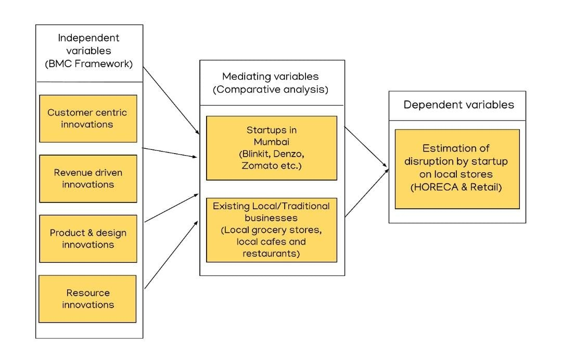

The BMC model has 9 aspects on which the framework is made and here we categorize them into 4 groups and they are as follows,

1. Customer-centric innovations - This involves the Customer relationships, Channels, and customer segments part of the BMC. Customer is the biggest factor in the industry and hence analysing this segment to understand the success of the industry is crucial. This involves the ways in which the company builds and establishes ties with the customers, the categories of customers that the industry focuses on and through what medium the company establishes contact with its consumers, and how it implements its value proposition.
2. Revenue-driven innovations - Revenue-driven innovations are the tactics used in the fields of revenue streams and cost structure of the BMC to ease the payment process and possibly increase the revenue. The cost structure gives insight into where the company puts in its money and the revenue streams tell you how they get the money. Analysing this data itself gives a clear idea of comparing the success of two or more companies or industries.
3. Product & design innovations - Consists of Value proposition and key activities. Tells the researcher what the company or industry stands for, what changes they want to make, and how they intend on making them. It gives an idea of what the company’s future might look like based on the goals they have. Key activities focus on the present-day work done by the industry to make it profitable and loved by its consumers.
4. Resource innovations - The final part of the framework involves the key partners and the key resources of the industry. The key partners will in themselves give an idea of how powerful the company/ industry is based on the support and funding it receives. The more powerful giants the industry partners with, the better its stability. The key resource gives the means required for making the products and that can be the people, their intelligence, just raw materials, or even money.

These independent variables are then observed in the two markets that we are comparing, the local and established stores with respect to the new and emerging Startups in the HORECA and the retail sector in Mumbai. The BMC analysis of the two can be formed after detailed study and research and this comparative BMC model of the two will give us the answer to our research, if Startups are disrupting the local markets or not?

Following is a detailed explanation of every BMC parameter and how it impacts the retail and HORECA industry.

**1)** **Key Partners**: Key partners are firms or individuals with whom your company collaborates to develop a strategic partnership. Suppliers and distribution partners are two examples of significant partners in the supply chain.

**A.** **Retail**: In the retail industry we have observed over the years that the supply chain and operations should be very efficient. Thus, Key partners for companies operating in the retail industry will be their delivery partners. For example- Companies like Blinkit have a business model where they deliver everything that you order in 10 Minutes. Startups like Fraazo have been slowly getting a significant market share in the Mumbai region because of the referral and reward system. Additionally, we have taken a survey where we understood if consumers would like everything home delivered or do they prefer to pick the products by going to the store.

**B.** **Horeca:** Horeca Industry has seen its all-time low during the pandemic. As mentioned earlier collaborations and strategic partnerships between companies help everyone to grow. In this industry, we have seen how Startups like Zomato and Swiggy have proved to be crucial partners for restaurants and cafes. Partnering with these services cafes and restaurants get more popularity and a wider reach. Additionally, for hotels services like MakeMyTrip have been significant in getting a larger consumer base. Collaborating with these services again will help the hotels to get a wider reach and increase their customer reachability. We are collecting data on the same via surveys and have interviewed owners of cafes, restaurants and hotels in order to understand the positioning of the HORECA industry.

* Blinkit is previously known as Grofers.

**2) Customer Segments:** Customer Segments refer to separating the total number of clients into segments based on how well an organization's products or services meet the demands of each segment. This comprises users that don't earn income but are essential to the business model's success. (AG, *Customer segments - business model canvas*)

**A.** **Retail**

When it comes to retail, it's a lot like the HORECA industry. The major goal of the businesses is to reach out to as many people as possible. The retail business is always evolving, with new items arriving on a regular basis, attracting a growing number of customers. They also track a large client base. For example, let’s take the famous athletic giant Nike. Nike markets athletic and sports gear, footwear, and equipment to anybody interested in buying them, again a mass market. (Pereira, *Nike Business Model* 2022)

**B.** **HORECA**

Going on with the HORECA industry requires a proper idea of who you want your customers to be. The majority of companies working under it tend to have a mass customer segment i.e., they focus on a group with broadly similar needs. This comes with the fact that there aren’t many ways to categorize your consumers in HORECA and people tend to swift from one trend to another easily. For example, if you are planning on opening a Chinese restaurant, you will aim at targeting any type of consumer who loves having Chinese food. Let us even look at the world’s largest coffee chain, Starbucks. Starbucks' client categories include everyone who desires high-quality coffee. To put it another way, the mass market. (Pereira, *Starbucks business model* 2022)

**3) Customer Relationships:** Keeping your customers satisfied and hearing them out is very important for a company. A happy customer is a loyal customer and they will stay with you even when competition arises if you keep listening to them. Apart from customer retention or 5acquisition, even boosting sales is an upside to a well-established consumer relationship. (*The business model canvas explained - Bauer college of ...*)

**A.** **Retail**

The retail sector tries to provide their customers with the service they need mainly through customer support. Many retail outlets try to give the customers the freedom to look around and come up with their choice and usually limit their interaction. Frequent customers may get loyalty rewards or tailored suggestions according to their previous purchases. For example, retail giant Nike provides a great customer relationship through live chat and interactive FAQs on their website and also provides a unique customer ID for ease of shopping.

**B.** **HORECA**

The HORECA sector tries its best and is always coming up with more and more innovative ideas to make their customers love them more. It is especially more of a challenge since many companies do the same things as the others (providing loyalty cards and offers, discounts and coupons etc.) The majority of the companies put their best foot forward to try and stand out from their competitors and ensure their customers stay with them. One of the best examples is Starbucks giving a personalised cup with the customer’s name written on it and providing loyalty offers on their card and mobile app for their customers. (Pereira, *Starbucks business model, customer relationships* 2022) Airbnb, one of the most recognised hospitality companies boasts of giving the perfect customer relationship where their platform itself is designed to be as user-friendly as possible, giving tailored suggestions, and customer service assistance, which is available 24/7.

**4) Channels:** Channels are the source through which the companies are selling their products. These may include Amazon, Flipkart, DMart and several other places where they have been capable of putting up or placing their products.

**A.** **Retail**

Retail has very well adapted to the technological advancements by not only tying up with delivery channels to increase their sales but also tying up with marketing channels to increase the traffic on their page. In contrast to other industries, the retail industry during lockdown had proved to be the most profitable and successful sector. Where normal people wouldn’t reach, the delivery channels would deliver essentials. So, using the perfect marketing and delivery channels, the retail industry has leaped ahead while adapting to technological advancements.

**B.** **HORECA**

HORECA is considered to introduce and tie up with numerous different channels which have been giving them very positive responses. Channels like Zomato, Swiggy and Zepto have been allowing them to gain much higher profits than only relying on their own delivery channels. Now even considering marketing as a channel, the HORECA industry has been at its peak where there can be seen the best marketing channels used to create the most effective strategies for their companies.

**5) Revenue Streams**: These are the various payment modes through which consumers can pay for their products.

**RETAIL AND HORECA:**

Retail and HORECA both have been able to include various types of payment options in their transaction portal. With the introduction of UPI, it has been very easy not only for the consumers but also for the retail companies to accept payments. BharatPe has done an excellent job of coming up with one QR code for all the UPI payments be it any company( Paytm, googlepay, phonepay etc..) so they have been very well adapting to the digital India concept and avoiding cash transactions to flush out the black money into the system. Digital transactions are a big constituent of the same.

**6) Key Activities**: Key activities are all the essential tasks that a business must perform to operate smoothly. The key activities of a business depend on the business model they have, for example, the key activities of FedEx include supply chain management, and the key activities of Ikea include manufacturing furniture.

**A. Retail**- Key activities of a retail store include procurement of the goods as per their demand and requirements by the consumer. Its most important activity includes sales. Most retail shops in India do sales by traditional methods. But by partnering with any delivery Startups, the local retail shops (Kirana) can increase sales and increase access to the local markets.

**B. HORECA**- the key activities of hotels and restaurants include, providing food and caterings services to their consumers. Startups have changed the dynamics of this industry to a huge extent, especially in the last 4-5 years. Because of food delivery Startups, even then small restaurants and cafes have increased their reach to the customers.

**7) Key resources:**

**A. Retail** - Key resources for a retail store include, its inventory, people, QR codes, and sales data (if it is a bigger store). With the help of Startups, the stores can be able to get resources like the sales data of the region & optimize their inventory requirements and human resource for delivery easily.

**B. HORECA**- Key resources for HORECA include supplies, human resources (both in-house and for delivery) and most important in today’s age data! With the help of food delivery Startups like Zomato, Swiggy, etc. HORECA industry has got a push. This is because now consumers can conveniently order food from their favourite place. This has also increased the reach of small cafes and restaurants.

**8) Customer Value Proposition:** A value proposition is a promise made by a business to a consumer or market group. The proposition is a simple explanation of why a consumer should purchase a product or service from that particular company.

**A. Retail-** In the Retail Industry, the retailers must deliver the promises and commitments to their customers. In the retail world, the value proposition is very important because of the heavy competition. Big Bazaar’s value proposition was they had all the necessities and a few luxury products under one roof. This resulted in creating an experience for their customers as they are street shopping.

**B. HORECA-** Providing a value proposition in the HORECA industry is very difficult. Many businesses are operating in the space. In the food sector- Restaurants and Cafes; a business can focus on a particular cuisine but there will be another restaurant or café that specialises in a similar cuisine. Moreover, in the hotel industry if a business is being cost-effective there will be different companies that will be cost-effective. The same goes for customer satisfaction. Thus, providing a unique value proposition in the HORECA industry is very difficult but it is possible.

# **10. How has the framework been tested?**

The framework that has been implemented for this research is- Business Model Canvas.

We have implemented the framework in our research by adding questions directly related to the BMC parameters in the survey form where we have collected over 200 responses. Refer to section 12 for a detailed explanation of the same.

Below mentioned are some of the questions that are related to the BMC and have been added to the survey-

**Customer Value Proposition-**

1. What are the reasons (value proposition) for your choice? (Retail shopping online)

**Customer Segments-**

1. Do you buy your daily need items (groceries) online or from a retail shop?

* Online
* Retail Shop

1. How do you mostly order food?

* Online
* Takeaway
* Dine-In

**Customer Relationships-**

1. Rate your overall customer experience with new Retail & HORECA Startups? (Ex- Big basket, Grofers, Jiomart, Licious & Zomato)

* On a scale of 1 to 5. With 1 being very low and 5 being very high.

1. Rate your overall customer experience with local grocery stores?

* On a scale of 1 to 5. With 1 being very low and 5 being very high.

1. Who do you think provides an overall better customer experience in terms of loyalty, customer support and post-sales services?

* Startups
* Local Stores

**Revenue Streams-**

1. How do you pay for the retail products that you purchase?

* Cash or Cash on Delivery
* Online payments (Cards or UPI)
* Credit system/ Udhaari (Local stores)

**Key Resources-**

1. How did you get to know about Retail and HORECA based Startups in Mumbai?

* Word of Mouth
* Social Media
* Banners
* Emails

**Key Partners-**

1. Will partnering up with delivery Startups prove to be beneficial for the local grocery stores?

* Yes
* No

**Key Activities-**

1. Where do you think it is relatively easier for you to make payment, process and collect items at the end?

* Online stores
* Traditional stores
* Both are preferable

Refer to section 12 for a detailed explanation and analysis of the survey.

# **11. Case study**

**Retail**

Big Bazaar is an Indian retail chain of hypermarkets, discount department stores, and grocery stores. The retail chain was founded by Kishore Biyani under his parent organisation Future Group., which is known for having a significant prominence in the Indian retail and fashion sectors. The company was founded in the year 2001. As of August 25, 2019, the company has 295 stores nationwide. The parent company is Future Group and the owner is Reliance retail.

Big Bazaar stores are designed like convenience stores. They do this to build a shopping experience similar to shopping on the streets. Their stores have electronics, clothing, footwear, and home appliances. Stationery, groceries, health products, beauty products and the list go on. This makes shopping in the stores of Big Bazaar a unique experience. Consumers can find all the necessary products and a few luxury products under one roof. They also have a few major subsidiaries like- Pantaloons, eZone and FBB.

They follow a revenue model where they buy products directly from the manufacturers and thus this eliminates all the middlemen and increases the margins. They also have major competition in the retail industry from Big Basket, DMart and Grofers(now Blink It). Thus, when the pandemic hit Big Bazaar faced major challenges. Because of the Pandemic, they suffered heavy losses because all the major retail outlets were shut down. Additionally, their competitors were performing better than them and they survived the pandemic (Chandra, 2021).

Big Bazaar which operates under the Future group of India failed to make payments for them to Reliance. Following this in the year 2020, Big Bazaar was acquired by reliance industries LTD. It was a transaction of 24,713 Crore INR. However, this is under dispute in the courts of Singapore (The Economic Times, 2022).

Now, focusing on the reasons for the downfall of Big Bazaar- As per the experts, the failure of a big organisation like Big Bazaar was because they didn’t have differentiation in a highly competitive retail market (Pinto, 2016). The company focused on diversification rather than differentiation. They were always in a phase of restructuring due to constants diversification and acquisitions. The conflict between Amazon vs Reliance over the future group was one of the major reasons for the downfall of this retail empire (Finology, 2021).

When we read the financial statements of Future retail, we can clearly see the drastic revenue drop in the financial year 2021. Their revenue was increasing constantly but suddenly in the year 2020-2021, their revenue was reduced by approximately 68% (Money Control, n.d.).

Their expenses were also drastically reduced because their purchases decreased by 75% and inventory management costs increased by 836.64%. Additionally, we could see a drastic 41% increase in employee benefit expenses. This all resulted in reduced expenses.

When it comes to profit and loss before tax, they were never stable. They saw a rise in profits in the year 2019 by 6380% but after that their profits decreased drastically and they were suffering losses of almost 9438%.

|  |  |  |  |  |  |
| --- | --- | --- | --- | --- | --- |
| **Financial Year** | **Mar-21** | **Mar-20** | **Mar-19** | **Mar-18** | **Mar-17** |
|  |  |  |  |  |  |
| **Total Revenue** | 6,437.40 | 20,201.92 | 20,185.37 | 18,489.64 | 17,098.89 |
| **Revenue change** | **-68.13%** | 0.08% | 9.17% | 8.13% |  |
|  |  |  |  |  |  |
| **Total Expenses** | 9,597.32 | 20,168.08 | 19,452.56 | 17,874.46 | 16,730.61 |
| **Change** | **-52.41%** | 3.68% | 8.83% | 6.84% |  |
|  |  |  |  |  |  |
| **Profit/Loss before Tax** | -3,159.92 | 33.84 | 732.81 | 11.31 | 368.28 |
| **Change** | **-9437.83%** | -95.38% | 6379.31% | -96.93% |  |

**Source:** Dion Global Solutions Limited (Money Control)

This shows how difficult it is for a big retail organisation to run in the retail space. Competition is a major factor in the downfall and especially in Mumbai. Where there are so many Startups in a similar space with better USPs like Fraazo and Blink It. We believe that the best course of action for big bazaar was to sell the company to Reliance industries. As the retail space is highly competitive in Mumbai and operating with weak financials will be very difficult.

**HORECA Industry**

To understand the HORECA industry in detail we are using the research strategy of a Case study. This case study will contain primary research. We source of the primary research is- Interview. We spoke to the owner of the restaurant chain in Mumbai- Fisco Restobar- Mr Monish.

When asked to explain what Fisco Restobar is; He said-  It is a great restaurant and one that just makes you feel like you're not sure whether you went out or you came home and confuses you. Our ideology matches these thoughts. We are an Industrial theme-based Restobar. Visit us to experience the magic of culinary skills.

He has been associated with the HORECA industry, especially in the restaurant business since the year 2016. Their business is not an established business but is surely on the verge of being renowned in Mumbai City once they open a few more restaurants. We can classify their business as a startup. In this research project, we are focusing on the correlation between how established businesses and Startups are working in harmony or are either one of them dominates the other.

In the HORECA industry delivery partners are very crucial and in this field companies like Zomato and Swiggy have captured a major market share. We are analysing how these Startups are making an impact on the HORECA industry. When asked about the role of Zomato and Swiggy in their business; We got to know how partnering with Zomato has resulted in an increase of 70% revenue that comes from home deliveries. The revenue model that Zomato follows is that they gain a percentage of money from every order and this is practical because of the data and the outreach that Zomato gives to these restaurants.

Additionally, we also understood how these restaurants will react if there are new entrants in this industry. The HORECA industry is very flooded with thousands of cafes and restaurants. But Fisco believed that customer retention is very crucial. There will be people who love to try out new restaurants and cafes. But once they visit their restaurant, they want to make sure they come back again.

Moreover, they also believe that it is crucial to be available on services like Zomato and other services for online reservations like Dineout.  On these platforms, consumers look for new restaurants and it will help the business to gain more visibility. In addition to this, we asked about is there any space left for new entrants in the industry. We understood that the HORECA industry is flooded but consumers are always looking for new options and the Restaurant/cafe/food business will rarely suffer loss. Thus, we understood that Startups can still disrupt the industry if they have a USP that can attract consumers.

When we talk about the delivery Startups collaborating with the businesses in the food industry. We learnt how new companies can collaborate with the existing businesses by obtaining data and not asking for a percentage from the orders that they receive for some period. He advised that any new entrant in this space should follow a freemium model until they have established themselves in the entire city.

After analysing the interview and talking about the business model of Fisco. We understood that the HORECA industry is still open to new Startups and businesses. However, the market share won’t be affected that much when we compare it with the retail industry because there, we have established businesses that are capturing the major market share. In the HORECA industry majorly there are a lot of startup restaurants and cafes.  This results in a division of market share in smaller percentages.

In conclusion, the Retail Industry is dominated by established businesses like DMart and Reliance. Thus, becomes very difficult for Startups to operate in the industry if they do not have a Unique Selling Point (USP). Their revenue will be too less when compared with the established businesses. However, they can focus on a small market area or a small region of Mumbai and could provide delivery in a very short amount of time. A company that is doing this in the retail industry is Fraazo. They are operating in only one part of Mumbai- Vasai. Slowly they are getting the appreciation and well-deserved market share and thus now they can slowly look to expand. On the other hand, the HORECA industry will always be open to new Startups and entrants. Because consumers are expecting new most of the time and to cater for this need it will be very rare that a restaurant will fail to deliver; Provided they have their USP that is been accepted by the majority of the people in Mumbai.

**These are the major questions and analyses of questions that have a direct impact on our research.**

**Q- Age:**

***Figure 12.1***

After analysing in the figure 11.1, we understood that; It is crucial to ask the age of the respondents because it will shape the research’s perception. To give a context- There is a high possibility that a 15-year-old child might not be aware of the retail industry and the HORECA industry. However, anyone who is above 18 years of age might be aware of the basics of the industry and might be updated on the current affairs such as: Which new Startups are there in the industry or which established company is on the verge of bankruptcy.

The majority of the survey takers have been in the category of 18-25 years. Additionally, the average age of the respondents is- 28. Thus, we can infer that the data is credible enough for the research.

**Q- Check which applies to you:**

It is important to understand the sample size and type for the research. In our research, we are understanding the situation from three aspects-

1. Consumers
2. Established businesses
3. Startups

***Figure 12.2***

From the mix created of the responses, 48%, which is almost half of the survey takers were consumers, while 26% were local or established businesses, and 26% were associated with a startup.

**CONSUMER SURVEY**

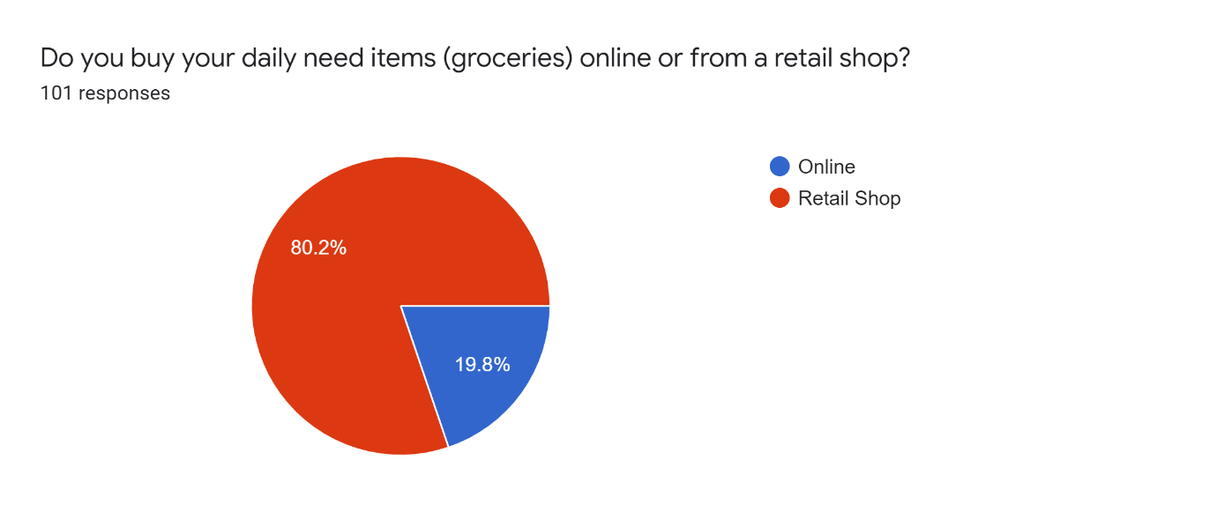**Q-**

***Figure 12.3***

Daily need items are very important because consumers buy these items regularly and there is a constant transaction for these products. Daily need items include- Bread, Tea, Coffee, Detergents, Groceries, Soap, etc. We have seen a rise in online shopping even for such items because of the pandemic. However, there was a rise because people couldn’t go out to buy these items by themselves. They didn’t have any other alternatives. This can be reflected in our survey because now when people can go out and everything is coming back to normal people prefer to buy their daily needs items from a retail shop instead of online shopping.

Out of the 100 responses, 81% of the respondents bought their groceries from the local retail shop while 19% bought them online.

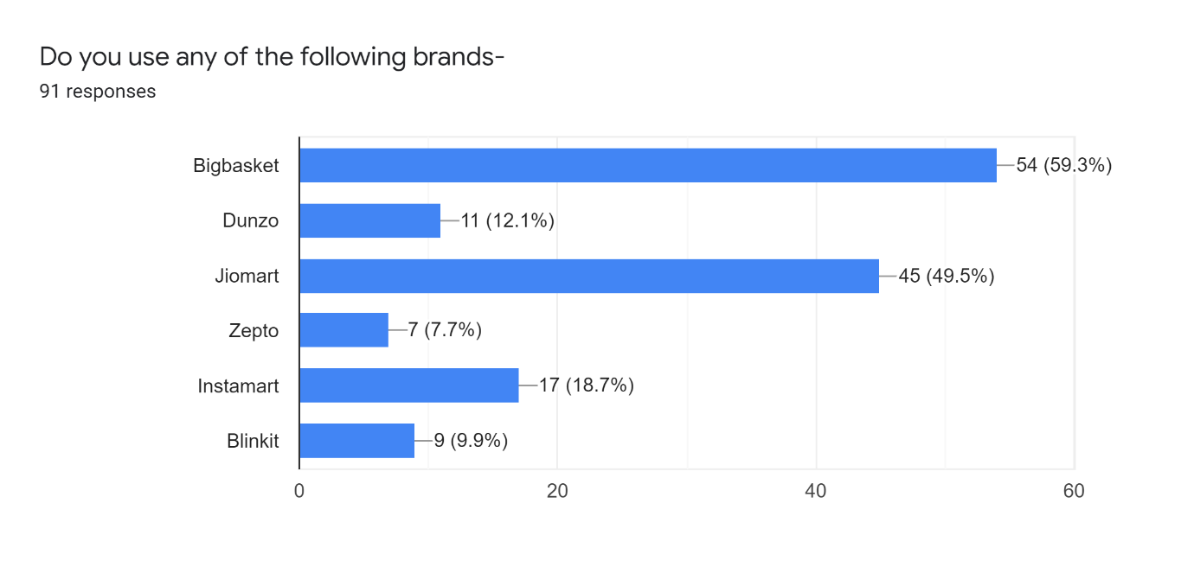**Q-**

***Figure 12.4***

In India, there is a startup trend and there are several Startups in every industry. Similarly, in the Retail Industry, there are these Startups. Our main focus during this research is to infer if these Startups are affecting the established and local businesses or not. 53 of the ones that took the survey use a big basket, while 45 people use Jio-mart and other applications like Instamart and Dunzo are still getting their way up to the consumers.

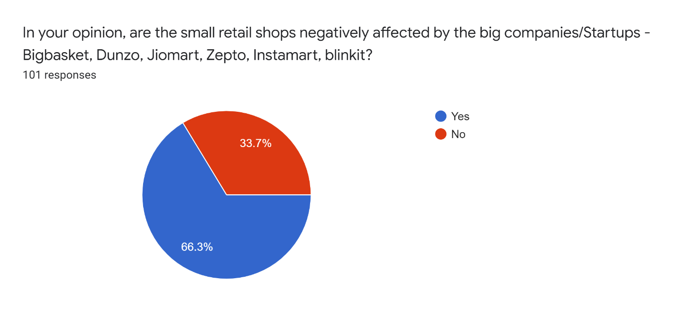

**Q-**

***Figure 12.5***

66% of the sample think that the small retail shops are being affected by the Startups while 34% still feel that the local retail stores aren’t being impacted.

We also agree that the local retail shops are being negatively affected because of these Startups. The reason is- Startups have more funding and can market themselves to a wide consumer base.

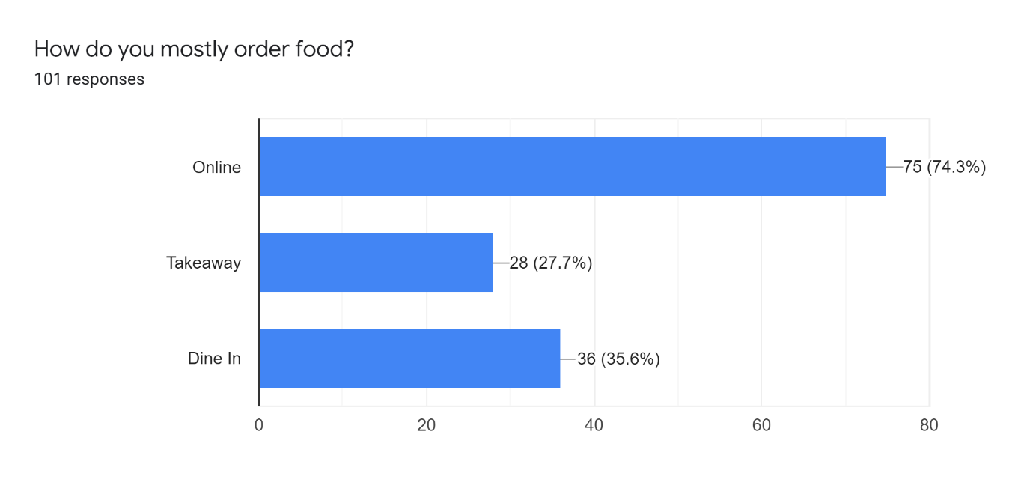

**Q-**

***Figure 12.6***

Most of the people- 74%, order food online, in the times of pandemic that was sought to be the best option possible while being safe at our homeplace. This is also possible because Startups like Zomato & Swiggy are disrupting the delivery channels and are also helping the Food Industry to grow. In the case study, we saw how Zomato helped Fisco Restobar increase online delivery revenue and similarly other cafes & restaurants also benefit from these Startups.

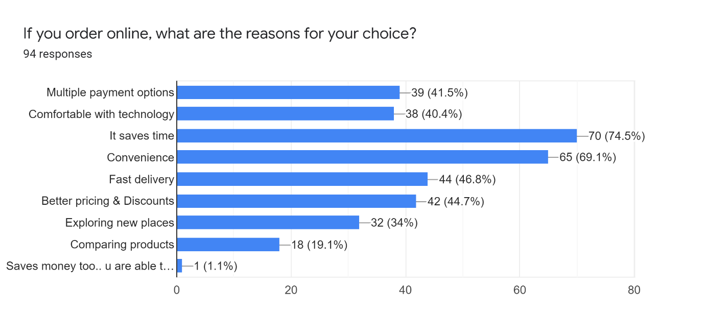

**Q-**

***Figure 12.7***

Saving time is of utmost importance as shown in the result, while convenience is another common reason that our survey takers feel. Convenience maybe in terms of sitting cosily at home while having food or in payment modes. Additionally, all other reasons are credible. Respondents don’t think that ordering online saves money and we can also track our spending. We also agree to this because ordering food online costs more than dine-in because it will include delivery charges & percentage cuts for the delivery partners.

**Comparative Study of customer experience between Startups and Local stores**

|  |  |
| --- | --- |
| **Rate your overall customer experience with new Retail & HORECA Startups? (Ex- Big basket, Grofers, Jiomart, Licious & Zomato)** | **Rate your overall customer experience with local retail stores?** |
| ***Figure 12.8*** | ***Figure 12.9*** |
| 49% which is almost half of the people think that they would give the user experience in HORECA as 4 out of 5. With an average being 3.8.  ***Scale- 1- Very low to 5- Very High*** | The responses remain the same as the other majority of 46% feel that retail stores provide a better personal touch which online retail cannot provide. With the average being 3.9.  ***Scale- 1- Very low to 5- Very High*** |

Consumer response to both is quite similar. There are a few outliers (4- Startups & 3- Local stores).

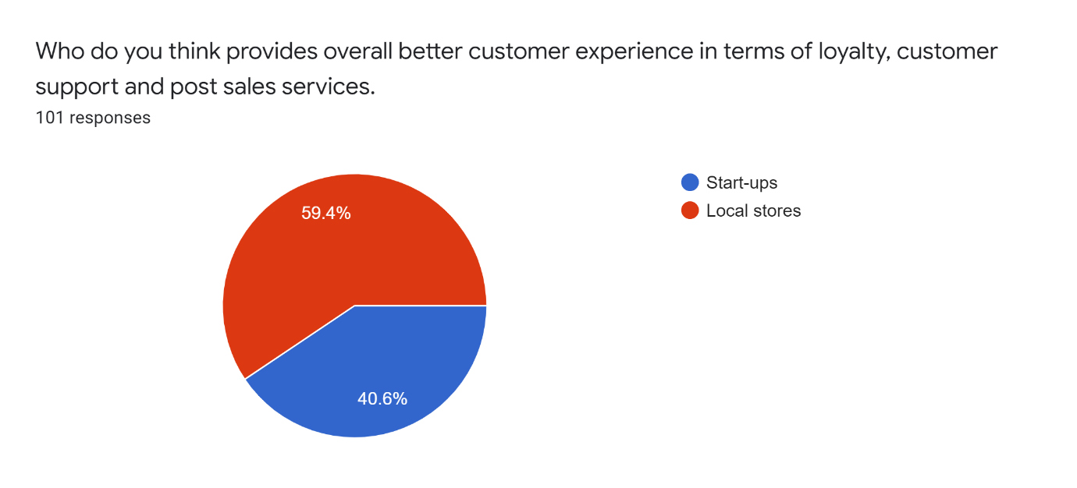**Q-**

***Figure 12.10***

Here, we can observe that 60% of the respondents believe that local stores are more customers centric and they can be loyal to them as compared to Startups. We believe that after a few years people would slowly change their preference and will start trusting the stat-ups provided Startups continue to be customer-centric.

**Q-**

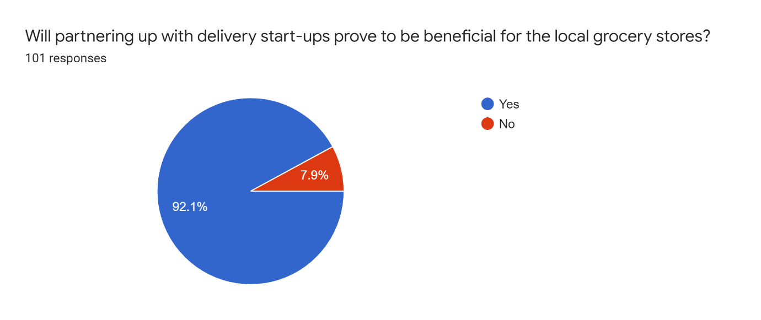

***Figure 12.11***

We believe that collaborations and partnerships can be a key to success for many businesses; our respondents also believe the same. 92% of those who have taken the survey feel that the local grocery stores should 100% tie-up with delivery partners.

If the local stores do this then they will be able to severe a wide consumer base and people can trust the Startups as well.

**Established Business Survey**

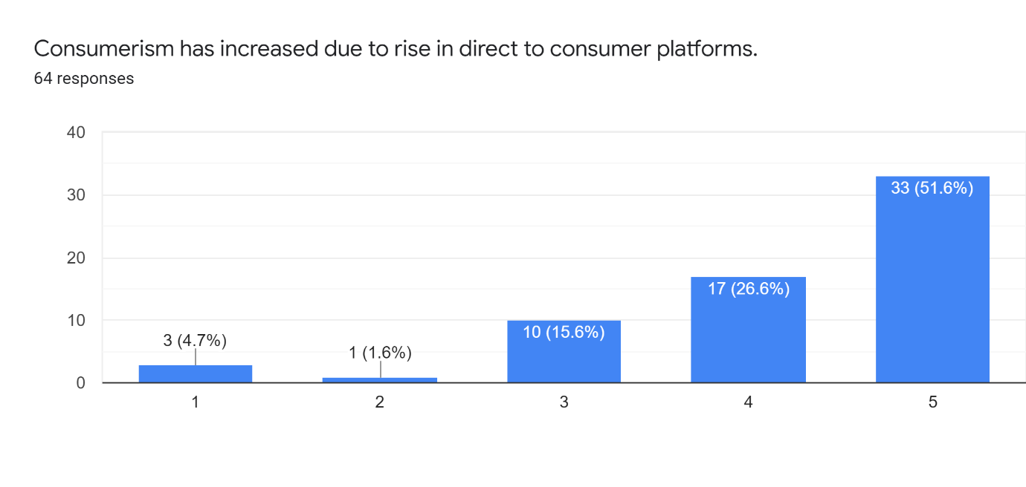**Q-**

***Figure 12.12***

***Scale: 1- Strongly Disagree to 5- Strongly Agree***

We can clearly infer that the respondents believe that consumerism (Increased purchasing and selling of goods and services) has increased due to the rise in D2C platforms. Because of D2C platforms now businesses can directly contact the consumers eliminating the middle men and extra transportation charges.

|  |  |
| --- | --- |
| ***Figure 12.13*** | ***Figure 12.14*** |
| Out of all the ones who are associated with established businesses and have responded to the survey, only 43.8% of them have partnered up with delivery-based Startups. | Of the 56.3% of respondents who didn’t partner with any delivery Startups, 60.4% of them wish to partner with them in the future. |
| **This shows the importance of Startups like Zomato, Swiggy, Dunzo & etc.** | |

**Comparative Analysis between partnership with delivery Startups**

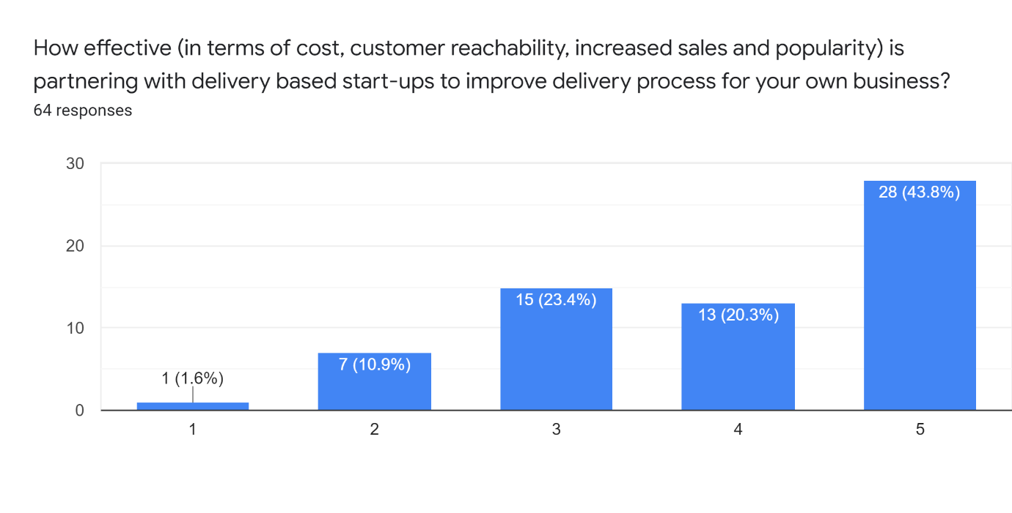**Q-**

***Figure 12.15***

***Scale: 1- Least effective to 5- Extremely Effective***

43% of respondents feel that it is very highly effective to partner up with delivery-based Startups, it not only increases the sales and reach of the business but is also cost-efficient. We also agree with this result because outsourcing a job that you are not specialised in is always more efficient than you doing it.

**Comparative study between the positive spillage in both Retail & HORECA Industries.**

1 being Strongly disagreed and 5 strongly agree.

|  |  |
| --- | --- |
| ***Figure 12.16*** | ***Figure 12.17*** |
| **It is evident from figures 11.16 & 11.17- that those respondents think that Startups in the retail & HORECA industry have a positive spillage effect in Mumbai. We also agree with this statement because when there are new Startups there are more opportunities for people.**  ***Scale: 1- Strongly Disagree to 5- Strongly Agree.*** | |

**Q-** 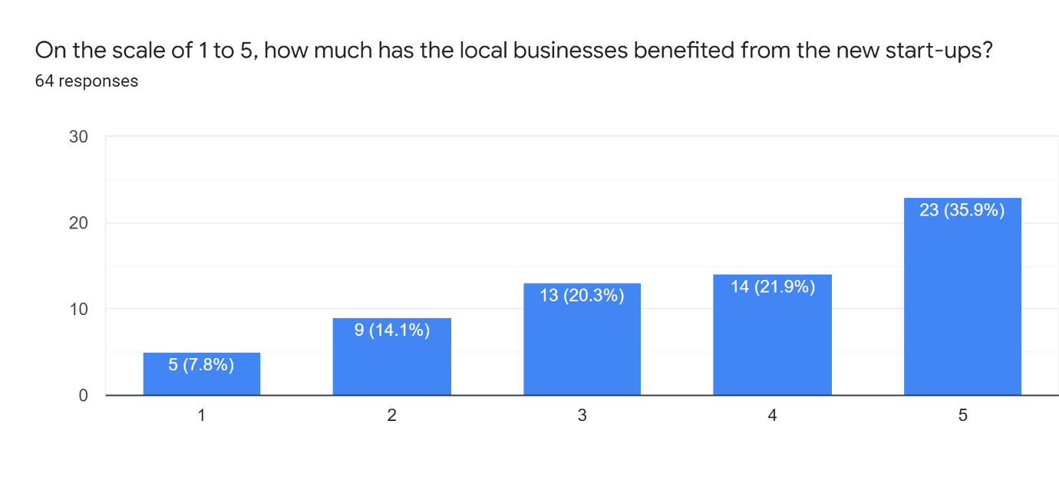

***Figure 12.18***

***Scale: 1- Not benefited to Benefited.***

35% of the respondents believe that the local businesses have benefited from the new Startups. While 7.8% of respondents think they have not benefited.

According to us- If the established business is collaborating with Startups, it will be beneficial for both parties because Established businesses have customer loyalty and Startups have disruptive ideas. Together they can operate in harmony.

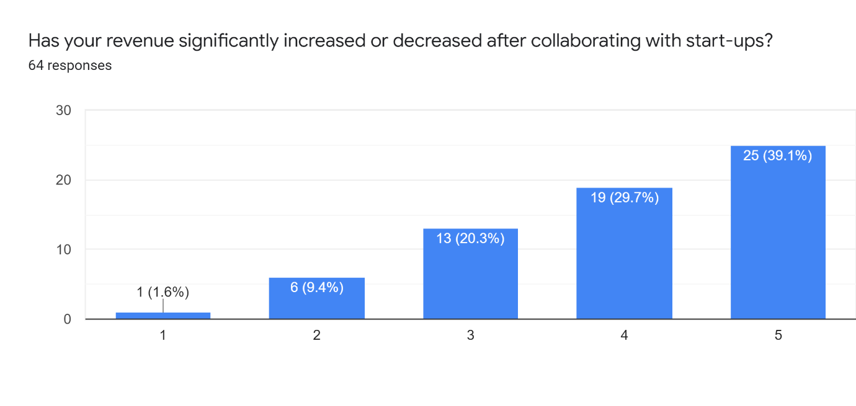**Q-**

***Figure 12.19***

***Scale: 1- Decreased to 5- Increased***

From this chart, we can clearly infer that the revenue of the established businesses has increased after collaborating with Startups.

**Q-** 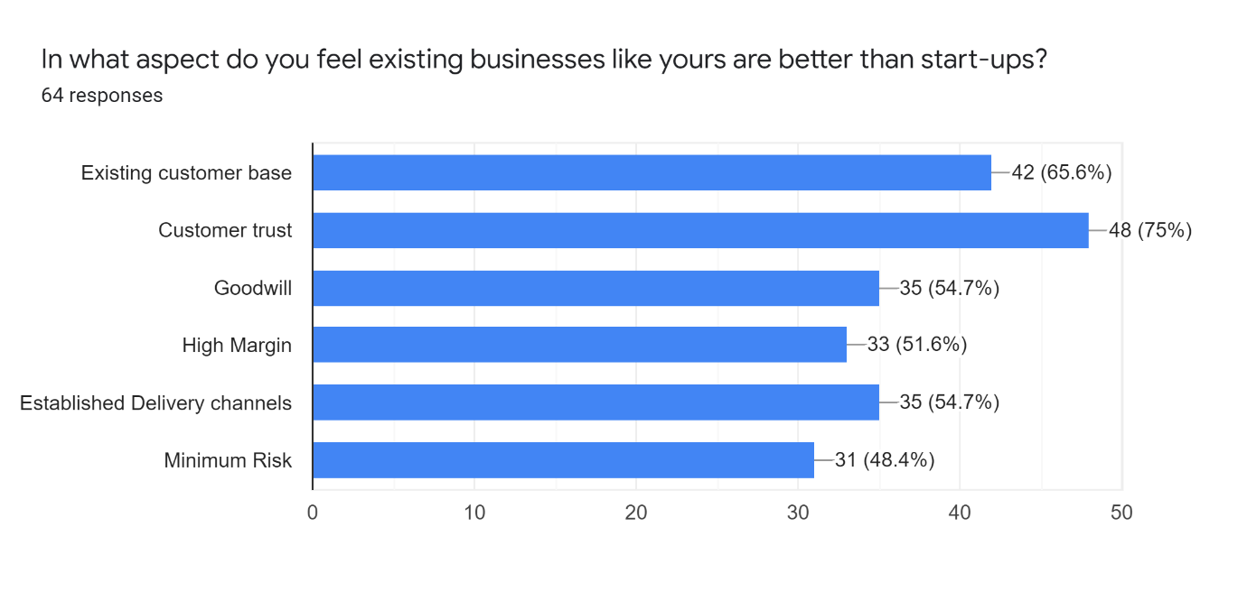

***Figure 12.20***

75% of the respondents think that the existing businesses are better in customer trust and 65.6% think that the existing businesses are better in the existing customer base when compared to the Startups. Additionally, Goodwill- 54.7%, Established Delivery Channels- 54.7%, High Margin- 51.6% & Minimum Risk- 48.4%; are all the aspects that the respondents think established businesses are better at when compared to Startups. Refer ***Figure 11.20 & 11.21 for graphical reference.***

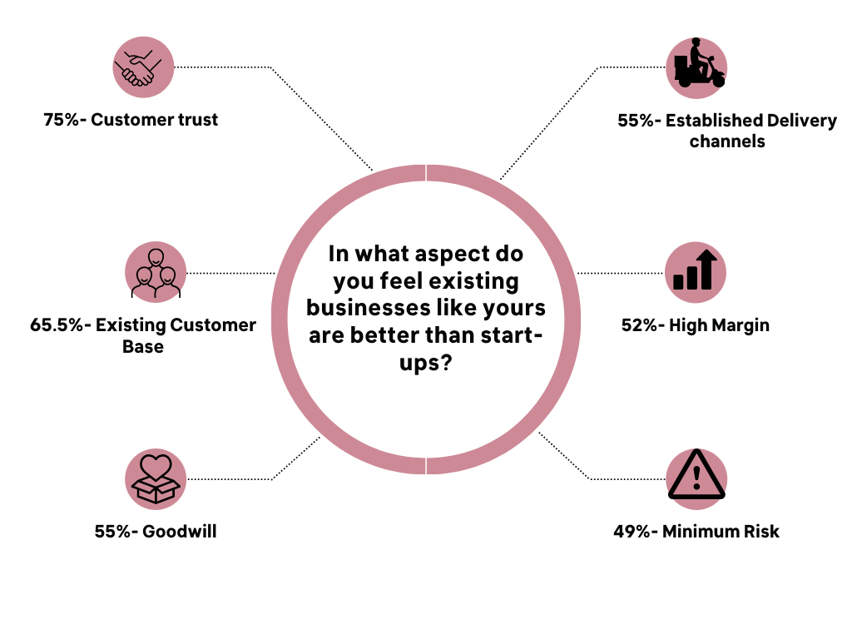

***Figure 12.21***

**Q-** 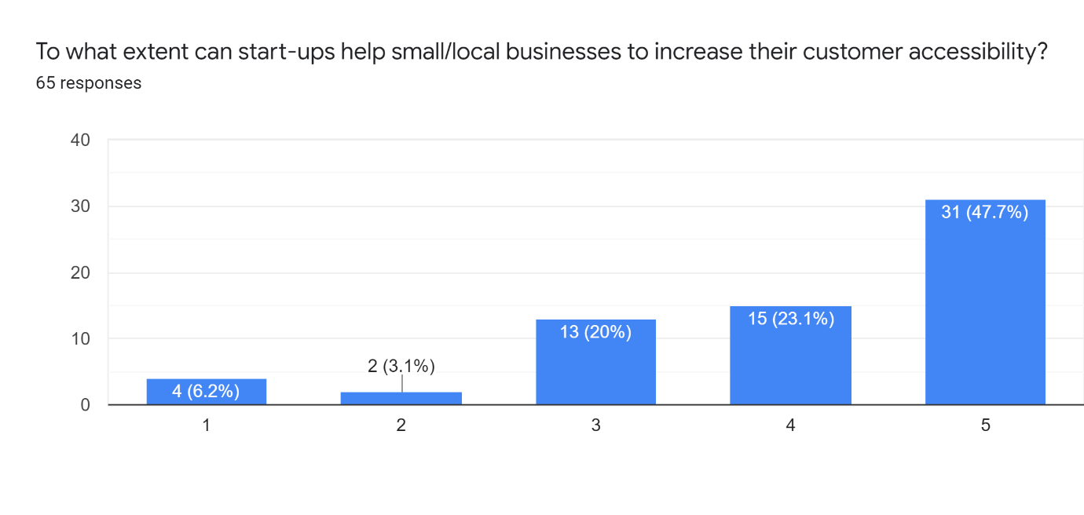

**Startups Survey**

***Figure 12.22***

***Scale: 1- Less to 5- High***

47.7% of respondents very strongly feel that Startups help small/local businesses to increase their customer accessibility. If the delivery Startups like dunzo, and retail Startups like Blinkit and Fraazo can partner with local businesses then they can deliver the products to the customers more easily and quickly. The delivery team will have to pick up products from local stores and deliver them near that locality. Additionally, local stores can promote the services so that consumers who are shopping in person can utilise the services in their times of need. This will help the local businesses to increase their customer reachability.

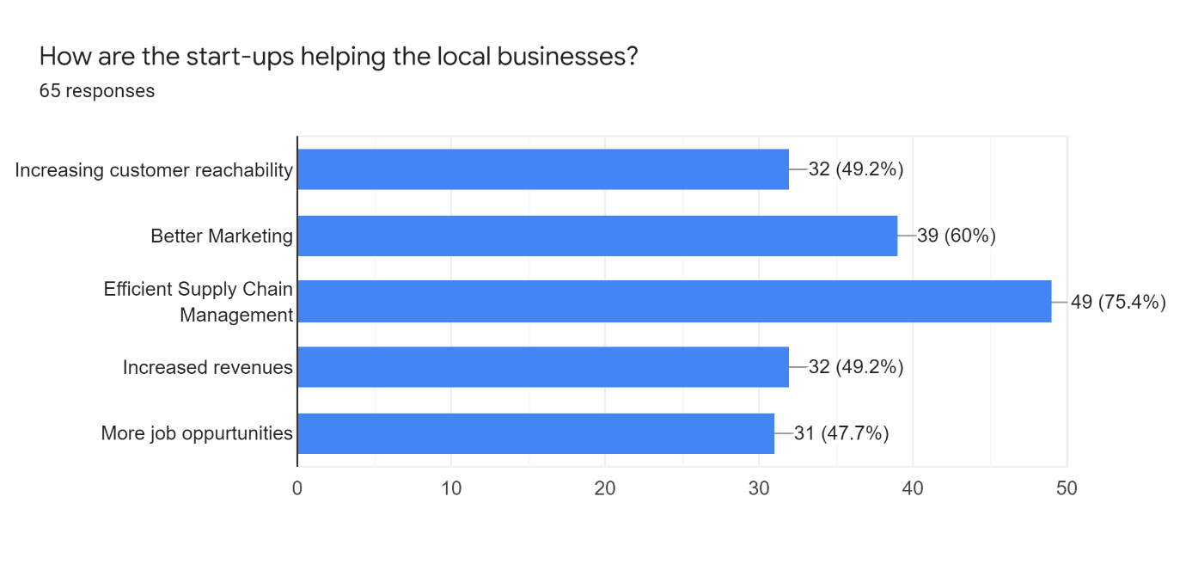**Q-**

***Figure 12.23***

According to the respondents, Startups are helping the local businesses in the following ways-

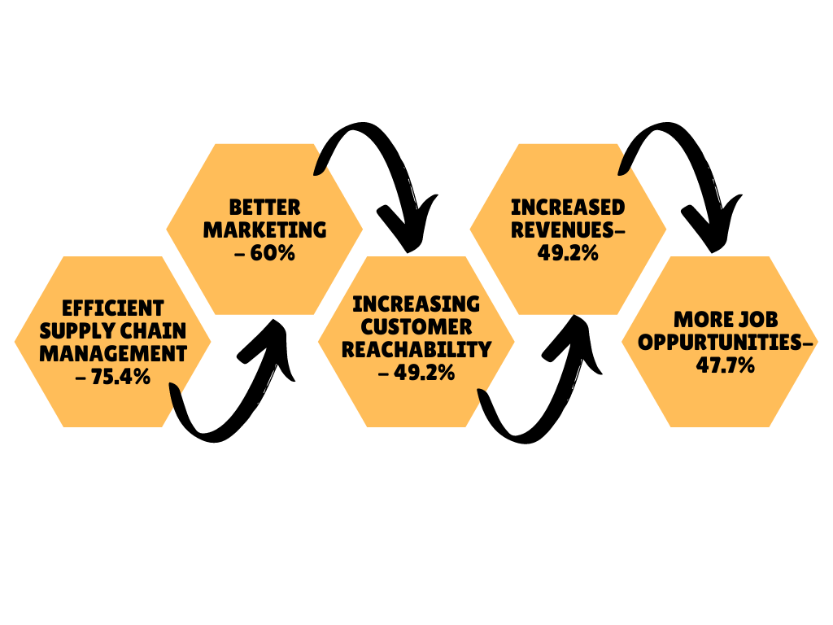

***Figure 12.24***

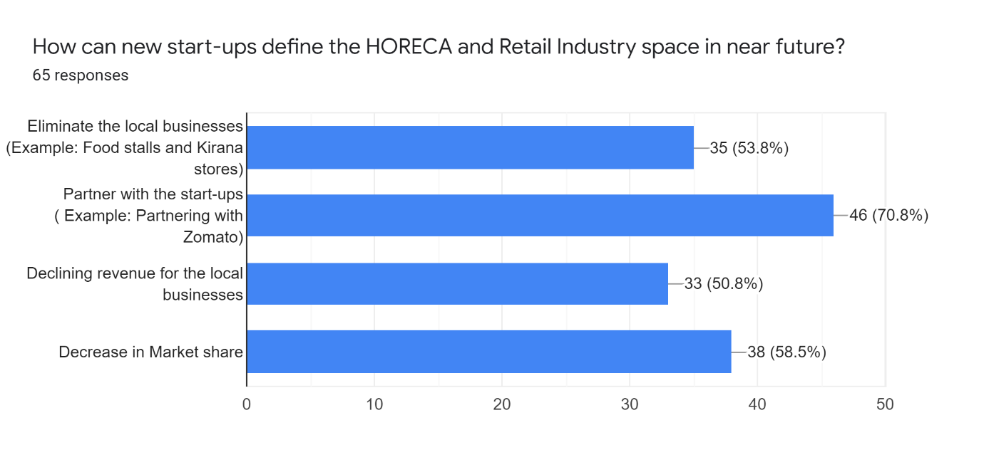

**Q-**

***Figure 12.25***

According to our respondents, these are the 4 possibilities of how Startups in the HORECA & Retail industry will shape the marketplace for the local businesses in the future.

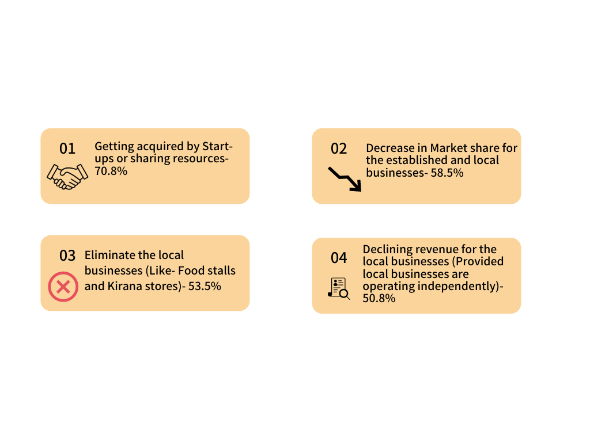

***Figure 12.26***

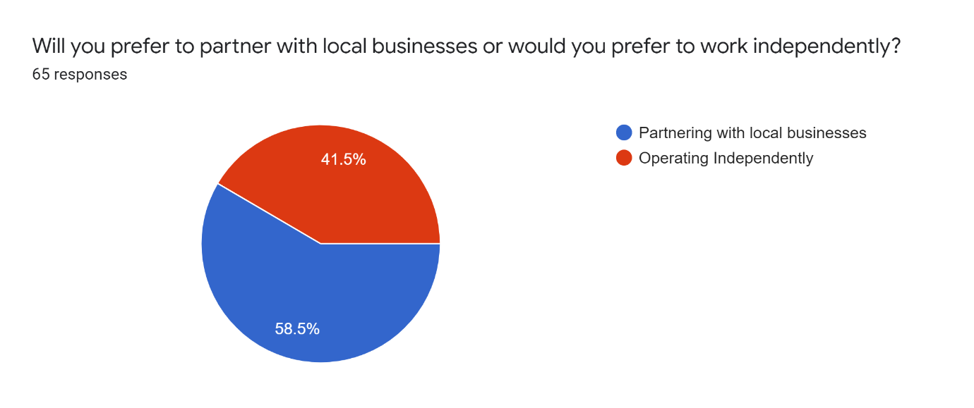**Q-**

***Figure 12.27***

58.5% of respondents from Startups said that they will prefer partnering with local businesses. After looking at this graph we cannot infer the trend because the decision is not clear. Thus, we can say that businesses that have high competition can prefer partnering with local businesses while businesses that do not have much competition in their industry prefer operating independently.

**Q-** 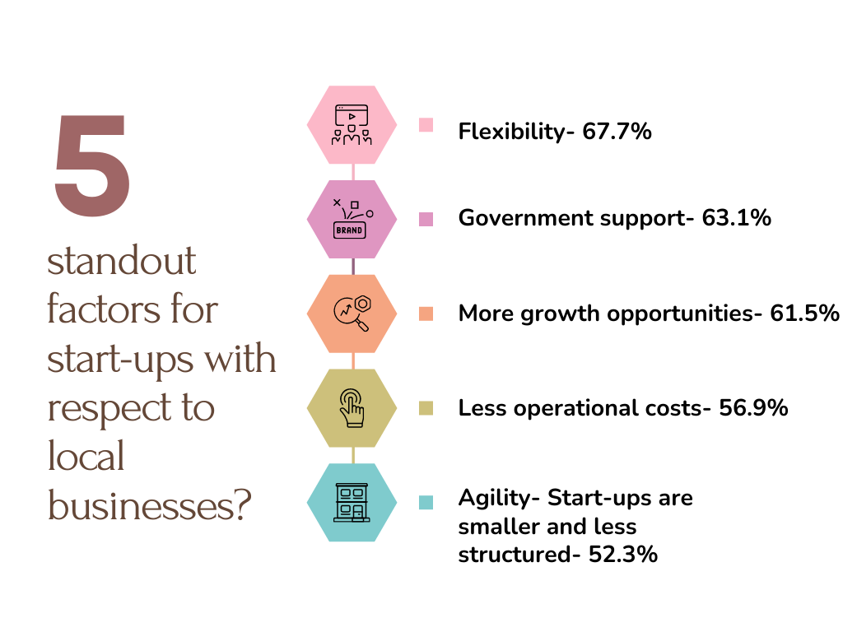

***Figure 12.28***

According to respondents, these are the 5 Standout factors for Startups with respect to local businesses we got from our survey.

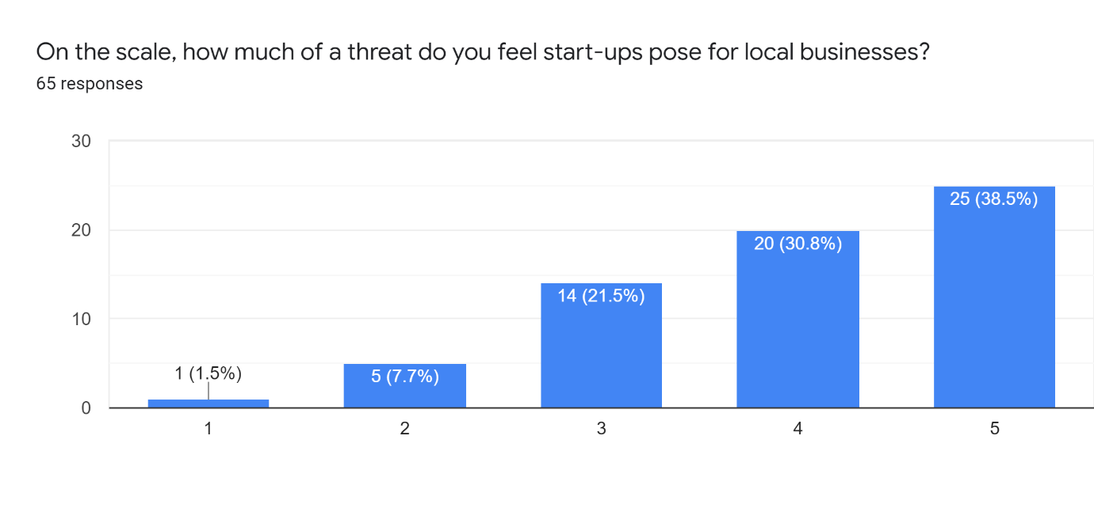

**Q-**

***Figure 12.28***

***Scale: 1- Extremely Low to 5- Extremely High***

It is very evident that respondents think that Startups pose a major threat to local businesses. We also agree with this statement because they have ample resources at their disposal. Additionally, they are in their growing stages and are disruptive in the marketplace therefore it is practical and logical that they are a major threat to the local businesses.

# **13. Insights using Data Analysis**

**Situation 1:**

Weka: Association Algorithm

**Survey Questions:**

1. Who do you think provides an overall better customer experience in terms of loyalty, customer support and post-sales services?
2. Will partnering up with delivery Startups prove to be beneficial for the local grocery stores?

**Statement**: If a consumer feels that a startup is providing a better customer experience will the consumer suggest the local grocery stores partner with delivery Startups?

***Figure 13.1***

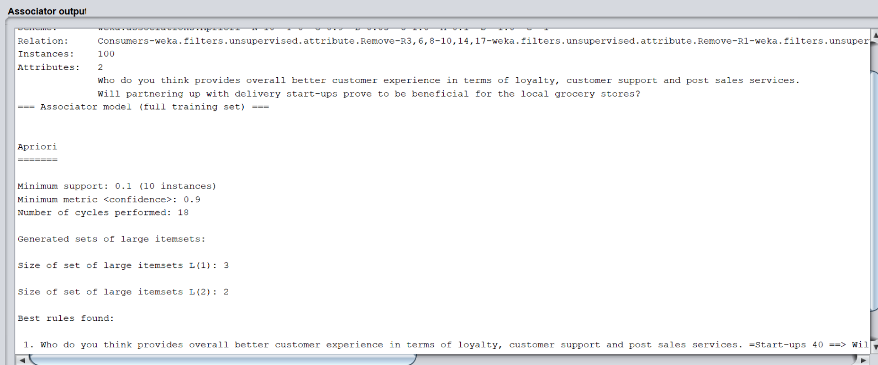

1. Who do you think provides an overall better customer experience in terms of loyalty, customer support and post-sales services. =Startups 40 ==> Will partnering up with delivery Startups prove to be beneficial for the local grocery stores?=Yes 38 <conf:(0.95)> lift:(1.03) lev:(0.01) [1] conv:(1.07)

Here, the confidence level is 95%. Thus, there is a high probability that the consumer will suggest the local grocery store partner with delivery Startups.

Every business decision is taken while considering consumer preferences. We also observed in the survey that 95% of consumers feel that it would be beneficial for the local grocery stores to partner with Startups. Additionally, respondents also feel that in the future Startups will capture the majority of the market share from the local shops. If the local stores want to survive in this current market, they have to partner with such Startups that will help them to attain more customer reachability.

We also observed that the local food stalls are now using the services of Zomato and Swiggy. This is a sign of collaborative work culture; which will benefit both the businesses in the future as well as in the present.

***Situation 2-*** Weka: Association Algorithm

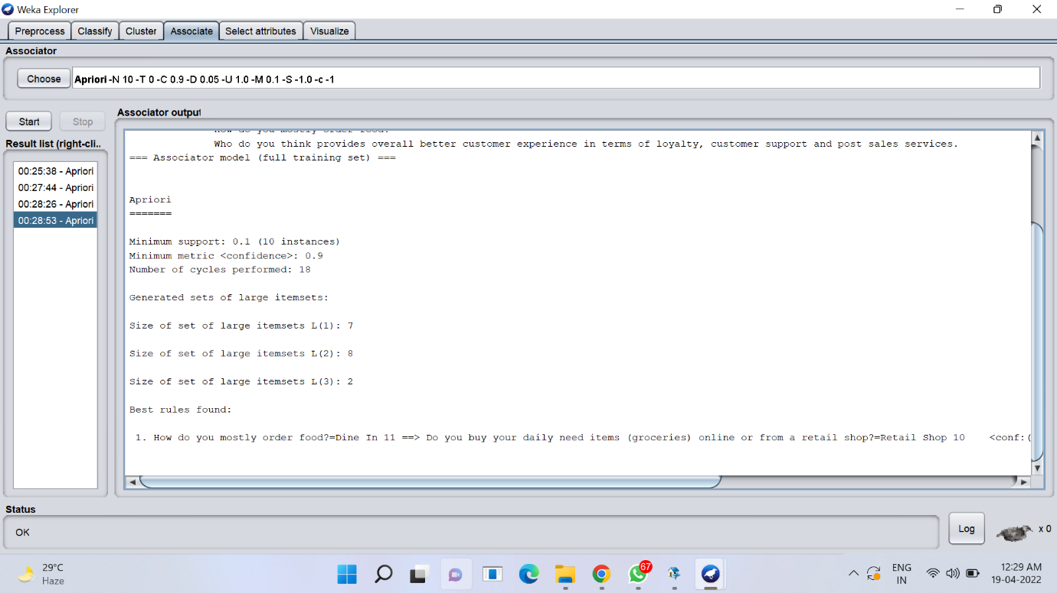***Figure 13.2***

**Survey Questions:**

1. How do you mostly order food?
2. Do you buy your daily need items (groceries) online or from a retail shop?

**Statement**: What is the probability that the consumer who goes out (Dine In) for their meal will order retail products mainly groceries from an online startup?

How do you mostly order food?=Dine In 11 ==> Do you buy your daily need items (groceries) online or from a retail shop?=Retail Shop 10    <conf:(0.91)> lift:(1.12) lev:(0.01) [1] conv:(1.04)

Here, after using the association algorithm that says 91% of the consumers who dine in will buy groceries from a retail shop (Local stores or established retail stores like DMart)

This, here we tried to achieve our objective- To understand how consumer preferences lead to business decisions. We understood that consumers who are going out to eat also prefer to buy retail products from a retail shop over online shopping.

**Situation 3:**

***Figure 13.3***

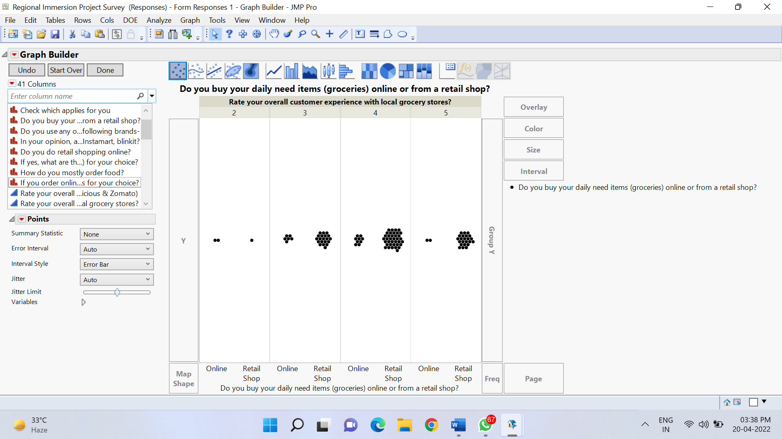

In order to validate the responses and prove their credibility- We used a graph builder.

Here, the two attributes are-

1. Rate your overall customer experience with local grocery stores
2. Do you buy your daily needs items online or from a retail shop?

We are doing this analysis to fulfil our objective to understand consumer behaviour and preferences. As we can see consumers who believe that local grocery stores provide a very good customer experience do not buy the grocery items from online stores/Startups. Here, we can say that customer retention that the local grocery/retail stores have will be very difficult to break in for the new Startups in this sector.

**Situation 4:**

***Figure 13.4***

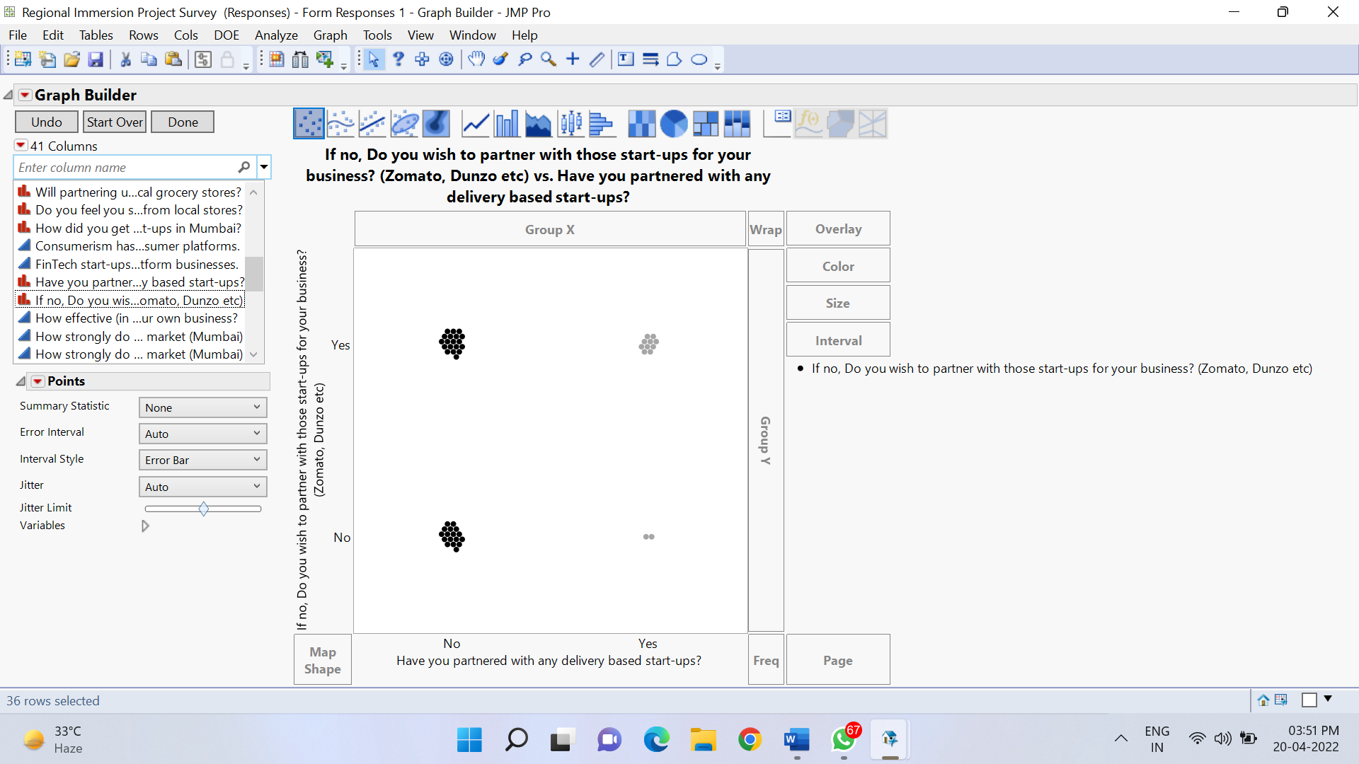

Here, the two attributes are-

1. Have you partnered with any delivery-based Startups?
2. If not, do you wish to partner with those Startups for your business?

Analysing this graph will help us to fulfil our objective- “How have the Startups disrupted the supply chain in the retail & HORECA industry”. Supply chain disruption has been a pivotal role in both the industries- HORECA & Retail. We have seen Startups like Zomato, Blink It & Fraazo come up and disrupt the entire industry.

After reading the graph our general analysis is that the existing business that has already partnered with these Startups are fewer (as per the data from our report). However, there are other people who are associated with an established/local business and are willing to partner with these delivery-based Startups in order to increase their revenue and customer reachability.

**Situation 5:**

***Figure 13.5***

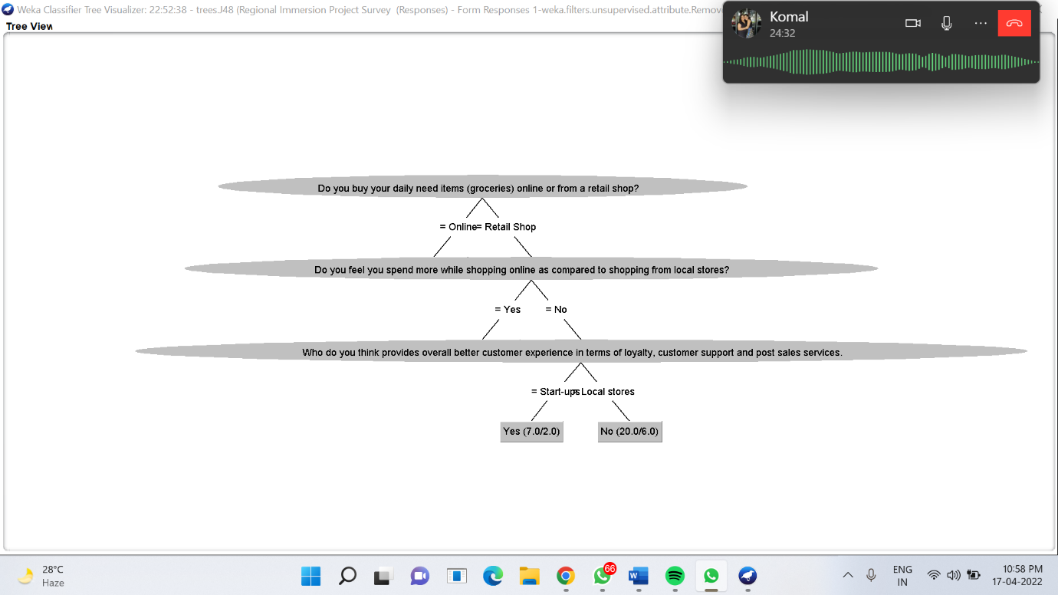

Here, the attributes are-

1. Do you buy your daily needs items online or from a retail shop?
2. Do you feel you spend more while shopping online as compared to shopping from local stores?
3. Who do you think provided an overall better customer experience in terms of loyalty, customer support and post-sales services?

The **label** is- “Do you do retail shopping online?”

In weka, we applied the J48 algorithm, which is a classification algorithm. The label was “Do you do retail shopping online?”  and included attributes such as do you feel you spend more shopping online as compared to shopping from local stores. Who do you think provides an overall better customer experience in terms of loyalty, customer support and post-sale services?

With this, the decision tree was made.

The outcome was- Consumers who believe that Startups provide a better customer experience do their retail shopping online. While consumers who believe retail shops do not do their retail shopping online.

We can conclude that the online retail platform is captured by all the Startups. There is no competition from the local/established business in the online space. Additionally, this also leads to a reduction in the market share of local/established businesses.

***Situation 6***

***Figure 13.6***

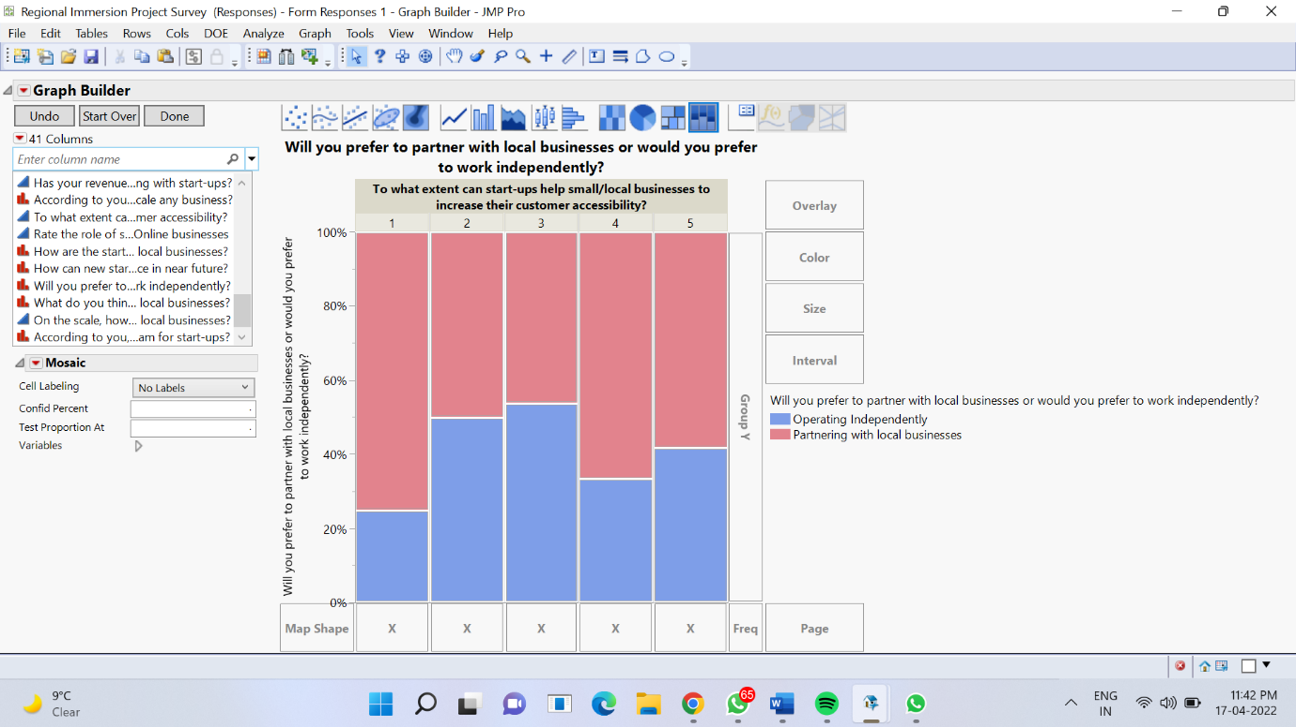

*JMP: Graph Builder*

In the figure 12.6, we have considered the following attributes-

1. Will you prefer to partner with local businesses or would you prefer to work independently?
2. To what extent can Startups help small/local businesses to increase their customer reachability?

After analysing this graph, we came up with some possible theories-

1. People who want to partner with local businesses strongly believe that startups can’t help the local businesses to increase their customer accessibility. Now, our interpretation of this is that- Startups are willing to partner with local stores to gain access to the customers that the local businesses already have.
2. Additionally, people who wish to work independently believe that Startups will help small businesses increase their customer reachability to some extent (4 on 5).
3. The rest of the analysis is around 50% which says that no matter how the Startups wish to operate but a collaborative work environment will help both the organisations to survive and grow in the future.

***Situation 7:***

***Figure 13.7***

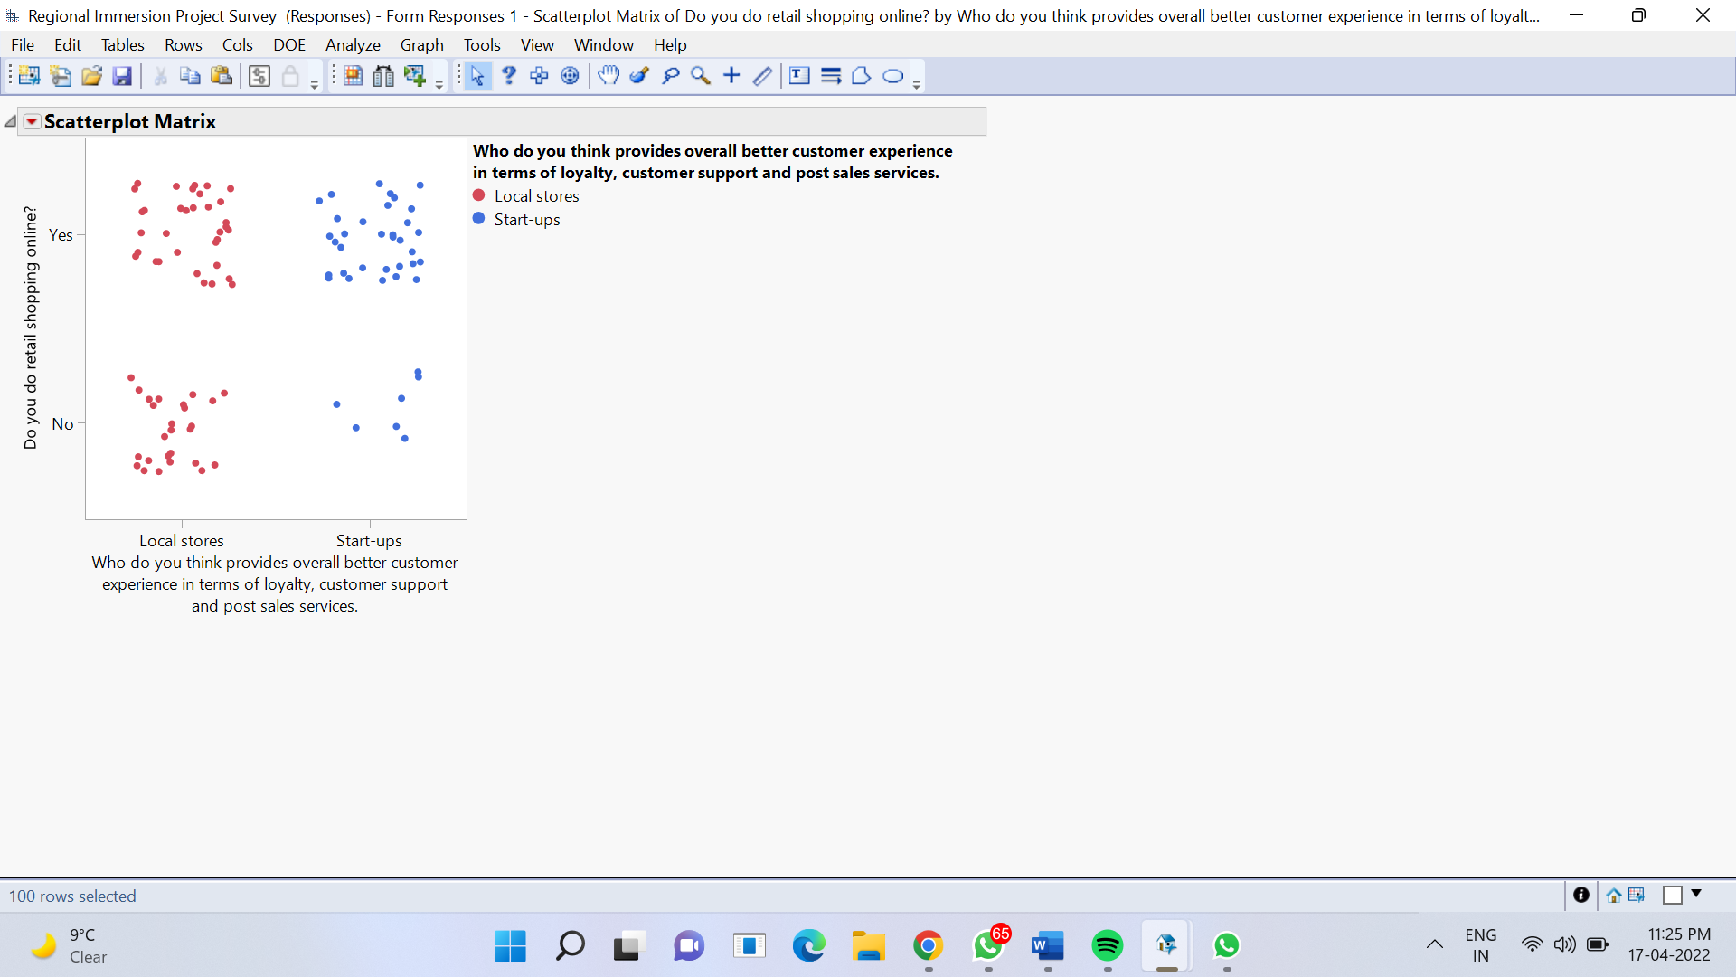

*JMP: Graph Builder*

In the figure 12.7, we have considered the following attributes-

1. Who do you think provides an overall better customer experience in terms of loyalty, customer support and post-sales services?
2. Do you do retail shopping online?

After analysing the scatter plot- we understood that even if the consumers believe that local stores are better than the Startups in terms of customer experience, they still buy retail products online from Startups. These may be the reasons for the same-

1. Time-saving- Ordering online saves time and in the current fast-paced world everyone values time.
2. Variety of products- Online shopping from the Startups gives the consumers a wide pool of products to choose from and local retail stores cannot provide this liberty.
3. Cost-efficient- Startups have several benefits such as card discounts, cash backs and referral points that can serve monetary benefits for the consumers.

These two points have been analysed from the survey.

***Refer to figure 13.8 below-***

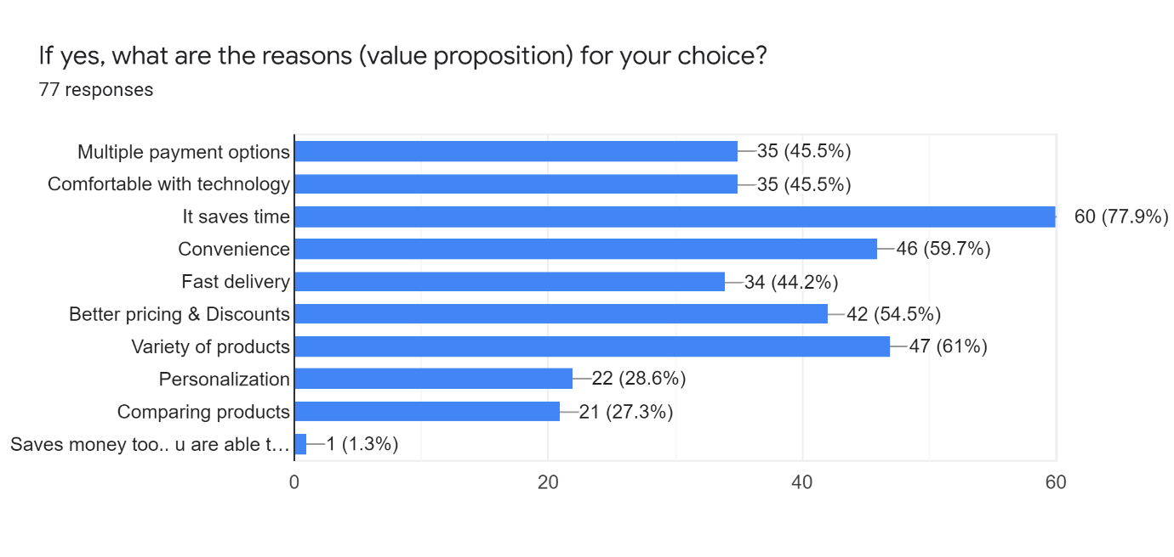

This was a detailed data analysis of our survey. We were able to fulfil several research objectives after analysing the data such as-

1. How have the Startups disrupted the supply chain in the retail & HORECA industry?
2. Reach out to the local businesses and gather data and perform a descriptive analysis on the same.
3. To understand if the Startups are helping or affecting the local & existing businesses.
4. To understand how consumer preferences lead to business decisions.

# **14. Limitations of the research**

**LIMITATIONS**

Every study has potential limitations we are listing down the ones we could identify below,

HORECA stands for Hotel Restaurant and Cafes, but in the study, we are conducting, the focus is only on the restaurant and cafe part and therefore does not include the accommodations and hospitality section of HORECA. The hospitality sector in itself has a significant presence and would take up more time to fit into this study. Due to which it can be noted that the study cannot be generalized to the whole sector of HORECA but only applies to the restaurant and cafes under it.

The method used for primary data collection in this study is survey. But surveys have their own limitations for example, they cannot be entirely relied on as survey responses are not always 100% accurate and adding on to it, online surveys sometimes get tailored due to any connection or data interpretation issue which hampers the data collected and the result generated.

It was easier to get the viewpoints and thoughts of people associated with startups and local or established businesses as they enter the business after a minimum level of education but when we compare that to the basic local grocery stores based in Mumbai (Kirana stores), the owners of such stores usually don't possess much knowledge related to the topic of our study and hence it is difficult to get responses from them to be included in our study.

Lastly, the inclusion of a case study method for the research has its limitations too. Case study is done by closely researching on a single aspect of the topic and using that to understand the behaviour of the whole group. But that said, it is to be noted that some data and results can be biased for only the chosen company and they may not at all be used or encouraged by the others. This makes it inappropriate to use the company as the general idea for the whole sector.

# **15. How did we achieve the objectives?**

To achieve objectives, we collected responses, from 3 sets of people -

* Buyers, i.e., **consumers**
* People associated with **existing businesses**
* People associated with **start-ups**

We applied various algorithms on the data collected using software’s like SAS JMP and Weka to achieve objectives.

Responses collected from consumers, helped to understand their preferences and how it affects the business decisions. Responses collected from start-ups helped us to understand if the start-ups are helping or affecting the local & existing businesses.

From the graphs obtained, after doing the descriptive analysis we could get a sense of how the start-ups have disrupted the supply chains of retail businesses and HORECA, and how have they affected both the sectors.

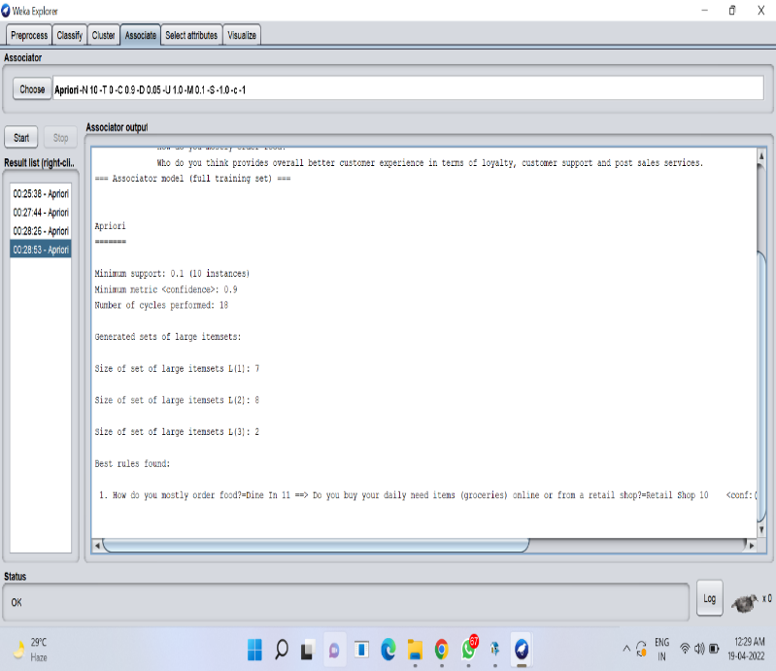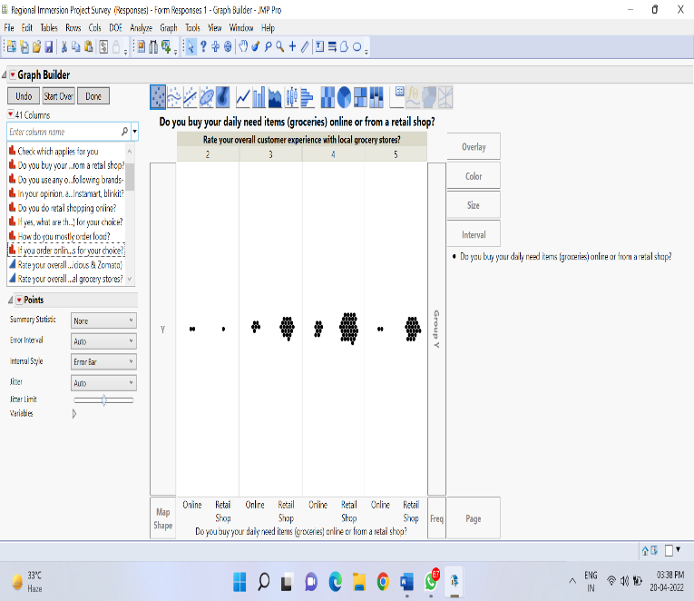For detailed understanding figures 13.2, 13.3 and 13.4 can be referred.

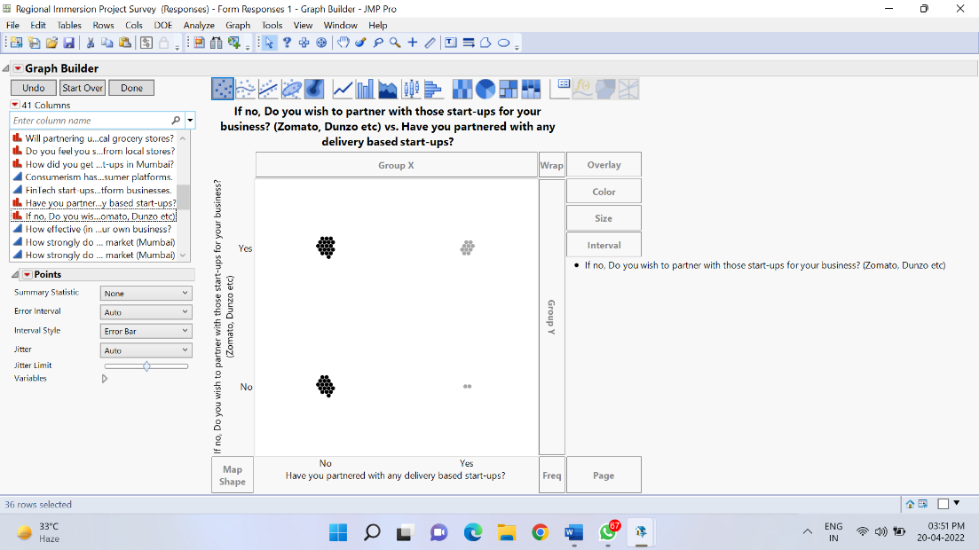

# **16. Research Findings**

The findings from the research are that first is customer preference. Loyalty programs , experience center and post-sale services. Trust on all these components is very important and customer accordingly prefer either startups or local stores to buy the products. Some of the loyalty programs that can be used by business are the basic points were a customer can earn points on every purchase and these points cab be redeemed either for discounts or buying an item on the points. One other way that businesses can increase customer retention is partner retail loyalty programs in which you can run your loyalty program along with strategic partners. For example, Local retail stores can partner up with delivery companies like zepto , Zomato or Blinkit where they can put special discounts on certain items if you purchase from their app. Second finding we got was whether customer prefer retail or online shopping. After reading the decision tree we understood that consumers who think startups are better do retail shopping online and those who prefer retail shops avoid shopping online. This because people who work independently believe that apps like Zomato and zepto will help them better as they do not have enough time to go to the retail shops. For them it is far more convenient to order it through the app. Although people who are been buying from the retail stores from a long period of time find them more convenient and trustworthy than buying online. Since they have developed a mutual understanding between them it becomes easy for them to return goods and buy them in credit. Third finding we got is validation. When it comes to startups, we saw a mixed reaction. There are people associated with startups who want to work independently and some of them wish to collaborate with established or local businesses. Nowadays more and more local retail stores are willing to partner with startups to gain access to large customer base and geographical area. Same goes for the startups there are willing to partner with local stores to gain access to the customers that the local business already have. In the near future both of them have work in a collaborative environment as day by day the competition would get tougher and in order to survive both the organization should grow hand in hand. It had become difficult to get your items out there, particularly when online marketing became oversaturated. Increasing foot traffic to your retail business is no easy task. However, collaborating with startups allows you to reach their current, loyal consumer base. One method to capitalize on the experiential retail trend is to collaborate with startups to arrange co-sponsored events. This might be anything from launching a new product line to offering a customized loyalty programme to its customers. From the findings from our report, we can say that it is beneficial for both startups and local retails stores to work closely and make the best opportunity of the resources that both the organizations bring.

# **17. Our recommendations**

After completing our research on the Retail and the HORECA industry and understating how Startups are disrupting the sector in some ways; these are our recommendations for the Startups as well as the local and the established business.

**17.1- Retail Industry**

1. **Startups:**

* We have observed from our case study that Big Bazaar’s downfall was major because of the heavy competition that faced in their industry by established business like DMart as well as Startups like Zepto and Blink It.
* Our recommendation for the Startups that are operating in the retail industry or who wish to operate in that industry is that; they should have a clear USP, i.e., a Unique Selling Point. Blink It promised that customers will get their orders within 10-15 minutes. This is a USP and especially in a fast-moving city like Mumbai. Moreover, Startups should look out to collaborate with local stores to gain their customer base and also build customer trust and loyalty.

1. **Local/Established Businesses:**

* We noticed that the local businesses especially the Kirana stores are slowly running out of customers. This is because the Startups are offering discounts and benefits that are very attractive. Moreover, it is very difficult for these shop owners to build their delivery services like Startups because they don’t have the necessary resources.
* We recommend that if these local shops wish to operate for the long run with more customers and increased profits, they should partner with Startups who are in the retail space as well as with delivery Startups. They can act as suppliers and thus it will help them to gain more revenue.
* Established businesses should also consider having an online presence. We saw how DMart has started its online delivery services. Similarly, all other established businesses in the retail sector should follow the same path.

**17.2- HORECA industry**

1. **Startups:**

* After doing our research, we understood that majorly Startups that are concerned with delivery are creating a major impact in the sector. We saw how Zomato and Swiggy have disrupted the HORECA industry indirectly.
* We recommend that all the restaurant, café and street food stall owners should partner with delivery Startups like Zomato & Swiggy. Moreover, Startups who wish to enter the HORECA space wouldn’t find major resistance from other businesses because consumers are always looking for new options.
* This was validated after interviewing the owner of a restaurant chain in Mumbai- Fisco. He mentioned that the industry will always be open to new businesses.

1. **Local/Established businesses:**

* HORECA industry has been always flooded with local businesses and it is very rare that any businesses to go out of business.
* Our recommendation for the local and the established businesses is that they should invest more in the marketing and promotions of their business. Moreover, they should always look out for growing and diversifying their businesses by opening different branches all over the cities.

# **18. Future scope**

Good research should consist of learning outcomes for the researchers as well as for readers and future researchers. According to us, this is the future scope of our research and the following points can be adopted by the future researchers to research or take reference from-

1. Our target city was Mumbai. Thus, future researchers can focus on other metro cities like- Delhi for their research using a similar framework.
2. We have established the importance of a collaborative work environment between the Startups and local & established businesses throughout our research. Researchers can analyse a similar trend and can adopt a longitudinal time series method to research a similar topic.
3. Our focus was on the retail industry and we have researched every aspect that is concerned with our research question and the retail industry specifically. However, in our research, our main focus was on Restaurants and Cafes that are a part of the HORECA industry but we couldn’t gather enough data on the Hotel industry. Thus, researchers can accept our research on the HORECA industry based on Restaurants and Cafes and can further research on the Hotel or the accommodation industry to complete the research on the HORECA industry.
4. In the retail industry, we have focused on both Startups and established businesses and research can adopt our analysis on the same but can add more data from local stores because our data from those stores were not sufficient enough to research on

# **19. Conclusion**

“Are Startups disrupting the Retail & HORECA industries in Mumbai?”

After completing our research, understanding both the industries, learning about the roles of Startups in the industry and how local and established businesses are operating in both the industries we have a clear understanding of the research question.

**Retail Industry**:

We strongly believe that the future of the local businesses is in question. Moreover, the market share of the established businesses is also slowly decreasing because of the heavy competition in the industry and we have seen this in the case study on Big Bazaar.

Moreover, the Startups in the retail space have successfully established their USPs and they are growing every day. For example- Blink It started promising that customers will get their delivery in 10-15 minutes all the customers were happy with this feature and they were able to capture a significant share of the market. Now, consumers are also realising that when it is not that necessary, they can utilise other later delivery options; Just to reduce the amount of workload on the delivery partners of Blink It. This will result in customer loyalty and will build trust and better relations between the company and the consumers.

Local/ Kirana stores have been suffering ever since the startup boom in Mumbai and the country. The consensus is that they should uplift themselves and accept and adopt the startup services for their growth and operational efficiency.

**HORECA Industry:**

Horeca Industry is on the opposite end when we compare it with the Retail industry.

There is fierce competition, the entire industry is flooded with businesses and still, people are entering the industry. The restaurant and café business that is the food industry will never be closed to new entrants. One business cannot capture the entire market share, unlike Retail Industry. There won’t be Monopoly or Duopoly ever in this Industry. The reason is the high demand and expectations of the consumers which increases every day.

Consumers will always look out for different options, unique options and thus if there is a new business/startup that has a unique value proposition then there are high chances for that business to become successful in the industry.

Moreover, the RECA industry- Restaurants and Cafes are also being supported by other Startups like Zomato & Swiggy. Partnering with them will result in better consumer reachability and increased revenue as seen in the case study on Fisco Restobar- Mumbai.

Thus, yes Startups are disrupting the Retail & HORECA businesses in Mumbai.

# Works Cited

(n.d.). Retrieved from https://www.moneycontrol.com/financials/futureretail/profit-lossVI/FR#FR

(n.d.). Retrieved from https://blinkit.com/

Blinkit. (n.d.). Retrieved from https://blinkit.com/

Chandra, S. (2021, August 14). *Digital Yug*. Retrieved from https://thedigitalyug.com/startup/kishore-biyani-s-big-bazaar-and-the-story-of-its-rise-fall-and-controversial-journey

Finology. (2021, February 3). Retrieved from https://blog.finology.in/business/downfall-of-future-retail

Jain, V. (n.d.). *Mumbai has highest potential for modern retail in India.* Economic Times.

Mittal, N. (2020). *COVID-19 Oubreak: Impact on HORECA Segment.*

Money Control. (n.d.). Retrieved from https://www.moneycontrol.com/financials/futureretail/profit-lossVI/FR#FR

Pinto, V. S. (2016, September 13). Retrieved from https://www.business-standard.com/article/specials/how-big-bazaar-lost-its-way-online-116091300883_1.html#:~:text=But%20experts%20say%20the%20real,in%20the%20e%2Dcommerce%20space

Sharma, R. (2021). *Indian restaurant industry shrank 53% in pandemic year: NRAI report.* The Economic Times.

Stratten, J. (2019). *What’s happening in Mumbai’s retail scene?* Insider Trends.

The Economic Times. (2021, February 23). Retrieved from https://economictimes.indiatimes.com/small-biz/sme-sector/this-sector-thrived-amid-covid-gloom/an-e-commerce-boom/slideshow/80787561.cms

The Economic Times. (2022, April 9). Retrieved from https://economictimes.indiatimes.com/topic/big-bazaar

TYAGI, A. (2021). *Indian Retail: Trends and Opportunities in 2021 and Beyond.*

YES BANK & Federation of Indian Chambers of Commerce and Industry (FICCI). (February, 2018). *STARTUPS: Transforming India’s Food Processing Economy.*