

H.R COLLEGE OF COMMERCE & ECONOMICS

NAME- JAYESH PATOLI

CLASS- FY.M.COM BANKING & FINANCE SEM1

ROLL NO. 051

SUBJECT- RESEARCH METHODOLOGY

**PROJECT REPORT ON -APPLE & SAMSUNG**

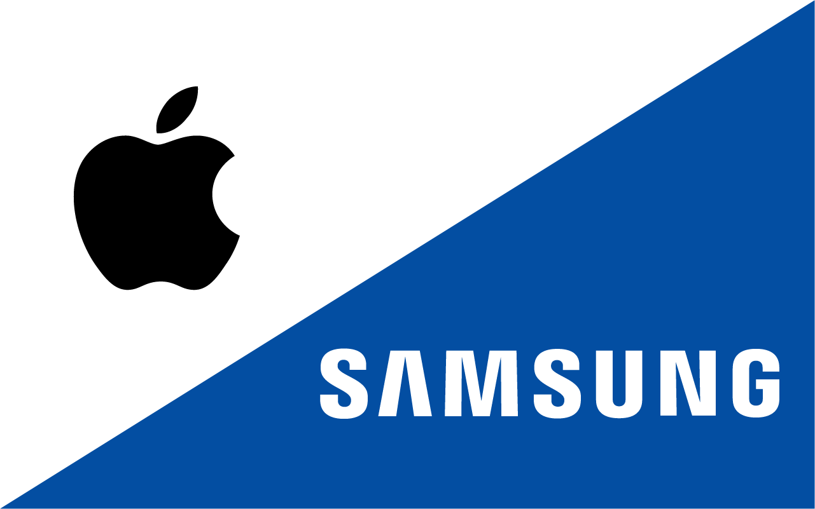

INDEX

1.INTROCUCTION

2. OBJECTIVE

3.HYPOTHESIS

4. LTERATURE REVIEW

5. SECONDARY DATA

6. PRIMARY DATA

7.DATA ANALYSIS

8. SUGGESTION

9. CONCLUSION

10. REFERNCES

INTRODUCTION:

Smartphone has revolutionized the way we do thing: the role Smartphone play in today's society is phenomenal. Today's Smartphone is taking the role of computer, making it possible to do a lot with this small hand device. It has a broad use such as sharing information, paying for products, browsing, and shopping.

According to the survey, Smartphone can be defined to be a device that enables the user to make telephone call and at the same time has some features that allow the user to do some activities that in the past was not possible unless using a computer or a personal digital assistant (PDA), such as sending and receiving e mails, amending an office document.

Nowadays brand plays a very vital role in consumer buying decision. While consumers usually go for a familiar brand, but the concept of brand transcend beyond a trademark or name. The concept of brand encompasses much more than trademark.

The brand name signified a level of quality and consistency consumers could trust. Thus, Quaker Oats, Ivory Soap, and Levi have instilled in consumers a degree of confidence that their unbranded competition did not. An nereasing number of high technology companes have undertaken brand-building initiatives under the premise that these initiatives can create an asset that generate long-term profit, e.g. Intel's Intel inside campaign, which began in 1991.

Brand equity is the value associated with the marketing activties that enhanced the overall offering such that a premium could be eamed over the same offering if it were unbranded. This indicates that customers see and interpret brands in different ways, giving brands meaning and validity. Brand equity describes stakeholder response in the form of an 8 increase in customers, revenues, and margins than would otherwise be possible without marketing support to build awareness.

The findings of this research study would be significant to Smartphone producers, in understanding the bases for student's preferences between Apple and Samsung brands of Smartphone. An understanding of brand equity, personality and identity in Smartphone is crucial, it cannot be over emphasized. A profound knowledge or understanding would provide a clue as to student preferences of one brand over the other, the motive behind brand loyalty and how brand awareness is built. The benefit of brand knowledge is relevant for high tech companies such as, Apple and Samsung. If Smartphone producers could understand this, they would have edge over their competitors. It is also vital in comprehending the role that brand plays in consumer buying behavior, which would help Smartphone producers in building preference for their brand. The knowledge gained from this research would also provide Smartphone producers with the strategic ways they could build strong brand equity and identity that would lead to increasing their sales volume.

**OBJECTIVE**

• The findings on this research would be significant to Smartphone producers, in understanding the basis for student's preferences betwefy apple and Samsung brands of Smartphone's.

• An understanding of brand equity, personality and identity in Smartphone is crucial it cannot be over-emphasized.

• A profound knowledge or understanding woul provide a chue as to student preferences of one brand over the other, the motive behind brand loyalty and how brand awareness is built.

**HYPOTHESIS**

Apple and Samsung will continue to be the dominant players in the global smartphone market in the foreseeable future. They will maintain their strong market positions by leveraging their brand reputations, extensive product portfolios, and strong innovation capabilities. However, they will face increasing competition from Chinese smartphone manufacturers, such as Huawei and Xiaomi. These Chinese companies are rapidly gaining market share and could pose a serious threat to Apple and Samsung in the future.

* Apple and Samsung will continue to be the dominant players in the global smartphone market.
* Chinese smartphone manufacturers will continue to gain market share and could pose a serious threat to Apple and Samsung in the future.
* The global smartphone market will become increasingly competitive.
* Smartphone prices will continue to fall.
* Consumers will have a wider range of high-quality smartphone options to choose from.

Overall, the future of the global smartphone market is uncertain. However, Apple and Samsung are well-positioned to continue to be successful in this market. They will need to continue to innovate and adapt to the changing market conditions in order to maintain their strong market positions.

**LITERATURE REVIEW**

• The reason why it is chosen to write about brand preference among students is because most students purchase Smartphone's, they are enthusiastic about technology. Students can be accessed easily for interview and questionnaires.

• This research study compares between two major Smartphone brands, Apple and Samsung. these two are the largest Smartphone brands producers, who are constantly competing and challenging each other and in result of this competition they are providing consumers with best quality and cheaper products. In 2011, Samsung became the market leader for the first time, it ranked 20% global share while Apple ranked 19%.

**SECONDARY DATA**  

**Brand**

A brand is the total emotional experience a customer as with your company and its product or service. The author describes the brand to be an experience that's implanted in the mind of customers that have experienced an interaction with a company or that got in contact with the company's staff, product or service. In case the customer experience is different from what the company illustrate its brand. In that case the company is losing. However other parts of the brand such as "logos, advertising campaigns, mission statements, colors holds also great importance but they should always come after the customer, it is vital to put the customer and the company's relationship with him/her in the first position and think how to develop this relationship and then as a second stage a company can use all important tools like logo's, color's and advertising campaigns.

Strong brand increases company's sales volume, it create great awareness and introduces the product or the service that the company is offering, in addition to that it builds a long-lasting customers relationship and loyalty, and in some cases i give the chance for the company to offer their product and services with a premium pricing. Companies with powerful brands also enjoy having devoted employees who believe in the brand and are loyal to it. On the other hand having a powerful brand becomes worth huge amount of money added to the company's balance sheet, for example Apple, IBM,

Microsoft was worth around $80 million and above.

**Brand Equity**

Brand equity is among the few strategic assets available to the companies that provide a long-lasting competitive advantage to the company.

Brand equity constitutes the assets and the liabilities that is link to a particular brand, like name, or logo. It comprises of brand loyalty, brand awareness, brand association, brand assets, and perceived quality. Creating strong, favorable and unique brand association is a real challenge for markets but it is essential in building strong brand. Strong brands typically have firmly established strong, favorable and unique brand association with customer. Brand equity is a set of asset and legal responsibility connected to the brand's name and figure that add to (or take away from) the value presented by the product or service to a company and/or that company's customers, the main assets are grouped in the followings:

* Brand name awareness
* Brand Loyalty
* V Perceived quality
* Brand associations

Brand equities is said to be the most intangible assets that a company posses, that is not reflected in the balance sheet, given that it provide competitive advantage for the company. Having a brand guarantees future eamings. Despite the fact that the corporate balance sheet display only assets of the company without mentions of the brand equity does not change the fact that it is precious assets to the company. While a competitor can copy a company's product but its brand is unique.

**Brand Loyalty**

Brand loyalty is often described as a behavioral sense through the number of repeat purchases, it entails consumer sticking with the brand and reject the overture of competitors. Strong brand equity holds consumer loyalty because consumer values the brand on the basis of what it is and what it represents. Brand loyalty is attributed to brand image and brand equity. It is also worth noting that brand commitment is the substantial expression of brand preference and brand loyalty. Brand loyalty of current customers represents a strategic assets, and when properly managed would provide the company with several values. Brand loyalty it associated more closely to the use experience, in the sense that it does not exist without prior purchase and use experience.

There are five different level of brand loyalty: each level poses different challenges and different assets to companies. The bottom loyalty level is the nonlocal buyers who have no preference for any brand. These groups of buyers place no value on the brand name and consider any brand as adequate.

The second level includes buyers who are satisfied with pleased with the product. These groups of buyer are vulnerable to a competitor who offers them a visible benefit to switch; hence they are classified as habitual buyers. The third levels are class of buyers who are please with the brand, these buyer might switch brand if competitors overcome the switching cost by

inducing the buyer to switch to their brand. The fourth levels of brand loyalty are the category of loyal customer that really likes the brand. Their preference for the brand is on the symbol, previous experiences or the logo of the company.The top levels are category of buyers who are committed to the brand, because of the brand functionality or because the brand is the expression of whom they are.

**Smartphone Brand Loyalty**

However, Phones Review 2012 conducted voting hype for people to share their idea and what would they rather purchase an iPhone 5 or Samsung Galaxy S3, and by going throw the comments that many people posted, we can note that Samsung has succeeded in building a strong brand loyalty and brand awareness, as many people were loyal to that brand and are willing to purchase it upgraded devices.

According to the survey in 2010) Samsung had many happy customers in the U.S., Samsung closed 2009 as the No. 1 handset market share holder, further to the Strategic Analytics' also no. 1 in cell phone marker in 2010. Brand Keys Customer Loyalty Engagement Index, which measures clients favorite mobile devices design and performance according to identify brands that meet up or exceed consumer's outlook. The Brand Key national survey for Smartphone and standard cell phone showed that Apple ranked no.1 in the Smartphone categories, in second comes Samsung and then followed by Blackberry.

**Brand Awareness**

The power and force of the brand's presence in the consumer's mind and this awareness is measured by how consumer keeps in mind the brand and how they recall it, acknowledgment measures such as "Have you been exposed to the brand before? , What brands of the product class can you recall?, "top of mind" (the first brand recalled) or (the only brand recalled).Recognition of a brand is based on the knowledge added from earlier exposure, it is not essential to remember where the brand was seen or why it is diverse from other brands neither it needs to be remembered the class of the brand, remembering the earlier exposure is the most important thing. Economist explains that when costumers recall being exposed to a brand this will be transmitted in their brain to be a "signal" of a good brand because they believe that companies don't pay out large amount of money on bad product.

The crucial part of brand awareness is the brand name dominance because when a recall test is made for customers, it illustrated that customers can remember one brand only, this becomes a risky factor if the brand name is not distinguished and is a common tag for products that are legally protected. This is why companies should start protecting at the beginning of its existence. When choosing a brand name firms should beware of descriptive names, such as Windows because this makes it harder for customers to differentiate from the generic product.

Due to the fact that customers are being exposed to more and more brands and messages, creating brand awareness is a big challenge. There is two ways to create the awareness:

**First** is by creating "healthy awareness level" this wide trade base is typically an asset, but it is expensive and for small unit sales and for life measured in years and not in decades this can be impossible. This is why huge companies have an advantage in building the awareness. Multiple businesses sustain and back up the brand name. **Second** in future companies will experts in working outer the usual media channels, by using occasion promotions, sponsorships, advertising and sampling, these companies will be the most successful companies in creating the brand awareness.

However, companies should always put in mind while managing the brand that it is necessary that brands are managed not for "general awareness" but for strategic awareness" it is important that customers recall this brand for good reasons and not for bad ones.

**SMARTPHONE BRAND AWARNESS**

**Apple**

Apple is one of the brands that have strong brand awareness; nearly 90% of consumers are aware of it. Which gives the opportunity for Apple to present consumers with different products with an effective position, which increase's Apple market shares because many consumers will choose Apple products over a similar product of different company because of the company high awareness. Apple awareness tools is the logo the smart and simple design of the logo, made this logo the most recognized brand symbol all over the world, it has demonstrated that is effective and easy to remember. Apple gone through in creating its current logo, as shown in the figure the design that Apple logos have now is after a long and deep thinking, a story is behind this logo evolution. Sir Isaac Newton, who created the law of gravity, was sitting under a tree and an Apple fell down which inspired him in finding this theory of law gravity. The logo of Apple is clearly connected to this Apple. At the beginning the logo was designed in having a rainbow colour which represented the new creation of colours in the IT world. Some people believe that logo is also connected to Alan M. Turing, who is considered to be the father of computer science, who gave end to his life by eating a poisoned apple. Now the logo of Apple is colored in polished silver adding a modem touch to the logo. This logo is only one of its kinds and holds a fascinating background and story. It is easy to understand and signifies the best quality of products.

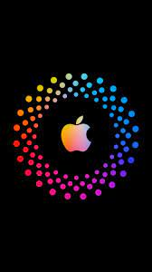

**SAMSUNG**

Samsung logo color, blue mean honesty, trust and reliability and dedication in service. As shown in the figure

Two character distinguish the Samsung logo from other companies logos, first is the figure is turn around ten degrees from the x-axis, which presents a sense of dynamic tension.

The second character is the brand's name "Samsung" which flashes out from the figure, this clearly dissect it and give the impression as if the out shape is a spotlight for the clearing and defining the brand name.

According to the report provided Samsung aggressive brand recognition campaigns has eamed them huge brand awareness among consumers. The research report conducted shows that 54% of prospective Smartphone buyer discloses that they would go for iPhone.

Recently there has been 5% increase in consumers interested in Samsung Smartphone.

Samsung embarked on sponsorship in order to create brand awareness. It sponsored Athens

2004 Olympic game which contributed positively to the brand awareness, giving it a boost from 57% to 62%. Also, the sponsorship help to build a good reputation and brand image. The awareness rise leaded to the sales surge.

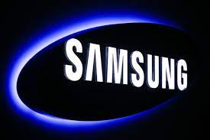

**PRIMARY DATA**  

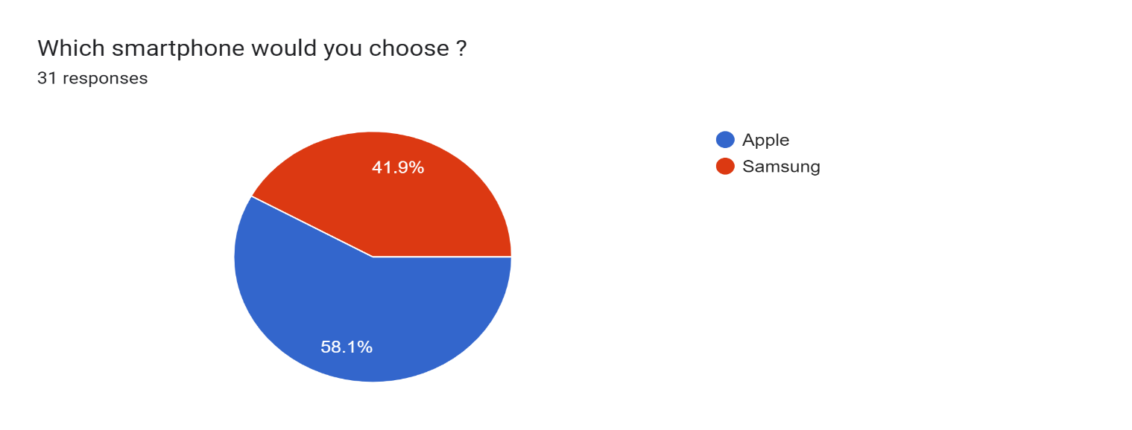

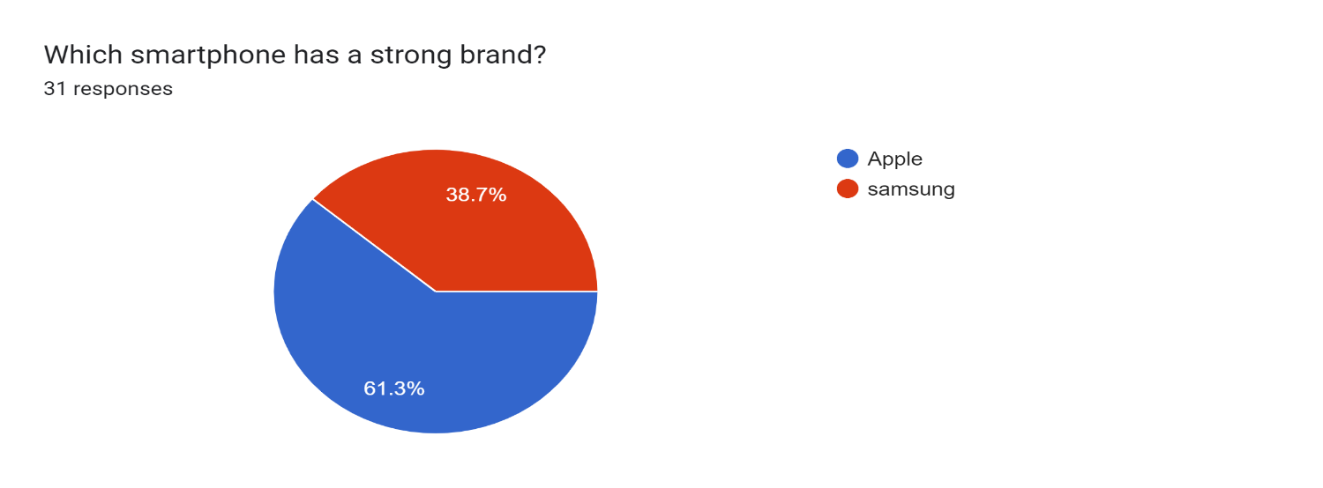

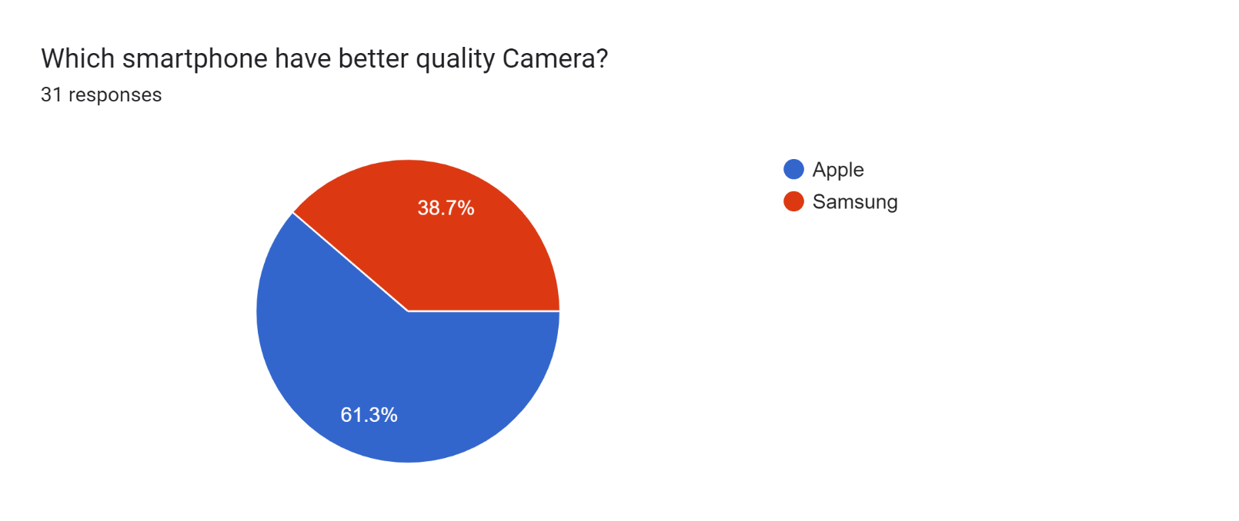

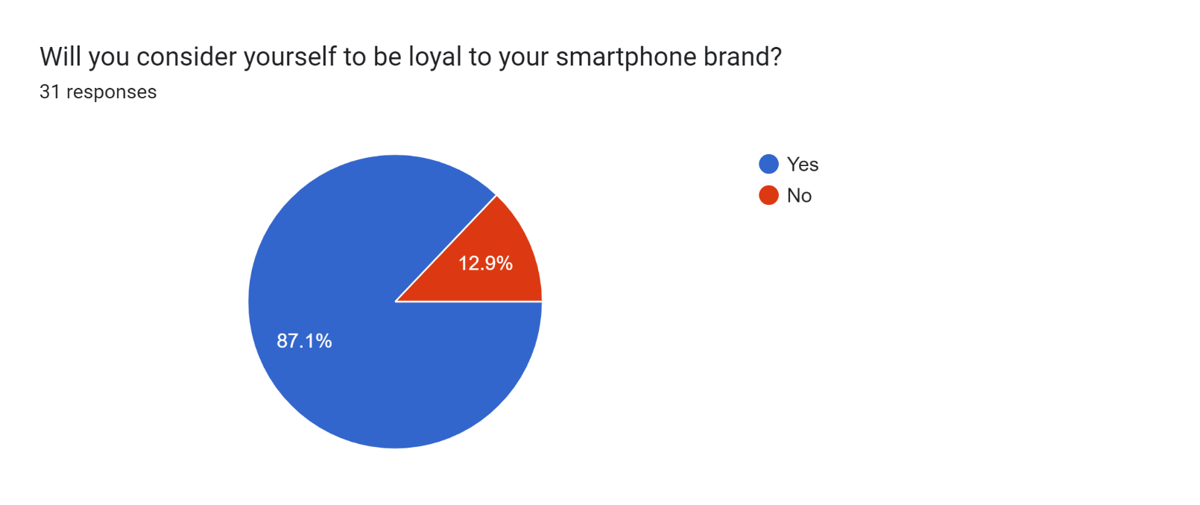

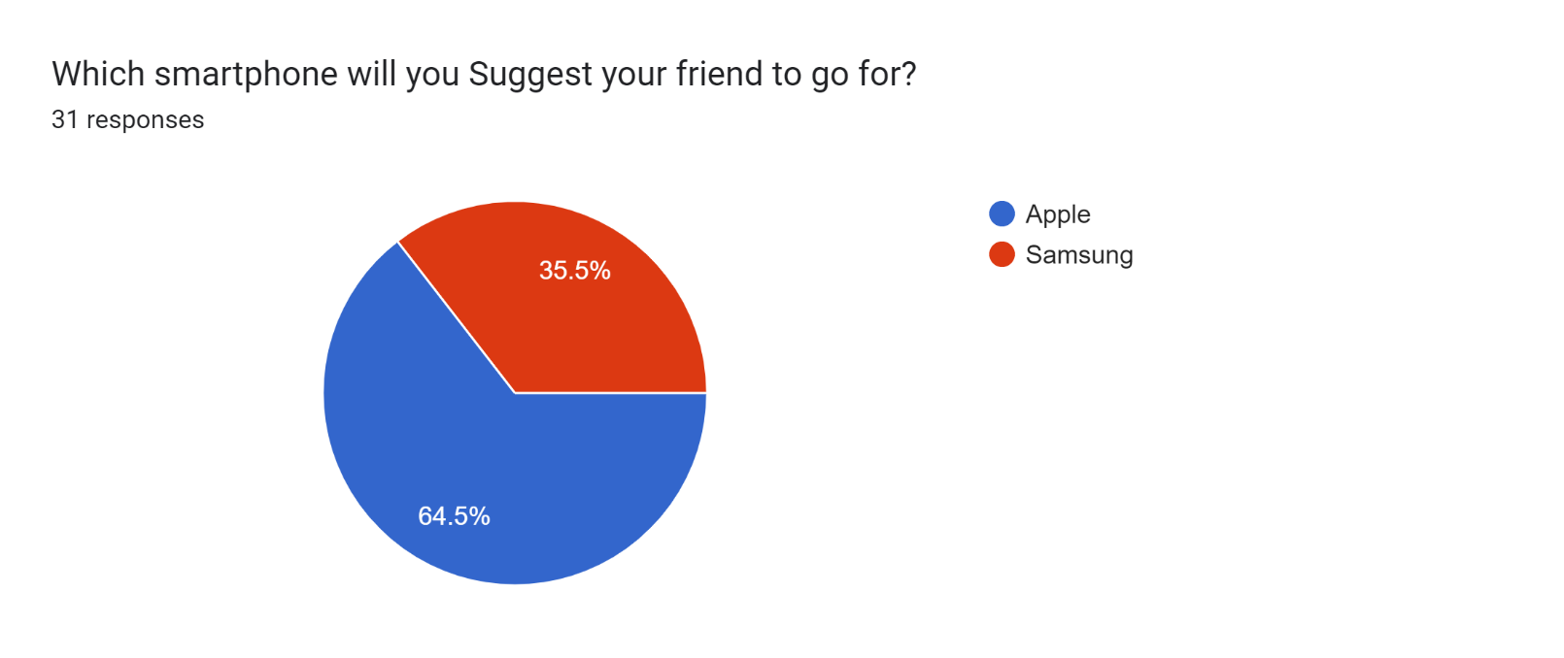

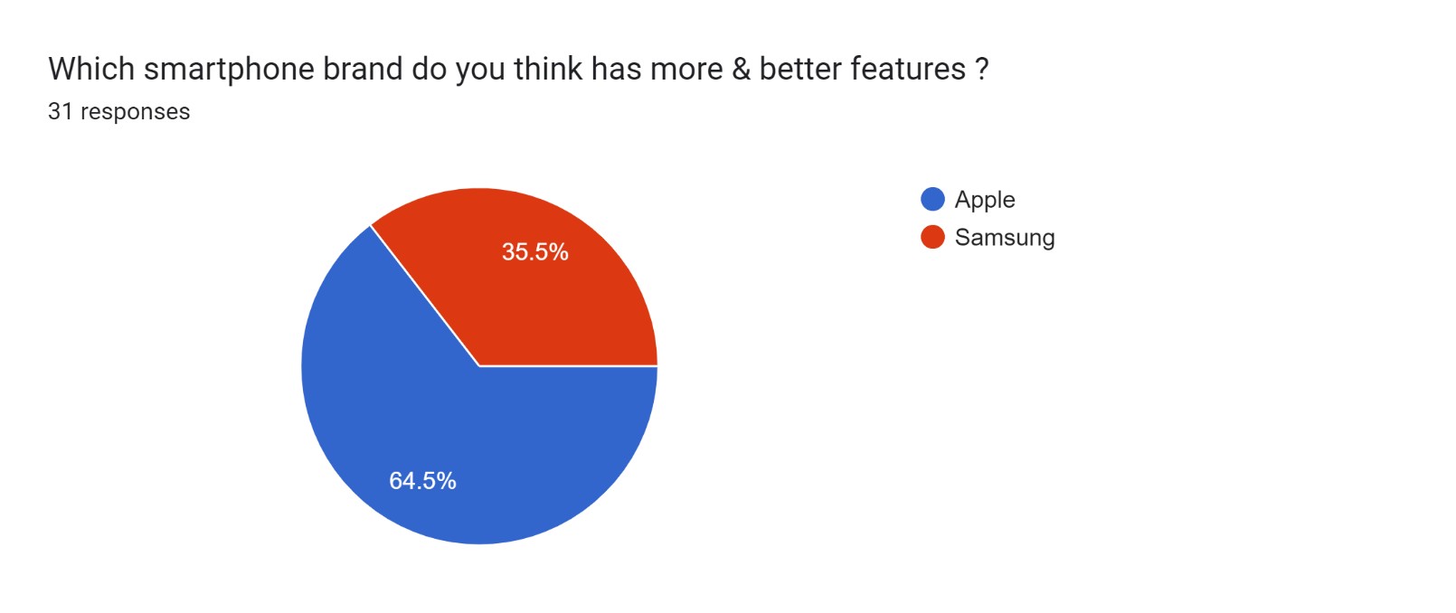

**DATA ANALYSIS**

According to the survey results, a majority of the participants expressed their preference for Apple in compare to Samsung. When comparing the brand according to the survey people have given more preference to Apple (63.3%) & for Samsung (38.7%). Also apple has the better quality of camera in comparsion to Samsung. Also according to the survey apple has more better features than Samsung.

Also people would be happy in being loyal to their brand & suggest the same brand to there friends.

**SUGGESTIONS**

Samsung Smartphone producers should concentrate on brand loyalty and perceived quality. Students have high brand loyalty towards a brand if they are satisfied with the product delivered by it. This is why Samsung should focus their strategy to create or attract loyal customers which can be done through delivering a high quality products, this will result in establishing a bong term commitment with loyal customers who will not switch easily to another brand, compared to non loyal customer who can switch easily. This will lead in increasing the sales volume of Samsung and would give that brand the chance to present is Smartphone in the market with a premium price.

In the aspect of brand awareness, it is recommended that Samsung should embark on intensive campaign to create stronger brand awareness and brand image. An interesting observation made from this research study was that students are more influences by the brand image of the Smartphone. In order to build a strong customer brand loyalty, it has to create a higher customer perceived quality, given that brand loyalty and perceived quality are intertwined. A relatively large number of satisfied customer has provides an image of the brand as an accepted, successful product which will be around and will be able to afford service back up and product improvement.

One of the advantages that Apple has over Samsung is that the country of origin is the

USA, which is well known for it good high tech and electronic production. Country of origin represents brand identity. It is recommended that Apple should capitalize on this advantage in order to reinforce its brand identity, market positioning and increase their sales volume. This recommendation is not only for Apple and Samsung producers but also for other Smartphone producers.

REFERNCES:

<https://docs.google.com/forms/d/1H6OjMshiEiGZ6X_EZPgFa8jqx9VjsBoX2kVSpGwzsLs/edit#responses>

<https://www.slideshare.net/OjasNarsale/project-report-on-research-methodology>