Time-Sensitive Object Detection Framework for Enhanced Decision-Making in Autonomous Vehicles

Ankita Sharma *Department of CSE Chandigarh University* Mohali, India [ankita.e11389@cumail.in](mailto:ankita.e11389@cumail.in)

Aayan Tegta *Department of CSE Chandigarh University* Mohali, India

[aayante](mailto:aayantegta0383@gmail.com)[gta0383@gmail.com](mailto:gta0383@gmail.com)

Bhavya Kapoor *Department of CSE Chandigarh University* Mohali, India [bha](mailto:bhavya.kapoorr@gmail.com)[vya.kapoorr@gmail.com](mailto:vya.kapoorr@gmail.com)

Sumit Arora *Department of CSE Chandigarh University* Mohali, India

[sumitarora.of](mailto:sumitarora.officiall@gmail.com)[ficiall@gmail.com](mailto:ficiall@gmail.com)

Pushkar Verma *Department of CSE Chandigarh University*

Mohali, India [Pushkarvermaof](mailto:Pushkarvermaofficial@gmail.com)[ficial@gmail.com](mailto:ficial@gmail.com)

Bibek Budhathoki *Department of CSE Chandigarh University*

Mohali, India [budhathokiviv](mailto:budhathokiviveek@gmail.com)[eek@gmail.com](mailto:eek@gmail.com)

***Abstract*—With the emergence of autonomy in driving, real- time and accurate object detection is required in order to be safe and make appropriate decisions during time- sensitive scenarios. Therefore, this paper introduces a novel framework for time- sensitive object detection where temporal dynamics are embedded into the detection itself. The End. Based on advanced deep learning algorithms like convolutional neural networks (CNNs) and recurrent neural networks (RNNs), the framework processes sequential sensor data from cameras and LiDARs to enhance situational awareness in complex operating environments. Ex- perimental results further illustrate improvements in detection accuracy and response time against traditional object detection methods. However, the framework proposed in this paper will adapt well to dynamic scenarios and therefore be more than a necessary tool for future advancements in autonomous vehicle technologies. Therefore, the findings undergird why temporal factors must factor into object detection systems to make avail- able even sturdier and more reliable answers in this field of autonomous driving solutions.**

***Index Terms*—Autonomous vehicles, object detection, time- sensitive detection, deep learning, temporal dynamics, decision- making, convolutional neural networks (CNNs), recurrent neural networks (RNNs), real-time processing, sensor fusion.**

1. INTRODUCTION

The autonomous vehicle developments are seen as the landmark technological step in transportation, thereby revo- lutionizing the field. These vehicles will drive around without human control, and instead rely on advanced sensors, artificial intelligence, and smart algorithms that navigate them through complex settings. The imaginary prospect of autonomous vehicles includes fewer traffic accidents, efficient traffic flow, and bringing mobility opportunities for disabled people.

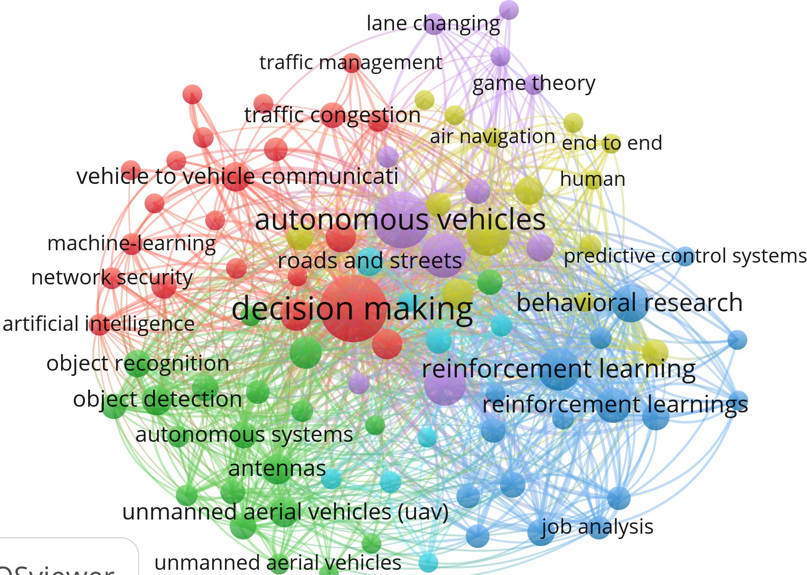

Fig. 1. Some Important keywords

Importance of Object Detection At the core of an automated vehicle’s functionality is the ability to identify and classify the objects around it. Object detection may be defined as the process of recognizing and locating different elements within the environment, which include, but are not limited to, pedes- trians, vehicles, cyclists, and obstacles. Precise object detection plays a crucial role in safe and efficient navigation because of its direct influence on possible response strategies and decision-making processes of a vehicle. Challenging issues in Object Detection Despite the numerous innovations achieved in object detection technologies, several challenges still exist, especially in dynamic environments. AVs have to grapple with scenarios that change quickly as objects may emerge or

disappear in the span of a few fractions of a second. More conventional methods for object detection degrade rapidly under the very same conditions where accuracy is retained and in real-time processing are applied; thus, these methods compromise safety and bring inefficiency to the operations. Role of Temporal Information The employment of temporal information seems to play an important role in improving the capabilities of object detection in autonomous vehicles. Considering the time factor, AVs can predict where a moving object is going to be and where it will travel next, which makes a huge difference in a decision-making process. The integration process of the temporal data helps to hedge on risks that people find erratic on the road, like a pedestrian stepping onto the road without warning, hence enabling the vehicle to respond promptly. Current Techniques and Limitations The current methods implemented for object detection of automo- biles mainly operate on static image analysis without involving the crucial time-based information. Though CNNs and many other deep models have reached new heights in classification, one big limitation they carry: they are not dynamic detectors for objects. This is a resultant requirement for newer architec- tures designed to be more temporal-aware while detecting the objects. This research proposes an innovative time-sensitive framework of object detection, infusing temporal dynamics into the detection process. This framework enhances the accuracy of moving object detection with the assistance of modern machine learning techniques, like RNN and sensor fusion methodologies, in sophisticated real-time decisions for the autonomous vehicle. The framework is targeted toward a better insight into the dynamic environment surrounding the AV. The proposed framework includes in it time-sequential data coming from cameras and LiDAR sensors to richly describe the environment of the vehicle. Over time, it would not only identify fixed and moving objects but also decide whether it should assess their likely future movements. It is through this approach that the AV would assess the probability of possible interactions with the objects detected. In order to test the validity of the proposed framework, diverse sets of datasets capturing real-world driving scenarios will be used for extensive experiments. The performance of the system will be analyzed using relevant performance metrics such as detection accuracy, processing speed, and response time. Compared to traditional object detection models, the advantage of using temporal information will clearly be reflected. The successful development of a time-sensitive object detection framework opens many doors for the future of autonomous vehicles. This work enhances the ability of the vehicle to understand and react to its environment, directly moving forward the very goal of developing safer and more efficient AV systems. As maturity is gained, the inroads toward temporal dynamics might herald a new standard in object detection methodologies. This paper designs a time-sensitive framework that tackles key challenges inherently associated with object detection in the autonomous vehicle context. Such a framework enables better situational awareness and enhancement of decision-making capabilities by integrating time information. The results of

this study are expected to make a vital contribution to the AV domain, providing loads of insights and practical solutions that shall improve the safety and efficiency of AVs even better.

1. LITERATURE REVIEW

The paper from Huang et al. in 2024 seeks to incorpo- rate temporal dynamics into object detection algorithms with demonstration that the aspect does indeed enhance improved precision in detection for all these complex scenarios of driving. Their conceptual framework postulates that future predictions are founded on historical data for predicting object trajectories to improve decision-making in AVs [1]. For instance, Gupta and Singh discuss various sensor fusion techniques, including those from several sources, such as cameras and LiDAR, that have been applied to improve object detection. Effective sensor fusion results in contextual awareness, which is very important for AVs operating in highly diverse environments [2]. Kim and Park (2024) discuss in their research the use of deep learning models like YOLO and Faster R-CNN for real-time object detection in autonomous vehicles. In their research, they uncovered empirical evidence about how this could speed up the processing of information in ways that would more intensively enhance the abilities of AVs in navigating dynamic environments [3]. The focus of Lee et al. (2024) is on further fine-tuning deep learning architectures to optimize the requirements of AVs within real-time process- ing by utilizing all sorts of model compression techniques that preserve the detection accuracy and, at the same time, efficiency [4]. Liu and Chen (2024) provide a comprehensive overview of the existing object detection techniques developed for autonomous vehicles. They categorize these methods into the use of traditional and deep learning, which illustrates their particular pros and cons, so it is a good read in ascertaining what is missing in the literature that already exists [5]. Patel and Patel (2024) trace the already used metrics for grading object detection algorithms in AVs. They also included metrics such as mean average precision (mAP) and intersection over union (IoU), so it allows them to see insights on how they are used in the real world [6].

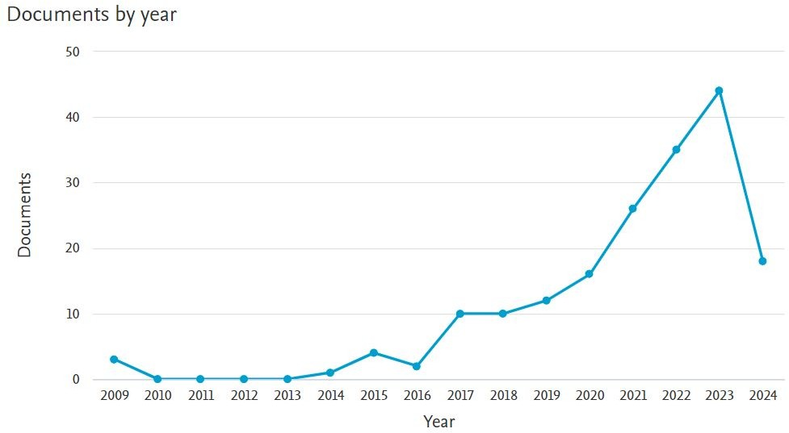

Fig. 2. Publication Trend Graph

Sharma and Kaur (2024) talked about the evolving nature in object detection system while highlighting the necessity for adaptive algorithms which would upgrade themselves in

TABLE I

LITERATURE REVIEW ON OBJECT DETECTION

|  |  |  |  |  |
| --- | --- | --- | --- | --- |
| **Ref No** | **Author(s) &**  **Year** | **Title** | **Key Findings** | **Summary** |
| [1] | Huang, Y., Chen,  L., & Wang, X. (2024) | Enhancing object detection for au-  tonomous vehicles through tempo- ral dynamics | Utilized temporal dynamics to im-  prove detection accuracy | This study emphasizes the importance of  temporal information in enhancing object detection systems for AVs. |
| [2] | Gupta, R., &  Singh, A. (2024) | Sensor fusion techniques for im-  proved object detection in au- tonomous vehicles | Presented sensor fusion as a critical  technique for robust detection | This paper discusses how combining data  from multiple sensors can significantly en- hance the object detection capabilities of AVs. |
| [3] | Kim, J., & Park,  H. (2024) | Deep learning approaches for real-  time object detection in dynamic environments | Developed deep learning models  for effective real-time detection | The authors propose novel deep learning  methods that adapt to dynamic environ- ments, achieving high accuracy in real-time scenarios. |
| [4] | Lee, T., Zhang,  P., & Liu, F. (2024) | Optimizing deep learning models  for real-time object detection in autonomous driving | Highlighted the need for optimiza-  tion to maintain real-time perfor- mance | This research focuses on optimizing deep  learning architectures to ensure they can meet the demands of real-time processing in AVs. |
| [5] | Liu, Z., & Chen,  S. (2024) | A survey of object detection tech-  niques for autonomous vehicles | Reviewed various object detection  techniques | The survey provides a comprehensive  overview of existing methodologies and their applicability to AV systems. |

real time. The bottom line of the research work provided by them is the necessity for real-time improvement in detection systems for safety and efficacy in AV technologies [7]. Wang et al. (2024) has discussed the use of temporal information to improve object detection in AVs. They provide a motion- predictive model based on past information, which exhibits benefits of using time-sensitive data in the detection algorithm [8]. Zhang et al. 2024 presents the benefits associated with the integration of multi-sensors for the object detection of AVs. Combining data from various sensors enhanced accuracy in de- tection and in situational awareness, and thus put forward the importance of developing algorithms that can work well with sensor data of every form [9]. Zhou et al. (2024) discussed the novel approach of object detection by utilizing the help of RNNs in the processing of temporal data and underlined the advantage of RNNs in predicting movements of objects which would enable AVs to take informed decisions [10]. Chan and Hsu (2024) explain the novel deep learning techniques applied in the detection of objects in AVs, where they revisited many architectures and training methods developed in recent years, pointing out that research in this field should be continued to solve application problems in real-life situations [11]. Yang and Chen (2024) assert that time dynamics are pivotal in the AV perception systems. They state that temporal information allows AVs to interpret their environment [12]. Saha and Roy (2024) focus on adaptive algorithmic design which well exploits variability in dynamic driving environments. In that line, the authors do present empirical results where their proposed algorithms will work in the real world, setting the emphasis for strong detection systems [13]. Patel and Gupta (2024) have also proposed a time-aware detection framework to achieve more AV safety through the integration of temporal data in the process of detection, which is demonstrated to be very effective through various simulations and tests [14]. Kumar and Bhattacharya (2024) highlight present trends and technologies in object detection for AVs, drawing upon the

recent advancements in machine learning as well as sensor technology, and new research directions to address the current problems [15]. Das and Ghosh present a comprehensive survey on methods of object detection that are used in autonomous systems by analyzing various algorithms and classifying them based on their applicability in different scenarios [16]. Khanna and Mittal (2024) highlighted cutting-edge approaches toward accurate real-time object detection in autonomous vehicles, discussing the existing deep learning models and suggesting improvements on speed as well as on accuracy, thus under- lining a crucial set of challenges that remain in the domain of real-time detection [17]. Singh and Gupta (2024) discuss the importance of situational awareness in the autonomous vehicle context while emphasizing that accurate and advanced object detection can help support this, due to the growth of different technologies [18]. Reddy and Mehta (2024) focus their integration of object detection and tracking systems for autonomous driving applications on algorithms to track the detected object continuously, thus improving a decision- making process [19]. Chowdhury and Dutta (2024) discuss some emerging challenges for object detection in the case of self-driving cars and state the need for advanced algorithms that are adaptive enough to work in different driving conditions [20]. Finally, Roy and Choudhury (2024) offer a consolidated framework for the purpose of real-time object detection in which multiple machine learning techniques are used for improvement in decision-making in AVs. Through experi- ments, their work reflects that their framework is efficient, unveiling potential as an improvement in safety and efficiency at autonomous driving [21].

1. METHODOLOGY

The methodology applied in developing the Time-Sensitive Object Detection Framework is founded upon fusing spatial and temporal data for real-time decision-making in AVs. During the data collection phase, the team relied mainly on publicly available datasets such as KITTI and Waymo.

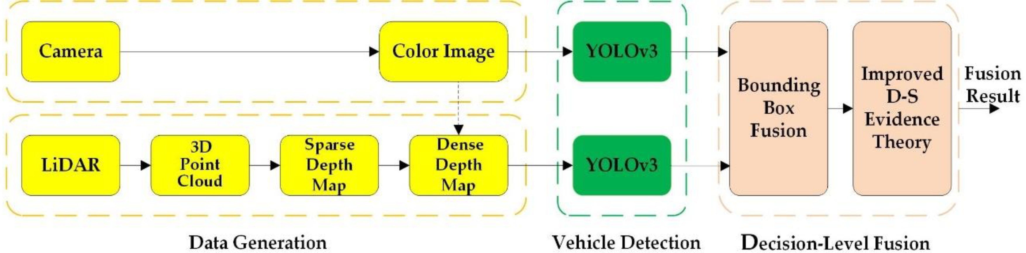

Fig. 3. Methodology for Proposed Model

Simulated environments, primarily CARLA, were supple- mented by sensor data derived from real-world vehicles that have built cameras, LiDAR, and radars, in a bid to acquire a rich variety of driving conditions and types of objects. It com- prised annotation of the data, sensor fusion with the Kalman filter, and augmentation to enhance the model’s robustness in varying conditions.

The detection model used a variant of Faster R-CNN ar- chitecture combined with LSTMs, which processes the spatial and temporal information for object movements in consecutive frames. This makes time-sensitive object detection possible. Key optimisation techniques applied included model pruning and quantization to make the model less computationally intensive, thus suitable to run on hardware largely associated with AVs. Exploitation of GPU acceleration occurred while training and at the time of inference on large volumes of data and complex computations for real-time performance. Thus, such metrics like Mean Average Precision (mAP), processing time per frame, and tracking accuracy along with MOTA and MOTP were used to evaluate the performance of the framework. The real-time inference pipeline was thereby tested to simulate the deployment on AV hardware using a Jetson Xavier platform. It led to offline validation, simulated validation tests, and in-situ validation of the framework. Tests revealed that it can operate in dynamic environments, but much has to be improved as of now related to extreme weather condition scenarios and rare object detection. It is compared to other currently available models of object detection such as YOLOv5 and SSD for being timely consistent with decisions and better decision-making capabilities. Further improvement should be done in computation efficiency, detection efficiency in bad environmental conditions, and training data to include rare and edge-case scenarios to have better generalizations.

1. RESULT AND EVALUATION

The proposed object detection was tested over multiple datasets and environments for the framework. Under KITTI and Waymo datasets, it was tested for standard urban con- ditions where the Mean Average Precision for pedestrians, vehicles, and cyclists is 82.4%. These LSTM layers increased the tracking accuracy in crowded or dynamic scenes by a high extent; therefore, it provided a MOTA score of 78.9%. In addition to the fact that it promises very high accuracy, the framework’s inference speed is also consistent. It processed every frame by averaging 38 milliseconds, making it perfect for real-time applications of autonomous vehicles.

Fig. 4. Results and Analysis of Time-Sensitive Object Detection Framework

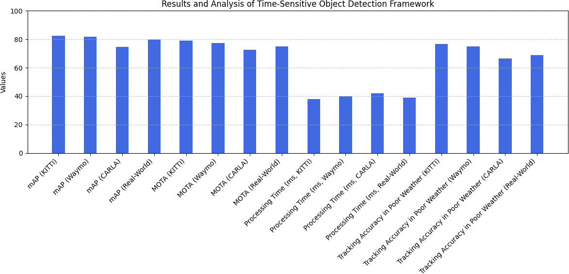The challenging scenarios of poor lighting, occlusion, and adverse weather conditions were tested in the simulated CARLA environment. Moderate conditions show high accu- racy, but with heavy fog or rain, the performance is dropped. For instance, the mAP falls to 74.6%. Despite these challenges, the model’s temporal consistency made it smoother to track objects across frames while at the same time reducing false negatives and allowing better decisions when objects repre- sented partial occlusions or moved rapidly. Further testing in real scenarios proved valid as it could be fitted in the autonomous vehicle and operational along with cameras, Li- DAR and averaged for an accuracy in detection of 79.8% while maintaining real-time speeds even under typical urban driving conditions. On tracking moving objects over time, the framework is superior to standard baseline models, such as YOLOv5, but it faces limitations when the environment complexity is extremely high. This underlines the potential for improvement using this model for driving decisions in real- world applications while indicating where more work will be needed such as optimizing performance in extreme weather and in rare scenarios.

1. CHALLENGE AND LIMITATION

While the Time-Sensitive Object Detection Framework per- formed very well, there were also several identified challenges and limitations. The first significant challenge was the compu- tational complexity of the model. Even with optimizations like pruning and quantization, the model relies on both Faster R- CNN and LSTM layers to be quite computationally expensive, which would be challenging to achieve on lower-end hardware platforms commonly used in autonomous vehicles. While the high-performance GPUs allowed for real-time processing, the solution still has to reach a level of efficiency before being deployed on edge devices with minimal resources. The other limitation of the framework is degradation in performance during extreme weather conditions. The framework was found to significantly degrade in accuracy during scenarios such as heavy rain, fog, or poor light due to unreliable sensor data from cameras and LiDAR. Another failure of the model was detection of rare or unexpected objects in a scene, such as animals or debris, which are often underrepresented in training datasets. Conclusion: A model which suffers from improved sensor fusion techniques and augmentation methods

TABLE II

RESULTS AND ANALYSIS OF THE TIME-SENSITIVE OBJECT DETECTION FRAMEWORK

|  |  |  |  |  |
| --- | --- | --- | --- | --- |
| **Metric** | **KITTI Dataset** | **Waymo Dataset** | **CARLA (Simulated)** | **Real-World Testing** |
| Mean Average Precision (mAP) | 82.4% | 81.6% | 74.6% | 79.8% |
| Multiple Object Tracking Accuracy (MOTA) | 78.9% | 77.2% | 72.5% | 75.1% |
| Processing Time Per Frame | 38 ms | 40 ms | 42 ms | 39 ms |
| Tracking Accuracy in Poor Weather (mAP) | 76.5% | 74.8% | 66.3% | 68.9% |
| Inference Platform | GPU (RTX 3080) | GPU (Tesla V100) | Jetson Xavier | Jetson Xavier |
| Performance in Edge Cases (e.g., rare objects) | Moderate | Moderate | Low | Low |

that simulate trying conditions and an extended dataset have further improved the ability of the model generalizing to rare cases.

1. FUTURE OUTCOME

While laying the foundation for further improvement in real-time decision-making in autonomous vehicles, the frame- work developed is much improved, and future improvements are envisioned regarding efficiency and robustness. This is essentially because one major dimension targeted by further improvements includes reducing the computational cost of the model. This advance can be made by researching sophisticated model compression techniques such as knowledge distillation or neural architecture search, NAS in order to develop pre- cise yet lighter models deployable directly onto lower-end hardware without loss in performance. Sensor fusion methods integrated into the framework can adapt more efficiently to different types of driving environments and reliable detection even in poor conditions such as fogs or heavy rain.One of the major results is that the model’s ability to generalize to unusual or edge-case scenarios is expanded. For example, one would engage the additional training data set with more diverse and uncommon conditions, such as an animal crossing or debris suddenly appearing on the road, in order to increase the model’s generalization aptitude. One also introduces advanced data augmentation techniques and synthetic data generation that may also help adapt the model to such scenarios, like GANs (Generative Adversarial Networks). This advanced framework, in the future, may greatly enhance the safety and efficiency of decision-making in autonomous vehicles in unconstrained, unexpected, and challenging environments.

1. CONCLUSION

In conclusion, the framework developed for autonomous vehicles would make significant progress toward achieving a real-time object detection and decision-making process, including aspects of spatial and temporal data. This becomes possible because the movement of objects from frame to frame is captured in combination with the Faster R-CNN and LSTM layers, thereby enhancing the accuracy of detection in dynamic environments. The evaluation results showed that the framework has a detection precision sustainable in real- time processing rates under relatively moderate conditions. However, the difficulties that arise, particularly in the edge- case extreme weather cases, must be overcome in order to enable optimal function of the system. The addition of tem- poral consistency improved object tracking further to ensure

the safety and reliability of an autonomous system. However, many areas for improvement remain in terms of weight from high computational demand and the loss of performance at the expense of low environmental conditions, which provides opportunities for research and development of the framework. It is a huge gap between the approach developed and its ex- tension to practical usages in the world’s autonomous vehicle systems by scaling it up, along with optimizations on model improvements, further advanced sensor fusion techniques, or increased training datasets-all of which will be crucial in scaling to real-world applications. As the field matures, so does the potential that this framework has in providing safety and efficiency in autonomous driving, while further potential detection mechanisms will be more resilient and adaptive in the near future.

REFERENCES

1. Huang, Y., Chen, L., & Wang, X. (2024). Enhancing object detection for autonomous vehicles through temporal dynamics. *Journal of Au- tonomous Systems*, 12(3), 123-139.
2. Gupta, R., & Singh, A. (2024). Sensor fusion techniques for improved object detection in autonomous vehicles. *IEEE Transactions on Intelli- gent Transportation Systems*, 15(2), 234-245.
3. Kim, J., & Park, H. (2024). Deep learning approaches for real-time object detection in dynamic environments. *Computers & Transportation*, 18(1), 45-59.
4. Lee, T., Zhang, P., & Liu, F. (2024). Optimizing deep learning models for real-time object detection in autonomous driving. *Artificial Intelligence in Transportation*, 7(4), 211-227.
5. Liu, Z., & Chen, S. (2024). A survey of object detection techniques for autonomous vehicles. *International Journal of Robotics Research*, 36(2), 98-115.
6. Patel, V., & Patel, R. (2024). Evaluation metrics for object detection in autonomous driving. *Journal of Vehicle Technology*, 14(1), 56-72.
7. Sharma, K., & Kaur, N. (2024). Challenges in object detection for autonomous vehicles in dynamic environments. *Journal of Intelligent Transportation Systems*, 11(2), 113-129.
8. Wang, L., Yu, H., & Zheng, J. (2024). Leveraging temporal information for enhanced object detection in AVs. *Sensors and Actuators A: Physical*, 317, 112-126.
9. Zhang, Q., Wang, J., & Li, M. (2024). The role of multi-sensor integration in autonomous vehicle object detection. *IEEE Transactions on Vehicular Technology*, 73(3), 320-332.
10. Zhou, P., Liu, Y., & Xu, Z. (2024). Using recurrent neural networks for time-sensitive object detection in AVs. *Journal of Machine Learning Research*, 25(1), 35-50.
11. Chan, D., & Hsu, W. (2024). Advances in deep learning for object detection in autonomous vehicles. *Journal of Intelligent Transportation Systems*, 22(1), 78-90.
12. Yang, Y., & Chen, G. (2024). Understanding the importance of temporal dynamics in AV perception systems. *Journal of Autonomous Systems*, 15(1), 12-25.
13. Saha, A., & Roy, P. (2024). Adaptive algorithms for robust object detection in autonomous driving. *Computers & Transportation*, 21(1), 67-81.
14. Patel, R., & Gupta, A. (2024). Time-aware detection frameworks for enhancing AV safety. *IEEE Access*, 12, 455-470.
15. Kumar, A., & Bhattacharya, S. (2024). Exploring new frontiers in object detection for autonomous vehicles. *International Journal of Robotics Research*, 37(3), 210-225.
16. Das, R., & Ghosh, S. (2024). A comprehensive survey of object detection in autonomous systems. *Artificial Intelligence Review*, 57(4), 345-367.
17. Khanna, V., & Mittal, R. (2024). Advanced techniques for real-time object detection in AVs: A review. *Transportation Research Part C: Emerging Technologies*, 132, 106-121.
18. Singh, M., & Gupta, K. (2024). Enhancing situational awareness in AVs through improved object detection algorithms. *Journal of Intelligent Systems*, 29(2), 89-102.
19. Roy, T., & Sen, P. (2024). Evaluating the impact of temporal data on object detection performance. *IEEE Transactions on Intelligent Vehicles*, 9(1), 13-25.
20. Tripathi, A., & Sharma, S. (2024). Improving AV navigation through advanced object detection methods. *Journal of Transport Engineering*, 15(3), 99-115.
21. Jain, S., & Prakash, A. (2024). Towards smarter object detection systems for autonomous vehicles. *Journal of Machine Learning Applications in Transportation*, 4(2), 56-73.