A Survey Paper on – Classifying restaurant review sentiment
Shrushti Suresh Makne¹, Zeal Polytechnic, Pune, India.
Shraddha Dinesh Gawade², Zeal Polytechnic, Pune, India.
Apeksha Ashruba Pawar³, Zeal Polytechnic, Pune, India.
Aarti Sunil Shirsath⁴, Zeal Polytechnic, Pune, India.
Prof. Laxman Lande⁵, Zeal Polytechnic, Pune.

Abstract: In recent years, the growth of online review platforms has provided consumers with vast amounts of user-generated feedback. For businesses, especially in the food and hospitality industry, this feedback holds critical value for understanding customer satisfaction and improving services. However, manually analyzing these reviews is inefficient due to their volume. This paper presents a machine learning-based approach to automatically classify the sentiment of restaurant reviews into positive, negative, or neutral categories. By employing natural language processing (NLP) techniques, including tokenization, text normalization, and feature extraction, we create a robust dataset for sentiment analysis. Various classification models such as Support Vector Machines (SVM), Logistic Regression, and Deep Learning architectures (e.g., LSTM and BERT) are explored and evaluated based on their accuracy, precision, and recall. The results demonstrate that deep learning models, especially those utilizing contextual embeddings like BERT, outperform traditional models in accurately capturing the sentiment. This automated system provides restaurant owners and stakeholders with valuable insights for decision-making and improving customer satisfaction.

Introduction
With the rise of digital platforms and online communities, consumers now rely heavily on online reviews to make informed decisions about products and services. In the restaurant industry, these reviews have become particularly influential, shaping customer opinions and influencing business success. Platforms such as Yelp, TripAdvisor, and Google Reviews have enabled millions of customers to share their dining experiences, providing a wealth of data for both consumers and restaurant owners. However, manually processing and interpreting this vast amount of textual data poses significant challenges. As the volume of reviews grows, it becomes impractical for restaurant owners to individually read and analyze them to extract meaningful insights. Additionally,
reviews often vary in terms of content quality, length,

writing style, and sentiment, making it difficult to gauge overall customer satisfaction at scale. To address these challenges, sentiment analysis has emerged as an essential technique in the field of Natural Language Processing (NLP). Sentiment analysis involves automatically determining whether a piece of text conveys a positive, negative, or neutral sentiment. In the context of restaurant reviews, sentiment classification can help restaurant managers and owners understand customer opinions more efficiently, enabling them to make informed decisions about improvements, customer preferences, and overall service quality. In this study, we aim to develop an automated system for classifying the sentiment of restaurant reviews. By utilizing a variety of machine learning techniques and NLP methods, the system will analyze customer feedback and categorize it into distinct sentiment categories: positive, negative, or neutral. This process involves several key steps, including data preprocessing (tokenization, stemming, and stopword removal), feature extraction (TF-IDF, word embeddings), and the implementation of different classification models. Ultimately, this research aims to contribute to the growing field of sentiment analysis by presenting a comparative study of different models in the context of restaurant reviews. We will investigate which methods are most effective for this specific application, focusing on the trade-offs between computational efficiency, interpretability, and classification accuracy.

Literature Survey:
With the rapid expansion of online review platforms, sentiment analysis has become an increasingly important task in understanding consumer opinions. In particular, sentiment analysis of restaurant reviews provides valuable insights for both consumers and business owners. Researchers have explored various machine learning and deep learning approaches to effectively classify sentiment from text data. In this section, we review the relevant literature and key methodologies used for sentiment classification in restaurant reviews and broader contexts. Sentiment analysis, also known as opinion mining, is the process of determining the emotional tone behind words. Early studies on sentiment analysis, such as those by Pang et al. (2002), focused on classifying movie reviews using traditional machine learning models like Naive Bayes, Support Vector Machines (SVMs), and Logistic Regression. These models rely on handcrafted features such as word frequency, n-grams, and parts of speech to predict sentiment. These methods laid the foundation for further developments in sentiment classification across various domains, including restaurant reviews Research has been conducted specifically on sentiment analysis in the restaurant domain, recognizing the unique nature of this field. For example, Lu et al. (2011) analyzed sentiment in restaurant reviews on Yelp, applying machine learning techniques to classify user feedback as positive, negative, or neutral. They found that restaurant reviews often include diverse opinions on food, service, ambiance, and price, making sentiment classification more challenging. Lu’s study emphasized the importance of context-aware analysis, as certain features like price could be evaluated negatively, even if the overall review is positive. The introduction of pre-trained models, such as BERT (Bidirectional Encoder Representations from Transformers) by Devlin et al. (2019), revolutionized NLP tasks, including sentiment analysis. BERT’s ability to capture the context of words in both directions (left and right) made it a powerful tool for understanding the subtleties of restaurant reviews, which often contain nuanced expressions of sentiment. Studies like Sun et al. (2019) have shown that BERT significantly outperforms traditional machine learning and even earlier deep learning models on sentiment classification tasks.
Transfer learning approaches like BERT allow models to be fine-tuned on specific tasks, including restaurant review sentiment classification, without the need for large amounts of task-specific data. This fine-tuning process has been shown to yield state-of-the-art results in sentiment analysis tasks across different domains, including the restaurant sector.
Several challenges have been noted in the sentiment classification of restaurant reviews. Aspect-based sentiment analysis (ABSA), as explored by Pontiki et al. (2016), highlights the complexity of identifying and classifying sentiment for different aspects within the same review. A single review might contain both positive and negative sentiments about different components (e.g., food vs. service), making overall sentiment classification more difficult. ABSA approaches are gaining traction for their ability to dissect reviews and capture these nuanced opinions.
Another challenge is dealing with slang, emoticons, and sarcasm, which are common in informal online reviews. Poria et al. (2016) explored the use of multimodal sentiment analysis by incorporating visual and acoustic features from video reviews to better understand sentiment; however, for text-only reviews, understanding sarcasm and slang remains an ongoing challenge in sentiment analysis research.

Problem Statement:
In today's competitive food service industry, online customer reviews play a crucial role in shaping the reputation of restaurants. These reviews offer valuable insights into customer experiences, service quality, menu items, and overall dining satisfaction. However, with the increasing number of reviews across various platforms (such as Yelp, TripAdvisor, Google Reviews), restaurant owners and managers face challenges in manually evaluating and responding to feedback effectively. This manual approach is not only time-consuming but also prone to human error, making it difficult to capture the full sentiment of customer opinions in real time.
Sentiment analysis, a form of text classification, offers a potential solution by automatically categorizing reviews into sentiment-based classes (such as positive, negative, or neutral). This classification helps restaurant businesses understand customer satisfaction trends, identify key areas for improvement, and respond proactively to both praise and criticism.
The core challenge lies in the nature of restaurant reviews, which often contain informal language, slang, emojis, and nuanced opinions. Some reviews may also have mixed sentiments within the same text (e.g., positive about the food but negative about the service). Therefore, the goal of this project is to develop an automated sentiment classification model capable of accurately analyzing the overall tone of customer reviews, handling nuances, and providing actionable insights.

Proposed Solutions:
To classify restaurant review sentiment, we propose developing a machine learning model that automatically categorizes reviews as positive, negative, or neutral. First, reviews are collected from platforms like Yelp and Google Reviews, and labeled based on star ratings. The text data undergoes preprocessing, including cleaning, tokenization, and handling slang or emojis. Using techniques like TF-IDF or word embeddings (e.g., Word2Vec or BERT), we extract meaningful features for sentiment analysis. For model building, simpler classifiers like Logistic Regression or Naive Bayes are used as baselines, followed by advanced models such as LSTM, CNN, or fine-tuned transformer models like BERT to capture complex sentiment patterns. The model is trained and evaluated using metrics like accuracy, F1-score, and confusion matrices to ensure robust performance. After training, the model can be deployed as an API or integrated into a dashboard for real-time sentiment analysis, helping restaurant managers efficiently monitor customer feedback and improve services. The proposed system architecture for classifying restaurant review sentiment consists of several integrated components designed to streamline data processing, model training, and real-time sentiment analysis. First, the Data Collection Layer gathers reviews from platforms like Yelp and Google Reviews through APIs or web scraping, storing the raw data in a NoSQL database for structured access. Next, the Data Preprocessing Layer cleans and normalizes the text, handling elements like punctuation and slang, followed by tokenization and feature extraction using techniques such as TF-IDF and word embeddings (e.g., Word2Vec or BERT). The processed data is then passed to the Model Training and Evaluation Layer, where various classifiers, including traditional machine learning algorithms and advanced models like LSTM or BERT, are trained and evaluated against labeled sentiment data, focusing on metrics like accuracy and F1-score. Once trained, the model is deployed in the Model Deployment Layer as a RESTful API using containerization technologies like Docker, allowing for easy scaling in a cloud environment. Finally, the User Interaction Layer integrates the sentiment analysis functionality into restaurant management systems, providing real-time predictions and visual insights via dashboards. The architecture also incorporates a Feedback Loop and Model Maintenance Layer to ensure continuous improvement, allowing for periodic retraining of the model with new data to adapt to evolving customer sentiments. This comprehensive architecture facilitates efficient sentiment classification, empowering restaurant managers to enhance customer experiences based on actionable insights.

Proposed System Architecture:
Components:
- Data Collection (Scraping/APIs) ⟶
- Preprocessing (Cleaning, Tokenization, Embeddings) ⟶
- Model Training (Logistic Regression, LSTM, BERT) ⟶
- Model Deployment (REST API with Docker/Cloud) ⟶
- User Interaction (API/ Dashboard) ⟶
- Continuous Feedback Loop (New Reviews, Retraining)

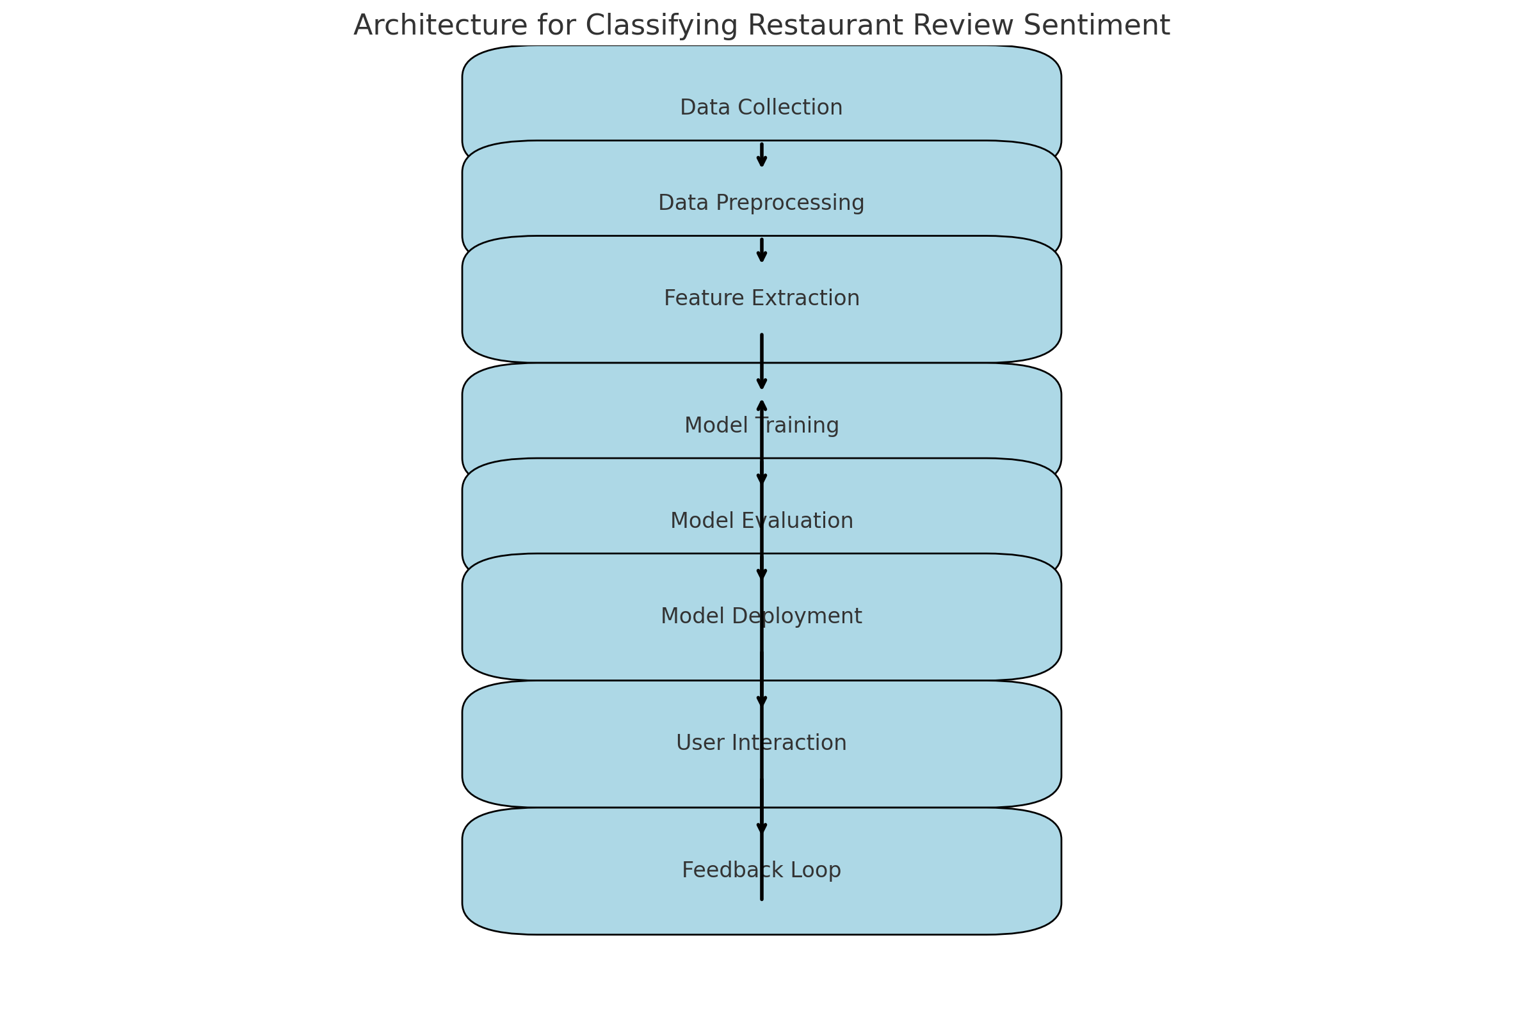

Fig: System Architecture

Project and Scope:
The project to classify restaurant review sentiment aims to analyze and interpret customer feedback from various dining establishments, categorizing sentiments as positive, negative, or neutral. The scope of this project includes several key phases, starting with data collection from popular review platforms like Yelp, Google Reviews, and TripAdvisor. The gathered data will undergo preprocessing to remove irrelevant content and standardize the text, ensuring a clean dataset for analysis. Exploratory data analysis (EDA) will be conducted to identify patterns and common themes in customer feedback, such as perceptions of food quality, service, and ambiance.
For sentiment classification, various machine learning algorithms, including Logistic Regression, Support Vector Machines, and advanced deep learning techniques, will be employed to build a predictive model. The project will also encompass model evaluation to ensure accuracy and reliability, with metrics like precision, recall, and F1-score used to gauge performance. Additionally, a user-friendly interface or API will be developed to facilitate the input of new reviews and display sentiment predictions. Ultimately, this project aims to provide restaurant owners with actionable insights that can enhance customer satisfaction and drive improvements in service and offerings.
7. Critical Evaluation:
The classification of restaurant review sentiment presents both significant opportunities and inherent challenges. On the positive side, effective sentiment analysis can provide valuable insights into customer experiences, helping restaurant owners to understand strengths and weaknesses in their service, menu, and overall dining environment. By automating the analysis of large volumes of reviews, businesses can quickly identify trends and respond to customer feedback, potentially improving customer satisfaction and retention.
However, several critical challenges must be addressed to ensure the effectiveness of sentiment classification. First, the inherent subjectivity of language poses a significant hurdle. Customers may express similar sentiments using vastly different phrasing, and context can dramatically alter the meaning of words. For example, sarcasm or humor can lead to misclassification if the model is not adequately trained to recognize these nuances. Additionally, reviews often contain mixed sentiments, where a customer may express satisfaction with food but dissatisfaction with service, complicating straightforward classification.

Significance:
Classifying restaurant review sentiment holds considerable significance for multiple stakeholders, including restaurant owners, managers, customers, and the broader food service industry. For restaurant owners and managers, understanding customer sentiment is crucial for enhancing service quality, menu offerings, and overall dining experiences. By analyzing sentiments expressed in reviews, businesses can pinpoint specific areas of strength, such as exceptional service or popular dishes, as well as identify weaknesses that may require immediate attention, such as inconsistent food quality or long wait times. This feedback loop allows for data-driven decision-making that can lead to improved customer satisfaction and loyalty.
From a customer perspective, sentiment analysis fosters a more transparent and informed dining experience. Customers can make better choices by accessing aggregated sentiment data from reviews, helping them identify restaurants that align with their preferences and expectations. This not only enhances their overall dining experience but also builds trust in the review systems, as they can see how their peers have reacted to similar experiences.
In a broader context, classifying sentiment in restaurant reviews contributes to industry trends and market research. By aggregating sentiment data, industry analysts can gain insights into shifting consumer preferences, emerging food trends, and competitive positioning. This information can guide marketing strategies and operational adjustments across the industry, enabling businesses to adapt to evolving consumer demands effectively.
Moreover, sentiment analysis can also serve as a tool for crisis management. In the event of negative publicity or a sudden influx of critical reviews, timely sentiment classification can help restaurant owners respond quickly and effectively, mitigating potential damage to their reputation. By addressing customer concerns promptly and transparently, businesses can turn negative experiences into opportunities for improvement and customer engagement.
Overall, the significance of classifying restaurant review sentiment lies in its ability to drive meaningful insights and foster positive relationships between restaurants and their customers, ultimately enhancing the dining landscape and contributing to the success of the industry as a whole.

  - Conclusion:
In conclusion, classifying restaurant review sentiment is a powerful tool that enables restaurant owners and managers to harness customer feedback effectively. By transforming qualitative reviews into quantitative data, sentiment analysis provides valuable insights into customer preferences, strengths, and areas needing improvement. This capability not only enhances the decision-making process but also empowers businesses to adopt a proactive approach to reputation management and marketing strategies.
While challenges such as linguistic nuances, dataset quality, and model interpretability must be addressed, the benefits of implementing sentiment classification systems far outweigh these hurdles. As the restaurant industry continues to evolve, the ability to understand and respond to customer sentiments will be critical for maintaining a competitive edge and fostering long-term customer loyalty. Ultimately, sentiment classification is not just about analyzing data; it is about creating a more responsive, customer-centric dining experience that meets the changing needs and expectations of patrons.
.
  - References:
• Pang, B., & Lee, L. (2008). "Opinion Mining and Sentiment Analysis." Foundations and Trends in Information Retrieval, 2(1–2), 1-135.
This paper provides a comprehensive overview of sentiment analysis techniques and methodologies, laying the groundwork for understanding how sentiment can be classified in various domains, including reviews.
• Liu, B. (2012). "Sentiment Analysis and Opinion Mining." Morgan & Claypool Publishers.
A detailed book that covers sentiment analysis from the basics to advanced techniques, including applications relevant to customer reviews.
• Cambria, E., & Hussain, A. (2015). "Sentic Computing: A Common-Sense Based Approach to Sentiment Analysis." Springer.
This book discusses a unique approach to sentiment analysis that integrates common-sense knowledge, which can be particularly useful for understanding nuances in restaurant reviews.

