  





Student (UG) Student (UG)

HIET,Shahpur HIET,Shahpur





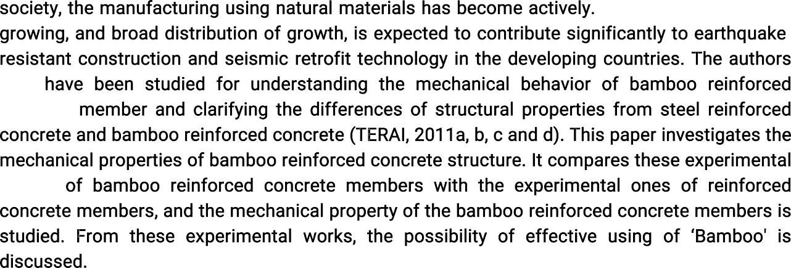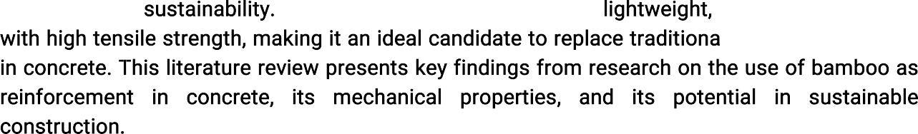







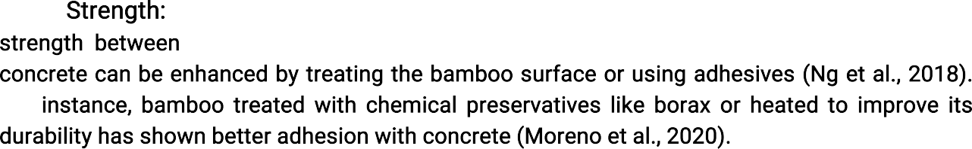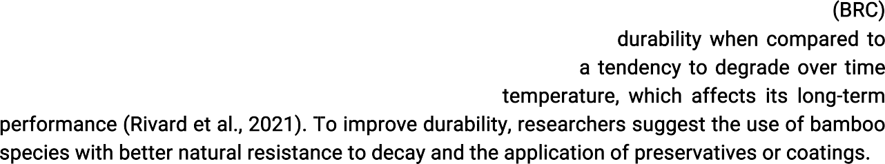













 Some studies have explored combining bamboo with other materials, such as steel or synthetic fibers, to improve the mechanical properties and durability of the reinforcement (Sharma et al., 2023). These hybrid systems aim to leverage the strengths of both materials while minimizing their weaknesses.



